Flight Reservation (FR) Project

First Steps

**Software Requirements Specification**

Table of Contents

Table of Contents II

Table of Figures III

Revision Log IV

1. Introduction 1

1.1 Purpose 1

1.2 Document Conventions 1

1.2.1 Abbreviations 1

1.2.2 Symbols 2

1.3 Intended Audience 2

1.4 Project Scope 3

1.5 References 3

2. Overall Description 4

2.1 Product Features 4

2.1.1 Secured Login 4

2.1.2 Inserting new reservations 4

2.1.3 Confirmations 4

2.1.4 Updating existing reservations. 4

2.1.5 Removing existing reservations. 4

2.1.6 Search capabilities. 5

2.1.7 Reporting 5

2.1.8 Database 5

2.2 Known Bugs 5

2.3 Operating Environment 5

2.4 User Documentation 6

2.5 Assumptions and Dependencies 6

3. Requirements 6

3.1 Login 6

3.1.1 Description 6

3.1.2 Functional Requirements 7

3.1.3 Login – Graphical User Interface 8

3.2 Flight Reservation 9

3.2.1 Description 9

3.2.2 Flight Reservation – Graphical User Interface 11

3.2.3 Functional Requirements 19

3.3 New Order Process 20

3.3.1 Description 20

3.3.2 Functional Requirements 20

3.3.3 Error Messages 24

4. User Challenge 25

4.1 Fax Preview 25

4.1.1 Gui Defaults 26

4.2 Menu 27

4.2.1 Functionality 27

4.3 Fax Order No. <n> 29

4.3.1 Functionality 29

4.4 About Flight Reservations System 29

4.4.1 Gui Defaults 29

4.5 Open Order Process 30

4.5.1 Description 30

4.5.2 Functional Requirements 31

4.5.3 Functional Requirements 32

4.6 Deleting an Order Process 33

4.7 Reporting 33

4.7.1 Description 33

4.7.2 Graphical User Interface Defaults 34

Table of Figures

Figure 1 - Login Dialog 6

Figure 2 - Login Image 8

Figure 3 - Flights Table 8

Figure 4 - Flights Reservation Window 9

Figure 5 – Fax Order No. <n> 10

Figure 6 – Flight Reservation Toolbar 10

Figure 7 – Flight Schedule Frame 10

Figure 8 – Order Information Frame 11

Figure 9 – Summary Frame 15

Figure 10 – Window Image 15

Figure 11 – Order Information Frame 15

Figure 12 – Flights Table Image 16

Figure 13 – Fax Order No. <n> Dialog 17

Figure 14 – Fax Preview Dialog 25

Figure 15 – Fax Preview Image 26

Figure 16 – About Image 29

Figure 17 – Open Order Dialog 29

Figure 18 – Search Results Dialog 30

Figure 18 – Graphical Report 33

Revision Log

|  |  |  |  |
| --- | --- | --- | --- |
| **Name** | **Date** | **Revision Description** | **Version** |
| Dani Vainstein | 18 Dec 2007 | Draft | 1.0 |
|  |  |  |  |
|  |  |  |  |
|  |  |  |  |
|  |  |  |  |
|  |  |  |  |
|  |  |  |  |
|  |  |  |  |
|  |  |  |  |
|  |  |  |  |
|  |  |  |  |
|  |  |  |  |
|  |  |  |  |
|  |  |  |  |
|  |  |  |  |
|  |  |  |  |
|  |  |  |  |
|  |  |  |  |
|  |  |  |  |

# Introduction

A Product requirements document is used in product marketing to plan and execute new products.

A Software Requirements Specification is a complete description of the behavior of the system to be developed. It includes a set of use cases that describe all of the interactions that users will have with the software.

Use Cases are also known as Functional Requirements. In addition to use cases, the **SRS** also contains nonfunctional requirements.

The software requirements document is a written statement of what the software will do.

What the software does is directly perceived by its users. When the user performs some action, the software responds in a particular way.

Therefore you must agree on actions the users can perform and response they should expect. This common understanding is captured in the requirements document.

## Purpose

This document contains the tests requirements for the Automation FR Project.

These software requirements were established by Dani Vainstein.

**This Software requirements document was done using our imagination and our understanding on the Mercury "Flight Reservation" application, and also to demonstrate and simulate a real QA automation project.**

This SRS specifies to Mercury Flight Application Version 4a.

## Document Conventions

### Abbreviations

|  |  |
| --- | --- |
| AUT | Application Under Test |
| GUI | Graphical User Interface |
| UI | User Interface |
| LIB | Library folder contains QTP library functions |
| MTM | Multi Test Manager Tool. |
| QFL | File Extension (QTP File Library ) |
| VBS | File Extension ( VBScript ) |
| N/A | Not Available |
| DP | Descriptive Programming |
| OR | Object Repository |
| SOR | Shared Object Repository |
| OO | Object Oriented |
| OOP | Object Oriented Programming |
| OOT | Object Oriented Testing |
| STD | Software Test Documentation |
| PK | Primary Key ( Database relationships ) |
| FK | Foreign key ( Database relationships ) |

### Symbols

|  |  |
| --- | --- |
| Exclamation |  |
| Question |  |
| Information |  |
| Critical |  |

## Intended Audience

This project is for "First Steps" members that want to learn how to practically learn how to use QTP as well as intermediate and expert users that want to review different methodology methods, code tricks and implementations.

|  |  |
| --- | --- |
| Natwarlal Asawa from India, Hyderabad | **Project Team :** |
| Bharathi Babu from India, Pune |  |
| Dinkar Singh from India, Delhi |  |
| Ayyappa Koppolu from India, Pune |  |
| Paul Grossman from USA, Chicago |  |
| Sumit Singhal from India, Bangalore |  |
| Sanjeev Mathur from India, Noida |  |
| Manasa VN from India, Bangalore |  |
| Prakash Kumar from India, Pune |  |
| Richi Sharma from USA, New Jersey |  |
| Suresh K from India, Bangalore |  |
| Janardhan Kalvakuntla from USA, New England |  |
| Joydeep Das from India, Hyderabad |  |
| Indlamudi Rajesh from India, Mumbai. |  |
| Monika Arora Gautam from USA, Austin | **Project Manager** |
| Dani Vainstein from Israel, Petah Tikva | **Senior Manager** |
| Yaron Assa from Israel, Ramat Gan | **Advisors** |
| Meir Bar-Tal from Israel, Beer Sheva |  |

## Project Scope

This document defines at a functional level the business activities that are encompassed by the system and the rules that apply to them. It also encompasses some of the key high and low level technical requirements of the system.

It draws heavily on both proposed Framework and Business Rules and the Technical Architecture documents. The scope of the detailed analysis project phase specifies that this document will include.

* Classification of requirements according to their functional areas.
* A description of each process in the system, including their inputs, outputs, and data transformation rules.

## References

* VBScript Tutorial  
  VBScript Basics  
  VBScript Advanced  
  Databases
* Dictionary   
  Regular Expressions  
  CheckPoints  
  Negative Testing
* DP  
  Overall Description

## Product Features

### Secured Login

The system supports a secured login user/password.

Insert a new flight reservation.

### Inserting new reservations

The application is able to insert new flight reservations according a future date requested, destinations and flight selections.

### Confirmations

The application is send fax confirmations to clients, about new, updates and cancelled flights.

### Updating existing reservations.

The application is able to update any data from an existing reservation.

### Removing existing reservations.

The application is able to cancel any existing reservation.

### Search capabilities.

The application supports a searching mechanism by order number customer name and/or date of flight

### Reporting

The application supports graphical and text reports of reservations.

### Database

The Flight Reservation database is a MS-Access file ( .mdb ).

The database has 2 tables

* Flights table
  + **[PK]** Flight_Number – Integer
  + Departure_Initials – String( size = 3 )
  + Departure – String( size = 30 )
  + Day_Of_Week – String( size = 9 )
  + Arrival_Initials – String( size = 3 )
  + Arrival – String( size = 30 )
  + Departure_Time – String( size = 8 )
  + Arrival_Time – String( size = 8 )
  + Airlines – String( size = 5 )
  + Seats_Available – Integer
  + Ticket_Price - Currency
* Orders table
  + **[PK]** Order_Number – Long Integer
  + Customer_Name – String( size = 20 )
  + Departure_Date – Date
  + **[FK]** Flight_Number – Integer
  + Tickets_Ordered – Byte
  + Class – String ( size = 1 )
  + Agents_Name - String ( size = 10 )
  + Send_Signature_With_Order – String ( size = 1 🡪 Y/N )

## Known Bugs

* + 1. In the application database, table Flights, there is a field name **Seats_Available**. Usually the value is set to 250. I was trying to test if the reservations are limited and calculated. I ordered 400 tickets ( 40 iterations 10 tickets per-iteration ) and not get any error message.

## Operating Environment

The Project is implemented on QTP version 9.2

## User Documentation

It is recommended to use the QTP help. Every presentation has a "Before You Start" slide where all the topics that will be used in the current presentation.

## Assumptions and Dependencies

* The project was originally designed, tested and reviewed for QTP version 9.2. If you use a different version of QTP, some screenshots might see different from yours. Be aware that some functionality may not work in earlier versions of QTP.
* I will need **MS-Excel** installed on your computer, to create and modify datasheets files.
* You might need **MS-Access** to modify and view the flight application database. However you can use "Snapshot Viewer for MS-Access" from Microsoft at [www/microsoft.com/downloads](https://d.docs.live.net/2b5ef7dd2b0c2f8f/Local%20Settings/Temp/Local%20Settings/Local%20Settings/Temp/www/microsoft.com/downloads) site. This software is free.
* From presentation one you will need the "Multi Test Manager" provided by HP/Mercury. We will provide a download link fro this tool.
* We are assuming that you don’t have **Quality-Center**; this project was designed with no interaction to **Quality Center**.
* We are also assuming that you don’t have a “network” drive. So, always save your work.

# Requirements

This part of the requirements document serves to present the "big picture" of the application. Here you lay out the objectives of the application.

## Login

### Description

The Login dialog, logs to the Flight Reservation application. A shortcut to the application demo can be found in   
Start 🡪 Sample Applications 🡪 Flight.

The user must provide an *Agent Name* that must be at least 4 characters long and the *Password* is always "Mercury". Clicking the OK button will access the application if requested information is correct.

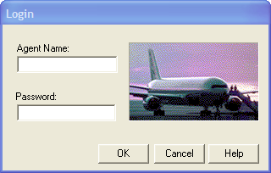

Figure 1 - Login Dialog

### Functional Requirements

#### Req0001

**Req0001a** - User activates the Flight Application executable file from installation directory plus "\samples\flight\app\flightxx.exe"

**Req0001b** - immediately afterwards the Dialog "Login" should be displayed.

#### Req0003

User press OK without entering any information.

**Req0003a** – Popup dialog is displayed.

**Req0003b** – Popup title "Flight Reservations"

**Req0003c** – message type: Exclamation

**Req0003d** – message text "please enter agent name"

#### Req0004

The agent name must be at least 4 characters long.

**Req0004a** - Popup dialog displayed: True.

**Req0004b** – Popup title: "Flight Reservations"

**Req0004c** – message type: Exclamation

**Req0004d** – message text "Agent name must be at least 4 characters."

#### Req0005

The password must be at least 4 characters long.

**Req0005a** - Popup dialog is displayed.

**Req0005b** – Popup title "Flight Reservations"

**Req0005c** – message type: Exclamation.

**Req0005d** – message text: "Password must be at least 4 characters long"

#### Req0006

The field “Password” should not be empty.

**Req0006a** - Popup dialog is displayed.

**Req0006b** – Popup title "Flight Reservations"

**Req0006c** – message type: Critical

**Req0006d** – message text "Please enter password"

#### Req0007

Wrong “Password” field will trigger a critical popup message

**Req0007a** – Popup dialog is displayed.

**Req0007b** – Popup title "Flight Reservations"

**Req0007c** – message type: Critical

**Req0007d** – message text: "Incorrect password. Please try again"

#### Req0008

Pressing "Cancel" at any time should close immediately the "Login" dialog

#### Req0009

After 4 bad attempts to login (bad password) the application will trigger an information message and closed.

**Req0009a** – Popup dialog is displayed.

**Req0009b** – Popup title "Flight Reservations"

**Req0009c** – message type: Exclamation

**Req0009d** – message text: "Login unsuccessful. Please try again later."

**Req0009e** – Application is closed.

### Login – Graphical User Interface

#### Req0002

User activates the application the first time.

**Req0002a** - Label "Agent Name" visible: **True**.

**Req0002b** - Textbox "Agent Name" text: "", enabled: **True**, focused : **True**.

**Req0002c** - Label "Password" visible: **True**.

**Req0002d** - Textbox "Password" enabled: **True**, text: "".

**Req0002e** - Button "OK" enabled: **True**.

**Req0002f** - Button "Cancel" enabled: **True**.

**Req0002g** - Button '"Help" enabled: **True**.

**Req0002h** Image Logo:



Figure 2 - Login Image

## Flight Reservation

### Description

By inserting a valid and future date, and selecting a base and destination city, the user can choose a flight; order 1 to 10 tickets on 3 different classes. A client can receive a fax confirmation.

The user must provide a future valid *Flight Date* and must select a *Fly From* city and a *Fly To* city.

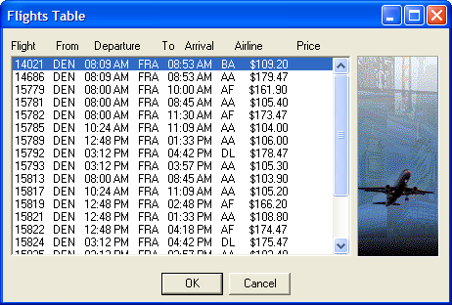

Figure 3 - Flights Table

The system will monitor from this point the price-per-ticket and the total amount to pay.

In addition the user can select 1 to 10 tickets and a flight class.

The information is inserted to a database, and a successful or failure message should be displayed in the transaction progress bar.

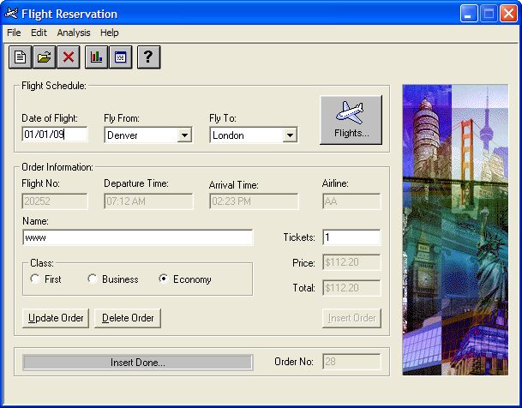

Figure 4 - Flights Reservation Window

In addition the user can get fax confirmation with an optional agent signature.

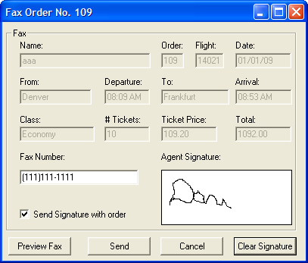

Figure 5 – Fax Order No. <n>

### Flight Reservation – Graphical User Interface

#### The Toolbar



Figure 6 – Flight Reservation Toolbar

#### Req0010

**Req0010a –** Button "New Order"

* enabled: **True**
* icon: 

**Req0010b –** Button "Open Order"

* enabled: **True**
* icon is: 

**Req0010c –** Button "Delete Order"

* enabled: **False**
* icon is: 

**Req0010d –** Button "Graphs"

* enabled: **True**,
* con is: 

**Req0010e –** Button "Reports"

* enabled: **True**
* icon is: 

**Req0010f –** Button "Help"

* enabled: **True**
* icon is: 

#### Flight Schedule Frame

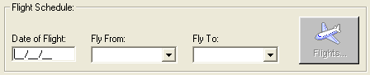

Figure 7 – Flight Schedule Frame

#### Req0011

**Req0011a –** "Date of Flight"

* enabled: **True**
* text: ""
* formattedText: "__/__/__"
* mask: "99/99/99"
* focused: **True**

**Req0011b –** "Flight From"

* enabled: **True**
* selection: ""

**Req0011c –** "Flight To"

* enabled: **True**
* selection: ""

**Req0011d –** "Flights"

* enabled: **False**

#### Order Information Frame

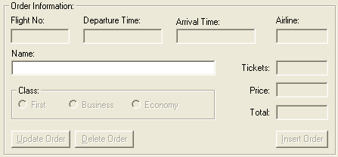

Figure 8 – Order Information Frame

#### Req0012

**Req0012a –** "Flight No." text: ""

**Req0012b –** "Departure Time" text: ""

**Req0012c –** "Arrival Time" text: ""

**Req0012d –** "Airline" text: ""

**Req0012e –** "Name", text: ""

**Req0012f –** "Tickets" text: ""

**Req0012g –** "Price", text: ""

**Req0012h –** "Total" text: ""

**Req0012i –** "Insert Order"

* Enabled: **False**

**Req0012j –** "Delete Order"

* Enabled: **False**

**Req0012k –** "Update Order"

* Enabled: **False**

**Req0012l –** "Business"

* enabled: **False**

**Req0012m –** "Economy"

* enabled: **False**

**Req0012n –** "First"

* enabled: **False**

#### Menu Defaults

#### Req0013

**Req0013a –** "File"

* Exists: **True**
* Enabled: **True**
* Index: 1
* Label: "File"
* SubMenuCount: 4

**Req0013b –** "Edit"

* Exists: **True**,
* Enabled: **True**
* Index: 2
* Label: "Edit"
* SubMenuCount: 3

**Req0013c –** "Analysis"

* Exists: **True**
* Enabled: **True**
* Index: 3
* Label: "Analysis"
* SubMenuCount: 2

**Req0013d –** "Help"

* Exists: **True**
* Enabled: **True**
* Index: 4
* Label: "Help"
* SubMenuCount: 2

**Req0013e –** "New Order"

* Exists: **True**
* Enabled: **True**
* Label: "New Order"
* HasSubMenu: **False**

**Req0013f –** "Open Order"

* Exists: **True**
* Enabled: **True**
* Label: "Open Order..."
* HasSubMenu: **False**

**Req0013g –** "Fax Order"

* Exists: **True**
* Enabled: **False**
* Label: "Fax Order…"
* HasSubMenu: **False**

**Req0013h –** "Fax Order"

* Exists: **True**,
* Enabled: **False**
* label: "Fax Order…"
* HasSubMenu: **False**

**Req0013i –** "Exit"

* Exists: **True**
* Enabled: **True**
* Label: "Exit"
* HasSubMenu: **False**

**Req0013j –** "Copy" Exists: **True**

**Req0013k –** "Cut" Exists: **True**

**Req0013l –** "Paste" Exists: **True**

**Req0013m –** "Reports"

* Exists: **True**
* Enabled: **True**
* Label: "Reports…"
* HasSubMenu: **False**

**Req0013n –** "Graphs"

* Exists: **True**
* Enabled: **True**
* Label: "Graphs…"
* HasSubMenu: **False**

**Req0013o –** "Contents"

* Exists: **True**
* Enabled: **True**
* Label: "Contents"
* HasSubMenu: **False**

**Req0013p –** "About"

* Exists: **True**
* Enabled: **True**
* Label: "About…"
* HasSubMenu: **False**

#### Summary Defaults



Figure 9 – Summary Frame

#### Req0014

**Req0014a –** "Order No." text: ""

**Req0014b –** Progress bar text: ""

#### Window Image

#### Req0015



Figure 10 – Window Image

#### Flights Table Dialog



Figure 11 – Order Information Frame

#### Req0016

**Req0016a** – List

* enabled: **True**
* columns count: 7

**Req0016b** – Columns

* "Flight"
* "From"
* "To"
* "Departure"
* "Arrival"
* "Airline"
* "Price"

**Req0016c** – Button "OK"

* enabled: **True**

**Req0016d** – Button "Cancel

* enabled: **True**

**Req0016e** – Image :



Figure 12 – Flights Table Image

#### Send Fax - Defaults

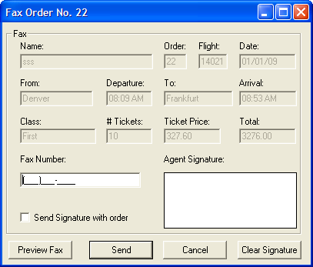

Figure 13 – Fax Order No. <n> Dialog

#### Req0018

Information match:

**Req0018a** – Dialog

* text: "Fax Order No. <num>"
* Ispopupwindow: **True**

**Req0018b** – *Name*

* text: <Name>
* Order: text: <Order>
* Flight: text: <Flight>
* Date: text: <Date>,
* From: text: <Fly From>
* Departure text: <Departure Time>
* To: text: <Flight To>
* Arrival: text: <Arrival Time>,
* Class: text: <Class>
* # Tickets text: <Tickets>,
* Ticket Price: <Price>
* Total text: <Total>

**Req0018c** – Fax Number;

* enabled: **True**
* format: "(###)###-####"
* FormattedText: "(___)___-____"
* mask: (999)999-9999; text: ""
* focused: **True**

**Req0018c** – Send Signature with order; enabled: **True**, checked: OFF

**Req0018d**– Agent Signature bitmap:



**Req0018e** – Preview Fax button

* enabled: True

**Req0018f** – Send button

* enabled: True

**Req0018g** – Cancel button

* enabled: True

Req0018h – Clear Signature button

* enabled: True

### Functional Requirements

#### Toolbar Functionality

#### Req0020

If Data displayed, selecting "New" button, should clear the form. However if information updated without saving changes:

**Req0020a** – Popup dialog is displayed.

**Req0020b** – Popup title "Flight Reservations"

**Req0020c** – message type: Question.

**Req0020d** – message text: "The information has changed. Save changes?"

#### Req0021

Toolbar "Open Order" will display the Dialog "Open Order".

**Req0021** - Open Order dialog exist: **True**

#### Req0022

Toolbar "Delete" will be enabled only after open an order.

**Req0022** – open an order "Delete" enabled: **True**

#### Req0023

Toolbar "Graphs" will open the dialog "Graph"

**Req0023** – Graph dialog

* exist: **True**

#### Req0024

Toolbar "Reports" will open "report.txt" notepad file.

**Req0024** – Reports text file

* exist: **True**

#### Req0025

Toolbar "Help" will open the window "Flight Reservation Help Version.*"

**Req0025** – Flight Reservation Help Version .*

* exist: **True**

## New Order Process

### Description

See Description

### Functional Requirements

#### Req0035

Only valid departures cities must be in list "Fly Form" and "Fly To"

**Req0035a** – Fly From

* all items: < all items >

**Req0035b** – Fly To

* all items: < all items >

#### Req0036

After selecting "Fly From" The "Fly To" field

**Req0035a** – Fly To

* items count : < FlyFrom >.count - 1

**Req0035b** – Fly To;

* < FlyFrom > value is not in the "all items"

#### Req0037

Only after selecting "Fly From" the access to **Flights Table** will be available.

**Req0037a** – Button "Flights"

* enabled: True.

**Req0037b** – icon



#### Req0038

All items are ordered by Flight.

**Req0038a** – List

* items count: <items count>
* all items: <all items>
* selected: <item 0>

#### Req0039

After selecting a flight from "Flights Table"

**Req0039a** – "Name"

* focused: True

**Req0039b** – "Tickets"

* enabled: True
* Text: "1"

**Req0039c** – "Economy"

* enabled: True
* checked: "ON"

**Req0039d** – "Flight No."

* text: <OrderNo>

**Req0039e** – "Departure Time"

* text: <DepartureTime>

**Req0039f** – "Arrival Time"

* text: <ArrivalTime>

**Req0039g** – "Airline"

* text: <Airline>

**Req0039h** – "Price"

* text: <Price>

**Req0039i** – "Total"

* text: <Price> * <Tickets>

#### Req0040

After typing a name, tickets or selecting a class

**Req0040a** – "Insert Order"

* enabled: **True**

**Req0040b** – "Total"

* text: <Price> * <Tickets>

#### Req0041

After pressing "Insert Order"

**Req0041a** – Application temporally disabled "Flight Reservation

* enabled: **False**

**Req0041b** – "Insert Order"

* enabled: **True**

**Req0040c** – "Update Order"

* enabled: **False**

**Req0041d** – "Delete Order"

* enabled: **False**

**Req0041e** – "Order No."

* text: <last order no> + 1

**Req0041f** – "Send Fax" menu item

* enabled: **True**

**Req0041g** – toolbar "Delete"

* enabled: **True**

**Req0041h** – toolbar button "Delete"

* image: 

**Req0041i** – progress bar message

* text: "Insert Done…"

**Req0041j** – new record was added to *Orders* table in database. Fields values must be consists.

* "Order_Number",
* "Customer_Name",
* "Departue_Date",
* "Flight_Number"
* "Tickets_Ordered", "Class"
* "Agents_Name"

#### Req0042

After pressing "Send"

**Req0042a** – Message "Dialing..."

**Req0042b** – Message "Connecting..."

**Req0042c** – Message "Sending Fax..."

**Req0042d** – dialog "Fax Order No. <x>

* Exists: **False**

**Req0042e** – progress bar message

* text: "Fax Sent Successfully…"

**Req0042f** – record <n> Field "Send Signature" must be consists.

#### Req0043

After pressing "Send"

**Req0043a** – dialog "Fax Preview

* Exists: **False**

**Req0043b** – Message "Dialing..."

**Req0043c** – Message "Connecting..."

**Req0043d** – Message "Sending Fax..."

**Req0043e** – progress bar message

* text: "Fax Sent Successfully…"

**Req0043f** – record <n> Field "Send Signature" must be consists.

### Error Messages

#### Req0044

User types an invalid month.

**Req0044a** – Popup dialog is displayed.

**Req0044b** – Popup title: "Flight Reservations"

**Req0044c** – message type: Exclamation

**Req0044d** – message text: "Invalid month Entered.The month must be greater than 01 and less than 12."

#### Req0045

User types an invalid day

**Req0045a** – Popup dialog is displayed.

**Req0045b** – Popup title: "Flight Reservations"

**Req0045c** – message type: Exclamation

**Req0045d** – message text: "Invalid day Entered. The date should be valid for the given month."

#### Req0046

User type an invalid year (valid 2007-2038).

**Req0046a** – Popup dialog is displayed.

**Req0046b** – Popup title: "Flight Reservations"

**Req0046c** – message type: Exclamation

**Req0046d** – message text: "Invalid year Entered.

The year must be greater than 2007 and less than 2038.

#### Req0047

Valid dates are Today()+1, User type an old acceptable date.

**Req0047a** – Popup dialog is displayed.

**Req0047b** – Popup title: "Flight Reservations"

**Req0047c** – message type: Information

**Req0047d** – message text: "Valid flight dates are after <Today>"

#### Req0048

User select "Fly From" without "Date of Flight"

**Req0048a** – Popup dialog is displayed.

**Req0048b** – Popup title: "Flight Reservations"

**Req0048c** – message type: Information

**Req0048d** – message text: "Please enter a flight date"

#### Req0049

User select "Fly To" without "Fly From"

**Req0049a** – Popup dialog is displayed.

**Req0049b** – Popup title: "Flight Reservations"

**Req0049c** – message type: Information

**Req0049d** – message text: "Please enter a fly 'from' city."

#### Req0050

Valid number of tickets between 1 and 10, The user types an amount greater than 10.

**Req0050a** – Popup dialog is displayed.

**Req0050b** – Popup title: "Flight Reservations"

**Req0050c** – message type: Critical

**Req0050d** – message text: "Only ten tickets may be ordered at one time"

# User Challenge

This part of the requirements document is for students that want to go forward and complete the whole project.

**AdvancedQTP** staff will help you, on the "Student Challenge" part.

Use the FR Project Forum to ask question, report errors in the presentations, and any other issue regarding the FR Project.

In addition, you want to add more ( we know there are more ) requirements to this document, write me to [oficer@netvision.net.il](mailto:oficer@netvision.net.il)

## Fax Preview

### Gui Defaults

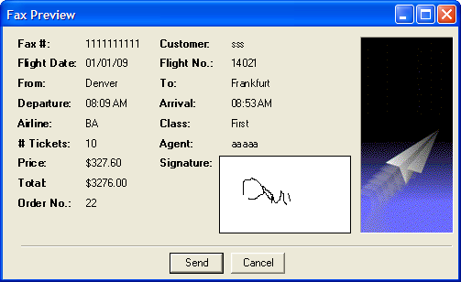

Figure 14 – Fax Preview Dialog

#### Req0019

Information match:

**Req0019a** – Dialog; Ispopupwindow: **True**

**Req0019b** – Fax # = < faxNo >

**Req0019c** – Customer = < customer >

**Req0019d** – Flight Date = < flightDate>

**Req0019e** – Flight No. = < flightNo >

**Req0019f** – From = < flyFrom >

**Req0019g** – To = < flyTo >

**Req0019h** – Departure = < departure >

**Req0019i** – Arrival = < arrival >

**Req0019j** – Airline = < airline >

**Req0019k** – Class = < class >

**Req0019l** – # Tickets = < tickets >

**Req0019m** – Agent = < agent >

**Req0019n** – Price = < price >

**Req0019o** – Total = < total >

**Req0019p** – Order No. = < orderNo >

**Req0019q –** Button "send"

* enabled" True

**Req0019r –** Button "Cancel"

* enabled: True

**Req0019s –** image :



Figure 15 – Fax Preview Image

## Menu

### Functionality

#### Req0026

If Data displayed, selecting "File; New" menu item, should clear the form. However if information updated without saving changes:

**Req0026a** – Popup dialog is displayed.

**Req0026b** – Popup title "Flight Reservations"

**Req0026c** – message type: Question.

**Req0026d** – message text: "The information has changed. Save changes?"

#### Req0027

If Data displayed, selecting "File; New" menu item, should clear the form. However if information updated without saving changes:

**Req0026a** – Popup dialog is displayed.

**Req0026b** – Popup title "Flight Reservations"

**Req0026c** – message type: Question.

**Req0026d** – message text: "The information has changed. Save changes?"

#### Req0028

Toolbar "Open Order" will display the Dialog "Open Order".

However if information updated without saving changes:

**Req0026a** – Open Order dialog exist:

**Req0026b** – Popup dialog is displayed.

**Req0026c** – Popup title "Flight Reservations"

**Req0026d** – message type: Question.

**Req0026e** – message text: "The information has changed. Save changes?"

#### Req0029

If "File; Fax Order" is enabled it should open the "Fax Order No. x" Dialog, where "x" is the currently opened reservation.

**Req0029a** – "Fax Order No. x"

* exist: True

**Req0029b** – "x"; currently opened reservation. < orderNo >

#### Req0030

Menu item "File; Exit" should close application

#### Req0031

Menu item "Analysis; Graphs" will open the dialog "Graph"

* Graph dialog exist: True

#### Req0032

Menu item "Analysis; Reports" will open "report.txt" notepad file.

* Reports text file exist: True

#### Req0033

Menu item "Help; Contents" will open the window "Flight Reservation Help Version.*"

Flight Reservation Help Version .*

* exist: **True**

#### Req0034

Menu item "Help; About" will open the dialog "About Flight Reservation System"

About Flight Reservation System

* exist: True

## Fax Order No. <n>

### Functionality

#### Req0051

Click on "Cancel" button will close dialog.

**Req0041** – "Fax Order No. <x>"; Exists: **False**

#### Req0052

Clear Signature Button will erase the signature.

**Req0042** – Agent Signature; bitmap:



#### Req0053

User Clicks **Send** or **Preview Fax** with empty fax number or less than 10 digits.

**Req0043a** – Popup dialog is displayed.

**Req0043b** – Popup title "Flight Reservations"

**Req0043c** – message type: Critical

**Req0043d** – message text "Please complete the fax number."

#### Req0054

User Clicks Send or Preview Fax with checked field "Send Signature with order" and without signature.

**Req0043a** – Popup dialog is displayed.

**Req0043b** – Popup title "Flight Reservations"

**Req0043c** – message type: Critical

**Req0043d** – message text "Please sign the fax."

## About Flight Reservations System

### Gui Defaults

#### Req0055

**Req0055a** – Button "OK"

* enabled: True

**Req0055b** – Static "Version" text: "Version 4.0"

**Req0055a** – Icon: 

**Req0055a** – image



Figure 16 – About Image

## Open Order Process

### Description

When the Flight Reservation Main window is displayed, the agent is able to open an existing order for review, update or delete an existing order.

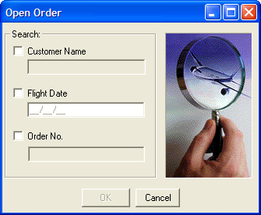

Figure 17 – Open Order Dialog

By entering an *Order No* Or *a Customer Name* Or *a Flight Date* Or a combination of *Customer Name* and *Flight Date*, the relevant order will open.

Opening an order by *Order No*. will open the order directly if it exists.

Opening an order by *Customer Name* and/Or *Flight Date* will open a dialog "Search Results" if more than one matches the description.

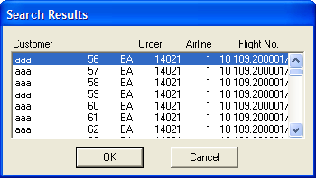

Figure 18 – Search Results Dialog

### Functional Requirements

#### Req0056

**Req0056a -** Check only "Customer Name" option.

"Customer Name" field

* enabled: **True**
* focused: **True**

"Flight Date" field

* enabled: **True**

"Order No" option

* enabled: **False**

"Order No" field

* enabled: **False**

**Req0056b -** Check "Order No" option

"Order No" field

* enabled: **True**
* focused: **True**

"Flight Date" field

* enabled: **False**

"Flight Date" option

* enabled: **False**

"Customer Name" option

* enabled: **False**

"Customer Name" field

* enabled: **False**

**Req0056c -** Check only "Flight Date" option

"Flight Date" field

* enabled: **True**
* focused: **True**

"Customer Name" field

* enabled: **False**

"Customer Name" option

* enabled: **True**

"Order No" option

* enabled: **False**

"Order No" field

* enabled: **False**

**Req0056d -** Check "Customer Name" and then "Flight Date" options

"Flight Date" field

* enabled: **True**
* focused: **True**

"Customer Name" field

* enabled: **True**

"Order No" option

* enabled: **False**

"Order No" field

* enabled: **False**

#### Req0057

Pressing "Cancel" close the dialog

### Functional Requirements

#### Req0058

Trying to open a non-existing order No. will display a critical message

**Req0058a** – Popup dialog is displayed.

**Req0058b** – Popup title "Flight Reservations"

**Req0058c** – message type: Critical

**Req0058d** – message text "Order Number < OrderNo > does not exist"

#### Req0059

Trying to open a non-existing Customer Name will display a critical message

**Req0059a** – Popup dialog is displayed.

**Req0059b** – Popup title "Flight Reservations"

**Req0059c** – message type: Critical

**Req0059d** – message text "No order found. Please try again"

#### Req0060

Trying to open a non-existing "Flight Date" will display a critical message

**Req0060a** – Popup dialog is displayed.

**Req0060b** – Popup title "Flight Reservations"

**Req0060c** – message type: Critical

**Req0060d** – message text "No order found. Please try again"

## Deleting an Order Process

Make your own requirements for this process

## Reporting

### Description

The flight application supports two report mechanism

1. Textual Report
2. Graphical Report

Both are available from the menu and toolbar.

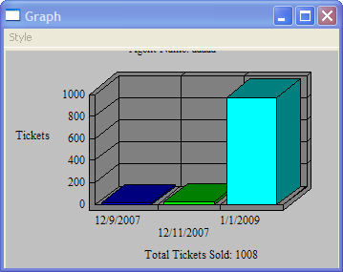

Figure 18 – Graphical Report Dialog

### Graphical User Interface Defaults

#### Req0061

**Req0061a –** Dialog

* ispopupwindow: **True**

**Req0061b –** "Style"

* Exists: **True**
* Enabled: **True**
* Index: 1
* Label: "File"
* SubMenuCount: 4

**Req0061c –** "Style; 2D Bar"

* Exists: **True**
* Enabled: **True**
* Label: "2D Bar Graph"
* HasSubMenu: False

**Req0061d –** "Style; 3D Bar"

* Exists: **True**
* Enabled: **True**
* Label: "3D Bar Graph"
* HasSubMenu: False

**Req0061e –** "Style; 3D Bar"

* Exists: **True**
* Enabled: **True**
* Label: "3D Pie Graph"
* HasSubMenu: False

**Req0061f –** "Agent Name: <AgentName>

**Req0061g –** "Total Tickets Sold: <TotalTickets>