**About the Tutorial**



HTML stands for Hyper Text Markup Language, which is the most widely used language on Web to develop web pages.

HTML was created by Berners-Lee in late 1991 but "HTML 2.0" was the first standard HTML specification which was published in 1995. HTML 4.01 was a major version of HTML and it was published in late 1999. Though HTML 4.01 version is widely used but currently we are having HTML-5 version which is an extension to HTML 4.01, and this version was published in 2012.

**HTML Tags**



As told earlier, HTML is a markup language and makes use of various tags to format the content. These tags are enclosed within angle braces **<Tag Name>**. Except few tags, most of the tags have their corresponding closing tags. For example, **<html>** has its closing tag**</html>** and **<body>** tag has its closing tag **</body>** tag etc.

Above example of HTML document uses the following tags:

|  |  |  |  |  |
| --- | --- | --- | --- | --- |
| **Tag** |  | | **Description** |  |
|  |  | |  |  |
|  |  | |  |  |
| <!DOCTYPE...> | | This tag defines the document type and HTML version. | |  |
|  |  | |  |  |
|  |  | | This tag encloses the complete HTML document and mainly comprises |  |
| <html> |  | | of document header which is represented by <head>...</head> and |  |
|  |  | | document body which is represented by <body>...</body> tags. |  |
|  |  | |  |  |
| <head> |  | | This tag represents the document's header which can keep other HTML |  |
|  | | tags like <title>, <link> etc. |  |
|  |  | |  |
|  |  | |  |  |
| <title> |  | | The <title> tag is used inside the <head> tag to mention the |  |
|  | | document title. |  |
|  |  | |  |
|  |  | |  |  |
| <body> |  | | This tag represents the document's body which keeps other HTML tags |  |
|  | | like <h1>, <div>, <p> etc. |  |
|  |  | |  |
|  |  | |  |  |
| <h1> |  | | This tag represents the heading. |  |
|  |  | |  |  |

<p>

HTML

This tag represents a paragraph.

To learn HTML, you will need to study various tags and understand how they behave, while formatting a textual document. Learning HTML is simple as users have to learn the usage of different tags in order to format the text or images to make a beautiful webpage.

World Wide Web Consortium (W3C) recommends to use lowercase tags starting from HTML 4.

**HTML Document Structure**



A typical HTML document will have the following structure:

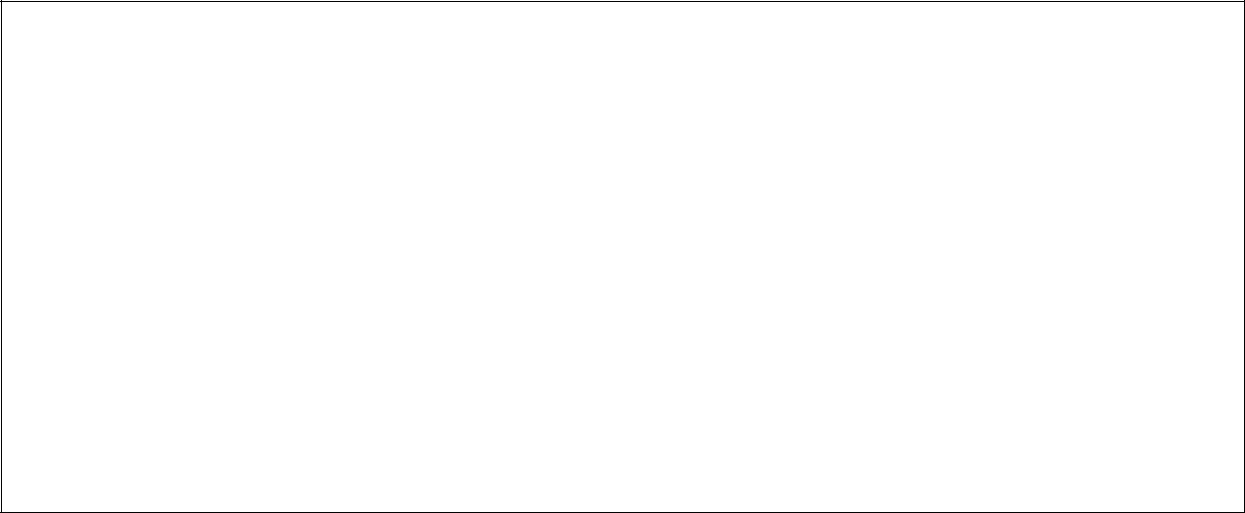

Document declaration tag

<html>

<head>

Document header related tags

</head>

<body>

Document body related tags

</body>

</html>

We will study all the header and body tags in subsequent chapters, but for now let's see what is document declaration tag.

**The <!DOCTYPE> Declaration**



The <!DOCTYPE> declaration tag is used by the web browser to understand the version of the HTML used in the document. Current version of HTML is 5 and it makes use of the following declaration:



<!DOCTYPE html>

There are many other declaration types which can be used in HTML document depending on what version of HTML is being used. We will see more details on this while discussing <!DOCTYPE...> tag along with other HTML tags.

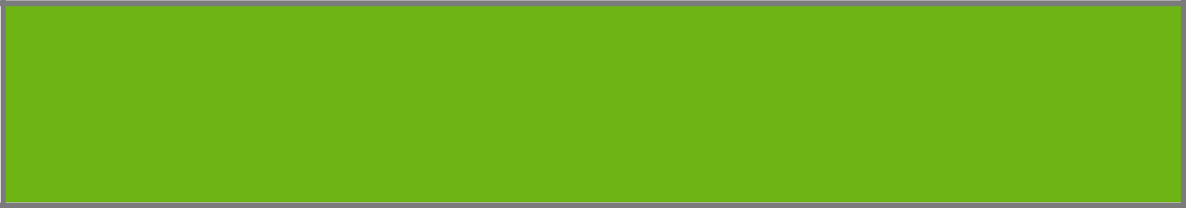**2. HTML – BASIC TAGS**

HTML

**Heading Tags**



Any document starts with a heading. You can use different sizes for your headings. HTML also has six levels of headings, which use the elements **<h1>, <h2>, <h3>, <h4>, <h5>, and <h6>**. While displaying any heading, browser adds one line before and one line after thatheading.

**Example**

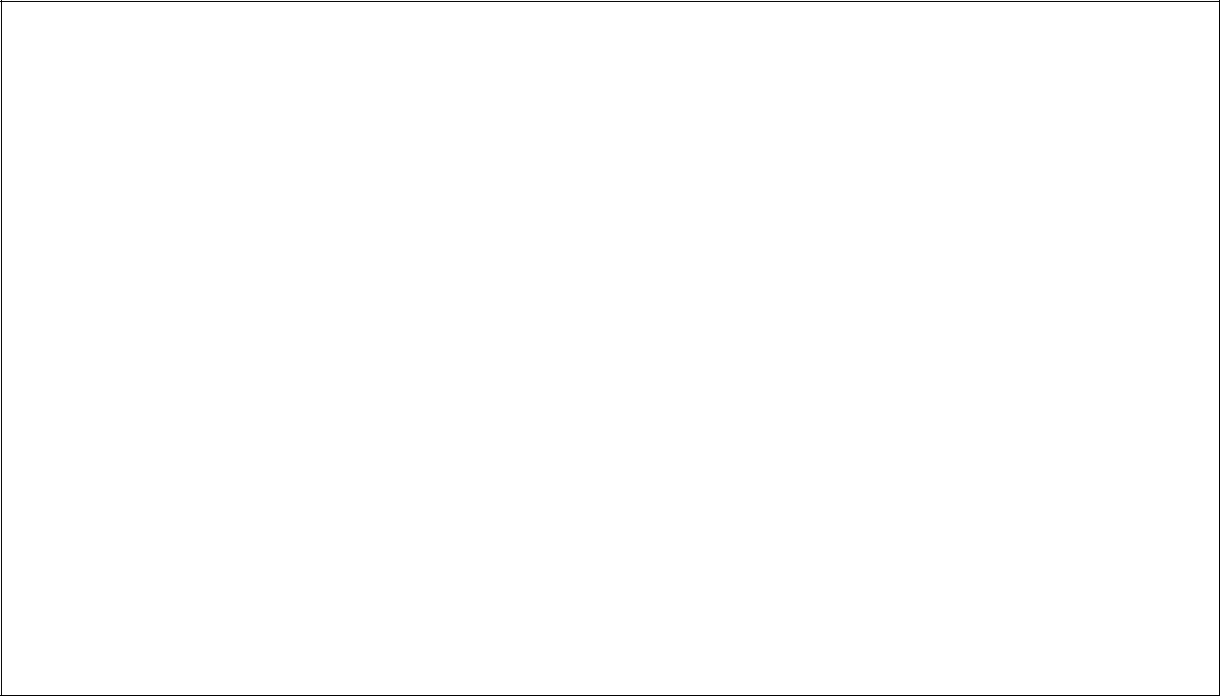

<!DOCTYPE html>

<html>

<head>

<title>Heading Example</title>

</head>

<body>

<h1>This is heading 1</h1>

<h2>This is heading 2</h2>

<h3>This is heading 3</h3>

<h4>This is heading 4</h4>

<h5>This is heading 5</h5>

<h6>This is heading 6</h6>

</body>

</html>

This will produce the following result:

**Paragraph Tag**



The **<p>** tag offers a way to structure your text into different paragraphs. Each paragraph of text should go in between an opening <p> and a closing </p> tag as shown below in the example:

**Example**

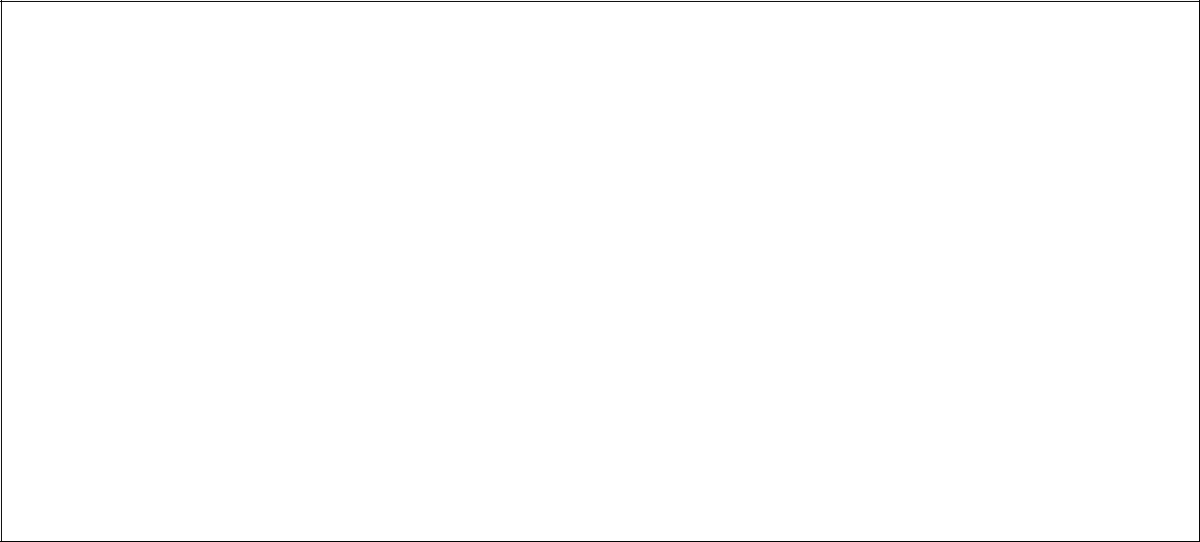

<!DOCTYPE html>

<html>

<head>

<title>Paragraph Example</title>

</head>

<body>

<p>Here is a first paragraph of text.</p>

<p>Here is a second paragraph of text.</p>

<p>Here is a third paragraph of text.</p>

</body>

</html>

This will produce the following result:

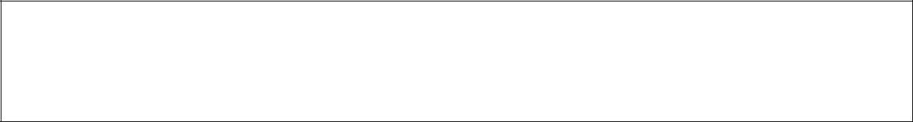

Here is a first paragraph of text.

Here is a second paragraph of text.

Here is a third paragraph of text.

**Line Break Tag**



Whenever you use the **<br />** element, anything following it starts from the next line. This tag is an example of an **empty** element, where you do not need opening and closing tags, as there is nothing to go in between them.

The <br /> tag has a space between the characters **br** and the forward slash. If you omit this space, older browsers will have trouble rendering the line break, while if you miss the forward slash character and just use <br> it is not valid in XHTML.

**Example**

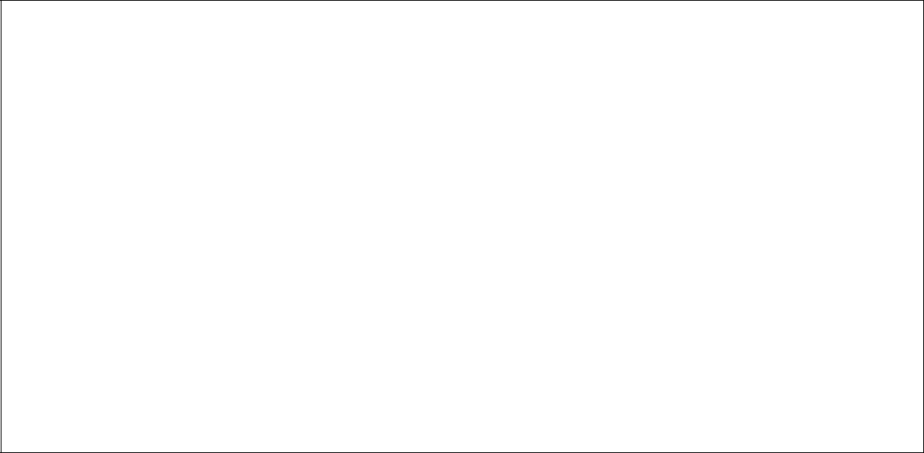

<!DOCTYPE html>

<html>

<head>

<title>Line Break Example</title>

</head>

<body>

<p>Hello<br />

You delivered your assignment on time.<br />

Thanks<br />

Mahnaz</p>

</body>

</html>

This will produce the following result:

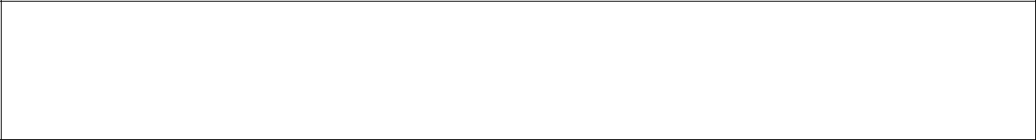

Hello

You delivered your assignment on time.

Thanks

Mahnaz

**Centering Content**



You can use **<center>** tag to put any content in the center of the page or any table cell.

**Example**



<!DOCTYPE html>

<html>

<head>

<title>Centring Content Example</title>

</head>

<body>

<p>This text is not in the center.</p>

<center>

<p>This text is in the center.</p>

</center>

</body>

</html>

This will produce the following result:

This text is not in the center.

This text is in the center.

**Horizontal Lines**



Horizontal lines are used to visually break-up sections of a document. The **<hr>** tag creates a line from the current position in the document to the right margin and breaks the line accordingly.

For example, you may want to give a line between two paragraphs as in the given example below:

**Example**

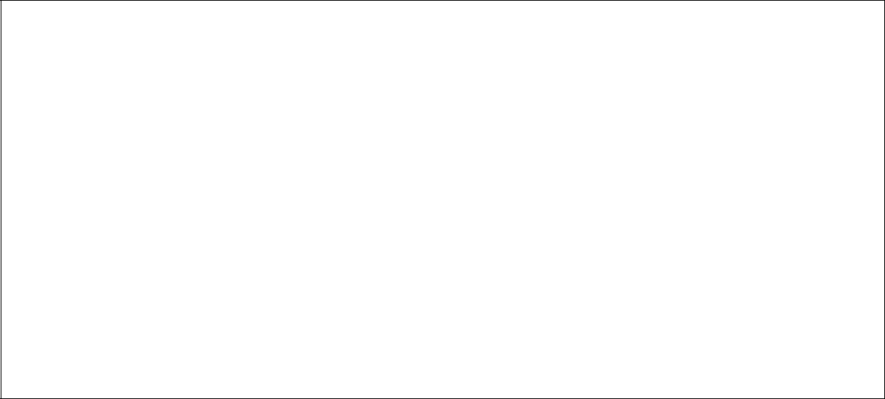

<!DOCTYPE html>

<html>

<head>

<title>Horizontal Line Example</title>

</head>

<body>

<p>This is paragraph one and should be on top</p>

<hr />

<p>This is paragraph two and should be at bottom</p>

</body>

</html>

This will produce the following result:

This is paragraph one and should be on top

This is paragraph two and should be at bottom

Again **<hr />** tag is an example of the **empty** element, where you do not need opening and closing tags, as there is nothing to go in between them.

The **<hr />** element has a space between the characters **hr** and the forward slash. If you omit this space, older browsers will have trouble rendering the horizontal line, while if you miss the forward slash character and just use **<hr>** it is not valid in XHTML

**Preserve Formatting**



Sometimes, you want your text to follow the exact format of how it is written in the HTML document. In these cases, you can use the preformatted tag **<pre>**.

Any text between the opening **<pre>** tag and the closing **</pre>** tag will preserve the formatting of the source document.

**Example**

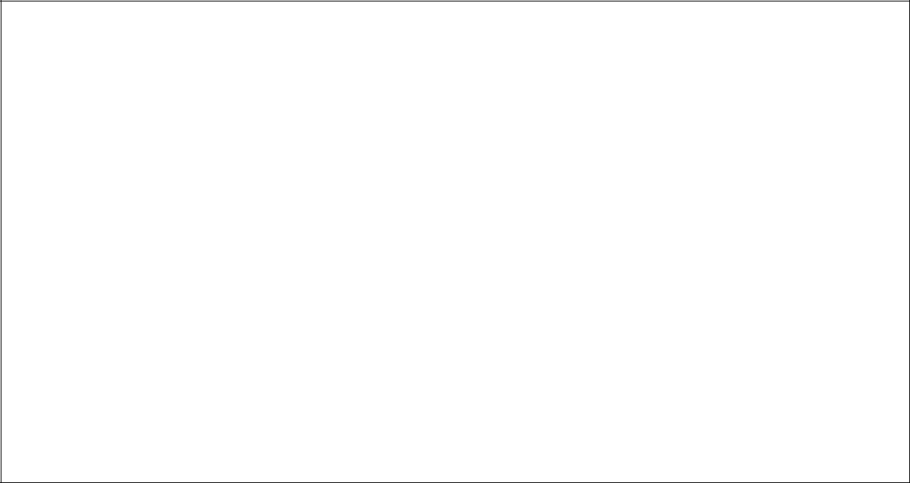

<!DOCTYPE html>

<html>

<head>

<title>Preserve Formatting Example</title>

</head>

<body>

<pre>

function testFunction( strText ){

alert (strText)

}

</pre>

</body>

</html>

This will produce the following result:

function testFunction( strText ){  
alert (strText)

}

Try using the same code without keeping it inside **<pre>...</pre>** tags

**Nonbreaking Spaces**



Suppose you want to use the phrase "12 Angry Men." Here, you would not want a browser to split the "12, Angry" and "Men" across two lines:



An example of this technique appears in the movie "12 Angry Men."

In cases, where you do not want the client browser to break text, you should use a nonbreaking space entity **&nbsp;** instead of a normal space. For example, when coding the "12 Angry Men" in a paragraph, you should use something similar to the following code:

**Example**

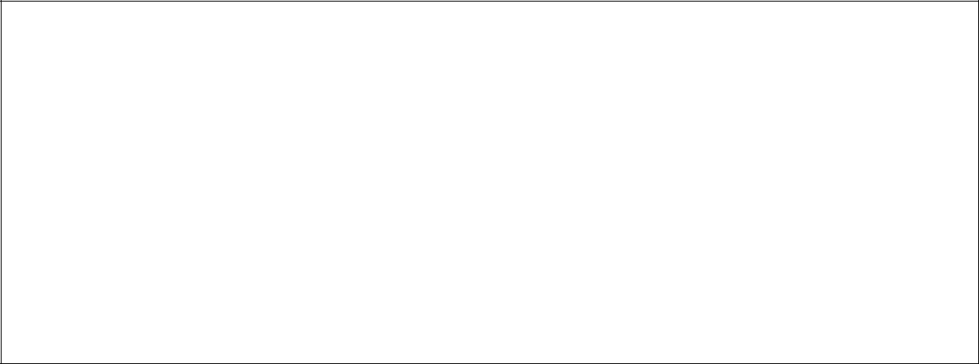

<!DOCTYPE html>

<html>

<head>

<title>Nonbreaking Spaces Example</title>

</head>

<body>

<p>An example of this technique appears in the movie "12&nbsp;Angry&nbsp;Men."</p>

</body>

</html>

**3. HTML – ELEMENTS**

HTML

An **HTML element** is defined by a starting tag. If the element contains other content, it ends with a closing tag, where the element name is preceded by a forward slash as shown below with few tags:

|  |  |  |
| --- | --- | --- |
| **Start Tag** | **Content** | **End Tag** |
|  |  |  |
|  |  |  |
| <p> | This is paragraph content. | </p> |
|  |  |  |
| <h1> | This is heading content. | </h1> |
|  |  |  |
| <div> | This is division content. | </div> |
|  |  |  |
| <br /> |  |  |
|  |  |  |

So here **<p>....</p>** is an HTML element, **<h1>...</h1>** is another HTML element. There

are some HTML elements which don't need to be closed, such as **<img.../>**, **<hr />** and **<br />** elements. These are known as **void elements**.

HTML documents consists of a tree of these elements and they specify how HTML documents should be built, and what kind of content should be placed in what part of an HTML document.

**HTML Tag vs. Element**



An HTML element is defined by a *starting tag*. If the element contains other content, it ends with a *closing tag*.

For example, **<p>** is starting tag of a paragraph and **</p>** is closing tag of the same paragraph but **<p>This is paragraph</p>** is a paragraph element.

**Nested HTML Elements**



It is very much allowed to keep one HTML element inside another HTML element:

**Example**

<!DOCTYPE html>

<html>

25

<head>

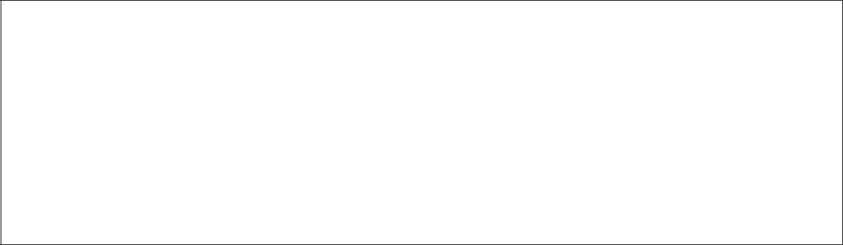

<title>Nested Elements Example</title>

</head>

<body>

<h1>This is <i>italic</i> heading</h1>

<p>This is <u>underlined</u> paragraph</p>

</body>

</html>

This will display the following result:

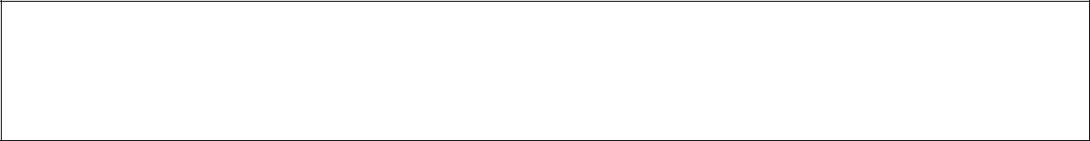

This is *italic* heading

This is underlined paragraph

**4. HTML – ATTRIBUTES**

HTML

We have seen few HTML tags and their usage like heading tags **<h1>, <h2>,** paragraph tag **<p>** and other tags. We used them so far in their simplest form, but most of the HTML tagscan also have attributes, which are extra bits of information.

An attribute is used to define the characteristics of an HTML element and is placed inside the element's opening tag. All attributes are made up of two parts: a **name** and a **value**:

* The **name** is the property you want to set. For example, the paragraph **<p>** element in the example carries an attribute whose name is **align**, which you can use to indicate

the alignment of paragraph on the page.

•

* The **value** is what you want the value of the property to be set and always put within quotations. The below example shows three possible values of align attribute: **left, center** and **right**.

Attribute names and attribute values are case-insensitive. However, the World Wide Web Consortium (W3C) recommends lowercase attributes/attribute values in their HTML 4 recommendation.

**Example**



<!DOCTYPE html>

<html>

<head>

<title>Align Attribute Example</title>

</head>

<body>

<p align="left">This is left aligned</p>

<p align="center">This is center aligned</p>

<p align="right">This is right aligned</p>

</body>

</html>

This will display the following result:



This is left aligned

This is center aligned

**Core Attributes**



The four core attributes that can be used on the majority of HTML elements (although not all)

are:

* Id
* Title
* Class
* Style

**The Id Attribute**

The **id** attribute of an HTML tag can be used to uniquely identify any element within an HTML page. There are two primary reasons that you might want to use an id attribute on an element:

* If an element carries an id attribute as a unique identifier, it is possible to identify just that element and its content.
* If you have two elements of the same name within a Web page (or style sheet), you can use the id attribute to distinguish between elements that have the same name.

We will discuss style sheet in separate tutorial. For now, let's use the id attribute to distinguish between two paragraph elements as shown below.

**Example**



<p id="html">This para explains what is HTML</p>

<p id="css">This para explains what is Cascading Style Sheet</p>

**The title Attribute**

The **title** attribute gives a suggested title for the element. They syntax for the **title** attribute is similar as explained for **id** attribute:

The behavior of this attribute will depend upon the element that carries it, although it is often displayed as a tooltip when cursor comes over the element or while the element is loading.

**Example**



<!DOCTYPE html>

<html>

<head>

<title>The title Attribute Example</title>

</head>

<body>

<h3 title="Hello HTML!">Titled Heading Tag Example</h3>

</body>

</html>

This will produce the following result:



**Titled Heading Tag Example**

Now try to bring your cursor over "Titled Heading Tag Example" and you will see that whatever title you used in your code is coming out as a tooltip of the cursor.

**The class Attribute**

The **class** attribute is used to associate an element with a style sheet, and specifies the class of element. You will learn more about the use of the class attribute when you will learn Cascading Style Sheet (CSS). So for now you can avoid it.

The value of the attribute may also be a space-separated list of class names. For example:



class="className1 className2 className3"

**The style Attribute**

The style attribute allows you to specify Cascading Style Sheet (CSS) rules within the element.



<!DOCTYPE html>

<html>

<head>

<title>The style Attribute</title>

</head>

<body>

<p style="font-family:arial; color:#FF0000;">Some text...</p>

</body>

</html>

This will produce the following result:  
  
Some text...

At this point of time, we are not learning CSS, so just let's proceed without bothering much about CSS. Here, you need to understand what are HTML attributes and how they can be used while formatting content.