

Bootstrap

**Aboutthe Tutorial**

Twitter Bootstrap is the most popular front end framework in the recent time. It is sleek, intuitive, and powerful mobile first front-end framework for faster and easier web development. It uses HTML, CSS and Javascript.

This tutorial will teach you the basics of Bootstrap Framework using which you can create web projects with ease. The tutorial is divided into sections such as Bootstrap Basic Structure, Bootstrap CSS, Bootstrap Layout Components and Bootstrap Plugins. Each of these sections contain related topics with simple and useful examples.

**Audience**

This tutorial has been prepared for anyone who has a basic knowledge of HTML and CSS and has an urge to develop websites. After completing this tutorial you will find yourself at a moderate level of expertise in developing web projects using Twitter Bootstrap.

**Prerequisites**

Before you start proceeding with this tutorial, we are assuming that you are already aware about the basics of HTML and CSS. If you are not well aware of these concepts, then we will suggest you to go through our short tutorial on HTML Tutorial and CSS Tutorial.

**Copyright & Disclaimer**

 Copyright 2014 by Tutorials Point (I) Pvt. Ltd.

All the content and graphics published in this e-book are the property of Tutorials Point

1. Pvt. Ltd. The user of this e-book is prohibited to reuse, retain, copy, distribute or republish any contents or a part of contents of this e-book in any manner without written consent of the publisher.

We strive to update the contents of our website and tutorials as timely and as precisely as possible, however, the contents may contain inaccuracies or errors. Tutorials Point (I) Pvt. Ltd. provides no guarantee regarding the accuracy, timeliness or completeness of our website or its contents including this tutorial. If you discover any errors on our website or in this tutorial, please notify us at [contact@tutorialspoint.com](mailto:contact@tutorialspoint.com)

i



Bootstrap

**Table ofContents**

**About the Tutorial····································································································································i**

**Audience ··················································································································································i**

**Prerequisites ············································································································································i**

**Copyright & Disclaimer·····························································································································i**

**Table of Contents····································································································································ii**

1. BOOTSTRAP ─ OVERVIEW······························································································1
2. BOOTSTRAP ─ ENVIRONMENT SETUP············································································3

**Download Bootstrap ·······························································································································3**

**File structure···········································································································································3**

**HTML Template·······································································································································4**

1. BOOTSTRAP ─ GRID SYSTEM·························································································6

**What is a Grid?········································································································································6 What is Bootstrap Grid System?··············································································································6 Working of Bootstrap Grid System ··········································································································6**

**Media Queries·········································································································································7 Grid Options············································································································································8 Responsive Column Resets····················································································································14 Offset Columns······································································································································15 Nesting Columns ···································································································································16 Column Ordering···································································································································17**

1. BOOTSTRAP ─ CSS OVERVIEW ····················································································19

**HTML5 doctype ·····································································································································19**

**Mobile First···········································································································································19**

**Responsive Images································································································································20**

ii



Bootstrap

**Typography and Links····························································································································20**

**Normalize··············································································································································20**

**Containers·············································································································································20**

1. BOOTSTRAP ─ TYPOGRAPHY························································································22

**Headings ···············································································································································22**

**Lead Body Copy·····································································································································23**

**Emphasis···············································································································································23**

**Abbreviations········································································································································24**

**Addresses··············································································································································24**

**Blockquotes ··········································································································································25**

**Lists·······················································································································································26**

1. BOOTSTRAP ─ CODE ····································································································29
2. BOOTSTRAP ─ TABLES···································································································30

**Basic Table ············································································································································30**

**Optional Table Classes ··························································································································31**

**Contextual classes·································································································································35**

**Responsive tables ·································································································································37**

1. BOOTSTRAP ─ FORMS··································································································39

**Form Layout··········································································································································39 Supported Form Controls ······················································································································42 Static Control ········································································································································45**

**Form Control States ······························································································································46**

**Form Control Sizing ·······························································································································49**

**Help Text···············································································································································50**

iii



Bootstrap

1. BOOTSTRAP ─ BUTTONS······························································································51

**Button Size············································································································································52**

**Button State··········································································································································54**

**Button Tags···········································································································································57**

1. BOOTSTRAP ─ IMAGES·································································································58
2. BOOTSTRAP ─ HELPER CLASSES···················································································59

**Close icon··············································································································································59**

**Carets····················································································································································59**

**Quick Floats ··········································································································································59**

**Center Content Blocks···························································································································60**

**Clearfix··················································································································································60**

**Showing and Hiding Content ·················································································································61**

**Screen Reader Content··························································································································61**

12. BOOTSTRAP ─ RESPONSIVE UTILITIES··········································································62

**Print Classes ··········································································································································62**

13. BOOTSTRAP ─ GLYPHICONS·························································································64

**What are Glyphicons? ···························································································································64**

**Where to find Glyphicons?····················································································································64**

**Usage ····················································································································································64**

14. BOOTSTRAP ─ DROPDOWNS ·······················································································66

**Options ·················································································································································67**

15. BOOTSTRAP ─ BUTTON GROUPS ·················································································70

**Basic Button Group ·······························································································································71**

**Button Toolbar······································································································································71**

**Button Size············································································································································72**

iv



Bootstrap

**Nesting··················································································································································72**

**Vertical Buttongroup·····························································································································73**

16. BOOTSTRAP ─ BUTTON DROPDOWNS·········································································75

**Split Button Dropdowns························································································································76**

**Button Dropdown Size ··························································································································77**

**Dropup Variation ··································································································································78**

17. BOOTSTRAP ─ INPUT GROUPS·····················································································80

**Basic Input Group··································································································································80 Input Group Sizing·································································································································81 Checkboxes and Radio Addons··············································································································82 Button Addons ······································································································································83 Buttons with Dropdowns ······················································································································84**

**Segmented Buttons·······························································································································85**

18. BOOTSTRAP ─ NAVIGATION ELEMENTS·······································································88

**Tabular Navigation or Tabs ···················································································································88**

**Pills Navigation ·····································································································································88**

**Justified Nav··········································································································································90**

**Disabled Links ·······································································································································90**

**Dropdowns ···········································································································································91**

19. BOOTSTRAP ─ NAVBAR································································································94

**Default Navbar······································································································································94 Responsive Navbar································································································································95 Forms in Navbar····································································································································96 Buttons in Navbar ·································································································································97**

**Text in Navbar·······································································································································98 Non-nav Links········································································································································98**

v



Bootstrap

**Component Alignment ··························································································································99**

**Fixed to Top ········································································································································101**

**Fixed to Bottom ··································································································································102**

**Static Top ············································································································································103**

**Inverted Navbar ··································································································································104**

1. BOOTSTRAP ─ BREADCRUMB ····················································································106
2. BOOTSTRAP ─ PAGINATION·······················································································107

**Pagination···········································································································································107**

**Pager···················································································································································110**

1. BOOTSTRAP ─ LABELS································································································112
2. BOOTSTRAP ─ BADGES ······························································································113

**Active Nav States ································································································································113**

1. BOOTSTRAP ─ JUMBOTRON ·······················································································115
2. BOOTSTRAP ─ PAGE HEADER·······················································································117
3. BOOTSTRAP ─ THUMBNAILS························································································118

**Adding Custom Content ······················································································································119**

27. BOOTSTRAP ─ ALERTS··································································································122

**Dismissal Alerts···································································································································122**

**Links in Alerts······································································································································124**

28. BOOTSTRAP ─ PROGRESS BARS ··················································································125

**Default Progress Bar····························································································································125**

**Alternate Progress Bar ························································································································125**

**Striped Progress Bar····························································································································127**

**Animated Progress Bar························································································································128**

vi



Bootstrap

**Stacked Progress Bar···························································································································128**

1. BOOTSTRAP ─ MEDIA OBJECT····················································································130
2. BOOTSTRAP ─ LIST GROUP ························································································135

**Adding Badges to List Group ···············································································································135**

**Linking List Group Items······················································································································136**

**Add Custom Content to List Group······································································································137**

31. BOOTSTRAP ─ PANELS ·······························································································139

**Panel with Heading ·····························································································································139 Panel with Footer································································································································140 Panel Contextual Alternatives·············································································································141 Panel with Tables ································································································································142 Panel with Listgroups ··························································································································143**

32. BOOTSTRAP ─ WELLS·································································································145

**Sizing···················································································································································145**

33. BOOTSTRAP ─ PLUGINS OVERVIEW ···········································································146

**Data Attributes ···································································································································146**

**Programmatic API ·······························································································································146**

**No Conflict ··········································································································································147**

**Events ·················································································································································147**

34. BOOTSTRAP ─ TRANSITION PLUGIN··········································································148

**Use Cases ············································································································································148**

35. BOOTSTRAP ─ MODAL PLUGIN··················································································149

**Usage ··················································································································································149**

**Options ···············································································································································151**

**Methods··············································································································································152**

vii



Bootstrap

**Events ·················································································································································154**

36. BOOTSTRAP ─ DROPDOWN PLUGIN ·········································································157

**Usage ··················································································································································157**

**Options ···············································································································································159**

**Methods··············································································································································160**

37. BOOTSTRAP ─ SCROLLSPY PLUGIN·············································································162

**Usage ··················································································································································162**

**Options ···············································································································································164**

**Methods··············································································································································165**

**Events ·················································································································································168**

38. BOOTSTRAP ─ TAB PLUGIN······························································································172

**Usage ··················································································································································172**

**Fade Effect ··········································································································································173**

**Methods··············································································································································174**

**Events ·················································································································································177**

39. BOOTSTRAP ─ TOOLTIP PLUGIN·······················································································180

**Usage ··················································································································································180**

**Options ···············································································································································182**

**Methods··············································································································································183**

**Events ·················································································································································185**

40. BOOTSTRAP ─ POPOVER PLUGIN·····················································································187

**Usage ··················································································································································187**

**Options ···············································································································································188**

**Methods··············································································································································190**

**Events ·················································································································································192**

viii



Bootstrap

41. BOOTSTRAP ─ ALERT PLUGIN ···················································································194

**Usage ··················································································································································194**

**Options ···············································································································································195**

**Methods··············································································································································195**

**Events ·················································································································································196**

42. BOOTSTRAP ─ BUTTON PLUGIN·················································································198

**Loading State ······································································································································198**

**Single Toggle ·······································································································································199**

**Checkbox·············································································································································199**

**Radio···················································································································································200**

**Usage ··················································································································································200**

**Options ···············································································································································200**

**Methods··············································································································································200**

43. BOOTSTRAP ─ COLLAPSE PLUGIN ·············································································204

**Usage ··················································································································································206**

**Options ···············································································································································207**

**Methods··············································································································································207**

**Events ·················································································································································210**

44. BOOTSTRAP ─ CAROUSEL PLUGIN ·············································································213

**Optional Captions ·······························································································································214**

**Usage ··················································································································································215**

**Options ···············································································································································216**

**Methods··············································································································································216**

**Events ·················································································································································219**

ix



Bootstrap

45. BOOTSTRAP ─ AFFIX PLUGIN ·····················································································222

**Usage ··················································································································································222**

**Positioning via CSS ······························································································································228**

**Options ···············································································································································229**

x



**1. Bootstrap ─ Overview**

**What is Twitter Bootstrap?**

Bootstrap is a sleek, intuitive, and powerful, mobile first front-end framework for faster and easier web development. It uses HTML, CSS, and Javascript.

Bootstrap was developed by *Mark Otto* and *Jacob Thornton* at *Twitter*. It was released as an open source product in August 2011 on GitHub.

**Why Use Bootstrap?**

* **Mobile first approach**: Bootstrap 3 framework consists of Mobile first styles throughout the entire library instead of them in separate files.
* **Browser Support**: It is supported by all popular browsers.

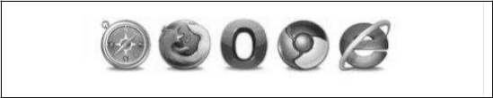

* **Easy to get started**: With just the knowledge of HTML and CSS anyone can get started with Bootstrap. Also the Bootstrap official site has a good documentation.
* **Responsive design**: Bootstrap's responsive CSS adjusts to Desktops, Tablets and Mobiles. More about the responsive design is in the chapter **Bootstrap**

**Responsive Design.**

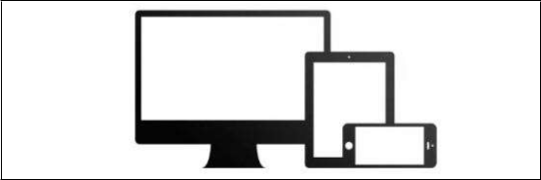

* Provides a clean and uniform solution for building an interface for developers.
* It contains beautiful and functional built-in components which are easy to customize.
* It also provides web-based customization.
* And best of all it is an open source.

1



Bootstrap

**What Bootstrap Package Includes?**

* **Scaffolding:** Bootstrap provides a basic structure with Grid System, link styles, and background. This is covered in detail in the section **Bootstrap**

**Basic Structure.**

* **CSS**: Bootstrap comes with the feature of global CSS settings, fundamental HTML elements styled and enhanced with extensible classes, and an advanced grid system. This is covered in detail in the section **Bootstrap with** **CSS**.

• **Components:** Bootstrap contains over a dozen reusable components built to provide iconography, dropdowns, navigation, alerts, pop-overs, and much more. This is covered in detail in the section **Layout Components**.

* **JavaScript Plugins:** Bootstrap contains over a dozen custom jQuery plugins. You can easily include them all, or one by one. This is covered in details in the section **Bootstrap Plugins**.
* **Customize:** You can customize Bootstrap's components, LESS variables, and jQuery plugins to get your very own version.

2



**2. Bootstrap ─ Environment Setup**

It is very easy to setup and start using Bootstrap. This chapter will explain how to download and setup Bootstrap. We will also discuss the Bootstrap file structure, and demonstrate its usage with an example.

**DownloadBootstrap**

You can download the latest version of Bootstrap from http://getbootstrap.com/. When you click on this link, you will get to see a screen as below:

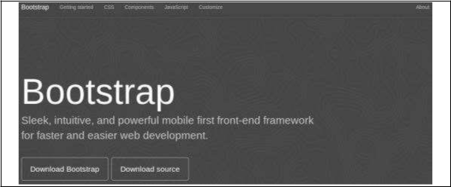

Here you can see two buttons:

•  ***Download Bootstrap***: Clicking this, you can download the precompiled and minified versions of Bootstrap CSS, JavaScript, and fonts. No documentation or original source code files are included.

•  ***Download Source***: Clicking this, you can get the latest Bootstrap LESS and JavaScript source code directly from GitHub.

If you work with Bootstrap's uncompiled source code, you need to compile the LESS files to produce usable CSS files. For compiling LESS files into CSS, Bootstrap officially supports only Recess, which is Twitter's CSS hinter based on less.js.

For better understanding and ease of use, we shall use precompiled version of Bootstrap throughout the tutorial. As the files are complied and minified, you don't have to bother every time including separate files for individual functionality. At the time of writing this tutorial the latest version (Bootstrap 3) was downloaded.

**File structure**

**Precompiled Bootstrap**

Once the compiled version Bootstrap is downloaded, extract the ZIP file, and you will see the following file/directory structure:

3



Bootstrap

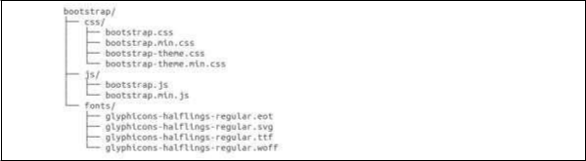

As you can see, there are compiled CSS and JS (bootstrap.*), as well as compiled and minified CSS and JS (bootstrap.min.*). Fonts from Glyphicons are included, as it is the optional Bootstrap theme.

**Bootstrap Source Code**

If you have downloaded the Bootstrap source code then the file structure would be as follows:

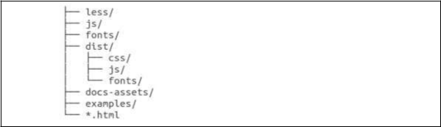

* The files under *less/*, *js/*, and *fonts/* are the source code for Bootstrap CSS, JS, and icon fonts (respectively).
* The *dist/* folder includes everything listed in the precompiled download section above.
* *docs-assets/*, *examples/*, and all *\*.html* files are Bootstrap documentation.

**HTMLTemplate**

A basic HTML template using Bootstrap would look like this:

<!DOCTYPE html>

<html>

<head>

<title>Bootstrap 101 Template</title>

<meta name="viewport" content="width=device-width, initial-scale=1.0">

<!-- Bootstrap -->

<link href="css/bootstrap.min.css" rel="stylesheet">



Bootstrap

<!-- HTML5 Shim and Respond.js IE8 support of HTML5 elements and media queries -->

<!-- WARNING: Respond.js doesn't work if you view the page

via file:// -->

<!--[if lt IE 9]>

<script src="https://oss.maxcdn.com/libs/html5shiv/3.7.0/ html5shiv.js"></script>

<script src="https://oss.maxcdn.com/libs/respond.js/1.3.0/

respond.min.js"></script>

<![endif]-->

</head>

<body>

<h1>Hello, world!</h1>

<!-- jQuery (necessary for Bootstrap's JavaScript plugins) --> <script src="https://code.jquery.com/jquery.js"></script>

<!-- Include all compiled plugins (below), or include individual files as needed -->

<script src="js/bootstrap.min.js"></script>

</body>

</html>

Here you can see the **jquery.js, bootstrap.min.js** and **bootstrap.min.css** files that are included to make a normal HTM file to the Bootstrapped Template. Just make sure to include jQuery library before you include Bootstrap library.

More details about each of the elements in this above piece of code will be discussed in the chapter Bootstrap CSS Overview.

This template structure is already included as part of the **Try it** (online compiler) tool. Hence in all the examples (in the following chapters) of this tutorial you will only see the contents of the <body> element. Once you click on the **Try it** option available at the top right corner of example, and you will see the entire code.

**Example**

Now let's try an example using the above template. Try the following example using Try it option available at the top right corner of the below sample code box on our website:

<h1>Hello, world!</h1>

In all the subsequent chapters we have used dummy text from the site http://www.lipsum.com/.

5



**3. Bootstrap ─ Grid System**

In this chapter, we shall discuss the Bootstrap Grid System.

**Whatis a Grid?**

As put by Wikipedia:

In graphic design, a grid is a structure (usually two-dimensional) made up of a series of intersecting straight (vertical, horizontal) lines used to structure the content. It is widely used to design layout and content structure in print design. In web design, it is a very effective method to create a consistent layout rapidly and effectively using HTML and CSS.

To put in simple words, grids in web design organize and structure content, makes the websites easy to scan and reduces the cognitive load on users.

**Whatis Bootstrap Grid System?**

As put by the official documentation of Bootstrap for grid system:

Bootstrap includes a responsive, mobile first fluid grid system that appropriately scales up to 12 columns as the device or viewport size increases. It includes predefined classes for easy layout options, as well as powerful mixins for generating more semantic layouts.

Let us understand the above statement. Bootstrap 3 is mobile first in the sense that the code for Bootstrap now starts by targeting smaller screens like mobile devices, tablets, and then “expands” components and grids for larger screens such as laptops, desktops.

**Mobile First Strategy**

* **Content**
  1. Determine what is most important.
* **Layout**

1. Design to smaller widths first.
   1. Base CSS address mobile device first; media queries address for tablet, desktops.

* **Progressive Enhancement**

o Add elements as screen size increases.

**Working ofBootstrap GridSystem**

Grid systems are used for creating page layouts through a series of rows and columns that house your content. Here's how the Bootstrap grid system works:

•  Rows must be placed within a **.container** class for proper alignment and padding.

•  Use rows to create horizontal groups of columns. 6



Bootstrap

* Content should be placed within the columns, and only columns may be the immediate children of rows.
* Predefined grid classes like **.row and .col-xs-4** are available for quickly making grid layouts. LESS mixins can also be used for more semantic layouts.
* Columns create gutters (gaps between column content) via padding. That padding is offset in rows for the first and the last column via negative margin on **.rows**.
* Grid columns are created by specifying the number of twelve available columns you wish to span. For example, three equal columns would use three **.col-xs-4**.

**Media Queries**

Media query is a really fancy term for "conditional CSS rule". It simply applies some CSS, based on certain conditions set forth. If those conditions are met, the style is applied.

Media Queries in Bootstrap allow you to move, show and hide content based on the viewport size. Following media queries are used in LESS files to create the key breakpoints in the Bootstrap grid system.

/* Extra small devices (phones, less than 768px) */

/* No media query since this is the default in Bootstrap */

/* Small devices (tablets, 768px and up) */

@media (min-width: @screen-sm-min) { ... }

/* Medium devices (desktops, 992px and up) */

@media (min-width: @screen-md-min) { ... }

/* Large devices (large desktops, 1200px and up) */

@media (min-width: @screen-lg-min) { ... }

Occasionally these are expanded to include a max-width to limit CSS to a narrower set of devices.

@media (max-width: @screen-xs-max) { ... }

@media (min-width: @screen-sm-min) and (max-width: @screen-sm-max) { ... }

@media (min-width: @screen-md-min) and (max-width: @screen-md-max) { ... }

@media (min-width: @screen-lg-min) { ... }

Media queries have two parts, a device specification and then a size rule. In the above case, the following rule is set:

7



Bootstrap

Let us consider this line:

@media (min-width: @screen-sm-min) and (max-width: @screen-sm-max) { ... }

For all devices no matter what kind with *min-width: @screen-sm-min,* if the width of the screen gets smaller than *@screen-sm-max*, *then do something*.

**Grid Options**

The following table summarizes aspects of how Bootstrap grid system works across multiple devices:

|  |  |  |  |  |  |
| --- | --- | --- | --- | --- | --- |
|  | **Extra small** | **Small devices** | **Medium** | **Large devices** |  |
|  | **devices** | **devices** |  |
|  | **Tablets** | **Desktops** |  |
|  | **Phones** | **Desktops** |  |
|  | **(≥768px)** | **(≥1200px)** |  |
|  | **(<768px)** | **(≥992px)** |  |
|  |  |  |  |
|  |  |  |  |  |  |
| Grid | Horizontal at | Collapsed to | Collapsed to | Collapsed to |  |
| start, horizontal | start, horizontal | start, horizontal |  |
| behavior | all times | above | above | above |  |
|  |  | breakpoints | breakpoints | breakpoints |  |
|  |  |  |  |  |  |
| Max |  |  |  |  |  |
| container | None (auto) | 750px | 970px | 1170px |  |
| width |  |  |  |  |  |
|  |  |  |  |  |  |
| Class | **.col-xs-** | **.col-sm-** | **.col-md-** | **.col-lg-** |  |
| prefix |  |
|  |  |  |  |  |
|  |  |  |  |  |  |
| # of | 12 | 12 | 12 | 12 |  |
| columns |  |
|  |  |  |  |  |
|  |  |  |  |  |  |
| Max |  |  |  |  |  |
| column | Auto | 60px | 78px | 95px |  |
| width |  |  |  |  |  |
|  |  |  |  |  |  |
|  | 30px | 30px | 30px | 30px |  |
| Gutter | (15px on each | (15px on each | (15px on each |  |
| (15px on each side |  |
| width | side of a | side of a | side of a |  |
| of a column) |  |
|  | column) | column) | column) |  |
|  |  |  |
|  |  |  |  |  |  |
| Nestable | Yes | Yes | Yes | Yes |  |
|  |  |  |  |  |  |
| Offsets | Yes | Yes | Yes | Yes |  |
|  |  |  |  |  |  |



8



Bootstrap

Column ordering

Yes

Yes

Yes

Yes

**Basic Grid Structure**

Following is basic structure of Bootstrap grid:

<div class="container">

<div class="row">

<div class="col-*-*"></div>

<div class="col-*-*"></div>

</div>

<div class="row">...</div>

</div>

<div class="container">....

Let us see some simple grid examples:

**Example: Stacked-to-horizontal**

Let us see a simple grid example with simple layout: two columns, two paragraphs per column. (Here styling for each column is used. You can avoid it.)

<div class="container">

<h1>Hello, world!</h1>

<div class="row">

<div class="col-md-6" style="background-color: #dedef8; box-shadow:

inset 1px -1px 1px #444, inset -1px 1px 1px #444;">

<p>Lorem ipsum dolor sit amet, consectetur adipisicing elit, sed do eiusmod tempor incididunt ut labore et dolore magna aliqua. Ut enim ad minim veniam, quis nostrud exercitation ullamco laboris nisi ut aliquip ex ea commodo consequat. </p>

<p>Sed ut perspiciatis unde omnis iste natus error sit voluptatem

accusantium doloremque laudantium, totam rem aperiam, eaque ipsa

quae ab illo inventore veritatis et quasi architecto beatae

vitae dicta sunt explicabo.

</p>

9



Bootstrap

</div>

<div class="col-md-6" style="background-color: #dedef8;box-shadow:

inset 1px -1px 1px #444, inset -1px 1px 1px #444;">

<p>Sed ut perspiciatis unde omnis iste natus error sit voluptatem accusantium doloremque laudantium. </p>

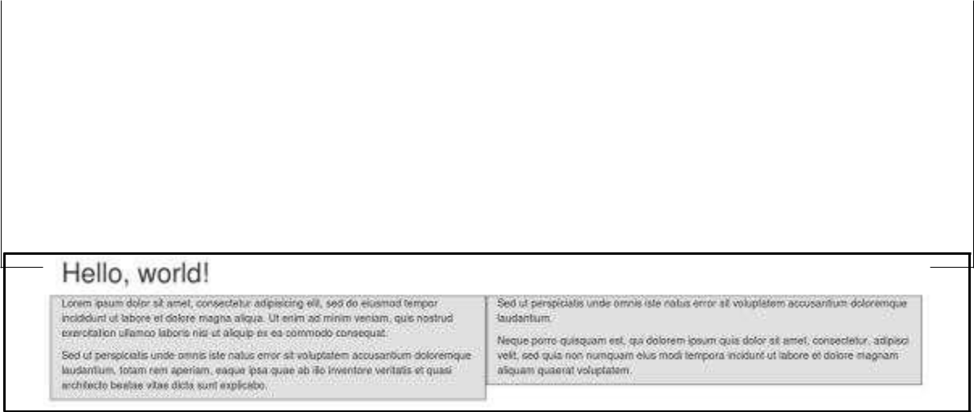

<p> Neque porro quisquam est, qui dolorem ipsum quia dolor sit

amet, consectetur, adipisci velit, sed quia non numquam eius

modi tempora incidunt ut labore et dolore magnam aliquam quaerat

voluptatem.

</p>

</div>

</div>

**Details**

* **<div class="container">...</div>** element is added to ensure proper centering and maximum width for layout.
* Once container is added, next you need to think in terms of rows. Add **<div class="row">...</div>** and columns **<div class="col-md-6"></div>** insidethe rows.
* Every row in the grid is made up of 12 units and you can define the desired size of your columns using those units. In our example we have two columns each made of 6 units wide i.e 6+6=12.

You can try some more options like:

<div class="col-md-3"></div> and <div class="col-md-9"></div>

or <div class="col-md-7"></div> and <div class="col-md-5"></div>.

Experiment and make sure that the sum always needs to be 12.

10



Bootstrap

**Example: Medium and Large Device**

We have seen the basic grid system in ‘Example: Stacked-to-horizontal’. Here we have used 2 divs and gave them the 50%/50% split at the medium viewport width:

|  |  |  |
| --- | --- | --- |
| <div | ....class="col-md-6"> | </div> |
| <div | class="col-md-6">.... | </div> |
|  |  |  |

But at large, your design could really be better as a 33%/66%. So what we’re going to do is, set it up to change the column widths at the breakpoint:

|  |  |  |  |
| --- | --- | --- | --- |
| <div | class="col-md-6 | ....col-lg-4"> | </div> |
| <div | class="col-md-6 | col-lg-4">.... | </div> |
|  |  |  |  |

Now Bootstrap is going to say “at the medium size, I look at classes with **md** in them and use those. At the large size, I look at classes with the word **lg** in them and use those. In this case, our 2 divs will go from a 50%/50% split and then up to a 33%/66%. Check it out in the following example. (Here styling for each column is used. You can avoid it.)

<div class="container">

<h1>Hello, world!</h1>

<div class="row">

<div class="col-md-6 col-lg-4" style="background-color: #dedef8; box-shadow: inset 1px -1px 1px #444, inset -1px 1px 1px #444;"> <p>Lorem ipsum dolor sit amet, consectetur adipisicing elit, sed do eiusmod tempor incididunt ut labore et dolore magna aliqua. Ut enim ad minim veniam, quis nostrud exercitation ullamco laboris nisi ut aliquip ex ea commodo consequat. </p>

<p>Sed ut perspiciatis unde omnis iste natus error sit voluptatem

accusantium doloremque laudantium, totam rem aperiam, eaque ipsa

quae ab illo inventore veritatis et quasi architecto beatae

vitae dicta sunt explicabo.

</p>

</div>

<div class="col-md-6 col-lg-8"" style="background-color: #dedef8;

box-shadow: inset 1px -1px 1px #444, inset -1px 1px 1px #444;">

11



Bootstrap

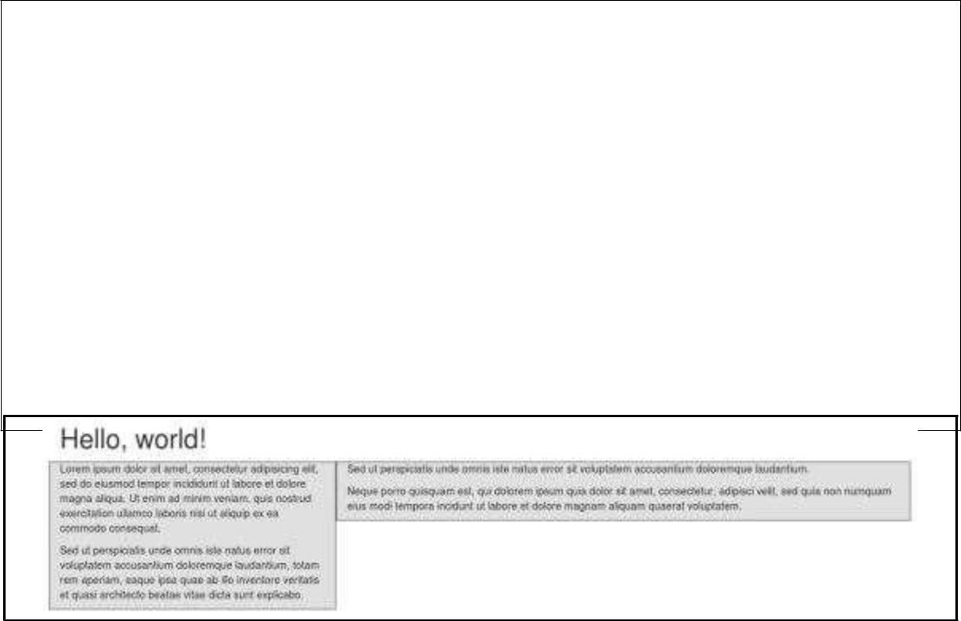

<p>Sed ut perspiciatis unde omnis iste natus error sit voluptatem accusantium doloremque laudantium.

</p>

<p> Neque porro quisquam est, qui dolorem ipsum quia dolor sit

amet, consectetur, adipisci velit, sed quia non numquam eius

modi tempora incidunt ut labore et dolore magnam aliquam quaerat

voluptatem.

</p>

</div>

</div>

**Example: Mobile, tablet, desktops**

We have seen an example for Medium and Large Device. Now let us take it to another level, where we would want to change it for the extra small phone size as well. Say we want to add the option for the columns to be split 75%/25% for tablets, we go like this:

|  |  |  |  |  |
| --- | --- | --- | --- | --- |
| <div | class="col-sm-3 | col-md-6 | col-lg-4">.... | </div> |
| <div | class="col-sm-9 | col-md-6 | col-lg-8">.... | </div> |
|  |  |  |  |  |

Now this gives us 3 different column layouts at each point. On a phone, it will be 75% on the left, and 25% on the right. On a tablet, it will be 50%/50% again, and on a large viewport, it will be 33%/66%. Three different layouts for each of the three responsive sizes. Check it out in the following example. (Here styling for each column is used. You can avoid it.)

<div class="container">

<h1>Hello, world!</h1>

<div class="row">

<div class="col-sm-3 col-md-6 col-lg-8" style="background-color: #dedef8; box-shadow: inset 1px -1px 1px #444,

12



Bootstrap

inset -1px 1px 1px #444;">

<p>Lorem ipsum dolor sit amet, consectetur adipisicing elit, sed do eiusmod

tempor incididunt ut labore et dolore magna aliqua. Ut enim ad minim veniam,

quis nostrud exercitation ullamco laboris nisi ut aliquip ex ea commodo

consequat.

</p>

<p>Sed ut perspiciatis unde omnis iste natus error sit voluptatem accusantium doloremque laudantium, totam rem aperiam, eaque ipsa

quae ab illo inventore veritatis et quasi architecto beatae vitae dicta

sunt explicabo.

</p> </div>

<div class="col-sm-9 col-md-6 col-lg-4"

style="background-color: #dedef8; box-shadow: inset 1px -1px 1px #444, inset -1px 1px 1px #444;">

<p>Sed ut perspiciatis unde omnis iste natus error sit voluptatem accusantium doloremque laudantium.

</p>

<p> Neque porro quisquam est, qui dolorem ipsum quia dolor sit

amet, consectetur, adipisci velit, sed quia non numquam eius

modi tempora incidunt ut labore et dolore magnam aliquam quaerat

voluptatem.

</p>

</div>

</div>

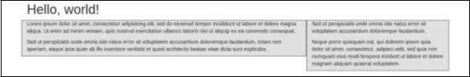

13



Bootstrap

**Responsive Column Resets**

With the four tiers of grids available, you are bound to run into issues where at certain breakpoints, the columns don't clear quite right as one is taller than the other. To fix that, use a combination of a class **.clearfix** and the responsive utility classes as shown in the following example:

<div class="container">

<div class="row" >

<div class="col-xs-6 col-sm-3"

style="background-color: #dedef8;

box-shadow: inset 1px -1px 1px #444, inset -1px 1px 1px #444;"> <p>Lorem

ipsum dolor sit amet, consectetur adipisicing elit.</p>

</div>

<div class="col-xs-6 col-sm-3"

style="background-color: #dedef8;box-shadow:

inset 1px -1px 1px #444, inset -1px 1px 1px #444;">

<p>Lorem ipsum dolor sit amet, consectetur adipisicing elit, sed do eiusmod tempor incididunt ut labore et dolore magna aliqua. Ut

enim ad minim veniam, quis nostrud exercitation ullamco laboris

nisi ut aliquip ex ea commodo consequat.

</p>

<p>Lorem ipsum dolor sit amet, consectetur adipisicing elit, sed do

eiusmod tempor incididunt ut.

</p>

</div>

<div class="clearfix visible-xs"></div>

<div class="col-xs-6 col-sm-3"

style="background-color: #dedef8;

box-shadow:inset 1px -1px 1px #444, inset -1px 1px 1px #444;"> <p>Ut enim

ad minim veniam, quis nostrud exercitation ullamco

laboris nisi ut aliquip ex ea commodo consequat. </p> </div>

<div class="col-xs-6 col-sm-3"

style="background-color: #dedef8;box-shadow:

14



Bootstrap

inset 1px -1px 1px #444, inset -1px 1px 1px #444;">

<p>Lorem ipsum dolor sit amet, consectetur adipisicing elit, sed do eiusmod tempor incididunt ut labore et dolore magna aliqua. Ut enim ad minim </p> </div>

</div>

</div>

Resize your viewport or check it out on your phone for a desired result of this example.

**OffsetColumns**

Offsets are a useful feature for more specialized layouts. They columns over for more spacing (for example). The **.col-xs=\*** offsets, but they are easily replicated by using an empty cell.

can be used to push classes don’t support

To use offsets on large displays, use the **.col-md-offset-\*** classes. These classes increase the left margin of a column by **\*** columns where **\*** range from **1** to **11**.

In the following example, we have <div class="col-md-6">..</div>. We will center this using class **.col-md-offset-3**.

<div class="container">

<h1>Hello, world!</h1>

<div class="row" >

<div class="col-xs-6 col-md-offset-3"

style="background-color: #dedef8;box-shadow:

inset 1px -1px 1px #444, inset -1px 1px 1px #444;">

<p>Lorem ipsum dolor sit amet, consectetur adipisicing elit. </p> </div>

</div>

</div>



15



#dedef8;box-shadow:

Bootstrap

**Nesting Columns**

To nest your content with the default grid, add a new **.row** and set of **.col-md-**

* columns within an existing **.col-md-\*** column. Nested rows should include a set of columns that add up to 12.

In the following example, the layout has two columns, with the second one being split into four boxes over two rows.

<div class="container">

<h1>Hello, world!</h1>

<div class="row">

<div class="col-md-3" style="background-color: inset

1px -1px 1px #444, inset -1px 1px 1px #444;"> <h4>First Column</h4>

<p>Lorem ipsum dolor sit amet, consectetur adipisicing elit.</p> </div>

<div class="col-md-9" style="background-color: #dedef8;box-shadow: inset 1px -1px 1px #444, inset -1px 1px 1px #444;"> <h4>Second Column- Split into 4 boxes</h4>

<div class="row">

<div class="col-md-6" style="background-color: #B18904;

box-shadow: inset 1px -1px 1px #444, inset -1px 1px 1px 444;">

<p>Consectetur art party Tonx culpa semiotics. Pinterest

assumenda minim organic quis.

</p>

</div>

<div class="col-md-6" style="background-color: #B18904;

box-shadow: inset 1px -1px 1px #444, inset -1px 1px 1px 444;"> <p> sed do eiusmod tempor incididunt ut labore et dolore magna

aliqua. Ut enim ad minim veniam, quis nostrud exercitation ullamco laboris nisi ut aliquip ex ea commodo consequat.

</p> </div>

</div>

16



Bootstrap

<div class="row">

<div class="col-md-6" style="background-color: #B18904;

box-shadow: inset 1px -1px 1px #444, inset -1px 1px 1px 444;"> <p>quis nostrud

exercitation ullamco laboris nisi ut

aliquip ex ea commodo consequat. </p>

</div>

<div class="col-md-6" style="background-color: #B18904; box-shadow: inset 1px -1px 1px #444, inset -1px 1px 1px #444;"> <p>Lorem ipsum dolor sit amet, consectetur adipisicing elit,

sed do eiusmod tempor incididunt ut labore et dolore magna aliqua. Ut enim ad

minim.</p>

</div> </div>

</div> </div>

</div>

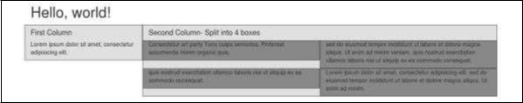

**Column Ordering**

Another nice feature of Bootstrap grid system is that you can easily write the columns in an order, and show them in another one. You can easily change the order of built-in grid columns with **.col-md-push-\*** and **.col-md-pull-\*** modifier classes where **\*** range from **1** to**11**.

In the following example we have two columns layout with left column being the narrowest and acting as a sidebar. We will swap the order of these columns using **.col-md-push-\*** and**.col-md-pull-\*** classes.

<div class="container">

<h1>Hello, world!</h1>

<div class="row">

17



Bootstrap

<p>Before Ordering</p>

<div class="col-md-4" style="background-color: #dedef8; box-shadow: inset 1px -1px 1px #444, inset -1px 1px 1px #444;"> I am on left

</div>

<div class="col-md-8" style="background-color: #dedef8; box-shadow: inset 1px -1px 1px #444, inset -1px 1px 1px #444;"> I am on right

</div>

</div><br>

<div class="row"> <p>After

Ordering</p>

<div class="col-md-4 col-md-push-8" style="background-color: #dedef8; box-shadow: inset 1px -1px 1px #444, inset -1px 1px 1px #444;">

I was on left </div>

<div class="col-md-8 col-md-pull-4" style="background-color: #dedef8; box-shadow: inset 1px -1px 1px #444, inset -1px 1px 1px #444;">

I was on right </div>

</div>

</div>

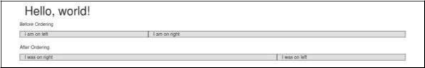

18



**4. Bootstrap ─ CSS Overview**

This chapter provides an overview of the key pieces of Bootstrap's infrastructure, including Bootstrap's approach to better, faster, stronger web development.

**HTML5 doctype**

Bootstrap makes use of certain HTML elements and CSS properties that require the use of the HTML5 doctype. Hence, include the below piece of code for HTML5 doctype at the beginning of all your projects using Bootstrap.

<!DOCTYPE html>

<html>

....

</html>

**Mobile First**

Since Bootstrap 3 has been launched, Bootstrap has become ‘mobile first’. It means mobile first styles can be found throughout the entire library instead of them in separate files. You need to add the **viewport meta tag** to the **<head>** element, to ensure proper rendering and touch zooming on mobile devices.

<meta name="viewport" content="width=device-width, initial-scale=1.0">

•  *width* property controls the width of the device. Setting it to *device-width* will make sure that it is rendered across various devices (mobiles, desktops, tablets...) properly.

•  *initial-scale=1.0* ensures that when loaded, your web page will be rendered at a 1:1 scale, and no zooming will be applied out of the box.

Add **user-scalable=no** to the **content** attribute, to disable zooming capabilities on mobile devices as shown below. Users are only able to scroll and not zoom with this change, and results in your site feeling a bit more like a native application.

<meta name="viewport" content="width=device-width,

initial-scale=1.0,

maximum-scale=1.0,

user-scalable=no">

Normally *maximum-scale=1.0* is used along with *user-scalable=no*. As mentioned above **user-scalable=no** may give users an experience more like a native app, henceBootstrap doesn't recommend using this attribute.

19



Bootstrap

**Responsive Images**

Bootstrap 3 allows you to make the images responsive by adding a class **.img-responsive** to the **<img>** tag. This class applies **max-width: 100%;** and **height: auto;** to the image so that it scales nicely to the parent element.

<img src="..." class="img-responsive" alt="Responsive image">

**Typographyand Links**

Bootstrap sets a basic global display (background), typography, and link styles:

* **Basic Global display:** Sets *background-color: #fff;* on the *<body>* element.
* **Typography:** Uses the *@font-family-base*, *@font-size-base*, and *@line-height-base* attributes as the typographic base.
* **Link styles:** Sets the global link color via attribute *@link-color* and apply link underlines only on*:hover*.

If you intend to use LESS code, you may find all these within *scaffolding.less*.

**Normalize**

Bootstrap uses Normalize to establish cross browser consistency.

Normalize.css is a modern, HTML5 -ready alternative to CSS resets. It is a small CSS file that provides better cross-browser consistency in the default styling of HTML elements.

**Containers**

Use class **.container** to wrap a page's content and easily center the content's as shown below.

<div class="container">

...

</div>

Take a look at the **.container** class in *bootstrap.css* file:

.container {

padding-right: 15px;

padding-left: 15px;

margin-right: auto;

margin-left: auto;

}

Note that, due to padding and fixed widths, containers are not nestable by default.

20



Bootstrap

Take a look at *bootstrap.css* file:

@media (min-width: 768px) {

.container {

width: 750px;

}

}

Here you can see that CSS has media-queries for containers with **width**. This helps for applying responsiveness and within those the container class is modified accordingly to render the grid system properly.

21



**5. Bootstrap ─ Typography**

Bootstrap uses Helvetica Neue, Helvetica, Arial, and sans-serif in its default font stack. Using typography feature of Bootstrap you can create headings, paragraphs, lists and other inline elements. Let see learn each one of these in the following sections.

**Headings**

All HTML headings (h1 to h6) are styled in Bootstrap. An example is shown below:

<h1>I'm Heading1 h1</h1>

<h2>I'm Heading2 h2</h2>

<h3>I'm Heading3 h3</h3>

<h4>I'm Heading4 h4</h4>

<h5>I'm Heading5 h5</h5>

<h6>I'm Heading6 h6</h6>

The above code segment with Bootstrap will produce following result:

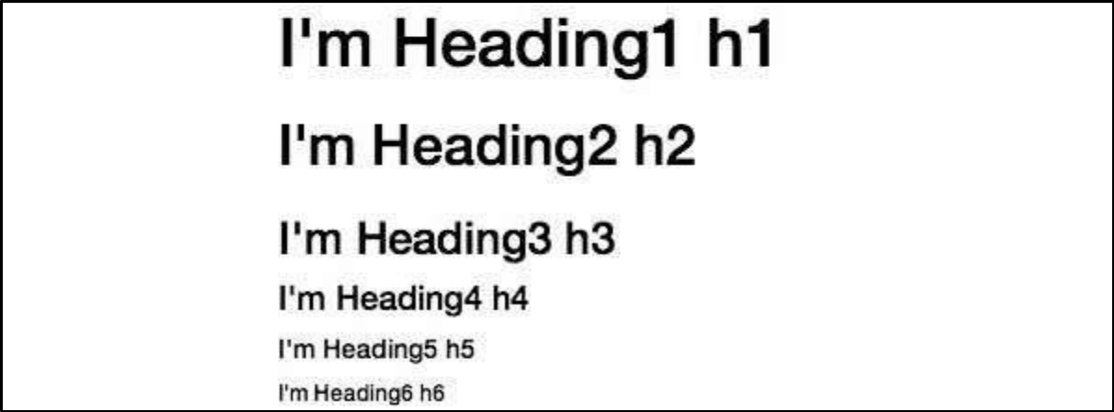

**Inline Subheadings**

To add an inline subheading to any of the headings, simply add <small> around any of the elements or add **.small** class and you will get smaller text in a lighter color as shown in the example below:

<h1>I'm Heading1 h1. <small>I'm secondary Heading1 h1</small></h1> <h2>I'm Heading2 h2. <small>I'm secondary Heading2 h2</small></h2> <h3>I'm Heading3 h3. <small>I'm secondary Heading3 h3</small></h3> <h4>I'm Heading4 h4. <small>I'm secondary Heading4 h4</small></h4> <h5>I'm Heading5 h5. <small>I'm secondary Heading5 h5</small></h5> <h6>I'm Heading6 h6. <small>I'm secondary Heading1 h6</small></h6>

22



Bootstrap

The above code segment with Bootstrap will produce the following result:

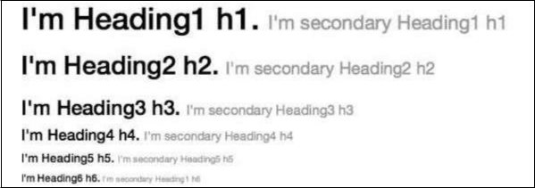

**Lead BodyCopy**

To add some emphasis to a paragraph, add class="lead". This will give you a larger font size, lighter weight, and a taller line height as in the following example:

<h2>Lead Example</h2>

<p class="lead">This is an example paragraph demonstrating the use of lead body copy. This is an example paragraph demonstrating the use of lead body copy.This is an example paragraph demonstrating the use of lead body copy.This is an example paragraph demonstrating the use of lead body copy.This is an example paragraph demonstrating the use of lead body copy.</p>

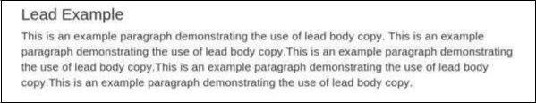

**Emphasis**

HTML's default emphasis tags such as <small>, sets text at 85% the size of the parent, <strong> emphasizes a text with heavier font-weight, and <em> emphasizes a text in italics.

Bootstrap offers a few classes that can be used to provide emphasis on texts as seen in the following example:

34



Bootstrap

End of ebook preview

If you liked what you saw…

Buy it from our store @ **https://store.tutorialspoint.com**

35

