4 host were used for this trace route example

Host name with IP are printed for extra credit.

GOOGLE.COM

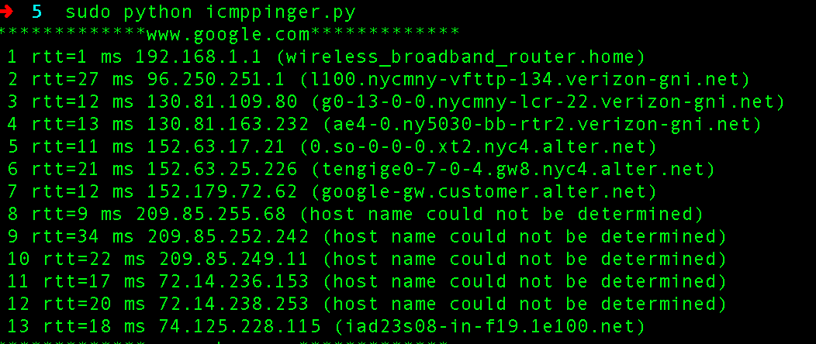

PROEXAM.ORG

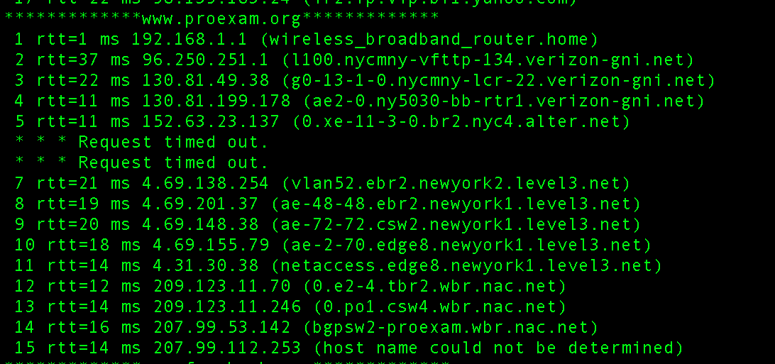

YAHOO.COM

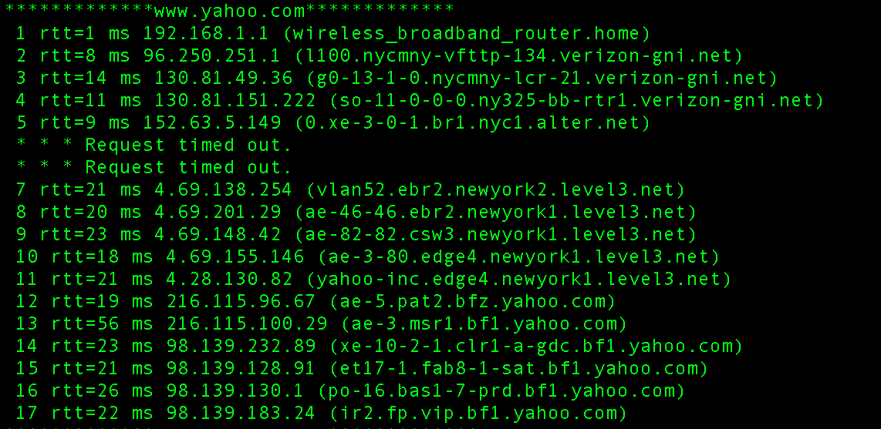

FACEBOOK.COM

