NAME: ANURAG VILAS DHONDGE
COLLEGE: CDAC-IACSD
CLASS: PGCP-AC
ROLL: 268013
PRN: 260841220030

--------------------------------------------------------------------------------------------------------------- Assignment 1 (DAY 01)

MYSQL BASIC PROGRAMMING ASSIGNMENT

EMP TABLE – QUERIES WITH OUTPUT
---------------------------------------------------------------------------------------------------------------

- To list all records with sal > 2000 and comm>200
Query-
select * from emp where sal>2000 and comm>200;

Output-

- To list all record with job='Clerk' or sal>2000
Query-
select * from emp where job='clerk' or sal>2000;

Output-
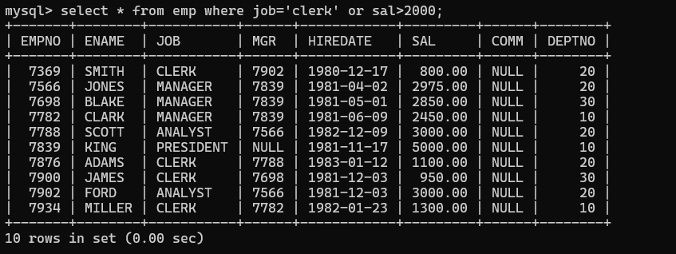

- To list all the record with sal=1250 or 1100 or 2850
Query-
select * from emp where sal in (1250,1100,2850);

Output-
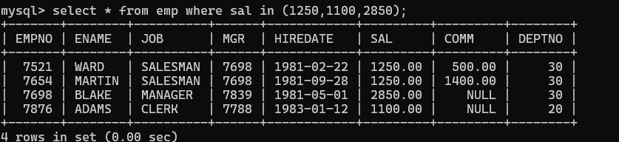

- To list all employees with sal>1250 and <2850
Query-
select * from emp where sal between 1251 and 2849;

Output-
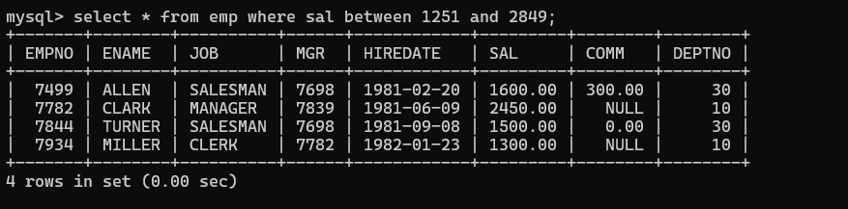

- To list all employees with name ends with AS
Query-
select * from emp where ename like '%as';

Output-

- To list all employees with job starts with C and ends with K
Query-
select * from emp where job like 'c%k';

Output-
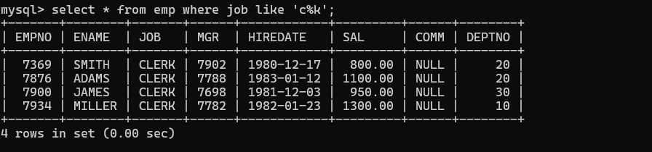

- To list all employees with job contains L at third position and M at third last position
Query-
select * from emp where job like ' l%m ';
Output-
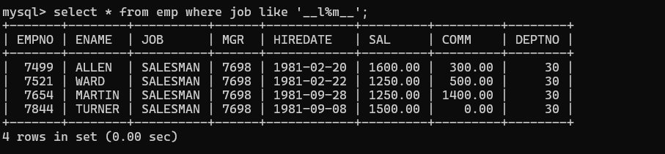

- To list all the record with sal not equal to 1250 or 1100 or 2850
Query-
select * from emp where sal not in(1250,1100,2850);

Output-
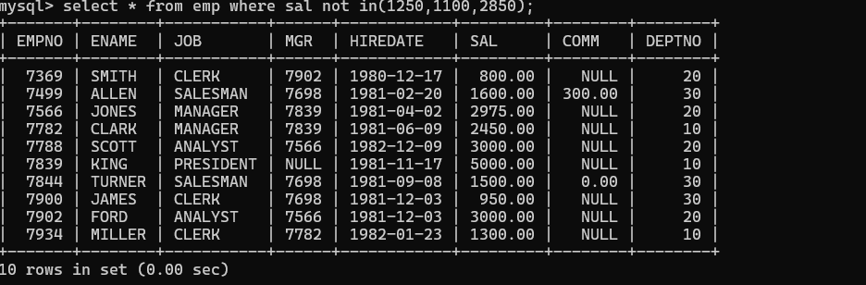

- To list all employees with sal not >1250 and <2850
Query-
select * from emp where sal not between 1250 and 2850;

Output-
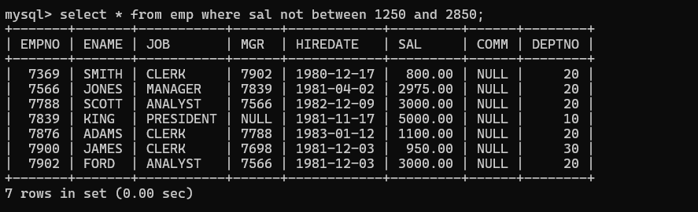

- To list all employees with job starts with C, E at 3rd position and ends with K
Query-
select * from emp where job like 'c%e%k';

Output-
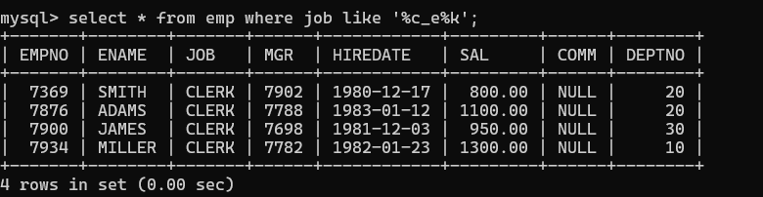

- To list all rows with comm is null
Query-
select * from emp where comm is NULL;

Output-
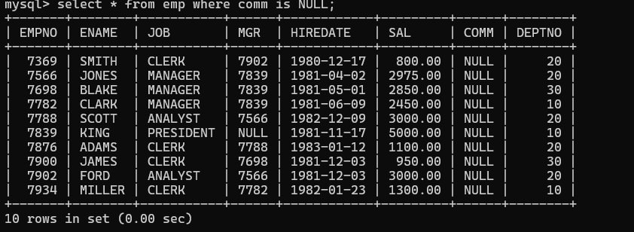

- To list all employees with sal is null and name starts with 'S'
Query-
select * from emp where sal is NULL and ename like 's%';

Output-

- To list all employees with job contains 5 characters
Query-
select * from emp where job like ' ';
Output-
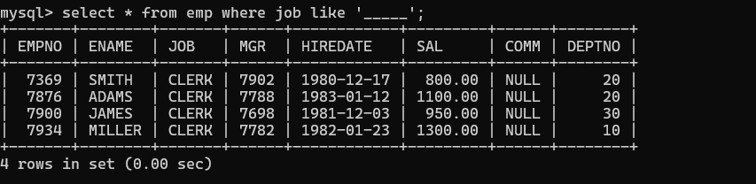

- To list all employees with name contain 'A' at 1 position and job contains 5 characters
Query-
select * from emp where ename like 'a%' and job like ' ';
Output-
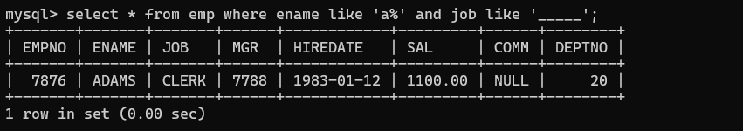

- Retrieve the details (Name, Salary and dept no) of the emp who are working in department code 20, 30 and 40.
Query-
select ename,sal,deptno from emp where deptno in(20,30,40);

Output-
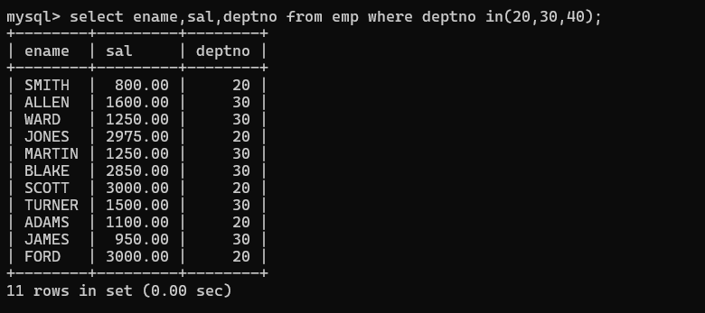

- Display the total salary of all employees. Total salary will be calculated as sal+comm+sal*0.10
Query-
select *, sal+(ifnull(comm,0)+sal*0.10) from emp;

Output-
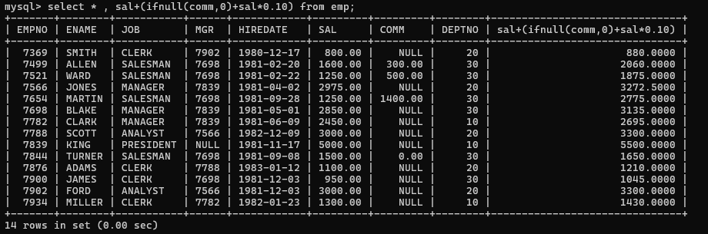

- List the Name and job of the emp who have joined before 1 Jan 1986 and whose salary >= 1200 and <=2500. Display the columns with user defined Column headers.
Query-
select ename Name,job Job from emp where hiredate < '1986-01-01' and sal between 1200 and 2500;

Output-
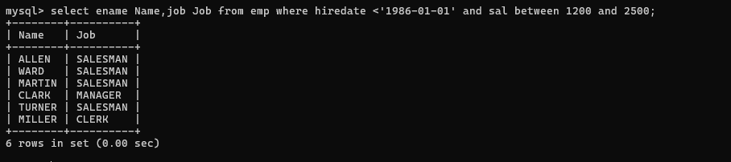

- List the empno, name, and department number of the emp works under manager with id 7698
Query-
select ename Name,job,deptno from emp where mgr =7698;

Output-
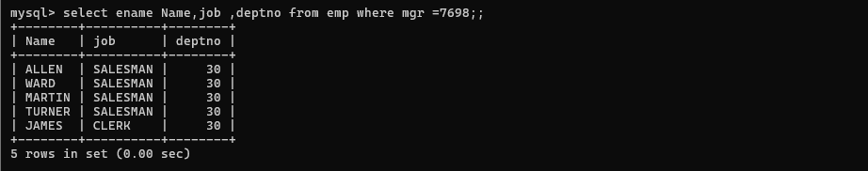

- List the name, job, and salary of the emp who are working in departments 10 and 30.
Query-
select ename Name,job,sal,deptno from emp where deptno in(10,30);

Output-
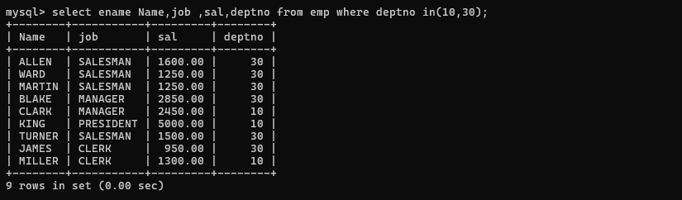

- Display the emp details who do not have manager.
Query-
select * from emp where mgr is NULL;

Output-
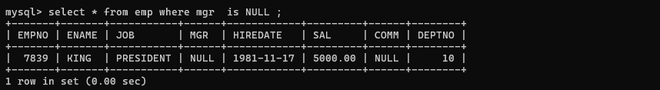

- Display name, department no and date of joining of all employee who were joined between January 1, 1981 and March 31, 1983.
Query-
select ename,deptno,hiredate from emp where hiredate between '1981-01-01' and '1983-03-31';

Output-
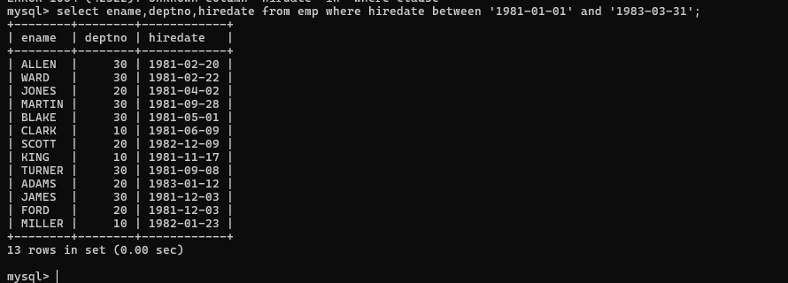

- Display the employee details where the job contains word 'AGE' anywhere in the Job
Query-
select * from emp where job like '%AGE%';

Output-
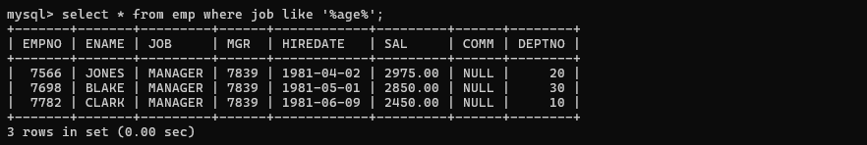

- List the details of the employee, whose names start with 'A' and end with 'S' or whose names contains N as the second or third character, and ending with either 'N' or 'S'.
Query-
select * from emp where ename like 'A%S' or ename like '_N%N' or ename like '_N%S' or ename like ' N%N' or ename like ' N%S';
Output-
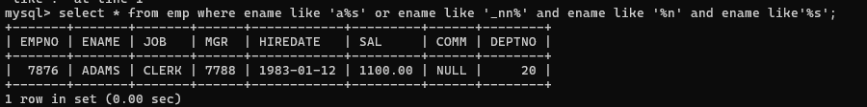

- List the names of the emp having '_' character in their name.
Query-
select ename from emp where ename like '%\_%' escape '\\';

Output-

- List all employees who joined in September. (without using functions)
Query-
select * from emp where hiredate like '%-09-%';

Output-
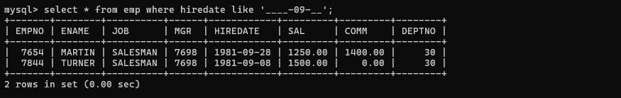

Assignment 1 (DAY 02)

PRODUCT & CATEGORY SQL ASSIGNMENT

---------------------------------------------------------------------------------------------------------------
- Display the product name and quantity of all products whose quantity is greater than 20. Query-
select pname, qty from product where qty>20;
Output-
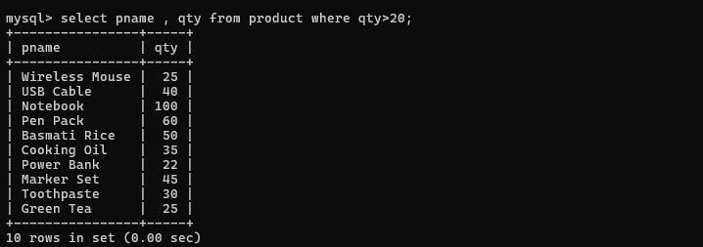

- Display pid, pname and qty for products whose quantity is less than or equal to 15. Query-
select pid, pname, qty from product where qty<=15;
Output-
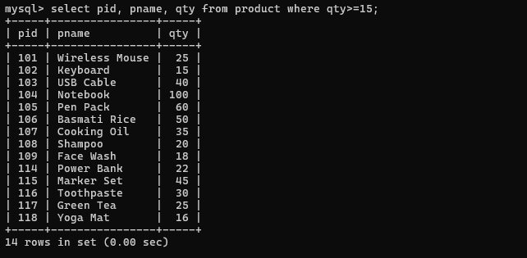

- Display pname and a calculated column showing the quantity after adding 10 units to the current quantity. Query-
select pname,qty+10 from product;
Output-
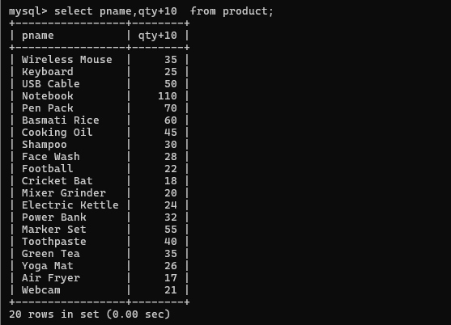

- Display pname and a calculated column showing the quantity after removing 5 units from the current quantity. Query-
select pname,qty-5 from product;
Output-
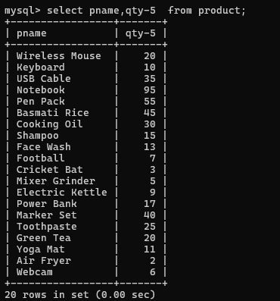

- Display pname and a calculated column showing half of the current quantity. Query-
select pname,qty/2 from product;
Output-
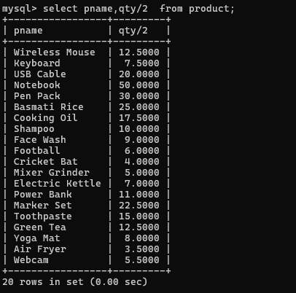

- Display pid, pname and qty for products whose quantity is between 10 and 30. Query-
select pid,pname,qty from product where qty between 10 and 30;
Output-
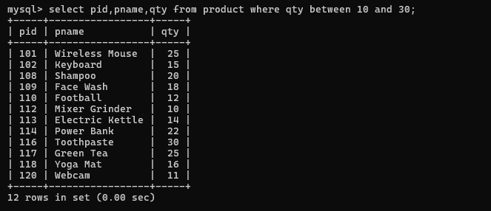

- Display all products whose quantity is NOT between 10 and 30. Query-
select pid,pname,qty from product where qty not between 10 and 30;
Output-
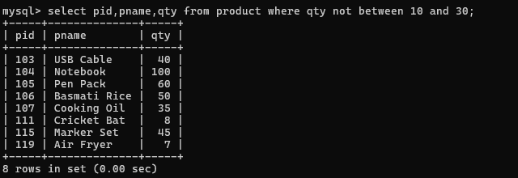

- Display products belonging to category IDs 1, 3, or 5 using the IN operator. Query-
select * from product where cid in (1,3,5);
Output-
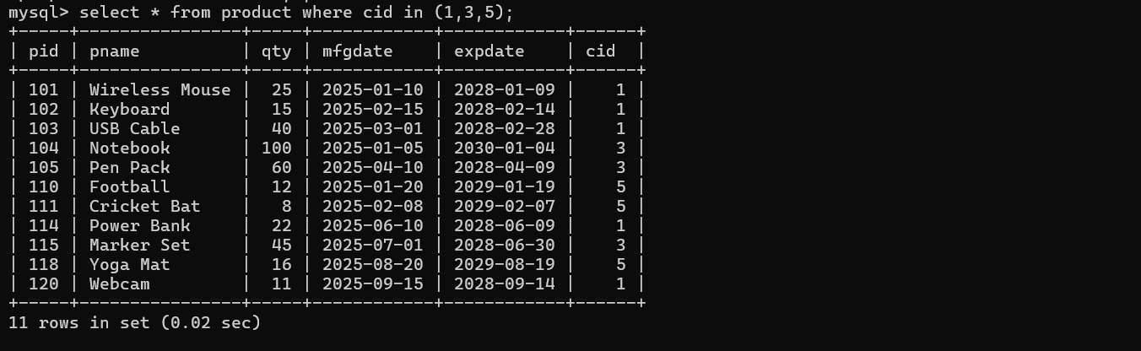

- Display products whose category ID is NOT IN 2, 4, and 6. Query-
select * from product where cid not in(2,4,6);
Output-
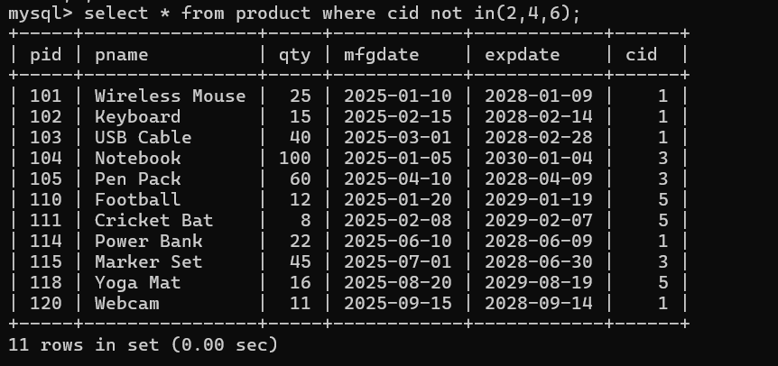

- Display products whose quantity is greater than 20 AND category ID is 1. Query-
select * from product where qty>20 and cid=1;
Output-
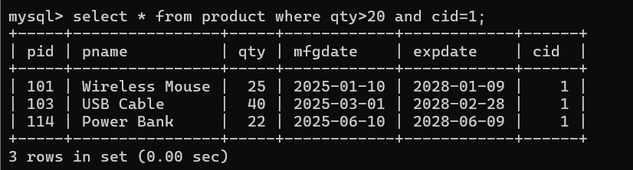

- Display products whose quantity is less than 20 OR category ID is 5. Query-
select * from product where qty<20 or cid=5;
Output-
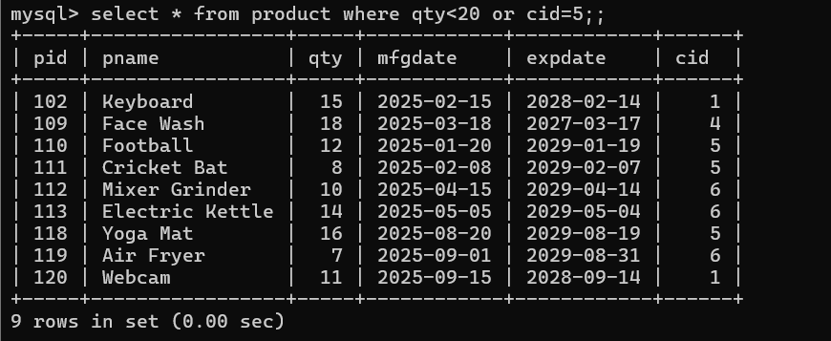

- Display products whose quantity is between 10 and 30 AND category ID is either 1 or 3. Query-
select * from product where qty between 10 and 30 and cid in(1,3);
Output-
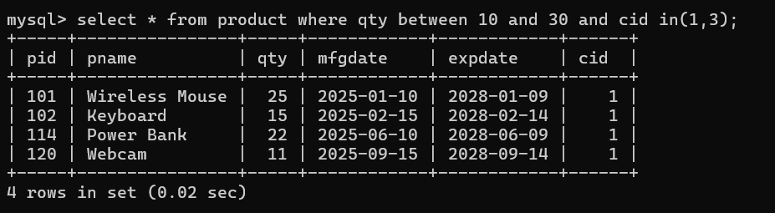

- Display products whose quantity is greater than 40 OR quantity is less than 10. Query-
select * from product where qty>40 or qty<10;
Output-
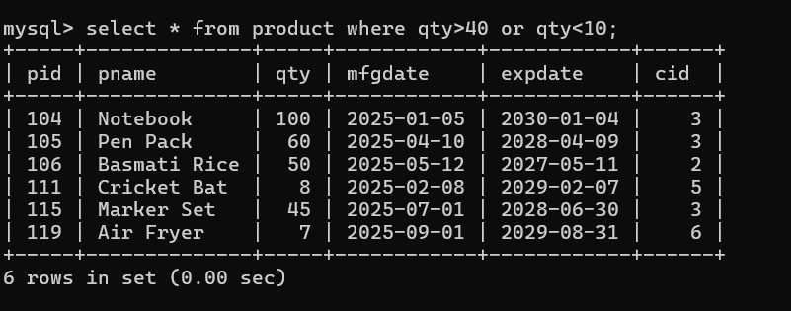

- Display products whose quantity is greater than 15 AND quantity is less than 50 AND category ID is 1. Query-
select * from product where qty>15 and qty<50 and cid=1;
Output-
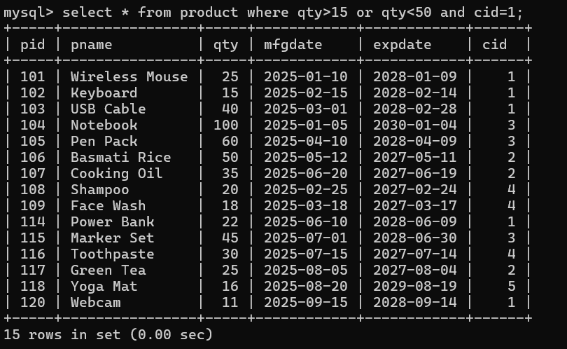

- Display products manufactured between '2025-02-01' and '2025-06-30' using the BETWEEN operator. Query-
select * from product where mfgdate between '2025-02-01' and '2025-06-30';
Output-
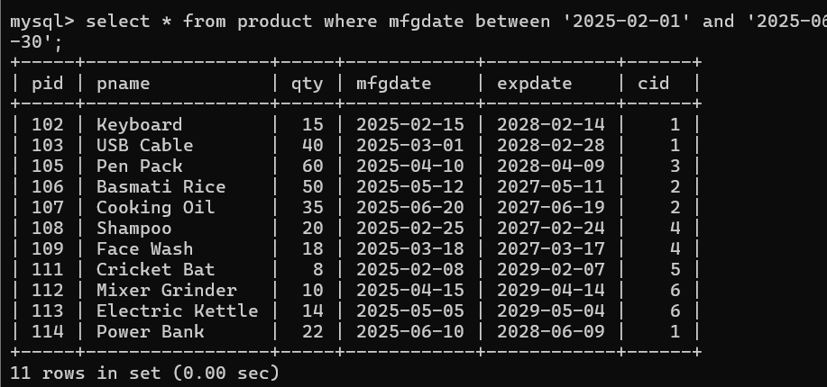

- Display products whose expiry date is NOT between '2027-01-01' and '2028-12-31'. Query-
select * from product where expdate not between '2027-01-01' and '2028-12-31';
Output-
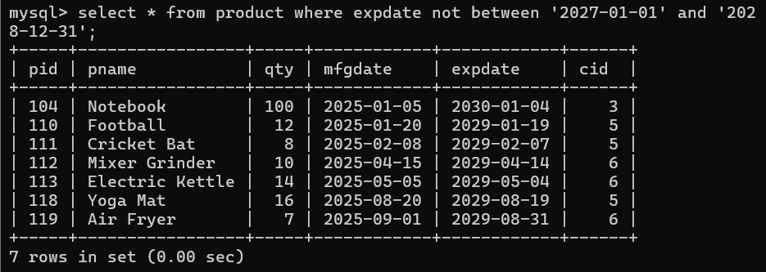

- Display products whose quantity, when divided by 5, has remainder 0. Use the modulo (%) operator. Query-
select pname,qty%5 from product where qty%5=0;
Output-
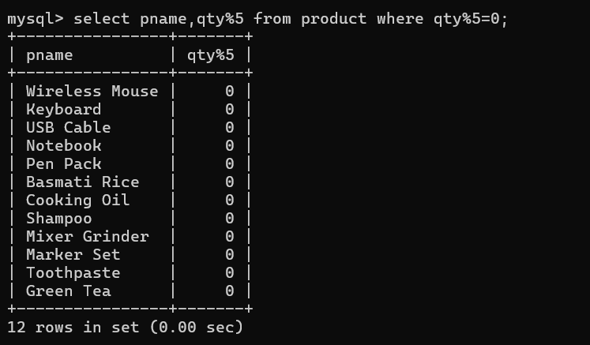

- Display products whose quantity is greater than 20 AND whose category ID is NOT 2. Query-
select * from product where qty>20 and cid!=2;
Output-
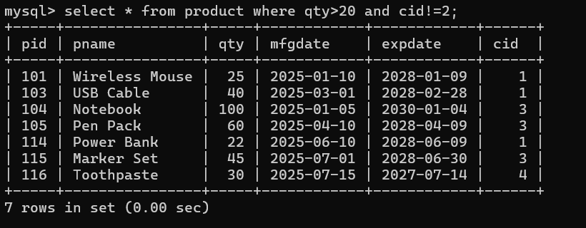

- Display products where either quantity is between 10 and 20 AND category ID is 1, OR quantity is between 30 and 50 AND category ID is 2.
Query-
select * from product where qty between 10 and 20 and cid=1 or qty between 30 and 50 and cid=2;
Output-
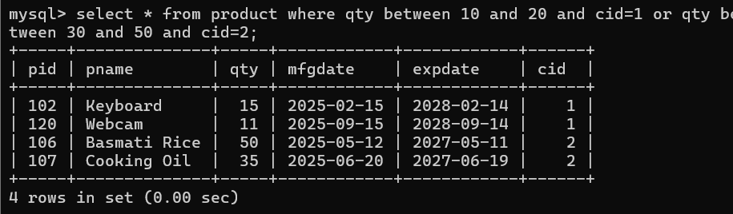

LIKE OPERATOR PRACTICE QUESTIONS

- Display all products whose pname starts with 'W'.
Query-
SELECT * FROM product WHERE pname LIKE 'W%';
Output-
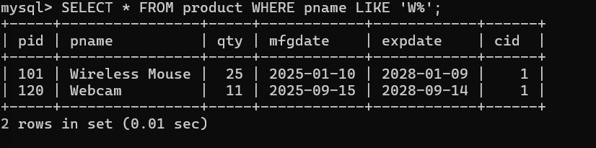

- Display all products whose pname ends with 'e'.
Query-
SELECT * FROM product WHERE pname LIKE '%e';
Output-
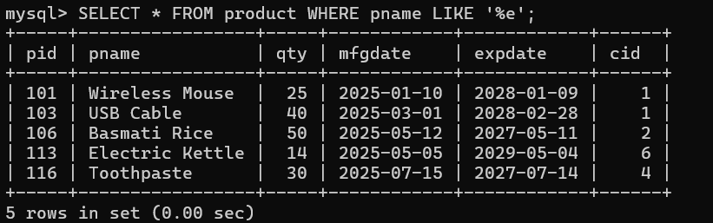

- Display all products whose pname contains the letter 'a'.
Query-
SELECT * FROM product WHERE pname LIKE '%a%';
Output-
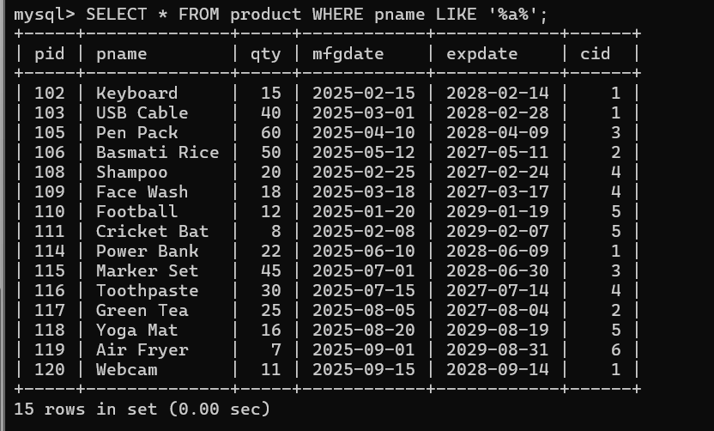

- Display all products whose pname contains the word 'Wash'.
Query-
SELECT * FROM product WHERE pname LIKE '%Wash%';
Output-
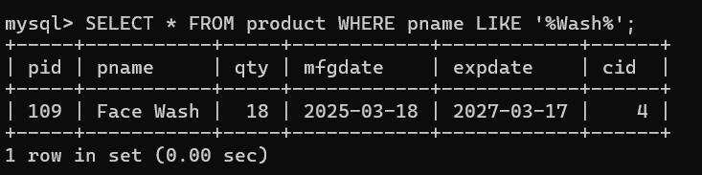

- Display all products whose pname starts with 'C' and has any number of characters after it.
Query-
SELECT * FROM product WHERE pname LIKE 'C%';
Output-
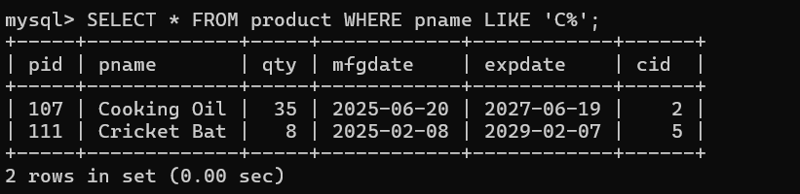

- Display all products whose pname has exactly 6 characters.
Query-
SELECT * FROM product WHERE pname LIKE ' ';
Output-
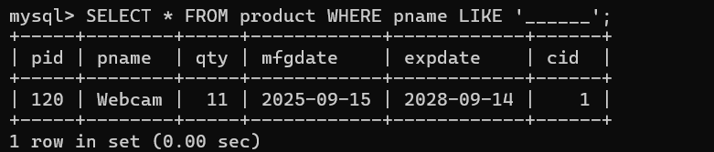

- Display all products whose pname has exactly 5 characters.
Query-
SELECT * FROM product WHERE pname LIKE ' ';
Output-
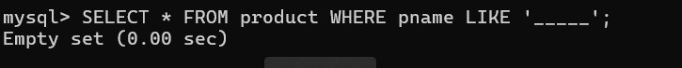

- Display all products whose pname has 'e' as the second character.
Query-
SELECT * FROM product WHERE pname LIKE '_e%';
Output-
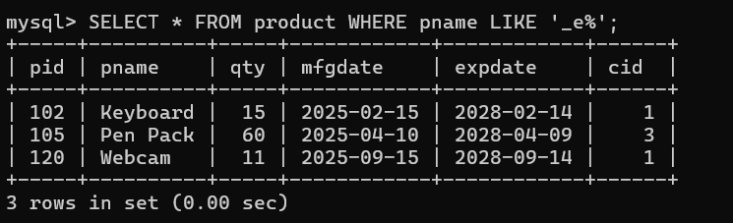

- Display all products whose pname has 'a' as the third character.
Query-
SELECT * FROM product WHERE pname LIKE ' a%';
Output-
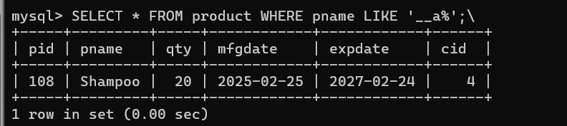

- Display all products whose pname starts with 'P' and ends with 'k'.
Query-
SELECT * FROM product WHERE pname LIKE 'P%k';
Output-
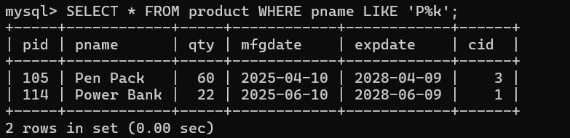

- Display all products whose pname contains 'er' anywhere in the name.
Query-
SELECT * FROM product WHERE pname LIKE '%er%';
Output-
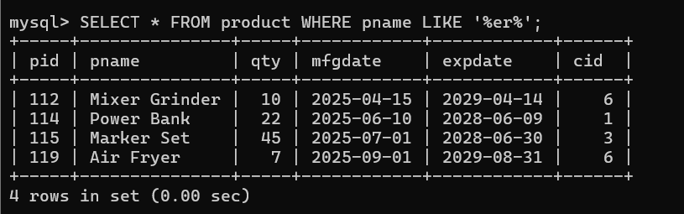

- Display all products whose pname starts with either 'M' or 'W'.
Query-
SELECT * FROM product WHERE pname LIKE 'M%' OR pname LIKE 'W%';
Output-
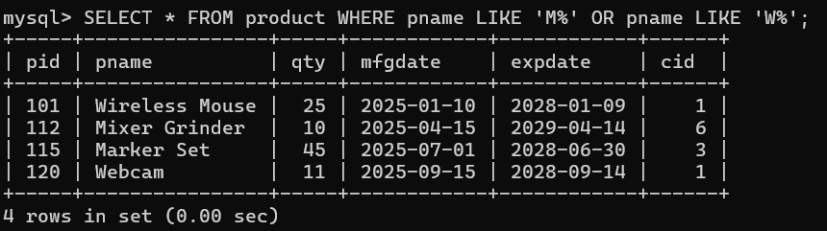

- Display all products whose pname does not start with 'W'.
Query-
SELECT * FROM product WHERE pname NOT LIKE 'W%';
Output-
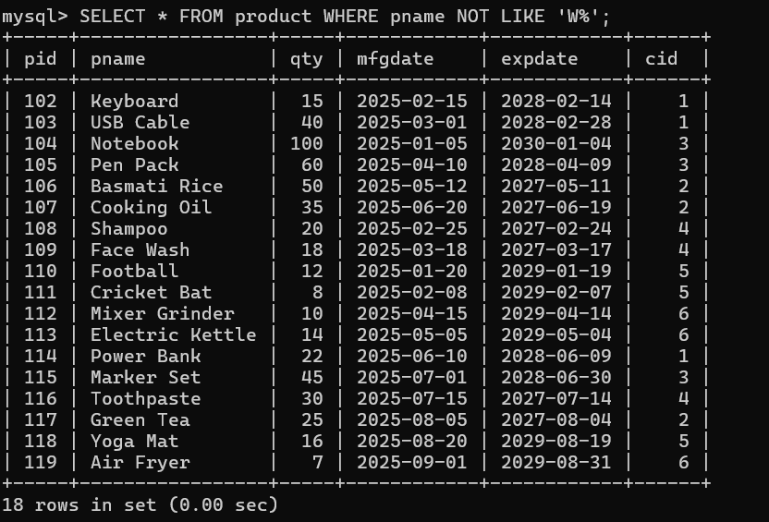

- Display all products whose pname does not contain the letter 'a'.
Query-
SELECT * FROM product WHERE pname NOT LIKE '%a%';
Output-
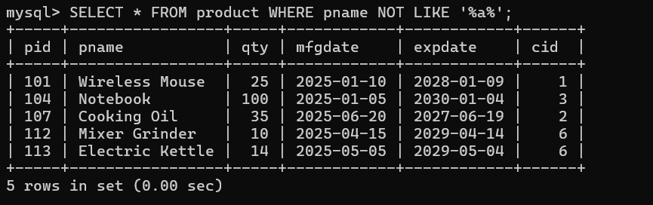

- Display pid, pname, and qty for products whose name starts with 'E' and quantity is greater than 10.
Query-
SELECT pid, pname, qty FROM product WHERE pname LIKE 'E%' AND qty > 10;
Output-
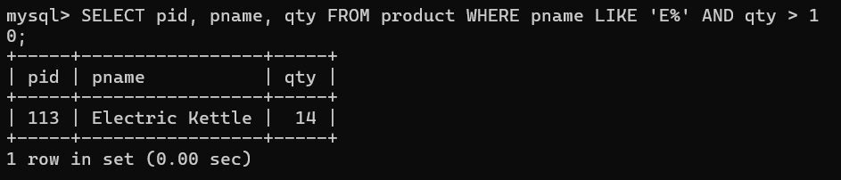

- Display products whose name contains 'a' and whose cid is either 1 or 5.
Query-
SELECT * FROM product WHERE pname LIKE '%a%' AND cid IN (1,5);
Output-
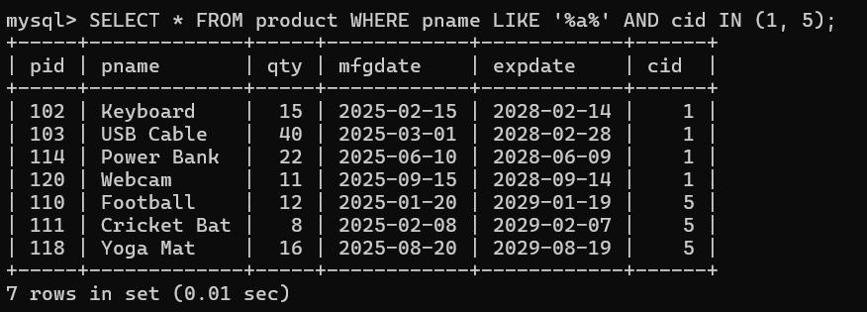

- Display products whose name starts with 'S' OR whose name ends with 'e'.
Query-
SELECT * FROM product WHERE pname LIKE 'S%' OR pname LIKE '%e';
Output-
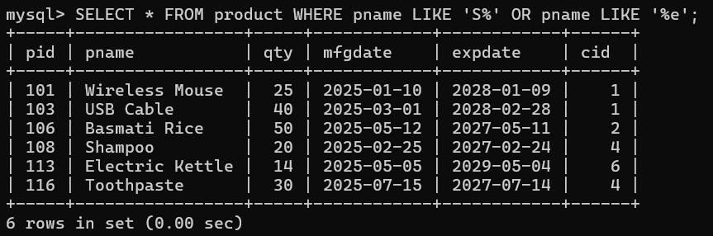

- Display products whose name contains 'o' AND quantity is between 10 and 30.
Query-
SELECT * FROM product WHERE pname LIKE '%o%' AND qty BETWEEN 10 AND 30;
Output-
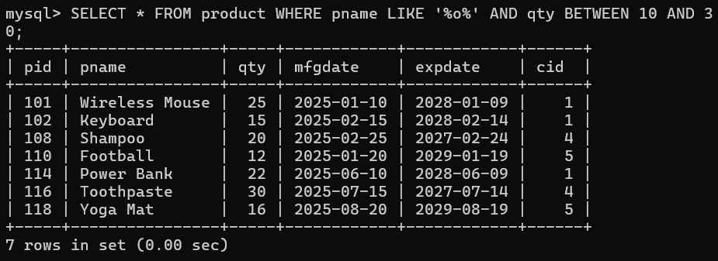

- Display products whose name starts with 'C' but does not contain 'r'.
Query-
SELECT * FROM product WHERE pname LIKE 'C%' AND pname NOT LIKE '%r%';
Output-
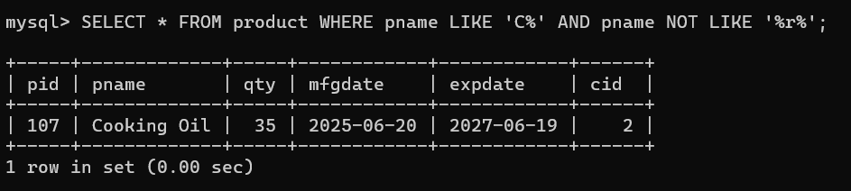

- Display products whose name contains 'a' OR 'e', and whose quantity is greater than 20.
Query-
SELECT * FROM product WHERE (pname LIKE '%a%' OR pname LIKE '%e%') AND qty > 20;
Output-
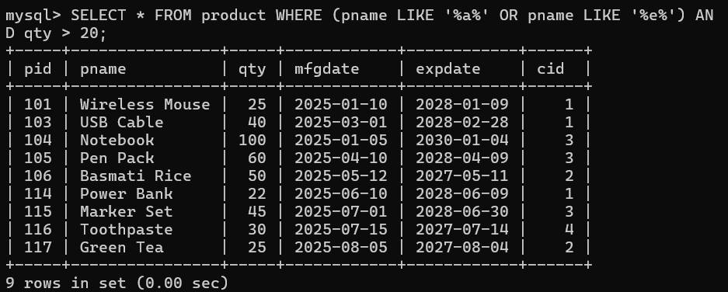

- Find products whose name starts with 'M' or 'P'.
Query-
SELECT * FROM product WHERE pname LIKE 'M%' OR pname LIKE 'P%';
Output-
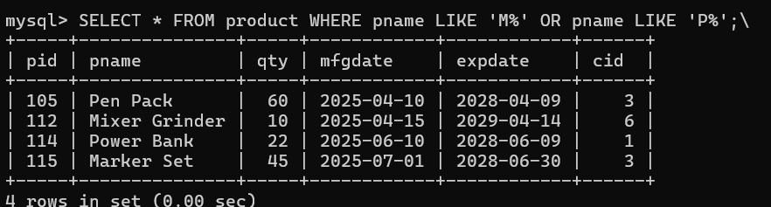

- Find products whose name contains 'a' or 'e'.
Query-
SELECT * FROM product WHERE pname LIKE '%a%' OR pname LIKE '%e%';
Output-
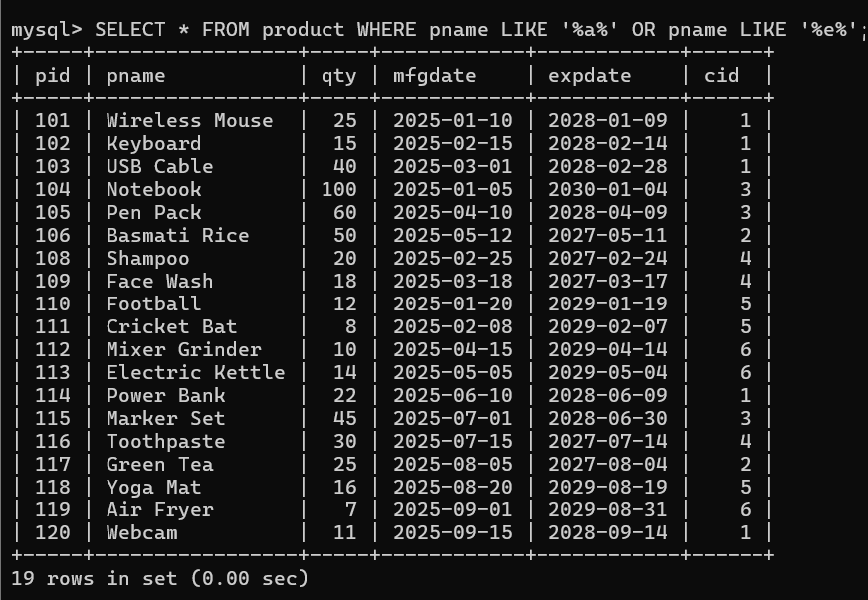

- Find products whose name ends with 'e' or 't'.
Query-
SELECT * FROM product WHERE pname LIKE '%e' OR pname LIKE '%t';
Output-
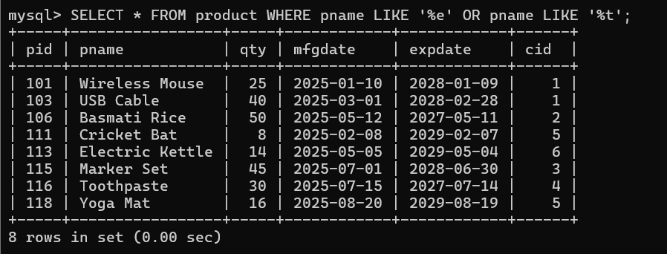

Assignment 1 (DAY 02)

SINGLE ROW FUNCTIONS & GROUP FUNCTIONS

- To list all employees and their email, to generate email use 2 to 5 characters from ename. Concat it with 2 to 4 characters in job and then concat it with '@mycompany.com'.
Query-
select ename ,concat(substr(ename,2,5),substr(job,2,4),'@[mycompany.com](http://mycompany.com/)') email from emp;
Output-
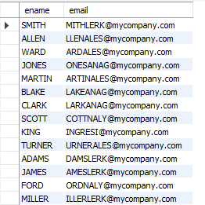

- List the empno, name, and department number of the emp who have experience of 18 or more years and sort them based on their experience.
Query-
select empno,ename,desptno,hiredate ,timestampdiff(year,hiredate,curdate()) experience from emp where timestampdiff(year,hiredate,curdate())>=18 order by experience desc;
Output-
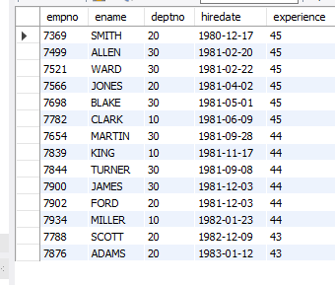

- Display the employee details who joined on 3rd of any month or any year.
Query-
select empno,ename,hiredate,day(hiredsSate) Day\_of\_joining from emp where day(hiredate)=3;
Output-
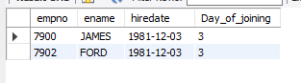

- Display all employees who joined between years 1981 to 1983.
Query-
select empno,ename,hiredate,year(hiredate) from emp where year(hiredate) between '1981-01-01' and '1983-01-01' order by year(hiredate) desc ;
Output-
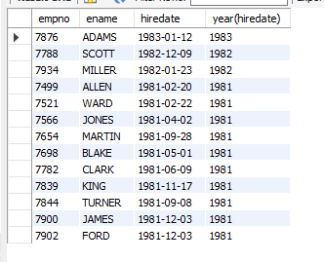

- Display name concatenated with dept code separated by comma and space. Name the column as 'Emp info'.
Query-
select ename,deptno, concat(ename," , ",deptno) as "name deptno" from emp;
Output-
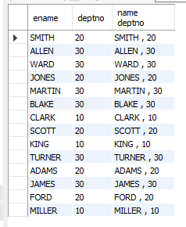

- Display the Highest, Lowest, Total & Average salary of all employee. Label the columns Maximum, Minimum, Total and Average respectively for each Department. Also round the result to the nearest whole number.
Query-
select deptno,min(sal) Minimum,max(sal) maximum,round(avg(sal),2) Aveage,sum(sal) Sum from emp group by deptno;
Output-
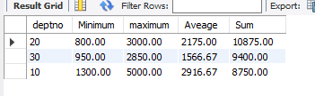

- Display Department no and number of managers working in that department. Label the column as 'Total Number of Managers' for each department.
Query-
select deptno,count(*) from emp where job='manager' group by deptno;
Output-
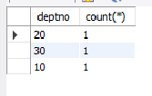

- Get the Department number, and sum of Salary of all non managers where the sum is greater than 20000.
Query-
select * from emp;
select job,deptno from emp where job='manager';

select deptno,job,sum(sal) salary from emp where job!='manager' group by deptno,job having sum(sal)>2000;

Output-
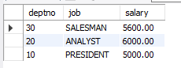

Assignment 3 (DAY 03)

- Write a query to display the first day of the month (in datetime format) three months before the current month.

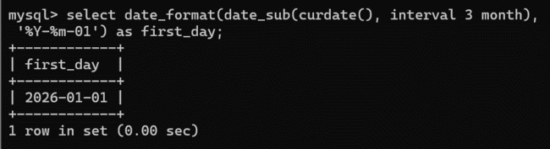

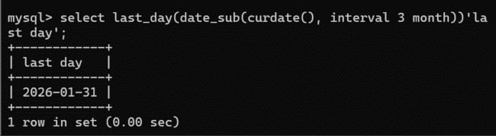
- Write a query to display the last day of the month (in datetime format) three months before the current month.

- Write a query to get the distinct Mondays from hiredate in emp tables.
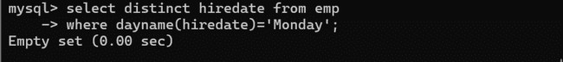
- Write a query to get the first day of the current year.
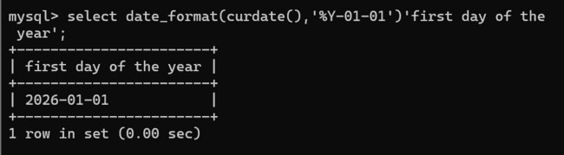

- Write a query to get the last day of the current year.
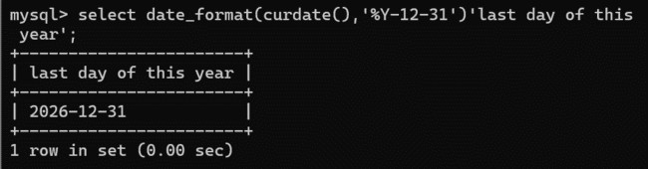

- Write a query to calculate your age in year.
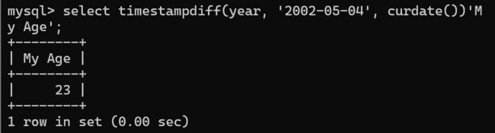

- Write a query to get the current date in the following format.

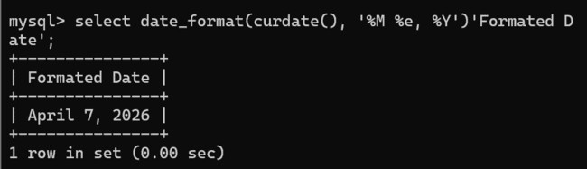

- Write a query to get the current date in Thursday September 2014 format.
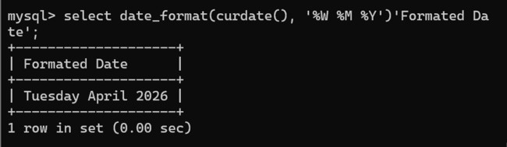

- Write a query to extract the year from the current date.
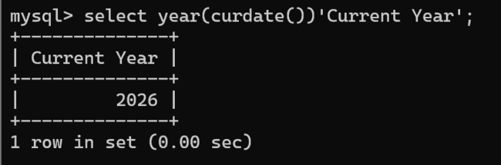

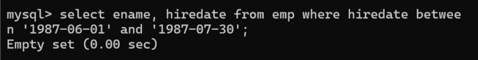
- Write a query to get the first name and hire date from employees table where hire date between '1987-06-01' and '1987-07-30'

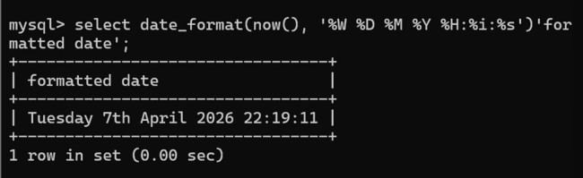
- Write a query to display the current date in the following format. Sample output: Thursday 4th September 2014 00:00:00
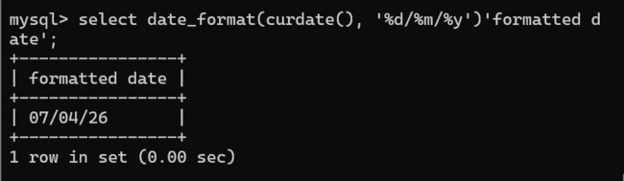
- Write a query to display the current date in the following format. Sample output: 05/09/2014

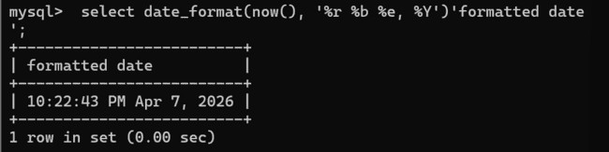
- Write a query to display the current date in the following format. Sample output: 12:00 AM Sep 5, 2014

- Write a query to get the employees who joined in the month of June.

- Write a query to get the years in which more than 10 employees joined.
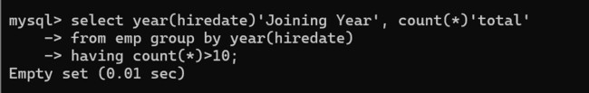

- Write a query to get first name of employees who joined in 1987.

- Write a query to get employees whose experience is more than 5 years.

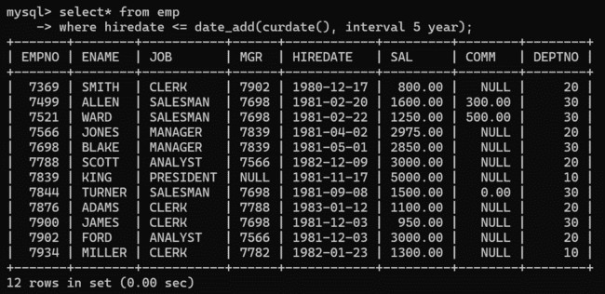

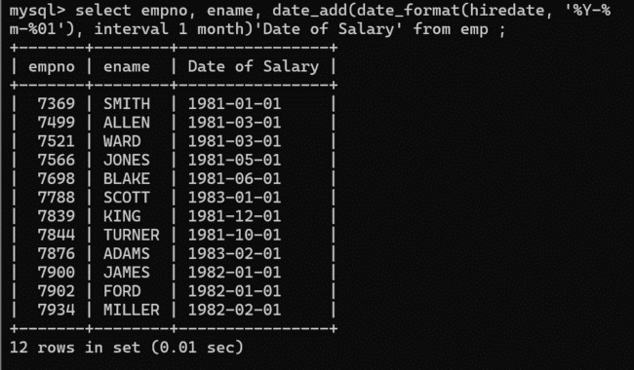
- Write a query to get employee ID, last name, and date of first salary of the employees.

- Write a query to get first name, hire date and experience of the employees.
Sample table: employees
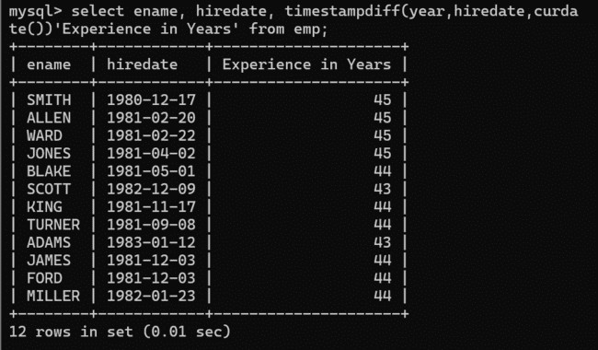

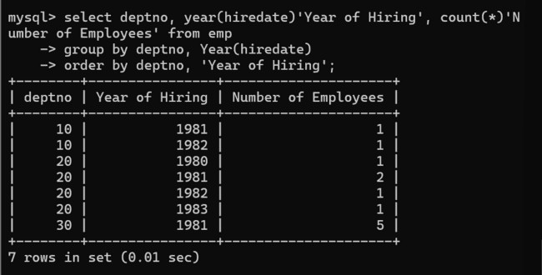
- Write a query to get the department ID, year, and number of employees joined.

Assignment 4 (DAY 04)

Question 1 – Online Shopping System
Customer and Orders tables, their CREATE/ALTER/INSERT/UPDATE/DELETE operations, default values, column rename, and foreign-key behavior.

Screenshot 1
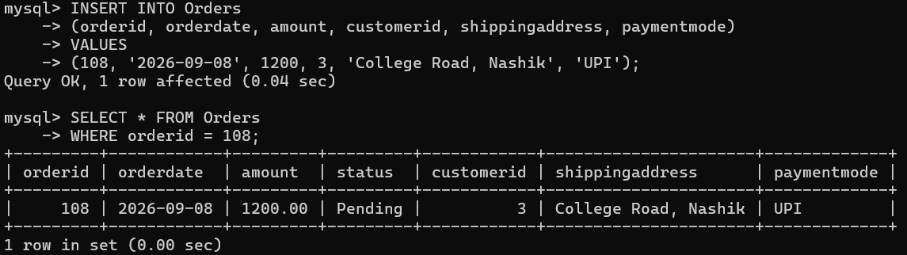

Screenshot 2
Screenshot 2026-09-25 222803.png

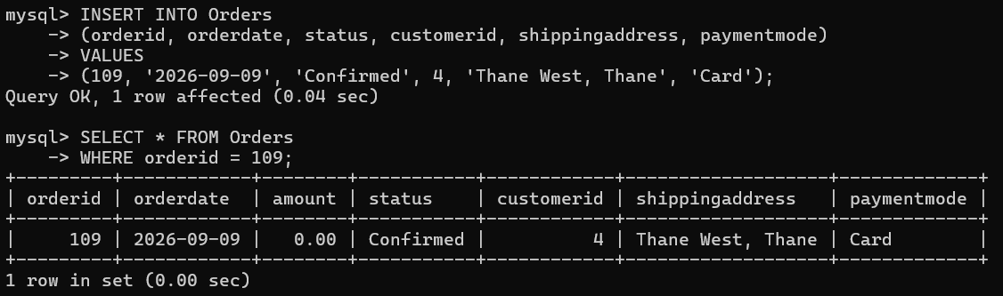

Screenshot 2026-09-25 222837.png

Screenshot 3
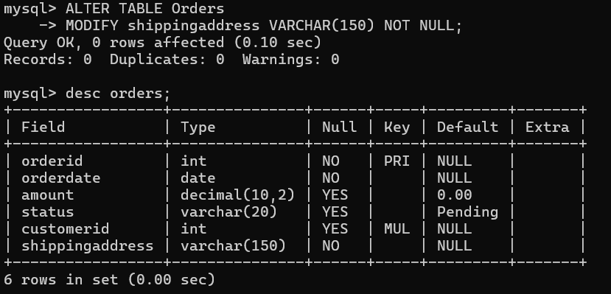

Screenshot 4
Screenshot 2026-09-25 222058.png

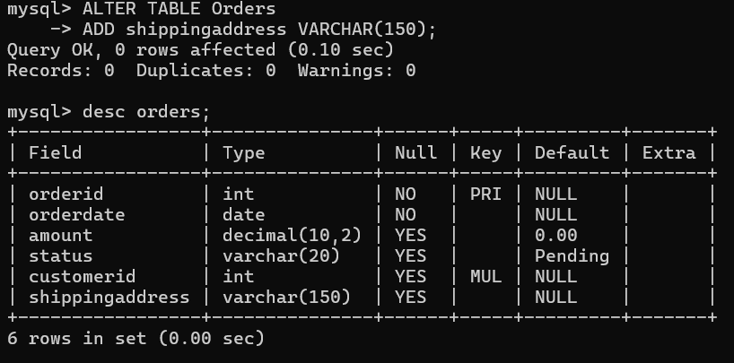

Screenshot 2026-09-25 221946.png

Screenshot 5
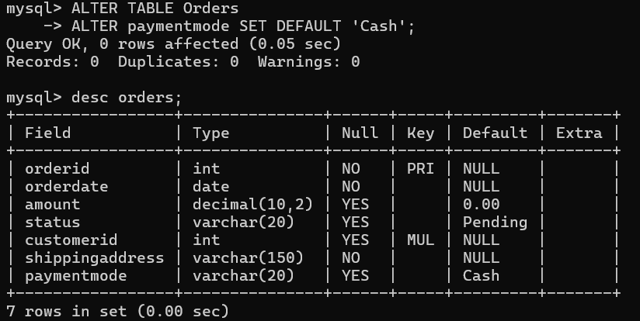

Screenshot 6
Screenshot 2026-09-25 222336.png

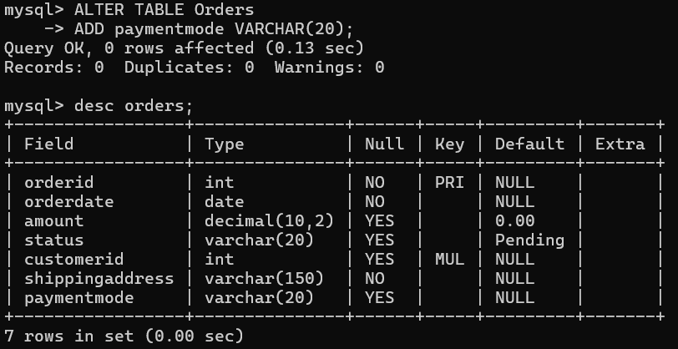

Screenshot 2026-09-25 222232.png

Screenshot 7
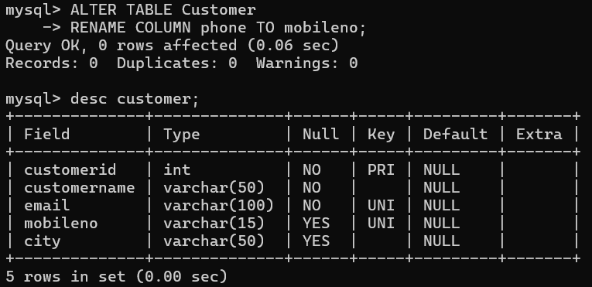

Screenshot 8
Screenshot 2026-09-25 222423.png

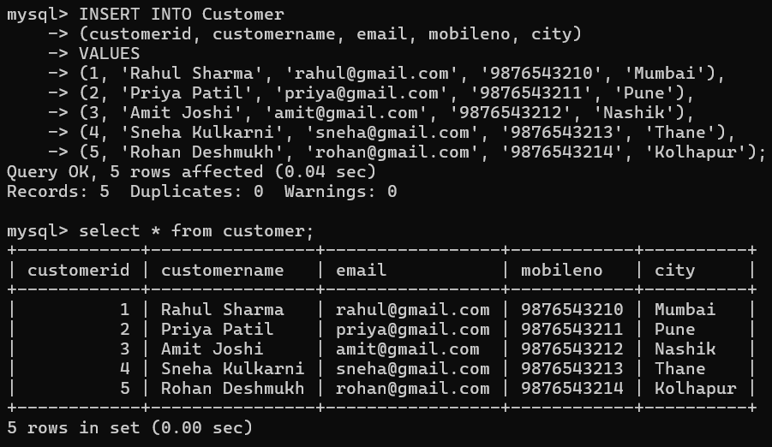

Screenshot 2026-09-25 222550.png

Screenshot 9
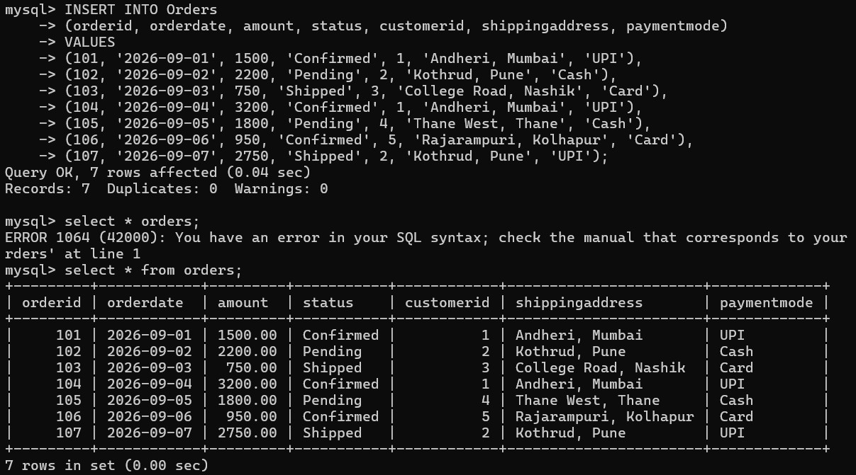

Screenshot 10
Screenshot 2026-09-25 222712.png

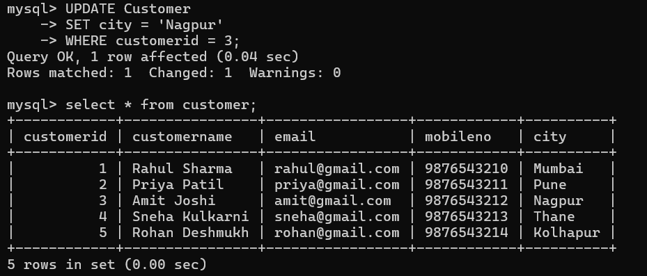

Screenshot 2026-09-25 222933.png

Screenshot 11
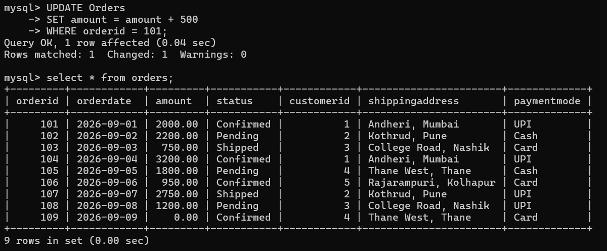

Screenshot 12
Screenshot 2026-09-25 223022.png

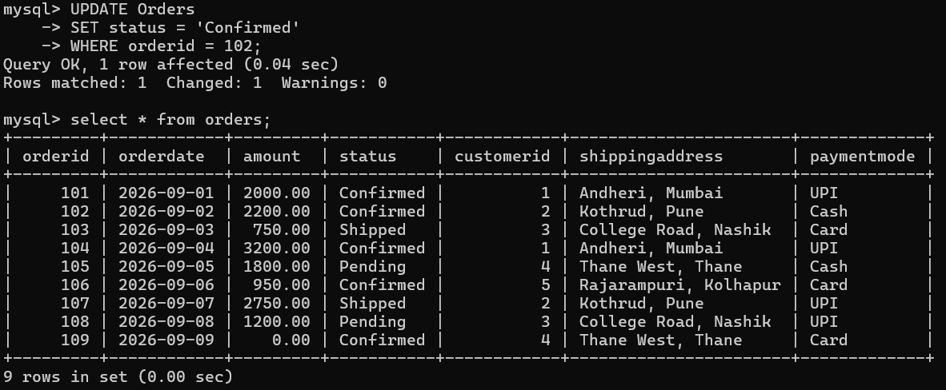

Screenshot 2026-09-25 223102.png

Screenshot 13
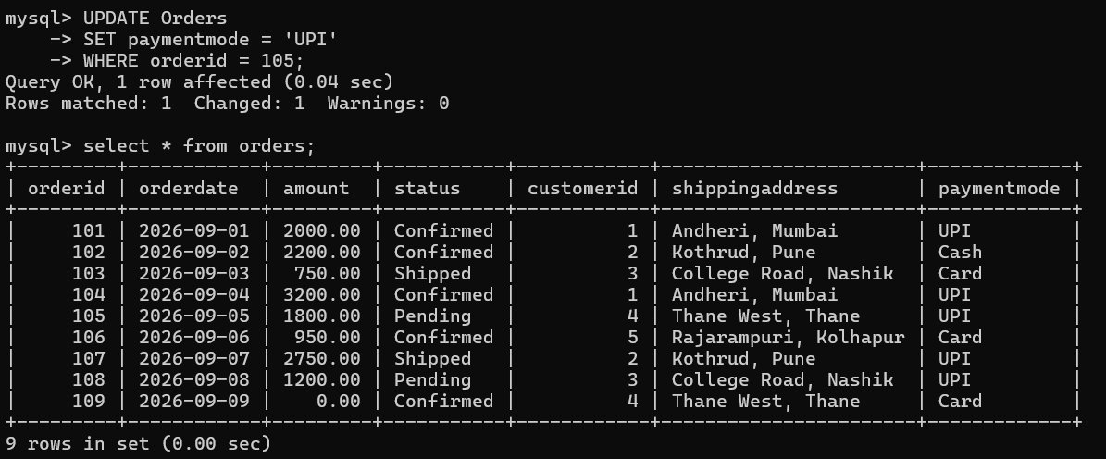

Screenshot 14
Screenshot 2026-09-25 223146.png

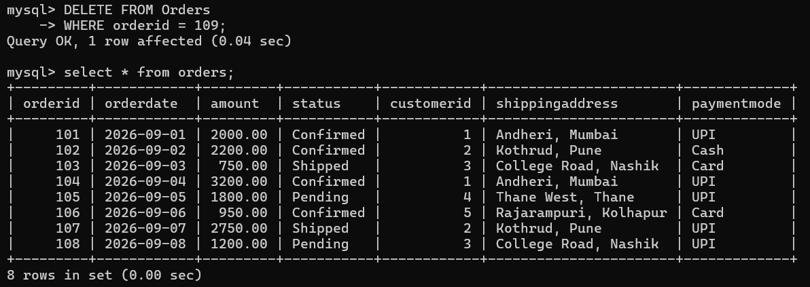

Screenshot 15
Screenshot 2026-09-25 223215.png

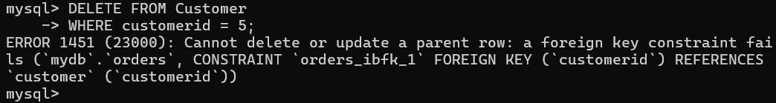

Screenshot 16
Screenshot 2026-09-25 223253.png

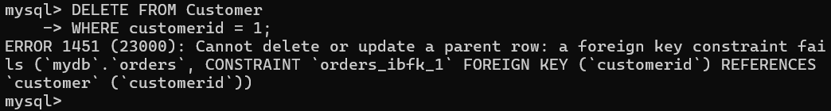

Screenshot 17
Screenshot 2026-09-25 223341.png

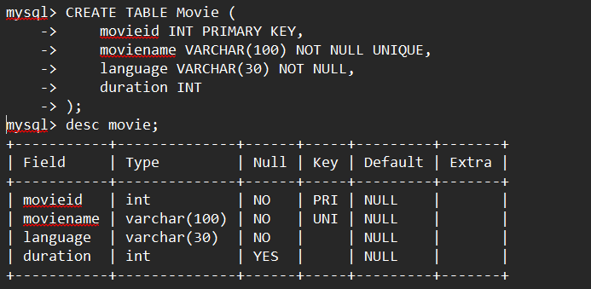

Screenshot 18
Screenshot 2026-09-25 225819.png

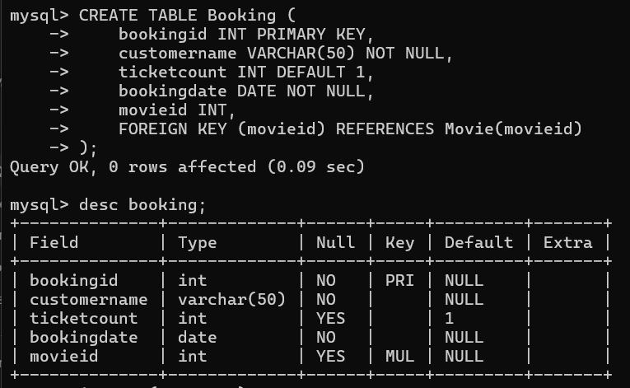

Screenshot 2026-09-25 225856.png

Screenshot 19

Screenshot 20
Screenshot 2026-09-26 020341.png

Screenshot 2026-09-26 020433.png

Question 2 – Movie Ticket Booking System
Movie and Booking tables, CREATE/ALTER/INSERT/UPDATE/DELETE operations, default values, theatre constraint handling, and foreign-key behavior.

Screenshot 1
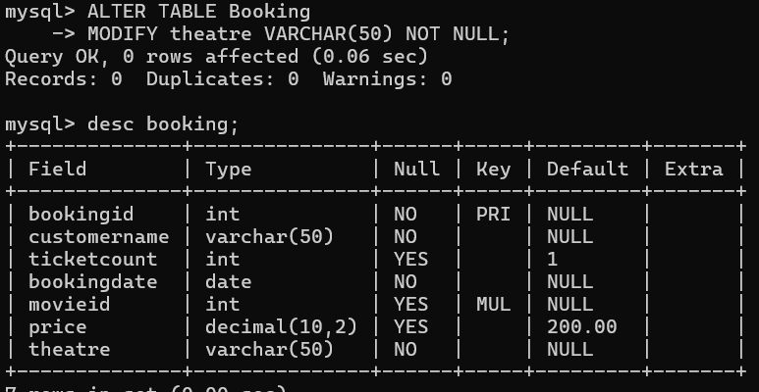

Screenshot 2
Screenshot 2026-09-26 013756.png

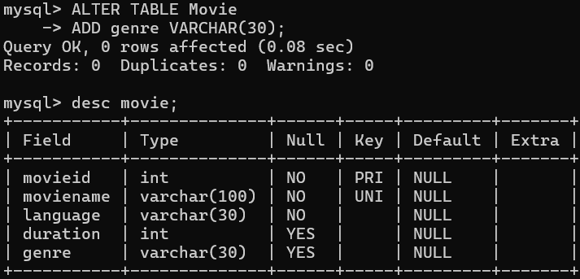

Screenshot 2026-09-26 013825.png

Screenshot 3
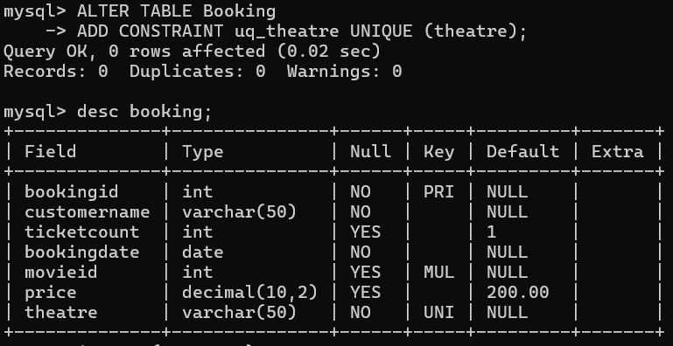

Screenshot 4
Screenshot 2026-09-26 013940.png

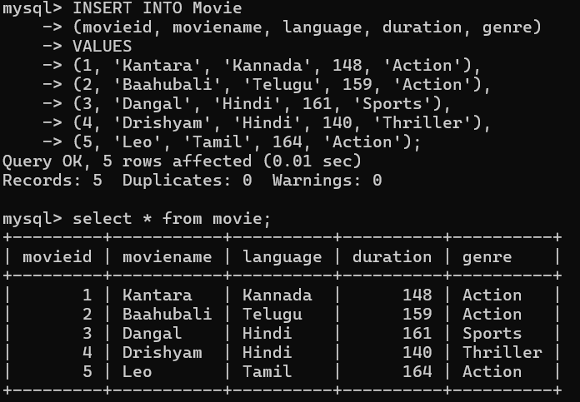

Screenshot 2026-09-26 014010.png

Screenshot 5
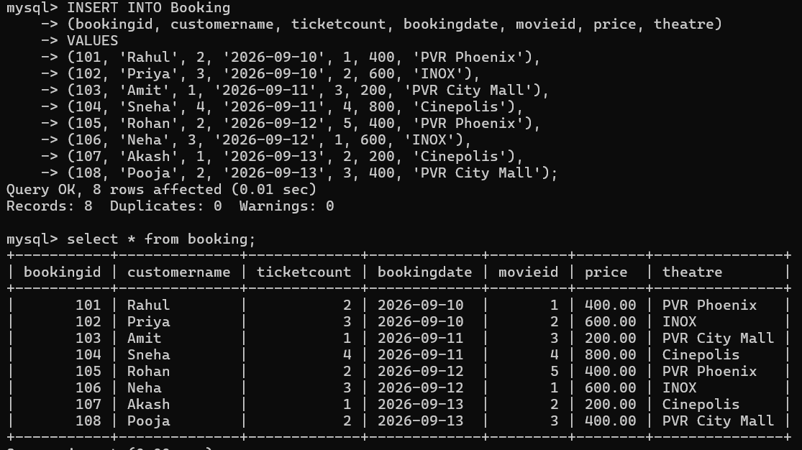

Screenshot 6
Screenshot 2026-09-26 014326.png

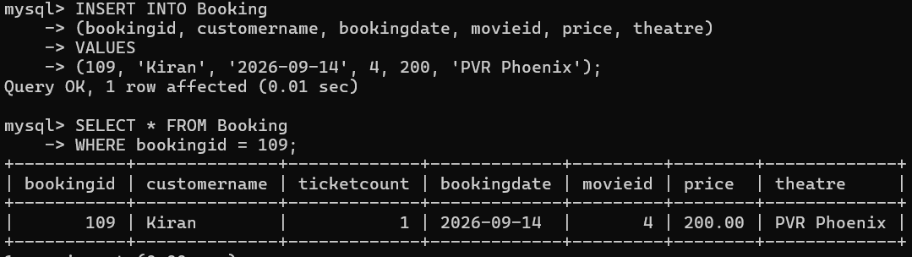

Screenshot 7
Screenshot 2026-09-26 014413.png

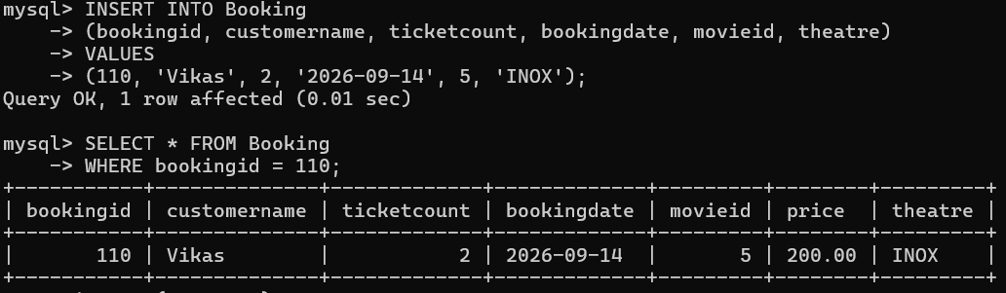

Screenshot 2026-09-26 014654.png

Screenshot 8
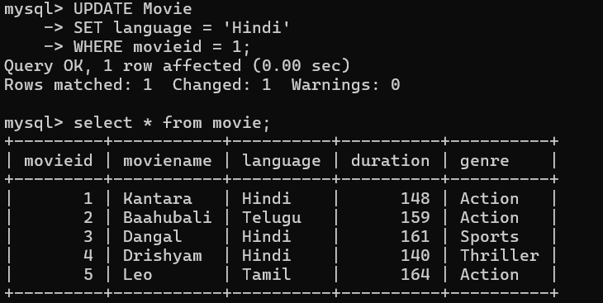

Screenshot 9
Screenshot 2026-09-26 014736.png

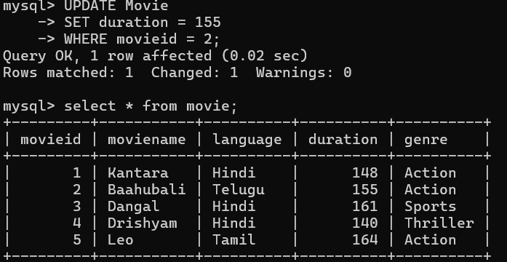

Screenshot 2026-09-26 014802.png

Screenshot 10
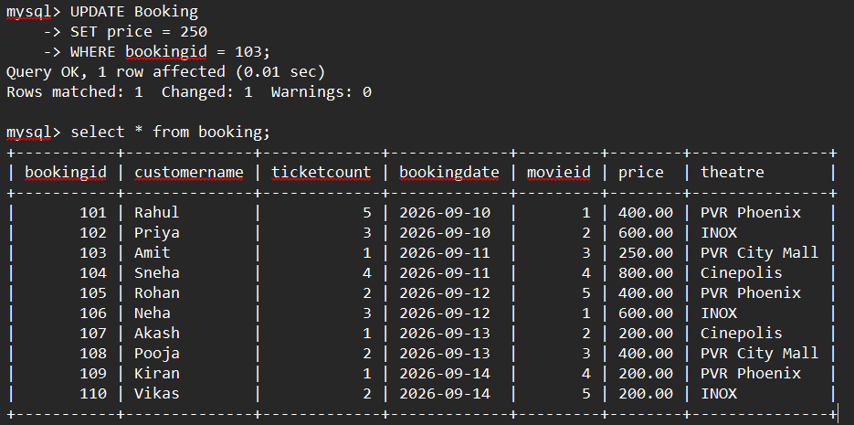

Screenshot 11
Screenshot 2026-09-26 015012.png

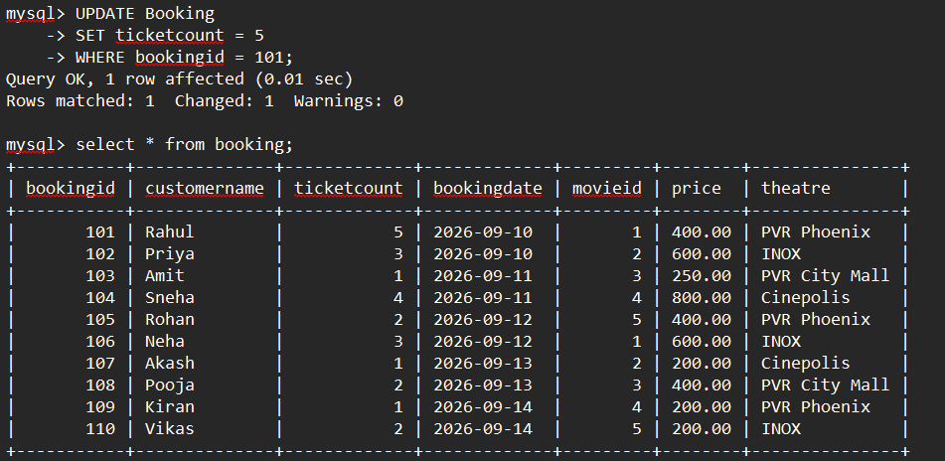

Screenshot 2026-09-26 015102.png

Screenshot 12
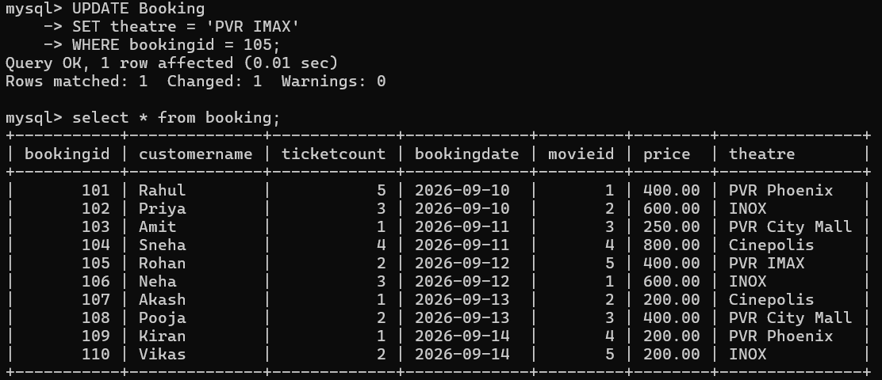

Screenshot 13
Screenshot 2026-09-26 015142.png

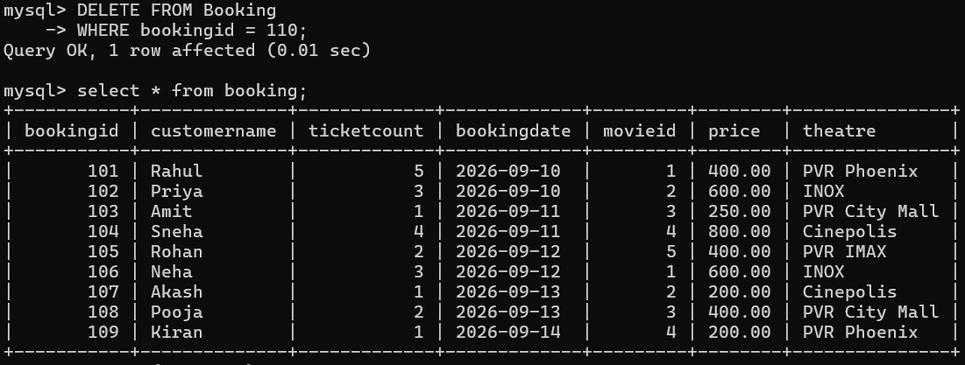

Screenshot 14
Screenshot 2026-09-26 015228.png

Screenshot 15
Screenshot 2026-09-26 015253.png

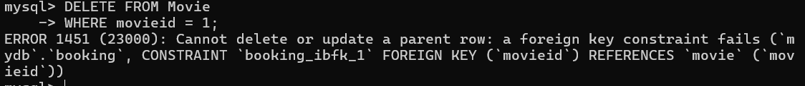

Screenshot 2026-09-26 015331.png

Screenshot 16
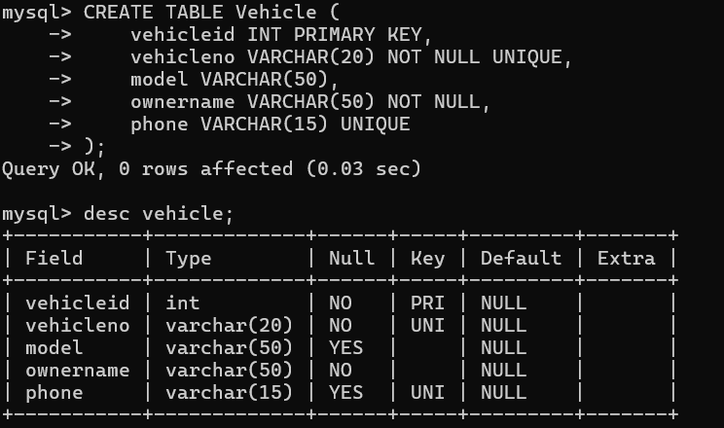

Screenshot 17
Screenshot 2026-09-26 015412.png

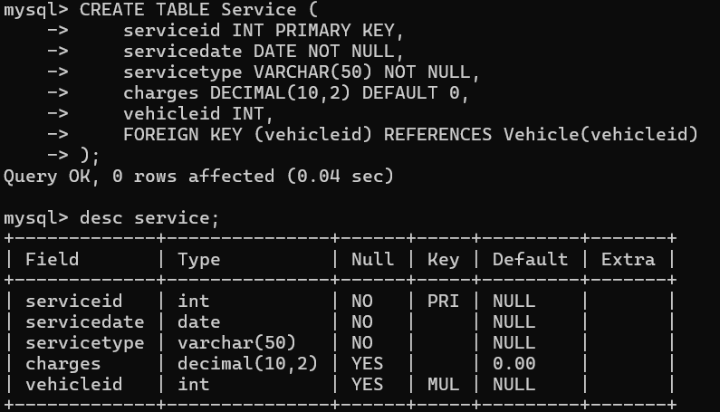

Screenshot 2026-09-26 015439.png

Screenshot 18
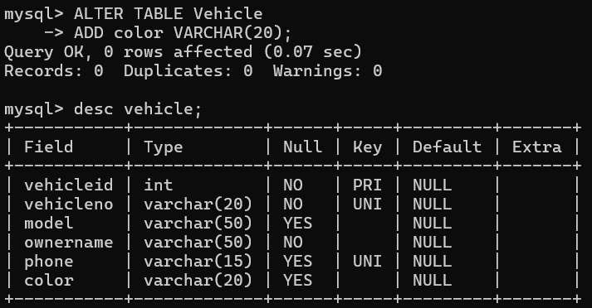

Screenshot 2026-09-26 015510.png

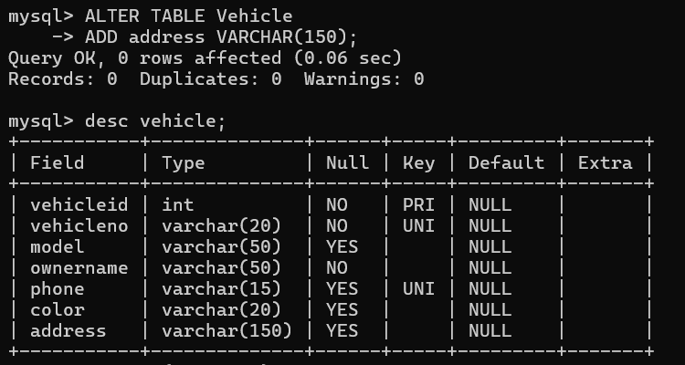

Screenshot 2026-09-26 015531.png

Screenshot 20
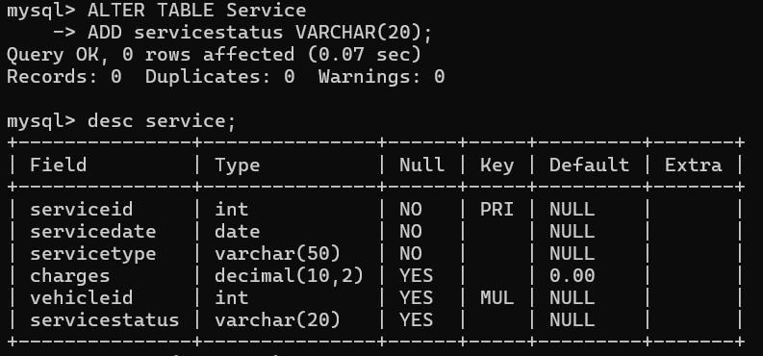

Screenshot 21
Screenshot 2026-09-26 015600.png

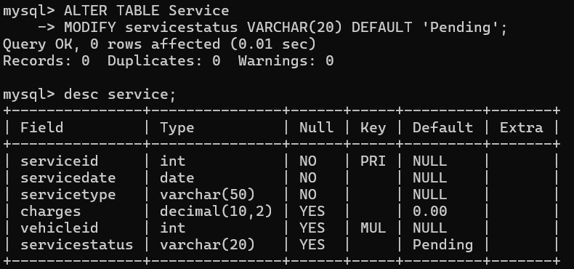

Screenshot 2026-09-26 015621.png

Screenshot 22
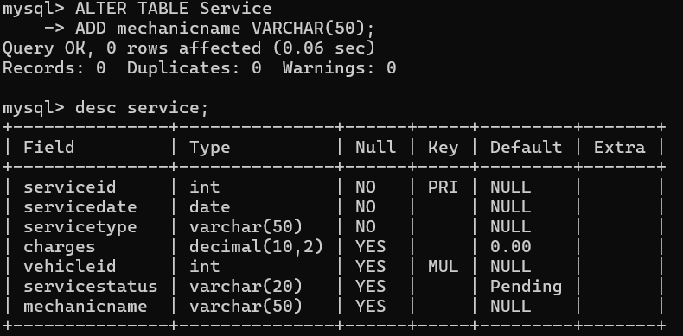

Screenshot 2026-09-26 015650.png

Question 3 – Vehicle Service Center
Vehicle and Service tables, CREATE/ALTER/INSERT/UPDATE/DELETE operations, default values, ownername size modification, and foreign-key behavior.

Screenshot 1
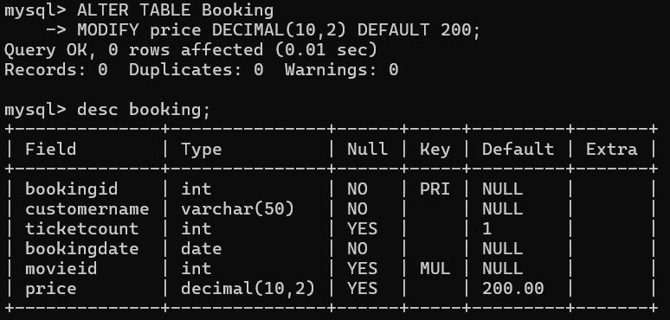

Screenshot 2
Screenshot 2026-09-26 013645.png

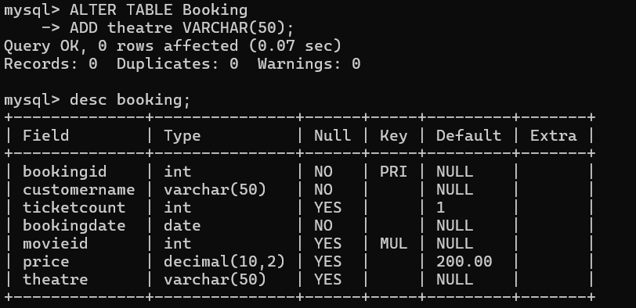

Screenshot 2026-09-26 013712.png

Screenshot 3

Screenshot 4
Screenshot 2026-09-26 013756.png

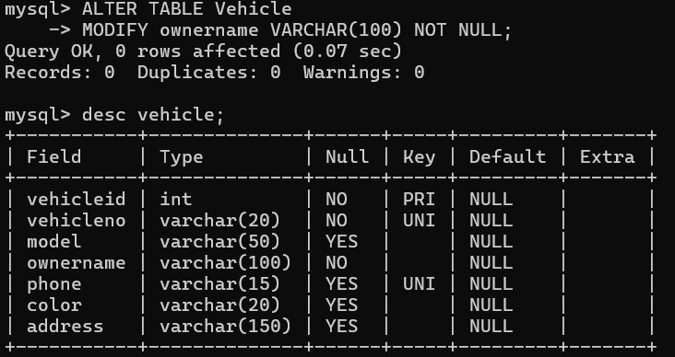

Screenshot 2026-09-26 015720.png

Screenshot 5
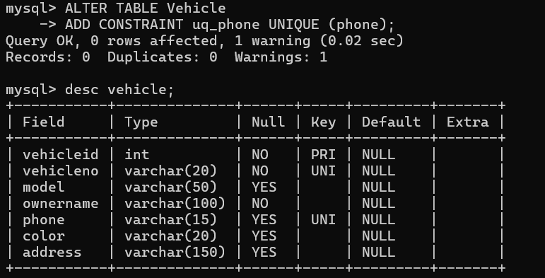

Screenshot 6
Screenshot 2026-09-26 015827.png

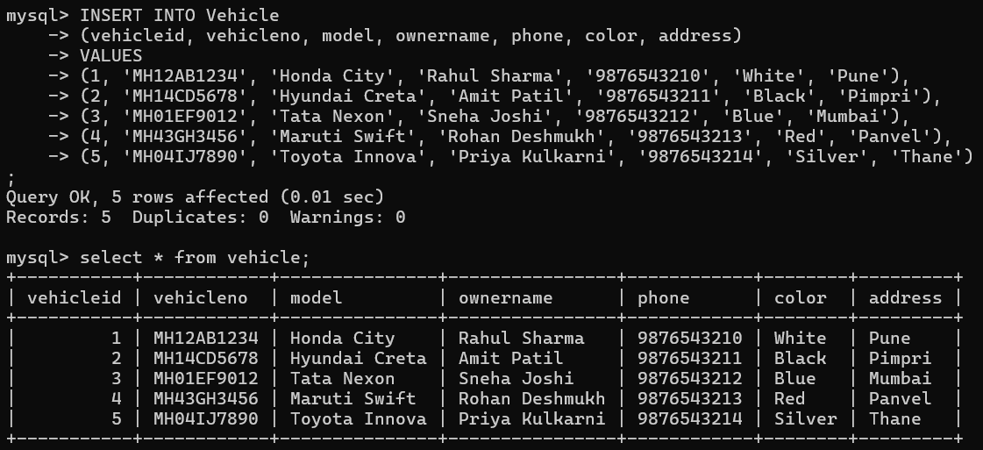

Screenshot 2026-09-26 015859.png

Screenshot 7
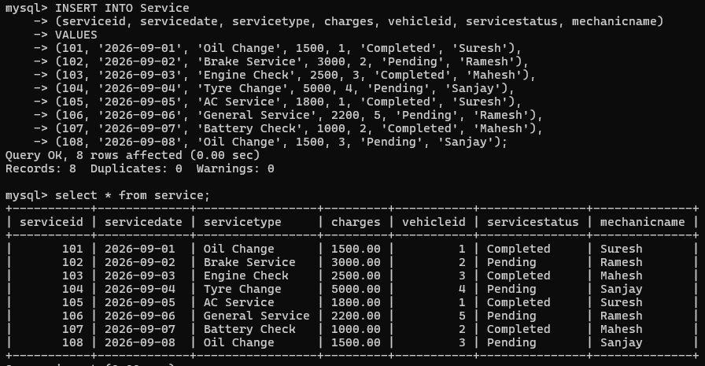

Screenshot 8
Screenshot 2026-09-26 015930.png

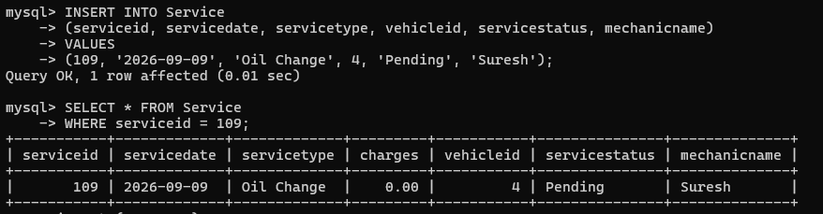

Screenshot 9
Screenshot 2026-09-26 015956.png

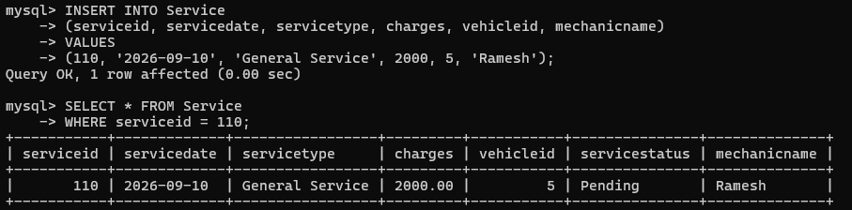

Screenshot 2026-09-26 020030.png

Screenshot 10
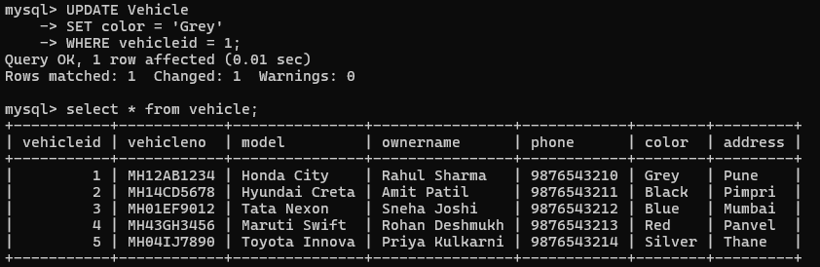

Screenshot 11
Screenshot 2026-09-26 020104.png

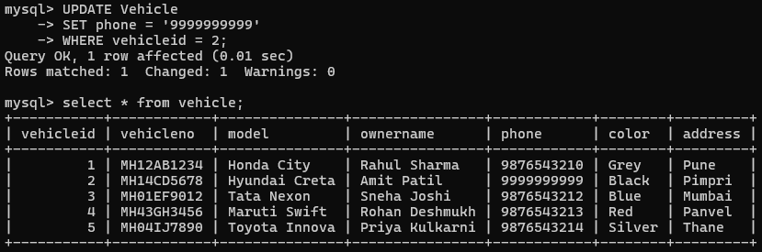

Screenshot 12
Screenshot 2026-09-26 020126.png

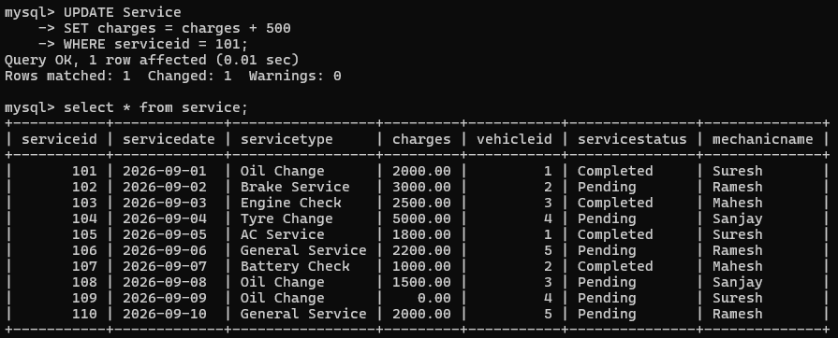

Screenshot 2026-09-26 020158.png

Screenshot 13
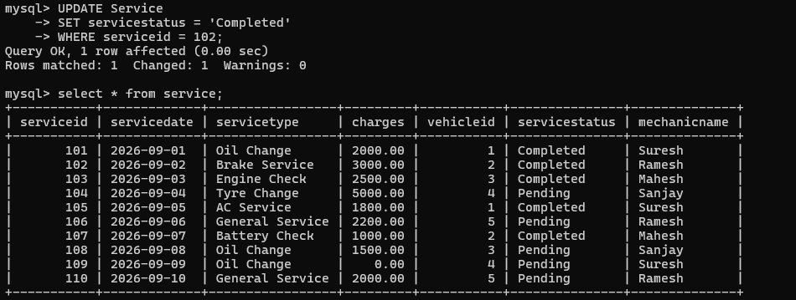

Screenshot 14
Screenshot 2026-09-26 020220.png

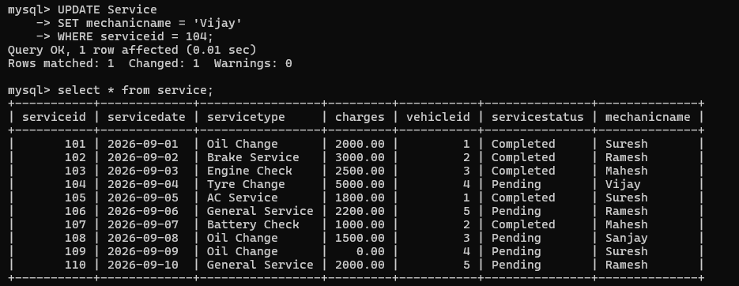

Screenshot 15
Screenshot 2026-09-26 020243.png

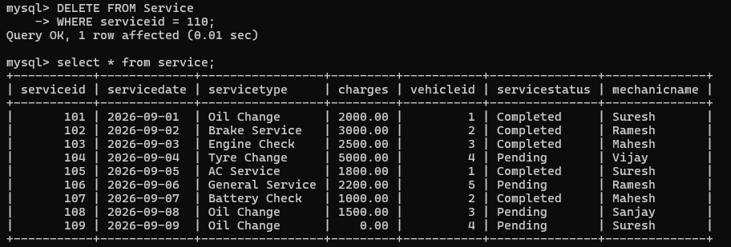

Screenshot 2026-09-26 020316.png

ASSIGNMENT 04 (day 04)

Question-wise SQL Query Outputs

Question 1: Find customer names for the “Aundh” branch.
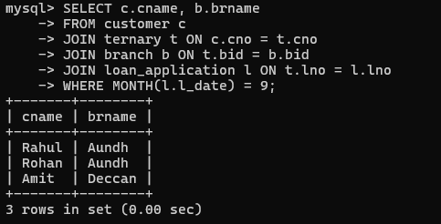

Question 2: Find customers who received a loan less than the required amount.
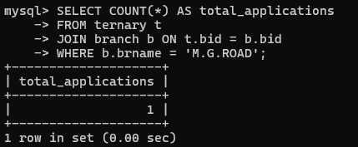

Question 3: Find the maximum approved loan amount.
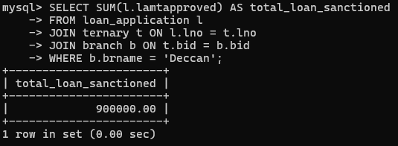

Question 4: Find the total loan amount sanctioned by “Deccan”.
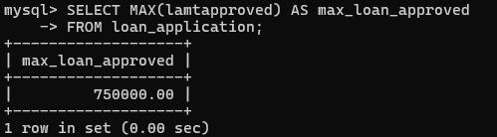

Question 5: Count the loan applications received by “M.G.ROAD”.
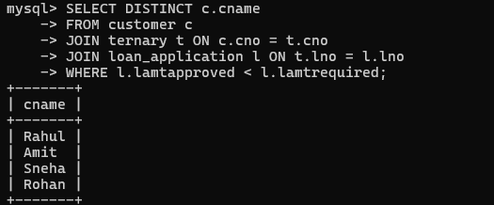

Question 6: Display customer names and branch names for loans applied in September.
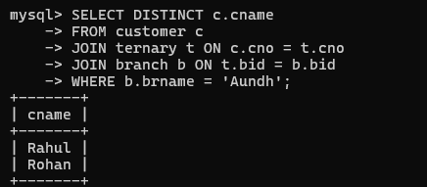

Assignment 5 (day 05)
- To find all managers with salary >1500
Query-
select * from emp where sal>1500 and job='manager';

Output-
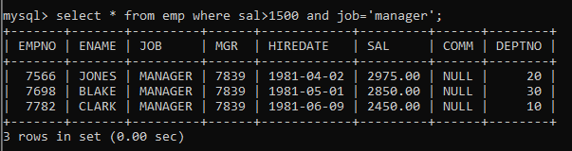

- list all employees with sal >1200 and < 2000
Query-
select * from emp where sal between 1200 and 2000;

Output-
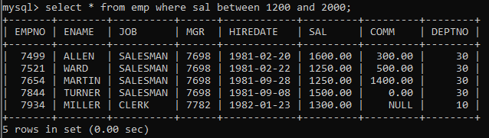

- list all employees with sal is 1600 or sal is 800 or sal is 1900
Query-
select * from emp where sal in(800,1600,1900);

Output-
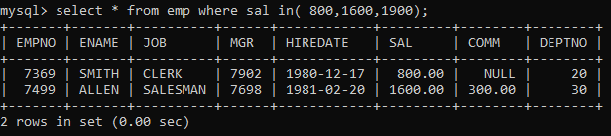

- list all employees with ‘R’ at second last position in name
Output-
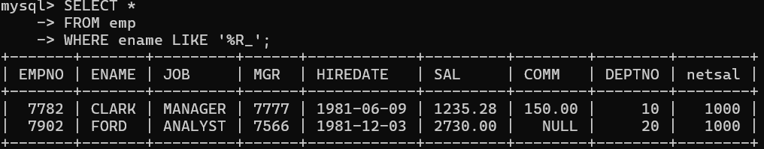

- List all employees with name starts with A and ends with N
Query-
select * from emp where ename regexp '^a.*n$';

Output-
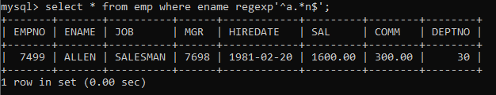

Q2. Solve the following
- list all employees with salary > 1250 and dept no=30
Output-
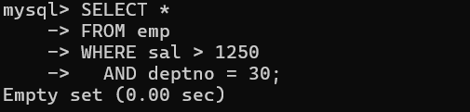

- list all employees with salary >=1250 and <= 3000
Query-
select * from emp where sal between 1250 and 3000;

Output-
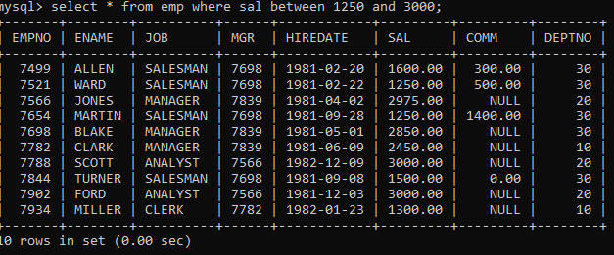

- list all employees with salary >1250 and < 3000
Output-
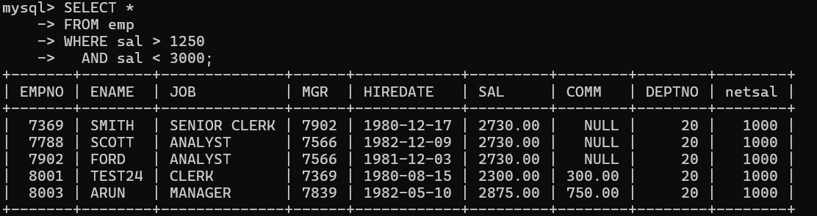

- list all employees with salary either equal to 3000 or 1250 or 2500
Query-
select * from emp where sal in(3000,1250,2500);

Output-
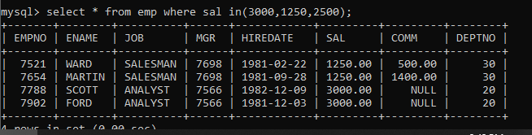

- list all employee with name=SMITH
Output-
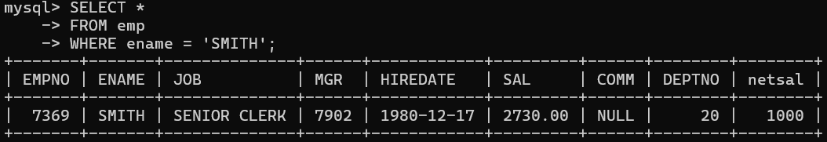

- list all employees with name starting with S
Query-
select * from emp where ename regexp '^s';

Output-
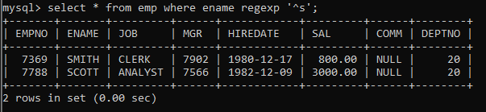

- list all employees with name ending with S
Query-
select * from emp where ename regexp 's$';

Output-
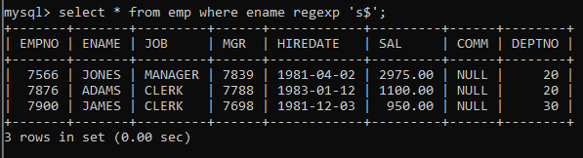

- list all employees with name contains I at 2nd position
Query-
select * from emp where ename regexp '^.I';

Output-

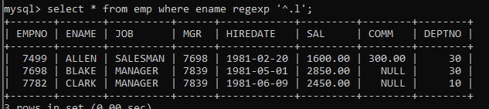

- list all employees with name starts with A ends with N and somewhere in between L is there
Query-
select * from emp where ename regexp '^a.*l.*n$';

Output-
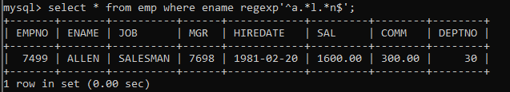

- list all employees with name starts with A and B at 3 rd position and P at second last position
Output-
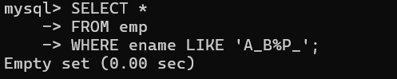

- List all employees with name starts with either A or starts with S or starts with W
Query-
select * from emp where ename regexp '^[a s w]';

Output-
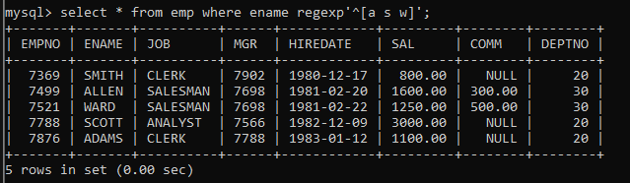

- find max sal and min sal for each job
Query-
select job, max(sal),min(sal) from emp group by job;

Output-
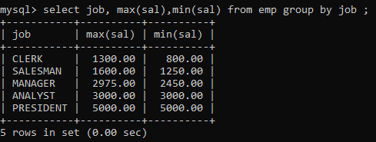

- find how many employess have not received commission
Query-
select * from emp where comm is NULL or comm=0;

Output-
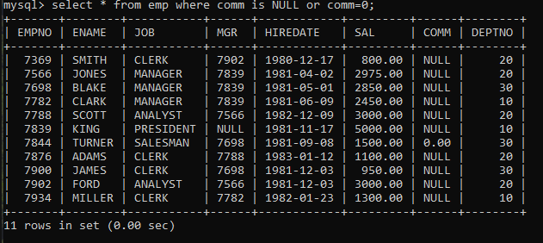

- find sum of sal of all employees working in dept no 10
Query-
select deptno,sum(sal) from emp where deptno=10;

Output-
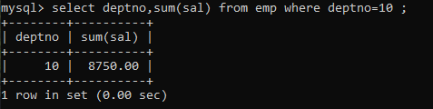

- find maximum salary,average sal for each job in every department
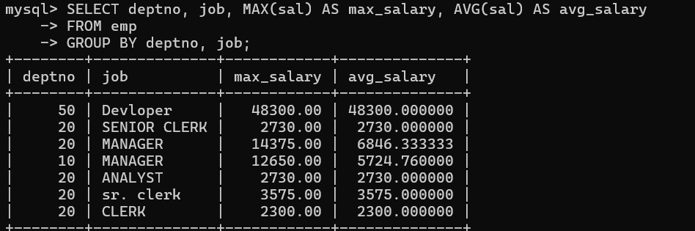
Outp

- find max salary for every department if deptno is > 15 and arrange data in deptno order.
Output-
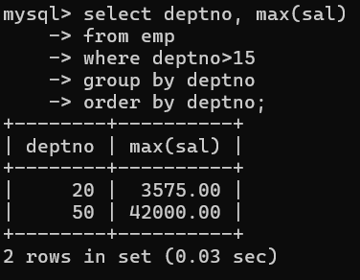

- find sum salary for every department if sum is > 2000
Query-
select deptno,sum(sal) from emp group by deptno having sum(sal)>2000;

Output-
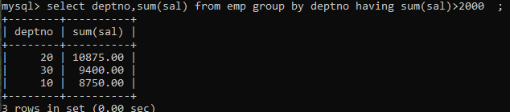

- list all department which has minimum 5 employees
Query-
select deptno,count(*) from emp group by deptno having count(*) >5;

Output-
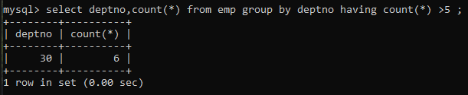

- count how many employees earn salary more than 2000 in each job
Query-
select job,count(*) from emp where sal>2000 group by job;

Output-

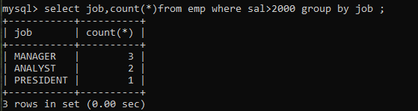

- list all enames and jobs in small case letter
Query-
Select lower(job),lower(ename) from emp;

Output-
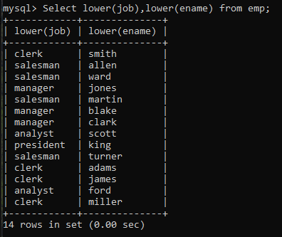

- list all names and jobs so that the length of name should be 15 if it is smaller then add spaces to left
Query-
select lpad(ename,15," "),job from emp;

Output-
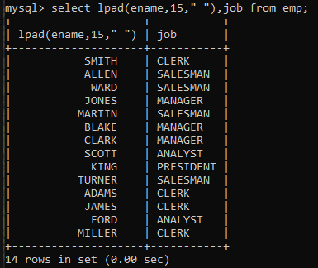

- display min sal,max sal, average sal for all employees working under same manager
Output-
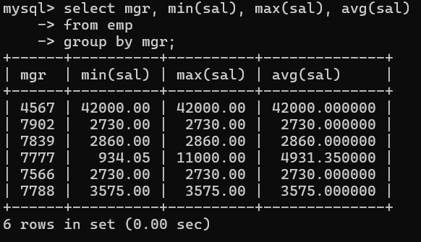

- find sum of total earnings(sal+comm), average of sal+comm, for all employees who earn sal > 2000 and work in either dept no 10 or 20
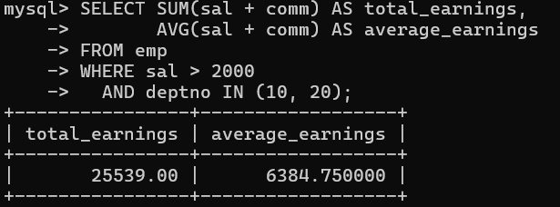
Output-

- list all employees who joined in Aug 1980 and salary is >1500 and < 2500
Output-
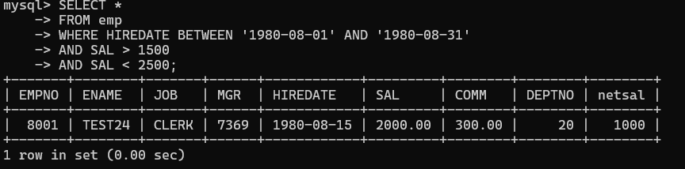

- list all employees joined in either aug or may or dec
Output-
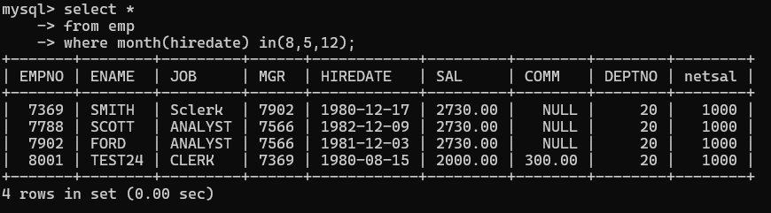

- ‘display name and hiredate in dd/mm/yy format for all employees whose job is clerk and they earn some commission
Output-
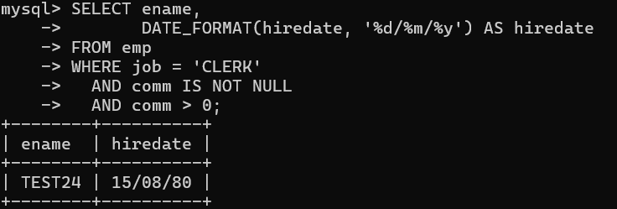

- list empcode,empno,name and job for each employee. (note :empcode is 3 to 5 characters from name and last 2 characters of job)
Output-
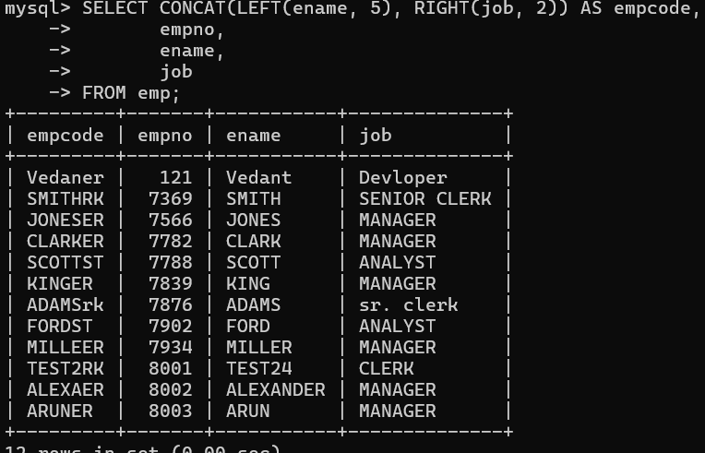

- display thousand separator and $ symbol for sal and commission if comm is null then display it as 0, for all employees whose name starts with A and ends with N
Output-

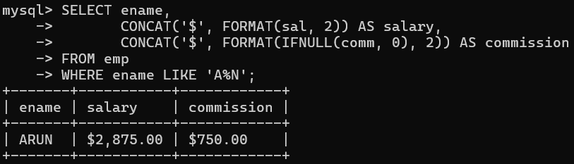

- Display empid,name,sal,comm,remark Remark should base on following conditions: comm >= 600 "excellent Keep it up"; if it < 600 or not null "good"; otherwise "Need improvement"
Output-
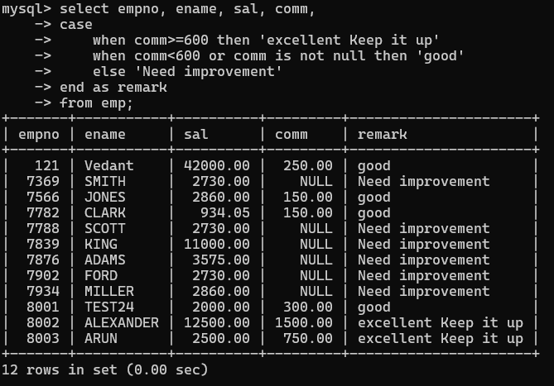

- Display empid, name, deptno and department name by using following conditions. dept 10 then "Hr"; if 20 then "Admin"; if 30 then "accounts"; otherwise purchase
Output-
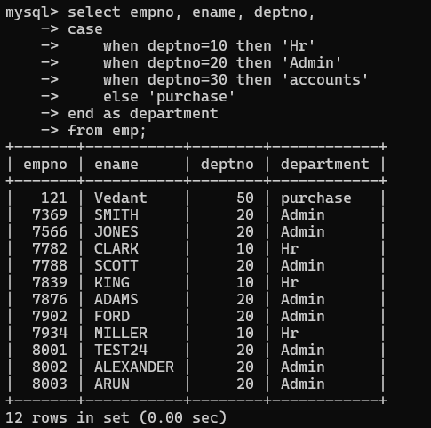

Topic — Create Table, DML, Subquery and Joins — Q31 to Q57
- Practice creating the following tables: create table mydept_DBDA and insert 5 rows into it. Deptid Primary key number; Dname Not null string; Dloc string.
Output-
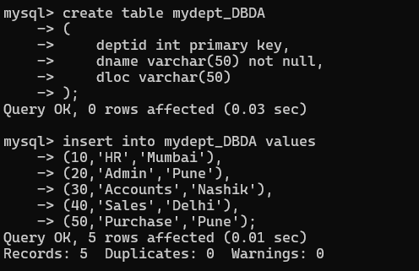

- Create myemployee table: Empno Primary key int; fname Not null string; Lname string; mname string; Sal
>1000 Float(9,2); Doj Date; Passportnum Unique String; Deptno foreign key references dept(deptno).
Output-
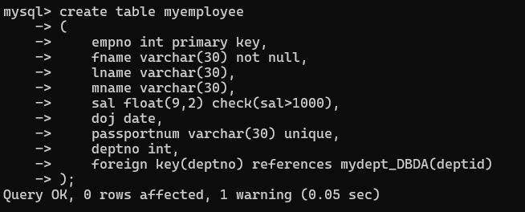

- Create empty table emp10 with table structure same as emp table.
Output-
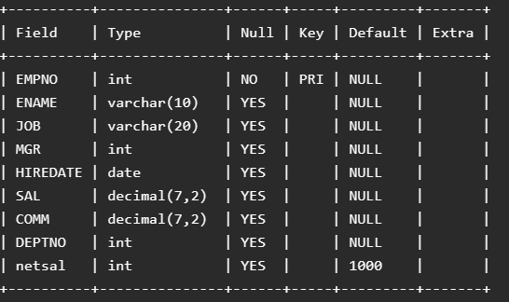

- Solve using alter table: (a) add primary key constraint in emp table deptno column references dept table deptno; (b) add new column in emp table netsal with constraint default 1000.
Output-
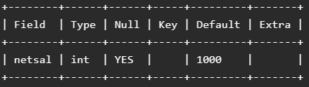
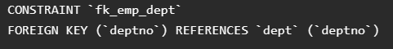

- Increase sal of each employee by 15% sal+comm, change the job to manager and mgr to 7777 for all employees in deptno 10.
Output-
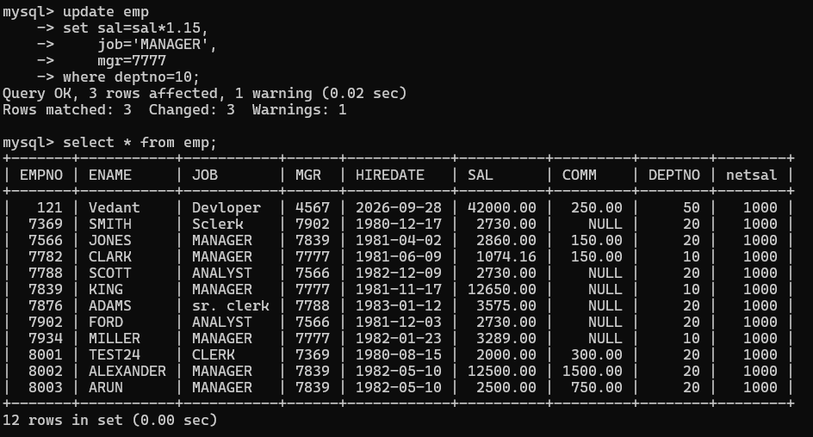

- Change job of smith to senior clerk.
Output-
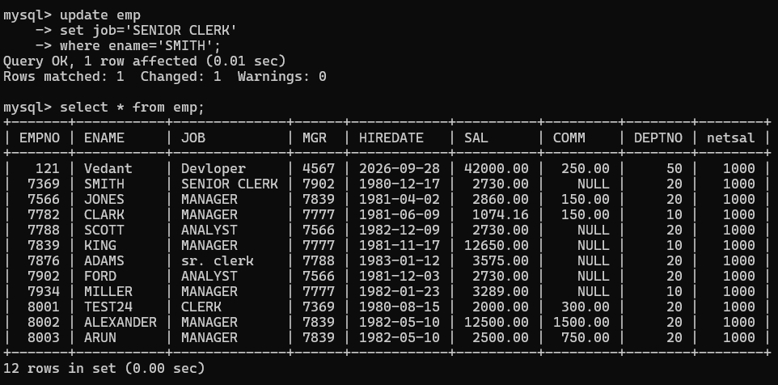

- Increase salary of all employees by 15% if they are earning some commission.
Output-
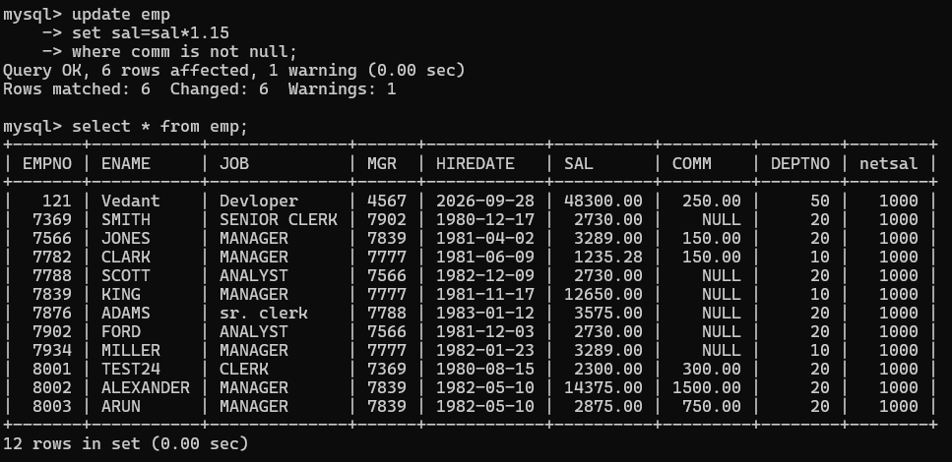

- List all employees with sal > Smith's sal.
Output-
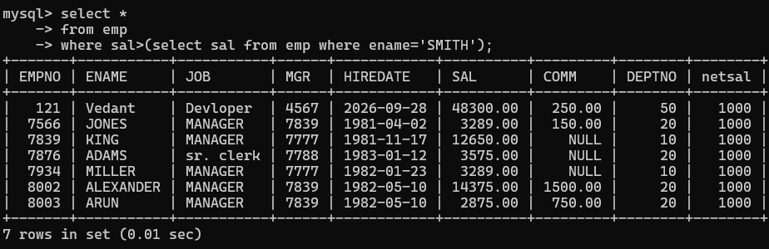

- List all employees who are working in Smith's department.
Output-
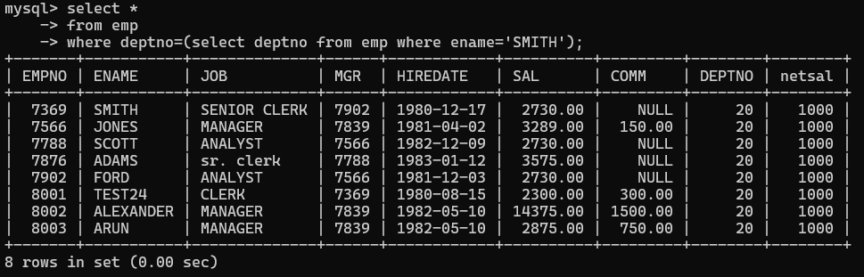

- List all employees with sal < Smith’s sal and salary > Blake’s sal.
Output-
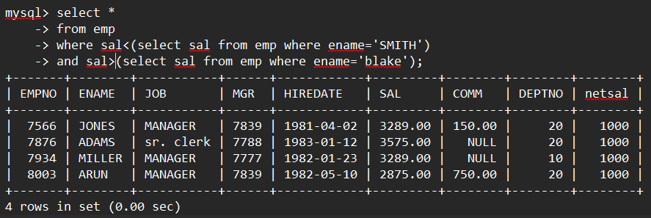

- Delete all employees working in Alan's department.
Output-
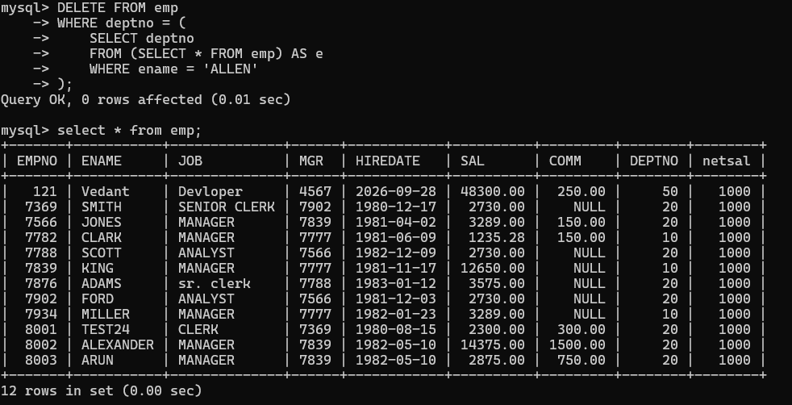

- Change salary of Alan to the salary of Miller.
Output-
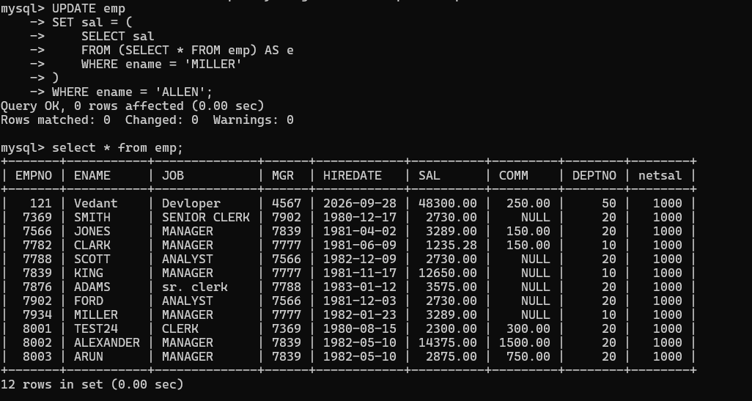

- Change salary of all employees who are working in Wall's department to the salary of Miller.
Output-
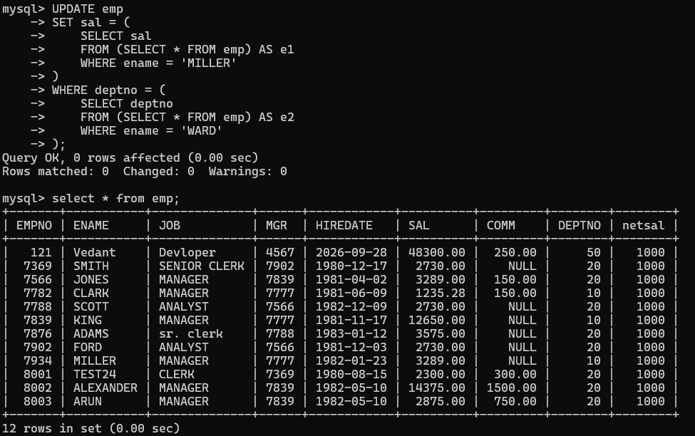

- List all employees with salary > either Smith's salary or Alan's sal.
Output-
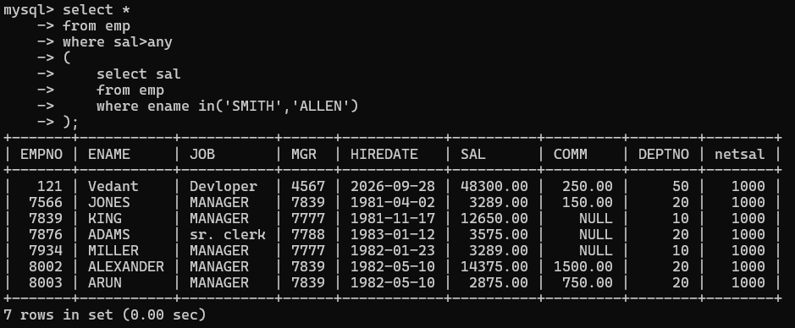

- List all employees who earn more than average sal of dept 10.
Output-
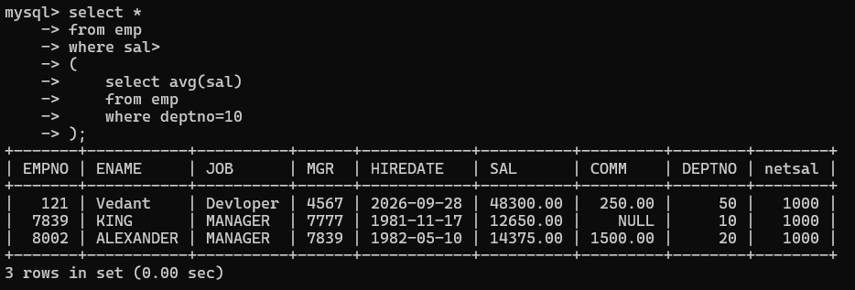

- List all employees who earn more than average sal of Alan's department.
Output-

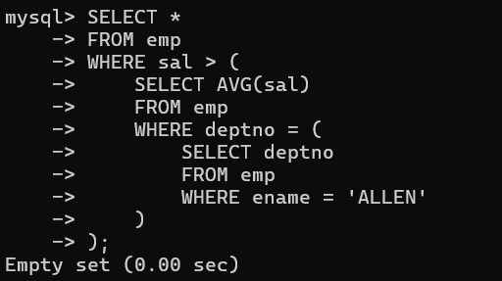

- List all employees who are working in purchase department.
Output-
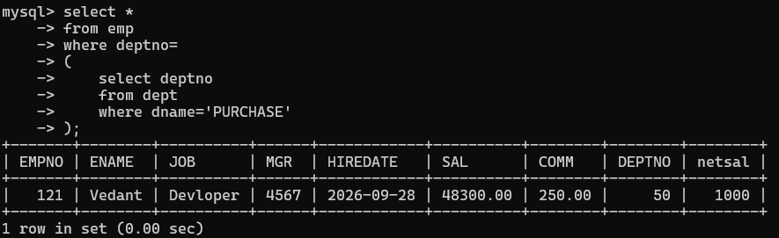

- List all employees who earn more than average salary of their own department.
Output-
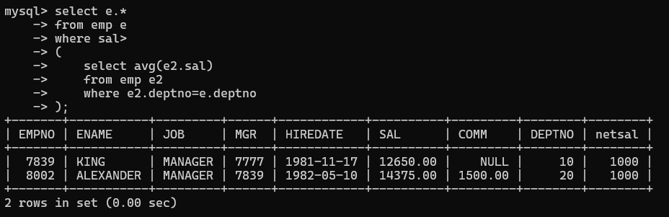

- List all employees who earn sal < than their managers salary.
Output-
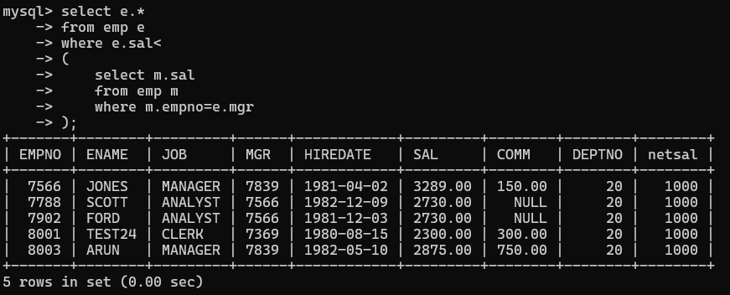

- List all employees who are earning more than average salary of their job.
Output-
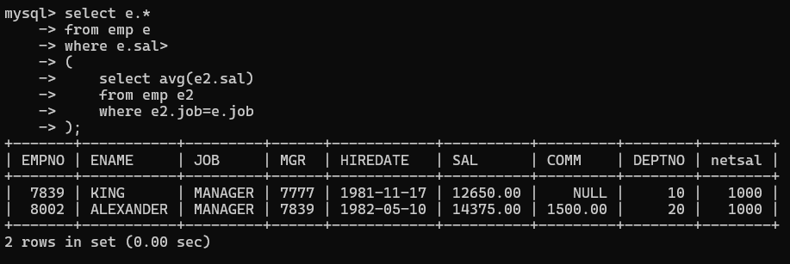

- Display employee name and department.
Output-
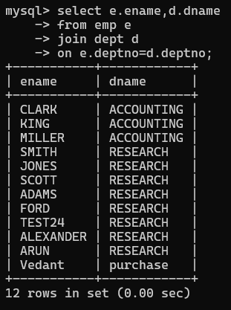

- Display empno, name, department name and grade (use emp, dept and salgrade table).
Output-
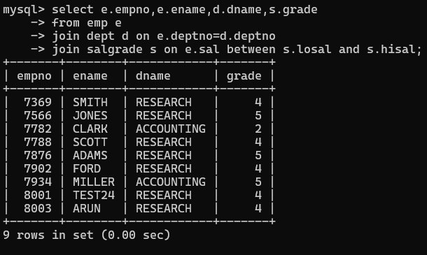

- List all employees number, name, mgrno and manager name.
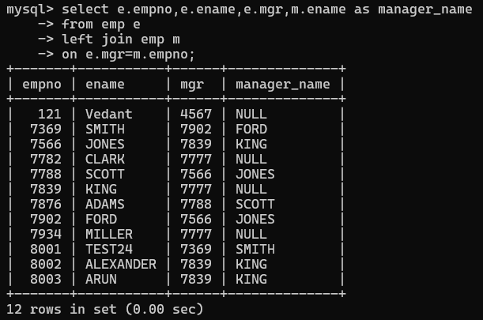
Output-

- Create the following tables and solve the following questions: product(pid,pname,price,qty,cid,sid); salesman(sid,sname,address); category(cid,cnam,descritpion).
Output-
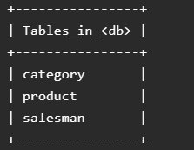

- List all product name, their category name and name of a person, who sold that product.
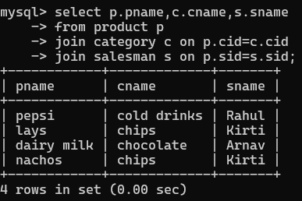
Output-

- List all product name and salesman name for all salesman who stays in Pune.
Output-
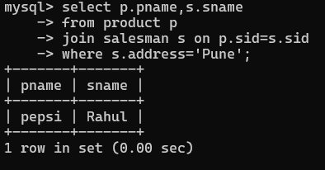

- List all product name and category name.
Output-
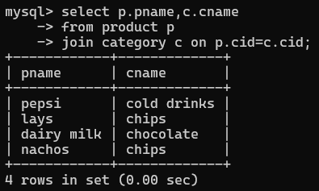

Q58 / Faculty-Course-Room and Product-Salesman-Category

- Create the following tables and solve the following questions: faculty(fid,fname,sp.skill1,sp.skill2); courses(cid,cname,rid,fid); room(roomid,rname,rloc). Given sample faculty, courses and room data are in the assignment.
Output-
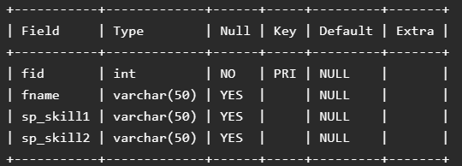
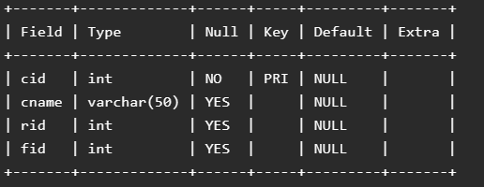
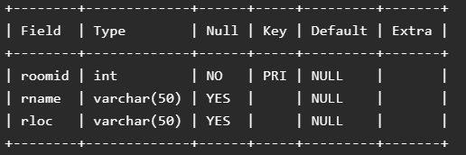

- List all courses for which no room is assigned and all rooms for which are available.
Output-
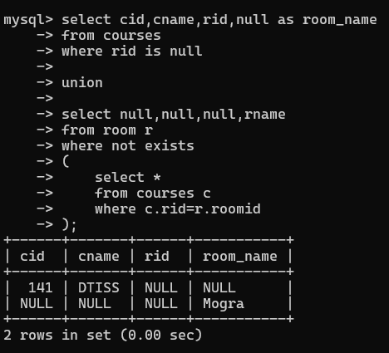

- List all faculties who are not allocated to any course and rooms which are not allocated to any course.
Output-
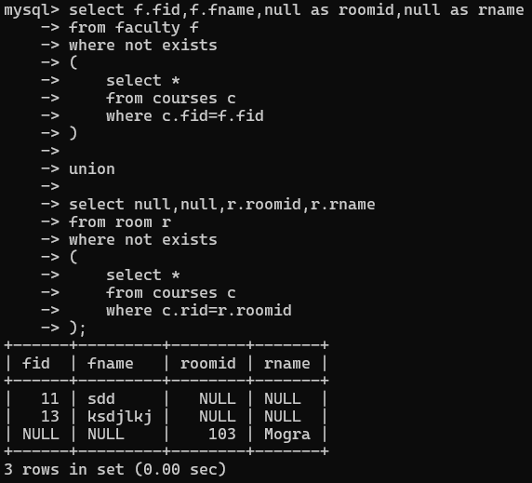

- List all rooms which are allocated or not allocated to any courses.
Output-
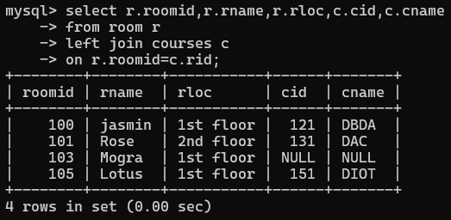

- List all rooms which are not allocated to any courses.
Output-
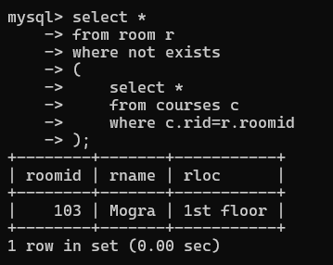

- Display courses and faculty assigned to those courses whose special skill is database.
Output-
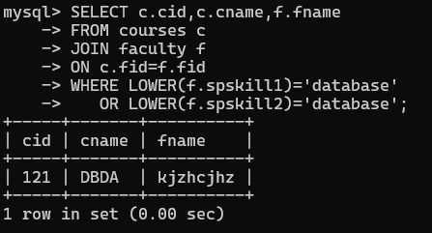

- Display course id, course name, faculty name and special courses and room name and room location.
Output-
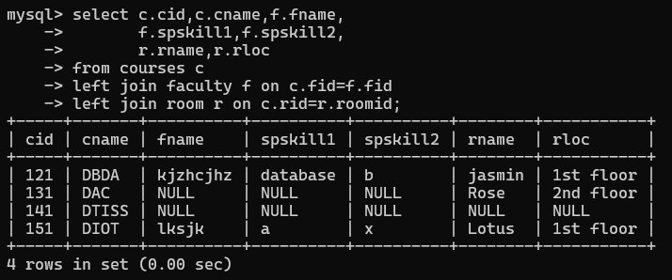

- Create the following tables with given constraints: product — qty >0, default 20.00, pname not null and unique; salesman — sname not null; category — cname unique and not null. Use the sample data provided in
the assignment.
Output-
CREATE TABLE category (cid INT PRIMARY KEY, cname VARCHAR(50) NOT NULL UNIQUE,description VARCHAR(100)); CREATE TABLE salesman (sid INT PRIMARY KEY,sname VARCHAR(50) NOT NULL,address VARCHAR(100));
CREATE TABLE product (pid INT PRIMARY KEY,pname VARCHAR(50) NOT NULL UNIQUE,price DECIMAL(10,2),qty DECIMAL(10,2) DEFAULT 20.00,cid INT,sid INT,CHECK (qty > 0));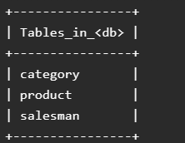

- List all products with category chips.
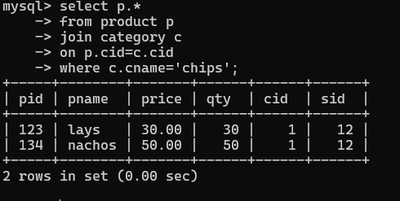
Output

- Display all products sold by Kirti.
Output-
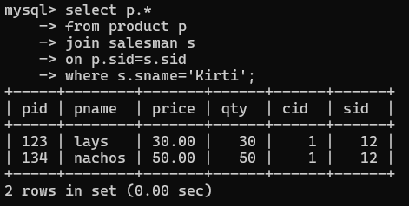

- Display all salesman who do not sold any product.
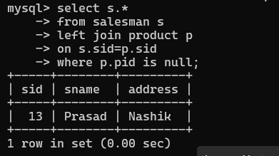
Output-

- Display all category for which no product is there.
Output-
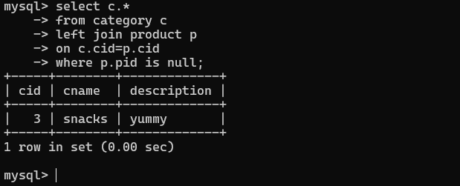

- Display all products with no category assigned.
Output-
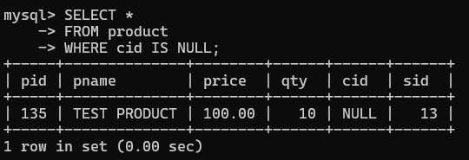

- List all salesman who stays in city with name starts with P or N.Output-
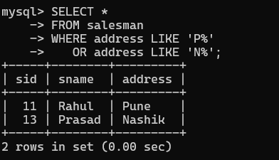

- Add new column in salesman table by name credit limit.
Output-
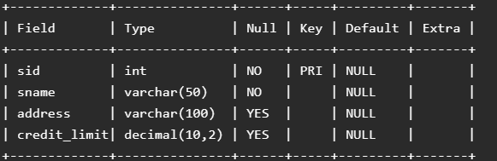

Assignment 6 (day 06)

SERVER – ADMIN – LOCATION QUERIES WITH OUTPUT

Display all server-name, location name of the server
Query-
select s.sname,l.address from server s,location l where s.locid=l.loc_id;
Output-
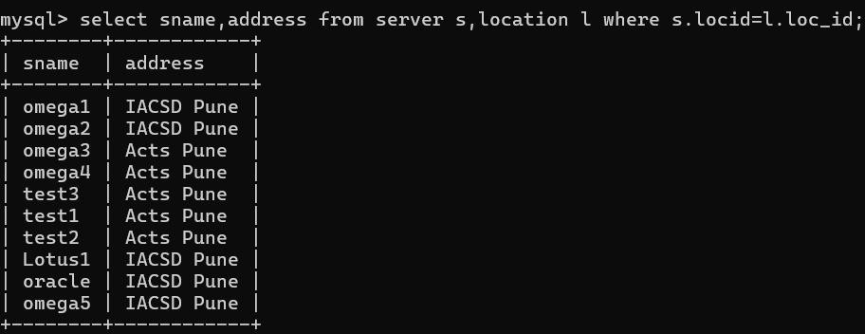

Display all server-name, admin-name, admin mobile
Query-
select sname,uname,mobile from server s left join admin a on s.adminid=a.adminid;
Output-
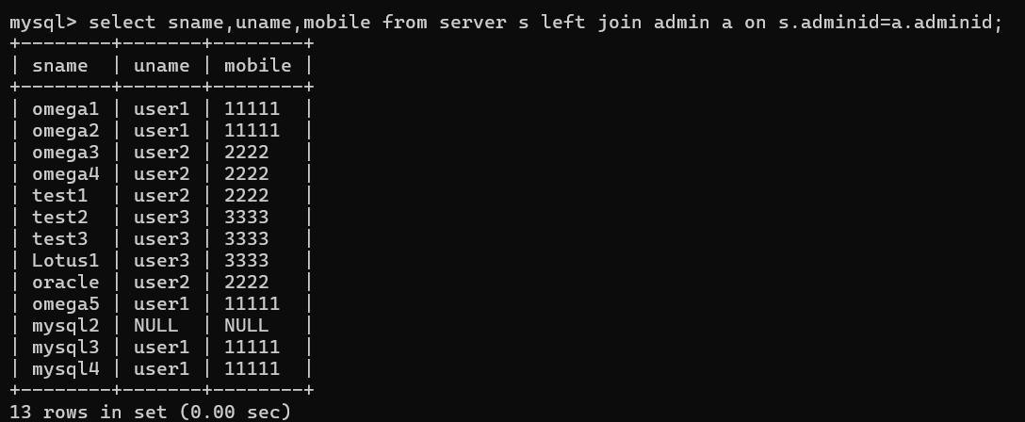

Display all server which are managed by admin Rohit
Query-
select sname,name,mobile from server s left join admin a on s.adminid=a.adminid where a.name="rohit";
Output-
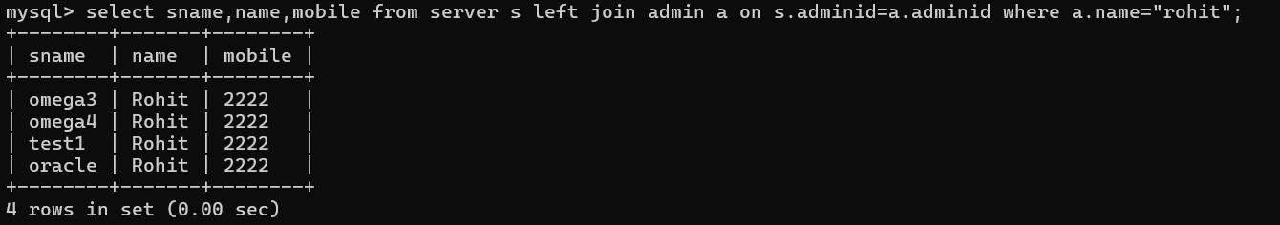

Display all server and the locations, for which admin is Rohit
Query-
select sname,address from server s left join location l on s.locid=l.loc_id inner join admin a on s.adminid=a.adminid where a.name="rohit";
Output-
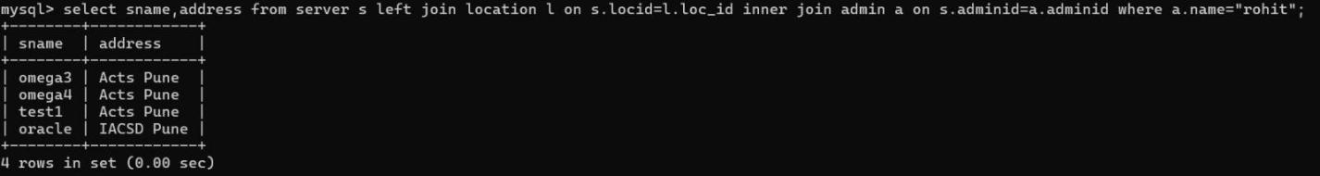

Display all admins, for whom no server is assigned
Query-
select name from admin a left join server s on s.adminid=a.adminid left join location l on s.locid=l.loc_id where s.serverid is null;
Output-
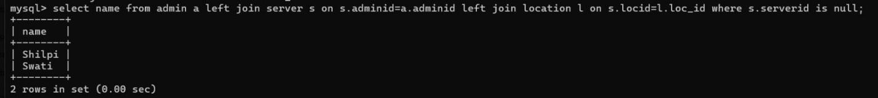

Display all servers and admin details, and also display admins for whom no server is assigned
Query-
select * from admin a left join server s on s.adminid=a.adminid where s.serverid is null;
Output-
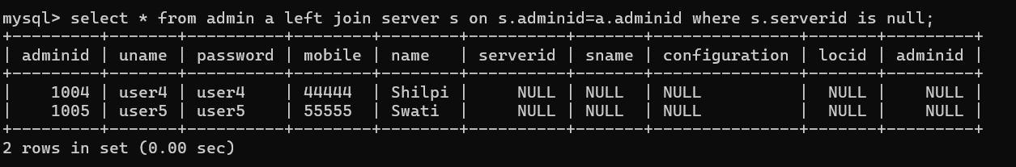

Display servers, admins and location of the server
Query-
select sname,name,address from server s left join admin a on a.adminid=s.adminid left join location l on s.locid=l.loc_id;
Output-
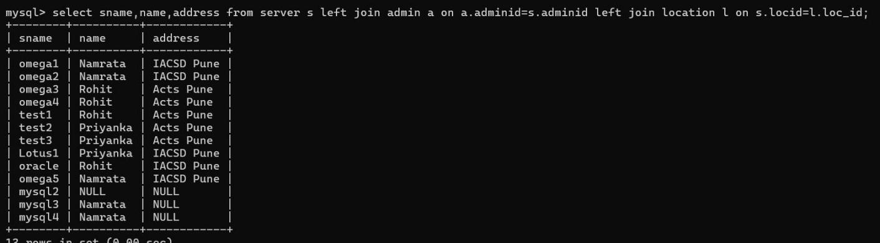

To display all admins for whom no server is assigned also display locations at which no server is placed
Query-
select serverid,sname,null adminid,null name from server where adminid is null
union
select null,null,adminid,name from admin a
where not exists(select * from server s where s.adminid=a.adminid);
Output-
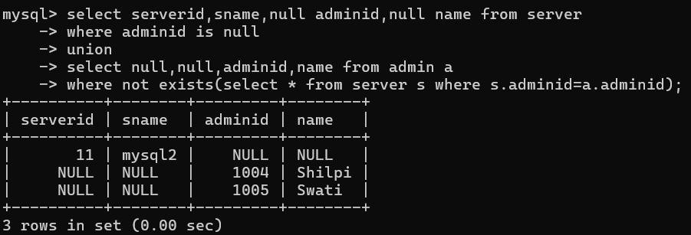

Display all servers for which no location is assigned
Query-
select * from server s left join location l on s.locid=l.loc_id where l.loc_id is null;
Output-
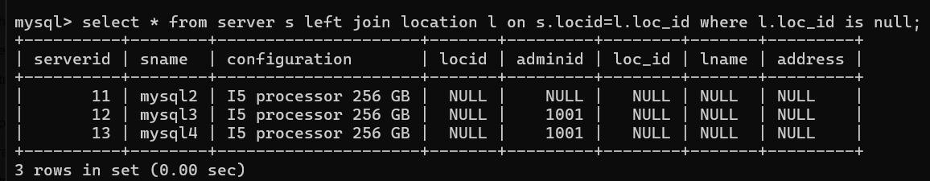

Display all servers, for which no location is assigned, whose admin is Namrata
Query-
select * from server s left join location l on s.locid=l.loc_id left join admin a on s.adminid=a.adminid where l.loc_id is null and a.name="namrata";
Output-
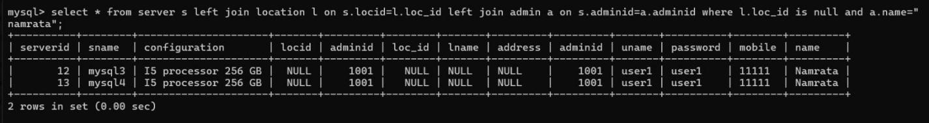

ASSIGNMENT 7 (DAY 07)

- Write a query to display the day and qty from the demand2 table along with the previous day's quantity using a window function.
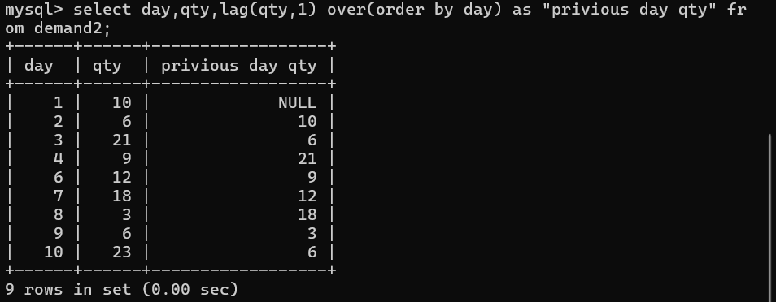

- Write a query to display the day, qty, and the next day's quantity using a window function.
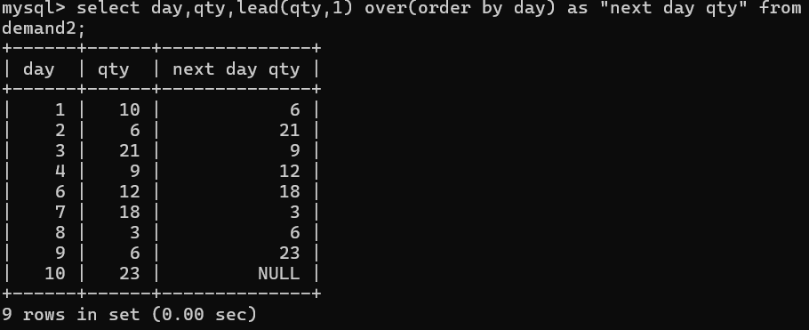

- Write a query to display the day, qty, and the difference between the current day's quantity and the previous day's quantity.
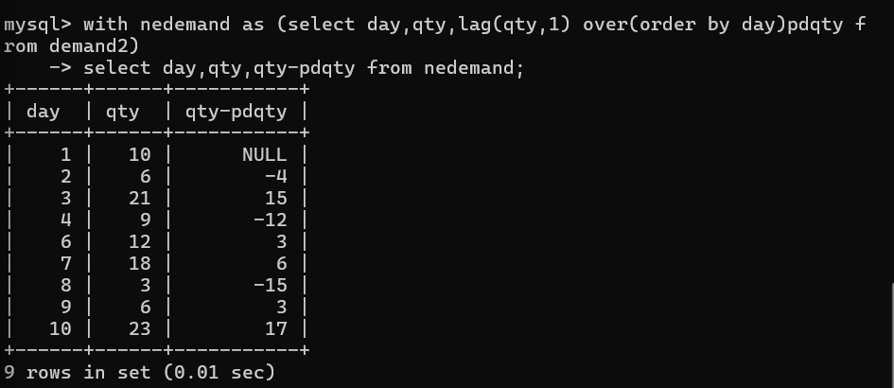

- Write a query to display the product, day, qty, and the previous day's quantity for each product using a window function.
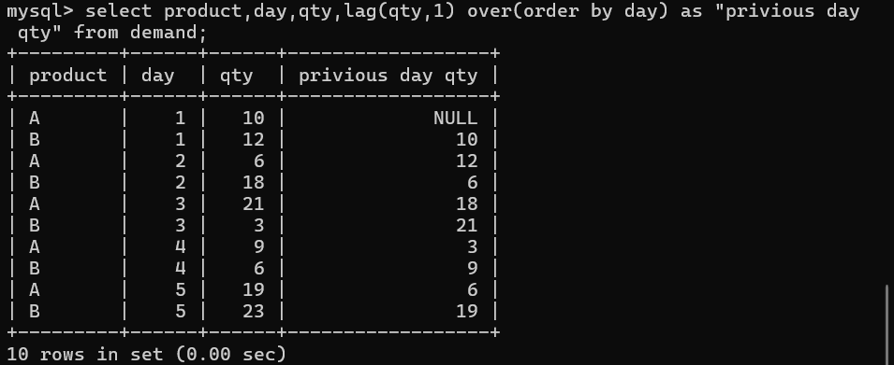

5.Write a query to display the product, day, qty, and the next day's quantity for each product.
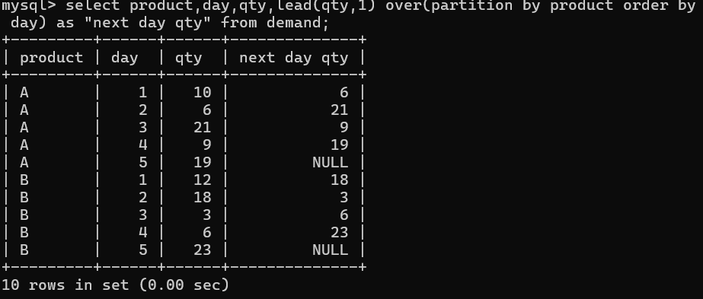
- Write a query to display the product, day, qty, and the difference between the current day's quantity and the previous day's quantity for each product
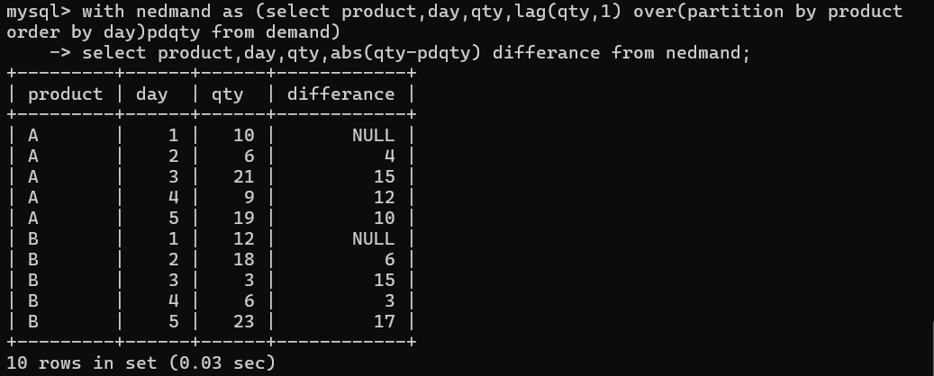
.
- Write a query to display the day, qty, and the cumulative sum of quantity using a window function.
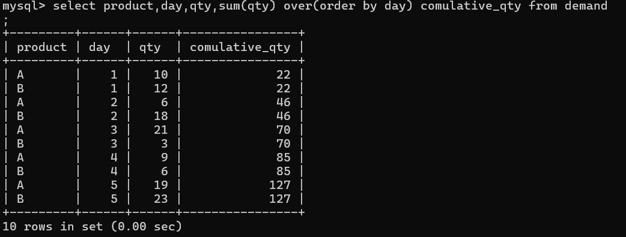

- Using the sales_data table, write a query to display product, location, sales, refunds, and net sales (sales - refunds).
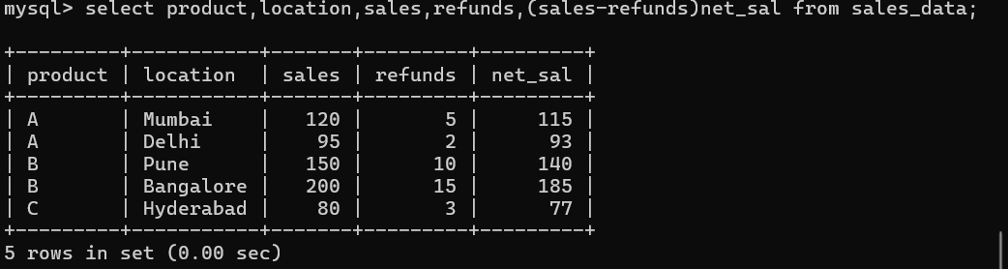

- Write a query to rank the products based on sales within each location using a window function.
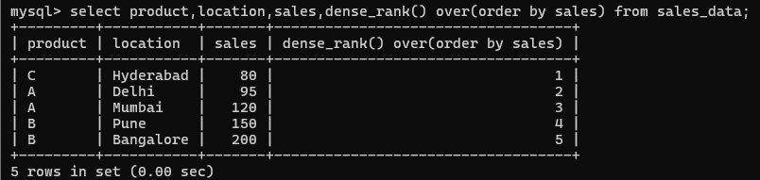

Write a query to calculate the total sales from the top 3 best-selling products in each location.
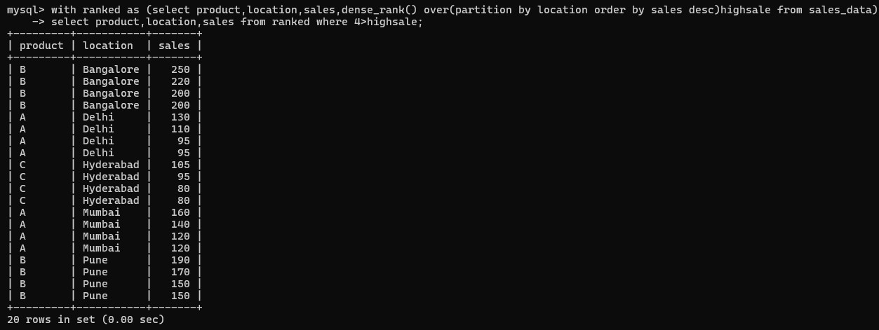
- Write a query to display each product's sales along with the total sales of its location using a window function.
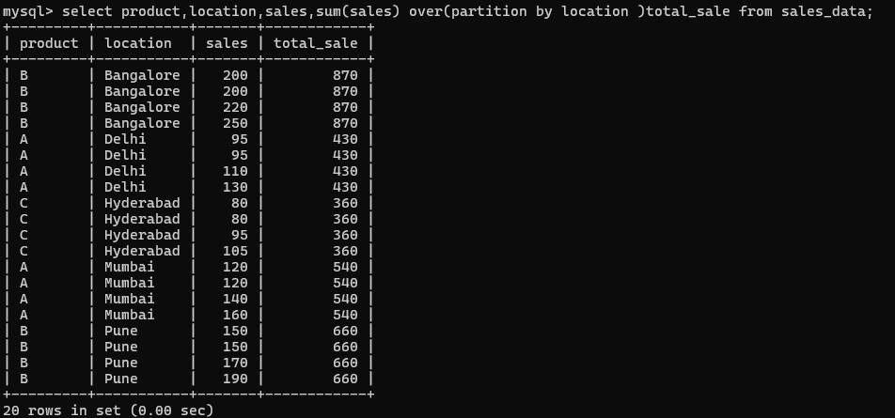

- Write a query to display each product's sales along with the percentage contribution of that product to the total sales of its location.
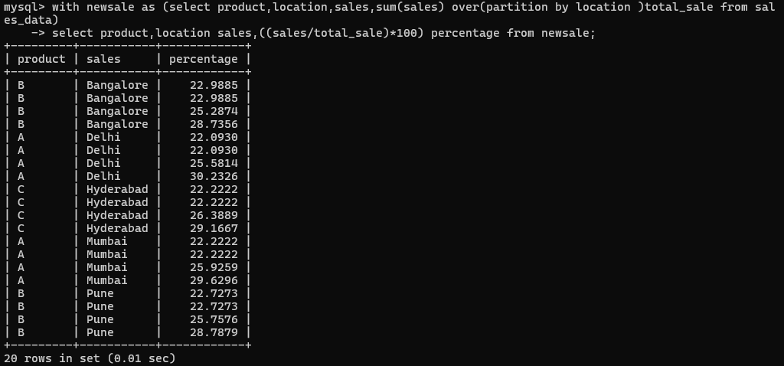

- Write a query to display the running total of sales for each location using a window function.
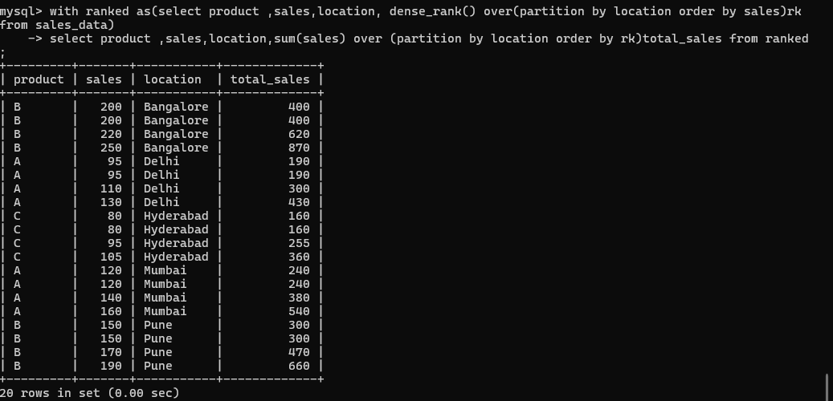

- Write a query to display each product's sales along with the previous product's sales within the same location.
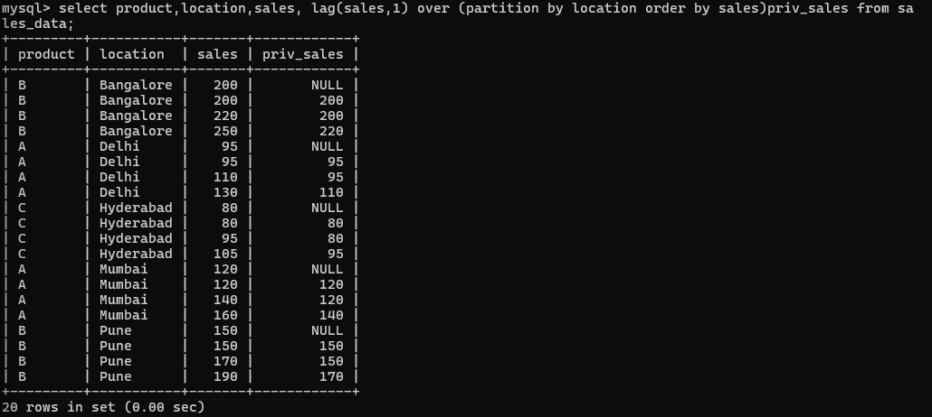

- Write a query to display each product's sales along with the difference between its sales and the previous product's sales within the same location.
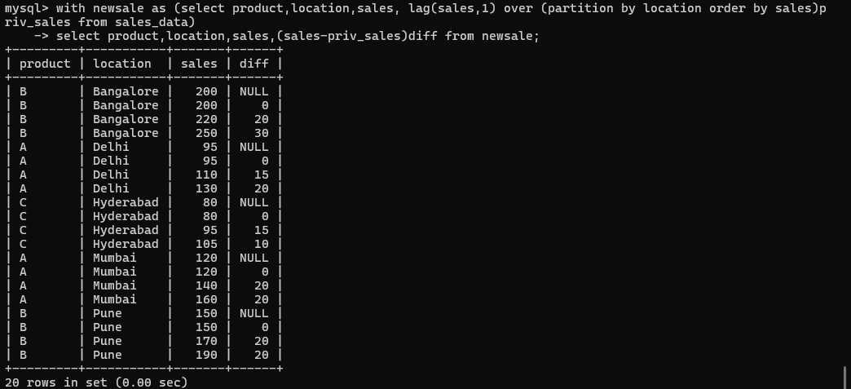

MYSQL PROCEDURES, FUNCTIONS, LOOPS & TRIGGERS ASSIGNMENT 8 (day 08)
  - Print the following pattern using loop:
*
**
***
****
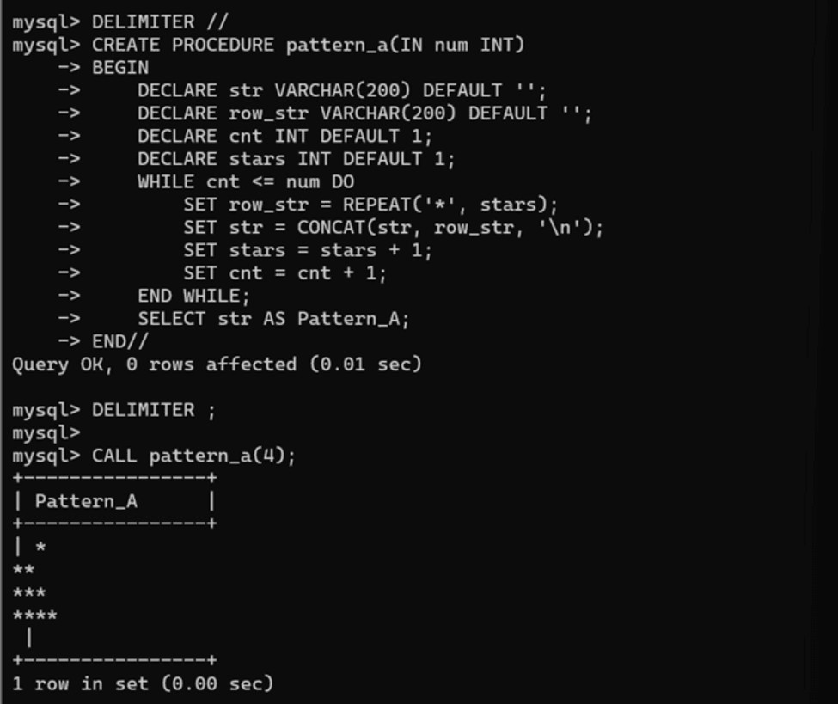
  - Print the following pattern using loop:
*
***
*****
***
*

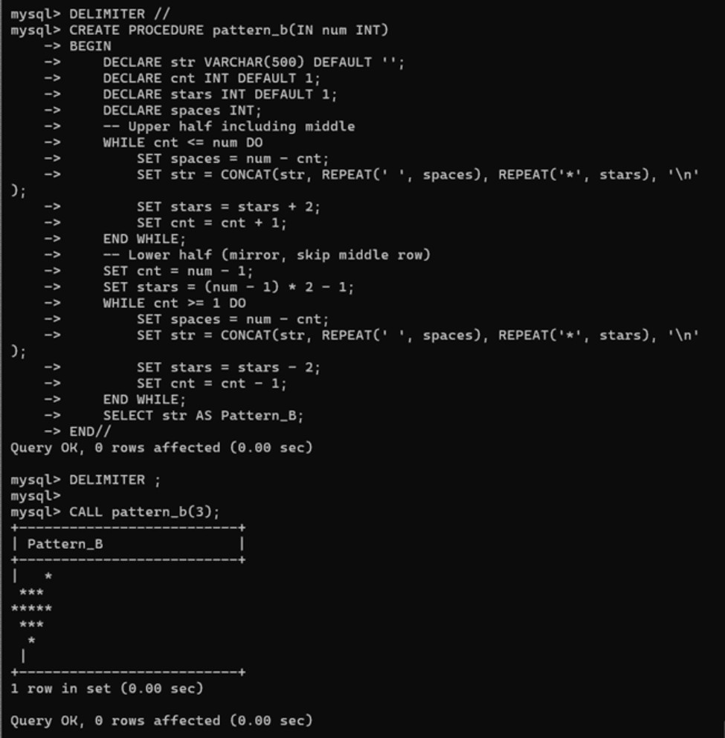

  - Print the following pattern using loop: 1010101
10101
101
1

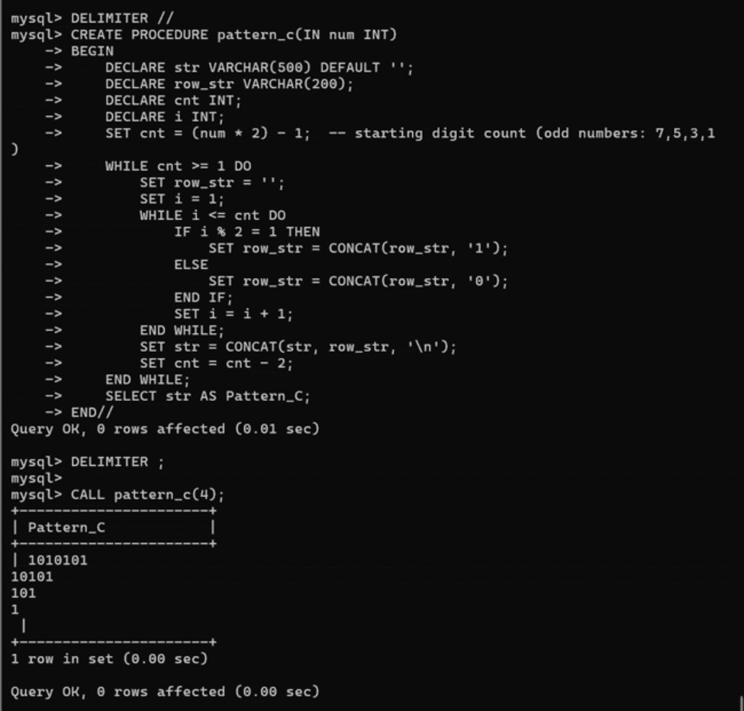
  - Print the following pattern using loop: 1
1 2
1 2 3
1 2 3 4
1 2 3 4 5

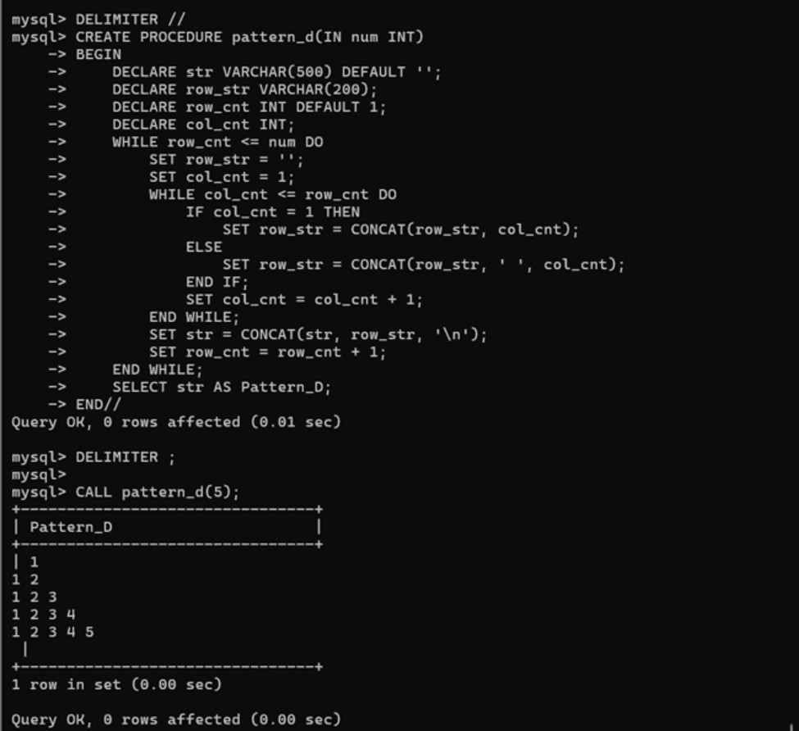

PROCEDURES
- Write a procedure to insert record into employee table. The procedure should accept empno, ename, sal, job, hiredate as input parameters. Write insert statement inside procedure insert_rec to add one record into table.

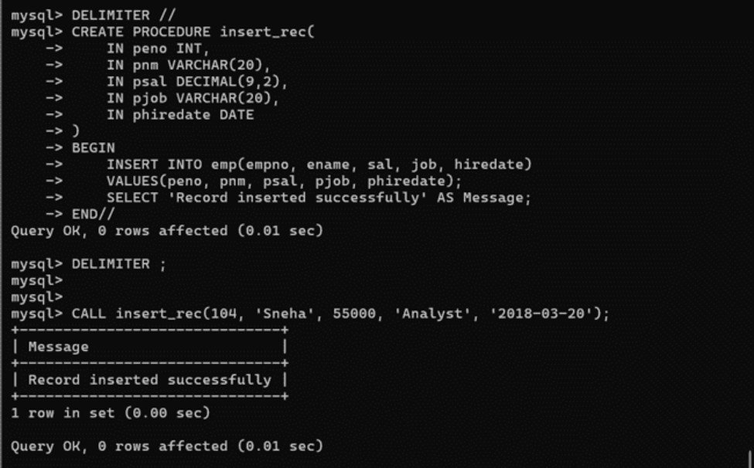
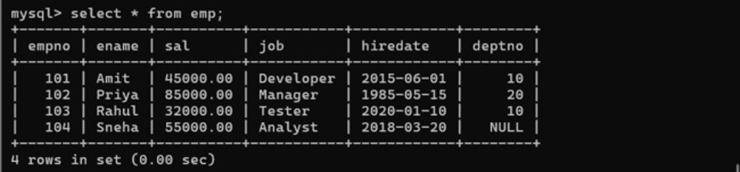
- Write a procedure to delete record from employee table. The procedure should accept empno as input parameter. Write delete statement inside procedure delete_emp to delete one record from emp table.

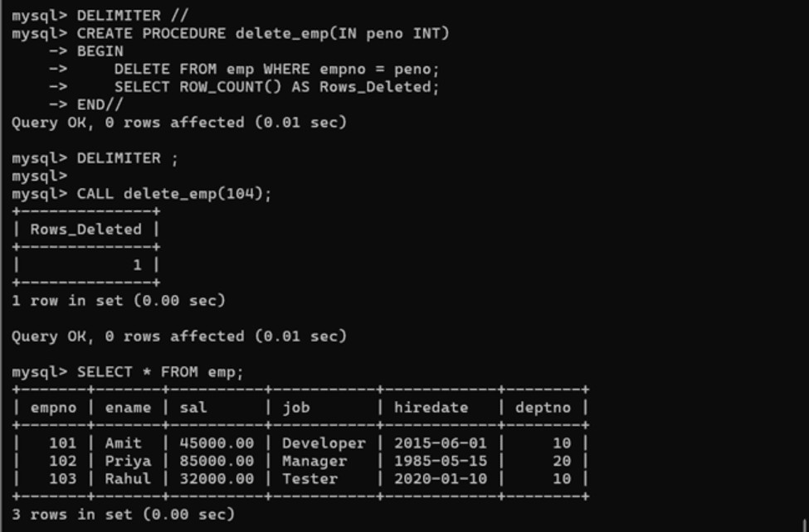
- Write a procedure to display empno, ename, deptno, dname for all employees with sal > given salary. Pass salary as a parameter to procedure.

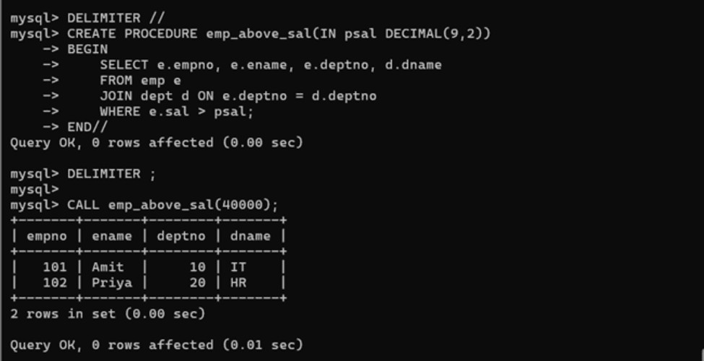
- Write a procedure to find min, max, avg of salary and number of employees in the given deptno. deptno → IN parameter; min, max, avg and count → OUT type parameters. Execute procedure and then display values min, max, avg and count.
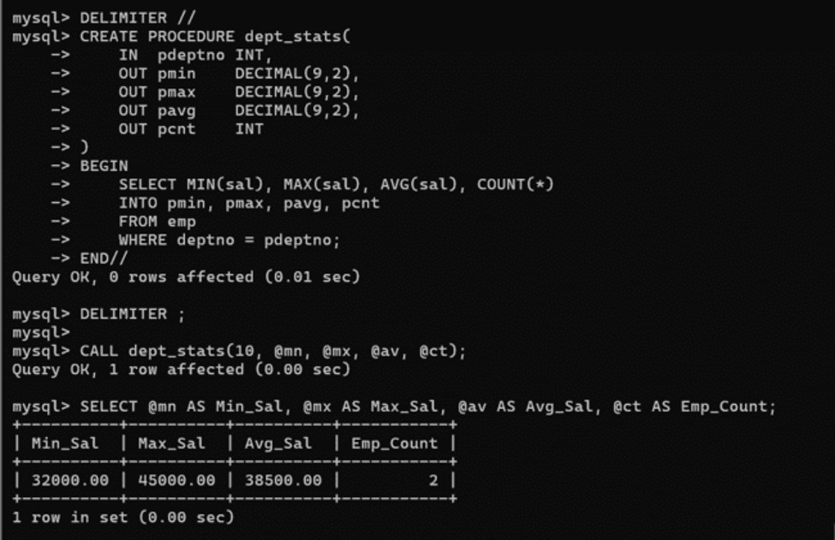

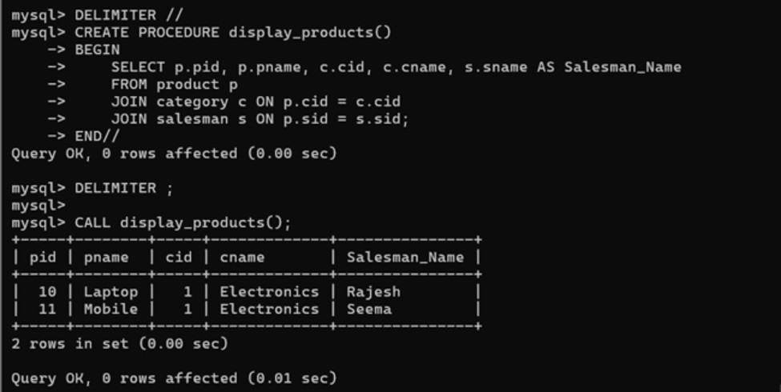
- Write a procedure to display all vehicles bought by a customer. Pass customer name as a parameter (use vehicle, salesman, customer and relation table).

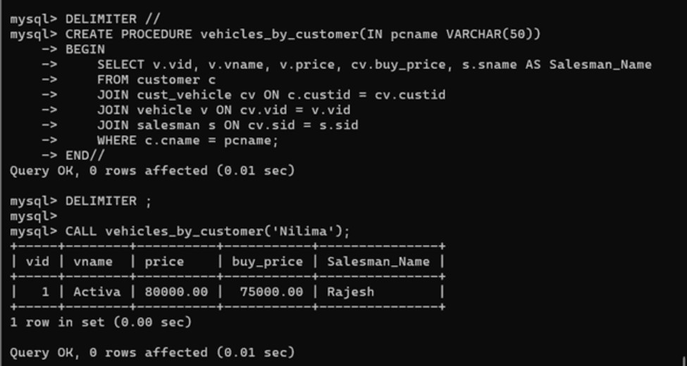
- Write a procedure that displays the following information of all emp: Empno, Name, job, Salary, Status, deptno. Status will be (Greater, Lesser or Equal) respective to average salary of their own department. Display an error message Emp table is empty if there is no matching record.

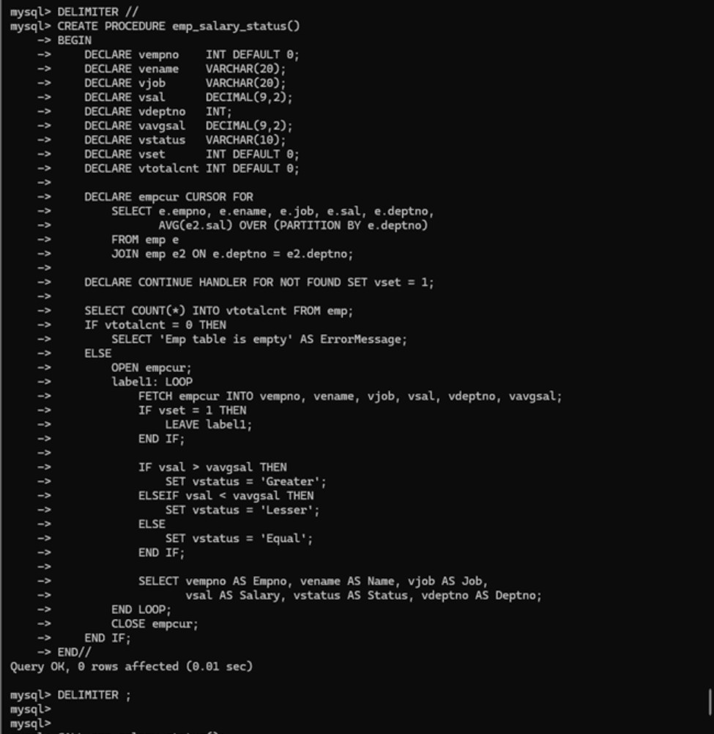

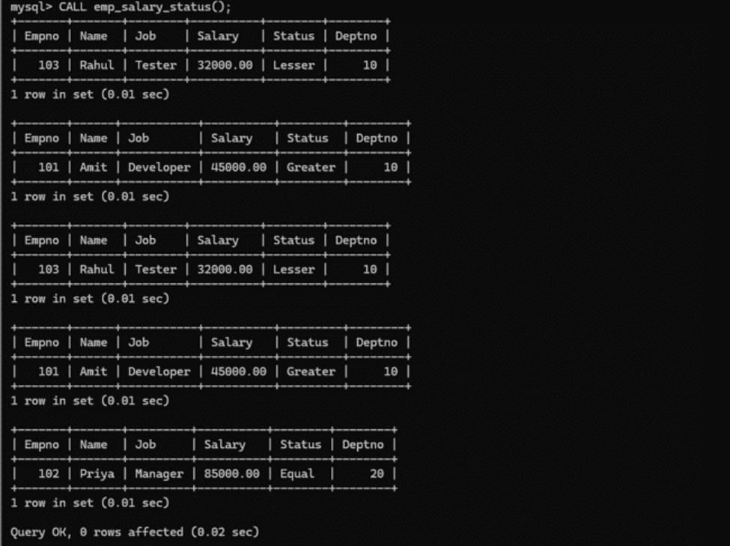

- Write a procedure to update salary in emp table based on following rules: Exp <= 35 then no update; Exp > 35 and <= 38 then 20% of salary; Exp > 38 then 25% of salary.

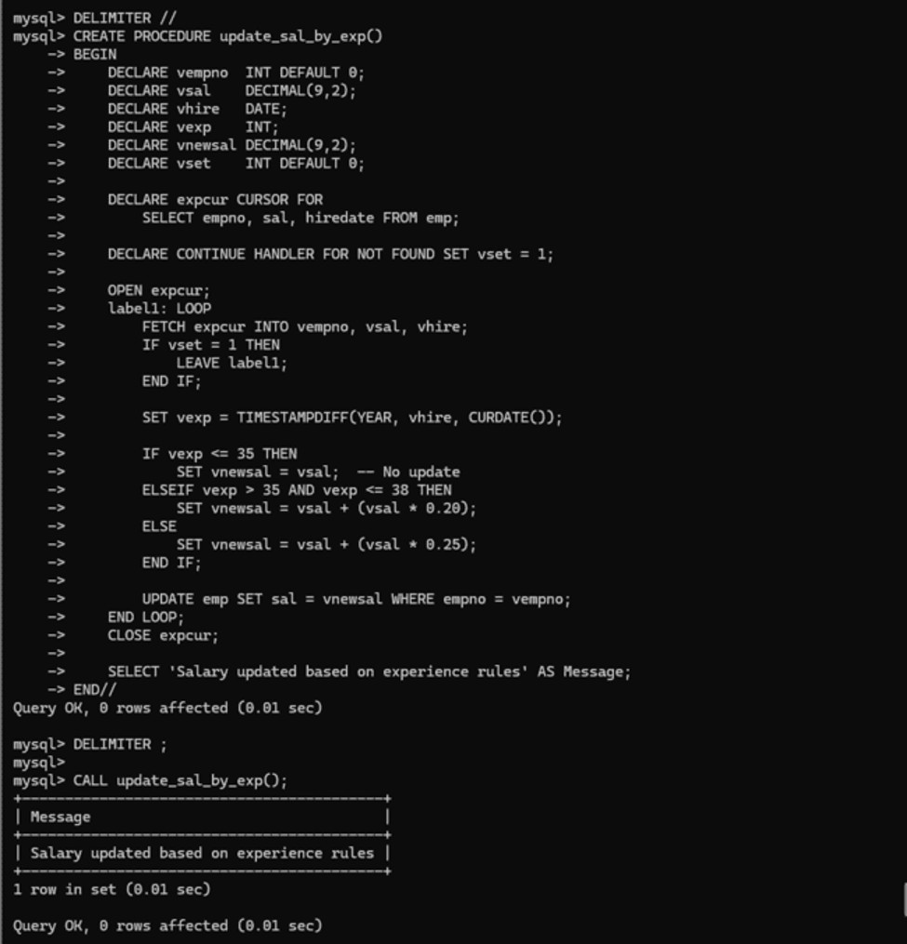
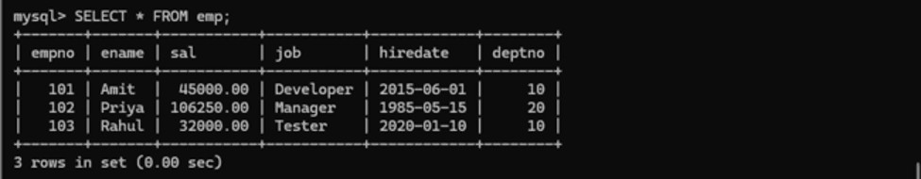

- Write a procedure and a function. Function: write a function to calculate number of years of experience of employee (pass hiredate as a parameter). Procedure: capture the value returned by the above function to calculate the additional allowance based on experience. Additional Allowance = Year of experience × 3000. Calculate the additional allowance and store Empno, ename, Date of Joining, Experience in years and additional allowance in Emp_Allowance table.
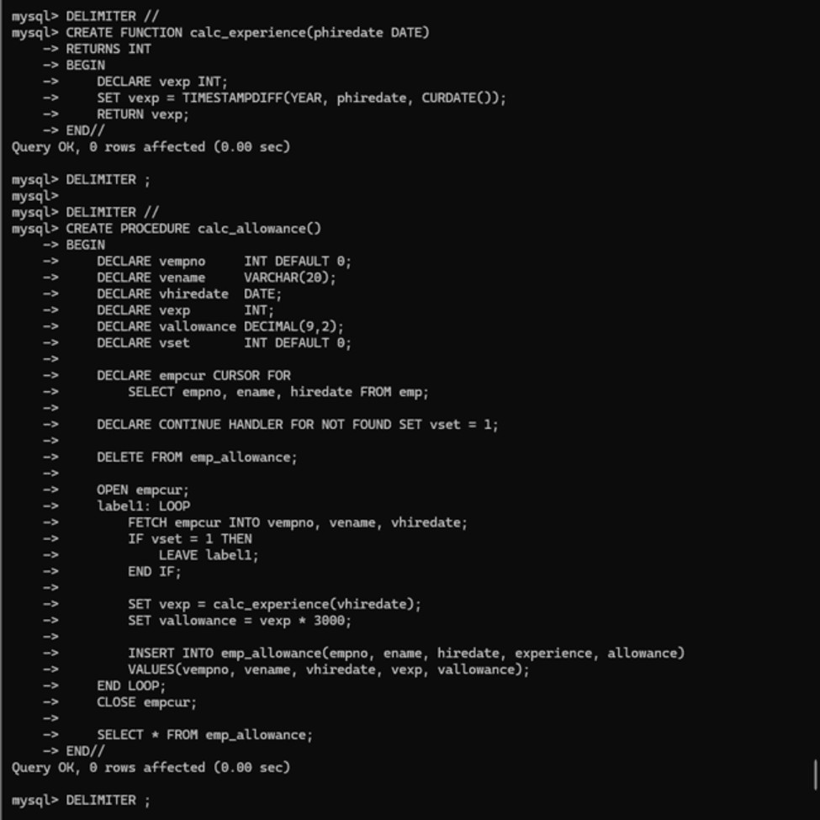
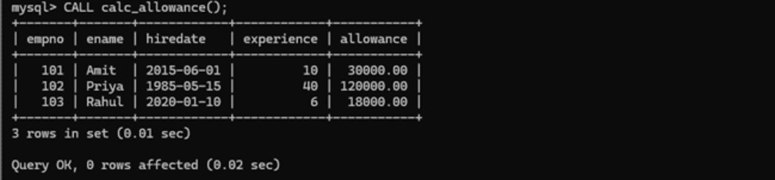
- Write a function to compute the following. Function should take sal and hiredate as input and return the netsal. DA = 15% Salary, HRA = 20% of Salary, TA = 8% of Salary, PF = 10% of salary. Netsal = sal + DA + HRA + TA - PF + special_allowance. Special Allowance depends on service in the company: < 1 Year Nil; >=1 Year <2 Year 10% of Salary; >=2 Year <4 Year 20% of Salary; >4 Year 30% of Salary.
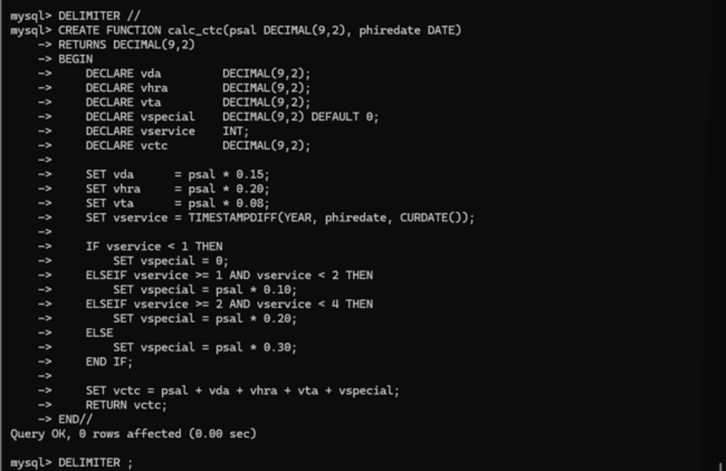
- Write query to display empno, ename, sal, netsal for all employees (use function written in question 11).
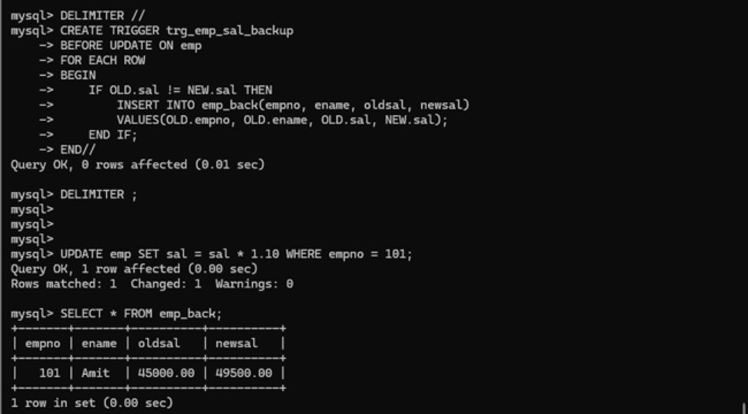

Q2. WRITE TRIGGER
Q2.1. Write a trigger to store the old salary details in Emp_Back (Emp_Back has the same structure as emp table without any constraint). Create emp_back table before writing trigger.

Q2.2. Write a trigger which adds an entry in audit table when user tries to insert or delete records in employee table. Store empno, name, username and date on which operation is performed and which action is done (insert or delete) in empaudit table.
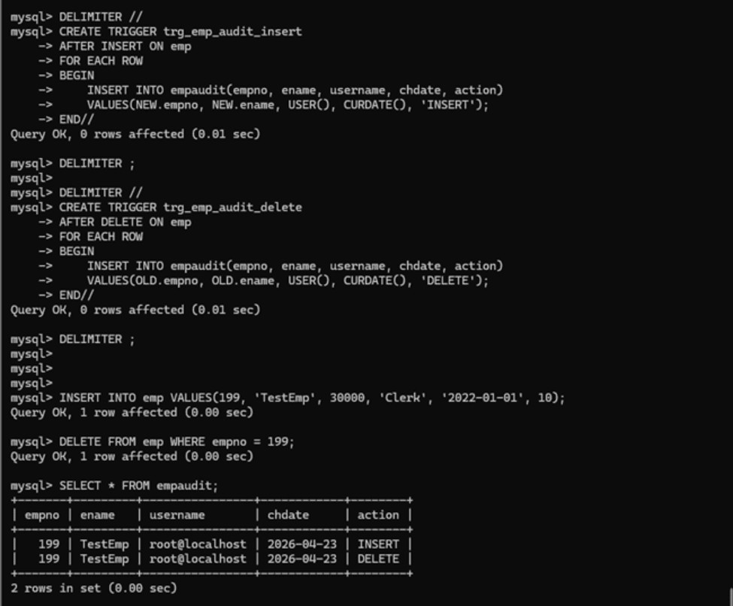

Q2.3. Create table vehicle_history. Write a trigger to store old vehicleprice and new vehicle price in history table before you update price in vehicle table.
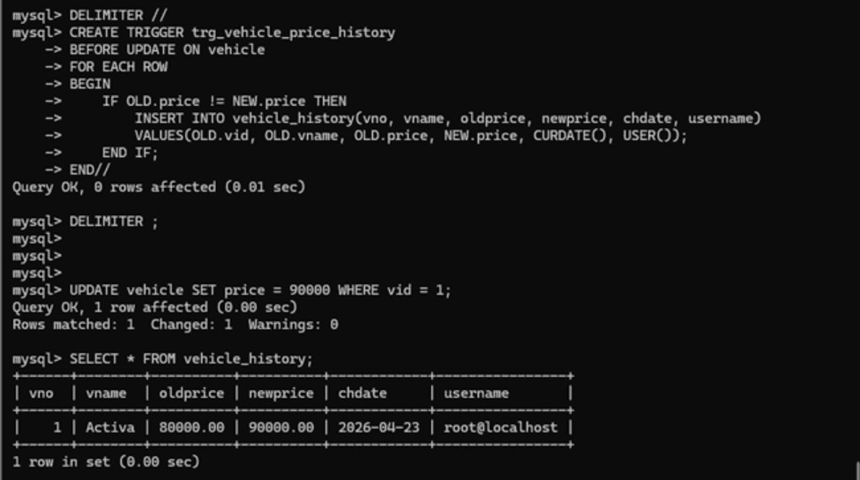

ASSIGNMENT 9 (day 11)

- Write a MongoDB query to display all the documents in the collection restaurants
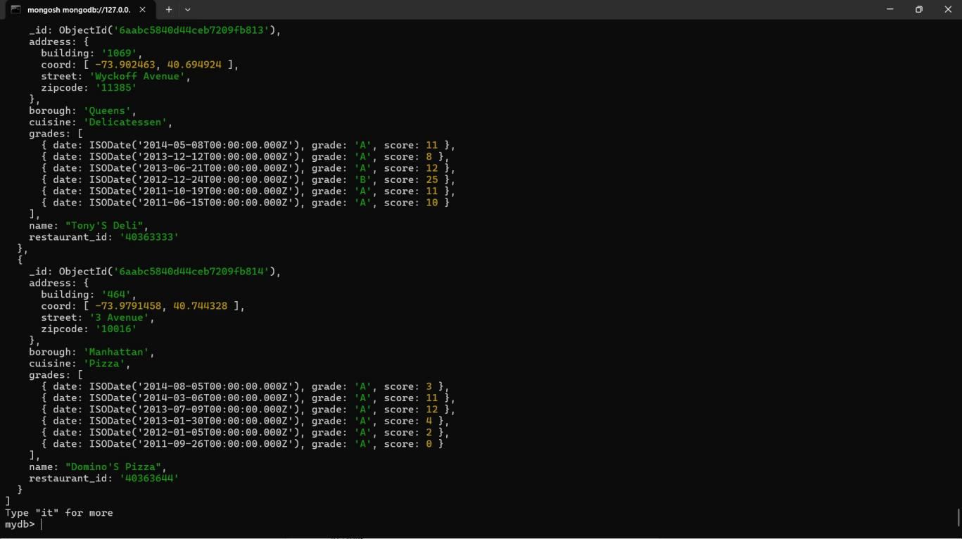

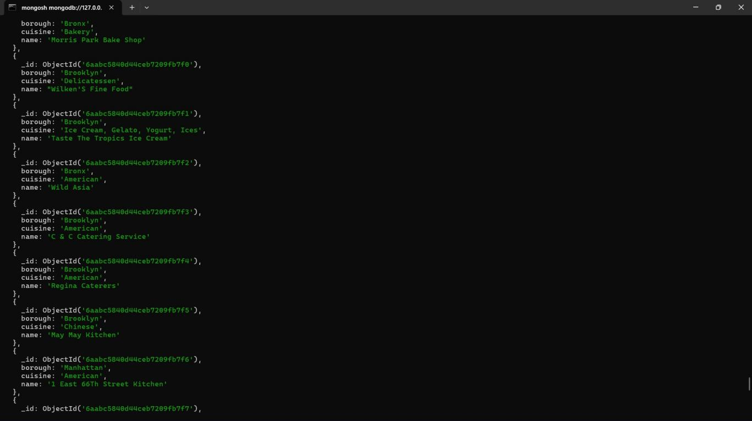
- Write a MongoDB query to display the fields restaurant_id, name, borough and cuisine for all the documents in the collection restaurant.

- Write a MongoDB query to display the fields restaurant_id, name, borough and cuisine, but exclude the field _id for all the documents in the collection restaurant.
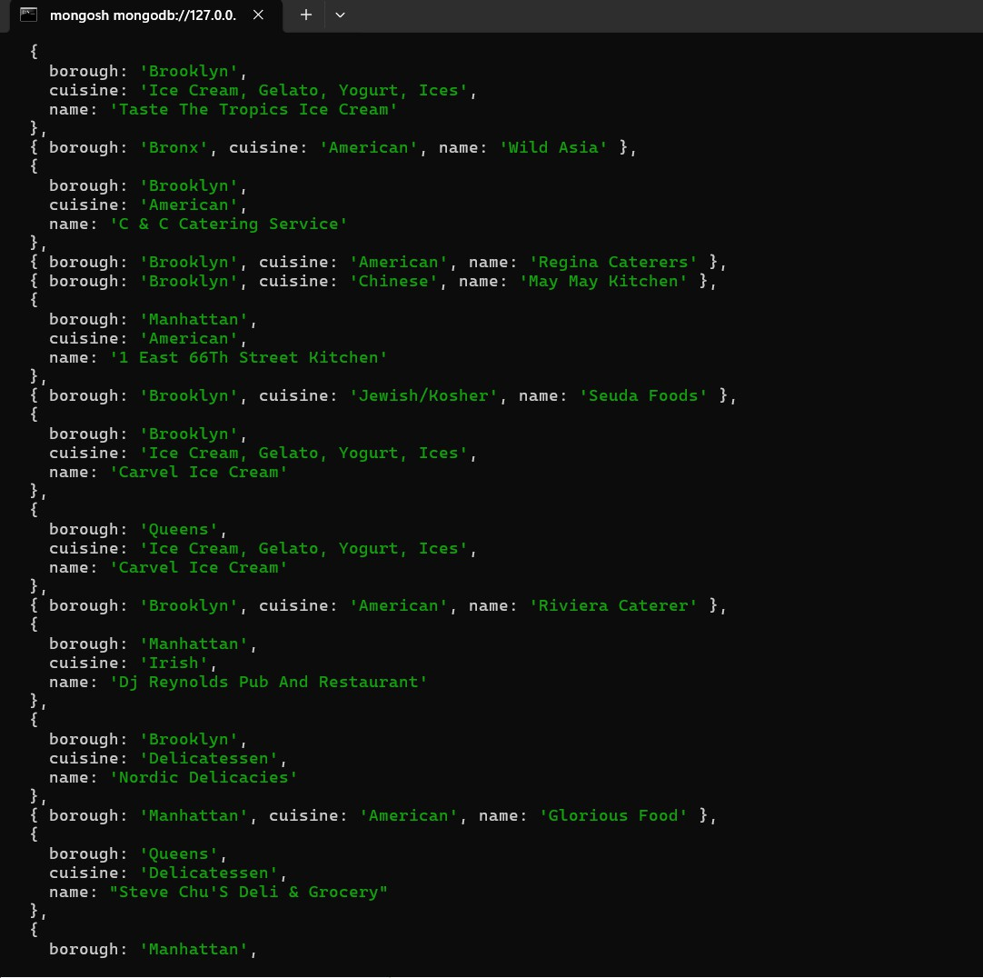

- Write a MongoDB query to display the fields restaurant_id, name, borough and zip code, but exclude the field _id for all the documents in the collection restaurant.
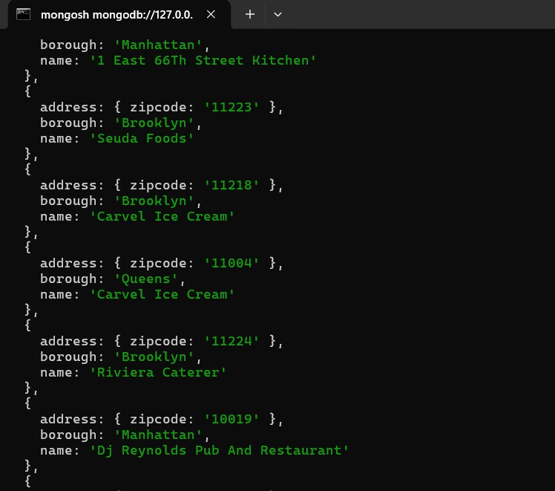

- Write a MongoDB query to display all the restaurant which is in the borough Bronx

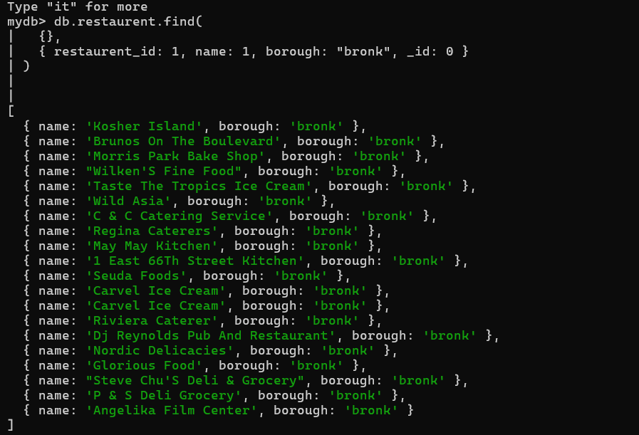

- Write a MongoDB query to display the first 5 restaurant which is in the borough Bronx.

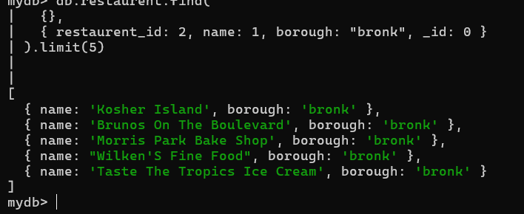

- Write a MongoDB query to display the next 5 restaurants after skipping first 5 which are in the borough Bronx.
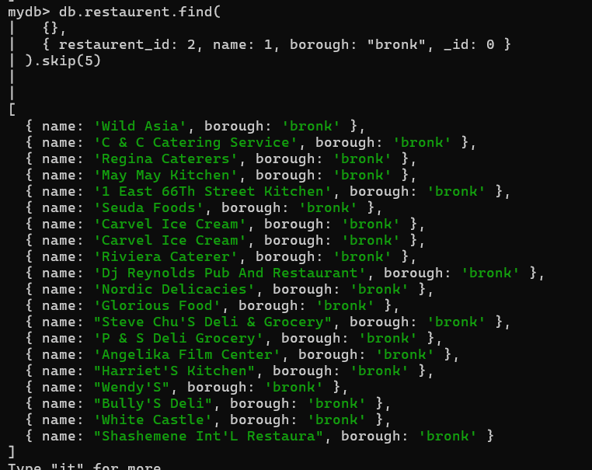

- Write a MongoDB query to find the restaurants who achieved a score more than 90.
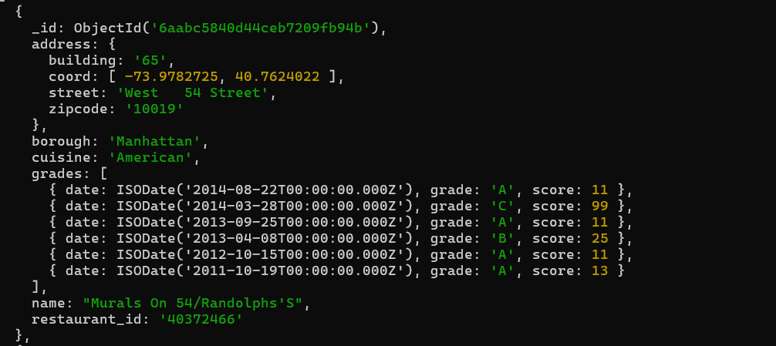

- Write a MongoDB query to find the restaurants that achieved a score, more than 80 but less than 100.

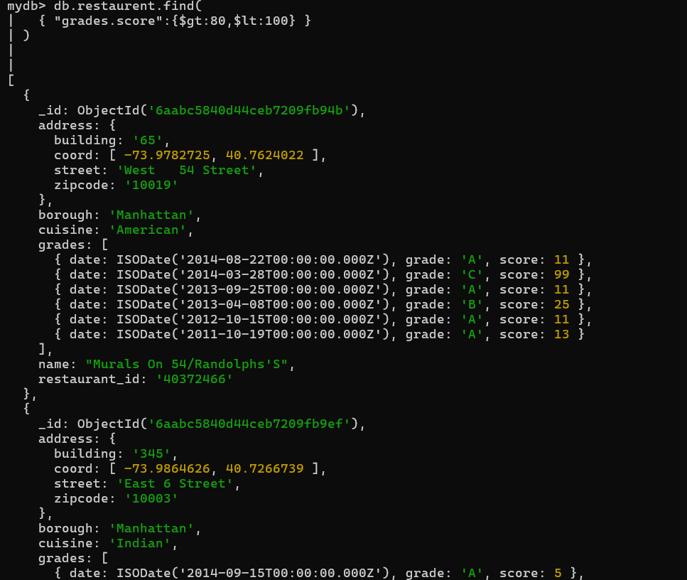

- Write a MongoDB query to find the restaurants which locate in latitude value less than - 95.754168.
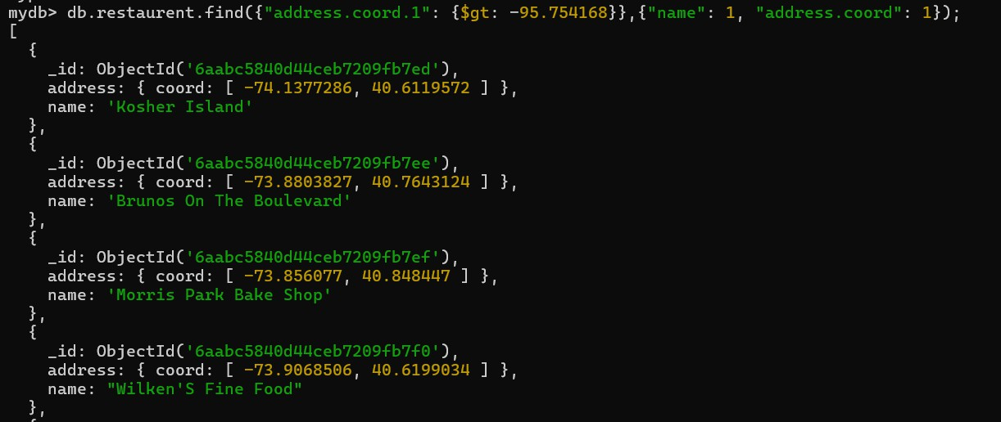

- Write a MongoDB query to find the restaurants that do not prepare any cuisine of 'American' and their grade score more than 70 and latitude less than -65.754168.
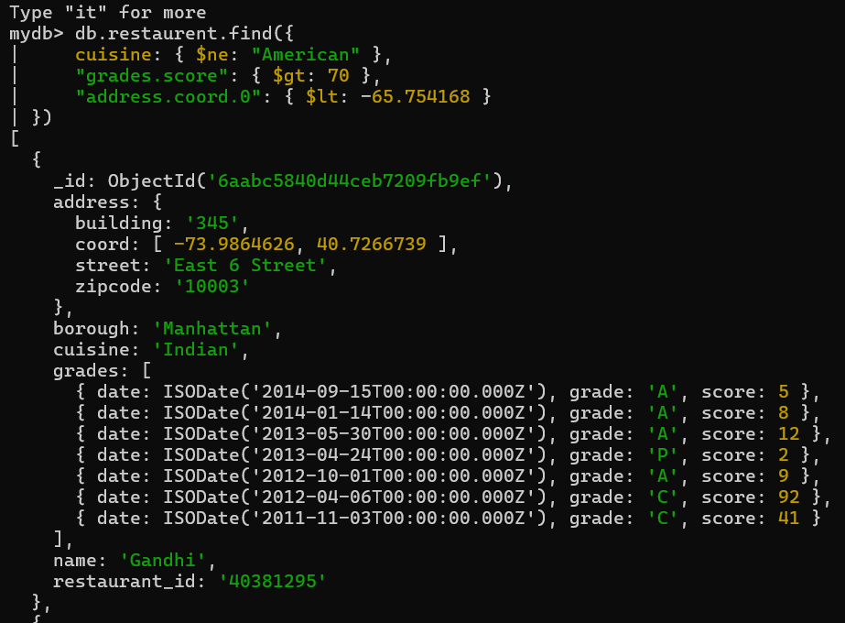

- Write a MongoDB query to find the restaurants which do not prepare any cuisine of 'American' and achieved a score more than 70 and located in the longitude less than - 65.754168.
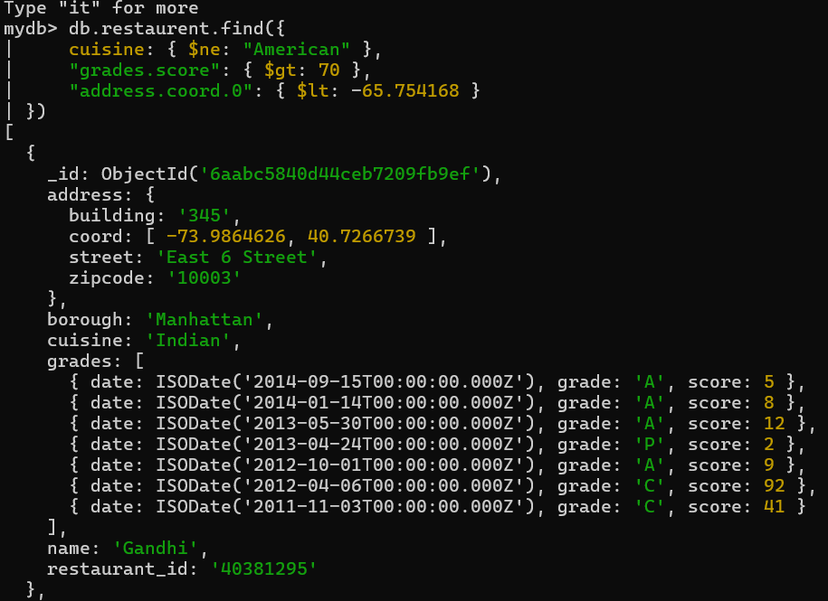

- Write a MongoDB query to find the restaurants which do not prepare any cuisine of 'American ' and achieved a grade point 'A' not belongs to the borough Brooklyn. The document must be displayed according to the cuisine in descending order.

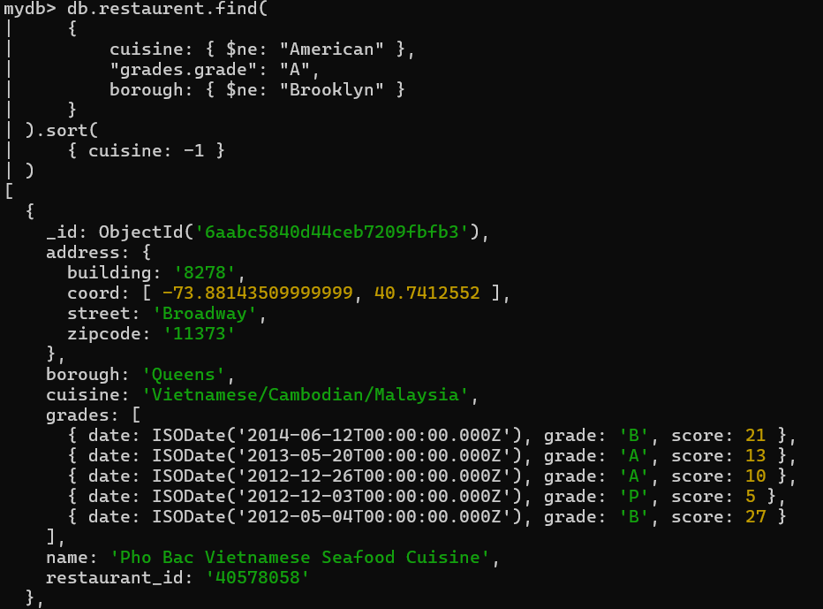

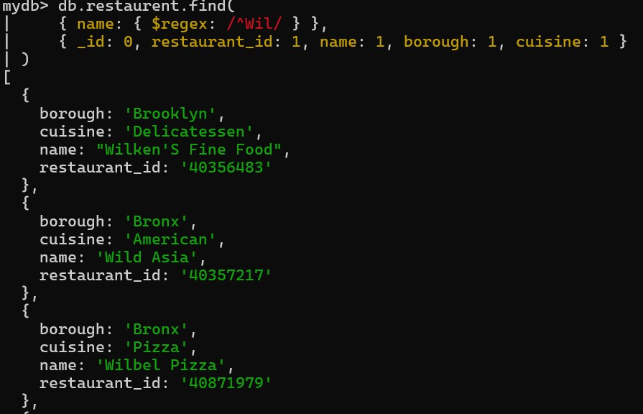
- Write a MongoDB query to find the restaurant Id, name, borough and cuisine for those restaurants which contain 'Wil' as first three letters for its name

- Write a MongoDB query to find the restaurant Id, name, borough and cuisine for those restaurants which contain 'ces' as last three letters for its name.
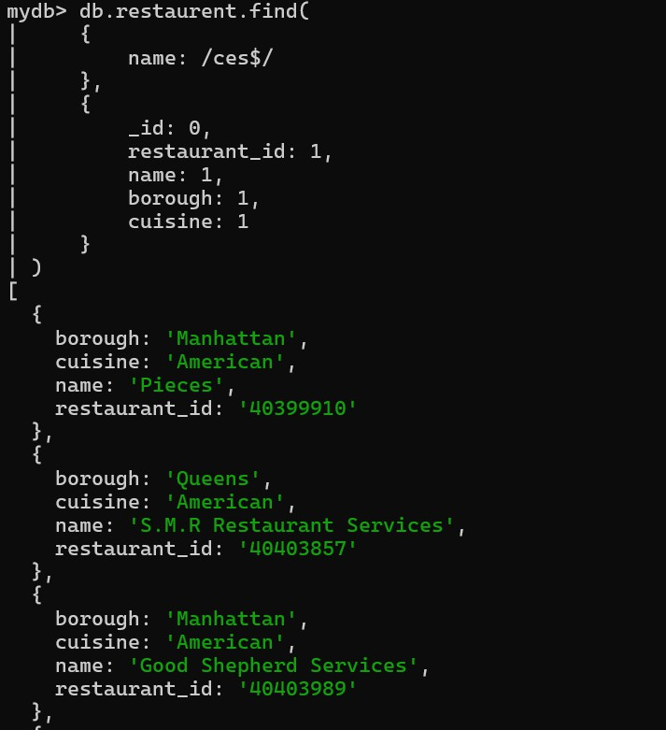

- Write a MongoDB query to find the restaurant Id, name, borough and cuisine for those restaurants which contain 'Reg' as three letters somewhere in its name.
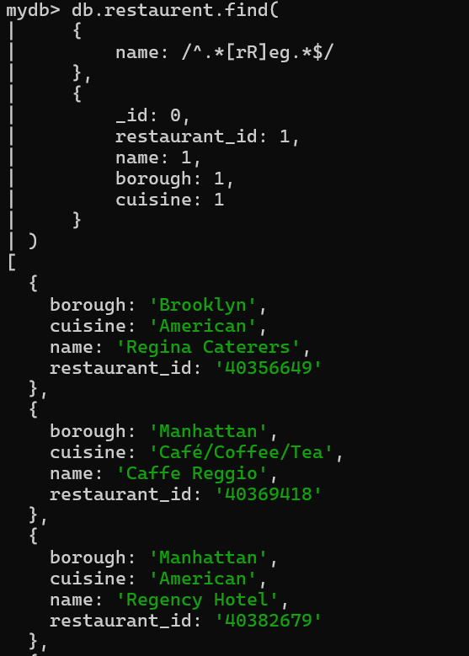

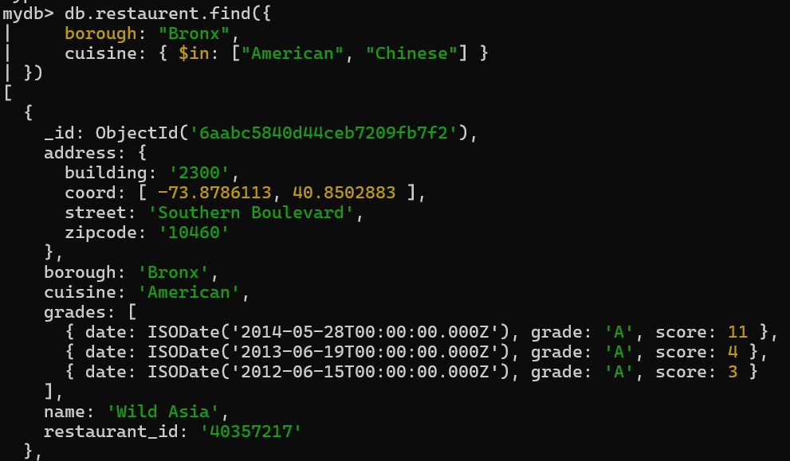
- Write a MongoDB query to find the restaurants which belong to the borough Bronx and prepared either American or Chinese dish.

- Write a MongoDB query to find the restaurant Id, name, borough and cuisine for those restaurants which belong to the borough Staten Island or Queens or Bronxor Brooklyn.
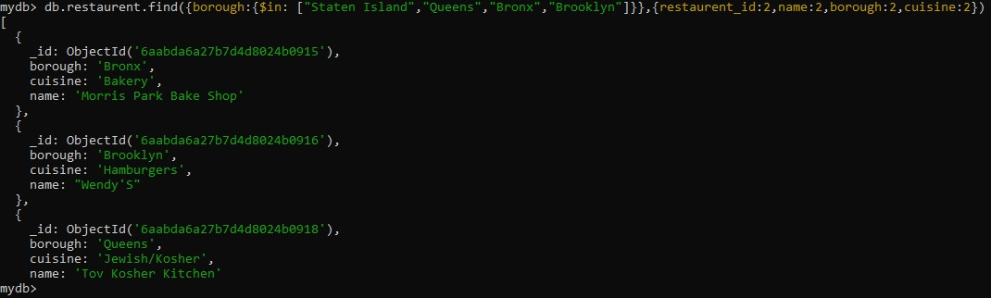

- Write a MongoDB query to find the restaurant Id, name, borough and cuisine for those restaurants which are not belonging to the borough Staten Island or Queens or Bronxor Brooklyn.
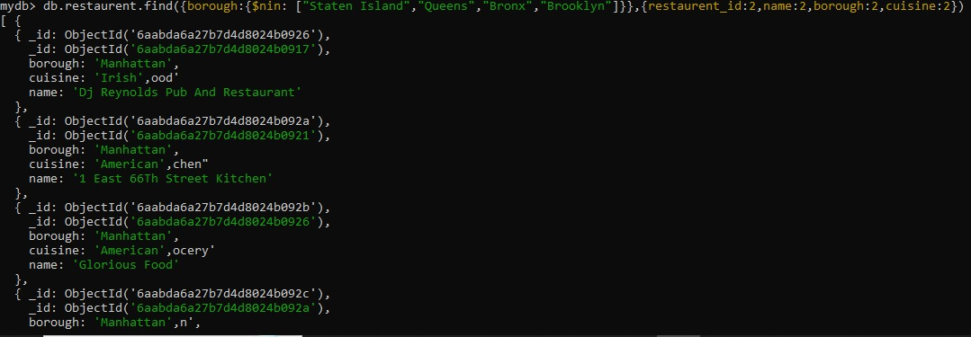

- Write a MongoDB query to find the restaurant Id, name, borough and cuisine for those restaurants which achieved a score which is not more than 10.
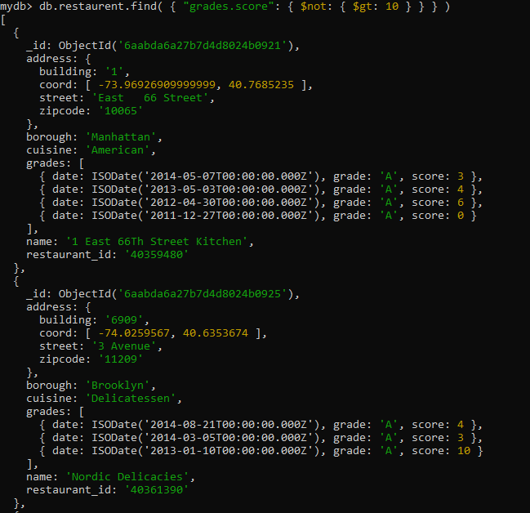

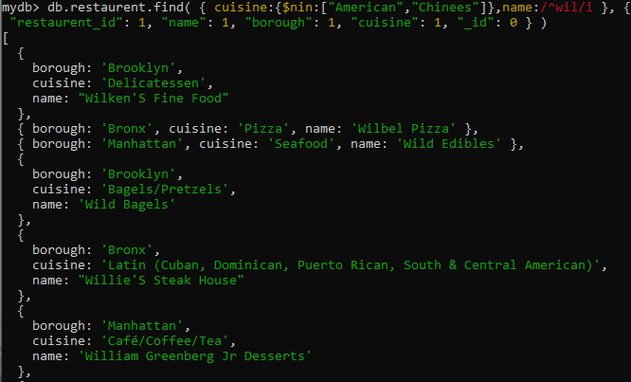
- Write a MongoDB query to find the restaurant Id, name, borough and cuisine for those restaurants which prepared dish except 'American' and 'Chinees' or restaurant's name begins with letter 'Wil'.

- Write a MongoDB query to find the restaurant Id, name, and grades for those restaurants which achieved a grade of "A" and scored 11 on an ISODate "2014-08-11T00:00:00Z" among many of survey dates
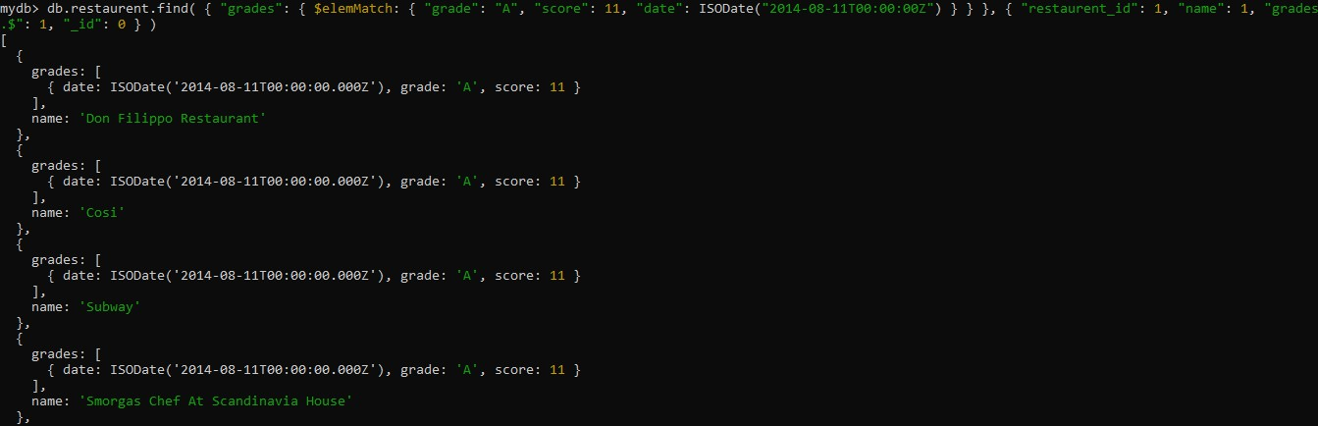

- Write a MongoDB query to find the restaurant Id, name and grades for those restaurants where the 2nd element of grades array contains a grade of "A" and score 9 on an ISODate "2014-08-11T00:00:00Z".
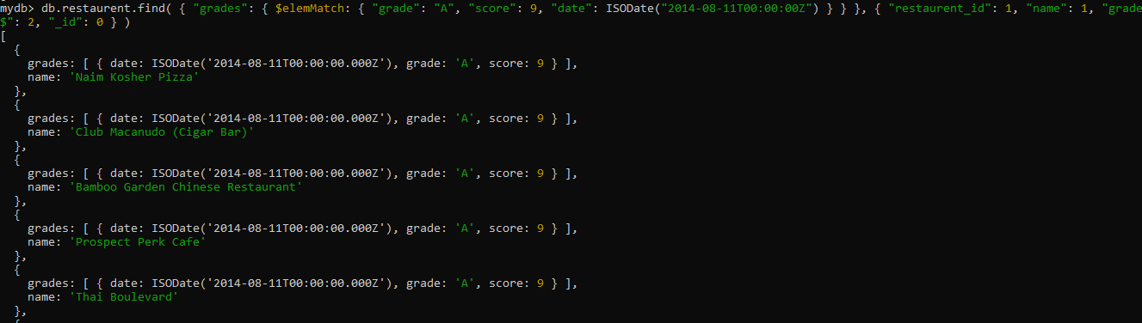

- Write a MongoDB query to find the restaurant Id, name, address and geographical location for those restaurants where 2nd element of coord array contains a value which is more than 42 and upto 52
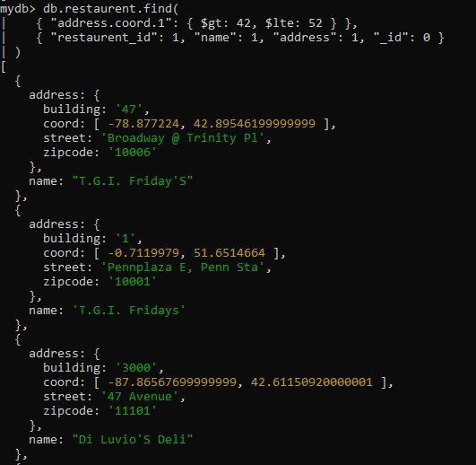

- Write a MongoDB query to arrange the name of the restaurants in ascending order along with all the columns.
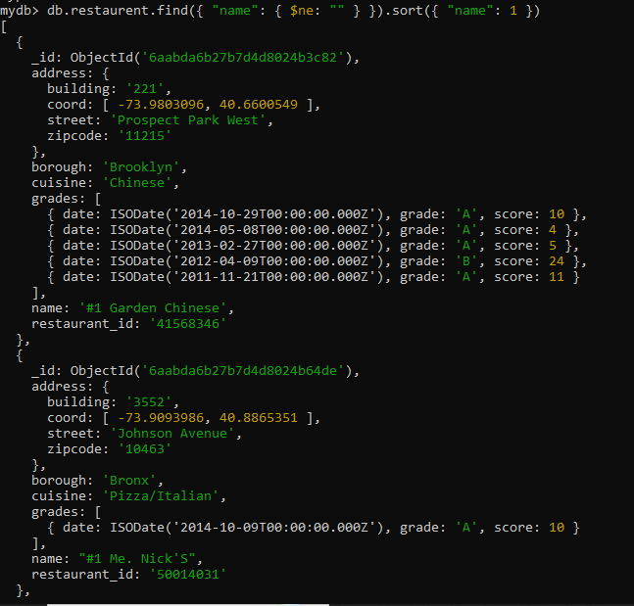

- Write a MongoDB query to arrange the name of the restaurants in descending along with all the columns.
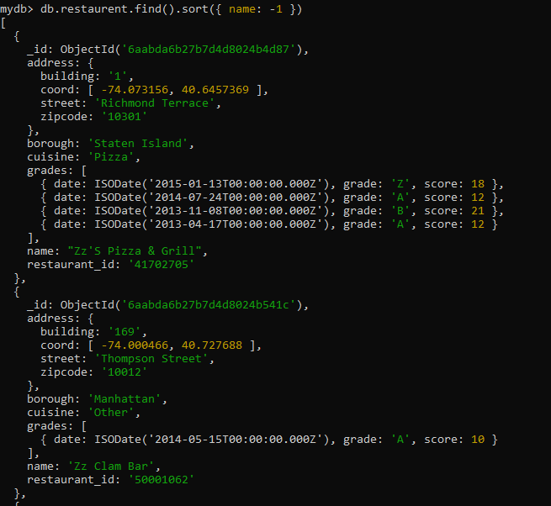

- Write a MongoDB query to arranged the name of the cuisine in ascending order and for that same cuisine borough should be in descending order.
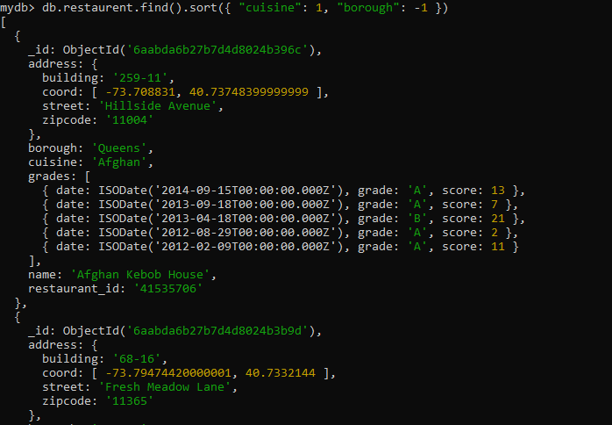

- Write a MongoDB query to know whether all the addresses contains the street or not.
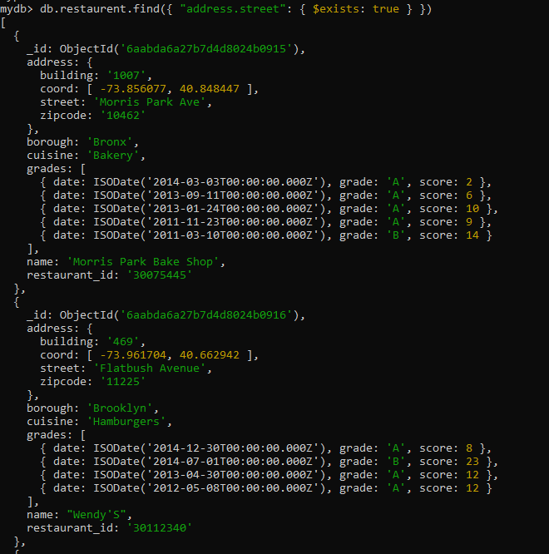

- Write a MongoDB query which will select all documents in the restaurants collection where the coord field value is Double.
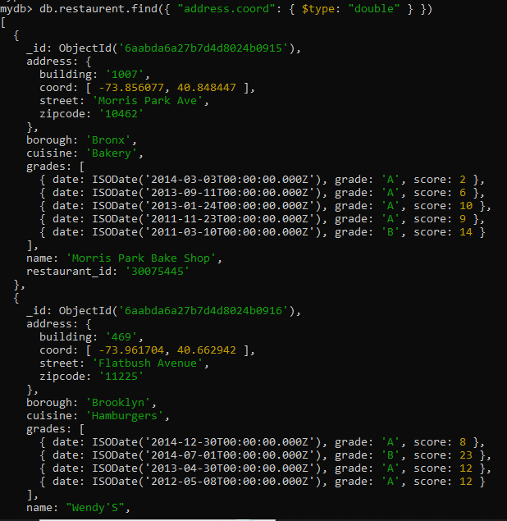

- Write a MongoDB query which will select the restaurant Id, name and grades for those restaurants which returns 0 as a remainder after dividing the score by 7.
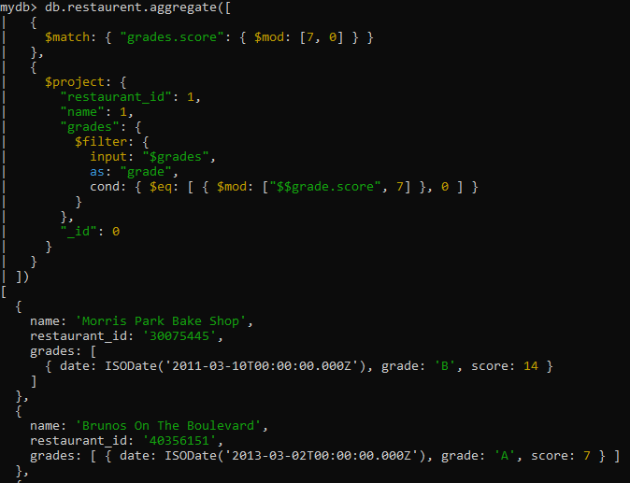

- Write a MongoDB query to find the restaurant name, borough, longitude and attitude and cuisine for those restaurants which contains 'mon' as three letters somewhere in its name.
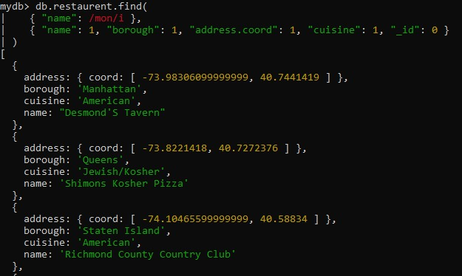

- Write a MongoDB query to find the restaurant name, borough, longitude and latitude and cuisine for those restaurants which contain 'Mad' as first three letters of its name.
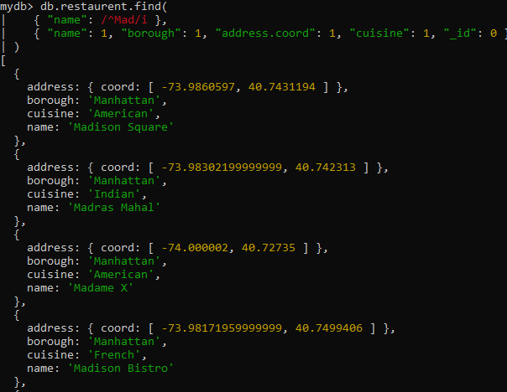

ASSIGNMENT 10 (day 12)

- All Employee’s with the desg as ‘CLERK’ are now called as (AO) Administrative Officers. Update the Employee collection for this.
Provided screenshot:
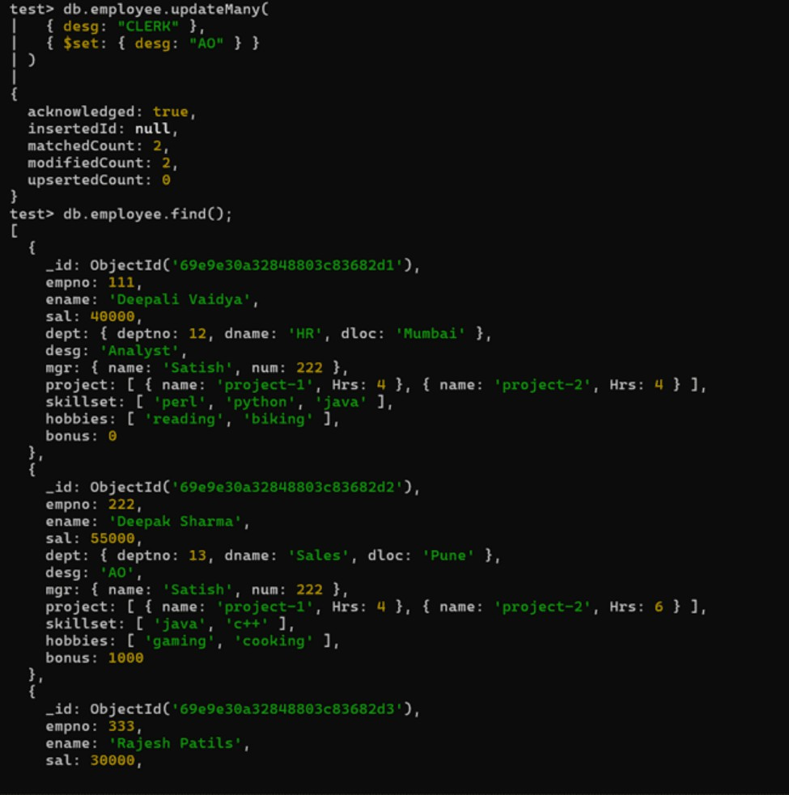

- Change the number of hours for project-1 to 5 for all employees with designation analyst.
Provided screenshot:
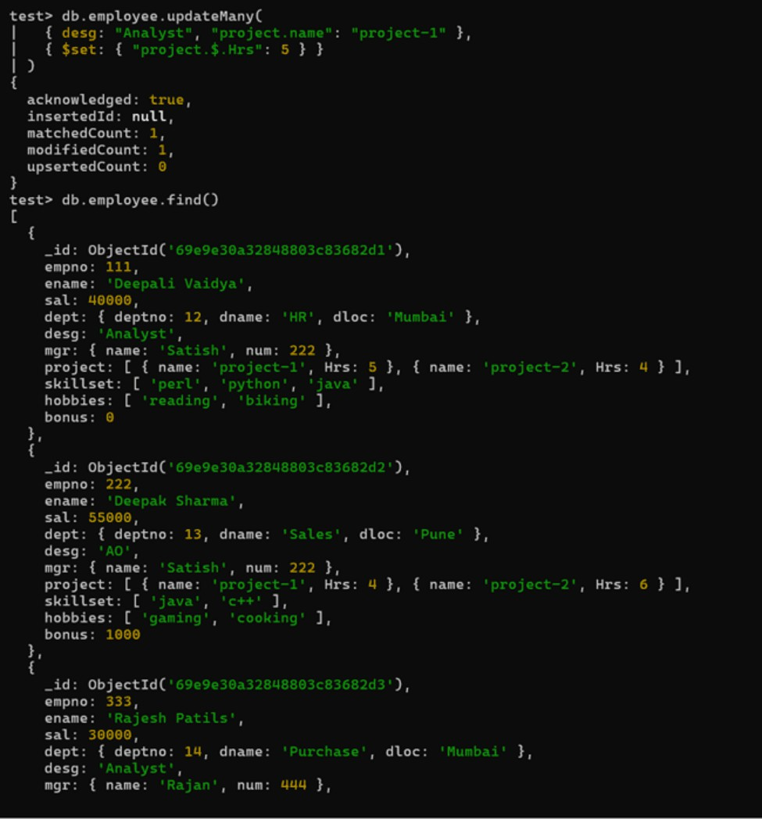

- Add 2 projects project-3 and project-4 for employee whose name starts with ”Deep” with 2 hrs.
Provided screenshot:
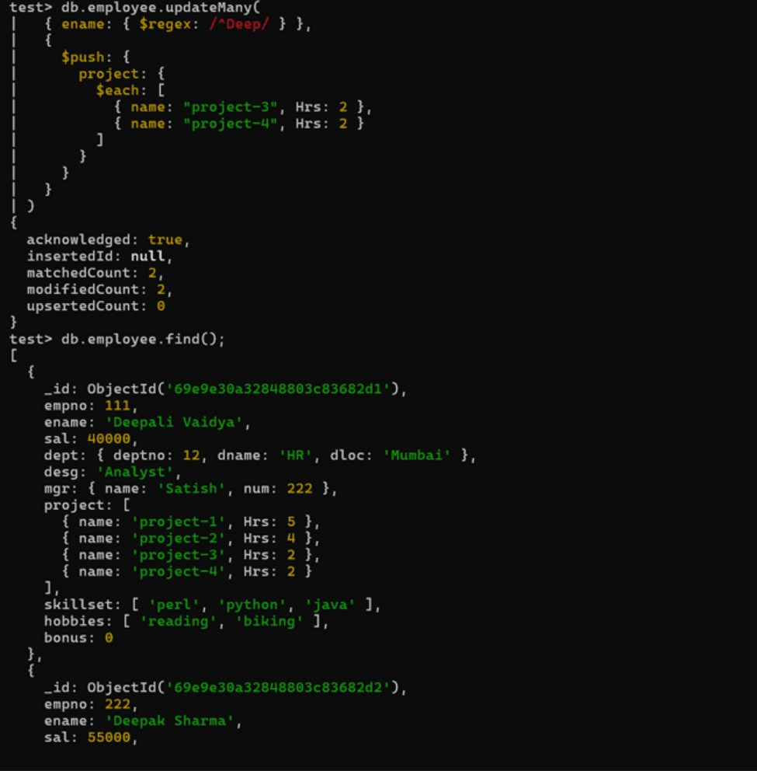

- Add bonus Rs 2000 for all employees with salary > 50000.
Provided screenshot:
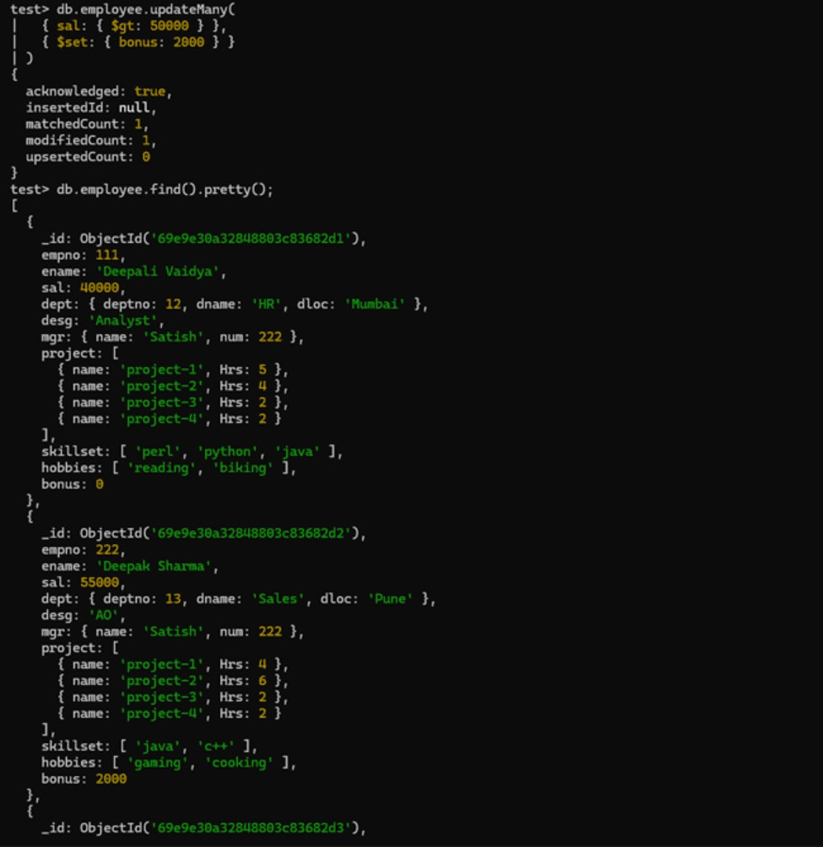

- Add bonus Rs 1500 if salary <50000 and > 30000.
Provided screenshot:
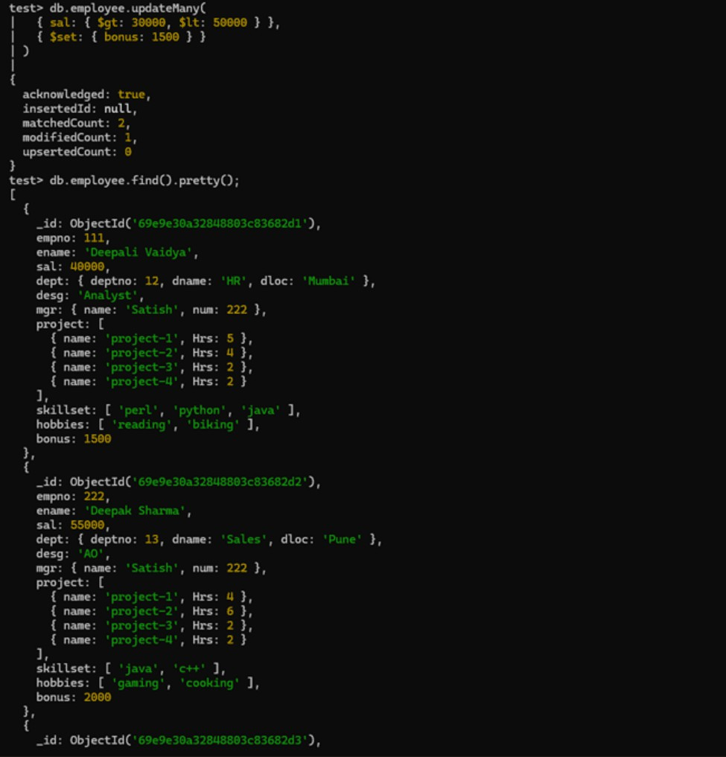

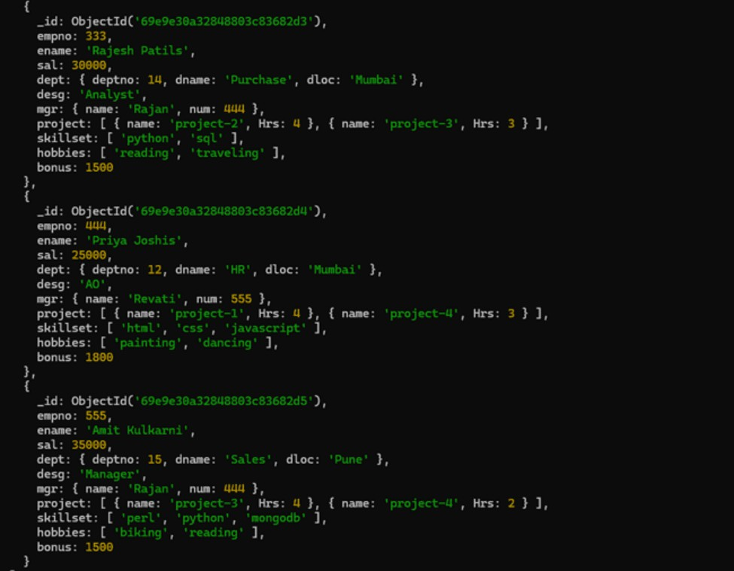

- Increment bonus by 1000 for all employees if salary <=30000.
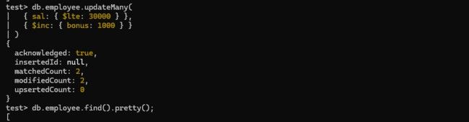

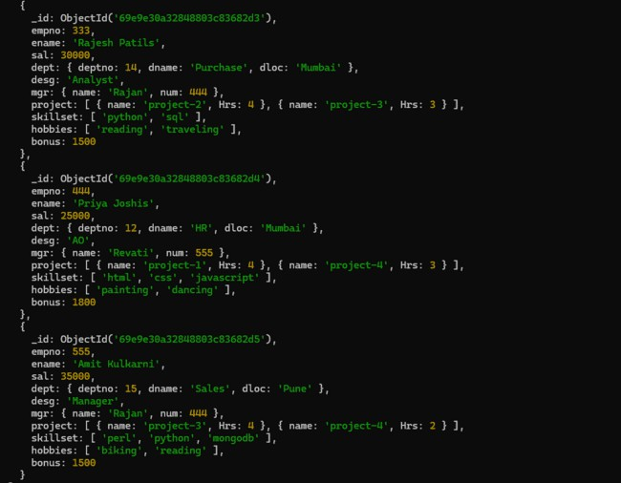

- Change manager name to Tushar for all employees whose manager is currently “satish” and manager number to 3333.
Provided screenshot:
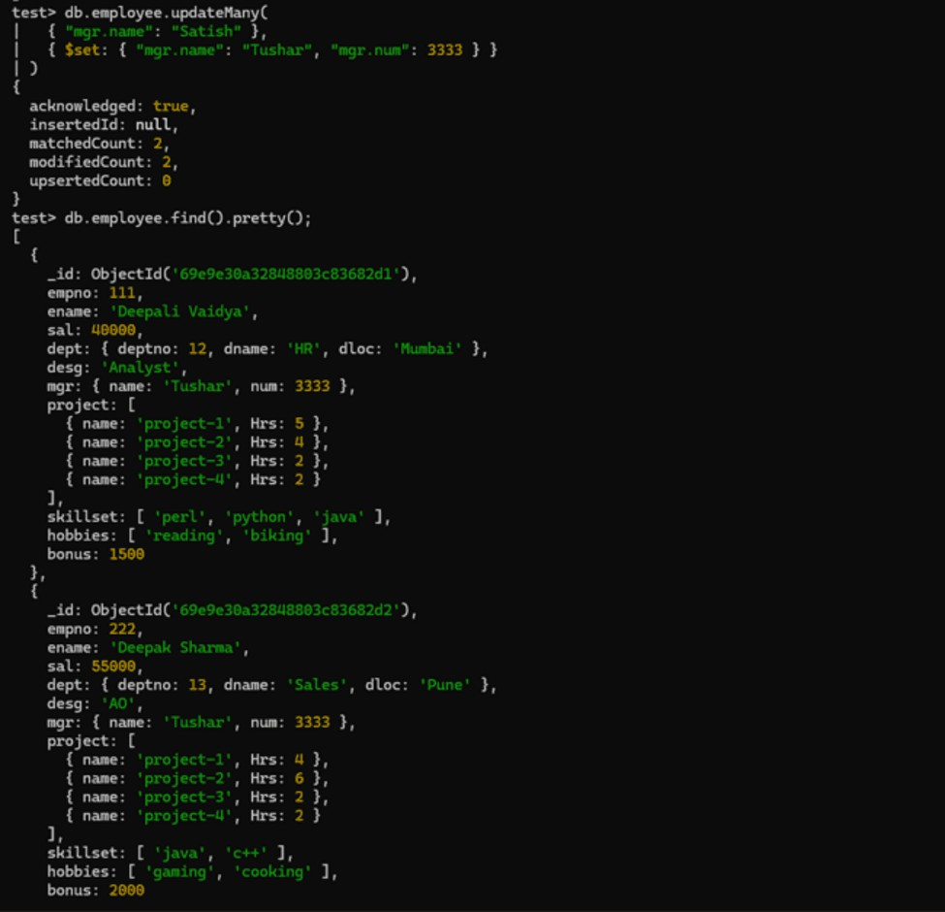

- Increase salary of all employees from “purchase department” by 15000.
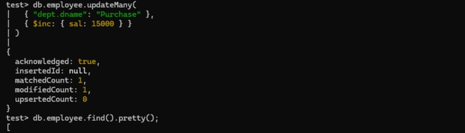
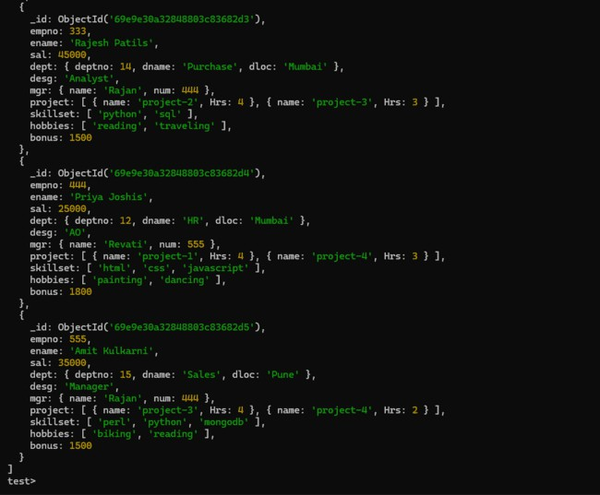

- Decrease number of hrs by 2 for all employees who are working on project-2.
Provided screenshot:
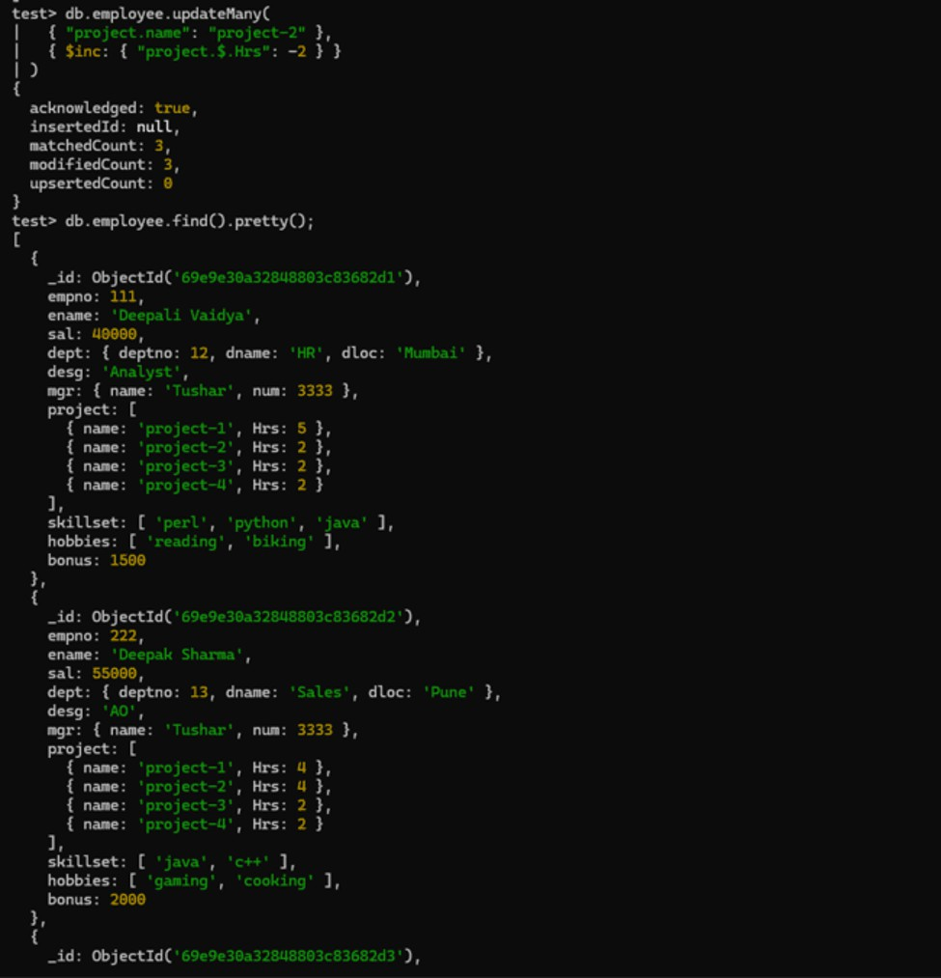

- Delete project-2 from all employee document if they are working on the project for 4 hrs.
Provided screenshot:
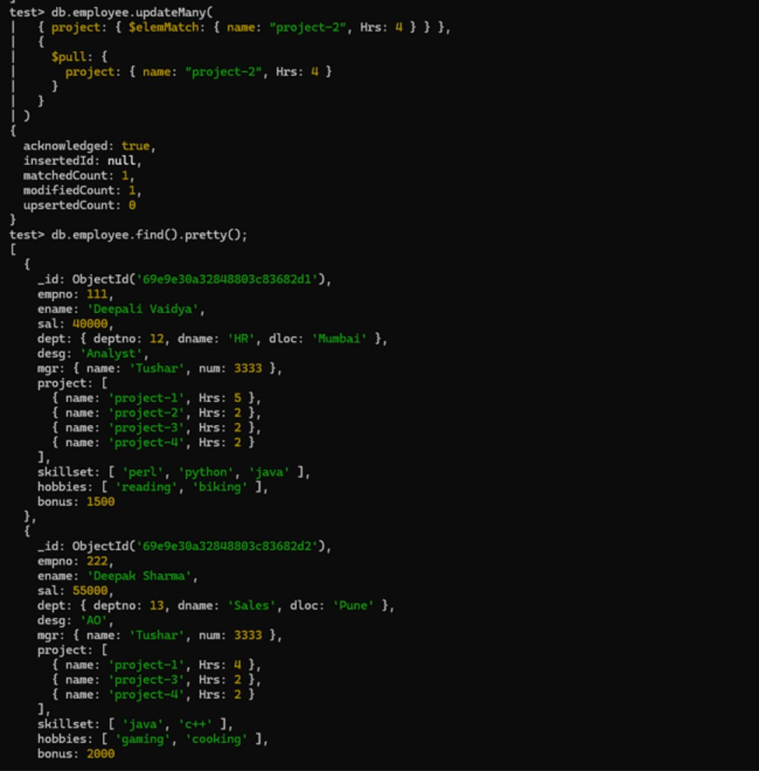

- Change the salary of employees to 10000 only if their salary is < 10000.
Provided screenshot:
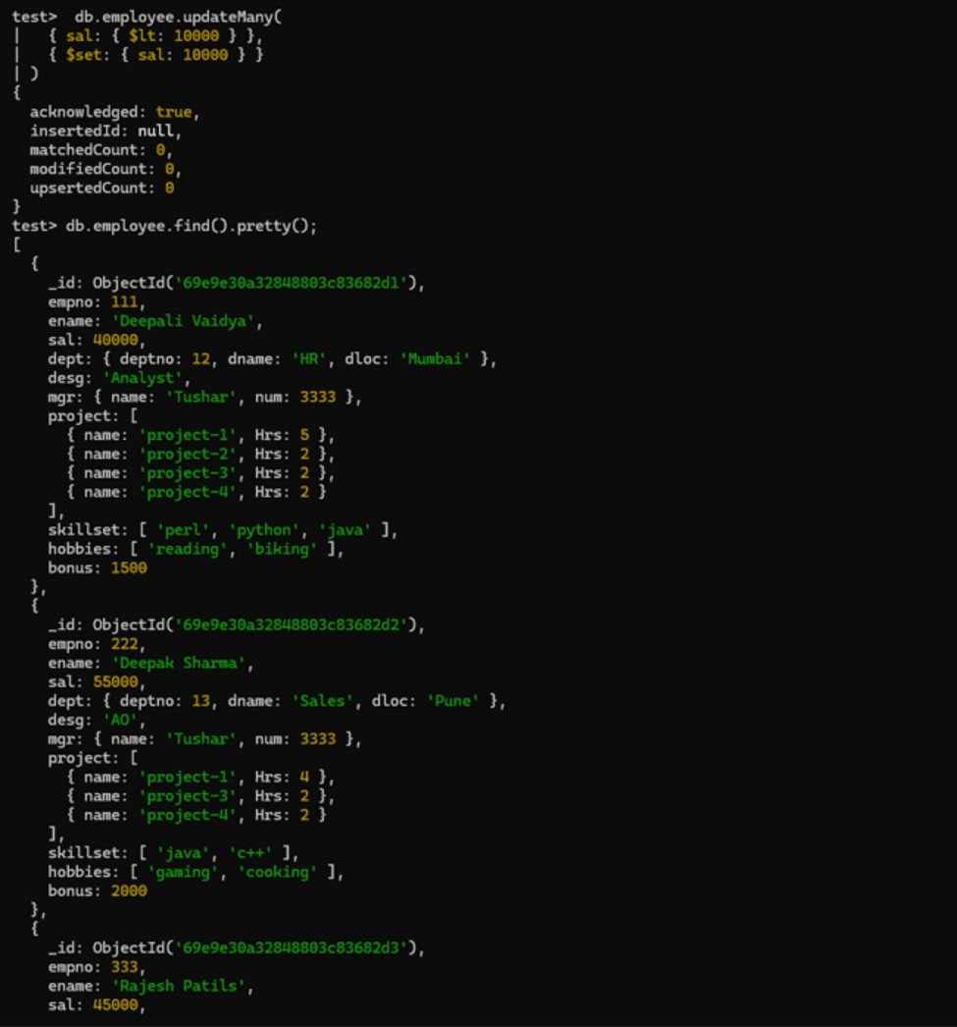

- Increase bonus of all employees by 500 if the bonus is <2000 or their salary is <20000 or if employee belong to sales department.
Provided screenshot:
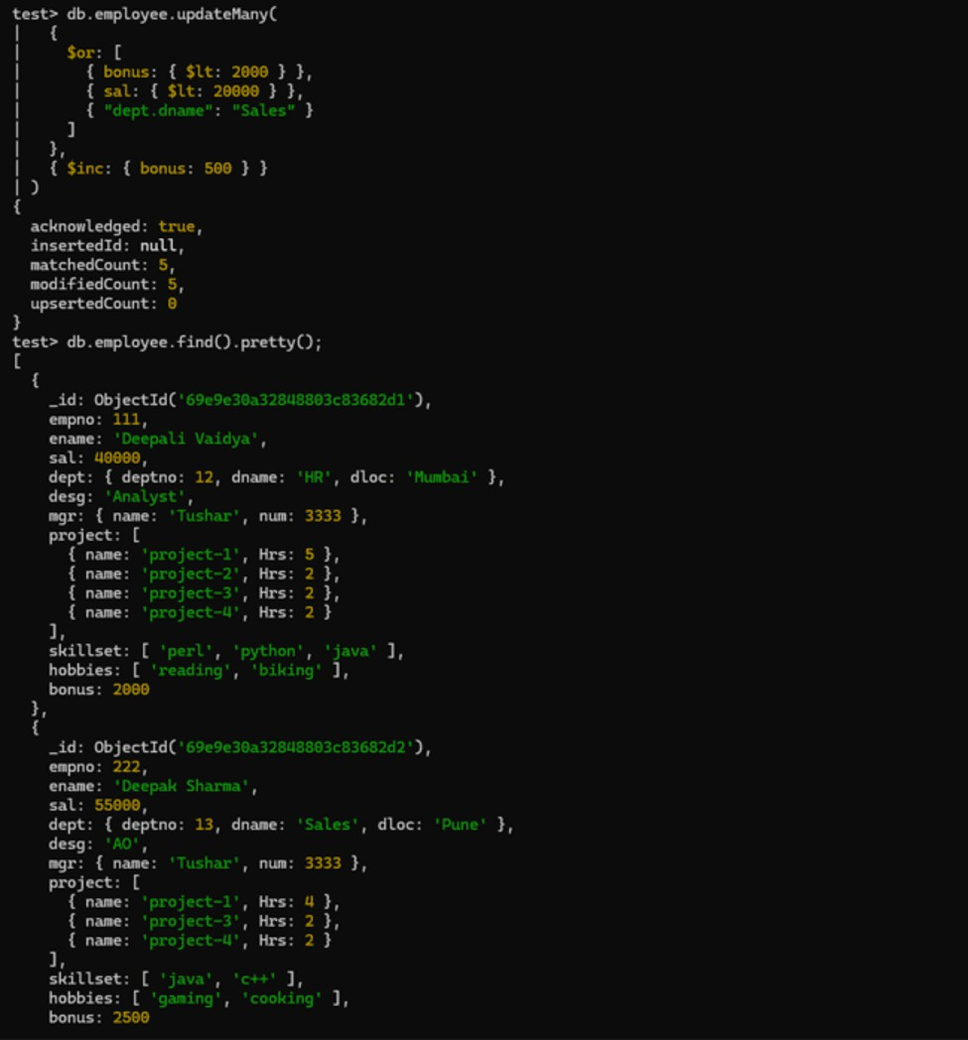

- Add 2 new project at position 2 for all employees with designation analyst or salary is equal to either 30000 or 33000 or 35000.
Provided screenshot:
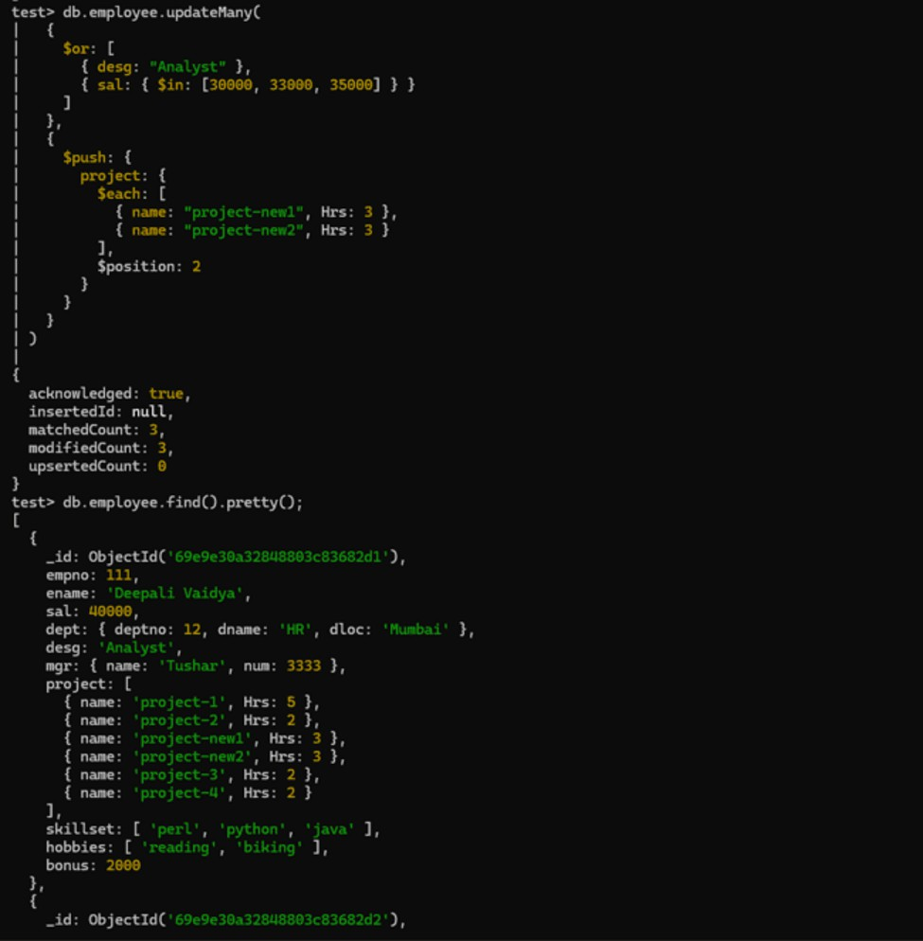

- Delete last project of all employees with department name is “HR” and if the location is Mumbai.
Provided screenshot:
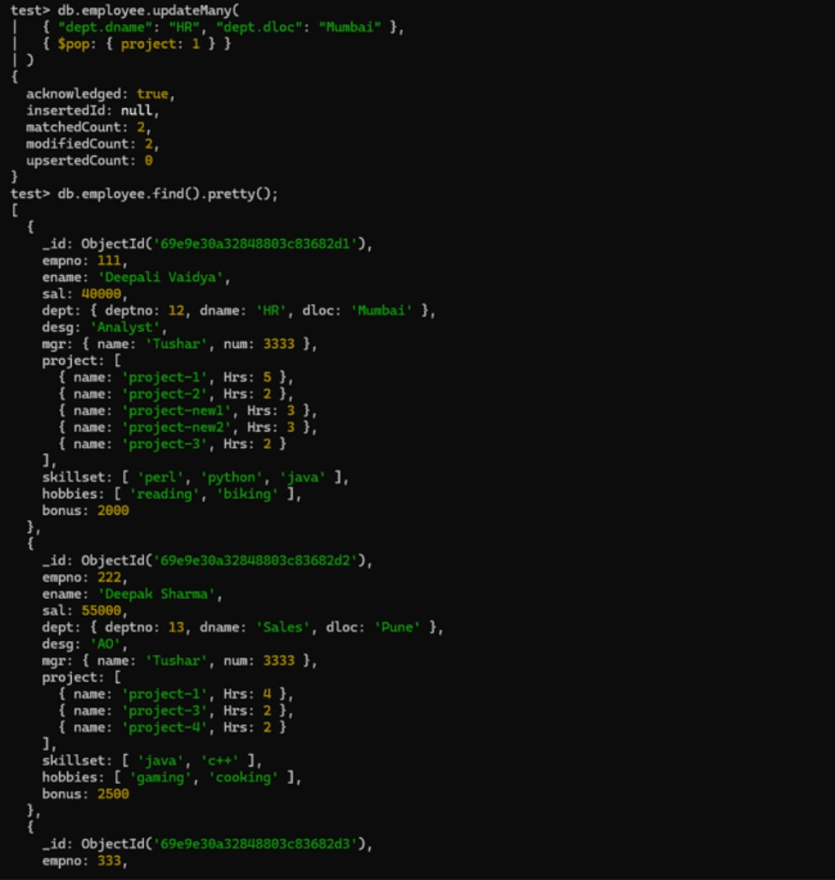

- Change designation of all employees to senior programmer if they are working on name:”Project-1” for 4 hrs.
Provided screenshot:
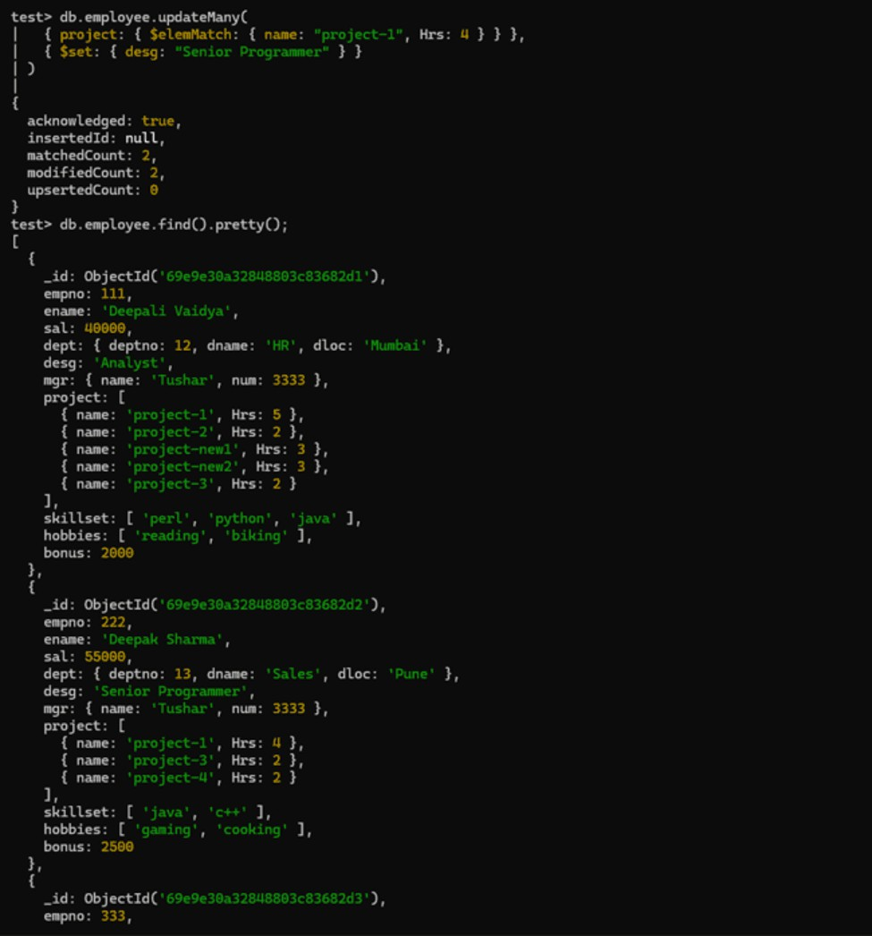

- Add list of hobbies in all employees document whose manager is Rajan or Revati.
Provided screenshot:
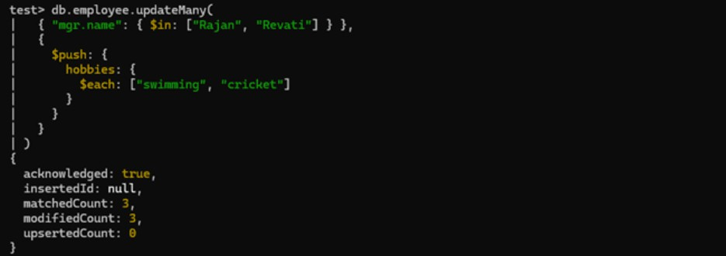
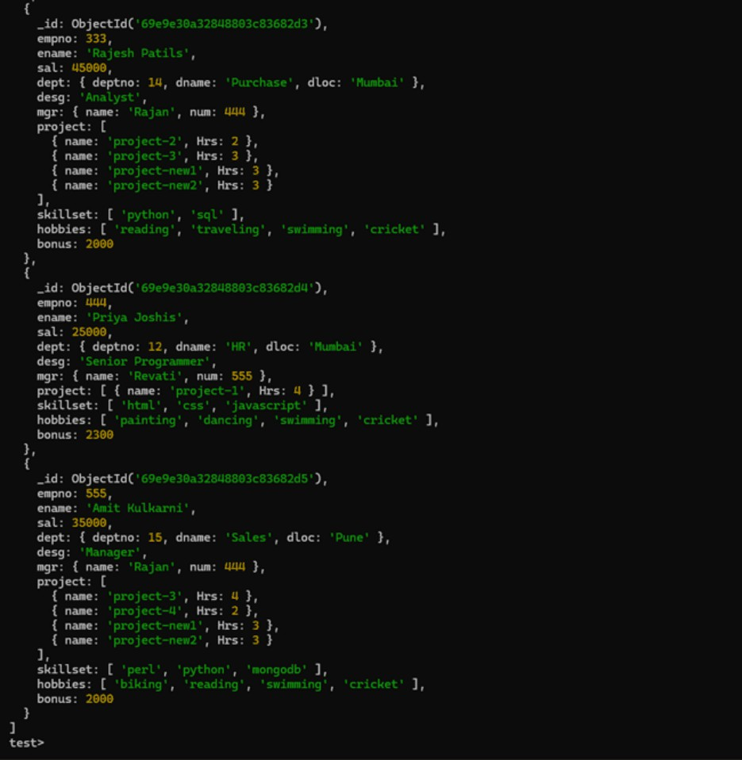

- Add list of skillset in all employee documents who are working on project-4 for 3 hrs or on project-3 for 4 hrs.
Provided screenshot:
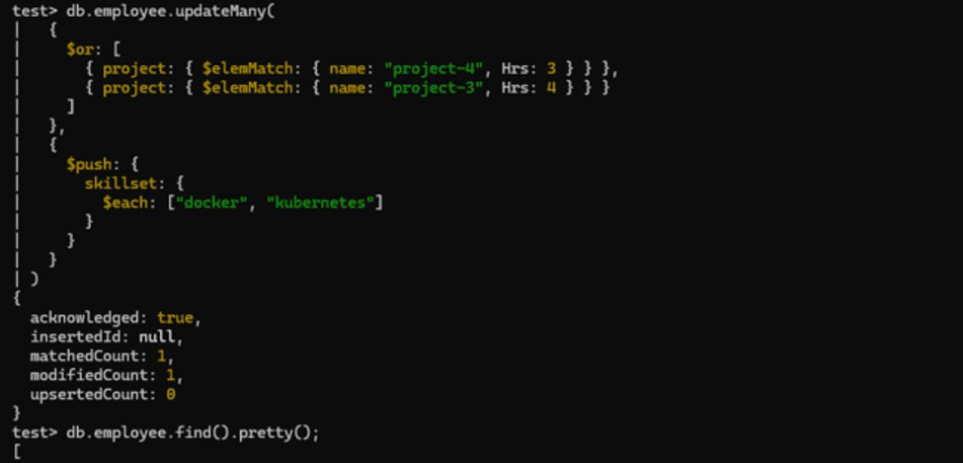

- Add a new hobby as blogging at 3 position in hobbies array for all employees whose name starts with R or p and ends with j or s.
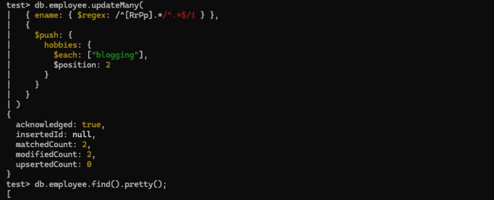
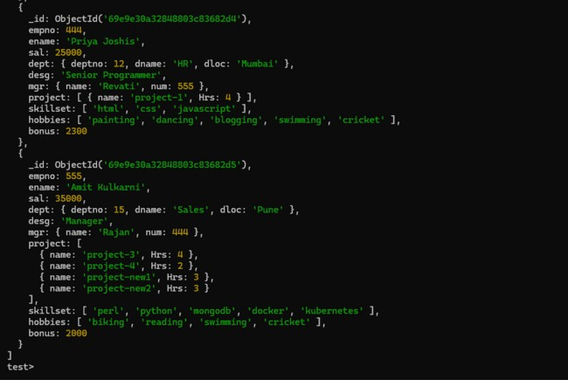

- Increase salary by 10000 for all employees who are working on project-2 or project-3 or project-1. Decrease bonus by 1000 Rs and increase salary by 1000 Rs for all employees whose department location is Mumbai.
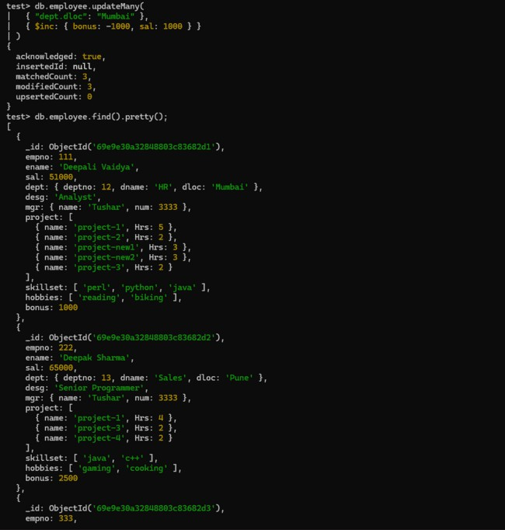

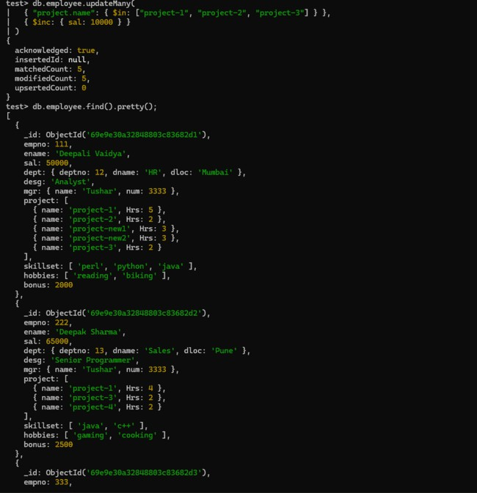

- Remove all employees working on project-1.
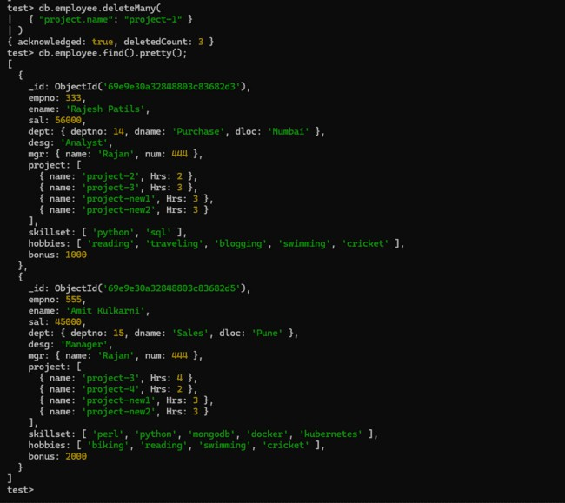

- Replace document of employee with name “Deepak” to some new document.
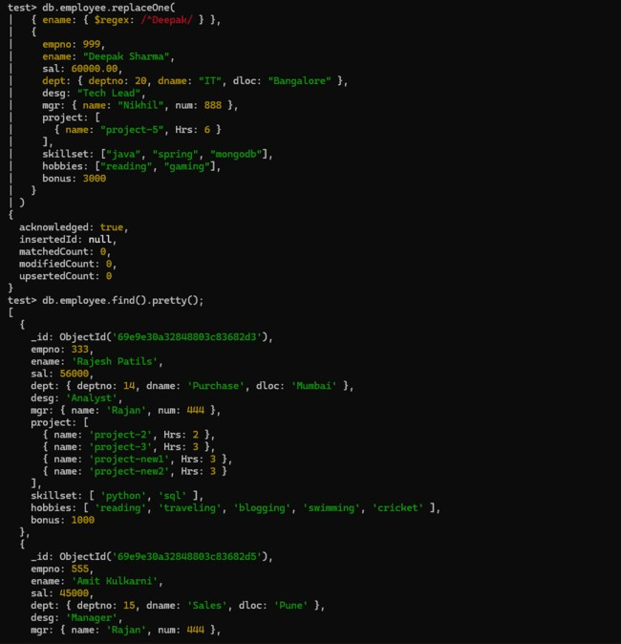

- Change skill python to python 3.8 for all employees if python is there in the skillset.
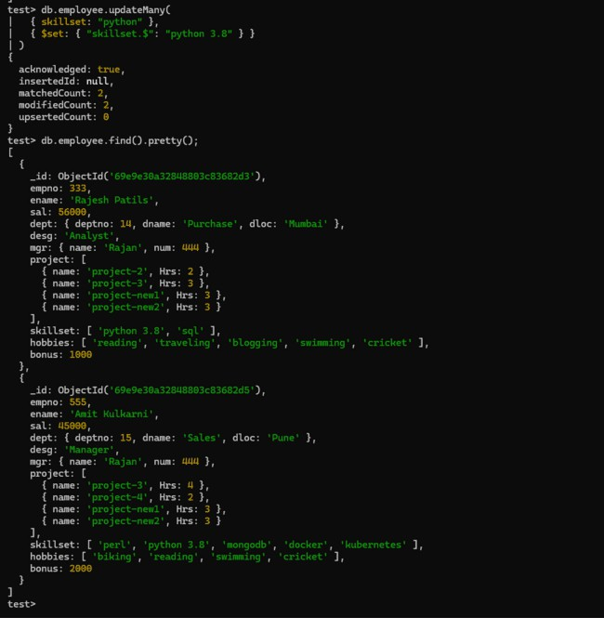

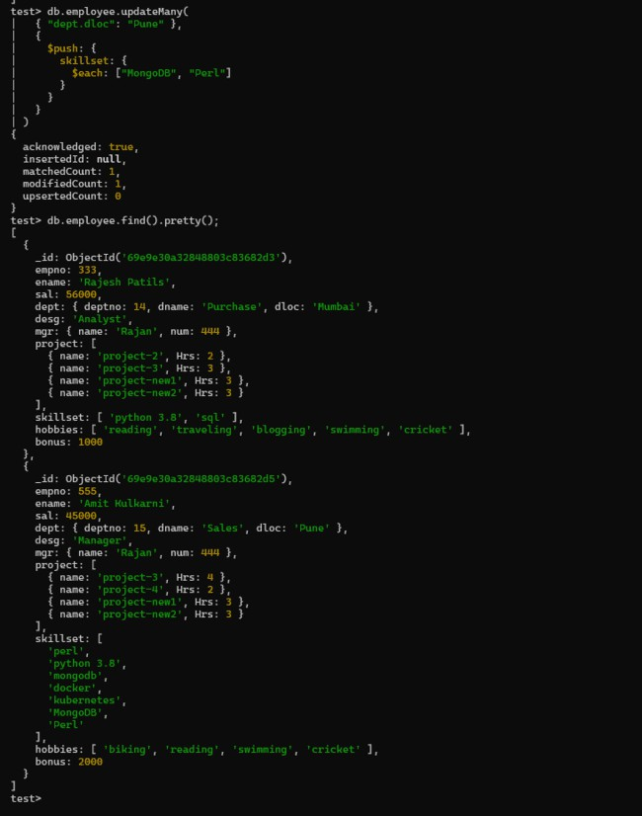
- Add 2 skills MongoDb and Perl at the end of skillset array for all employees who are working at Pune location.

- Delete first hobby from hobby array for all employees who are working on project-1 or project-2.
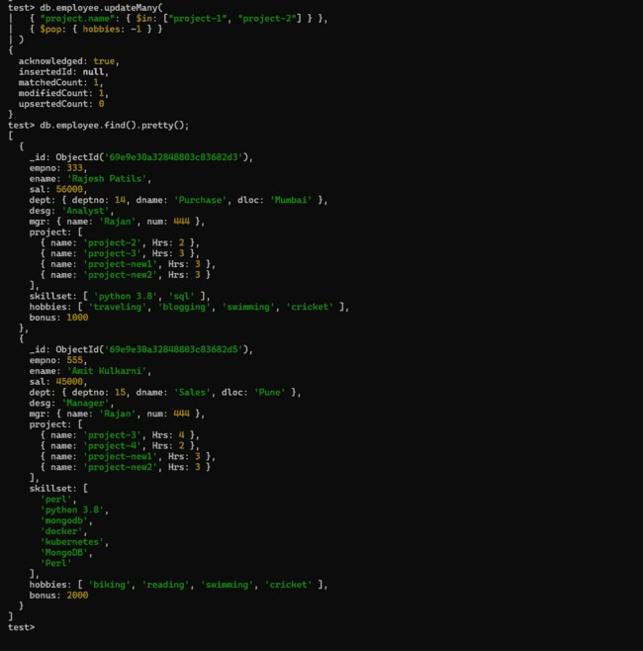

- Delete last hobby from hobbies array for all employees who are working on project which is at 2nd position in projects array for 4 hrs.
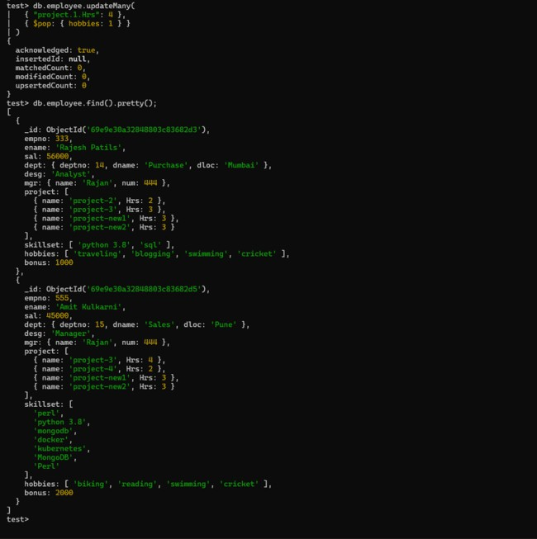

- Add 2 new projects at the end of array for all employees whose skillset contains Perl or python.
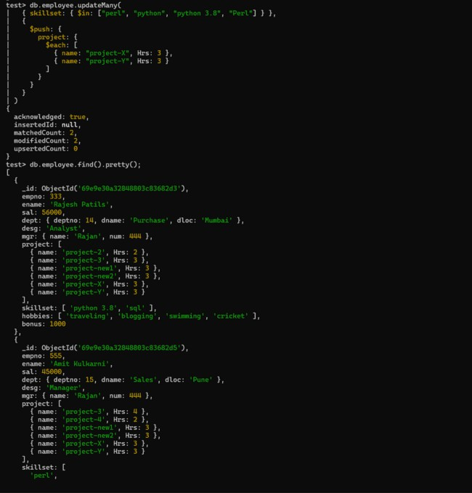

- Change hrs to 6 for project-1 for all employees if they are working on project-1 for <6 hrs. Otherwise keep the existing value.
