NAME: ANURAG VILAS DHONDGE
ROLL:268013
PRN:260841220030
COLLEGE: IACSD(CDAC)
DEPT:PGCP-AC

Q1. Write a program using HTML, CSS, JavaScript and jQuery to accept the following details and perform the required validations. OR Design front-end application in react
Design a web-page for a customer who wants to sell a used car.
Fields to be accepted:
- Owner Name
- Car Brand (Maruti Suzuki, Hyundai, Tata, Honda)
- Car Model
- Fuel Type (Petrol, Diesel, CNG, Electric)
- Manufacturing Year
- Selling Price
- Kilometers Driven
- Contact Number
- Negotiable (Checkbox)
Perform the following validations:
- All fields are mandatory except Negotiable.
- Owner Name cannot exceed 25 characters.
- Populate Car Model dynamically based on the selected Car Brand.
- Fuel Type must be selected from the given options.
- Manufacturing Year must be a valid year and cannot be in the future.
- Selling Price must be a positive number.
- Kilometers Driven must be zero or a positive number.
- Contact Number must contain exactly 10 digits.
- Display a success message after all validations pass.

Solution:
src/App.jsx:

import { useState } from "react";

function App() {
const [car, setCar] = useState({
owner: "",
brand: "",
model: "",
fuel: "",
year: "",
price: "",
km: "",
contact: "",
negotiable: false
});

const [msg, setMsg] = useState("");

const models = {
"Maruti Suzuki": ["Swift", "Baleno", "Brezza"],
Hyundai: ["i20", "Creta", "Venue"],
Tata: ["Nexon", "Punch", "Tiago"],
Honda: ["City", "Amaze", "Elevate"]
};

function handleChange(e) {
const { name, value, type, checked } = e.target;

setCar({
...car,
[name]: type === "checkbox" ? checked : value,
...(name === "brand" ? { model: "" } : {})
});

setMsg("");
}

function handleSubmit(e) {
e.preventDefault();

const currentYear = new Date().getFullYear();

if (
!car.owner.trim() ||
!car.brand ||
!car.model ||
!car.fuel ||
!car.year ||
!car.price ||
car.km === "" ||
!car.contact.trim()
) {
setMsg("All fields are mandatory except Negotiable.");
} else if (car.owner.trim().length > 25) {
setMsg("Owner name cannot exceed 25 characters.");
} else if (
!Number.isInteger(Number(car.year)) ||
Number(car.year) < 1886 ||
Number(car.year) > currentYear
) {
setMsg("Enter a valid manufacturing year.");
} else if (!Number.isFinite(Number(car.price)) ||
Number(car.price) <= 0) {
setMsg("Selling price must be positive.");
} else if (!Number.isFinite(Number(car.km)) ||
Number(car.km) < 0) {
setMsg("Kilometers must be zero or positive.");
} else if (!/^\d{10}$/.test(car.contact.trim())) {
setMsg("Contact number must contain exactly 10 digits.");
} else {
setMsg("Car details submitted successfully!");
}
}

return (
<div className="container">
<h2>Sell Your Used Car</h2>

<form onSubmit={handleSubmit}>
<label>Owner Name:</label>
<input
name="owner"
value={car.owner}
onChange={handleChange}
maxLength="100"
/>

<label>Car Brand:</label>
<select name="brand" value={car.brand}
onChange={handleChange}>
<option value="">Select Brand</option>
<option>Maruti Suzuki</option>
<option>Hyundai</option>
<option>Tata</option>
<option>Honda</option>
</select>

<label>Car Model:</label>
<select name="model" value={car.model}
onChange={handleChange}>
<option value="">Select Model</option>
{models[car.brand]?.map((m) => (
<option key={m} value={m}>{m}</option>
))}
</select>

<label>Fuel Type:</label>
<select name="fuel" value={car.fuel}
onChange={handleChange}>
<option value="">Select Fuel</option>
<option>Petrol</option>
<option>Diesel</option>
<option>CNG</option>
<option>Electric</option>
</select>

<label>Manufacturing Year:</label>
<input type="number" name="year"
value={car.year} onChange={handleChange} />

<label>Selling Price:</label>
<input type="number" name="price"
value={car.price} onChange={handleChange} />

<label>Kilometers Driven:</label>
<input type="number" name="km"
value={car.km} onChange={handleChange} />

<label>Contact Number:</label>
<input type="text" name="contact"
value={car.contact} onChange={handleChange} />

<label className="check">
<input type="checkbox" name="negotiable"
checked={car.negotiable}
onChange={handleChange} />
Negotiable
</label>

<button type="submit">Submit</button>
</form>

{msg && (
<p className={msg.includes("successfully") ? "success" : "error"}>
{msg}
</p>
)}
</div>
);
}

export default App;

src/main.jsx

import { StrictMode } from "react";
import { createRoot } from "react-dom/client";
import App from "./App.jsx";
import "./index.css";

createRoot(document.getElementById("root")).render(
<StrictMode>
<App />
</StrictMode>
);

src/index.css

body {
font-family: Arial, sans-serif;
background: #f2f4f7;
}

.container {
width: 400px;
max-width: 90%;
margin: 30px auto;
padding: 20px;
background: white;
border-radius: 10px;
}

h2 {
text-align: center;
}

label {
display: block;
margin-top: 12px;
}

input:not([type="checkbox"]),
select {
width: 100%;
box-sizing: border-box;
padding: 9px;
margin-top: 5px;
}

.check {
display: flex;
align-items: center;
gap: 8px;
}

button {
width: 100%;
padding: 10px;
margin-top: 18px;
background: steelblue;
color: white;
border: none;
cursor: pointer;
}

.success {
color: green;
text-align: center;
}

.error {
color: red;
text-align: center;
}

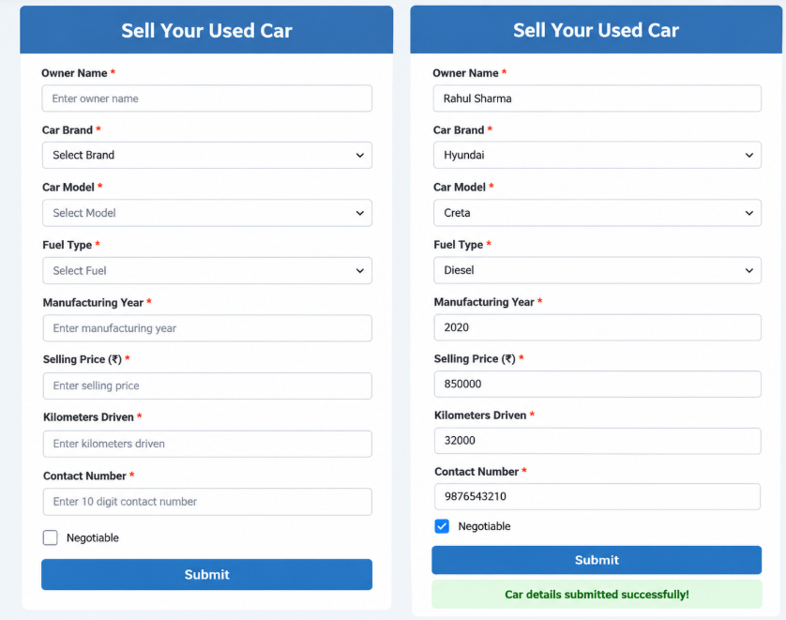

Q2.Write a program using HTML, CSS, JavaScript and jQuery to accept the following details and perform the required validations. Or Design front-end application in react
Design a webpage for a property owner who wants to list a property for rent.
Fields to be accepted:
- Owner Name
- Property Type (Flat, Bungalow, Shop, Office)
- Property Location
- Number of Bedrooms
- Furnishing Type (Furnished, Semi-Furnished, Unfurnished)
- Monthly Rent
- Security Deposit
- Available From Date
- Contact Number
Perform the following validations:
- All fields are mandatory.
- Owner Name cannot exceed 25 characters.
- Populate Number of Bedrooms dynamically based on Property Type.
- Monthly Rent must be a positive number.
- Security Deposit must be a positive number.
- Available From Date cannot be earlier than the current date.
- Contact Number must contain exactly 10 digits.
- Display a confirmation message after successful validation.

Solution:
src/App.jsx

import { useState } from "react";

function App() {
const [property, setProperty] = useState({
owner: "",
type: "",
location: "",
bedrooms: "",
furnishing: "",
rent: "",
deposit: "",
date: "",
contact: ""
});

const [msg, setMsg] = useState("");

const bedroomOptions = {
Flat: ["1 BHK", "2 BHK", "3 BHK", "4 BHK"],
Bungalow: ["2 BHK", "3 BHK", "4 BHK", "5 BHK"],
Shop: ["Not Applicable"],
Office: ["Not Applicable"]
};

function handleChange(e) {
const { name, value } = e.target;

setProperty({
...property,
[name]: value,
...(name === "type" ? { bedrooms: "" } : {})
});

setMsg("");
}

function handleSubmit(e) {
e.preventDefault();

const today = new Date();
const currentDate =
today.getFullYear() + "-" +
String(today.getMonth() + 1).padStart(2, "0") + "-" +
String(today.getDate()).padStart(2, "0");

if (Object.values(property).some(v => String(v).trim() === "")) {
setMsg("All fields are mandatory.");
} else if (property.owner.trim().length > 25) {
setMsg("Owner name cannot exceed 25 characters.");
} else if (Number(property.rent) <= 0 ||
!Number.isFinite(Number(property.rent))) {
setMsg("Monthly rent must be a positive number.");
} else if (Number(property.deposit) <= 0 ||
!Number.isFinite(Number(property.deposit))) {
setMsg("Security deposit must be a positive number.");
} else if (property.date < currentDate) {
setMsg("Available date cannot be earlier than today.");
} else if (!/^\d{10}$/.test(property.contact.trim())) {
setMsg("Contact number must contain exactly 10 digits.");
} else {
setMsg("Property listed successfully!");
}
}

return (
<div className="container">
<h2>List Your Property for Rent</h2>

<form onSubmit={handleSubmit}>
<label>Owner Name:</label>
<input
name="owner"
value={property.owner}
onChange={handleChange}
maxLength="100"
/>

<label>Property Type:</label>
<select name="type" value={property.type}
onChange={handleChange}>
<option value="">Select Property Type</option>
<option>Flat</option>
<option>Bungalow</option>
<option>Shop</option>
<option>Office</option>
</select>

<label>Property Location:</label>
<input
name="location"
value={property.location}
onChange={handleChange}
/>

<label>Number of Bedrooms:</label>
<select name="bedrooms" value={property.bedrooms}
onChange={handleChange}>
<option value="">Select Bedrooms</option>
{bedroomOptions[property.type]?.map(b => (
<option key={b} value={b}>{b}</option>
))}
</select>

<label>Furnishing Type:</label>
<select name="furnishing" value={property.furnishing}
onChange={handleChange}>
<option value="">Select Furnishing</option>
<option>Furnished</option>
<option>Semi-Furnished</option>
<option>Unfurnished</option>
</select>

<label>Monthly Rent:</label>
<input type="number" name="rent" min="0.01"
value={property.rent} onChange={handleChange} />

<label>Security Deposit:</label>
<input type="number" name="deposit" min="0.01"
value={property.deposit} onChange={handleChange} />

<label>Available From Date:</label>
<input type="date" name="date"
min={new Date().getFullYear() + "-" +
String(new Date().getMonth() + 1).padStart(2, "0") + "-" +
String(new Date().getDate()).padStart(2, "0")}
value={property.date} onChange={handleChange} />

<label>Contact Number:</label>
<input type="text" name="contact" maxLength="10"
value={property.contact} onChange={handleChange} />

<button type="submit">Submit Property</button>
</form>

{msg && (
<p className={msg.includes("successfully") ? "success" : "error"}>
{msg}
</p>
)}
</div>
);
}

export default App;

src/main.jsx

import { StrictMode } from "react";
import { createRoot } from "react-dom/client";
import App from "./App.jsx";
import "./index.css";

createRoot(document.getElementById("root")).render(
<StrictMode>
<App />
</StrictMode>
);

src/index.css
body {
font-family: Arial, sans-serif;
background: #f2f4f7;
}

.container {
width: 400px;
max-width: 90%;
margin: 30px auto;
padding: 20px;
background: white;
border-radius: 10px;
}

h2 {
text-align: center;
}

label {
display: block;
margin-top: 12px;
}

input, select {
width: 100%;
box-sizing: border-box;
padding: 9px;
margin-top: 5px;
}

button {
width: 100%;
padding: 10px;
margin-top: 18px;
background: steelblue;
color: white;
border: none;
cursor: pointer;
}

.success {
color: green;
text-align: center;
}

.error {
color: red;
text-align: center;
}

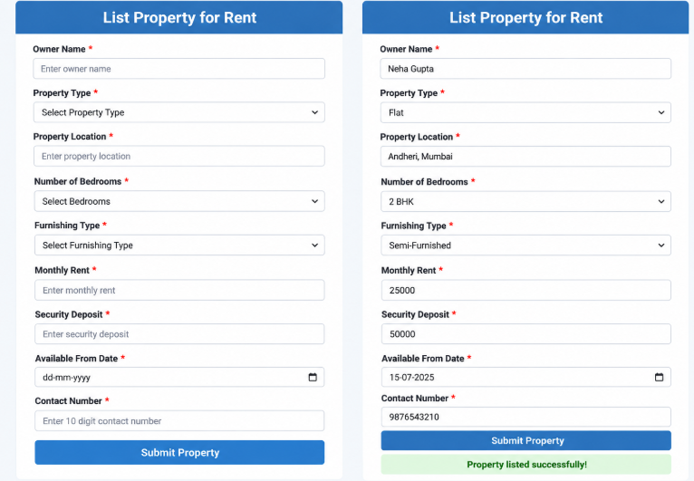

Q3.Write a program using HTML, CSS, JavaScript and jQuery to accept the following details and perform the required validations. Or Design front-end application in react

Design a webpage to accept the details of a seller who wants to sell a laptop online.
Fields to be accepted:
- Seller Name
- Laptop Brand (HP, Dell, Lenovo, Apple)
- Laptop Model
- Processor Type (i3, i5, i7, Ryzen 5, Ryzen 7)
- RAM Capacity
- Storage Type (HDD, SSD)
- Laptop Color
- Selling Price
- Contact Number
- Negotiable (Checkbox)
Perform the following validations:
- All fields are mandatory except Negotiable.
- Seller Name cannot exceed 20 characters.
- Populate Laptop Model dynamically based on the selected Laptop Brand.
- Populate Processor Type options based on the selected Laptop Brand.
- RAM Capacity must be selected from the available options (4 GB, 8 GB, 16 GB, 32 GB).
- Selling Price must be a positive number.
- Contact Number must contain exactly 10 digits.
- Display appropriate error messages for invalid fields.
- Display a success message after successful validation.

Solution:

src/App.jsx:

import { useState } from "react";

function App() {

const [laptop, setLaptop] = useState({

seller: "",

brand: "",

model: "",

processor: "",

ram: "",

storage: "",

color: "",

price: "",

contact: "",

negotiable: false

});

const [msg, setMsg] = useState("");

const [error, setError] = useState(false);

const laptopData = {

HP: {

models: ["Pavilion", "ProBook", "EliteBook"],

processors: ["i3", "i5", "i7", "Ryzen 5", "Ryzen 7"]

},

Dell: {

models: ["Inspiron", "Vostro", "XPS"],

processors: ["i3", "i5", "i7"]

},

Lenovo: {

models: ["IdeaPad", "ThinkPad", "Yoga"],

processors: ["i3", "i5", "i7", "Ryzen 5", "Ryzen 7"]

},

Apple: {

models: ["MacBook Air", "MacBook Pro"],

processors: ["M1", "M2", "M3"]

}

};

function handleChange(e) {

const { name, value, type, checked } = e.target;

setLaptop(prev => ({

...prev,

[name]: type === "checkbox" ? checked : value,

...(name === "brand" ? { model: "", processor: "" } : {})

}));

setMsg("");

}

function handleSubmit(e) {

e.preventDefault();

if (

!laptop.seller.trim() ||

!laptop.brand ||

!laptop.model ||

!laptop.processor ||

!laptop.ram ||

!laptop.storage ||

!laptop.color.trim() ||

laptop.price === "" ||

!laptop.contact.trim()

) {

setError(true);

setMsg("All fields are mandatory except Negotiable.");

} else if (laptop.seller.trim().length > 20) {

setError(true);

setMsg("Seller name cannot exceed 20 characters.");

} else if (

!Number.isFinite(Number(laptop.price)) ||

Number(laptop.price) <= 0

) {

setError(true);

setMsg("Selling price must be a positive number.");

} else if (!/^\d{10}$/.test(laptop.contact.trim())) {

setError(true);

setMsg("Contact number must contain exactly 10 digits.");

} else {

setError(false);

setMsg("Laptop details submitted successfully!");

}

}

return (

<div className="container">

<h2>Sell Your Laptop</h2>

<form onSubmit={handleSubmit}>

<label>Seller Name:</label>

<input

name="seller"

value={laptop.seller}

onChange={handleChange}

/>

<label>Laptop Brand:</label>

<select name="brand" value={laptop.brand}

onChange={handleChange}>

<option value="">Select Brand</option>

<option>HP</option>

<option>Dell</option>

<option>Lenovo</option>

<option>Apple</option>

</select>

<label>Laptop Model:</label>

<select name="model" value={laptop.model}

onChange={handleChange}>

<option value="">Select Model</option>

{laptopData[laptop.brand]?.models.map(m => (

<option key={m} value={m}>{m}</option>

))}

</select>

<label>Processor Type:</label>

<select name="processor" value={laptop.processor}

onChange={handleChange}>

<option value="">Select Processor</option>

{laptopData[laptop.brand]?.processors.map(p => (

<option key={p} value={p}>{p}</option>

))}

</select>

<label>RAM Capacity:</label>

<select name="ram" value={laptop.ram}

onChange={handleChange}>

<option value="">Select RAM</option>

<option>4 GB</option>

<option>8 GB</option>

<option>16 GB</option>

<option>32 GB</option>

</select>

<label>Storage Type:</label>

<select name="storage" value={laptop.storage}

onChange={handleChange}>

<option value="">Select Storage</option>

<option>HDD</option>

<option>SSD</option>

</select>

<label>Laptop Color:</label>

<input

name="color"

value={laptop.color}

onChange={handleChange}

/>

<label>Selling Price:</label>

<input

type="number"

name="price"

min="0.01"

value={laptop.price}

onChange={handleChange}

/>

<label>Contact Number:</label>

<input

type="text"

name="contact"

maxLength="10"

value={laptop.contact}

onChange={handleChange}

/>

<label className="check">

<input

type="checkbox"

name="negotiable"

checked={laptop.negotiable}

onChange={handleChange}

/>

Negotiable

</label>

<button type="submit">Submit Laptop</button>

</form>

{msg && (

<p className={error ? "error" : "success"}>{msg}</p>

)}

</div>

);

}

export default App;

src/main.jsx

import { StrictMode } from "react";

import { createRoot } from "react-dom/client";

import App from "./App.jsx";

import "./index.css";

createRoot(document.getElementById("root")).render(

<StrictMode>

<App />

</StrictMode>

);

src/index.css

body {

font-family: Arial, sans-serif;

background: #f2f4f7;

}

.container {

width: 400px;

max-width: 90%;

margin: 30px auto;

padding: 20px;

background: white;

border-radius: 10px;

}

h2 {

text-align: center;

color: #1d4ed8;

}

label {

display: block;

margin-top: 12px;

}

input:not([type="checkbox"]),

select {

width: 100%;

box-sizing: border-box;

padding: 9px;

margin-top: 5px;

border: 1px solid #ccc;

border-radius: 5px;

}

.check {

display: flex;

align-items: center;

gap: 8px;

}

button {

width: 100%;

padding: 11px;

margin-top: 18px;

background: steelblue;

color: white;

border: none;

border-radius: 5px;

cursor: pointer;

}

.success {

color: green;

text-align: center;

}

.error {

color: red;

text-align: center;

}

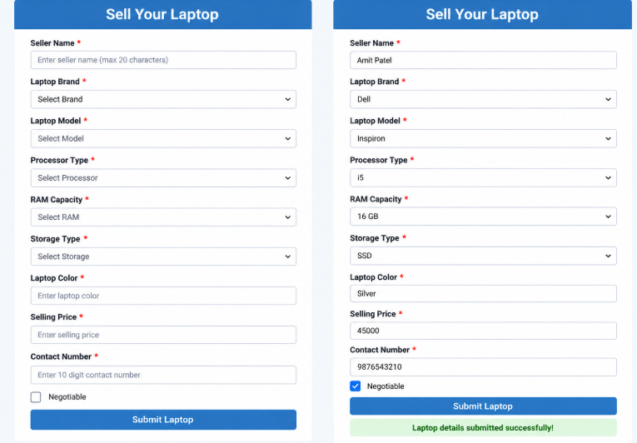

Q4: Student Management Web Service using Node.js, Express.js, and React

Part A: Design a Web Service using Node.js and Express.js
Create a module named studentModule.js. Store student information in an array named studentsarr. For each student, store the following attributes: (sid, sname, course).
Implement the following functions in studentModule.js:
- getAllStudents() — Return all student records in JSON format.
- addStudent(studentObject) — Add a new student object to the array and return the message "Student added successfully".
- updateStudent(sid, updatedStudent) — Update the details of the student with the specified student ID and return an appropriate success message.
- deleteStudent(sid) — Delete the student with the specified student ID and return an appropriate success message.
Write an Express application with the following requirements:
- A GET request to /students should return all student records in JSON format.
- A POST request to /students should add a new student to the array.
- A PUT request to /students/:sid should update the details of the student identified by sid.
- A DELETE request to /students/:sid should delete the student identified by sid.
- Return an appropriate success message after every successful operation.
- If a student ID does not exist during an update or delete operation, return an appropriate error message with a suitable HTTP status code.

Part B: Develop a React Application
Create a React application to communicate with the Express.js web service.
- Retrieve all student records using a GET request to /students.
- Display Student ID, Student Name, and Course in a table.
- Add an Add New Student button above the table.
- On clicking the button, display an empty form with fields for Student ID, Student Name, and Course.
- On clicking Submit Student, send a POST request to the Express.js application.
- Refresh the table after successful insertion and display a success message.
- Add an Edit button for each student record. On clicking it, display a form pre-filled with the selected student's details.
- On submitting the updated details, send a PUT request to /students/:sid and refresh the table.
- Add a Delete button for each student record. On clicking it, send a DELETE request to /students/:sid.
- Refresh the table after successful deletion and display an appropriate success message.
- Display appropriate error messages if an operation fails.

Solution:

studentModule.js:

let studentsarr = [

{ sid: "1", sname: "Amit Sharma", course: "BCA" },

{ sid: "2", sname: "Neha Patil", course: "MCA" },

{ sid: "3", sname: "Rohan Deshmukh", course: "BSc CS" }

];

function getAllStudents() {

return studentsarr;

}

function addStudent(studentObject) {

if (studentsarr.some(s => s.sid == studentObject.sid)) {

return "Student ID already exists";

}

studentsarr.push(studentObject);

return "Student added successfully";

}

function updateStudent(sid, updatedStudent) {

let found = false;

studentsarr = studentsarr.map(function (student) {

if (student.sid == sid) {

found = true;

return { ...updatedStudent, sid: String(sid) };

}

return student;

});

if (found) return "Student updated successfully";

return "Student ID not found";

}

function deleteStudent(sid) {

let oldLength = studentsarr.length;

studentsarr = studentsarr.filter(function (student) {

return student.sid != sid;

});

if (studentsarr.length < oldLength) {

return "Student deleted successfully";

}

return "Student ID not found";

}

module.exports = {

getAllStudents,

addStudent,

updateStudent,

deleteStudent

};

index.js:

const express = require("express");

const cors = require("cors");

const student = require("./studentModule");

const app = express();

app.use(cors());

app.use(express.json());

// GET: Display all students

app.get("/students", (req, res) => {

res.json(student.getAllStudents());

});

// POST: Add a student

app.post("/students", (req, res) => {

const { sid, sname, course } = req.body;

if (sid == null || !String(sid).trim() ||

!sname?.trim() || !course?.trim()) {

return res.status(400).json({

message: "All fields are required"

});

}

const result = student.addStudent({ sid: String(sid), sname, course });

if (result === "Student ID already exists") {

return res.status(409).json({ message: result });

}

res.status(201).json({ message: result });

});

// PUT: Update a student

app.put("/students/:sid", (req, res) => {

const { sname, course } = req.body;

if (!sname?.trim() || !course?.trim()) {

return res.status(400).json({

message: "Student name and course are required"

});

}

const result = student.updateStudent(req.params.sid, {

sname,

course

});

if (result === "Student ID not found") {

return res.status(404).json({ message: result });

}

res.json({ message: result });

});

// DELETE: Delete a student

app.delete("/students/:sid", (req, res) => {

const result = student.deleteStudent(req.params.sid);

if (result === "Student ID not found") {

return res.status(404).json({ message: result });

}

res.json({ message: result });

});

app.listen(2222, () => {

console.log("Server running on port 2222");

});

package.json:

{

"name": "student-server",

"version": "1.0.0",

"main": "index.js",

"scripts": {

"start": "node index.js"

},

"dependencies": {

"cors": "^2.8.5",

"express": "^4.21.2"

}

}

client/src/App.jsx:

import { useEffect, useState } from "react";

const API = "http://localhost:2222/students";

function App() {

const [students, setStudents] = useState([]);

const [student, setStudent] = useState({

sid: "",

sname: "",

course: ""

});

const [showForm, setShowForm] = useState(false);

const [editing, setEditing] = useState(false);

const [msg, setMsg] = useState("");

const [error, setError] = useState(false);

async function loadStudents() {

try {

const res = await fetch(API);

if (!res.ok) throw new Error("Failed to load students");

const data = await res.json();

setStudents(data);

} catch (err) {

setError(true);

setMsg("Cannot connect to server. Start the backend first.");

}

}

useEffect(() => {

loadStudents();

}, []);

function handleChange(e) {

setStudent({

...student,

[e.target.name]: e.target.value

});

}

function addNew() {

setStudent({ sid: "", sname: "", course: "" });

setEditing(false);

setShowForm(true);

setMsg("");

}

function editStudent(s) {

setStudent({ ...s });

setEditing(true);

setShowForm(true);

setMsg("");

}

async function handleSubmit(e) {

e.preventDefault();

try {

const url = editing ? `${API}/${student.sid}` : API;

const res = await fetch(url, {

method: editing ? "PUT" : "POST",

headers: {

"Content-Type": "application/json"

},

body: JSON.stringify(student)

});

const data = await res.json();

if (!res.ok) throw new Error(data.message);

setError(false);

setMsg(data.message);

setShowForm(false);

await loadStudents();

} catch (err) {

setError(true);

setMsg(err.message || "Operation failed");

}

}

async function deleteStudent(sid) {

if (!window.confirm("Delete this student?")) return;

try {

const res = await fetch(`${API}/${sid}`, {

method: "DELETE"

});

const data = await res.json();

if (!res.ok) throw new Error(data.message);

setError(false);

setMsg(data.message);

await loadStudents();

} catch (err) {

setError(true);

setMsg(err.message || "Delete failed");

}

}

return (

<div className="container">

<h2>Student Management</h2>

<button onClick={addNew}>Add New Student</button>

{showForm && (

<form onSubmit={handleSubmit}>

<h3>{editing ? "Edit Student" : "Add Student"}</h3>

<label>Student ID:</label>

<input

name="sid"

value={student.sid}

onChange={handleChange}

disabled={editing}

required

/>

<label>Student Name:</label>

<input

name="sname"

value={student.sname}

onChange={handleChange}

required

/>

<label>Course:</label>

<input

name="course"

value={student.course}

onChange={handleChange}

required

/>

<button type="submit">

{editing ? "Update Student" : "Submit Student"}

</button>

<button type="button" onClick={() => setShowForm(false)}>

Cancel

</button>

</form>

)}

{msg && (

<p className={error ? "error" : "success"}>{msg}</p>

)}

<table>

<thead>

<tr>

<th>Student ID</th>

<th>Student Name</th>

<th>Course</th>

<th>Actions</th>

</tr>

</thead>

<tbody>

{students.map(s => (

<tr key={s.sid}>

<td>{s.sid}</td>

<td>{s.sname}</td>

<td>{s.course}</td>

<td>

<button onClick={() => editStudent(s)}>

Edit

</button>

<button onClick={() => deleteStudent(s.sid)}>

Delete

</button>

</td>

</tr>

))}

{students.length === 0 && (

<tr>

<td colSpan="4">No students found</td>

</tr>

)}

</tbody>

</table>

</div>

);

}

export default App;

client/src/main.jsx:

import { StrictMode } from "react";

import { createRoot } from "react-dom/client";

import App from "./App.jsx";

import "./index.css";

createRoot(document.getElementById("root")).render(

<StrictMode>

<App />

</StrictMode>

);

client/src/index.css:

body {

font-family: Arial, sans-serif;

background: #f2f4f7;

margin: 0;

}

.container {

max-width: 900px;

margin: 40px auto;

padding: 25px;

background: white;

border-radius: 10px;

}

h2 {

text-align: center;

color: steelblue;

}

label {

display: block;

margin-top: 12px;

}

input {

width: 100%;

box-sizing: border-box;

padding: 10px;

margin-top: 5px;

border: 1px solid #ccc;

border-radius: 5px;

}

button {

padding: 9px 14px;

margin: 8px 5px 8px 0;

background: steelblue;

color: white;

border: none;

border-radius: 5px;

cursor: pointer;

}

table {

width: 100%;

border-collapse: collapse;

margin-top: 20px;

}

th, td {

border: 1px solid #ddd;

padding: 12px;

text-align: left;

}

th {

background: steelblue;

color: white;

}

.success {

color: green;

}

.error {

color: red;

}

@media (max-width: 600px) {

.container {

margin: 10px;

padding: 12px;

overflow-x: auto;

}

}

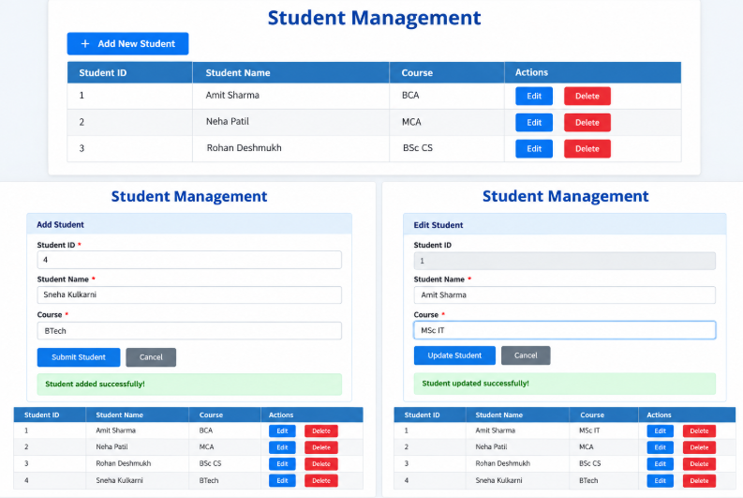

Q5 : Employee Management Web Service using Node.js, Express.js, and React

Part A: Design a Web Service using Node.js and Express.js
Create a module named employeeModule.js. Store employee information in an array named employeesarr. For each employee, store the following attributes: (eid, ename, salary).
Implement the following functions in employeeModule.js:
- getAllEmployees() — Return all employee records in JSON format.
- addEmployee(employeeObject) — Add a new employee object to the array and return the message "Employee added successfully".
- updateEmployee(eid, updatedEmployee) — Update the details of the employee with the specified employee ID and return an appropriate success message.
- deleteEmployee(eid) — Delete the employee with the specified employee ID and return an appropriate success message.
Write an Express application with the following requirements:
- A GET request to /employees should return all employee records in JSON format.
- A POST request to /employees should add a new employee object to the array.
- A PUT request to /employees/:eid should update the details of the employee identified by eid.
- A DELETE request to /employees/:eid should delete the employee identified by eid.
- Return an appropriate success message after every successful operation.
- If an employee ID does not exist during an update or delete operation, return an appropriate error message with a suitable HTTP status code.

Part B: Develop a React Application
Create a React application to communicate with the Express.js web service.
- Retrieve all employee records using a GET request to /employees.
- Display Employee ID, Employee Name, and Salary in a table.
- Add an Add New Employee button above the table.
- On clicking the button, display an empty form with fields for Employee ID, Employee Name, and Salary.
- On clicking Submit Employee, send a POST request to the Express.js application.
- Refresh the table after successful insertion and display a success message.
- Add an Edit button for each employee record. On clicking it, display a form pre-filled with the selected employee's details.
- On submitting the updated details, send a PUT request to /employees/:eid and refresh the table.
- Add a Delete button for each employee record. On clicking it, send a DELETE request to /employees/:eid.
- Refresh the table after successful deletion and display a success message.
- Display appropriate error messages if an operation fails.

Solution:

employeeModule.js:

let employeesarr = [

{ eid: "101", ename: "Ravi Kumar", salary: "45000" },

{ eid: "102", ename: "Sita Verma", salary: "52000" },

{ eid: "103", ename: "Arjun Mehta", salary: "60000" },

{ eid: "104", ename: "Kavita Nair", salary: "48000" },

{ eid: "105", ename: "Manoj Singh", salary: "75000" }

];

function getAllEmployees() {

return employeesarr;

}

function addEmployee(employeeObject) {

if (employeesarr.some(e => e.eid == employeeObject.eid)) {

return "Employee ID already exists";

}

employeesarr.push(employeeObject);

return "Employee added successfully";

}

function updateEmployee(eid, updatedEmployee) {

let found = false;

employeesarr = employeesarr.map(function (employee) {

if (employee.eid == eid) {

found = true;

return { ...updatedEmployee, eid: String(eid) };

}

return employee;

});

if (found) return "Employee updated successfully";

return "Employee ID not found";

}

function deleteEmployee(eid) {

const oldLength = employeesarr.length;

employeesarr = employeesarr.filter(function (employee) {

return employee.eid != eid;

});

if (employeesarr.length < oldLength) {

return "Employee deleted successfully";

}

return "Employee ID not found";

}

module.exports = {

getAllEmployees,

addEmployee,

updateEmployee,

deleteEmployee

};

index.js:

const express = require("express");

const cors = require("cors");

const employee = require("./employeeModule");

const app = express();

app.use(cors());

app.use(express.json());

// GET: Get all employees

app.get("/employees", (req, res) => {

res.json(employee.getAllEmployees());

});

// POST: Add employee

app.post("/employees", (req, res) => {

const { eid, ename, salary } = req.body;

if (eid == null || !String(eid).trim() ||

!ename?.trim() || salary == null ||

String(salary).trim() === "") {

return res.status(400).json({

message: "All fields are required"

});

}

if (!Number.isFinite(Number(salary)) || Number(salary) <= 0) {

return res.status(400).json({

message: "Salary must be a positive number"

});

}

const result = employee.addEmployee({

eid: String(eid),

ename: ename.trim(),

salary: String(salary)

});

if (result === "Employee ID already exists") {

return res.status(409).json({ message: result });

}

res.status(201).json({ message: result });

});

// PUT: Update employee

app.put("/employees/:eid", (req, res) => {

const { ename, salary } = req.body;

if (!ename?.trim() || salary == null ||

String(salary).trim() === "") {

return res.status(400).json({

message: "Employee name and salary are required"

});

}

if (!Number.isFinite(Number(salary)) || Number(salary) <= 0) {

return res.status(400).json({

message: "Salary must be a positive number"

});

}

const result = employee.updateEmployee(req.params.eid, {

ename: ename.trim(),

salary: String(salary)

});

if (result === "Employee ID not found") {

return res.status(404).json({ message: result });

}

res.json({ message: result });

});

// DELETE: Delete employee

app.delete("/employees/:eid", (req, res) => {

const result = employee.deleteEmployee(req.params.eid);

if (result === "Employee ID not found") {

return res.status(404).json({ message: result });

}

res.json({ message: result });

});

app.listen(2222, () => {

console.log("Server running on port 2222");

});

package.json

{

"name": "employee-server",

"version": "1.0.0",

"main": "index.js",

"scripts": {

"start": "node index.js"

},

"dependencies": {

"cors": "^2.8.5",

"express": "^4.21.2"

}

}

client/src/App.jsx

import { useEffect, useState } from "react";

const API = "http://localhost:2222/employees";

function App() {

const [employees, setEmployees] = useState([]);

const [employee, setEmployee] = useState({

eid: "",

ename: "",

salary: ""

});

const [showForm, setShowForm] = useState(false);

const [editing, setEditing] = useState(false);

const [msg, setMsg] = useState("");

const [error, setError] = useState(false);

async function loadEmployees() {

try {

const res = await fetch(API);

if (!res.ok) throw new Error("Failed to load employees");

setEmployees(await res.json());

} catch (err) {

setError(true);

setMsg("Cannot connect to server. Start the backend.");

}

}

useEffect(() => {

loadEmployees();

}, []);

function handleChange(e) {

setEmployee({

...employee,

[e.target.name]: e.target.value

});

}

function addNew() {

setEmployee({ eid: "", ename: "", salary: "" });

setEditing(false);

setShowForm(true);

setMsg("");

}

function editEmployee(e) {

setEmployee({ ...e });

setEditing(true);

setShowForm(true);

setMsg("");

}

async function handleSubmit(e) {

e.preventDefault();

try {

const url = editing ? `${API}/${employee.eid}` : API;

const res = await fetch(url, {

method: editing ? "PUT" : "POST",

headers: {

"Content-Type": "application/json"

},

body: JSON.stringify(employee)

});

const data = await res.json();

if (!res.ok) throw new Error(data.message);

setError(false);

setMsg(data.message);

setShowForm(false);

await loadEmployees();

} catch (err) {

setError(true);

setMsg(err.message || "Operation failed");

}

}

async function deleteEmployee(eid) {

if (!window.confirm("Delete this employee?")) return;

try {

const res = await fetch(`${API}/${eid}`, {

method: "DELETE"

});

const data = await res.json();

if (!res.ok) throw new Error(data.message);

setError(false);

setMsg(data.message);

await loadEmployees();

} catch (err) {

setError(true);

setMsg(err.message || "Delete failed");

}

}

return (

<div className="container">

<h2>Employee Management</h2>

<button onClick={addNew}>Add New Employee</button>

{showForm && (

<form onSubmit={handleSubmit}>

<h3>{editing ? "Edit Employee" : "Add Employee"}</h3>

<label>Employee ID:</label>

<input

name="eid"

value={employee.eid}

onChange={handleChange}

disabled={editing}

required

/>

<label>Employee Name:</label>

<input

name="ename"

value={employee.ename}

onChange={handleChange}

required

/>

<label>Salary:</label>

<input

type="number"

name="salary"

min="0.01"

value={employee.salary}

onChange={handleChange}

required

/>

<button type="submit">

{editing ? "Update Employee" : "Submit Employee"}

</button>

<button

type="button"

onClick={() => setShowForm(false)}

>

Cancel

</button>

</form>

)}

{msg && (

<p className={error ? "error" : "success"}>{msg}</p>

)}

<table>

<thead>

<tr>

<th>Employee ID</th>

<th>Employee Name</th>

<th>Salary</th>

<th>Actions</th>

</tr>

</thead>

<tbody>

{employees.map(e => (

<tr key={e.eid}>

<td>{e.eid}</td>

<td>{e.ename}</td>

<td>{e.salary}</td>

<td>

<button onClick={() => editEmployee(e)}>

Edit

</button>

<button onClick={() => deleteEmployee(e.eid)}>

Delete

</button>

</td>

</tr>

))}

{employees.length === 0 && (

<tr>

<td colSpan="4">No employees found</td>

</tr>

)}

</tbody>

</table>

</div>

);

}

export default App;

client/src/main.jsx

import { StrictMode } from "react";

import { createRoot } from "react-dom/client";

import App from "./App.jsx";

import "./index.css";

createRoot(document.getElementById("root")).render(

<StrictMode>

<App />

</StrictMode>

);

client/src/index.css

body {

font-family: Arial, sans-serif;

background: #f2f4f7;

margin: 0;

}

.container {

max-width: 900px;

margin: 40px auto;

padding: 25px;

background: white;

border-radius: 10px;

}

h2 {

text-align: center;

color: steelblue;

}

label {

display: block;

margin-top: 12px;

}

input {

width: 100%;

box-sizing: border-box;

padding: 10px;

margin-top: 5px;

border: 1px solid #ccc;

border-radius: 5px;

}

button {

padding: 9px 14px;

margin: 8px 5px 8px 0;

background: steelblue;

color: white;

border: none;

border-radius: 5px;

cursor: pointer;

}

table {

width: 100%;

border-collapse: collapse;

margin-top: 20px;

}

th, td {

border: 1px solid #ddd;

padding: 12px;

text-align: left;

}

th {

background: steelblue;

color: white;

}

.success {

color: green;

}

.error {

color: red;

}

@media (max-width: 600px) {

.container {

margin: 10px;

padding: 12px;

overflow-x: auto;

}

}

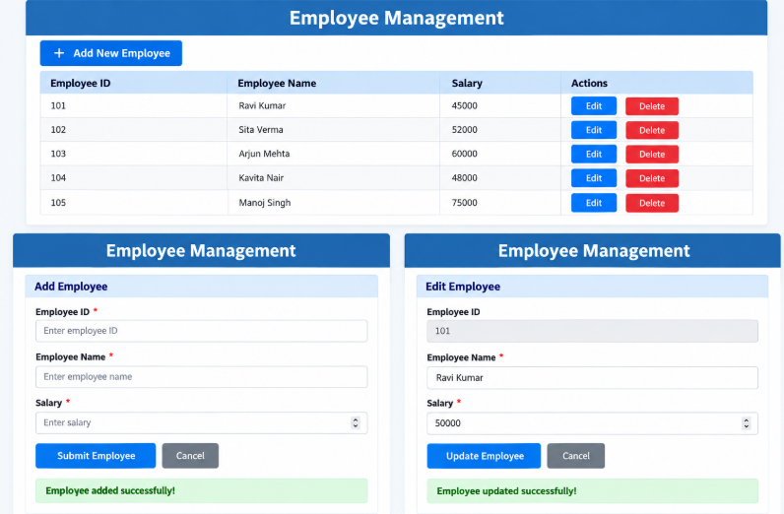

Q6 : Book Management Web Service using Node.js, Express.js, and React

Part A: Design a Web Service using Node.js and Express.js
Create a module named bookModule.js. Store book information in an array named booksarr. For each book, store the following attributes: (bookid, bname, price).
Implement the following functions in bookModule.js:
- getAllBooks() — Return all book records in JSON format.
- addBook(bookObject) — Add a new book object to the array and return the message "Book added successfully".
- updateBook(bookid, updatedBook) — Update the details of the book with the specified book ID and return an appropriate success message.
- deleteBook(bookid) — Delete the book with the specified book ID and return an appropriate success message.
Write an Express application with the following requirements:
- A GET request to /books should return all book records in JSON format.
- A POST request to /books should add a new book object to the array.
- A PUT request to /books/:bookid should update the details of the book identified by bookid.
- A DELETE request to /books/:bookid should delete the book identified by bookid.
- Return an appropriate success message after every successful operation.
- If a book ID does not exist during an update or delete operation, return an appropriate error message with a suitable HTTP status code.

Part B: Develop a React Application
Create a React application to communicate with the Express.js web service.
- Retrieve all book records using a GET request to /books.
- Display Book ID, Book Name, and Price in a table.
- Add an Add New Book button above the table.
- On clicking the button, display an empty form with fields for Book ID, Book Name, and Price.
- On clicking Submit Book, send a POST request to the Express.js application.
- Refresh the table after successful insertion and display a success message.
- Add an Edit button for each book record. On clicking it, display a form pre-filled with the selected book's details.
- On submitting the updated details, send a PUT request to /books/:bookid and refresh the table.
- Add a Delete button for each book record. On clicking it, send a DELETE request to /books/:bookid.
- Refresh the table after successful deletion and display a success message.
- Display appropriate error messages if an operation fails.

Solution:
bookModule.js

let booksarr = [
{ bookid: "1", bname: "Learning JavaScript", price: "450" },
{ bookid: "2", bname: "Node.js in Action", price: "650" },
{ bookid: "3", bname: "React Up and Running", price: "550" },
{ bookid: "4", bname: "Clean Code", price: "500" },
{ bookid: "5", bname: "Database System Concepts", price: "800" }
];

function getAllBooks() {
return booksarr;
}

function addBook(bookObject) {
if (booksarr.some(b => b.bookid == bookObject.bookid)) {
return "Book ID already exists";
}

booksarr.push(bookObject);
return "Book added successfully";
}

function updateBook(bookid, updatedBook) {
let found = false;

booksarr = booksarr.map(function (book) {
if (book.bookid == bookid) {
found = true;
return { ...updatedBook, bookid: String(bookid) };
}

return book;
});

if (found) return "Book updated successfully";
return "Book ID not found";
}

function deleteBook(bookid) {
const oldLength = booksarr.length;

booksarr = booksarr.filter(function (book) {
return book.bookid != bookid;
});

if (booksarr.length < oldLength) {
return "Book deleted successfully";
}

return "Book ID not found";
}

module.exports = {
getAllBooks,
addBook,
updateBook,
deleteBook
};

index.js

const express = require("express");
const cors = require("cors");
const book = require("./bookModule");

const app = express();

app.use(cors());
app.use(express.json());

// GET: Display all books
app.get("/books", (req, res) => {
res.json(book.getAllBooks());
});

// POST: Add a book
app.post("/books", (req, res) => {
const { bookid, bname, price } = req.body;

if (
bookid == null || !String(bookid).trim() ||
!bname?.trim() ||
price == null || String(price).trim() === ""
) {
return res.status(400).json({
message: "All fields are required"
});
}

if (!Number.isFinite(Number(price)) || Number(price) <= 0) {
return res.status(400).json({
message: "Price must be a positive number"
});
}

const result = book.addBook({
bookid: String(bookid),
bname: bname.trim(),
price: String(price)
});

if (result === "Book ID already exists") {
return res.status(409).json({ message: result });
}

res.status(201).json({ message: result });
});

// PUT: Update a book
app.put("/books/:bookid", (req, res) => {
const { bname, price } = req.body;

if (
!bname?.trim() ||
price == null || String(price).trim() === ""
) {
return res.status(400).json({
message: "Book name and price are required"
});
}

if (!Number.isFinite(Number(price)) || Number(price) <= 0) {
return res.status(400).json({
message: "Price must be a positive number"
});
}

const result = book.updateBook(req.params.bookid, {
bname: bname.trim(),
price: String(price)
});

if (result === "Book ID not found") {
return res.status(404).json({ message: result });
}

res.json({ message: result });
});

// DELETE: Delete a book
app.delete("/books/:bookid", (req, res) => {
const result = book.deleteBook(req.params.bookid);

if (result === "Book ID not found") {
return res.status(404).json({ message: result });
}

res.json({ message: result });
});

app.listen(2222, () => {
console.log("Server running on port 2222");
});

package.json

{
"name": "book-server",
"version": "1.0.0",
"main": "index.js",
"scripts": {
"start": "node index.js"
},
"dependencies": {
"cors": "^2.8.5",
"express": "^4.21.2"
}
}

client/src/App.jsx

import { useEffect, useState } from "react";

const API = "http://localhost:2222/books";

function App() {
const [books, setBooks] = useState([]);
const [book, setBook] = useState({
bookid: "",
bname: "",
price: ""
});

const [showForm, setShowForm] = useState(false);
const [editing, setEditing] = useState(false);
const [msg, setMsg] = useState("");
const [error, setError] = useState(false);

async function loadBooks() {
try {
const res = await fetch(API);
if (!res.ok) throw new Error("Failed to load books");

setBooks(await res.json());
} catch (err) {
setError(true);
setMsg("Cannot connect to server. Start the backend.");
}
}

useEffect(() => {
loadBooks();
}, []);

function handleChange(e) {
setBook({
...book,
[e.target.name]: e.target.value
});
}

function addNew() {
setBook({ bookid: "", bname: "", price: "" });
setEditing(false);
setShowForm(true);
setMsg("");
}

function editBook(b) {
setBook({ ...b });
setEditing(true);
setShowForm(true);
setMsg("");
}

async function handleSubmit(e) {
e.preventDefault();

try {
const url = editing
? `${API}/${book.bookid}`
: API;

const res = await fetch(url, {
method: editing ? "PUT" : "POST",
headers: {
"Content-Type": "application/json"
},
body: JSON.stringify(book)
});

const data = await res.json();

if (!res.ok) throw new Error(data.message);

setError(false);
setMsg(data.message);
setShowForm(false);
await loadBooks();
} catch (err) {
setError(true);
setMsg(err.message || "Operation failed");
}
}

async function deleteBook(bookid) {
if (!window.confirm("Delete this book?")) return;

try {
const res = await fetch(`${API}/${bookid}`, {
method: "DELETE"
});

const data = await res.json();

if (!res.ok) throw new Error(data.message);

setError(false);
setMsg(data.message);
await loadBooks();
} catch (err) {
setError(true);
setMsg(err.message || "Delete failed");
}
}

return (
<div className="container">
<h2>Book Management</h2>

<button onClick={addNew}>Add New Book</button>

{showForm && (
<form onSubmit={handleSubmit}>
<h3>{editing ? "Edit Book" : "Add Book"}</h3>

<label>Book ID:</label>
<input
name="bookid"
value={book.bookid}
onChange={handleChange}
disabled={editing}
required
/>

<label>Book Name:</label>
<input
name="bname"
value={book.bname}
onChange={handleChange}
required
/>

<label>Price:</label>
<input
type="number"
name="price"
min="0.01"
value={book.price}
onChange={handleChange}
required
/>

<button type="submit">
{editing ? "Update Book" : "Submit Book"}
</button>

<button
type="button"
onClick={() => setShowForm(false)}
>
Cancel
</button>
</form>
)}

{msg && (
<p className={error ? "error" : "success"}>{msg}</p>
)}

<table>
<thead>
<tr>
<th>Book ID</th>
<th>Book Name</th>
<th>Price</th>
<th>Actions</th>
</tr>
</thead>

<tbody>
{books.map(b => (
<tr key={b.bookid}>
<td>{b.bookid}</td>
<td>{b.bname}</td>
<td>{b.price}</td>
<td>
<button onClick={() => editBook(b)}>
Edit
</button>

<button onClick={() => deleteBook(b.bookid)}>
Delete
</button>
</td>
</tr>
))}

{books.length === 0 && (
<tr>
<td colSpan="4">No books found</td>
</tr>
)}
</tbody>
</table>
</div>
);
}

export default App;

client/src/main.jsx:

import { StrictMode } from "react";
import { createRoot } from "react-dom/client";
import App from "./App.jsx";
import "./index.css";

createRoot(document.getElementById("root")).render(
<StrictMode>
<App />
</StrictMode>
);

client/src/index.css

body {
font-family: Arial, sans-serif;
background: #f2f4f7;
margin: 0;
}

.container {
max-width: 900px;
margin: 40px auto;
padding: 25px;
background: white;
border-radius: 10px;
}

h2 {
text-align: center;
color: steelblue;
}

label {
display: block;
margin-top: 12px;
}

input {
width: 100%;
box-sizing: border-box;
padding: 10px;
margin-top: 5px;
border: 1px solid #ccc;
border-radius: 5px;
}

button {
padding: 9px 14px;
margin: 8px 5px 8px 0;
background: steelblue;
color: white;
border: none;
border-radius: 5px;
cursor: pointer;
}

table {
width: 100%;
border-collapse: collapse;
margin-top: 20px;
}

th, td {
border: 1px solid #ddd;
padding: 12px;
text-align: left;
}

th {
background: steelblue;
color: white;
}

.success {
color: green;
}

.error {
color: red;
}

@media (max-width: 600px) {
.container {
margin: 10px;
padding: 12px;
overflow-x: auto;
}
}



