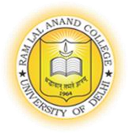
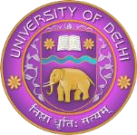
RAM LAL ANAND COLLEGE (University of Delhi)
Faculty Details

Title | Mr. | First Name | Krishan | Last Name | Kumar | Photograph
Designation |  | Assistant Professor
Address |  | A67, Himalayan Apartment Sector A9 Narela, Delhi -110040
Email |  | Krishan.commerce@rla.du.ac.in
Educational Qualifications B.COM(H), M.Com, DIGL, NET JRF
Degree |  | Institution |  |  |  | Year
PhD |  | Jagannath University, Jaipur |  |  |  | Pursuing
M. Com |  | Indira Gandhi National Open University, New Delhi |  |  |  | 2019
B. Com(H) |  | University of Delhi |  |  |  | 2016
Diploma in German language |  | University of Delhi |  |  |  | 2016
Career Profile
- Assistant Professor (Regular) Ram Lal Anand College, University of Delhi (31st July- till date)
- Assistant Professor Visiting faculty, Shri Ram College of Commerce, University of Delhi
- Assistant Professor Visiting faculty, Department of Management Studies, MBA SOL, University of Delhi
4. Assistant Professor (Ad-hoc basis) , Department of commerce ( 25th July 2019 – 31st July 2023)
5. Academic Counsellor (Indira Gandhi National Open University) Till December 2023.

Administrative Assignments
Member in various committees of the College

Areas of Interest / Specialization
Corporate Law
Marketing
Human Resource Management
Business ethics and sustainability
Cost Accounting
Business Law
Financial Markets, Institutions and Services

Subjects Taught
Corporate Law
Business Law
GST
Marketing
Financial Markets and institutions
Business organisation and Management
Business Ethics and Sustainability

