CryptoCabana
TryHackMe • Azure Cloud Security Walkthrough
Portfolio documentation • Flags and live credentials intentionally redacted

Room Profile
Platform | TryHackMe
Room | CryptoCabana
Category | Cloud / Azure
Difficulty | Medium
Primary services | Azure Storage, Blob Storage, Key Vault, Service Principal
Objective | Trace the cloud trust chain and recover the protected room secret without publishing challenge flags or credentials.

1. Executive Summary
The challenge presents an Azure-hosted cryptocurrency backup kiosk. The initial web application exposes a storage access mechanism to the client. That access can be used to enumerate storage beyond the container referenced by the UI. A sensitive service-principal configuration is then recovered from a hidden blob container. Those credentials provide an Azure identity with enough Key Vault visibility to enumerate secrets and their metadata, but the obvious current-value retrieval path is blocked by RBAC. The final pivot is to inspect secret version history through the Key Vault REST API and request a prior version. The resulting shard data can be combined to reach the room's final answer. All challenge flags, live tokens, client secrets, and other sensitive values are redacted in this portfolio copy.

2. Attack Chain
- Public static website → inspect client-side JavaScript
- Hardcoded SAS token → identify read/list scope
- Blob enumeration → discover the unreferenced vault container
- Vault blob → recover service-principal configuration (sanitized)
- Azure CLI authentication → operate as the leaked service identity
- Key Vault enumeration → identify secret names and RBAC boundary
- REST API → inspect secret-version metadata
- Historical version → recover an older shard value
- Shard reconstruction → derive the room answer (redacted)

3. Methodology

3.1 Initial Reconnaissance
The supplied target is an Azure Static Website. The landing page is intentionally simple, so client-side inspection is the first high-value action.
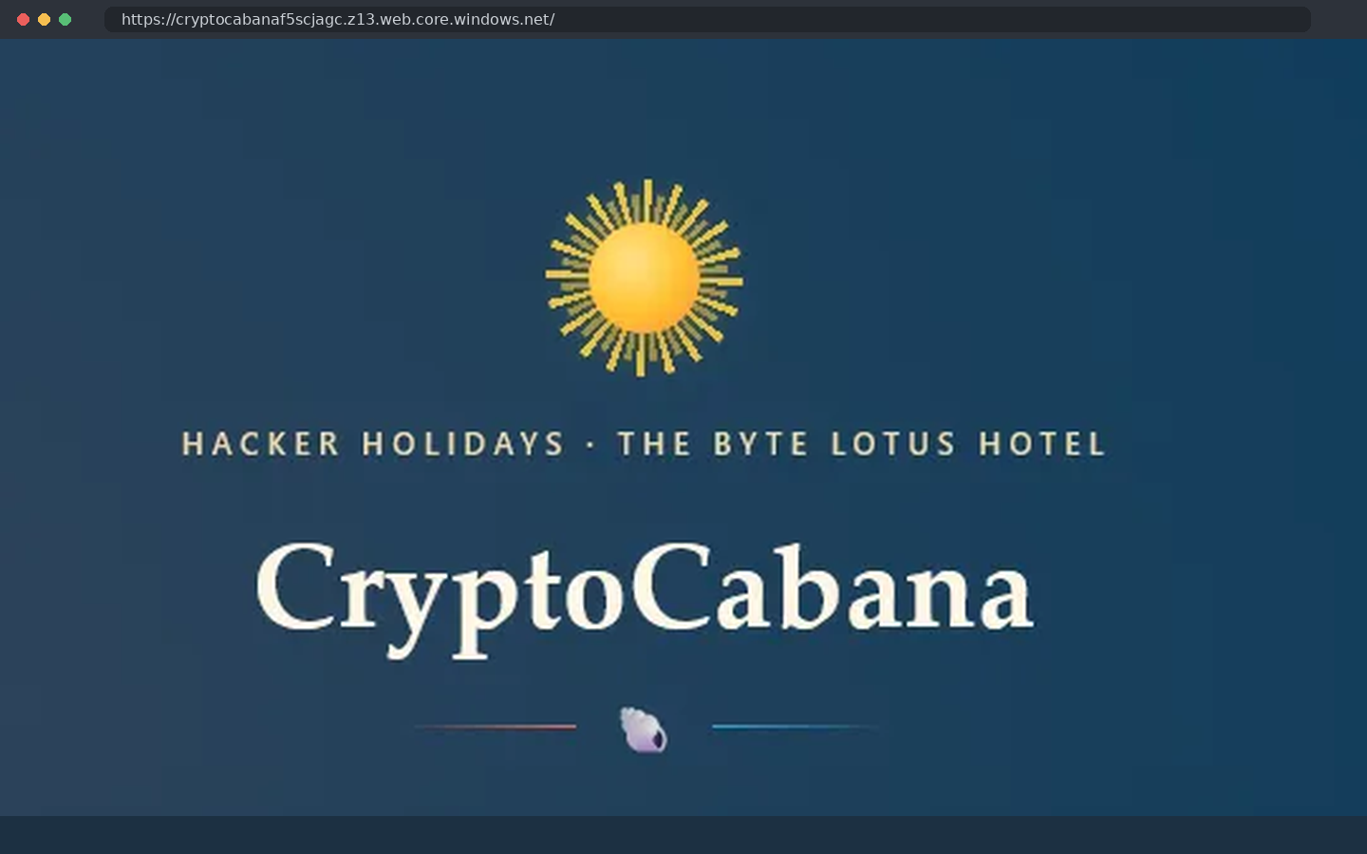
Figure 1 - CryptoCabana landing page viewed from a local browser session.

3.2 Client-Side Configuration Review
Inspecting the frontend resources reveals storage configuration and a SAS token embedded in JavaScript. The portfolio screenshot below redacts the token signature and other values.
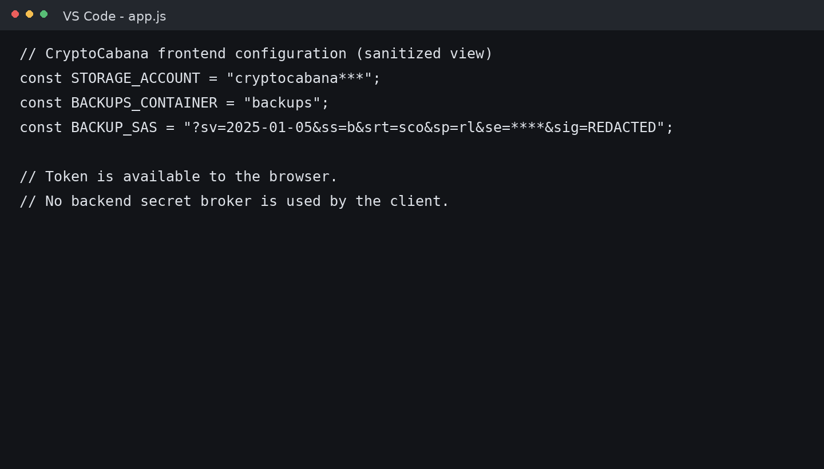
Figure 2 - Sanitized frontend configuration showing the client-exposed storage settings.

3.3 SAS Permission Analysis
The observed signed-permissions value is sp=rl. In Azure Storage, the SAS permission field defines what operations the token can perform; here, the important observation is read and list access rather than write access. A write attempt therefore fails and is useful as a permission boundary check.
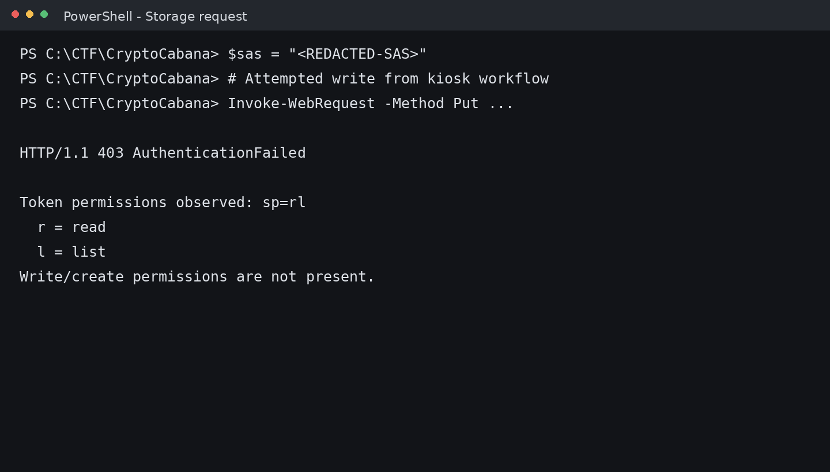
Figure 3 - Local verification of the SAS permission boundary and the resulting 403 response.

3.4 Blob Storage Enumeration
The same read/list capability can be used directly against the storage endpoint. Enumeration reveals the normal web container, the referenced backups container, and an additional vault container not surfaced by the application UI.
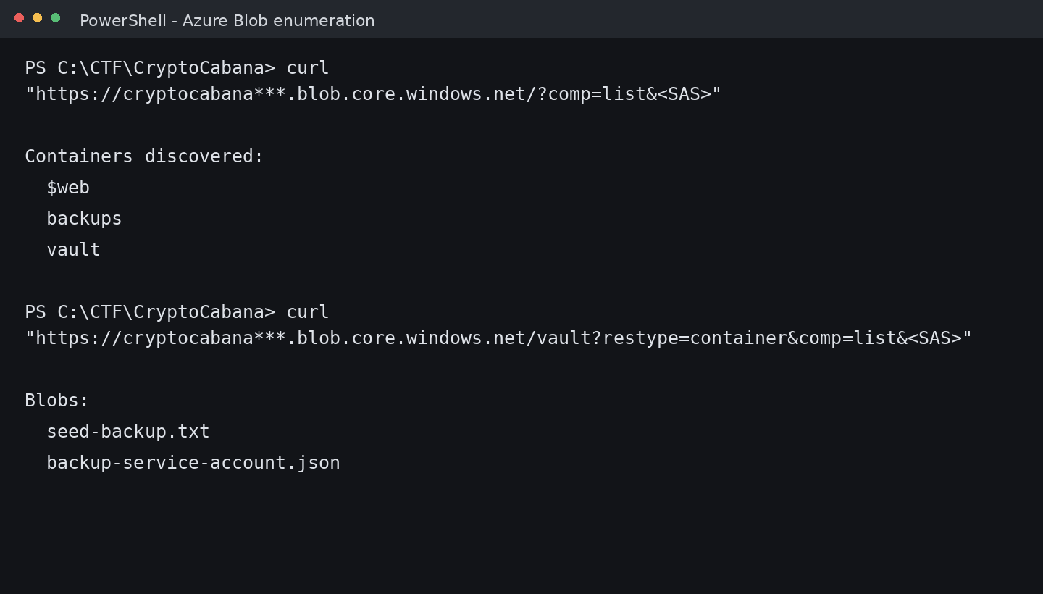
Figure 4 - Sanitized container and blob enumeration from a local PowerShell session.

3.5 Recovering the Service Identity
The hidden vault contains a backup-service-account configuration file. In the real challenge this file contains Azure authentication material and Key Vault details. In this documentation all credential material is replaced with placeholders.
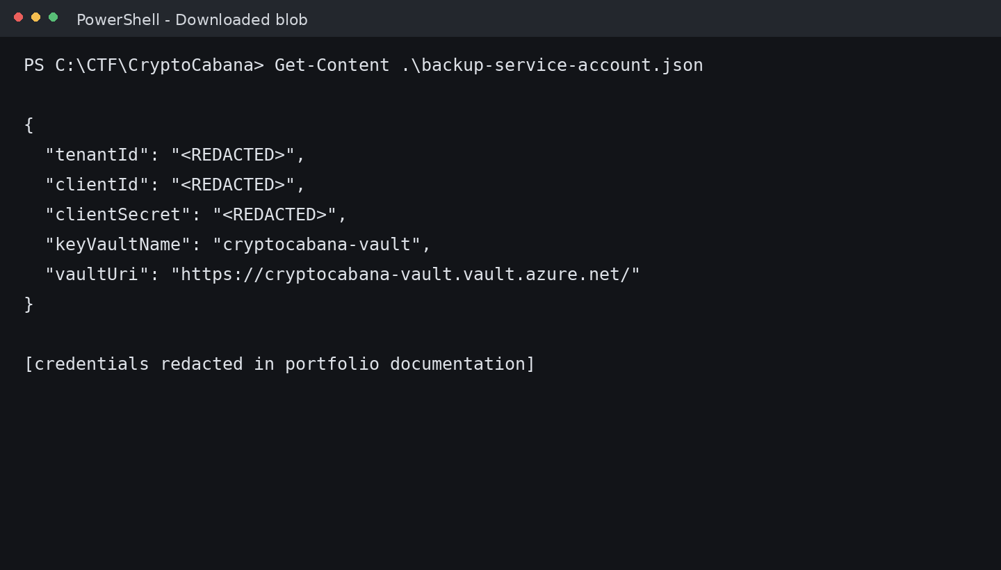
Figure 5 - Sanitized service-principal configuration recovered from Blob Storage.

3.6 Azure Authentication
The recovered identity can be used with Azure CLI in the lab. The screenshot demonstrates successful authentication without exposing the actual identifiers or secret.
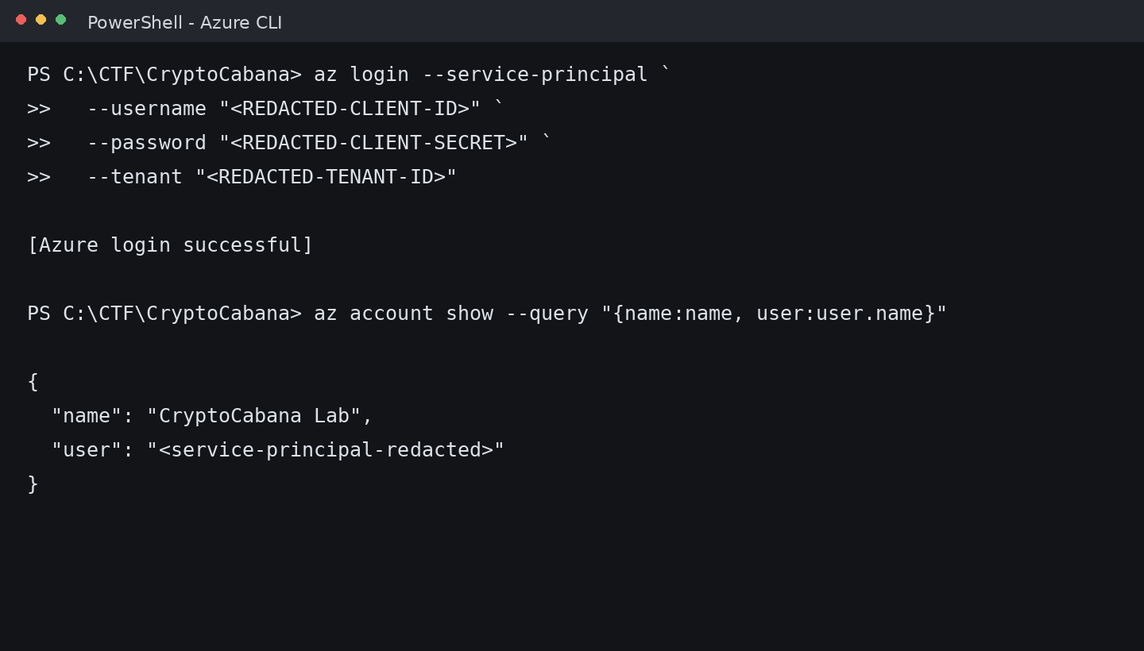
Figure 6 - Azure CLI authentication as the recovered service identity, with identifiers redacted.

3.7 Key Vault Permission Boundary
Key Vault enumeration shows several secret objects, including multiple shards and a master-key entry. Direct value retrieval is denied with a ForbiddenByRbac response. This distinction is important: the identity can discover metadata without having unrestricted secret-value access.
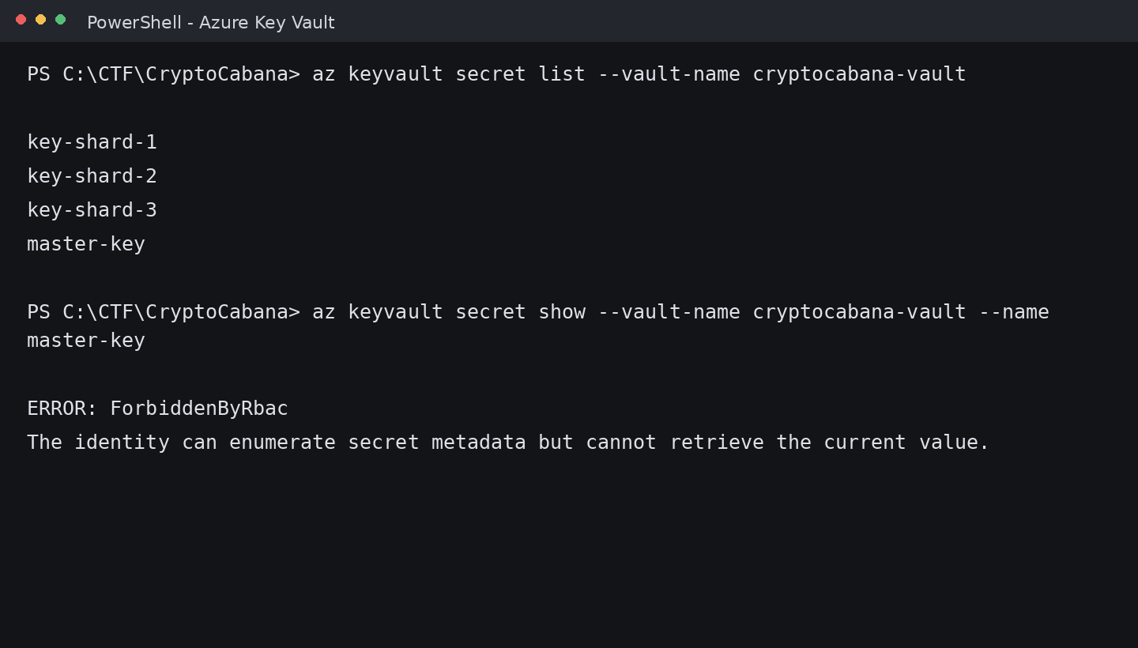
Figure 7 - Key Vault enumeration followed by the RBAC denial on direct secret retrieval.

3.8 Inspecting Secret Versions via REST
The room hint points toward rotation history. Azure Key Vault exposes secret-version operations via its REST API. Version metadata includes attributes such as creation and update times, allowing a recently rotated secret to be distinguished from its previous revision.
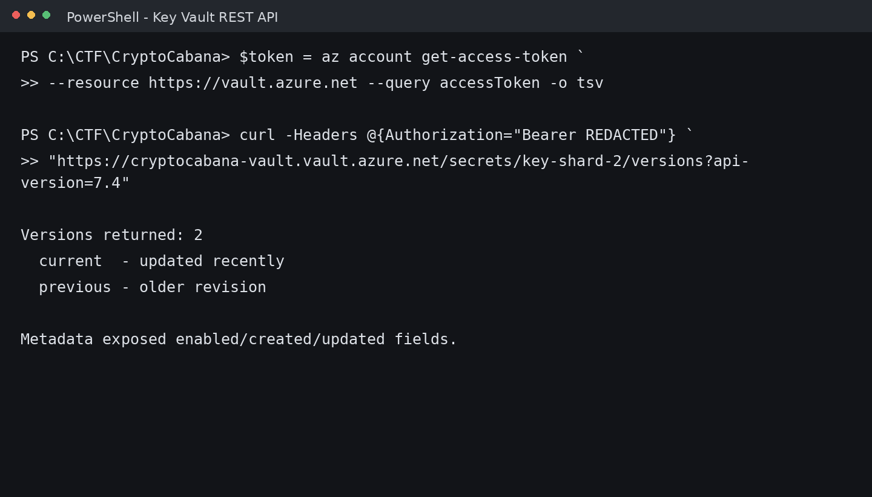
Figure 8 - Sanitized REST API request showing discovery of two secret versions.

3.9 Historical Version Retrieval
Requesting the older version directly succeeds in the lab and returns the historical shard. The final flag is deliberately omitted from this public write-up.
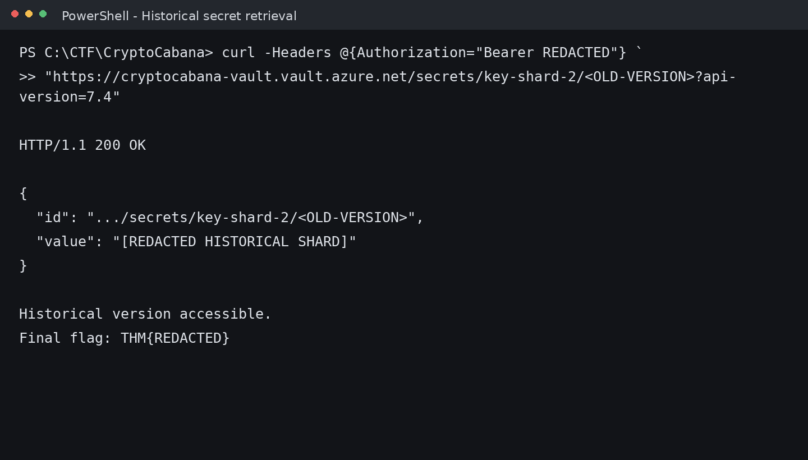
Figure 9 - Historical secret-version retrieval with the shard and final flag redacted.

4. Technical Findings
Client-exposed SAS: A storage SAS token is shipped to the browser, making storage authorization discoverable to every visitor.
Over-broad storage reach: The same token permits enumeration that reaches an additional container containing sensitive material.
Credential exposure in Blob Storage: A service-principal configuration file exposes material that can be used to authenticate to Azure.
Privilege separation gap: The identity can enumerate Key Vault metadata while direct current-value access is blocked, creating a useful side channel for discovery.
Historical secret exposure: An older secret version remains retrievable and contains useful material after a rotation event.

5. MITRE ATT&CK Mapping
Technique | Name | Observed use in room
T1552 | Unsecured Credentials | Sensitive credential material recovered from cloud storage.
T1078 | Valid Accounts | Recovered service identity used for authenticated cloud access.
T1087 | Account Discovery | Cloud identity/account context enumerated after authentication.
T1526 | Cloud Service Discovery | Azure storage and Key Vault services identified and queried.
T1528 | Steal Application Access Token | Client-exposed storage authorization is treated as a reusable access artifact.

6. Root Cause Analysis
- Secrets and privileged configuration should never be distributed to the browser or stored in publicly enumerable cloud storage.
- SAS tokens should be tightly scoped to the exact resource, operation set, and validity window required by the application.
- Service-principal credentials should be held in a dedicated secrets-management system and rotated after any exposure.
- Key Vault roles should be designed so that metadata discovery does not unintentionally create a path to historical sensitive values.
- Secret rotation must be paired with a review of old versions, access paths, and revocation requirements.

7. Defensive Recommendations
- Use Microsoft Entra ID and a backend authorization layer instead of distributing durable storage authorization to clients.
- Prefer user-delegation SAS where a SAS design is actually required, with minimal permissions and short expirations.
- Separate public website assets from sensitive backup data and administrative artifacts.
- Apply least privilege to service principals and use workload identities/managed identities where the platform supports them.
- Review Key Vault secret and version access policies; disable or remove obsolete sensitive versions when operationally appropriate.
- Enable storage, identity, and Key Vault logging and alert on unusual enumeration patterns or credential use.

8. Flag Handling / Anti-Plagiarism Policy
This repository intentionally does not publish the live TryHackMe flag, real SAS signatures, client secrets, access tokens, or the exact recovered shard contents. The write-up documents the methodology, trust boundaries, commands, and reasoning so the project demonstrates hands-on cloud-security skill without becoming a copy-paste answer key.

9. References
TryHackMe - CryptoCabana room and challenge description.
Microsoft Learn - Azure Storage SAS permissions and Blob Storage REST APIs.
Microsoft Learn - Azure Key Vault REST API, Get Secret, and Get Secret Versions.

