EXTRACTED
TryHackMe Forensic Walkthrough
PCAP analysis • PowerShell payload inspection • KeePass memory forensics
  - PUBLIC PORTFOLIO EDITION
Flag policy: The challenge flag, exact master password, and unique vault UUID are intentionally redacted.

Executive Summary
This investigation starts from a packet capture and follows the evidence through an HTTP-delivered PowerShell stage, TCP-stream artifact extraction, Base64/XOR reversal, KeePass database and process-dump recovery, memory analysis, and vault validation.

Investigation Chain
PCAP -> HTTP PowerShell -> TCP/1337 + TCP/1338 -> Base64 -> XOR -> .dmp + .kdbx -> memory analysis -> candidate credential -> vault validation

1. Wireshark Triage
The first pivot is an HTTP GET for a PowerShell script. The response body provides the logic needed to identify the exfiltration ports and the reversible transformation.
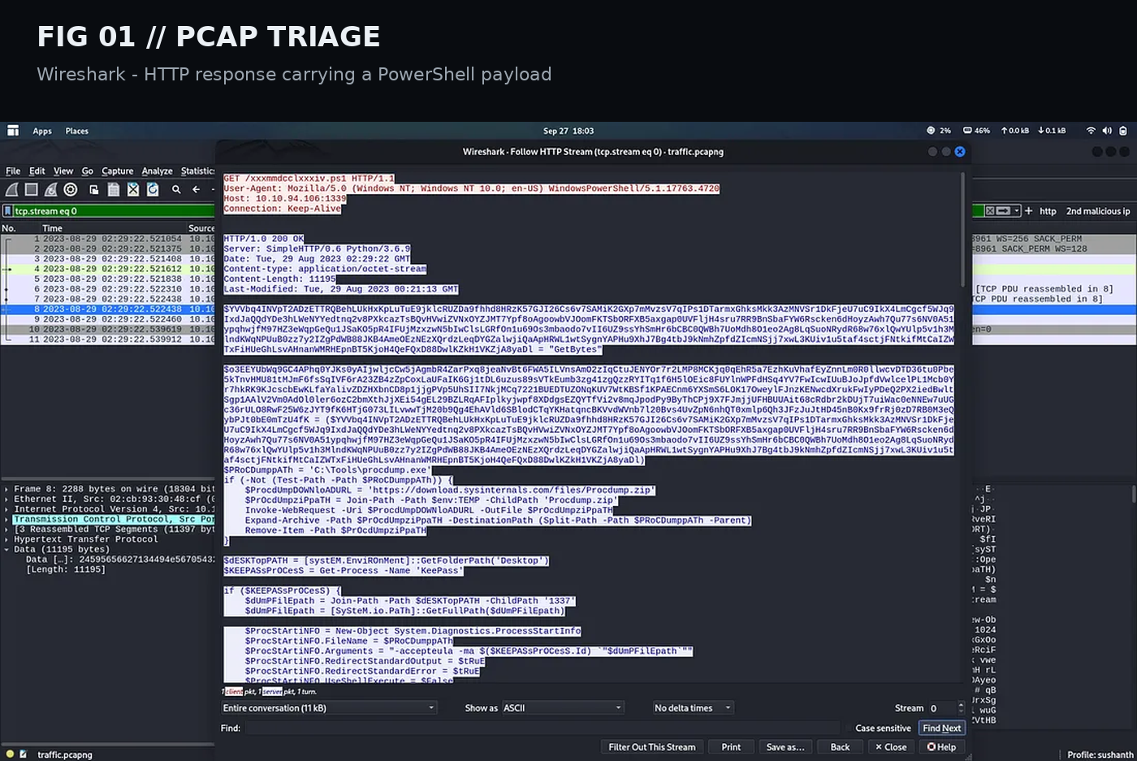
Figure 01 - HTTP PowerShell delivery observed in the capture.

2. Payload Behavior
The payload creates a KeePass process dump when the relevant process is present and also accesses an encrypted KeePass database. The process dump is XORed with 0x41 and transmitted on TCP/1337; the database is XORed with 0x42 and transmitted on TCP/1338. Both streams are Base64 encoded before transmission.

3. Stream Recovery
Use Wireshark Follow TCP Stream -> Raw -> Save whenever possible. For repeatable extraction, tshark can isolate tcp.payload fields for the selected port, after which xxd reconstructs the raw byte stream.
tshark -r traffic.pcapng -Y "tcp.port == 1338" -T fields -e tcp.payload | tr -d "\n" > combined_hex_1338.txt
xxd -r -p combined_hex_1338.txt > stream_1338.raw
Then reverse the transformations with Base64 decoding followed by the appropriate XOR key.

4. Artifact Validation
Validate the recovered artifacts with file and UTF-16LE-aware string extraction. A Windows minidump signature confirms successful reconstruction of the process artifact.

5. Memory Analysis
A KeePass process dump is valuable because runtime application memory can contain credential material or related strings while the vault is in use.
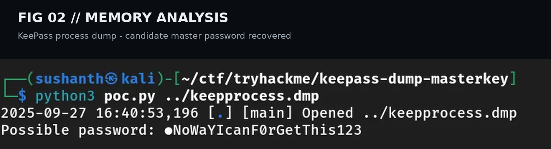
Figure 02 - Memory-analysis tooling producing a candidate password representation.

6. Candidate Validation
When one character is unresolved, treat it as uncertainty rather than assuming the output is final. Generate bounded candidates and validate them against the recovered database hash with John the Ripper.
keepass2john Database1337.kdbx > db.hash
john --wordlist=candidates.txt db.hash

7. KeePass Validation
After a candidate is validated, use KeePassXC CLI to inspect the vault and reach the target entry. Sensitive values are deliberately omitted from this public edition.
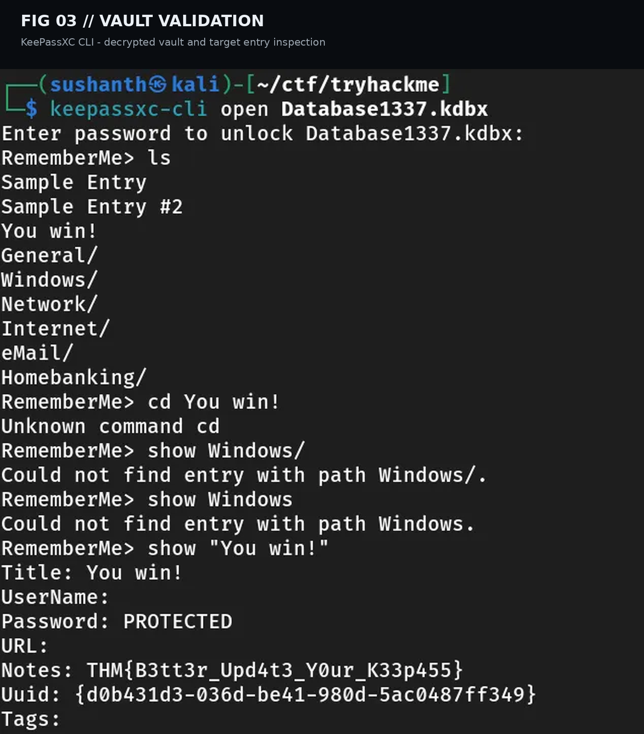
Figure 03 - KeePassXC CLI confirming vault access. Sensitive output is redacted in this portfolio version.

8. Skills Demonstrated
- Network forensics and TCP stream reconstruction
- PowerShell payload inspection
- Base64 and XOR artifact recovery
- Windows minidump and credential-memory analysis
- KeePass database validation
- Evidence correlation and incident-style documentation

9. Defensive Takeaways
Restrict untrusted PowerShell execution, monitor anomalous outbound traffic, detect unexpected process-dump creation, and protect credential-manager processes and sensitive runtime memory. Encrypted storage should be considered together with endpoint telemetry and memory artifacts.

10. Flag
THM{FLAG_REDACTED}
The original challenge answer is intentionally withheld from the public portfolio edition.

