FOOL'S MATE, REVENGE
TryHackMe • Advanced Web Security • Prototype Pollution

Platform | Room | Category | Primary Finding
TryHackMe | Fool's Mate, Revenge | Web Security | Prototype Pollution

Executive Summary
The target is a Node.js chess application whose sequel moved the security gate from the browser into the backend. A direct checkmate request therefore reaches the server, but the reward is withheld because session.config.unlocked is not present.
The Preferences feature exposes a JSON object-processing endpoint. Unsafe recursive merging of attacker-controlled keys permits prototype manipulation through constructor.prototype. This changes inherited object behavior and allows the reward-gate condition to resolve differently.
The exploitation is demonstrated using a stable flat prototype injection followed by the original Ra8# move. The public document intentionally redacts the challenge flag.

Attack Chain
Recon → /api/move analysis → authorization-state disclosure → /api/settings discovery → Prototype Pollution → inherited config state → Ra8# → reward

Figure 1 — TryHackMe room context


Figure 2 — Endgame position and winning move
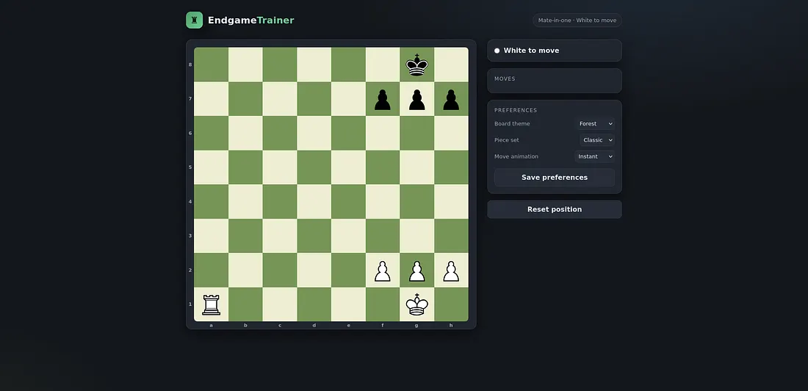

Figure 3 — Preferences as the object-processing surface
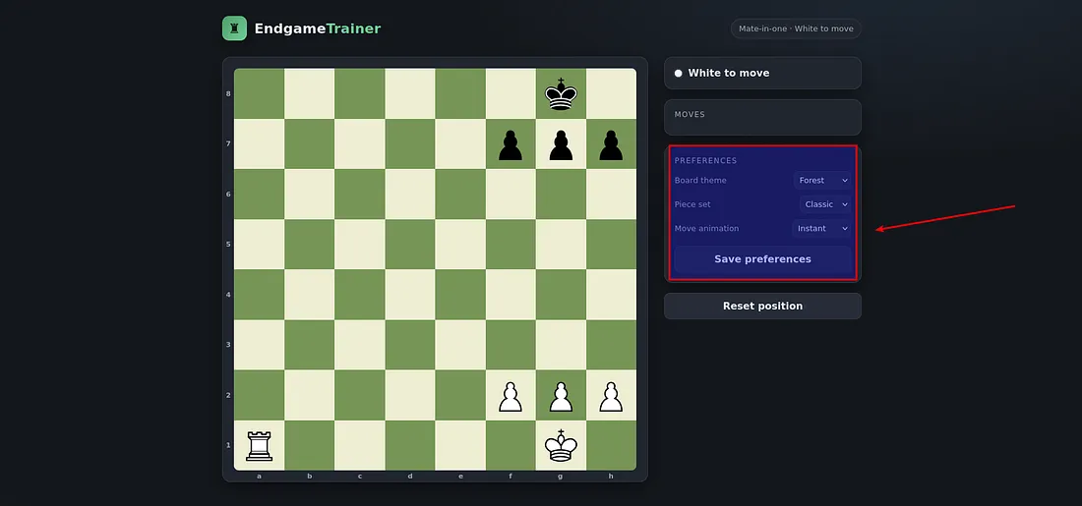

Figure 4 — Prototype pollution request / result
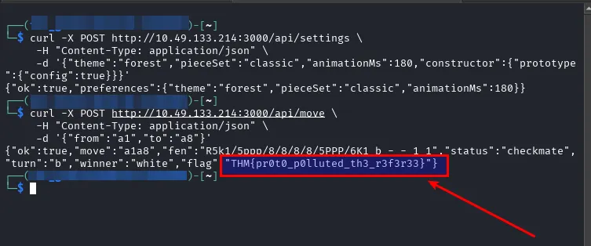

Figure 5 — Successful checkmate and reward path
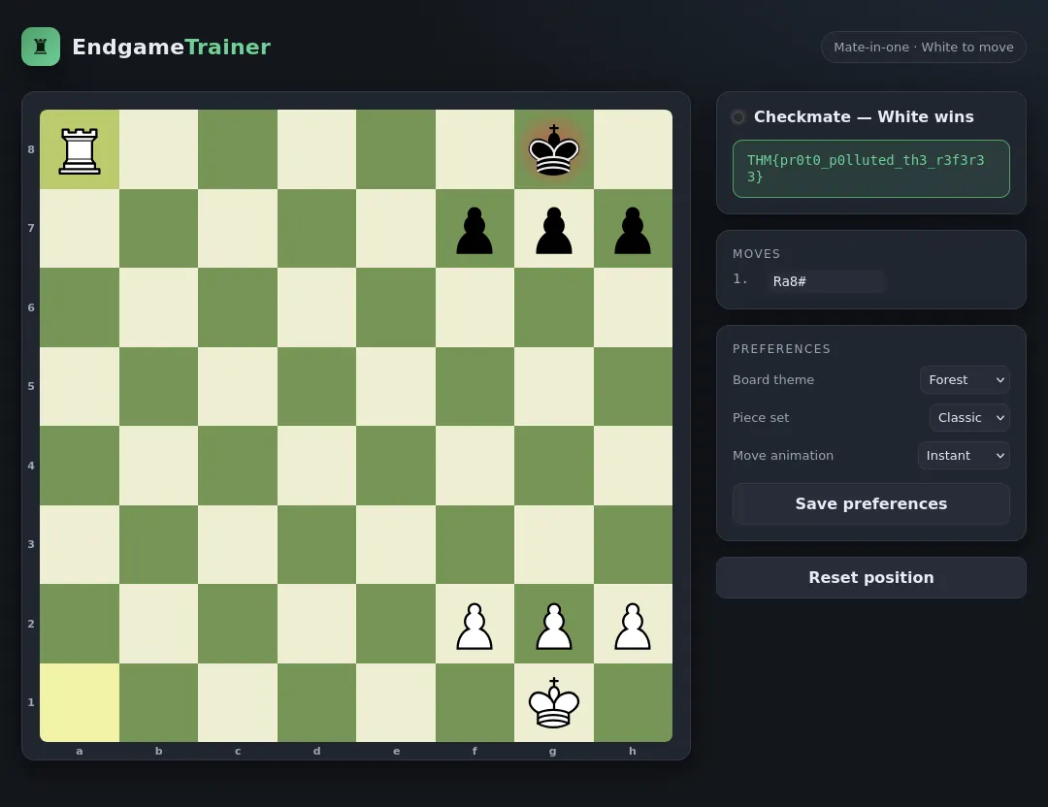

Scope & Safety
Testing is limited to the intentionally vulnerable TryHackMe lab. Do not apply these techniques to systems without explicit authorization.

Reconnaissance
The interface presents an obvious back-rank mate. The important assessment question is whether the backend reward gate can be influenced.

Server-Side Gate
POST /api/move with {"from":"a1","to":"a8"} returns a valid checkmate but reports: reward gate closed: session.config.unlocked is not set.

Attack Surface
The Preferences feature sends theme, pieceSet and animationMs to POST /api/settings. This becomes the key JSON processing surface.

Prototype Pollution
The backend's recursive merge logic accepts prototype-sensitive keys. Nested constructor/prototype payloads can trigger recursive failures, confirming the unsafe merge path. A stable flat injection conceptually sets constructor → prototype → config = true.

Authorization Bypass
Because JavaScript property lookup may traverse Object.prototype, the server can resolve session.config from inherited state. Replaying a1 → a8 then reaches the reward path.

Root Cause
The application combines unsafe deep merging, insufficient filtering of prototype-sensitive keys, and authorization logic that trusts inherited object state.

Impact
The demonstrated impact is reward-gate bypass. More broadly, prototype pollution can affect authorization, configuration, logic checks and availability.

Remediation
Use strict schema validation and allowlists; reject __proto__, constructor and prototype; avoid generic deep merge routines for untrusted input; use explicit own-property checks; suppress stack traces in production.

Lessons Learned
Moving a check server-side does not eliminate risk if the server trusts attacker-influenced object structures. Error messages and state paths should be treated as security-sensitive evidence.

Public Flag Policy
The final flag is redacted in this portfolio edition: THM{REDACTED_FOR_PUBLICATION}.

