♾️ INFINITY POOL
TryHackMe CTF — Professional Technical Report
Web Enumeration · Command Injection · Internal Services · Linux Privilege Escalation
Platform | TryHackMe
Room | Infinity Pool
Primary attack path | Web command injection → internal service pivot → root command execution
Evidence policy | Challenge-sensitive values redacted from public artifacts

1. Executive Summary
This report documents an authorized TryHackMe assessment of Infinity Pool. The observed route begins with external service discovery, moves through a web command-injection primitive, establishes shell access, discovers loopback-only services, pivots through internal Watchtower/UCP functionality, and ends with root-context command execution in an internal automation worker. Challenge flags and reusable secrets are intentionally redacted.

2. Attack Chain
- Nmap → HTTP :80
- robots.txt → /status
- OS command injection
- Reverse shell → web user
- Loopback service enumeration
- Watchtower :3000 → internal configuration
- UCP :8080 → voicemail artifact
- Automation :9000 → authenticated export
- Command injection → root context

3. Technical Walkthrough

3.1 Initial Enumeration
nmap <TARGET_IP> -sV
External enumeration identified SSH and HTTP. HTTP became the focus because usable SSH authentication was not initially available.

3.2 Web Discovery
/robots.txt → /status
robots.txt disclosed operational paths. /internal/ returned 404 in the documented run, while /status exposed a network-check function.

3.3 Command Injection
127.0.0.1;<test-command>
A shell separator caused an additional command to execute, confirming OS command injection.

3.4 Reverse Shell
nc -lvnp 4444
The injection primitive was converted into an interactive shell. The session was stabilized for further enumeration.

3.5 Local Services
ss -lntp
Loopback listeners including TCP/3000, TCP/8080 and TCP/9000 became visible from the compromised host.

3.6 Watchtower
curl http://127.0.0.1:3000/
Watchtower exposed health/config endpoints; configuration data disclosed additional internal services and lab authentication material.

3.7 SSH Forwarding
ssh -L ...
Local port forwarding exposed loopback-only interfaces to the testing workstation.

3.8 UCP / Voicemail
Internal UCP workflow
The UCP/voicemail workflow contained an automation key. Its exact value is redacted.

3.9 Automation API
POST /jobs/export
The export route accepted report data and built a shell command. Authentication was required.

3.10 Root Verification
uid=0(root) gid=0(root)
A controlled identity check confirmed root-context execution. The final flag is omitted.

4. Findings
Finding | Category | Observed impact
OS Command Injection in /status | CWE-78 | Attacker-controlled input reached a shell execution context.
Internal Configuration / Secret Exposure | CWE-200-style exposure | Internal service locations and challenge-specific authentication material became available after compromise.
Authenticated Command Injection in Automation API | CWE-78 | Untrusted report data was interpolated into a command executed by a root-privileged worker.

5. Defensive Recommendations
- Use direct process APIs instead of shell strings.
- Strictly allow-list command parameters.
- Remove reusable credentials from diagnostic/admin interfaces.
- Enforce authentication/authorization beyond network locality.
- Run automation workers as non-root accounts.
- Monitor abnormal shell/child-process execution from web-facing services.

6. Evidence Appendix
01 — Initial web application reconnaissance
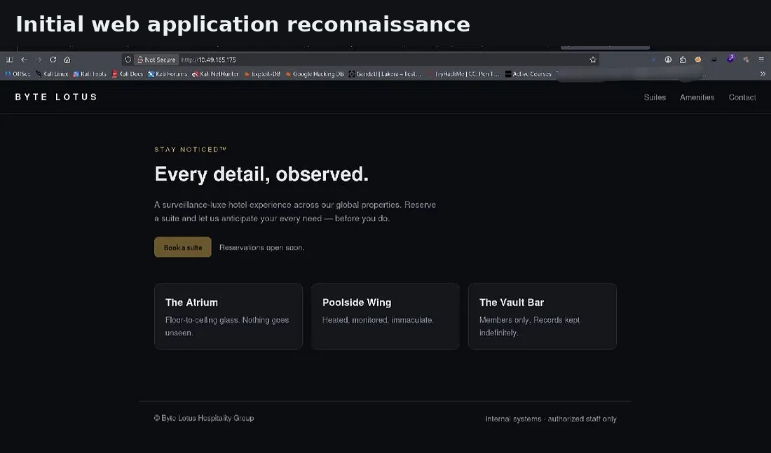
02 — Hidden /status netcheck endpoint
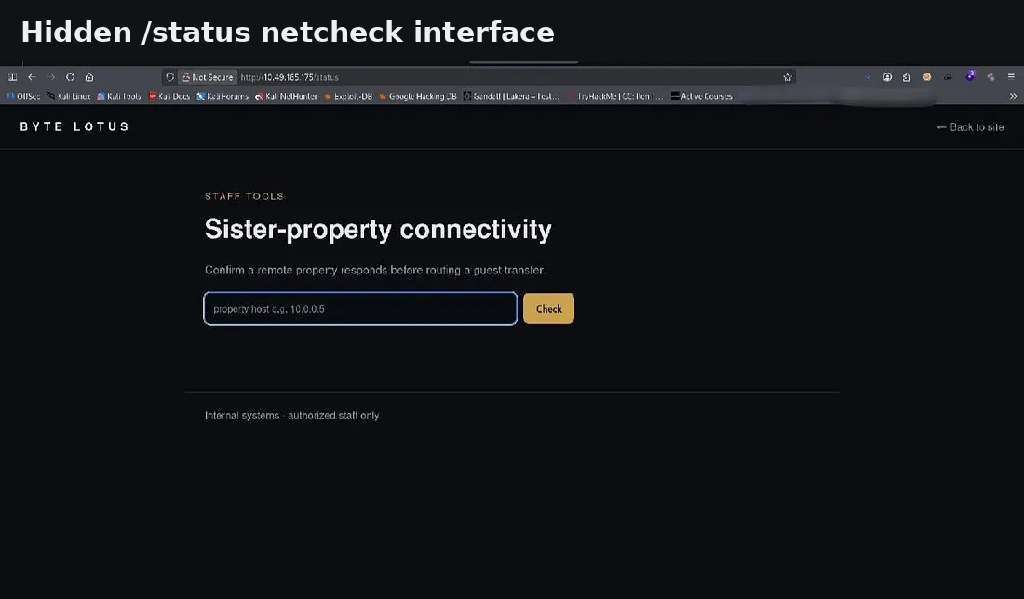
03 — Command injection validation
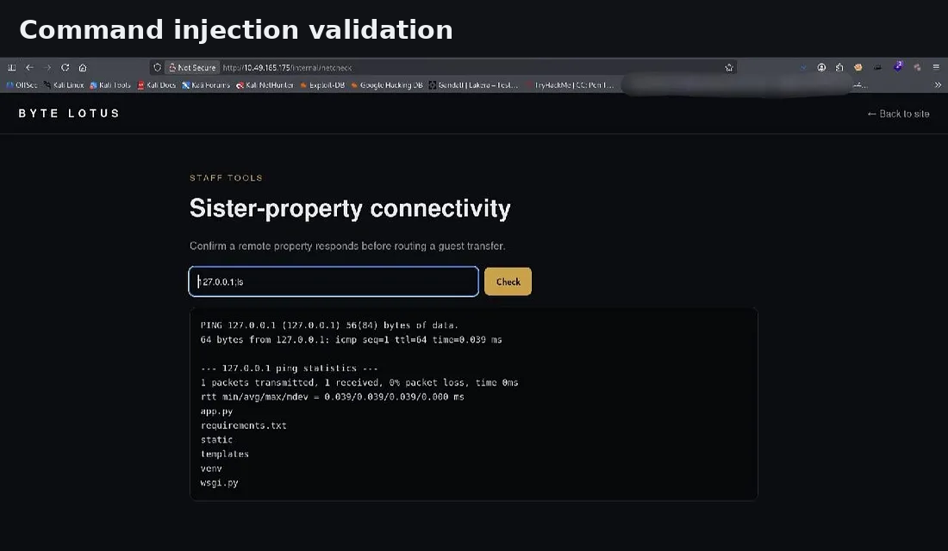
04 — Initial shell access
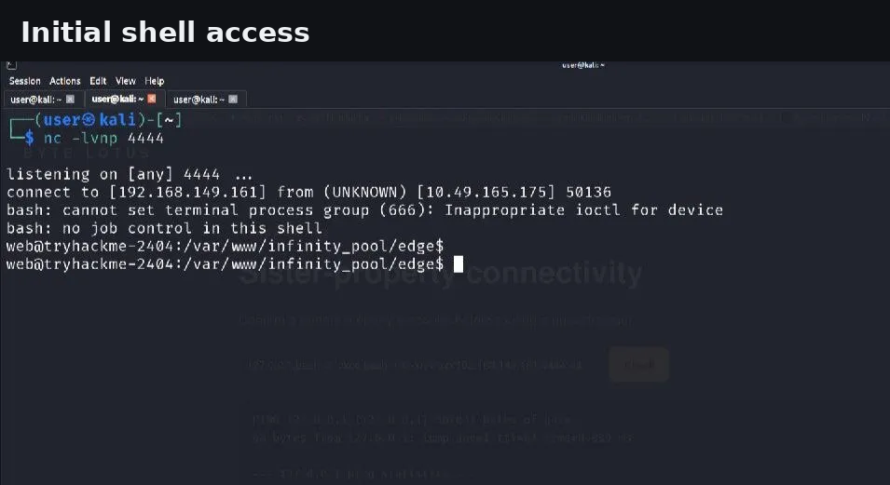
05 — Loopback-only service enumeration
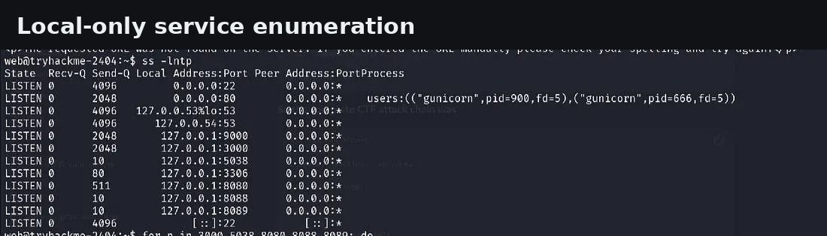
06 — Watchtower internal console
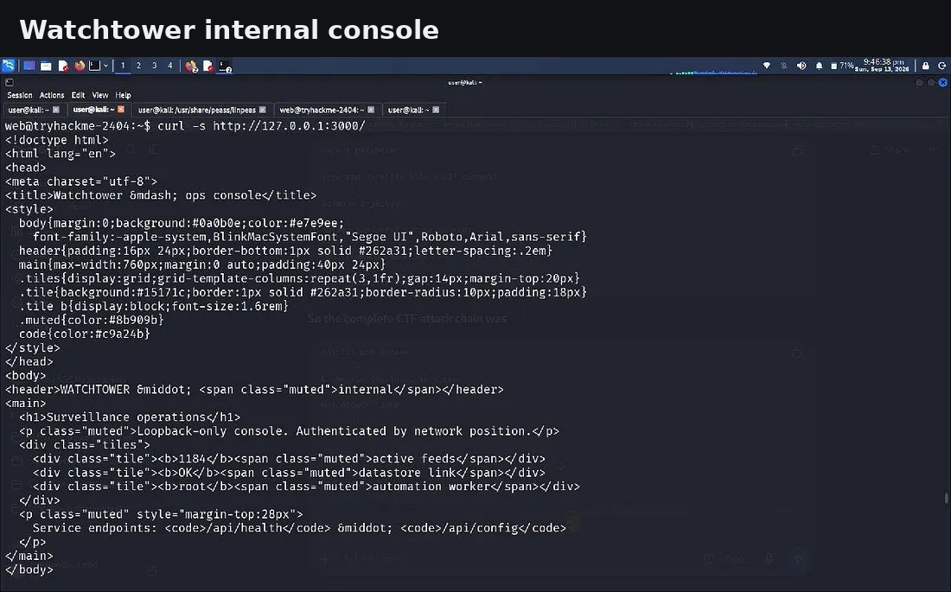
07 — Watchtower configuration disclosure
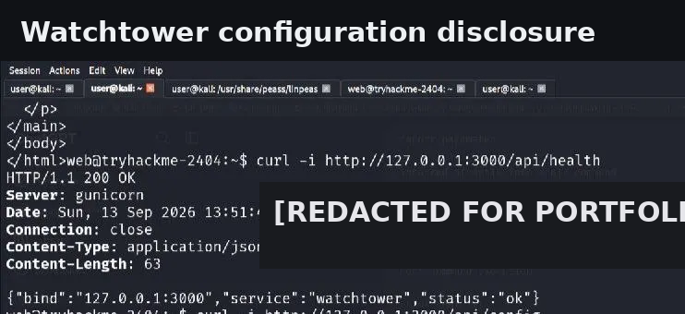
08 — SSH local port forwarding
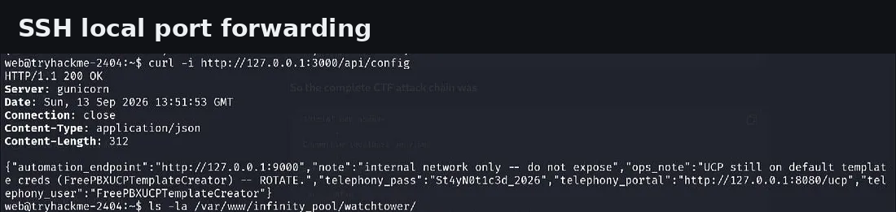
09 — UCP access
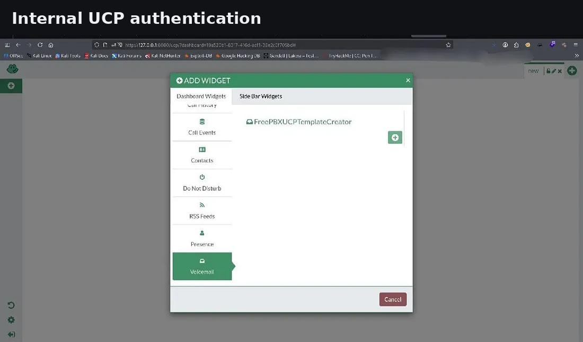
10 — Voicemail / automation artifact
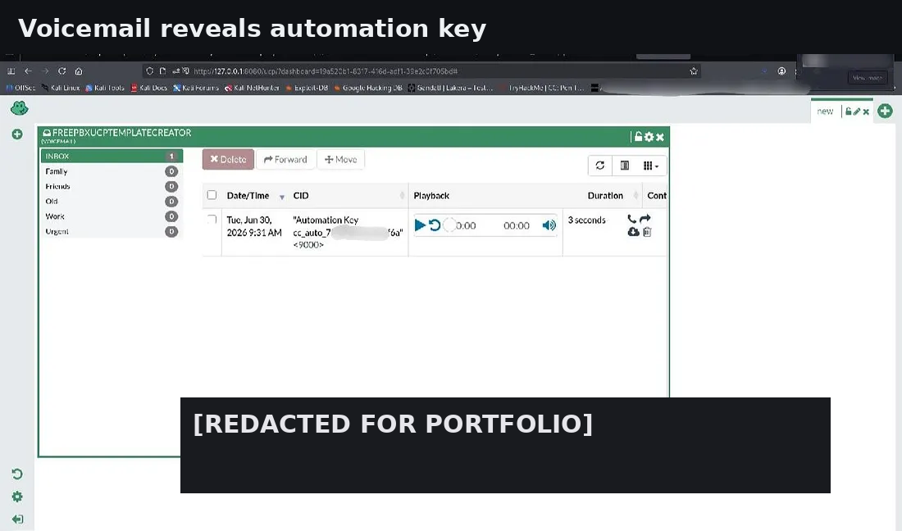
11 — Automation API
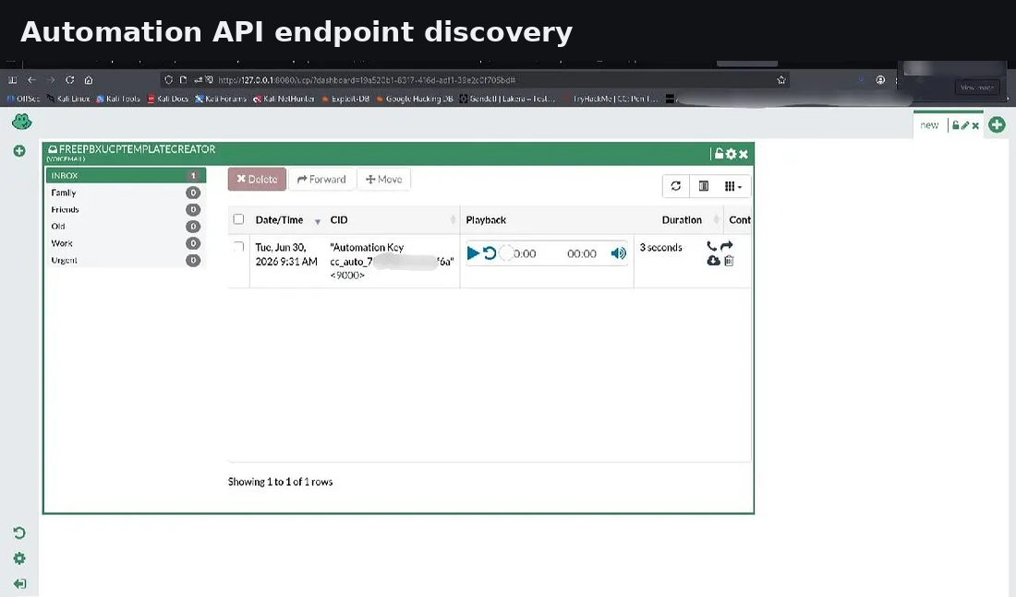
12 — Root execution confirmation
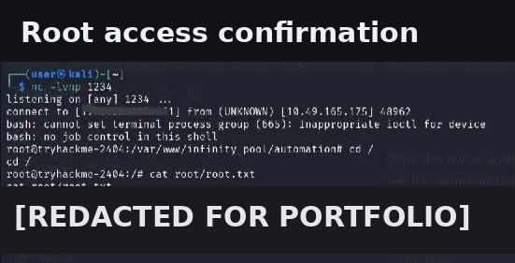

7. Responsible Use
All activity described here was performed against an authorized TryHackMe training target. The material is provided for educational and portfolio purposes. Do not test systems without explicit authorization.

