MAYHEM
TryHackMe • Network Forensics & Havoc C2

Professional forensic investigation report
Public-report policy: flags, direct answers, and credentials are intentionally redacted.

Executive Summary
Mayhem is a blue-team oriented investigation based on a packet capture. The workflow covers PCAP triage, HTTP recovery, PowerShell staging, PE extraction, Havoc C2 attribution, AES-CTR recovery, and C2 artifact reconstruction.

Scope
Observed hosts: 10.0.2.38 and 10.0.2.37. Staging service: HTTP/1337. Launcher: install.ps1. Payload: notepad.exe. C2: Havoc. Encryption: AES-CTR.

Forensic Chain
PCAP → HTTP transfer → PowerShell → PE extraction → Havoc attribution → DEMON_INIT → AES key/IV → encrypted traffic → decrypted artifacts.

Protocol Findings
Havoc request header: 20 bytes. Response header: 12 bytes. AES key: 32 bytes. IV: 16 bytes. Mode: CTR.

Key Artifacts
The decrypted traffic yields identity, network configuration, persistence activity, and the path C:\Users\paco\Desktop\Files\clients.csv. Direct answer strings are withheld.

Defensive Takeaways
Monitor suspicious PowerShell staging, masquerading, unusual HTTP C2, unexpected account creation, and sensitive-file access.

Evidence Gallery

PCAP Triage
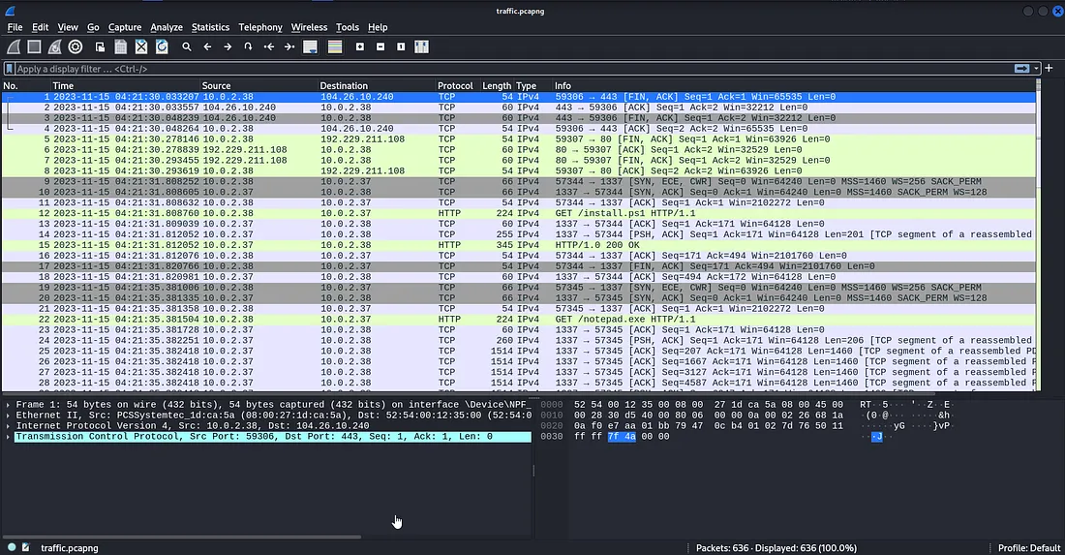

PowerShell
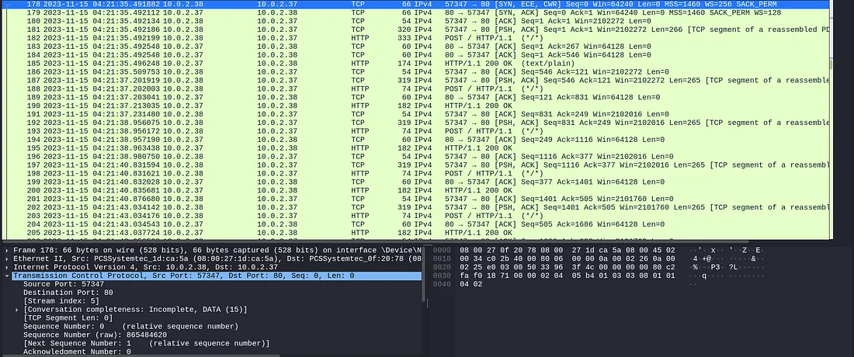

HTTP Objects
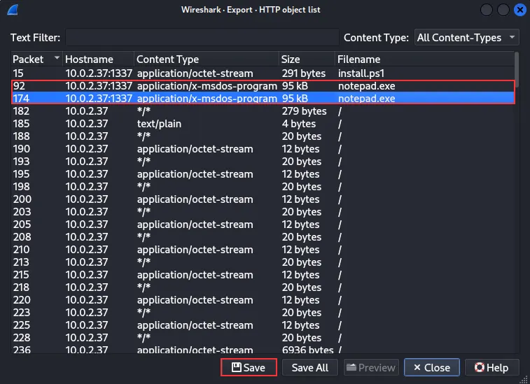

Strings
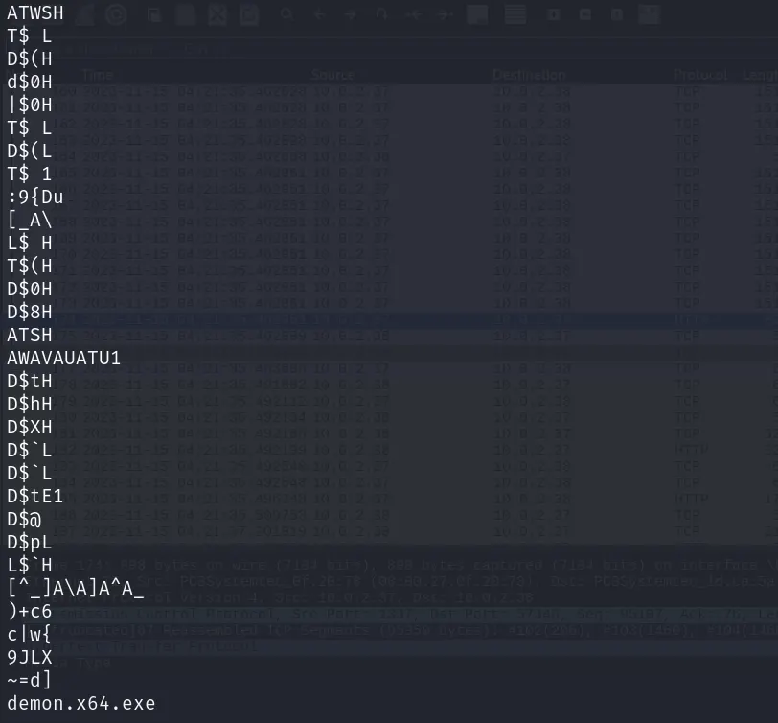

VirusTotal
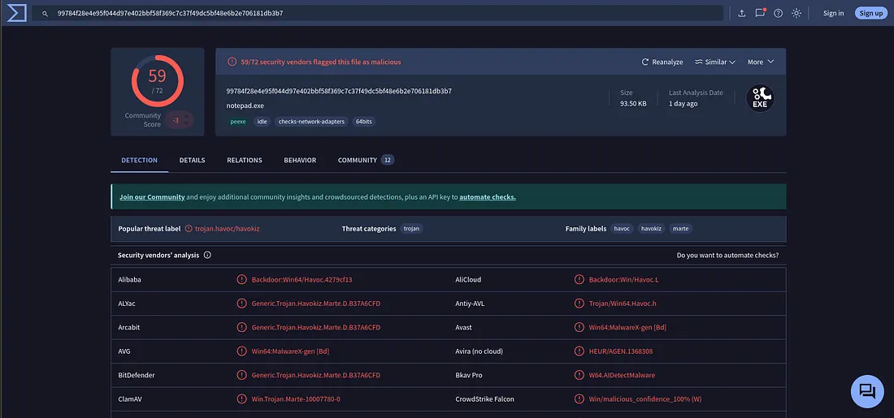

Havoc Initialization
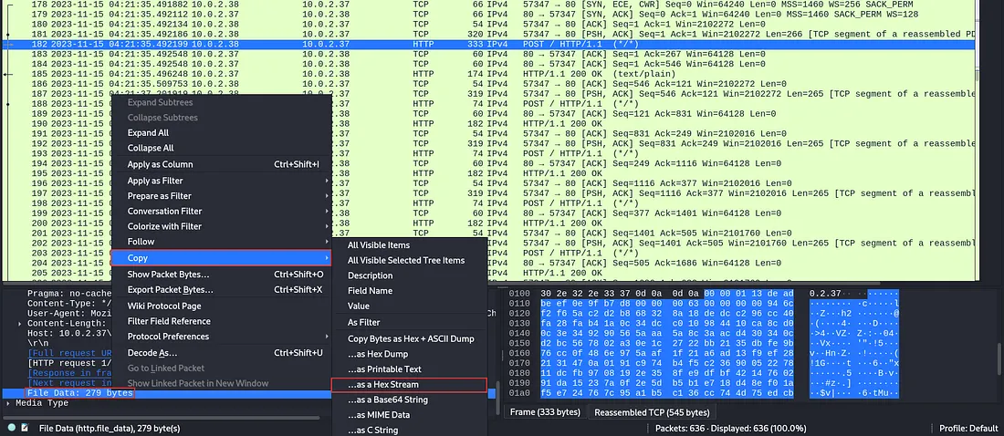

AES-CTR Parameters
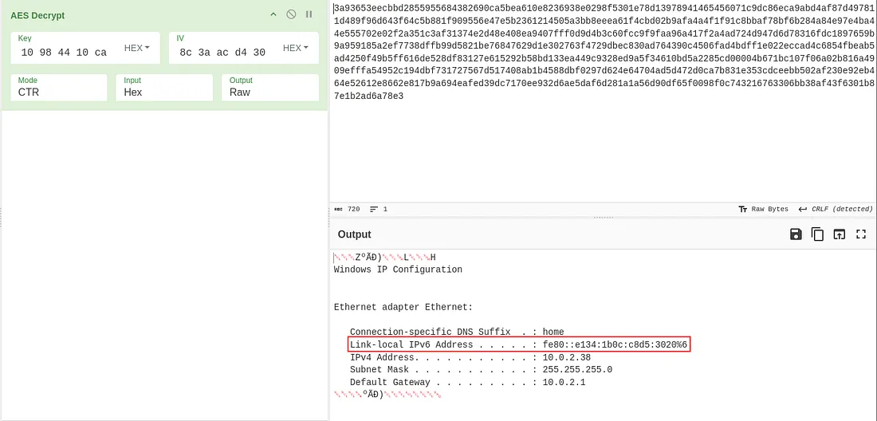

Ciphertext
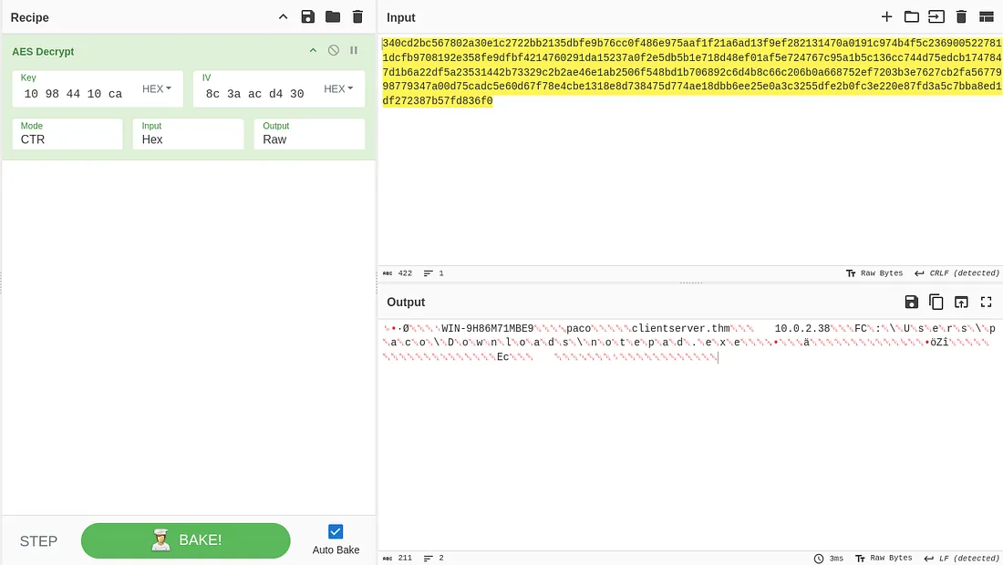

SID Artifact
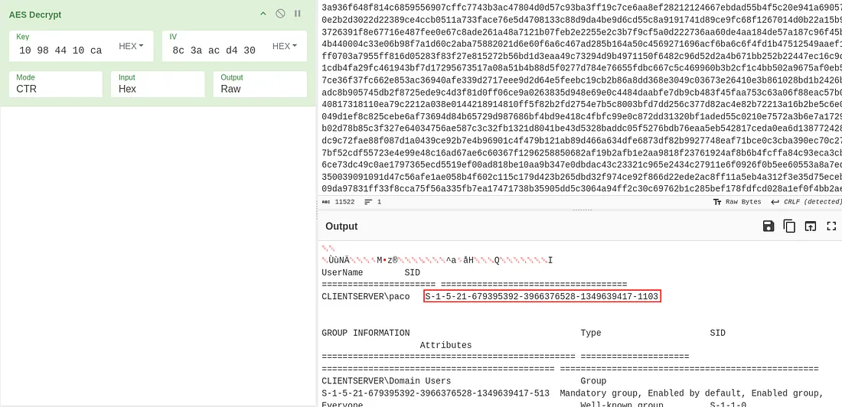

IPv6 Artifact
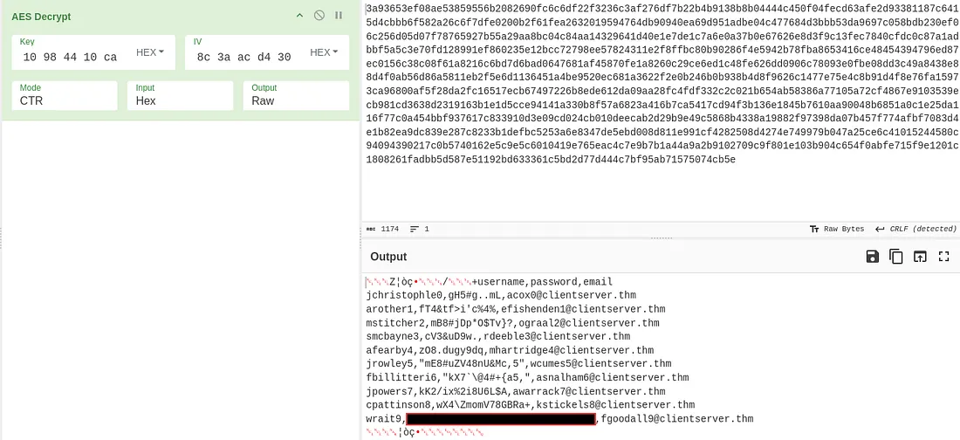

Sensitive File
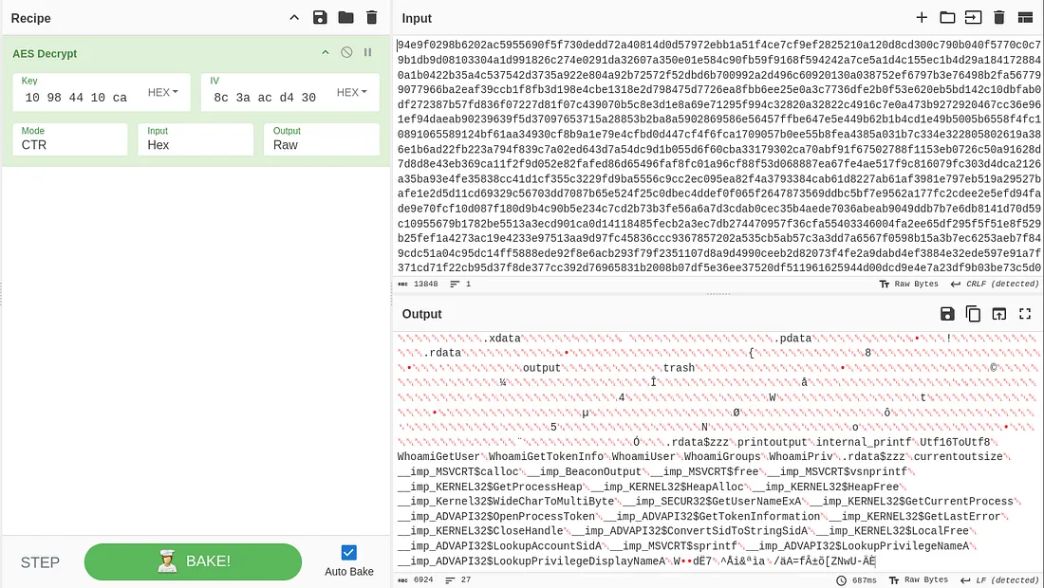

Final Response
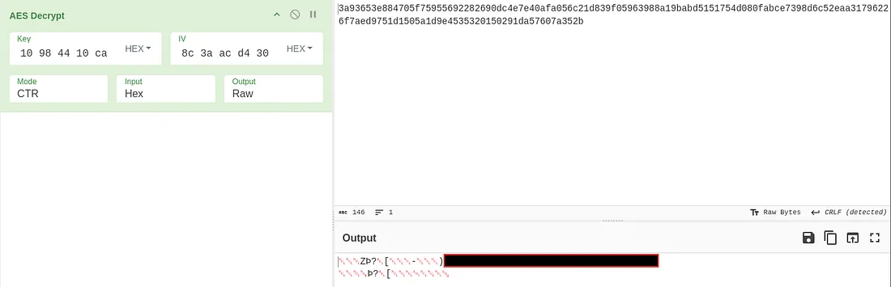

Reproduction Checklist
- Obtain the PCAP
- Open it in Wireshark
- Follow install.ps1
- Export notepad.exe
- Run strings
- Validate Havoc
- Locate DEMON_INIT
- Recover AES key and IV
- Strip headers
- Decrypt targeted traffic
- Correlate packet numbers
- Solve independently

Conclusion
The most transferable skill from Mayhem is moving methodically from packet → protocol → artifact → hypothesis → validation. This approach is relevant to SOC analysis, threat hunting, DFIR, and network forensics.

