Signed Messages
TryHackMe — Love at First Breach
Security Assessment & Technical Walkthrough
Classification: Web Application + Cryptography | Difficulty: Medium
Author: Anurag

Executive Summary
The LoveNote application relies on digital signatures for message authenticity. An exposed debug endpoint reveals deterministic key-generation logic, allowing the server's RSA private key to be reproduced and used to forge a signature accepted by the verifier.
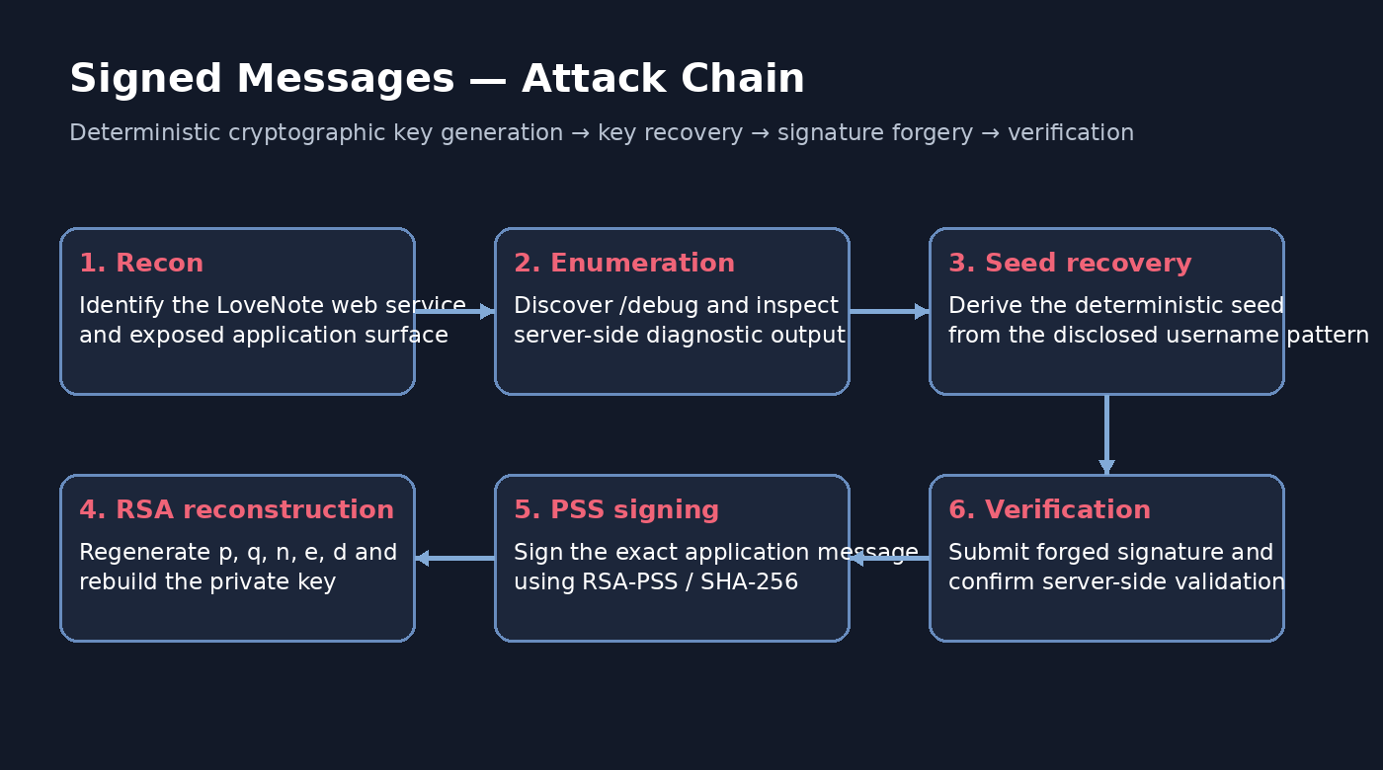

1. Reconnaissance
The application exposes a LoveNote messaging service with routes for authentication, messages and signature verification.

2. Web Enumeration
Directory enumeration identifies /debug, which provides implementation-level diagnostics.

3. Root Cause
The server constructs a predictable seed using the username and a static suffix, hashes it with SHA-256 and applies nextprime() directly to the resulting integer to derive RSA factors.

4. RSA Reconstruction
Knowing the username permits deterministic recovery of p and q, followed by n, phi(n), the public exponent e=65537 and the private exponent d.

5. Signature Forgery
The reconstructed private key is used with RSA-PSS and SHA-256 to sign the exact message expected by the application.

6. Verification
The verifier accepts the forged signature as authentic, demonstrating compromise of the application's message-authenticity boundary.

7. Remediation
Use CSPRNG-backed RSA key generation, remove sensitive debug endpoints, enforce real key-size guarantees and protect private keys with appropriate controls.

Evidence
Room context
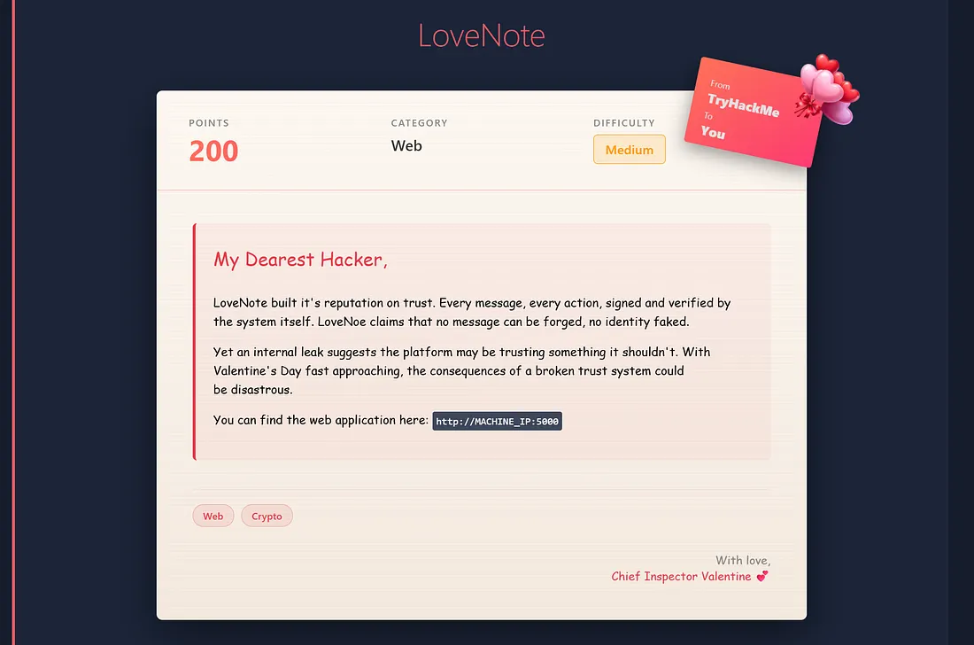
LoveNote application
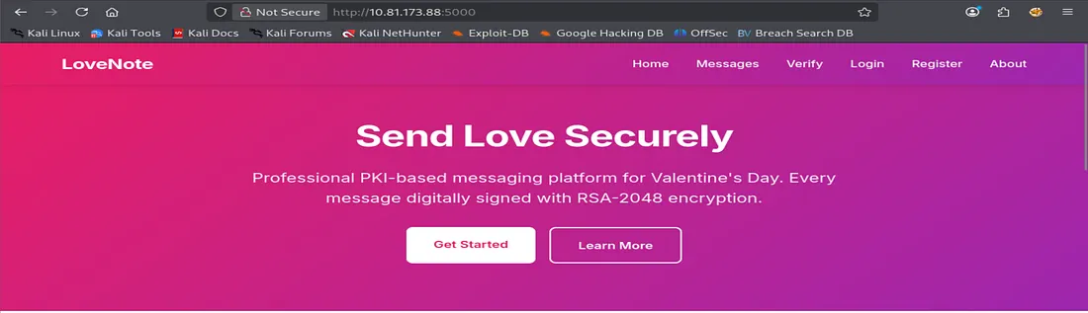
Directory enumeration
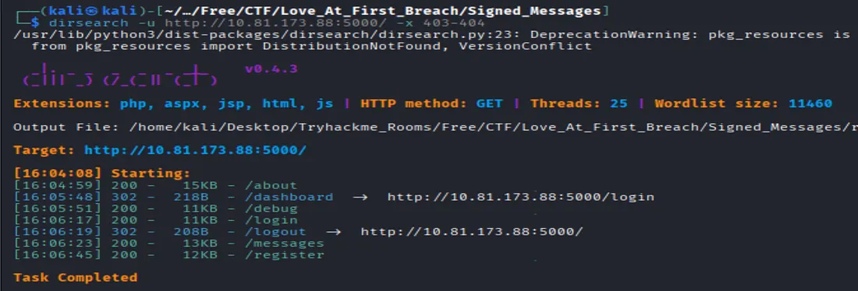
Deterministic RSA debug disclosure
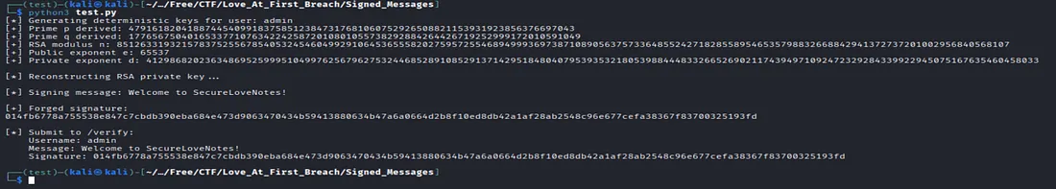
Verification of forged signature
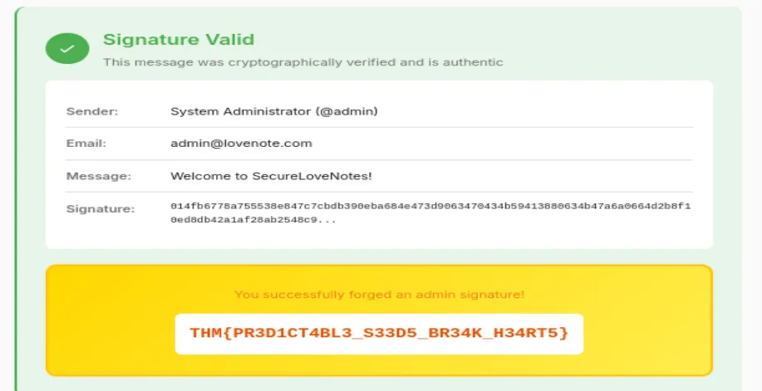

Public Release Note
The final TryHackMe flag is intentionally redacted from the public documentation to preserve the challenge's learning value and avoid publishing the answer.
Flag: THM{REDACTED_FOR_PUBLICATION}

