SUPERSECRET TIP
TryHackMe Technical Walkthrough
Source-Driven Web Exploitation & Linux Privilege Escalation
Portfolio-safe edition | Challenge flags redacted
Platform | TryHackMe
Room | SuperSecretTip
Assessment | Authorized CTF / Training Lab
Focus | Web exploitation, SSTI, RCE, Linux privilege escalation
Repository | anurag-rvnkr1/SuperSecretTip-TryHackMe-Walkthrough

Executive Summary
This report documents an end-to-end solution path for the SuperSecretTip TryHackMe lab. The assessment starts with service enumeration, progresses through source-code discovery and custom XOR secret reconstruction, and then demonstrates how an unsafe Jinja template path can be converted into server-side command execution.
After obtaining an initial shell, scheduled-task behavior and filesystem permissions expose a writable shell initialization file. PATH manipulation is then used for lateral movement. The final stage examines a root scheduled task that consumes an attacker-writable curl configuration file, demonstrating privileged file access.
Challenge flags, exact answer strings, and other unnecessary sensitive values are deliberately redacted from the public report. Screenshots remain as chronological evidence of the lab work.

Attack Chain
Recon -> Content discovery -> Source disclosure -> XOR analysis -> Authenticated debug -> SSTI -> Command execution -> Initial shell -> Cron inspection -> Writable .profile -> PATH hijacking -> Second user -> Root cron / curl config abuse

Methodology
- Enumerate network services and application content.
- Recover source code and map hidden functionality.
- Reproduce the secret transformation locally instead of brute forcing.
- Validate template execution with a harmless expression before command execution.
- Use process and permission enumeration to identify Linux escalation paths.
- Document evidence chronologically and separate observations from conclusions.

1. Reconnaissance

1.1 Port Scanning
The full TCP scan identified SSH on 22/tcp and a Werkzeug/Python HTTP service on 7777/tcp. The web service became the primary application attack surface.
nmap -sV -p- -T4 TARGET_IP
Full TCP service enumeration showing SSH and the Werkzeug web service.

1.2 Web Content Discovery
Content enumeration identified /cloud and /debug. These endpoints expanded the attack surface beyond the public landing page.
ffuf -w /usr/share/wordlists/seclists/Discovery/Web-Content/raft-medium-directories.txt -u http://TARGET_IP:7777/FUZZ -fc 403 -c
Web content discovery identifying the interesting application endpoints.

2. Source Discovery & Secret Reconstruction

2.1 Source-Code Retrieval
The /cloud download workflow was inspected in Burp Suite. Weak filename handling allowed application source to be recovered, revealing the debug flow and helper modules.
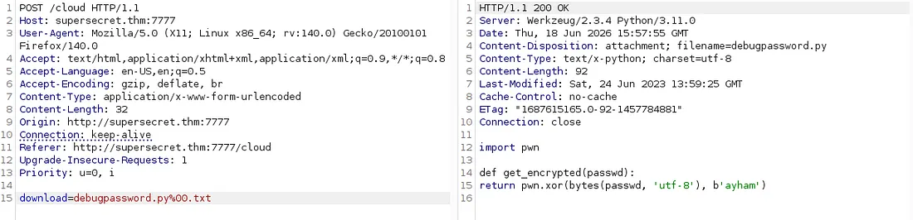
Burp evidence of source retrieval through the cloud download workflow.

2.2 Encrypted Tip Material
The same download functionality exposed the encrypted material used by the debug authentication logic.
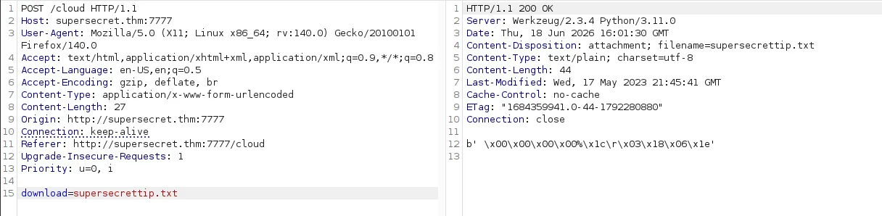
Burp evidence of the encrypted challenge material.

2.3 XOR Analysis
The recovered helper implemented a simple XOR transformation with a fixed byte sequence. Because XOR is self-inverse, the same operation can recover the original value when the ciphertext and key are both known.
ciphertext = plaintext XOR key
plaintext = ciphertext XOR key
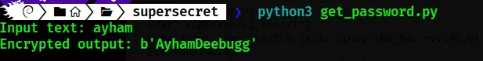
Local Python evidence for the XOR transformation.

3. Authenticated Debug Flow & SSTI

3.1 Debug Helper Analysis
The debug-related source showed that a request header was used as the localhost trust signal. This is a trust-boundary problem because request metadata can be attacker-controlled unless a trusted proxy sets and sanitizes it.
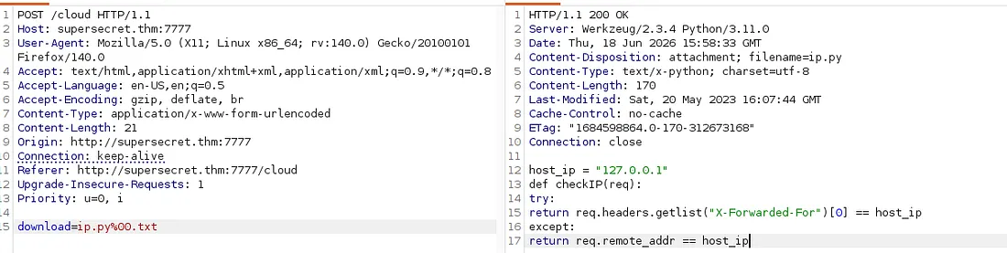
Source evidence for the debug/IP trust helper.

3.2 Authenticated Endpoint Access
A valid session was carried into the internal debug-result flow. Burp Repeater provided a controlled way to reproduce the authenticated request sequence.
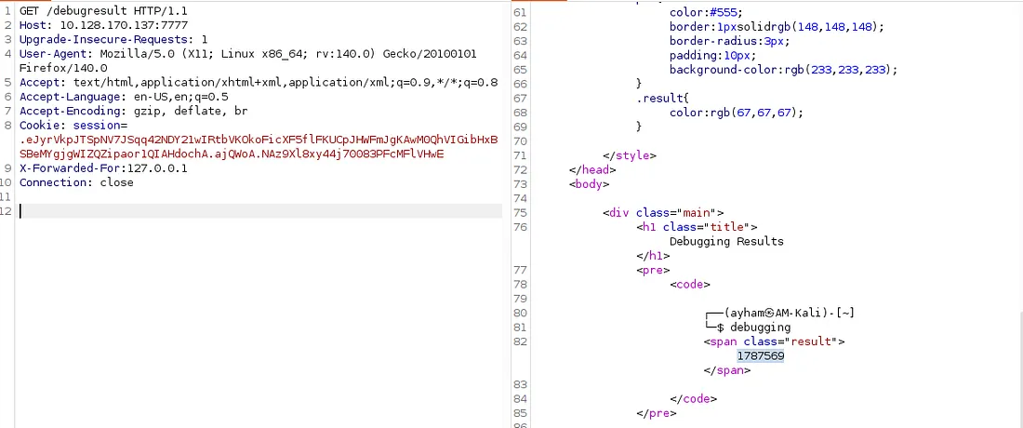
Authenticated debug-result request using session context.

3.3 SSTI Confirmation
A harmless Jinja arithmetic expression was evaluated by the application, confirming Server-Side Template Injection.
{{ 1337 * 1337 }}
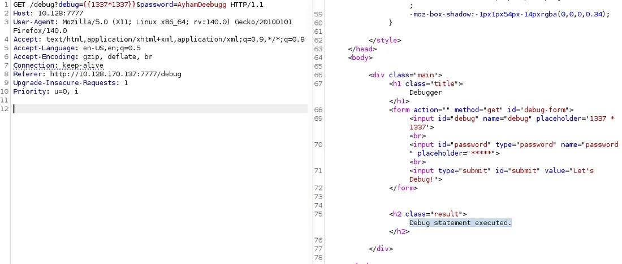
Harmless Jinja expression used to confirm SSTI.

4. SSTI to Command Execution

4.1 Runtime Introspection
The Python class hierarchy was enumerated to locate a subprocess-capable runtime object. The exact class index is runtime dependent and should be discovered rather than memorized.
{{"".__class__.__mro__[1].__subclasses__()}}
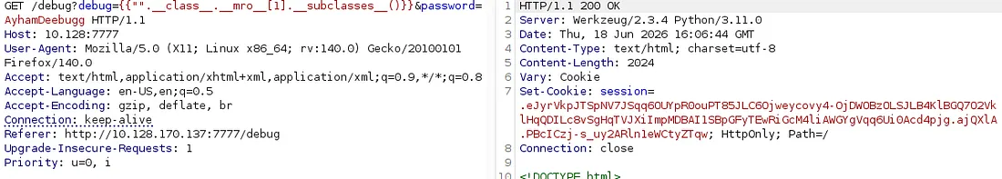
Python subclass enumeration used to inspect runtime objects.

4.2 Execution Primitive Discovery
The returned HTML was processed locally to locate the runtime entry corresponding to subprocess.Popen.
python3 -c "...subprocess.Popen..."
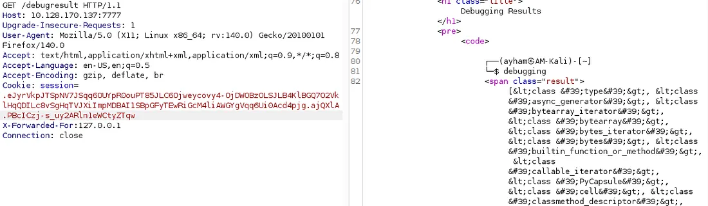
Local search for the subprocess execution primitive.

4.3 Shell Delivery
Input filtering interfered with direct shell metacharacters, so a controlled command was encoded for transport. The lab session then produced an initial shell.
nc -lnvp 4445
Preparation of an encoded command for the lab.

4.4 Encoded Web Payload
The payload was URL-encoded before submission to the debug application.
URL-encoded web payload evidence.

4.5 Initial Shell Evidence
The command-execution path was converted into a shell session in the lab. The first challenge flag is intentionally omitted.
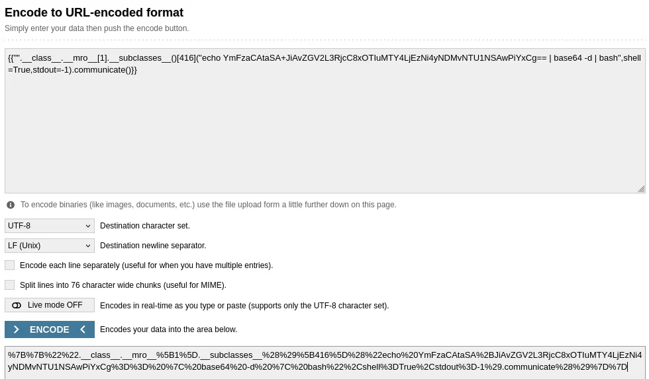
Initial shell evidence from the lab.

5. Lateral Movement via PATH Hijacking

5.1 Scheduled Tasks
Process monitoring exposed recurring jobs, including a login-shell job under another user and a separate root task.
pspy64
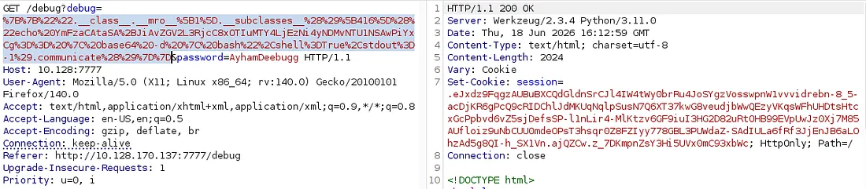
Cron/process monitoring showing scheduled tasks.

5.2 Writable .profile
The target user's .profile was writable from the initial account. Because the scheduled Bash process used login-shell behavior, PATH changes could influence command lookup.
Writable shell initialization file evidence.

5.3 Controlled Executable
A controlled executable was placed in an attacker-owned directory so it could take precedence during command lookup.
mkdir -p /home/INITIAL_USER/bin
chmod +x /home/INITIAL_USER/bin/cat
Controlled executable used to demonstrate PATH hijacking.

6. Root-Context curl Configuration Abuse

6.1 Root Scheduled Task
The root task invoked curl with -K/--config. Since the configuration file was writable by a lower-privileged user, curl inherited attacker-selected options.
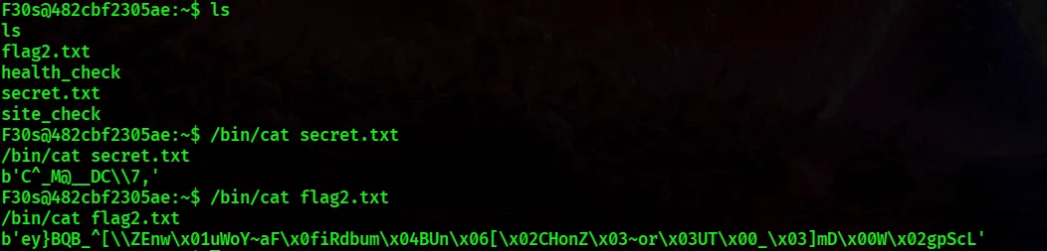
Root scheduled task and curl configuration abuse evidence.

6.2 File Access Demonstration
The writable configuration was redirected to a local file URI and an accessible output path, producing a root-context file access primitive. The final challenge answer remains redacted.

7. Vulnerability Analysis
Finding | Impact | Mitigation
Source-Code Disclosure | Implementation details, hidden routes, and secret-handling logic became remotely accessible. | Separate source from user-downloadable resources; use strict allowlists and canonical path validation.
Weak XOR Secret Protection | A reversible transform does not provide password security when the transformation and key are recoverable. | Use Argon2id, scrypt or bcrypt for passwords; use standard authenticated encryption when encryption is required.
SSTI | User input was treated as Jinja template source. | Render trusted templates and pass untrusted values as data. Never render user-controlled strings as templates.
Header-Based Trust | A forwarding header influenced a localhost-only access decision. | Strip untrusted forwarding headers at the edge and make authorization decisions using trusted context.
Writable Shell Initialization | A lower-privileged account could modify a target user's shell startup file. | Enforce strict ownership and permissions; avoid privileged login shells for automation.
Attacker-Writable curl Config | A privileged scheduled task consumed options from a lower-privileged writable file. | Protect configuration files and use fixed arguments, absolute paths, and least privilege.

8. Detection & Defensive Review
- Monitor requests for source files, debug endpoints, and template syntax in parameters.
- Alert on unexpected X-Forwarded-For values when they influence authorization.
- Monitor process chains such as Python -> shell -> curl and unexpected scheduled-task children.
- Audit ownership and permissions of .profile, .bashrc and similar shell initialization files.
- Review root cron jobs for user-controlled paths, config files, or relative executable names.
- Use absolute executable paths and least-privileged accounts for scheduled automation.

9. Lessons Learned
- Source-code exposure can convert a black-box web test into a white-box analysis.
- Homegrown reversible transformations are unsuitable for password protection.
- Unsafe template rendering can connect web input to Python runtime capabilities.
- Client-controlled headers should never silently become authorization boundaries.
- Login shells, PATH resolution, and writable startup files can combine into privilege escalation.
- Privileged command-line tools must not consume attacker-writable configuration.

10. Evidence Index
# | Screenshot | Purpose
00 | 00_room_banner.png | Room visual used as the report cover asset.
01 | 01_port_scan.png | Full TCP service enumeration showing SSH and the Werkzeug web service.
02 | 02_content_discovery.png | Web content discovery identifying the interesting application endpoints.
03 | 03_cloud_source_request.png | Burp evidence of source retrieval through the cloud download workflow.
04 | 04_secret_tip_download.png | Burp evidence of the encrypted challenge material.
05 | 05_xor_decryption.png | Local Python evidence for the XOR transformation.
06 | 06_debug_source_request.png | Source evidence for the debug/IP trust helper.
07 | 07_ssti_confirmation.png | Harmless Jinja expression used to confirm SSTI.
08 | 08_debugresult_cookie.png | Authenticated debug-result request using session context.
09 | 09_ssti_class_enumeration.png | Python subclass enumeration used to inspect runtime objects.
10 | 10_popen_index.png | Local search for the subprocess execution primitive.
11 | 11_base64_shell.png | Preparation of an encoded command for the lab.
12 | 12_payload_encoded.png | URL-encoded web payload evidence.
13 | 13_reverse_shell.png | Initial shell evidence from the lab.
14 | 14_cron_observation.png | Cron/process monitoring showing scheduled tasks.
15 | 15_profile_writable.png | Writable shell initialization file evidence.
16 | 16_fake_cat_payload.png | Controlled executable used to demonstrate PATH hijacking.
17 | 17_root_curl_cron.png | Root scheduled task and curl configuration abuse evidence.
18 | 18_flags_terminal.png | Final terminal artifacts; challenge answers intentionally omitted from public documentation.

11. Public-Safe Flag Policy
The original lab evidence contained challenge flags. This portfolio edition intentionally replaces them with FLAG_REDACTED so the repository demonstrates methodology and documentation quality without publishing direct answers.

12. Conclusion
SuperSecretTip demonstrates how several ordinary weaknesses can form a complete attack chain when they cross trust boundaries. The important skill is not memorizing payloads; it is using evidence from application behavior, source code, runtime state, scheduled tasks, and filesystem permissions to explain each transition.

Appendix - Tools Used
- Nmap
- ffuf
- Burp Suite
- Python 3
- Netcat
- pspy64
- Linux filesystem and permission utilities

