THE LONDON BRIDGE
TryHackMe Security Assessment Walkthrough
Web Enumeration • SSRF • Linux Privilege Escalation • Credential Recovery
PUBLIC PORTFOLIO EDITION — SECRETS REDACTED
Platform | TryHackMe
Room | The London Bridge
Primary surface | Gunicorn-backed HTTP service on TCP/8080
Access path | Web → SSRF → internal resources → beth SSH → root
Credential artifact | Firefox profile in charles home directory
Publication policy | Flags, passwords and private-key contents omitted

1. Executive Summary
The London Bridge is a TryHackMe training environment that rewards disciplined enumeration. The documented path begins with service discovery, moves to a Gunicorn web application on port 8080, identifies server-side resource fetching, validates SSRF with a controlled callback, bypasses a localhost restriction using an alternate loopback representation, and reaches SSH access as beth.
Host enumeration then exposes a kernel privilege-escalation research path. The lab chain reaches root and finishes with offline analysis of a Firefox profile associated with charles.
All flags, passwords, private-key contents, and other directly reusable secrets are redacted in this portfolio edition.

2. Lab Scope & Ethics
All techniques described here are intended for the TryHackMe target or another explicitly authorized environment. SSRF testing, key handling, kernel exploitation, and browser credential extraction should not be attempted against systems without permission.

3. Attack Surface
Initial reconnaissance identifies two externally visible TCP services.
PORT | OBSERVATION | SIGNIFICANCE
22/tcp | OpenSSH 7.6p1 Ubuntu | Candidate remote administration interface
8080/tcp | Gunicorn HTTP service | Primary web attack surface

4. Reconnaissance — Nmap
The initial scan uses default scripts, service/version detection, and a full TCP port range.
nmap -sC -sV -p- <TARGET>
22/tcp open ssh OpenSSH 7.6p1 Ubuntu
8080/tcp open http-proxy Gunicorn
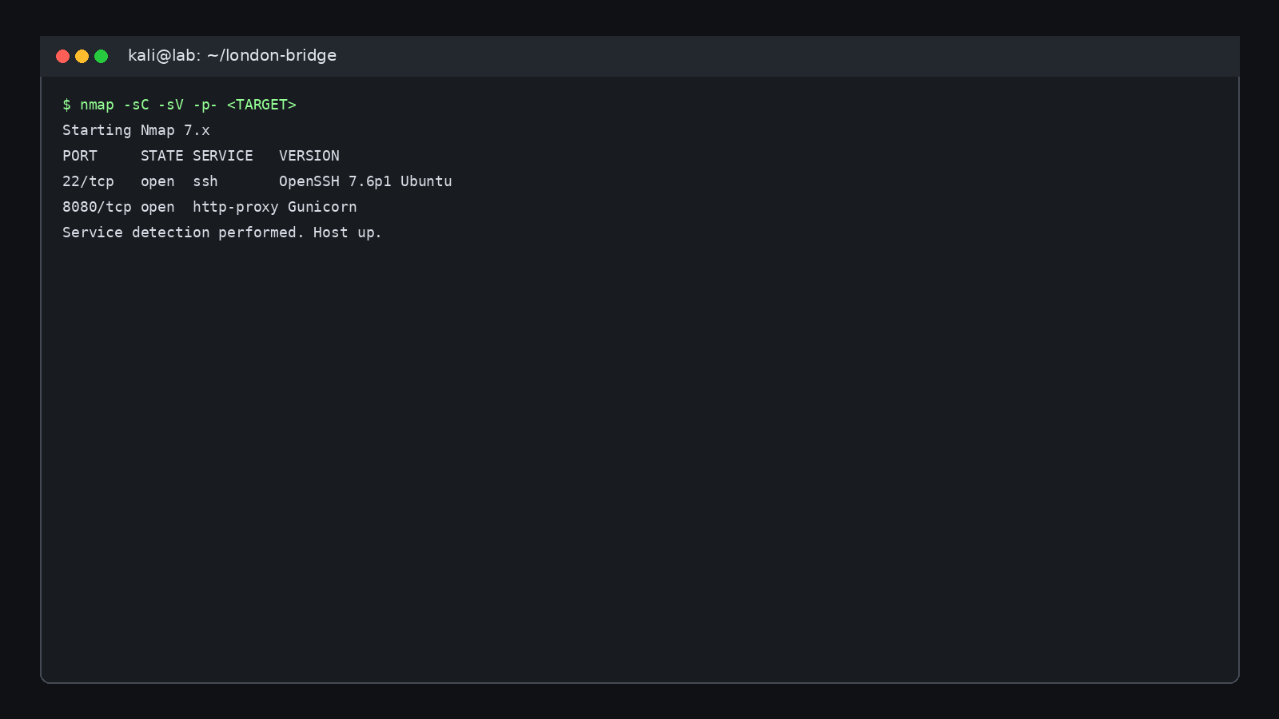
01 Nmap Enumeration

5. Web Enumeration — Port 8080
Browsing port 8080 reveals a small application with Gallery and Contact functionality. The Gallery is the higher-interest surface because it handles images and a server-side viewing workflow.
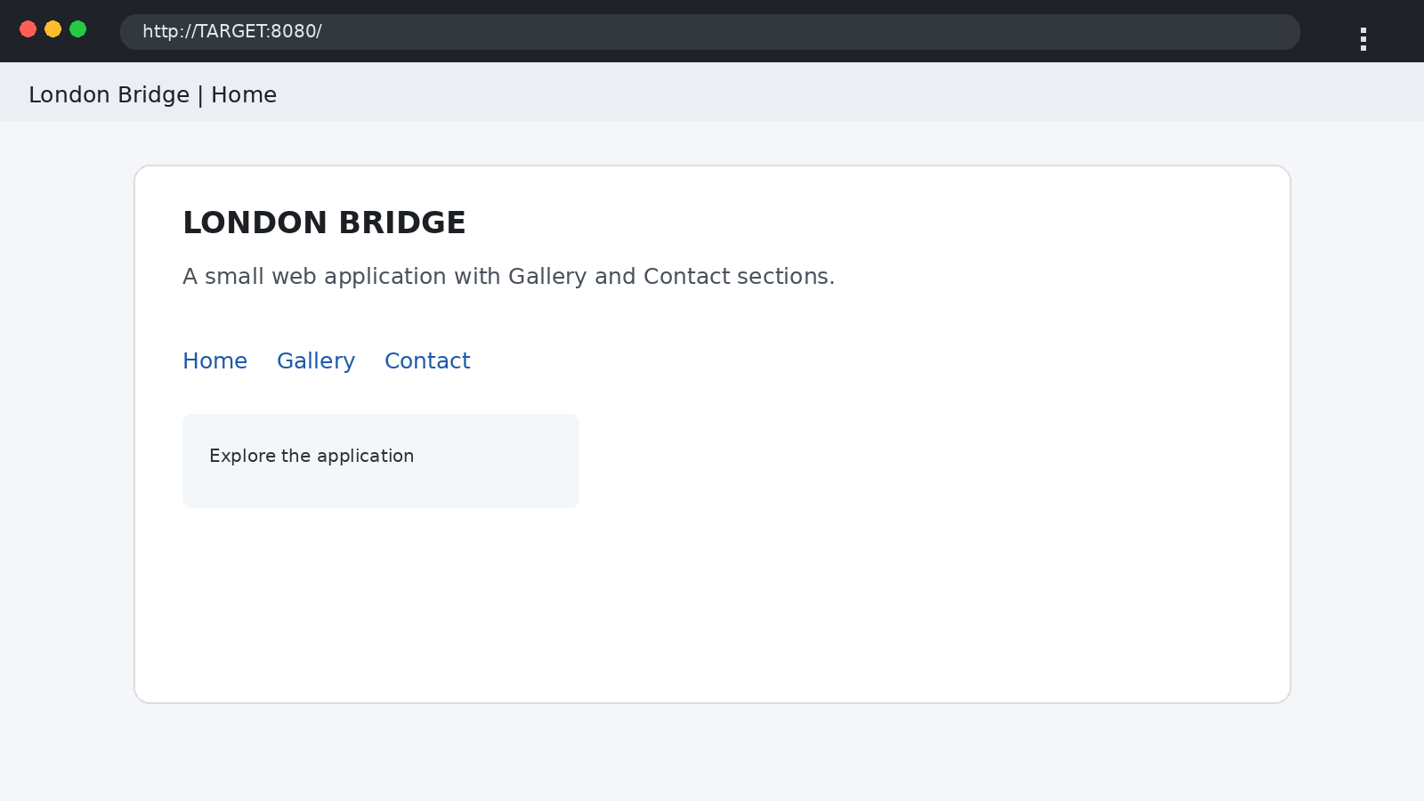
02 Web Home 8080
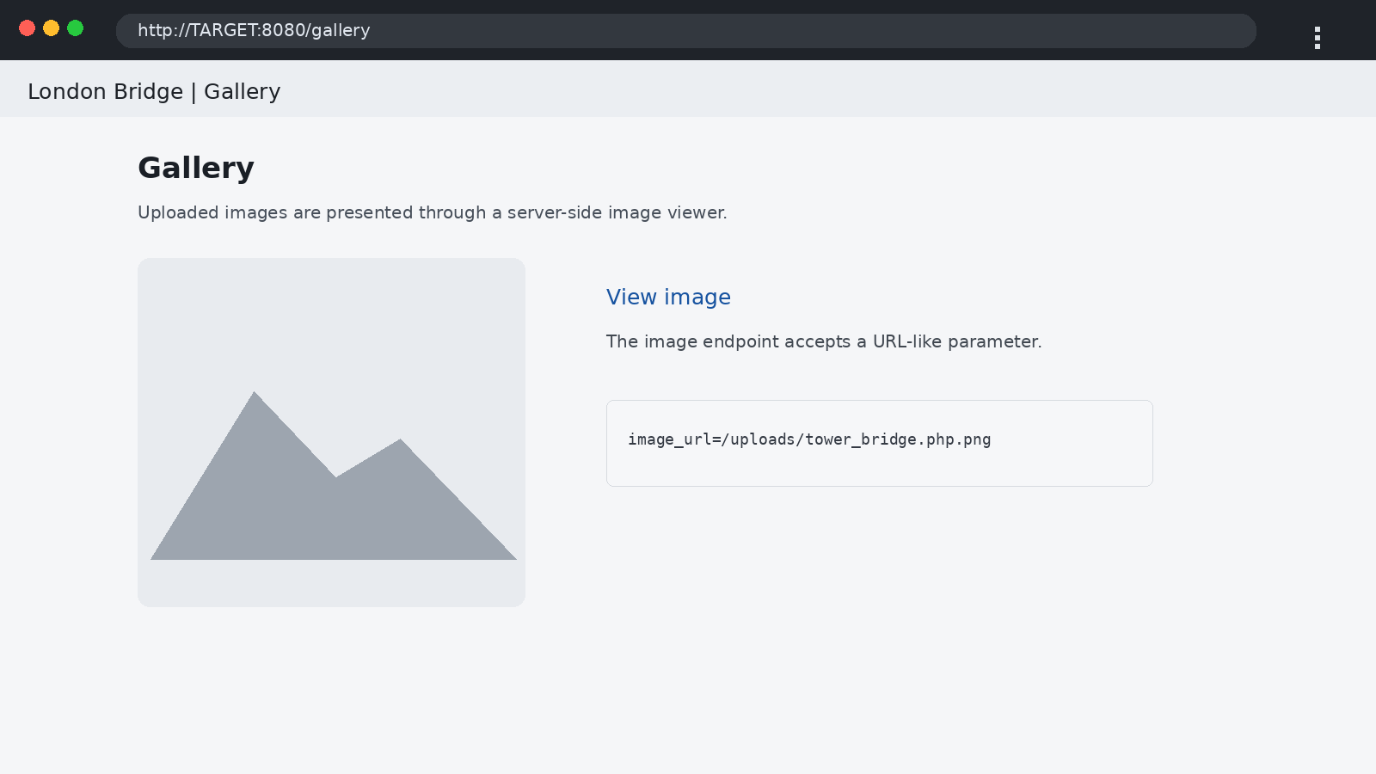
03 Gallery Page
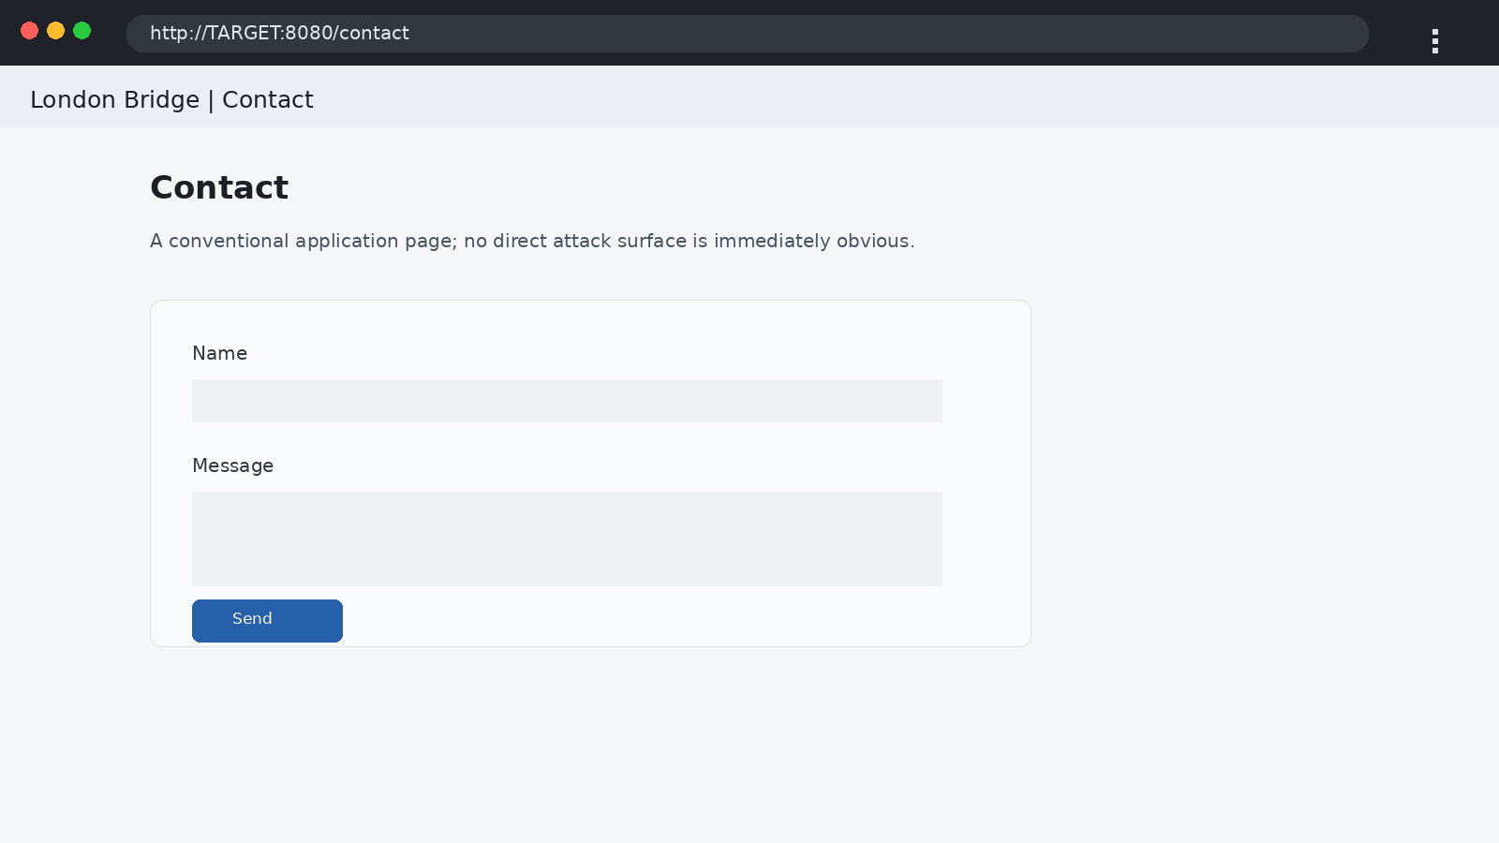
04 Contact Page

6. Upload Handling & Request Interception
The upload workflow is intercepted in Burp Suite so the request structure and response can be studied directly. Several upload-bypass ideas can be tested, but content discovery and request-parameter analysis provide a more productive route.
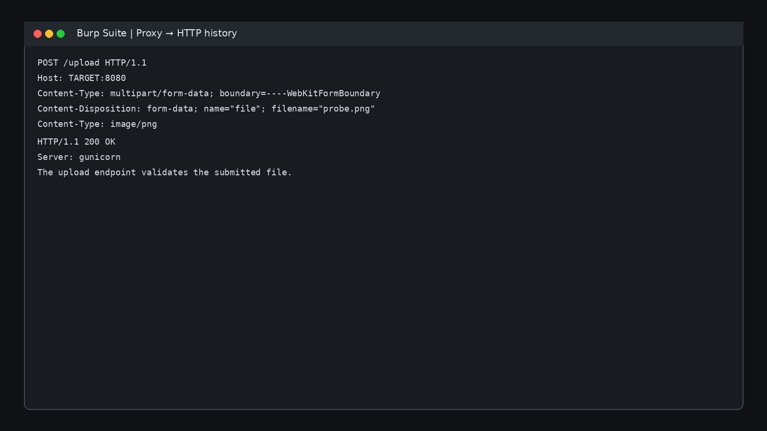
05 Upload Burp Intercept

7. Content Discovery
Feroxbuster is used to identify application paths and upload-related resources.
feroxbuster -u http://<TARGET>:8080 -w <WORDLIST>
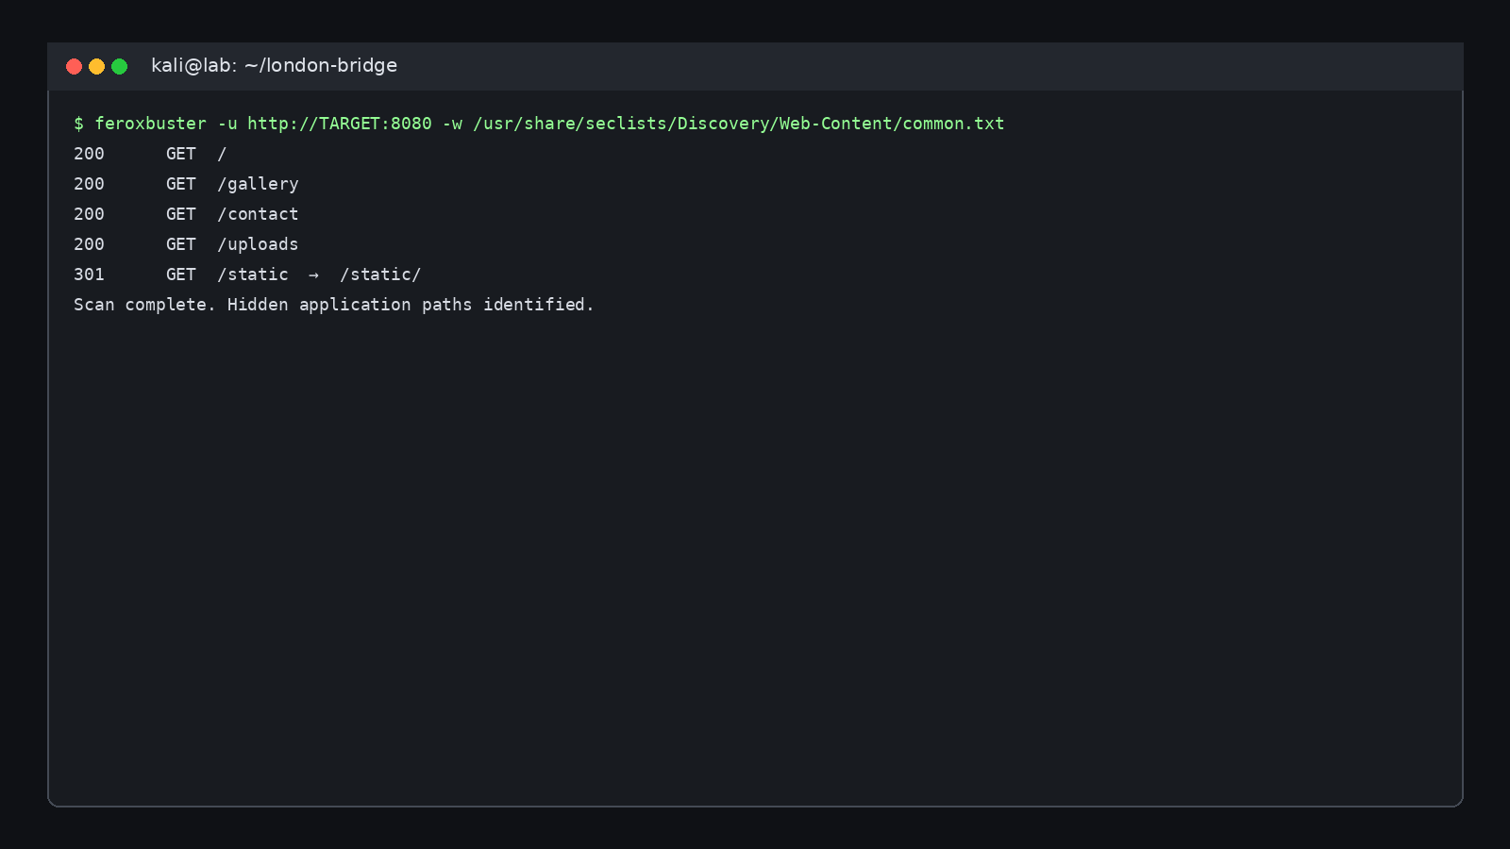
06 Feroxbuster Discovery

8. Burp Repeater — Parameter Analysis
The image-viewing request is moved into Repeater, allowing the resource parameter to be modified while observing server responses.
GET /view?image_url=/uploads/tower_bridge.php.png HTTP/1.1
Host: <TARGET>:8080
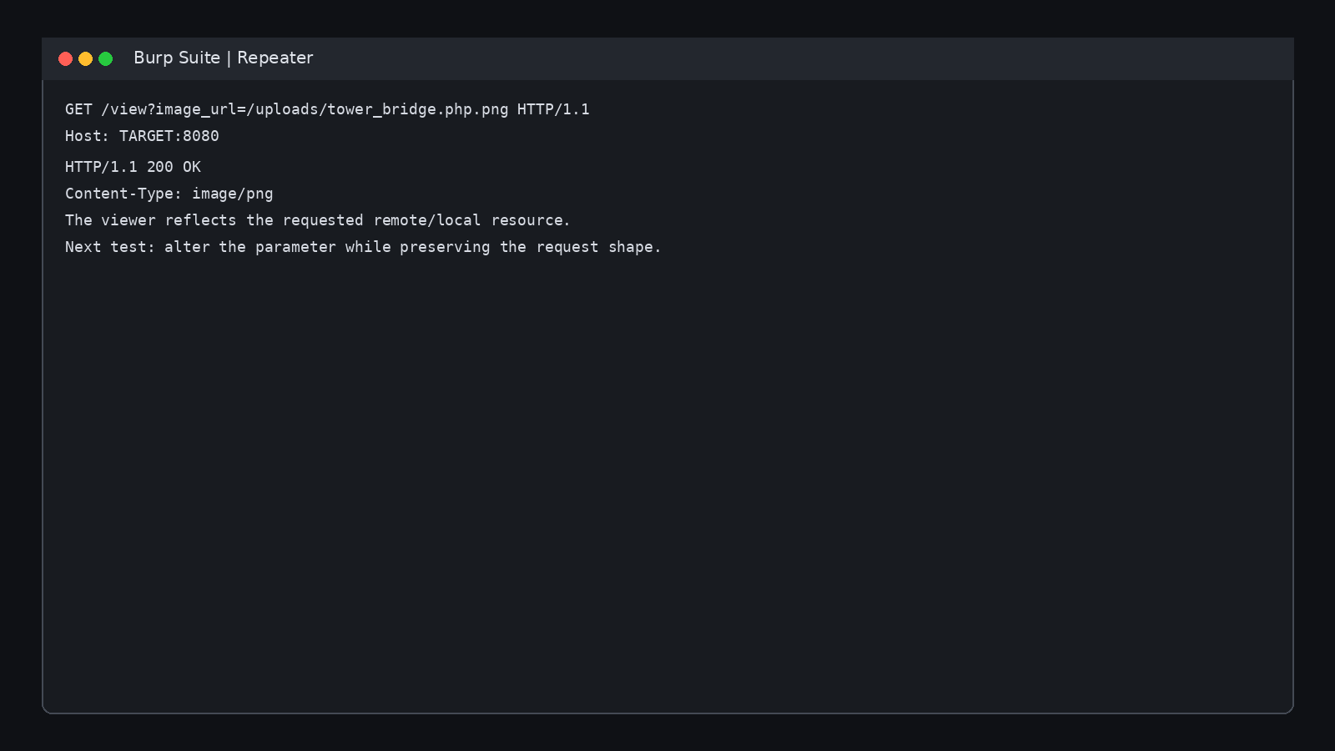
07 Burp Repeater Image Url

9. Parameter Discovery — www
A developer-facing hint suggests there may be a different parameter involved. FFUF is used to fuzz parameter names, leading to the discovery of a www parameter that changes the server-side request behavior.
ffuf -u "http://<TARGET>:8080/view?FUZZ=http://127.0.0.1/" -w <PARAM_WORDLIST>
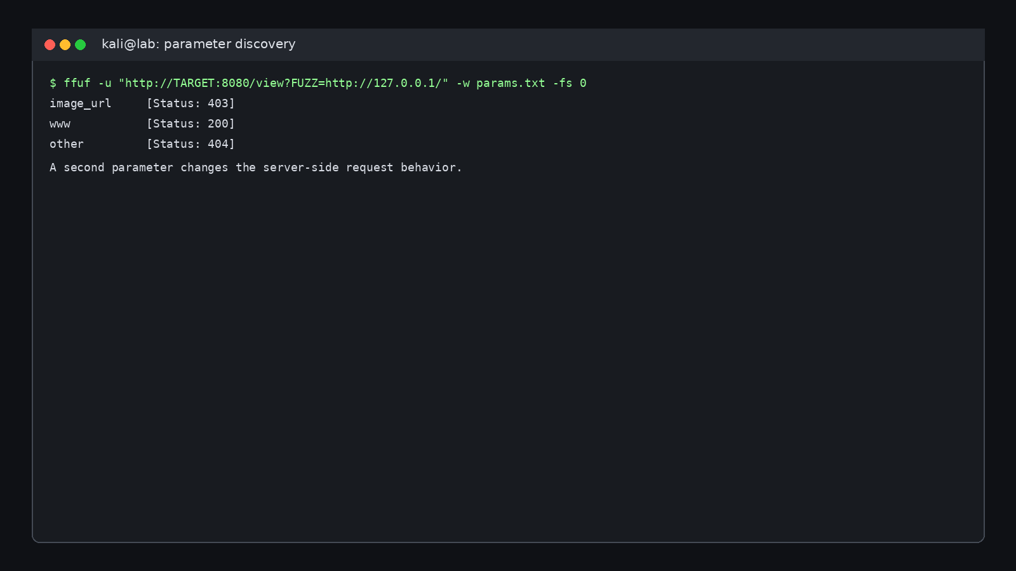
08 Parameter Fuzz Www

10. SSRF Validation
A controlled HTTP server is started locally. A request from the target application reaches that server, providing strong evidence that the application is making an outbound request on behalf of the user.
python3 -m http.server 8000 --bind 0.0.0.0
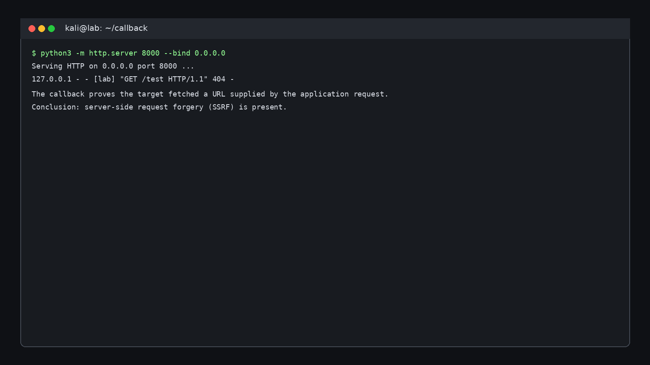
09 Ssrf Callback
This behavior establishes a Server-Side Request Forgery primitive. The security significance is that the target host can potentially reach resources unavailable from the tester’s position.

11. Loopback Filter Bypass
Direct localhost access is rejected, suggesting a brittle destination filter. Testing an alternate loopback representation, such as http://127.1.:80/, reaches a local web service.
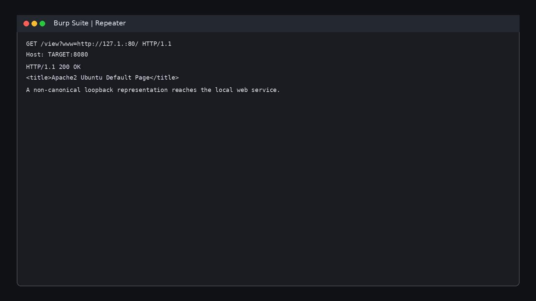
10 Localhost Filter Bypass
The defensive lesson is that string-based blacklist checks are not sufficient for SSRF protection; validation should occur after parsing and destination resolution.

12. Internal Resource Discovery
Once the internal service is reachable, it is enumerated like a newly discovered host. Hidden/dot-prefixed resource syntax is included in the content-discovery process.
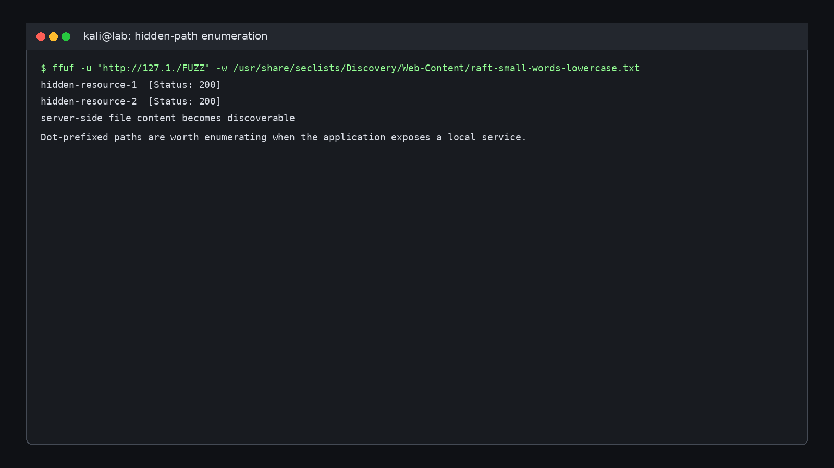
11 Hidden Directory Fuzzing

13. SSH Access as beth
Two hidden resources provide information that leads to SSH access for beth. Sensitive contents are intentionally omitted. The private-key file is stored with restrictive permissions and used only against the lab target.
chmod 600 <beth-key-file>
ssh -i <beth-key-file> beth@<TARGET>
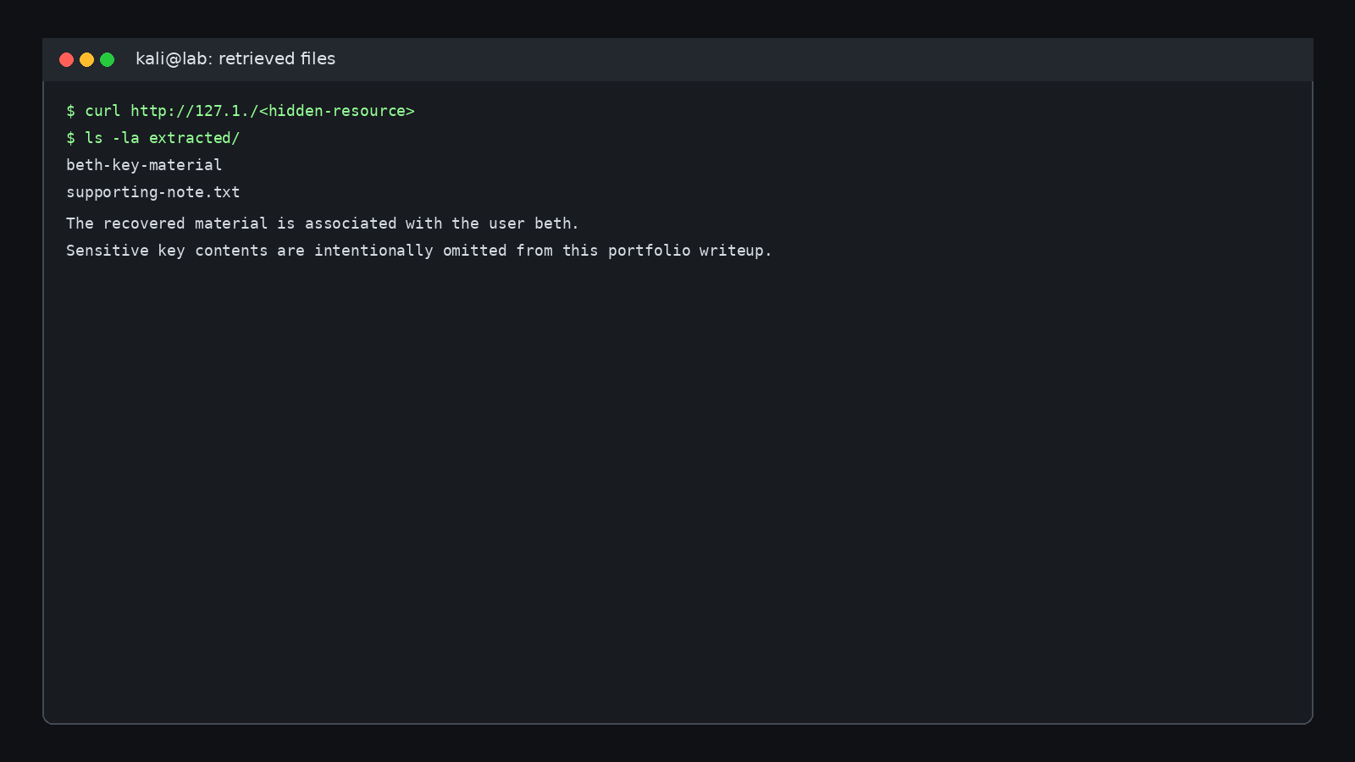
12 Beth Key Material
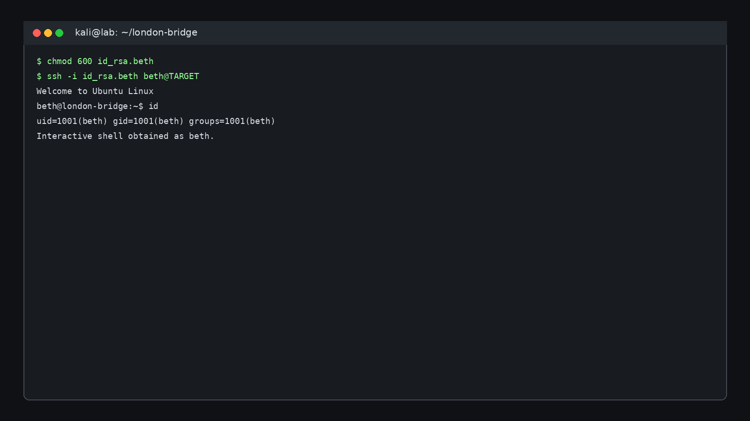
13 Ssh As Beth

14. Privilege Escalation Enumeration
After initial access, broad host enumeration is performed. The kernel is 4.15.0-112-generic, and the enumeration output points toward CVE-2018-18955 as a candidate path to investigate for the specific lab build.
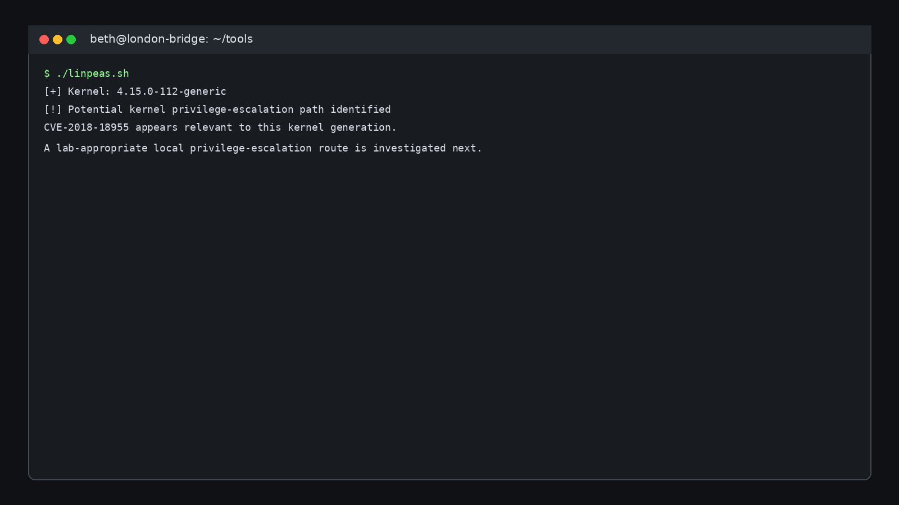
14 Linpeas Kernel Enumeration

15. Root Access
The selected lab exploit is compiled and executed successfully, producing a shell with UID 0. The root flag is not reproduced in this public edition.
gcc exploit.c -o exploit
./exploit
id
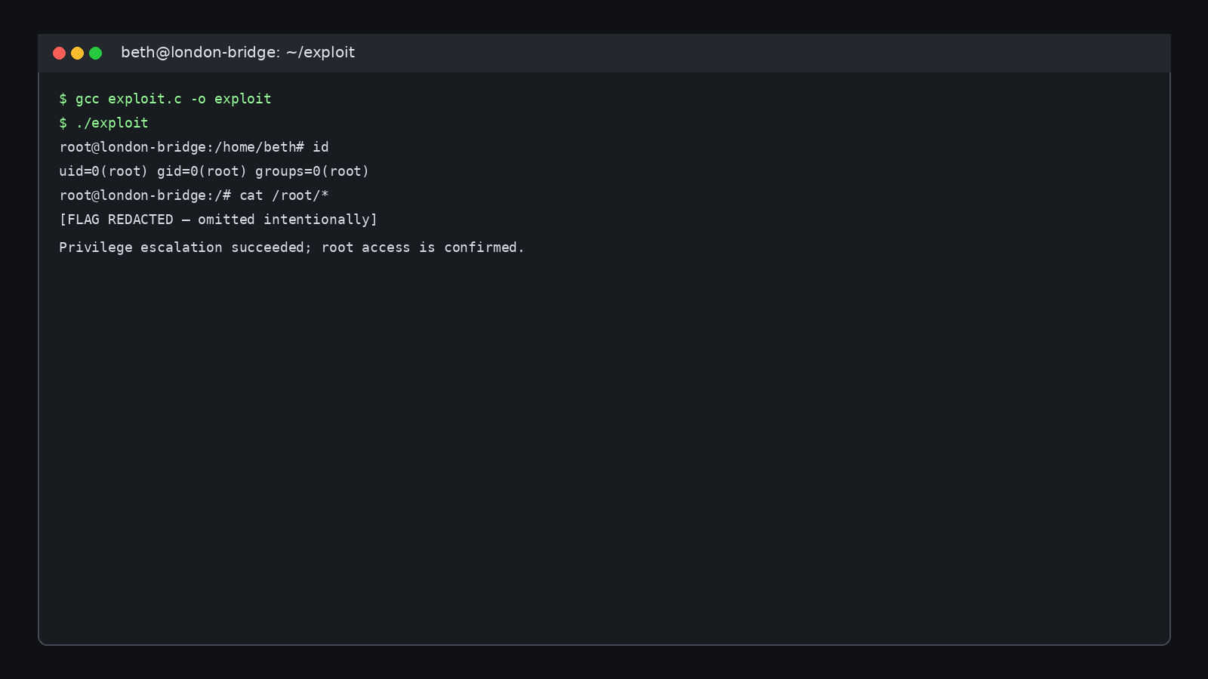
15 Root Shell Redacted

16. Firefox Credential Recovery
With root access, the charles home directory can be inspected. A Firefox profile is recovered and analyzed offline with a suitable browser credential decryption utility. The recovered password is intentionally redacted.
python3 firefox_decrypt.py <charles-firefox-profile>
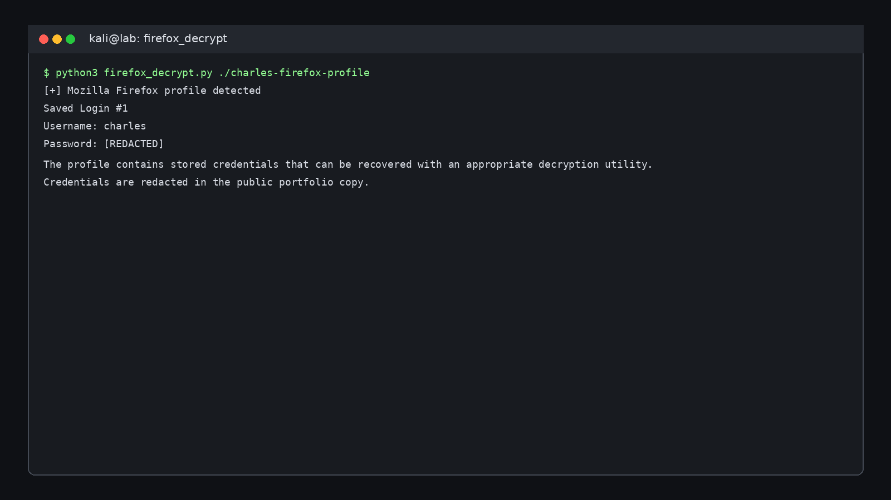
16 Firefox Profile Credential Recovery

17. Attack Chain Summary
Nmap → 8080/Gunicorn → Gallery → request interception → www parameter → SSRF → loopback bypass → internal resource enumeration → beth SSH material → SSH → host enumeration → kernel escalation → root → Firefox profile → charles credential recovery.

18. Key Security Lessons
SSRF is a trust-boundary failure: user-controlled input influences a server-side network destination.
Blacklists are fragile: blocking one hostname or one canonical loopback string is not a complete defense.
Enumeration compounds: each validated finding expands the set of resources that can be investigated next.
Files can be credentials: private keys, browser profiles, configuration files, logs, and backups can all contain authentication material.
Version discovery is a starting point: exploitability depends on exact build, configuration, mitigations, and prerequisites.

19. Defensive Recommendations
Finding | Defensive improvement
SSRF-capable URL parameter | Enforce a strict allowlist of approved origins
Loopback bypass | Parse, resolve, normalize, and validate the final destination
Internal resource exposure | Segment services and protect admin/debug endpoints
Sensitive key material | Restrict permissions and rotate exposed credentials
Browser credential exposure | Use controlled password management and protect profiles
Vulnerable kernel | Apply supported security updates
Broad privilege | Enforce least privilege

20. Evidence Handling & Attribution
This public portfolio edition redacts challenge flags, passwords, private-key contents, and other reusable secrets. The screenshot set is made from original lab-style recreations based on the supplied workflow rather than copied source images.
Reference: Tommaso Greco, “The London Bridge — TryHackMe”, Medium, December 16, 2024. https://medium.com/@tommasogreco/the-london-bridge-tryhackme-2c8f2f0e5b5a
END OF PUBLIC PORTFOLIO EDITION

