TOWEL ON THE SUNBED
TryHackMe Web Security Walkthrough
Business Logic • Race Condition • Burp Suite Repeater
Portfolio-ready documentation of an authorized TryHackMe lab. The final challenge flag is intentionally redacted from the public copy.

1. Overview
Platform: TryHackMe
Challenge: Towel on the Sunbed
Focus: Web application business logic and race conditions

2. Application Review
The dashboard exposes staking rewards and a Whale Vault. The visible flow awards 50 PONZI per successful claim and requires 150 PONZI to unlock the vault.

3. Request Capture
Burp Suite Proxy was used to intercept POST /claim. The public document omits the actual host and session cookie.

4. Baseline
A normal claim succeeds. An immediate sequential replay is rate-limited, establishing the expected cooldown.

5. Repeater Setup
The captured request is moved to Repeater and duplicated. The copies are placed into a request group.

6. Parallel Execution
The grouped requests are dispatched concurrently to test whether the cooldown check and balance mutation behave atomically.

7. Finding
Multiple requests can be accepted inside the same race window, producing multiple reward updates.

8. Verification
Refreshing the dashboard confirms the resulting balance and makes the Whale Vault available.

9. Remediation
Use atomic transactions, suitable locking/isolation, idempotency, server-side cooldown checks, database invariants, and concurrency regression testing.

10. Conclusion
The core lesson is that a business-logic control that works sequentially must also remain correct under concurrent execution.

11. Evidence
Figure | Screenshot
1 | 01-dashboard-initial.png
2 | 02-dashboard-staking.png
3 | 03-burp-captured-claim.png
4 | 04-repeater-request.png
5 | 05-repeater-tab-group.png
6 | 06-repeater-parallel-send.png
7 | 07-parallel-responses.png
8 | 08-whale-vault-unlocked.png
9 | 09-flag-redacted.png
10 | 10-whale-vault-final.png

12. Screenshot Evidence

Figure 1 — 01-dashboard-initial.png


Figure 2 — 02-dashboard-staking.png
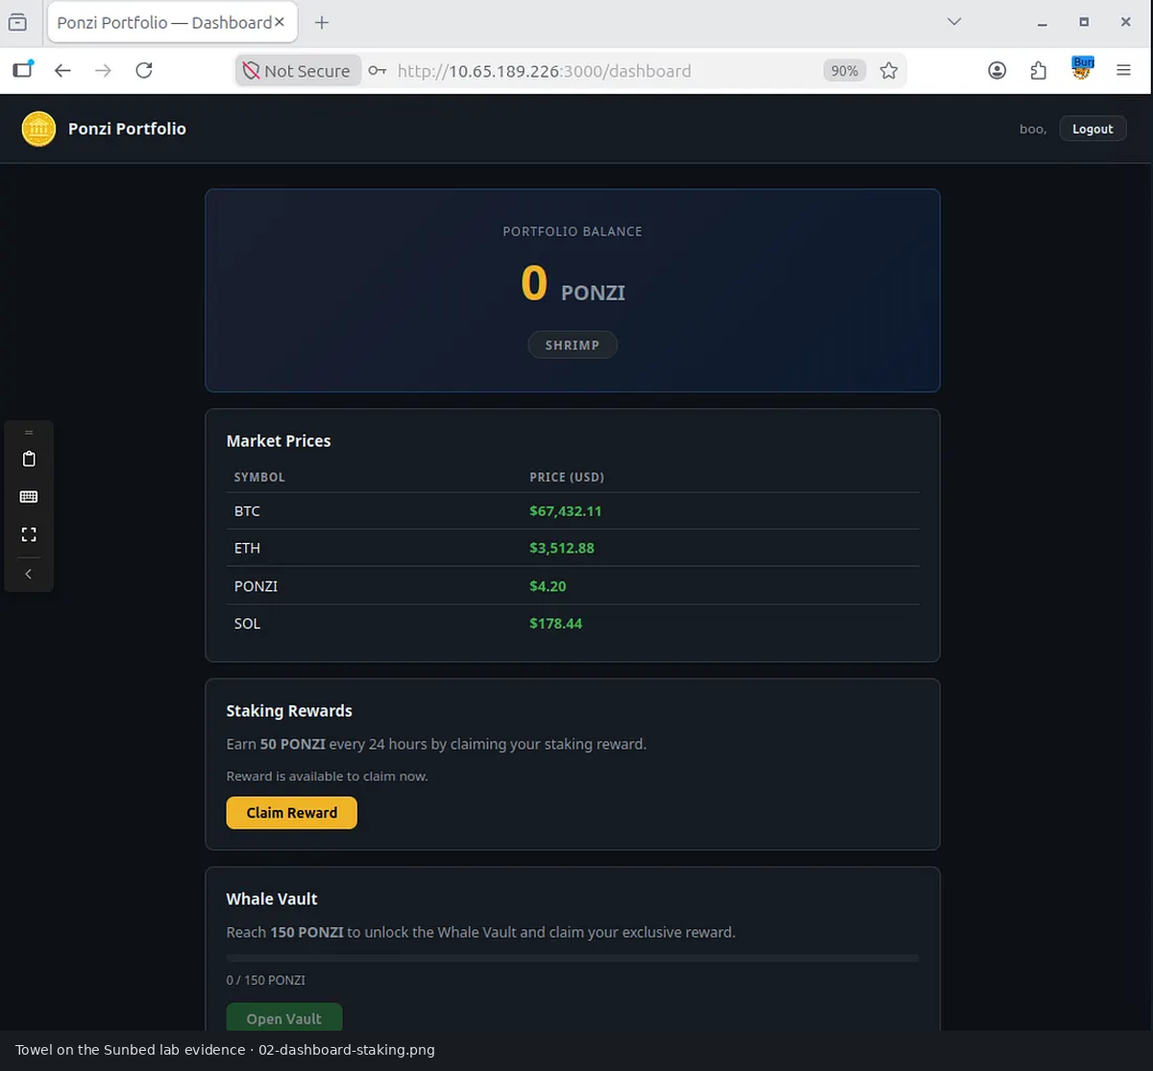

Figure 3 — 03-burp-captured-claim.png
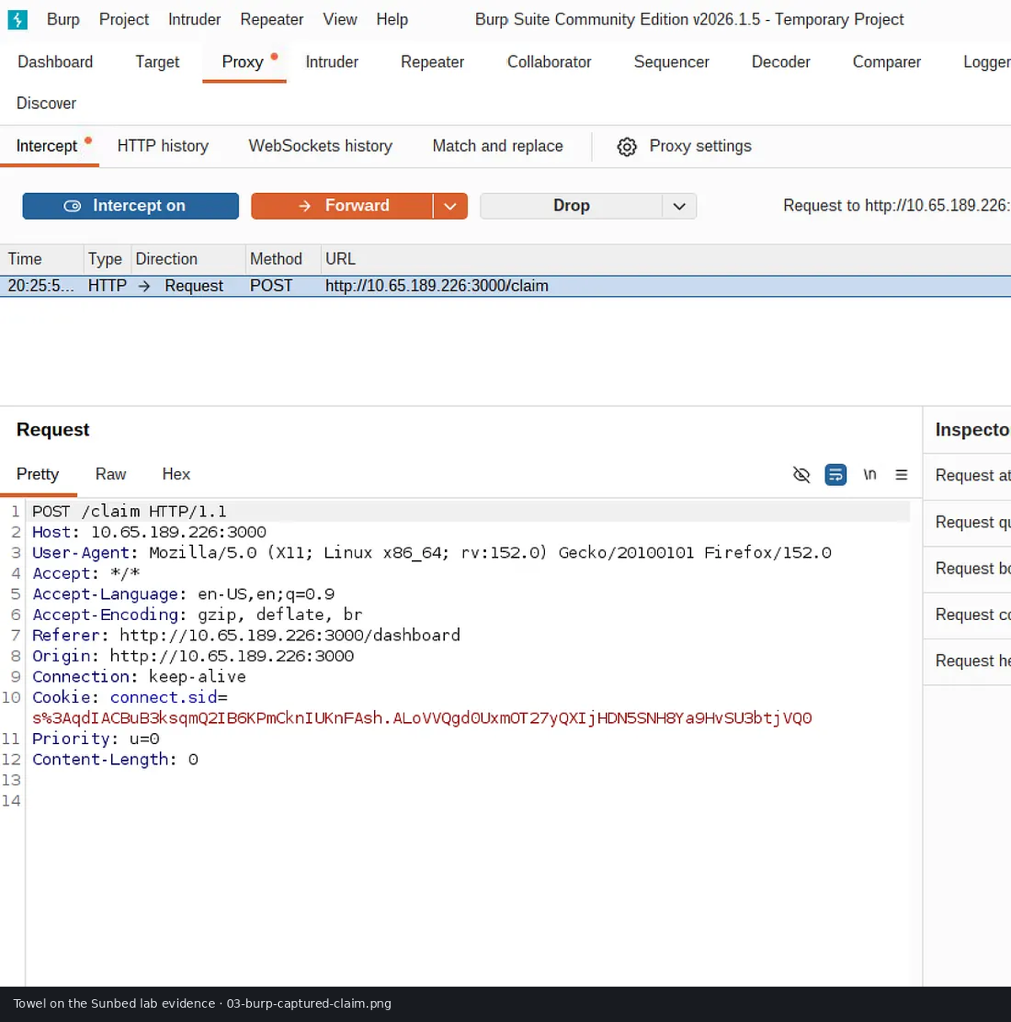

Figure 4 — 04-repeater-request.png
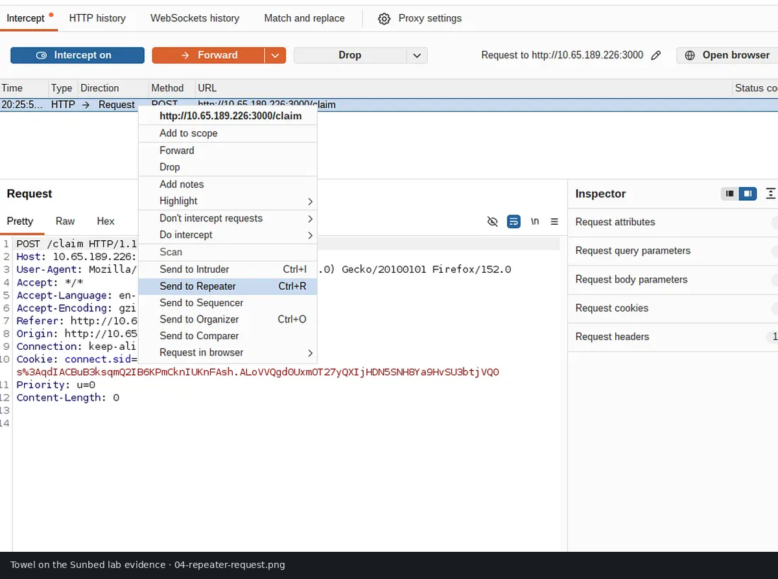

Figure 5 — 05-repeater-tab-group.png
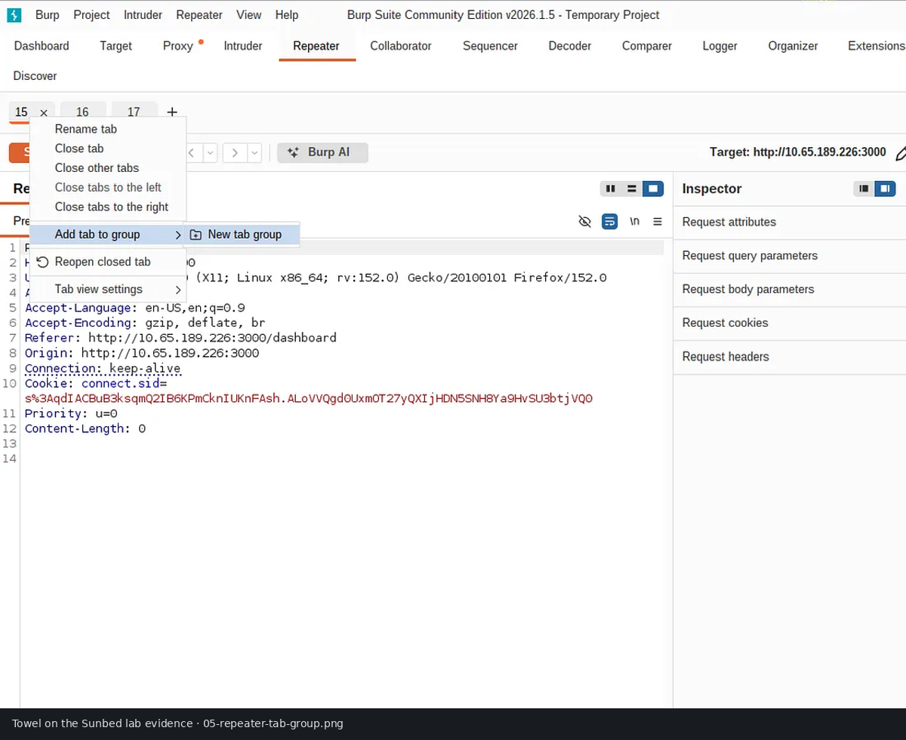

Figure 6 — 06-repeater-parallel-send.png
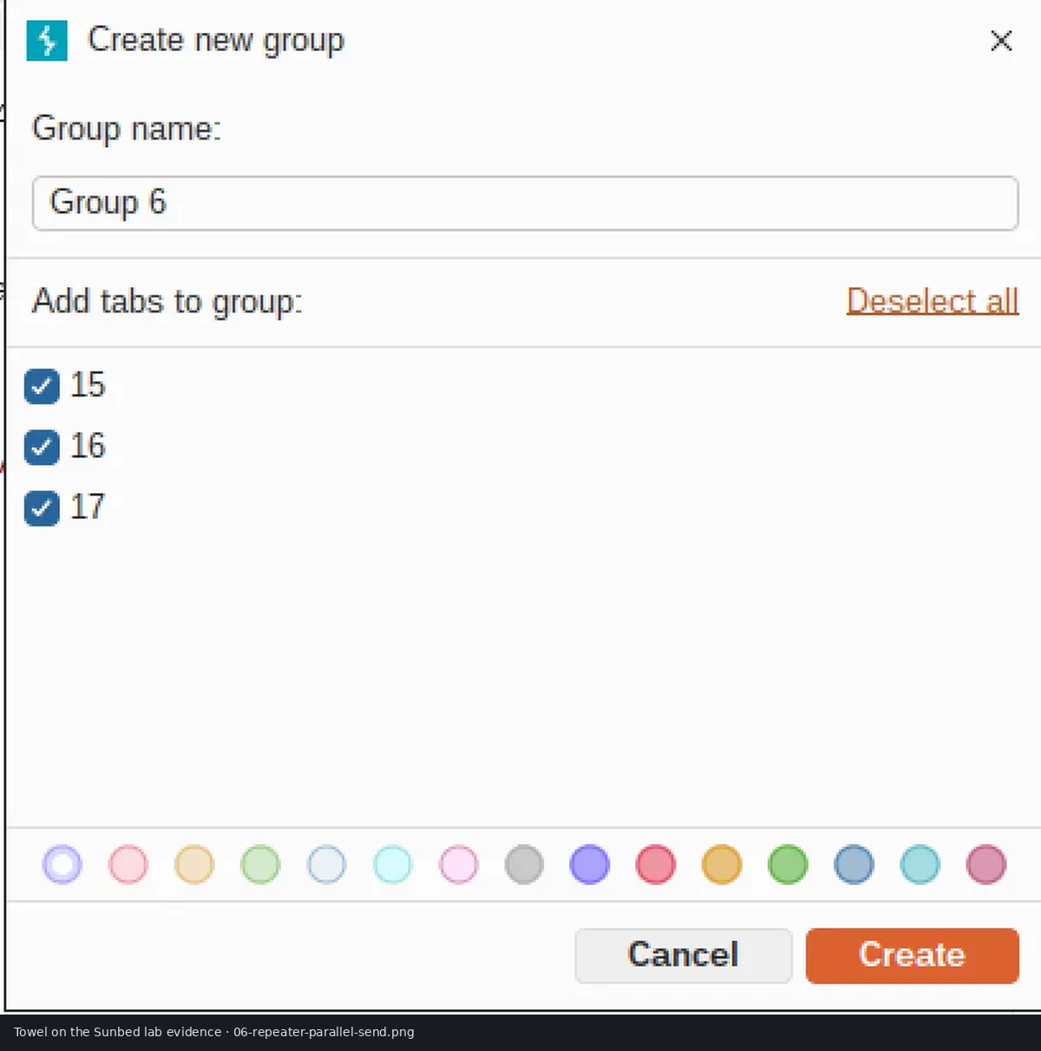

Figure 7 — 07-parallel-responses.png
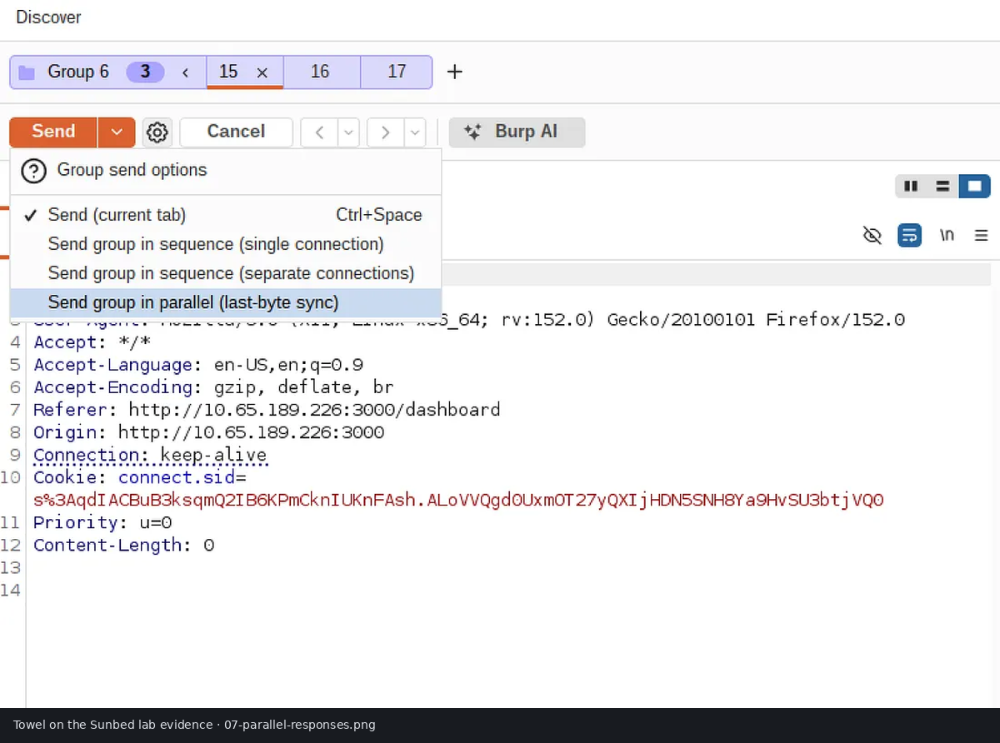

Figure 8 — 08-whale-vault-unlocked.png
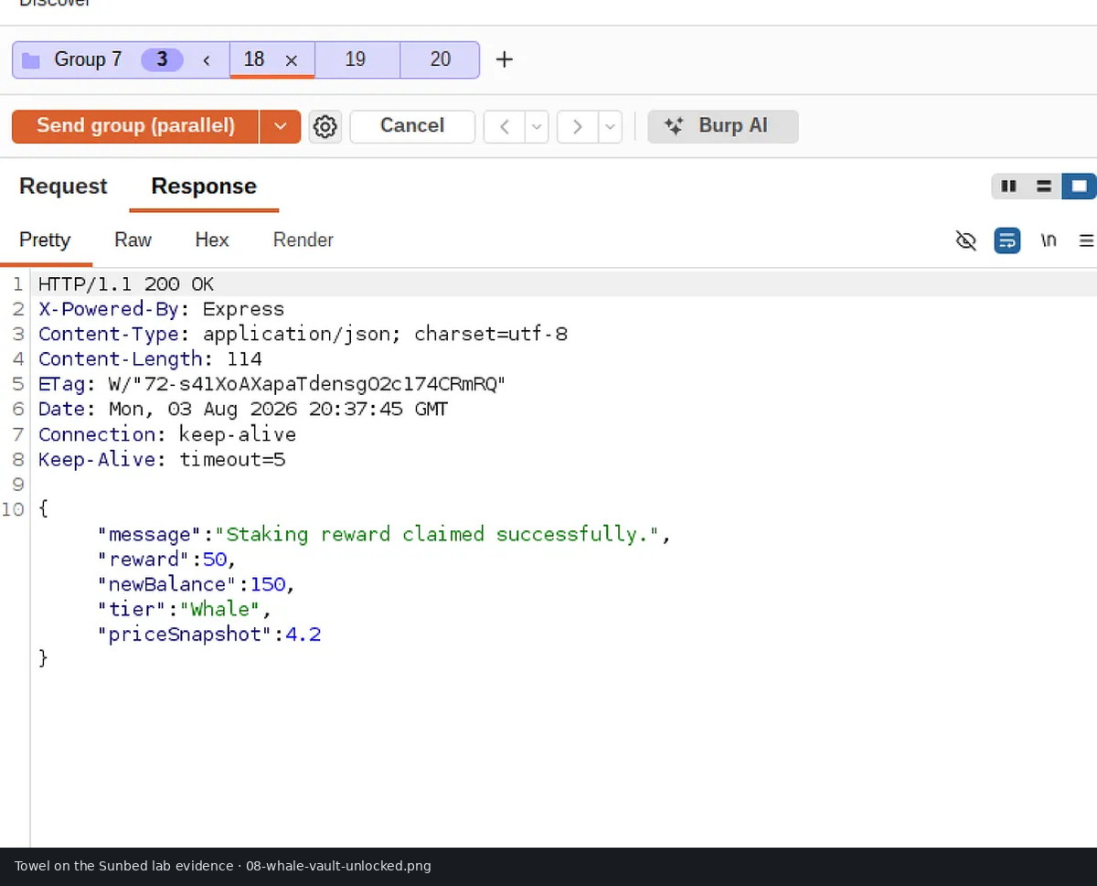

Figure 9 — 09-flag-redacted.png
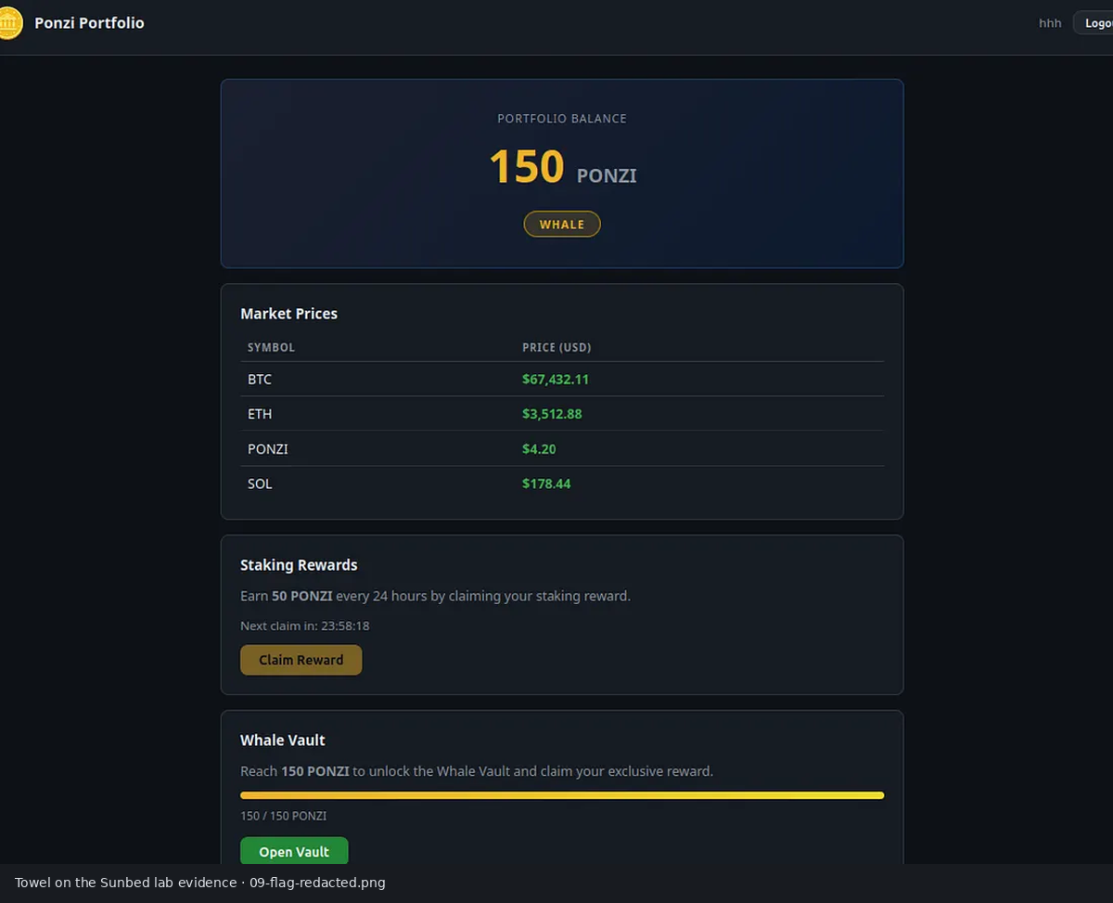

Figure 10 — 10-whale-vault-final.png
