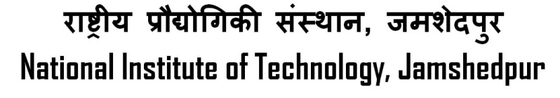

**(An Institute of National Importance, under MHRD, Govt. of India)**



# PRAKASH GUPTA

B TECH. (HONS), MECHANICAL ENGINEERING

**DOB:**-29 Feb 19XX **Reg. ID**: - ME112XXX

**OBJECTIVE**

**EDUCATIONAL QUALIFICATION:-**

|  |  |  |  |  |  |
| --- | --- | --- | --- | --- | --- |
|  | **Name of Examination** | **Year of passing** | **Board/**  **University** | **Institution** | **Percentage/**  **CGPA** |
| **Graduation** |  |  |  |  |  |
| **Senior Secondary(XII)** |  |  |  |  |  |
| **Secondary**  **School(X)** |  |  |  |  |  |

_

**ACADEMIC ACHIEVEMENTS**

**POSITION OF RESPONSIBILITIES**

* .

**EXTRA-CURRICULAR ACTIVITIES**



**HOBBIES & INTERESTS**

**PERSONAL INFORMATION**

|  |  |
| --- | --- |
| **Correspondance Address :-** |  |
| **Permanent Address :-** |  |
| **Email id :-** |  |
| **Phone/Mob No :-** |  |

**TRAINING / INTERNSHIP / PROFESSIONAL COURSE**

|  |  |  |
| --- | --- | --- |
| **ORANIZATION** | **PERIOD** | **PROJECT TITLE** |
|  |  |  |
|  |  |  |
|  |  |  |

*(Signature of Student)*