1. **A comparative analysis of the models and their accuracies**

In the figure attached below, we can see the accuracy of all the different models over the 7 folds. Some general observation points is that the LDA seems to be the best performing model, this can be due to the fact that most of the features are normally distributed. Following this is the ANN which has a single hidden layer of 10 neurons using the relu activation function and it runs for a total of 200 epochs. Then we see the Logistic Regression model which again uses 200 iterations for convergence although during the test run we did not achieve convergence as the training data was not scaled properly. It uses the Stochastic Average Gradient as the solver method. In the case of the Perceptron model not only do we see a comparatively low accuracy but also comparatively low precision as clear from the above image. Then we see the NaiveBayes classifier which uses Gaussian naive bayes algorithm for classification which basically means that the likelihood of all the features are assumed to be gaussian in nature. Then in terms of performance we have the Support vector machines (SVM) model which by default uses the RBF kernel. The worst performance is shown by the perceptron algorithm.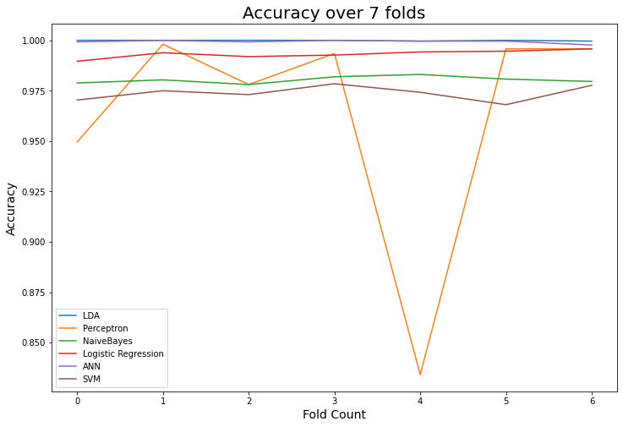

1. **The model that performed the best and one that performed the worst.**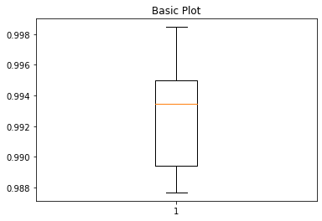

The best performing model is that of Linear Discriminant Analysis. The worst is the Perceptron. The reason why LDA performs the best is because most of the features of the data is normally distributed. Thus the underlying assumption works the best with this dataset Perceptron produces unsatisfactory results due the data not being normalized and a slow learning rate of 0.0001. In the adjacent graph, an increased learning rate of 0.01 is shown with high accuracy.

1. **The image, containing box-plots for each model.**

