
Xceedance Observability Strategy

Author: Anurag Thakur

Version: 0.1
Date: 27 April 2026

Contents
1. Executive Summary 5
1.1. Business Objectives & KPI’s 5
1.2. Standardise Telemetry Data The 5 Pillars 6
1.3. Build the Technical Foundation 7
1.4. Foster an Observability Culture 7
1.5. Continuous Improvement 7
2. Observability Strategy – High Level Architecture 8
3. Core Open-Source Observability Stack 9
4. Telemetry Collection Layers 10
4.1. Infrastructure Observability 10
4.2. Application Telemetry (Pre-Login / Post-Login) 11
4.2.1. Pre-Login Telemetry 11
4.2.2. Post-Login Telemetry 12
4.2.3. Alerting Guidelines 12
4.3. Database Observability 12
4.3.1. Database Observability Metrics and Ranges 12
4.3.2. Suggested Alerting Policy Guidelines 13
4.4. Network and Latency Observability 13
4.4.1. Network & Latency Observability Metrics 13
4.4.2. Severity Policy 14
4.4.3. Implementation Tips 14
5. Scaling and Performance Observability 15
5.1. Scaling and Performance Observability Metrics 15
5.2. Severity / Action Policy 15
5.3. Implementation Notes 16
6. Grafana Observability Layer 17
6.1. Key Metrics and Suggested Ranges 17
6.2. Recommended Alerting Policy 17
6.3. Implementation & Visualization Tips 17
7. AI-Driven Observability Layer 19
7.1. AI-Driven Observability: Key Metrics and Suggested Ranges 19
7.2. Interpreting the AI-Driven Metrics 19
7.3. Severity Policy for AI-Detected Events 20
7.4. Implementation Recommendations 20
8. Infrastructure as a Code Role in OpenTelemetry Deployment 21
8.1. Key Metrics for Infrastructure-as-Code Role in OpenTelemetry Deployments 21
8.2. Severity Policy 22
8.3. Implementation & Visualization Tips 22
9. Multi-Cloud Observability Design 23
10. Observability Data Model 24
11. Governance and Data Strategy 25
11.1. Telemetry retention tiers 25
11.2. Worked Example: Applying Retention Policy 25
11.3. Governance Model 26
11.4. Lifecycle Management and Cost Optimisation 27
11.5. 11.5 Compliance and Auditability 27
11.6. Success Criteria for Governance and Data Strategy 28
12. End-to-End Incident Sequence 29
13. Maturity Roadmap 30
13.1. Phase 1: Foundation (Months 1-3) 30
13.2. Phase 2: Correlation & Alerting (Months 4-6) 30
13.3. Phase 3: AI-Driven Intelligence (Months 7-12) 31
13.4. Maturity Assessment Framework 32
14. Final Architecture Summary 33
15. Architecture Governance and Review 34
15.1. Decision Log 34
16. Appendix 35

Document History
Date | Author | Change | Notes
26-Mar-2026 | Anurag Thakur | Version 0.1 | Initial Draft

Reviewers
Date | Reviewer | In Process / Review Type | Notes / references
27-04-2026 | Simon Armstrong | Initial review | Comments to be reviewed and acted up upon.

Executive Summary
[Extraction Annotation] Disposition: KEEP | Keep: Strategy doc only | Extract To: None | Notes: Executive framing remains in core strategy.
The observability strategy is designed to transition operations from reactive monitoring to proactive intelligence. A single-pane-of-glass view across integrated logs, metrics, and traces will provide the deep visibility required to navigate the technology estate. The strategy comprises several key components intended to facilitate deployment at customer sites, maintain application observability, enable client ecosystem integration, and support Xceedance PaaS and SaaS hosting capabilities.
Key Objectives:
- A single-pane-of-glass view across Xceedance-hosted capabilities is to be established, with integration to all dependent and supporting functions.
- Integration of generative capabilities within the observability stack is to be facilitated.
- Downtime is to be reduced by improving Mean Time to Resolution (MTTR) through identification of root causes in minutes rather than hours.
- Data silos are to be removed in-order-to foster seamless cross-team collaboration and unified decision-making, thereby improving operational efficiency.
- Performance bottlenecks are to be detected and resolved before end‑user experience is affected, thereby minimizing customer impact.
- Fragmented tools are to be consolidated into a single, scalable telemetry standard (OpenTelemetry) to achieve cost optimization.
Ultimately, this strategy is intended to transform observability from a technical overhead into a competitive advantage, enabling performance and IT operations functions to track scale, rectify issues, and manage production-level capabilities, while allowing engineering functions to spend less time on level-3 incident remediation and more time delivering high-value features.
Establishing an observability strategy is a dynamic, iterative journey that aligns technical systems with business objectives to ensure reliability and performance. Such a strategy moves an organisation from reactive monitoring—only identifying that something is broken—to proactive observability with a single-pane-of-glass view, enabling understanding of why an issue occurred and what its business impact is.

Business Objectives & KPI’s
[Extraction Annotation] Disposition: MIXED | Keep: Business objectives narrative | Extract To: D11 Observability KPI Scorecard | Notes: Move metric definitions, thresholds, and scorecard mechanics.
A successful strategy is developed by working backward from business needs rather than starting with tools. Organizational goals are defined prior to selection of specific tools. Each observability initiative is driven by business outcomes—reliability, performance, cost optimization, and customer experience—so that observability functions as a strategic enabler rather than a technical overhead.
- Identify Business Outcomes: Focus is placed on outcomes such as reduced downtime, improved user experience (UX), regulatory compliance, and operational efficiency. This approach establishes direct alignment between monitoring activities and value creation.
  - Core measurable examples - Mean Time to Detect (MTTD), Mean Time to Resolve (MTTR), Error Rate (%), and Customer Satisfaction (CSAT).
- Establish Measurable KPIs: Clear, quantifiable indicators are defined to assess performance and quality. These KPIs enable proactive visibility and accountability across engineering and operations.
  - Example metrics include - Conversion Rates, Service Availability, Incident Reduction, and Engineering Productivity.
- Set SLOs and SLAs: Achievable Service Level Objectives (SLOs) and Service Level Agreements (SLAs) are defined and tied to user expectations and service criticality, ensuring end-to-end reliability, uptime, and transparency in performance commitments.
- Enhance Resilience and Business Continuity: Recovery Point Objective (RPO) and Recovery Time Objective (RTO) are included to measure disaster recovery effectiveness and to ensure minimal data loss or downtime.
- Broaden Coverage and Quality: Scalability, alert quality, root-cause analysis efficiency, telemetry completeness, and compliance are monitored to secure operational excellence and governance.
Note: Detailed measurable metrics and KPIs are provided in the Appendix.

Standardise Telemetry Data The 5 Pillars
[Extraction Annotation] Disposition: EXTRACT | Keep: None | Extract To: D1 Enterprise Observability Standards Catalog | Notes: Standard definitions belong in enterprise standards.
Telemetry data is to be standardised so that systems generate consistent information, enabling a holistic view of the stack.
- Metrics: Numerical measurements, such as CPU usage and error rates, used for quantitative health checks.
- Logs: Detailed records of discrete events (for example, error messages) that provide narrative context.
- Traces: End-to-end journey maps of requests across distributed services, used to pinpoint bottlenecks.
- Changes: Configuration and infrastructure changes tracked across services (for example, by using Azure Change Analysis) to correlate modifications with system behaviour.
- Profiles: A newly emerging “fifth pillar” that uses stack traces to identify code-level issues.

Build the Technical Foundation
[Extraction Annotation] Disposition: MIXED | Keep: Strategic intent and principles | Extract To: D2 Observability Reference Architecture | Notes: Move architecture mechanics and platform detail.
A robust infrastructure for data collection and analysis is to be created.
- Centralised Data Collection: Data is to be consolidated into a unified platform to break down silos and enable correlation across different telemetry types.
- Open Standards: Vendor-neutral frameworks such as OpenTelemetry are to be adopted to avoid vendor lock-in and simplify integration.
- Tool Selection: Grafana is to be selected as the primary visualization and alerting tool based on scalability, ease of use, and cost.

Foster an Observability Culture
[Extraction Annotation] Disposition: EXTRACT | Keep: None | Extract To: D18 Observability Operating Model & Adoption Plan | Notes: Operating model and adoption content.
Observability is as much about people and processes as it is about tools.
- Cross-Functional Collaboration: Silos between DevOps, SRE, and business teams are to be reduced so that responsibility for system health is shared.
- Training & Education: Investment in team skills is required to ensure effective use of observability tools and accurate interpretation of data.
- Actionable Alerting: Intelligent thresholds are to be defined to reduce alert fatigue and to ensure that each alert is associated with a clear response playbook.

Continuous Improvement
[Extraction Annotation] Disposition: MIXED | Keep: Principles and intent | Extract To: D18 Observability Operating Model & Adoption Plan; D11 Observability KPI Scorecard | Notes: Process cadence to D18, measurement model to D11.
The strategy is to be regularly reassessed and refined as the technology landscape and business needs evolve.
- Audit Regularly: Data quality, alert effectiveness, and tool return on investment (ROI) are to be reviewed to ensure that the observability setup remains efficient.
- Leverage AI/ML: AIOps capabilities are to be used for automated anomaly detection, root-cause analysis, and predictive maintenance as the environment matures.
The remainder of this document builds on the points discussed above.

Observability Strategy – High Level Architecture
[Extraction Annotation] Disposition: MIXED | Keep: One-page strategy architecture view | Extract To: D2 Observability Reference Architecture | Notes: Detailed architecture and controls to reference architecture.
Core concepts
- OpenTelemetry Collector: Serves as the universal telemetry gateway, receiving metrics, logs, and traces from instrumented services, performing any required processing or enrichment, and forwarding the data to downstream storage and analysis systems. This centralization standardises telemetry ingestion and simplifies pipeline management.
- Data Flow to Backends: Telemetry data is routed from the OpenTelemetry Collector to specialised backends: Prometheus for metrics, Loki for logs, and Tempo for traces. This separation enables scalable, purpose-built storage and querying for each data type while maintaining consistent correlation across them.
- Grafana Docker Image: Provides visualization and alerting capabilities by connecting to Prometheus, Loki, and Tempo as data sources. Dashboards, exploratory queries, and alerts are configured within Grafana to present a unified, single-pane-of-glass view of system health, performance, and reliability.
- Agentic AI: Consumes telemetry via APIs exposed by Prometheus, Loki, Tempo, and related components. This AI layer performs automated root-cause analysis (RCA), identifies anomalies, and generates incident tickets enriched with context, impact assessment, and suggested remediation steps
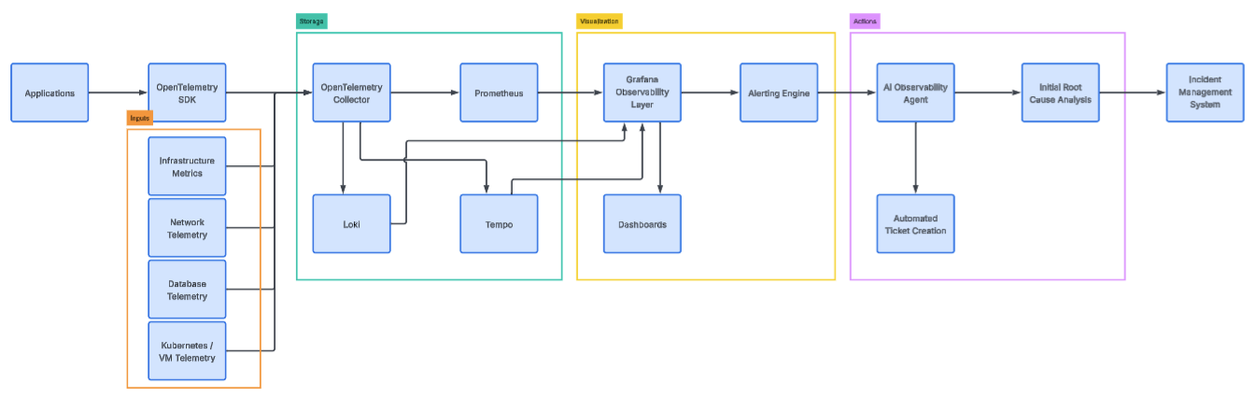

Core Open-Source Observability Stack
[Extraction Annotation] Disposition: EXTRACT | Keep: None | Extract To: D2 Observability Reference Architecture | Notes: Technical stack details in architecture artifact.
Layer | Tool | Role
Telemetry Standard | OpenTelemetry | Provides a unified instrumentation standard for metrics, logs, and traces across services and components.
Telemetry Gateway | OpenTelemetry Collector | Acts as a central telemetry pipeline, receiving, processing, and exporting telemetry data to downstream backends.
Metrics Storage | Prometheus | Stores and queries infrastructure and application metrics for performance, capacity, and health monitoring.
Logs Storage | Loki | Stores structured logs and enables efficient querying and correlation with metrics and traces.
Traces Storage | Tempo | Stores distributed traces to provide end-to-end visibility into request flows and service dependencies.
Visualization | Grafana | Provides dashboards, exploration views, and visual analytics across metrics, logs, and traces.
Infrastructure Observability | Node Exporter | Exposes operating system–level metrics (CPU, memory, disk, network) for hosts and nodes.
Kubernetes Observability | kube-state-metrics | Exposes Kubernetes object state (deployments, pods, nodes, etc.) for monitoring cluster health and capacity.
Network Monitoring | eBPF / Cilium / Pixie | Captures and analyses network traffic and flows to provide network tracing and service communication insights.
Database Observability | Postgres / MySQL exporter | Exposes database metrics (queries, latency, connections, errors) for monitoring database health and performance.
Alerting | Grafana Alerting / Alert manager | Manages alert rules, routing, and notifications for incidents based on telemetry signals.
Everything above is open-source and OpenTelemetry compatible.

Telemetry Collection Layers
[Extraction Annotation] Disposition: EXTRACT | Keep: None | Extract To: D2 Observability Reference Architecture | Notes: Collection design belongs in architecture artifact.
Your telemetry should be captured across four major layers

Infrastructure Observability
[Extraction Annotation] Disposition: EXTRACT | Keep: None | Extract To: D3 Domain Observability Runbooks Pack | Notes: Operational guidance belongs in runbooks.
Telemetry Metrics and Suggested Ranges
Metric | Description | Unit | Low (Healthy) | Normal / Acceptable Range | High / Concerning | Notes / Success Criteria
CPU Usage | Percentage of CPU resources utilized (per host or container) | % utilization | < 20% (under-utilized) | 40–70% | > 80% sustained for > 5 min | Keep average between 40–70%; trigger scale up or investigate at sustained >80%
Memory Pressure | Percentage of memory used vs. total available | % utilization | < 40% | 40–75% | > 85% sustained | Sustained high usage may cause OOM kills; aim for <75% steady state
Disk I/O (Read/Write Ops/sec or latency) | Throughput or latency of disk operations | IOPS / ms | Latency < 5 ms | Latency 5–15 ms, steady throughput | Latency > 20 ms, stalls | Keep disk latency <10 ms for production workloads
Container Restart Count | Number of restarts per container in given period | Count (per hour/day) | 0 | 0–1 occasional | > 2 per hour or repeating pattern | Investigate >2 restarts/hour; persistent restarts indicate memory leaks, config issues
Node Failures | Count of nodes marked “Not Ready” or lost in given period | Count per day/week | 0 | 0–1 transient per week | > 1/day or repeated node flapping | Node failures cause rescheduling: monitor MTBF, <1 node lost/week ideal
Cluster Scaling Events | Count of cluster scale-up or scale-down events | Count per day/week | 0–1 expected | 1–5 per day (adaptive scaling) | > 10/day frequent flapping | Very frequent scaling => review auto-scaler thresholds
Pod Scheduling Delays | Time taken between pod creation request and successful scheduling | Seconds | < 1s | 1–5s | > 10s | Long delay suggests resource scarcity or scheduling contention

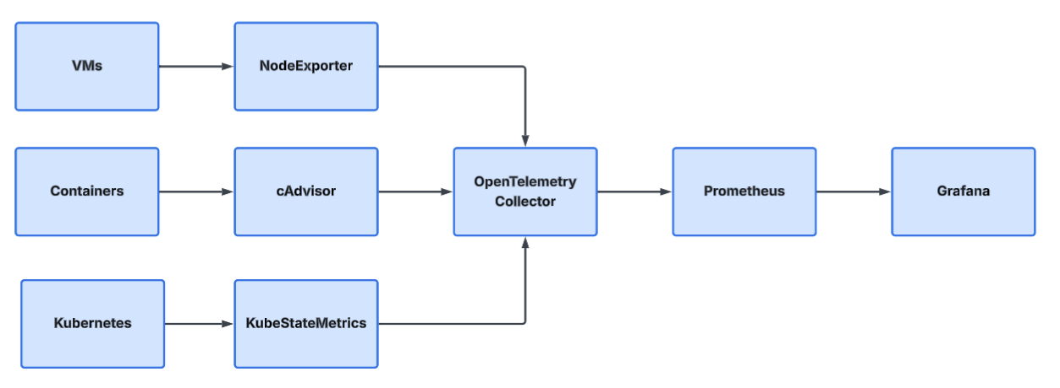

Application Telemetry (Pre-Login / Post-Login)
[Extraction Annotation] Disposition: MIXED | Keep: High-level requirement statement | Extract To: D17 Application Telemetry Standard | Notes: Implementation standards and fields to application telemetry standard.
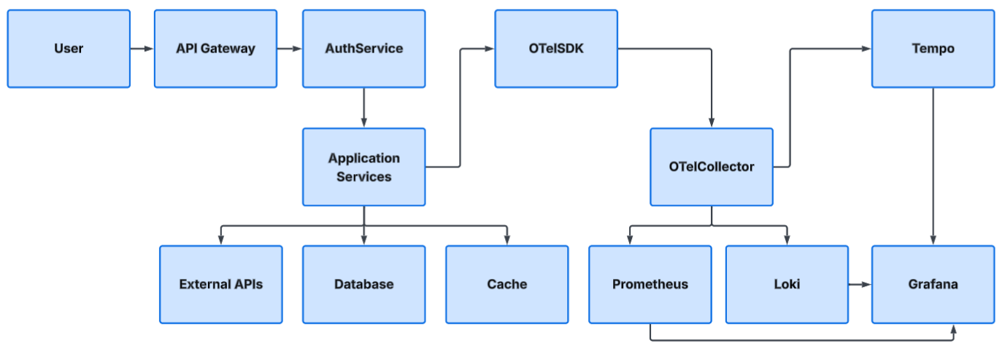

Pre-Login Telemetry
[Extraction Annotation] Disposition: EXTRACT | Keep: None | Extract To: D17 Application Telemetry Standard; D3 Domain Observability Runbooks Pack | Notes: Standards in D17, execution steps in D3.
Metric | Unit / Scope | Healthy Range | Warning Threshold | Critical Threshold | Notes / Success Criteria
Authentication Latency | ms (time from auth request → response) | < 300 ms | 500–800 ms for ≥5 min | > 1000 ms sustained or errors | Keep 95th percentile latency < 800 ms. Investigate if approaching 1 s; affects user experience.
Login Failures | % of login attempts failing | < 1 % | 1–3 % sustained 5 min | > 3 % sustained 5 min or spike to > 5 % | Elevated rate indicates credential or backend issue; validate at step-up auth.
MFA Failures | % of MFA challenges failing | < 0.5 % | 0.5–2 % sustained | > 2 % sustained or any outage of MFA service | Often third-party dependency; critical if blocking entry for > 5 min.
API Gateway Response Time | ms (average + P95) | P95 < 500 ms | P95 > 800 ms for ≥5 min | P95 > 1200 ms sustained | Include upstream services; long latency slows all endpoints.

Post-Login Telemetry
[Extraction Annotation] Disposition: EXTRACT | Keep: None | Extract To: D17 Application Telemetry Standard; D3 Domain Observability Runbooks Pack | Notes: Standards in D17, execution steps in D3.
Metric | Unit / Scope | Healthy Range | Warning Threshold | Critical Threshold | Notes / Success Criteria
Transaction Latency | ms (end-to-end user action) | < 500 ms P95 | P95 > 800 ms for ≥5 min | P95 > 1200 ms sustained | Reflects full user transaction; critical when latency degrades UX.
Service-Call Failures | % of calls failing | < 0.2 % | 0.5 %–1 % sustained | > 1 % sustained or > 3 % spike | Combination of call timeouts, 5xx errors, or retries.
Dependency Latency | ms (time for external or internal dependency response) | < 200 ms | 200–400 ms sustained | > 400 ms sustained or timeouts | Slow DB, cache, or API dependencies affect aggregate latency.
User-Journey Traces (Success Rate) | % of completed journeys without error | ≥ 98 % | 95–98 % | < 95 % | Track each major journey (login, checkout, report generation); objective is ≥ 98 % successful completion.

Alerting Guidelines
[Extraction Annotation] Disposition: EXTRACT | Keep: None | Extract To: D4 Alerting & Incident Severity Policy | Notes: Policy-level alerting guidance.
Severity | Trigger Logic | Recommended Action
Warning | Metric exceeds warning range for ≥5 min or crosses rolling 5-minute average | Review during business hours; look for trend or dependency lag.
Critical | Metric exceeds critical range for ≥2 min (95th percentile) | Immediate incident: page on-call team.
Info / Tracking | Deviations within normal range | Log trend; no alerting—use dashboards for capacity planning.

Database Observability
[Extraction Annotation] Disposition: EXTRACT | Keep: None | Extract To: D3 Domain Observability Runbooks Pack | Notes: Domain-specific operational runbook content.
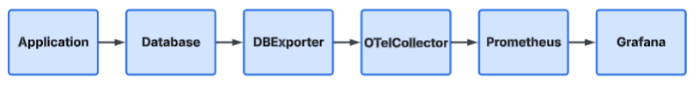

Database Observability Metrics and Ranges
[Extraction Annotation] Disposition: EXTRACT | Keep: None | Extract To: D1 Enterprise Observability Standards Catalog; D3 Domain Observability Runbooks Pack | Notes: Metric standards in D1, runbook usage in D3.
Metric | Unit / Scope | Healthy Range | Warning Threshold | Critical Threshold | Notes / Success Criteria
Slow Queries | % of total queries exceeding configured slow threshold (e.g. >1s) | < 1 % | 1–3 % sustained over 5 min | > 3 % sustained OR sudden spike > 5 % | Tune indexes or queries; acceptable is < 1 % of total execs. Track long-tail queries by duration distribution (P95/P99).
Lock Contention | % of queries waiting on locks / average lock wait time (ms) | < 50 ms avg lock wait | 50–100 ms sustained or > 1 % of queries waiting | > 100 ms sustained OR > 5 % of queries waiting | High contention implies transaction design or concurrency issues; critical when impacting throughput.
Connection Pool Usage | % of max available connections in use (per app / DB pool) | 40–70 % | > 80 % for > 5 min | > 90 % for > 2 min or exhaustion errors | Keep utilization below 75% steady; sustained > 90 % risks connection timeouts and refused connections.
Replication Lag | Seconds behind master / primary | < 1 s | 2–5 s sustained | > 10 s sustained or increasing trend | Applies to replicas. For read replicas, < 5 s acceptable; critical beyond 10 s if reads depend on fresh data.
Query Latency (Overall) | Avg / P95 ms per query | P95 < 100 ms | 100–200 ms sustained | > 200 ms sustained or large jumps > 300 ms | Evaluate slowest endpoints or queries; keep P95 ≤ 100 ms for responsive apps.

Suggested Alerting Policy Guidelines
[Extraction Annotation] Disposition: EXTRACT | Keep: None | Extract To: D4 Alerting & Incident Severity Policy | Notes: Consolidate in enterprise alert policy.
Severity | Trigger Example | Action Expectation
Warning | Metric crosses warning threshold for >5 min | Investigate within few hours; assess resource saturation or query regressions.
Critical | Metric above critical threshold for >2 min | Immediate incident handling; probable user impact or system instability.
Info / Trend | Gradual deviation but < warning | Monitor trend, auto-tune config, or plan capacity.

Network and Latency Observability
[Extraction Annotation] Disposition: EXTRACT | Keep: None | Extract To: D3 Domain Observability Runbooks Pack | Notes: Domain-specific operational runbook content.
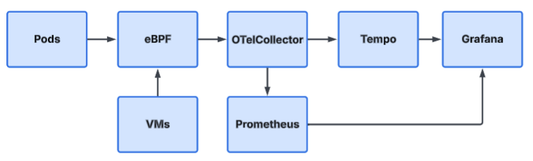

Network & Latency Observability Metrics
[Extraction Annotation] Disposition: EXTRACT | Keep: None | Extract To: D1 Enterprise Observability Standards Catalog; D3 Domain Observability Runbooks Pack | Notes: Metric standards in D1, runbook usage in D3.
Metric | Unit / Scope | Healthy Range | Warning Threshold | Critical Threshold | Notes / Success Criteria
Packet Drops | % of total packets lost (per node, pod, or network interface) | < 0.1 % | 0.1 – 0.5 % sustained ≥ 5 min | > 0.5 % sustained ≥ 2 min or spikes > 1 % | Keep loss < 0.1 %. Above 0.5 % begins to impact performance; investigate route saturation or link errors.
Cross-Service Latency | ms (service-to-service request-response round-trip, P95) | < 50 ms | 50 – 100 ms sustained ≥ 5 min | > 100 ms sustained or spikes > 200 ms | Indicates network or service hops delay. Maintain P95 < 100 ms for intra-region calls; < 200 ms for cross-region.
DNS Failures | % of failed DNS lookups or resolution errors | < 0.1 % | 0.1 – 0.5 % sustained ≥ 5 min | > 1 % sustained ≥ 2 min or resolver outage | Even small spikes increase latency; validate caching, propagation, or resolver health.
Service Mesh Errors | % of total requests returning 4xx/5xx or side-car-level failures | < 0.2 % | 0.2 – 1 % sustained ≥ 5 min | > 1 % sustained ≥ 2 min or control-plane outage | Combines app and mesh layer reliability. Keep < 0.2 %; review retries if climbing.
TCP Re-transmissions | % of total TCP packets retransmitted | < 0.5 % | 0.5 – 1 % sustained ≥ 5 min | > 1 % sustained ≥ 2 min or spikes > 2 % | High retransmits mean congestion or packet loss. Keep below 0.5 %. Above 1 % usually user-visible latency.

Severity Policy
[Extraction Annotation] Disposition: EXTRACT | Keep: None | Extract To: D4 Alerting & Incident Severity Policy | Notes: Severity model belongs in incident policy.
Severity | Typical Trigger | Recommended Action
Info / Normal | Within Healthy range | Record trend; no alert.
Warning | Warning threshold exceeded ≥ 5 min window | Check for transient congestion, partial outage, or config changes.
Critical | Critical threshold exceeded ≥ 2 min or repeated spikes | Immediate investigation; probable user impact or network fault.

Implementation Tips
[Extraction Annotation] Disposition: EXTRACT | Keep: None | Extract To: D3 Domain Observability Runbooks Pack | Notes: Implementation details belong in playbooks/runbooks.
- Measure percentiles, not only averages: Alerts are to be configured on P95/P99 latency to increase sensitivity to tail delays.
- Correlate signals:
  - Packet drops combined with TCP retransmissions typically indicate a physical or network-congestion issue.
  - Cross-service latency combined with service mesh errors typically indicates a dependency or routing problem.
- Scope: Metrics are to be collected per node/pod, per namespace, and across zones in order to pinpoint the location of issues.
- Visualization: Stacked-area charts or heat maps are to be used to observe trends in packet loss and latency over time.
These guidelines represent safe starting baselines applicable to most production environments. After several weeks of telemetry have been collected, thresholds should be adjusted so that warning levels correspond approximately to the 95th percentile of normal behaviour, and critical levels correspond to conditions that cause actual user impact.

Scaling and Performance Observability
[Extraction Annotation] Disposition: MIXED | Keep: Outcome and strategic posture | Extract To: D3 Domain Observability Runbooks Pack | Notes: Operational implementation detail to runbooks.

Scaling and Performance Observability Metrics
[Extraction Annotation] Disposition: EXTRACT | Keep: None | Extract To: D1 Enterprise Observability Standards Catalog; D3 Domain Observability Runbooks Pack | Notes: Metric standards in D1, runbook usage in D3.
Metric | Purpose | Unit / Scope | Healthy Range | Warning Threshold | Critical Threshold | Notes / Success Criteria
Queue Length | Scaling Trigger – indicates backlog waiting to be processed | Number of items / messages in queue (per service or worker) | < 50 items avg | 50 – 200 items sustained ≥ 5 min | > 200 items sustained ≥ 2 min or rapid growth trend | Use rising queue length as autoscaling signal; normal steady-state near zero. Maintain processing backlog within SLA window.
Request Latency | SLA Monitoring – measures end-to-end request response time | ms (P95 / P99) | P95 < 300 ms | P95 300 – 800 ms sustained ≥ 5 min | P95 > 800 ms or P99 > 1 s sustained | Align with user-facing SLAs. Maintain P95 under 300 ms for general APIs; under 100 ms for internal critical calls.
Error Rate | Service Health – monitors failures impacting success ratio | % of failed requests (4xx/5xx) | < 0.1 % | 0.1 – 1 % sustained ≥ 5 min | > 1 % sustained ≥ 2 min or > 5 % spike | Combine with latency to detect cascading failures. Sustained > 1 % indicates degraded health.
Pod Startup Time | Scaling Efficiency – how fast new pods become ready | Seconds from schedule → Ready state | < 10 s | 10 – 30 s | > 30 s sustained OR repeated Start failure | Prolonged start times slow horizontal scaling; aim for < 10 s average. If using images > 1 GB, track pull time separately.
Cold Start Latency | Autoscaling Tuning – time for scaled-down service / function-to-first-response | ms or seconds (per function / pod) | < 300 ms (FaaS) / < 2 s (container) | 300 – 800 ms (FaaS) / 2 – 5 s (container) | > 800 ms (FaaS) / > 5 s (container) sustained | Measure after idle scale-to-zero events. Tune pre-warming or concurrency to meet response SLAs.
Grafana dashboards should correlate
- Load with Scale Events
- Latency with CPU utilisation
- Queue length with throughput

Severity / Action Policy
[Extraction Annotation] Disposition: EXTRACT | Keep: None | Extract To: D4 Alerting & Incident Severity Policy | Notes: Incident policy and action model.
Severity | Trigger Example | Recommended Response
Info / Normal | Within Healthy range | Record baseline; use for capacity prediction.
Warning | Crosses Warning threshold for ≥ 5 min | Review scaling parameters, resource limits, or dependency latency.
Critical | Crosses Critical threshold for ≥ 2 min | Immediate intervention; possible user-visible impact or broken autoscaling.

Implementation Notes
[Extraction Annotation] Disposition: EXTRACT | Keep: None | Extract To: D3 Domain Observability Runbooks Pack | Notes: Execution notes belong in runbooks.
- Queue Length and Request Latency together: Represent the most effective real-time autoscaling signals. Increases in both typically indicate a scale-up event, whereas decreases in both typically indicate a scale-down opportunity.
- Error Rate and Latency spikes together: Usually indicate service saturation; in such cases, replicas are typically increased or dependency bottlenecks are investigated.
- Pod Startup Time and Cold Start Latency: Feed directly into scaling-lag indicators and should be tracked over time to validate auto-scaler responsiveness.
- Percentile-based latency (P95/P99) and 5-minute moving averages: Help prevent false alerts caused by short-lived spikes.
These guidelines serve as universal baseline values for establishing initial thresholds across teams. After several weeks of production data have been collected, each range should be narrowed so that the Warning level is approximately the 95th percentile of normal behaviour, and the Critical level corresponds to conditions that approach SLA breach.

Grafana Observability Layer
[Extraction Annotation] Disposition: MIXED | Keep: Role of Grafana in strategy | Extract To: D5 Grafana Platform Standard & Visualization Playbook | Notes: Platform standards and dashboard implementation.

Key Metrics and Suggested Ranges
[Extraction Annotation] Disposition: EXTRACT | Keep: None | Extract To: D1 Enterprise Observability Standards Catalog; D5 Grafana Platform Standard & Visualization Playbook | Notes: Standards in D1, platform visualization thresholds in D5.
 | Metric | Unit / Scope | Healthy Range | Warning Threshold | Critical Threshold | Notes / Success Criteria
Infrastructure  Dashboards | Cluster Health | % of nodes/pods in “Ready” state | 100 % | < 99 % for > 5 min | < 97 % or multiple nodes/pods down | < 1 % deviation tolerated; consistent “Ready” state indicates stable infra.
 | VM Utilization | % of CPU + Memory used per VM | 40 – 70 % | > 75 % sustained > 5 min | > 90 % sustained or OOM/CPU-throttling | Keep avg below 75 %; trigger proactive scaling above 80 %.
 | Network Saturation | % of link or interface bandwidth utilization | < 60 % | 60 – 80 % sustained > 5 min | > 80 % sustained > 2 min or packet drops > 0.5 % | Maintain headroom > 20 %. High saturation > 80 % risks latency spikes.
Application  Dashboards | API Latency | ms (P95 or P99 per API) | < 300 ms | 300 – 800 ms sustained | > 800 ms sustained > 2 min | Track P95 for stable baseline; P99 for outliers. Target < 300 ms median.
 | Error Rates | % of requests failing (HTTP 4xx/5xx) | < 0.2 % | 0.2 – 1 % sustained > 5 min | > 1 % sustained > 2 min or spikes > 3 % | High error rate directly affects SLOs; distinguish client vs server errors.
 | Request Throughput | requests / sec per service | Baseline-dependent trend | ± 10 % deviation from rolling average | ≥ 20 % deviation sustained 10 min (unexpected drop or spike) | Abrupt drops = service stall; sudden spikes = load surge or DDoS.
Business  Dashboards | Login Success Rate | % successful logins | ≥ 99 % | 98 – 99 % sustained | < 98 % sustained or failures > 3 % | Maintain ≥ 99 % stability; tie directly to revenue/user experience SLOs.
 | Payment Success Rate | % of successful payments | ≥ 98 % | 96 – 98 % sustained | < 96 % sustained > 2 min | Drop below 98 % indicates gateway or API issue; critical if < 95 %.
 | Checkout Latency | ms end-to-end user transaction | P95 < 2 s | 2–3 s sustained | > 3 s sustained > 2 min | Measure full checkout path, including payment; aim for consistently < 2 s (P95).

Recommended Alerting Policy
[Extraction Annotation] Disposition: EXTRACT | Keep: None | Extract To: D4 Alerting & Incident Severity Policy; D5 Grafana Platform Standard & Visualization Playbook | Notes: Policy in D4, Grafana implementation in D5.
Severity | Trigger Definition | Response Expectation
Info / Normal | Metric within “Healthy” range or brief transient spikes | Observe trend; log for baselining only.
Warning | Metric above Warning threshold for ≥ 5 min rolling window | Investigate within normal support hours; check dependency or resource limits.
Critical | Metric above Critical threshold for ≥ 2 min or repeated within 10 min | Immediate incident response; probable user or business impact.

Implementation & Visualization Tips
[Extraction Annotation] Disposition: EXTRACT | Keep: None | Extract To: D5 Grafana Platform Standard & Visualization Playbook | Notes: Grafana-specific implementation details.
- Dashboards structure:
  - Infrastructure layer → system reliability overview (cluster, VMs, network).
  - Application layer → service health & trace-driven metrics (latency, errors, throughput).
  - Business layer → customer-impact KPIs (success rates, conversion latencies).
- Percentile-based latency: P95 and P99 latency are always to be tracked, rather than relying solely on averages.
- Correlate metrics: For example, high API latency combined with elevated error rates typically indicates a backend or database issue.
- Use panels: Gauges (for current state) are to be combined with time-series panels (for trends) in Grafana.
These configurations represent industry-standard starting ranges. After a few weeks of live data have been collected, thresholds should be calibrated so that warning levels reflect approximately the 95th percentile of normal behaviour, and critical thresholds represent conditions where user impact or SLA breach begins.
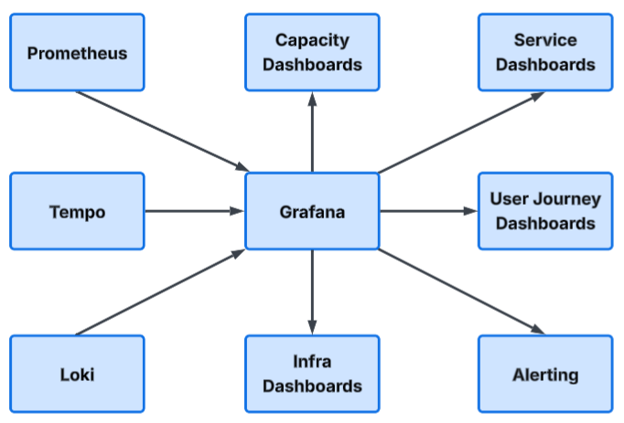

AI-Driven Observability Layer
[Extraction Annotation] Disposition: MIXED | Keep: Strategic intent and governance guardrails | Extract To: D6 AIOps Guardrails & Implementation Playbook | Notes: AIOps operating model and implementation details.

AI-Driven Observability: Key Metrics and Suggested Ranges
[Extraction Annotation] Disposition: EXTRACT | Keep: None | Extract To: D6 AIOps Guardrails & Implementation Playbook; D1 Enterprise Observability Standards Catalog | Notes: AIOps metrics in D6 aligned with enterprise metric standards.
AI-Driven Observability Metrics
Category | Metric | Unit / Scope | Healthy Range | Warning Threshold | Critical Threshold | Notes / Success Criteria
Anomaly Detection | Abnormal Latency Spikes | % deviation from baseline latency (using ML-predicted baseline) | ± 10 % of baseline | 10–25 % deviation sustained > 5 min | > 25 % deviation sustained > 2 min | The AI model forecasts expected P95 latency; deviations greater than 25 % imply a probable incident or dependency slowdown. A false-positive rate below 5 % is targeted.
 | Unusual Traffic Patterns | % deviation from expected traffic rate (requests / s or MBps) | ± 15 % | 15–30 % deviation sustained > 5 min | > 30 % deviation > 2 min or anomaly confidence > 95 % | Enables early detection of DDoS or load imbalance conditions. Acceptable model performance is defined as precision ≥ 90 % and recall ≥ 85 %.
Correlation Analysis | Deployment vs Error Spike | Correlation coefficient (r) between recent deployments and error-rate change | r < 0.3  (weak correlation) | 0.3–0.6 (moderate correlation) | r > 0.6 (strong correlation) | Strong positive correlation suggests that recent deployments are likely contributing to error-rate increases. Correlation insights are to be reviewed and fed back into deployment practices.
 | Scaling vs Database Saturation | Correlation coefficient (r) between auto-scale events and database resource utilisation (%) | r < 0.4 | 0.4–0.7 | r > 0.7 | Strong positive correlation indicates that scaling events are associated with database saturation, signalling a need to adjust scaling strategies or database capacity and tuning.

Interpreting the AI-Driven Metrics
[Extraction Annotation] Disposition: EXTRACT | Keep: None | Extract To: D6 AIOps Guardrails & Implementation Playbook | Notes: Interpretation framework and operations model.
Element | Interpretation / Goal | Tuning Guidance
Model Confidence | Indicates the strength of the AI’s detection (for example, probability > 90 %). | High-confidence thresholds are to be used for critical alerts to reduce noise; sensitivity is to be adjusted per metric.
Deviation Thresholds | Represents percentage change from the historical or expected baseline. | Baselines are to be computed over rolling windows (for example, 24 hours or the same day of week).
Correlation Coefficient (r) | Quantifies the relationship between two event series (−1 to +1). | Absolute values of “r” are to be used; higher values indicate stronger correlation. Thresholds are to be derived from historical data.

Severity Policy for AI-Detected Events
[Extraction Annotation] Disposition: EXTRACT | Keep: None | Extract To: D4 Alerting & Incident Severity Policy; D6 AIOps Guardrails & Implementation Playbook | Notes: Policy in D4, AI-specific tuning in D6.
Severity | Trigger Example | Recommended Action
Info / Normal | Deviation < Warning threshold OR anomaly confidence < 70 % | Record event for model training; no alert.
Warning | Deviation crosses warning, confidence ≥ 80 % | Validate with human triage; check recent deployments or infra changes.
Critical | Critical threshold crossed, anomaly confidence ≥ 90 % OR correlation > 0.6 sustained | Automatic incident creation or rollback trigger; strong indicator of system issue.

Implementation Recommendations
[Extraction Annotation] Disposition: EXTRACT | Keep: None | Extract To: D6 AIOps Guardrails & Implementation Playbook | Notes: Implementation detail to AIOps playbook.
- Data sources: Latency, error, and throughput metrics are to be ingested from OpenTelemetry, together with external business event streams (for example, deployments and scaling events).
- AI models: Moving‑average methods, seasonal‑trend decomposition, or ML‑based outlier‑detection techniques (such as Prophet or Isolation Forest) are to be used.
- Visualization:
  - Predicted versus actual curves are to be overlaid in Grafana.
  - Anomaly deviation percentages and model confidence values are to be displayed on dashboards.
- Success criteria:
  - False‑positive rate maintained below 5 %.
  - Detection latency kept below 2 minutes from anomaly onset.
  - Auto‑correlation insights (for example, deployment → error, scaling → load) routinely validated by operators for model retraining.
These ranges enable quantitative assessment of AI-augmentation performance, covering both anomaly detection and recognition of cause-and-effect relationships.
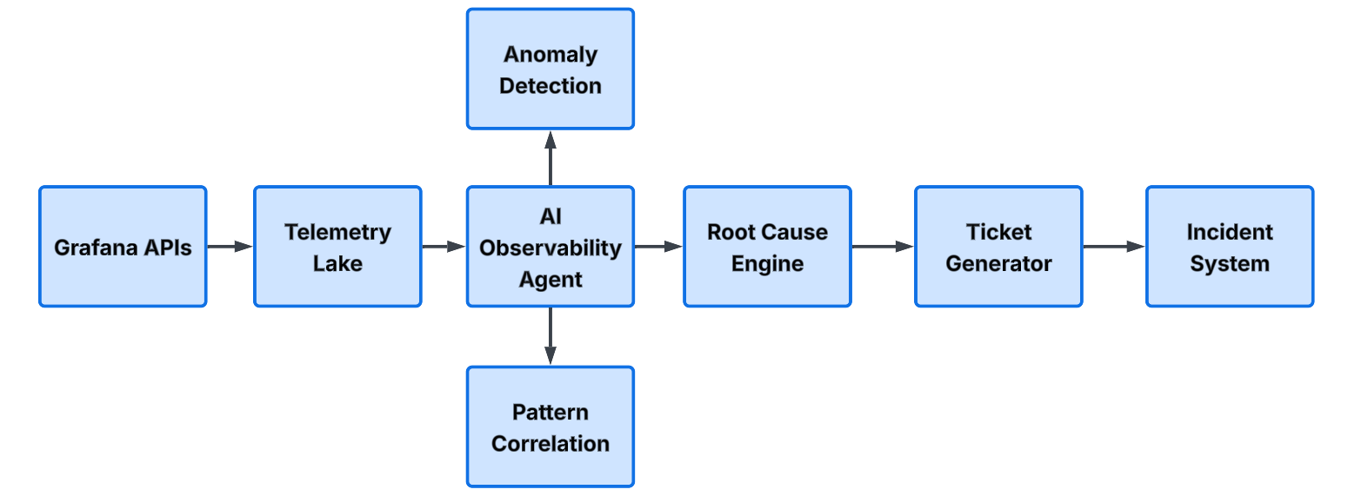

Infrastructure as a Code Role in OpenTelemetry Deployment
[Extraction Annotation] Disposition: MIXED | Keep: Strategic policy position | Extract To: D7 IaC for Observability Standard (OpenTelemetry + Pulumi) | Notes: Implementation patterns and controls to IaC standard.

Key Metrics for Infrastructure-as-Code Role in OpenTelemetry Deployments
[Extraction Annotation] Disposition: EXTRACT | Keep: None | Extract To: D7 IaC for Observability Standard (OpenTelemetry + Pulumi); D11 Observability KPI Scorecard | Notes: Platform KPIs in D7 with executive roll-up in D11.
 | Metric | Unit / Scope | Healthy Range | Warning Threshold | Critical Threshold | Notes / Success Criteria
Telemetry  Infrastructure | Deploy OpenTelemetry Collectors | Deployment success % across environments | 100 % | < 99 % for one environment | < 95 % or repeated deployment failures | Collectors should deploy reliably; target ≥ 99 % success rate. Failures imply IaC drift or config errors.
 | Configure Exporters | Valid exporter configuration success rate | ≥ 99 % | 97 – 99 % sustained | < 97 % sustained or repeated misconfigurations | Misconfigured exporters cause data gaps. Verify output endpoints per pipeline.
 | Deploy Observability Stack (Prometheus / Grafana / Tempo / Loki etc.) | End-to-end deployment completion time | ≤ 15 min | 15–25 min | > 25 min or deployment errors > 1 | Long deployment indicates IaC inefficiency. Use automation or caching to speed up.
Automatic  Instrumentation | Inject OpenTelemetry Sidecars (Pods/Services) | % of targeted workloads instrumented automatically | 95 – 100 % | 85 – 95 % sustained | < 85 % or error during injection | Sidecar injection ratio below 90 % means inconsistent monitoring coverage.
 | Enable Service Mesh Telemetry | % of namespaces successfully emitting mesh telemetry | ≥ 98 % | 95 – 98 % | < 95 % or missing spans/metrics in mesh layer | Ensures end-to-end traces through mesh. Aim for full coverage.
 | Configure Log Pipelines | Successful pipeline configuration runs / errors per deployment | 100 % success | 99 % success, minor retry | < 98 % success or repeated parse errors | Missing or broken log pipelines cause data loss; test each collector path post-deploy.
Cloud Portability (Azure AKS / AWS EKS / GCP GKE) | Pulumi Stack Provision Time | Minutes to deploy base stack | ≤ 10 min per cluster | 10–20 min sustained | > 20 min or failed provisioning > 1 % | Keep automated IaC runs efficient; large deviation means provider bottleneck.
 | Cross-Cloud Config Parity | % of variables / configs consistent across clouds | 95 – 100 % | 90 – 95 % | < 90 % mismatch or drift detected | Ensure same codebase works identically across providers; < 5 % drift target.
 | Exporter / Collector Version Alignment | % of collector / exporter versions matching across clusters | 100 % | 95 – 99 % | < 95 % version mismatch | Alignment ensures consistent telemetry schema and reduces troubleshooting effort.

Severity Policy
[Extraction Annotation] Disposition: EXTRACT | Keep: None | Extract To: D4 Alerting & Incident Severity Policy | Notes: Severity model belongs in incident policy.
Severity | Trigger Example | Recommended Action
Info / Normal | Metrics inside “Healthy / Normal” | Record for CI-CD trend analytics; no action.
Warning | Sustained threshold breach ≥ 5 min or 1 IaC run | Review deployment pipeline or IaC scripts; correct configuration drift.
Critical | Critical threshold breach or repeated IaC failures within 3 runs | Trigger incident or rollback; high chance of data loss / missing telemetry.

Implementation & Visualization Tips
[Extraction Annotation] Disposition: EXTRACT | Keep: None | Extract To: D7 IaC for Observability Standard (OpenTelemetry + Pulumi) | Notes: IaC implementation and operational visualization guidance.
- In Grafana:
  - Infrastructure dashboards → track deployment status and versions.
  - Coverage dashboards → display public (AKS/EKS/GKE) collector deployments vs successful telemetry exports.
  - Performance dashboards → show stack provisioning time trends.
- IaC validation: Use post-deployment checks (helm test, kubectl rollout status, or Pulumi’s outputs) to feed “success / failure” counts directly into OpenTelemetry metrics exporters.
- SLI example: Collector Deployment Success Rate = (Deployed Collectors ÷ Intended Collectors) × 100.
These starting baselines make your OpenTelemetry deployment process measurable. Once you’ve run a few cycles, you can refine thresholds: e.g., critical = “any misconfiguration that causes collector telemetry gaps,” and warning = “deployment slower than SLA window.”
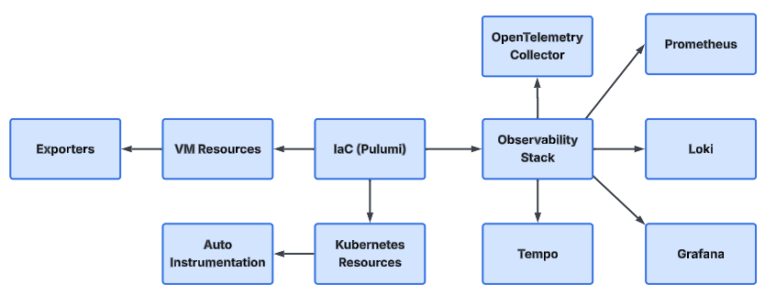
Pulumi might be the language of choice enabling IaC

Multi-Cloud Observability Design
[Extraction Annotation] Disposition: MIXED | Keep: Design principles and strategy stance | Extract To: D2 Observability Reference Architecture | Notes: Detailed architecture and patterns in reference architecture.
Advantages
- Centralized Dashboards
- Unified Telemetry Schema
- Cross-Cloud Incident Visibility
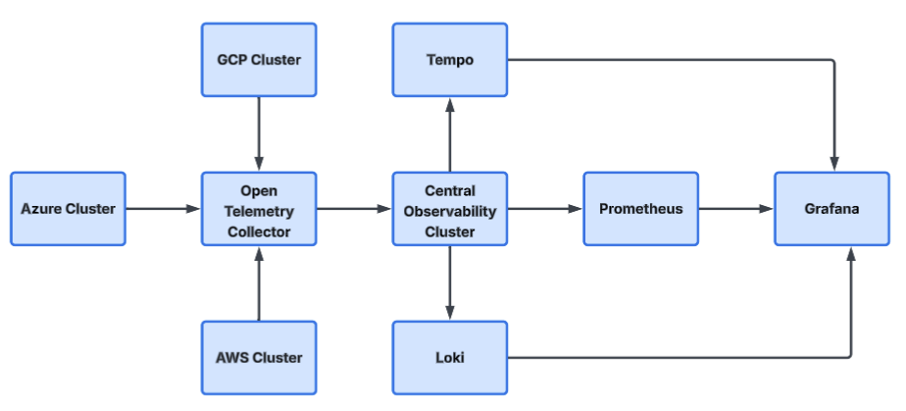

Observability Data Model
[Extraction Annotation] Disposition: EXTRACT | Keep: None | Extract To: D19 Observability Data Model Specification | Notes: Formal data model in dedicated specification.
Telemetry types
Signal | Tool
Metrics | Prometheus
Logs | Loki
Traces | Tempo
Events | OpenTelemetry
Profiles | Pyroscope
Together these form full stack observability

Governance and Data Strategy
[Extraction Annotation] Disposition: MIXED | Keep: Governance narrative and intent | Extract To: D8 Observability Data Governance & Retention Policy; D15 Observability Governance Charter & ARB Pack | Notes: Data governance controls to D8, governance model to D15.
A clear governance and data strategy ensures that observability data remains useful, compliant, and cost-effective throughout its lifecycle. The strategy typically defines:
- What telemetry is collected
- How long each data type is retained
- Where it is stored
- Who can access it
- How it is governed, audited, and eventually deleted or archived

Telemetry retention tiers
[Extraction Annotation] Disposition: EXTRACT | Keep: None | Extract To: D8 Observability Data Governance & Retention Policy | Notes: Retention policy belongs in data governance policy.
A tiered retention model balances cost, performance, and investigatory needs.
Data Type | Typical Retention  Window | Rationale
Metrics | 30–90 days | Trend analysis, capacity planning, and SLO/SLA tracking
Logs | 7–30 days | Near-term incident investigation and security analysis
Traces | 7 days | High-resolution debugging of recent issues and performance hotspots
RCA summaries | 1 year | Long-term learning, auditability, and governance reviews
Retention policies can be refined per environment (production, non-production), per service criticality, and per regulatory requirement.

Worked Example: Applying Retention Policy
[Extraction Annotation] Disposition: EXTRACT | Keep: None | Extract To: D8 Observability Data Governance & Retention Policy | Notes: Operational policy example in governance policy.
Scenario:
A customer-facing insurance platform processes policy quotes and claims 24/7. The platform must meet strict uptime SLAs, support operational analytics, and maintain auditability for at least 12 months.
Retention application:
- Metrics (30–90 days)
  - High-resolution (e.g., 10–30 second scrapes) retained for 30 days.
  - Down sampled metrics (e.g., 5–15 minute roll-ups) retained for 90 days.
  - Purpose:
    - Support SLO breach analysis (last 30 days).
    - Enable capacity planning, seasonal trend analysis, and cost optimisation (last 90 days).
- Logs (7–30 days)
  - Application and infrastructure logs stored in hot storage for 7–14 days.
  - Security and audit-relevant logs optionally forwarded to a SIEM with longer retention (for example, 90–365 days as required by policy).
  - Purpose:
    - Support root-cause analysis of recent incidents and deployments.
    - Provide short-term forensic visibility for security investigations.
- Traces (7 days)
  - Full-fidelity traces retained for 7 days.
  - Beyond 7 days, only trace-derived metrics (e.g., span counts, latency percentiles by endpoint) are retained via metrics backends.
  - Purpose:
    - Allow deep, end-to-end debugging for issues discovered shortly after occurrence.
    - Keep high-volume trace storage costs manageable.
- RCA Summaries (1 year)
  - For each major incident, structured RCA records (including timeline, impact, root cause, and corrective actions) are stored in a central knowledge base for 12 months or longer, depending on policy.
  - Purpose:
    - Enable compliance and audit reviews.
    - Support trend analysis of recurring failure modes and “never-repeat” actions.

Governance Model
[Extraction Annotation] Disposition: EXTRACT | Keep: None | Extract To: D15 Observability Governance Charter & ARB Pack | Notes: Governance structure in charter.
To ensure consistent application of these policies, a governance model is defined with clear roles and controls.
- Policy Ownership:
  - An observability governance body (for example, an architecture or SRE governance group) owns telemetry standards, retention policies, and access controls.
  - Policies are reviewed on a fixed cadence (for example, quarterly) or following major incidents/regulatory changes.
- Data Classification:
  - Telemetry is classified based on sensitivity (for example, public, internal, confidential).
  - PII and sensitive data are prohibited in logs and traces wherever possible; masking, tokenisation, or redaction is enforced at source or in the pipeline.
  - Classification determines storage location, encryption requirements, and access levels.
- Access Control:
  - Role-based access control (RBAC) is applied in tools such as Grafana, Loki, and Prometheus.
  - Least-privilege access is enforced:
    - Operations and SRE roles: broad read access to production telemetry.
    - Development roles: service-specific access.
    - Business roles: access to curated dashboards and reports only.
  - Access reviews are conducted periodically to remove stale or excessive permissions.
- Data Quality and Standards:
  - A standard telemetry schema (naming conventions for metrics, labels, log fields, and trace attributes) is maintained.
  - Data quality checks (for example, missing labels, malformed logs, excessive cardinality) are implemented within the telemetry pipeline.
  - Services are required to meet minimum instrumentation standards before production promotion.

Lifecycle Management and Cost Optimisation
[Extraction Annotation] Disposition: EXTRACT | Keep: None | Extract To: D9 Observability FinOps Standard | Notes: Cost lifecycle and optimization in FinOps standard.
Lifecycle policies are used to manage the cost and performance of observability platforms.
- Hot vs Warm vs Cold Storage:
  - Hot storage: recent, high-value data (for example, last 7–14 days of logs and traces, last 30 days of metrics) kept on fast, high-cost media.
  - Warm storage: down sampled metrics and compressed logs retained beyond hot windows.
  - Cold or archive storage: long-term RCA documents, audit reports, and selected aggregates kept in object storage.
- Down sampling and Aggregation:
  - Metrics are down sampled (for example, raw → 1-minute → 5-minute aggregates) after the hot period.
  - High-cardinality labels are either removed or bucketed after a defined retention window.
  - These measures reduce storage overhead while preserving trend and SLO visibility.
- Deletion and Retention Enforcement:
  - Automated retention rules are configured in storage backends (Prometheus, Loki, Tempo, object storage).
  - Deletion jobs and compaction processes are monitored to ensure compliance with policy and regulations (for example, GDPR-aligned deletion timelines when applicable).

11.5 Compliance and Auditability
[Extraction Annotation] Disposition: EXTRACT | Keep: None | Extract To: D10 Compliance & Audit Control Matrix | Notes: Control mapping and audit evidence in compliance matrix.
Observability data is governed so that regulatory and internal compliance requirements are met.
- Audit Trails:
  - Administrative actions on observability platforms (configuration changes, retention updates, access-policy modifications) are logged and retained.
  - Changes to alert rules, dashboards, and SLO definitions are version-controlled (for example, via GitOps).
- Regulatory Alignment:
  - Retention durations and storage locations are aligned with corporate policies and relevant regulations (for example, financial services or data-protection rules).
  - Periodic audits verify that telemetry does not contain prohibited data types (such as unmasked PII).
- Reporting: `
  - Compliance and governance reports (for example, “telemetry retention adherence,” “access review status,” “critical service SLO compliance”) are generated on a regular schedule and shared with appropriate stakeholders.

Success Criteria for Governance and Data Strategy
[Extraction Annotation] Disposition: EXTRACT | Keep: None | Extract To: D11 Observability KPI Scorecard | Notes: KPIs and scorecard tracking in dedicated scorecard.
Governance and data-strategy effectiveness can be assessed using measurable indicators, such as:
- 100 % of production services emitting telemetry that conforms to the approved schema.
- Retention policy adherence rate ≥ 99 % across metrics, logs, traces, and RCA repositories.
- No audit failures attributable to observability data handling.
- Reduction in storage cost per service over time while maintaining required visibility.
- Demonstrable reuse of RCA summaries in post-incident reviews and risk assessments.
This worked example illustrates how governance and retention tiers can be operationalised to deliver compliant, cost-efficient, and actionable observability.

End-to-End Incident Sequence
[Extraction Annotation] Disposition: EXTRACT | Keep: None | Extract To: D12 Incident Response Playbook (Telemetry to Resolution) | Notes: Detailed flow in incident playbook.
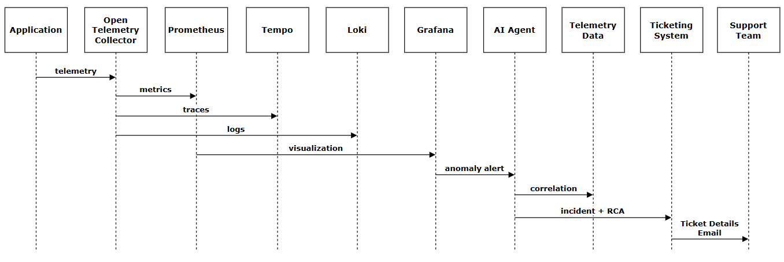

Maturity Roadmap
[Extraction Annotation] Disposition: MIXED | Keep: Executive roadmap view | Extract To: D13 Observability Roadmap Delivery Plan | Notes: Detailed milestones and dependencies to delivery plan.
The observability maturity roadmap represents your organization's journey from reactive monitoring to proactive, AI-driven observability. This phased approach ensures sustainable adoption while building upon each previous achievement.

Phase 1: Foundation (Months 1-3)
[Extraction Annotation] Disposition: EXTRACT | Keep: None | Extract To: D13 Observability Roadmap Delivery Plan | Notes: Execution plan detail.
"Establish the Core - See What's Happening"
This phase focuses on laying the groundwork for your observability platform. The goal is to move from having no visibility to having basic monitoring in place.
Objective | Description | Success Criteria
Deploy Core Stack | Install and configure the foundational tools: Prometheus for metrics, Loki for logs, and Grafana for visualization | All components operational and accessible
Instrument Critical Services | Add OpenTelemetry instrumentation to your most important applications to begin collecting telemetry data | Top 5 critical services emitting metrics, logs, and traces
Basic Dashboards | Create initial dashboards showing system health, resource utilization, and application performance | Teams can view real-time status of their systems
Define Baseline Metrics | Establish what "normal" looks like for key performance indicators | Documented baseline thresholds for CPU, memory, latency, and error rates
Team Onboarding | Train operations and development teams on accessing and interpreting dashboards | All relevant team members can navigate Grafana
Outcome: The Organization transitions from "we don't know what's broken" to "we can see when something breaks."

Phase 2: Correlation & Alerting (Months 4-6)
[Extraction Annotation] Disposition: EXTRACT | Keep: None | Extract To: D13 Observability Roadmap Delivery Plan | Notes: Execution plan detail.
"Connect the Dots - Understand Why It's Happening"
This phase focuses on linking your telemetry data together and implementing intelligent alerting. The goal is to reduce noise and accelerate troubleshooting.
Objective | Description | Success Criteria
Unified Telemetry Collection | Configure OpenTelemetry Collector as the central gateway for all telemetry data, standardizing how metrics, logs, and traces are processed | Single pipeline handling all telemetry types
Trace-Log-Metric Correlation | Link distributed traces to related logs and metrics using correlation IDs, enabling end-to-end visibility | Engineers can jump from an error log to the associated trace in one click
Implement Smart Alerting | Set up Grafana Alerting with severity-based routing and noise reduction rules | Alert fatigue reduced; only actionable alerts reach on-call teams
Service Dependency Mapping | Visualize how services connect and depend on each other | Clear topology maps showing upstream/downstream relationships
Distributed Tracing Rollout | Extend Tempo-based tracing to all production services | Full request path visibility across microservices
Cross-Team Dashboards | Create shared views that break down silos between development, operations, and support teams | Single pane of glass accessible to all stakeholders
Outcome: The organization moves from "something is broken" to "we understand why it broke and what else might be affected."

Phase 3: AI-Driven Intelligence (Months 7-12)
[Extraction Annotation] Disposition: EXTRACT | Keep: None | Extract To: D13 Observability Roadmap Delivery Plan | Notes: Execution plan detail.
"Predict and Automate - Fix Before Users Notice"
This phase introduces artificial intelligence to transform observability from a reactive tool into a proactive competitive advantage . The goal is to automate detection, analysis, and initial response.
Objective | Description | Success Criteria
Anomaly Detection | Deploy AI models that automatically identify unusual patterns in metrics, logs, and traces without manual threshold configuration | System detects anomalies before they trigger traditional alerts
Automated Root Cause Analysis (RCA) | Implement AI agents that analyze correlated telemetry to determine probable root causes when incidents occur | RCA reports generated within minutes of incident detection
Intelligent Ticket Creation | Enable AI to automatically create well-structured incident tickets with context, impact assessment, and suggested remediation steps | Tickets include all relevant information; no manual data gathering needed
Predictive Alerting | Use machine learning to forecast issues (capacity exhaustion, performance degradation) before they impact users | 30-minute advance warning on predictable issues
Runbook Automation | Connect AI recommendations to automated remediation workflows for common, well-understood issues | Pre-approved fixes execute automatically with audit trails
Feedback Loop Integration | Establish mechanisms for humans to validate AI decisions, continuously improving model accuracy | AI accuracy improves month-over-month based on operator feedback
Business Impact Correlation | Link technical incidents to business metrics (revenue impact, customer experience scores) | Executives receive business-context incident summaries
Outcome: The organization achieves the vision stated in the executive summary—transforming observability from "technical overhead into a competitive advantage" where teams "spend less time rectifying issues and more time shipping high-value features"

Maturity Assessment Framework
[Extraction Annotation] Disposition: EXTRACT | Keep: None | Extract To: D14 Observability Capability Assessment Framework | Notes: Assessment method in dedicated framework.
To track progress through these phases, consider measuring:
Metric | Phase 1 Target | Phase 2 Target | Phase 3 Target
Mean Time to Detect (MTTD) | < 15 minutes | < 5 minutes | < 1 minute
Mean Time to Resolution (MTTR) | Hours | 30 minutes | Minutes
Services Instrumented | 20% | 70% | 100%
Alert Noise Ratio | High | Moderate | Low (<10% false positives)
Manual RCA Required | 100% | 50% | <20%
Automated Ticket Creation | 0% | 50% | >90%

Final Architecture Summary
[Extraction Annotation] Disposition: KEEP | Keep: Strategy doc only | Extract To: None | Notes: Retain executive synthesis.
Observability pillars
- OpenTelemetry as universal telemetry layer
- Grafana ecosystem for visualization
- Prometheus Loki Tempo for storage
- Pulumi for deployment automation
- Agentic AI for intelligent incident response
This results in
- Vendor-neutral observability
- Multi-cloud portability
- AI-assisted incident management
- Full stack telemetry coverage

Architecture Governance and Review
[Extraction Annotation] Disposition: MIXED | Keep: High-level governance narrative | Extract To: D15 Observability Governance Charter & ARB Pack | Notes: Detailed governance mechanics in charter/ARB pack.
Please state below who has seen this document and the level of review.
Id. | Board | State | Action/ Review
1 | ARB | Not Seen
2 | Exception Panel | Not Seen | N/A
3 | SDG | Not Seen
4 | Change Board | Not Seen

Decision Log
[Extraction Annotation] Disposition: EXTRACT | Keep: None | Extract To: D16 Observability ADR / Decision Register | Notes: Move decisions to ADR register.
Id. | Review Group | Decision
1 |  | Pass/ Fail/ More work Required

Appendix
[Extraction Annotation] Disposition: MIXED | Keep: Light references and glossary | Extract To: D1 Enterprise Observability Standards Catalog; D3 Domain Observability Runbooks Pack; D5 Grafana Platform Standard & Visualization Playbook; D6 AIOps Guardrails & Implementation Playbook; D8 Observability Data Governance & Retention Policy | Notes: Move heavy operational tables to destination artifacts.
Observability Strategy — KPIs and Metrics Table
Objective | KPI / Metric | Metric Type | Suggested Target / Range | Success Criteria
Reduce Downtime | - Mean Time to Resolution (MTTR) | Operational Performance | - Reduce average MTTR by 50% in 6 months (e.g., from 180 mins to 90 mins) | Sustained lower MTTR and >80% incidents resolved without escalation
Operational Efficiency | - Cross-Team Incident Resolution Rate  - Number of Tools Consolidated | Collaboration / Efficiency | - ≥70% cross-team resolution within 6 months  - Reduce tool count by 30–40% over 12 months | Seamless team coordination, fewer “war room” sessions, measurable tool cost savings
Customer Impact / Reliability | - System Availability (Uptime)  - Performance Incident Lead Time | Service Reliability | - Maintain uptime ≥99.9%  - Detect anomalies and create incidents in <5 minutes | Reduced user-impact incidents; improved end-user performance experience
Cost Optimization | - Monthly Tooling & Integration Spend  - Tool Coverage Rate | Financial / Operational | - Reduce observability tool costs by 20–25% in 12 months  - Reach >90% coverage for unified observability stack | Consolidated systems, lower cost without visibility loss
Application Reliability | - Error Rate  - Deployment Success Rate | Technical Quality | - Error rate <1% per 1,000 requests  - Deployment success >95% | Fewer rollbacks; stable production operation
Engineering Productivity | - Time Spent on Feature Development vs. Issue Rectification  - Feature Delivery Velocity | Productivity / Innovation | - ≥70% engineering time on new feature work  - Increase delivery velocity by 15–20% over 9 months | Higher value output; sustained reduction in reactive work
Data Standardization | - Systems emitting consistent telemetry (coverage %) | Data Integrity | - 100% of critical services onboarded to OpenTelemetry framework | Unified “single pane of glass” observability across the tech estate

Additional Objectives and KPIs
Objective | Measurable Metric / KPI | Metric Type | Suggested Target / Range | Success Criteria
Business Continuity / Resilience | Recovery Point Objective (RPO) | Data Protection / Reliability | ≤ 15 minutes for critical systems | Minimal data loss during outages
 | Recovery Time Objective (RTO) | Service Restoration | ≤ 60 minutes for Tier 1 services | Systems restored within defined SLA window
System Scalability | Infrastructure Resource Utilization (CPU, memory, throughput) | Performance | Maintain ≤ 70–75% average utilization | Stable performance under scaling conditions
Alert Quality | Signal-to-Noise Ratio of Alerts | Monitoring Quality | ≥ 80% actionable alerts | Reduced alert fatigue and faster response
Root Cause Efficiency | Percentage of Incidents with Root Cause Identified | Incident Management | ≥ 90% | Continuous learning and prevention improvements
Data Completeness | Telemetry Coverage across apps/services | Observability Accuracy | ≥ 95% services emitting standardized telemetry | Full visibility across product and infra layers
Compliance & Auditability | Compliance Audit Pass Rate | Governance | 100% adherence to regulatory checks | No audit failures or security violations

