- Particulars of Inventors Name: Anup Kumar Course/Branch: B.Tech/CSE-AI Name: Anurag Kardam Course/Branch: B.Tech/CSE-AI
Address: Affiliated with ABES Institute Of Technology Ghaziabad

- Provide a brief descriptive title of the invention-
JalRakshak: An AI-Powered Water Body Health Monitoring, Pollution Detection, and Community Reporting System

- In 100 words or less, p lease p rovide an abstract or summary of the invention: (Novel Feature and benefits are important to highlight)-

JalRakshak is an AI-powered platform for real-time monitoring, assessment, and restoration of urban water bodies. The system integrates water quality parameters, satellite imagery, and citizen-generated reports to calculate a dynamic Water Health Score and identify pollution hotspots. Its novel features include AI-based pollution prediction, automated water quality analysis, geospatial visualization, and community-driven reporting through a centralized dashboard. The platform enables authorities to prioritize restoration efforts, improve environmental compliance, and enhance decision-making. By combining technology, data analytics, and public participation, JalRakshak provides a scalable and cost-effective solution for sustainable water body management and conservation.

- Detail description of the invention:

Problem the invention is solving:
Urban water bodies such as rivers, lakes, ponds, wetlands, and reservoirs are increasingly affected by pollution, encroachment, sewage discharge, and inadequate monitoring. Existing monitoring systems rely on periodic manual sampling, which is time-consuming, costly, and incapable of providing real-time insights. Furthermore, citizen complaints and environmental observations are often fragmented across multiple platforms, leading to delayed action and poor coordination among stakeholders.
The absence of a unified system for monitoring water quality, predicting pollution trends, and engaging communities limits effective restoration and conservation efforts. This invention addresses these challenges by providing a comprehensive, data-driven, and community-oriented solution for continuous water body health assessment and management

Technical features of the invention

The invention comprises the following technical components:

Water Health Scoring Engine

Proprietary scoring mechanism that evaluates water body health using parameters including:
  - pH
  - Dissolved Oxygen (DO)
  - Biological Oxygen Demand (BOD)
  - Temperature
  - Total coliform
The system generates a dynamic Water Health Score ranging from 0–100.

AI-Based Pollution Prediction Module

Machine learning algorithms analyze historical and real-time data to:
  - Detect pollution trends
  - Predict future degradation risks
  - Identify pollution hotspots
  - Generate restoration priority rankings

Geospatial Mapping and Visualization

Integration with GIS and satellite imagery enables:
  - Water body location mapping
  - Encroachment monitoring
  - Pollution hotspot visualization

Community Reporting Platform

Citizens can submit:
  - Images
  - Pollution complaints
  - Encroachment reports
  - Illegal dumping reports
  - Anonymous reports
Reports are geotagged and displayed on a centralized dashboard.

Administrative Decision Support Dashboard

Authorities receive:
  - Real-time alerts
  - Water quality analytics
  - Restoration recommendations
  - Performance tracking reports
- Data Integration Layer

The platform integrates data from:

  - Water quality sensors
  - Government databases
  - Satellite observations
  - Community reports
  - Historical environmental datasets

- General Utility /app lication of the invention

The invention can be utilized for:
- River monitoring and restoration
- Lake and pond management
- Wetland conservation
- Smart city environmental governance
- Municipal water resource management
- Pollution control board operations
- Academic and environmental research
- Climate resilience and sustainability programs

Applicable organizations include:
- Municipal Corporations
- CPCB and DPCC
- Smart City Missions
- Environmental NGOs
- Research Institutions
- Urban Development Authorities

- Advantages of the invention

Environmental Benefits
- Early detection of pollution events
- Improved ecosystem protection
- Better restoration planning

Technical Benefits
- Real-time monitoring capability
- AI-assisted decision making
- Automated health assessment

Social Benefits
- Community participation in conservation
- Increased environmental awareness
- Improved transparency

Economic Benefits
- Reduced monitoring costs
- Optimized resource allocation
- Preventive maintenance of water bodies

Administrative Benefits
- Faster response to incidents
- Centralized environmental management
- Data-driven policy formulation

Best way of using the invention as well as possible variants
Variant 1: IoT-Enabled Deployment Integrates real-time sensor networks to facilitate continuous, automated environmental monitoring.
Variant 2: Drone-Based Monitoring Deploys Unmanned Aerial Vehicles (UAVs) for high-resolution aerial surveys and rapid image acquisition.
Variant 3: Smart City Integration Connects the system directly to municipal command-and-control centers for centralized urban management.
Variant 4: National Water Monitoring Platform Scales the architecture across multiple cities and states to create a unified, high-capacity national network.

Drawing, schematics and flow diagrams if required with complete explanations
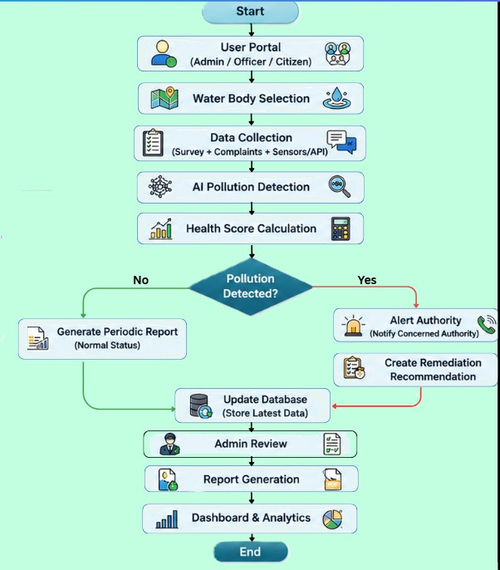

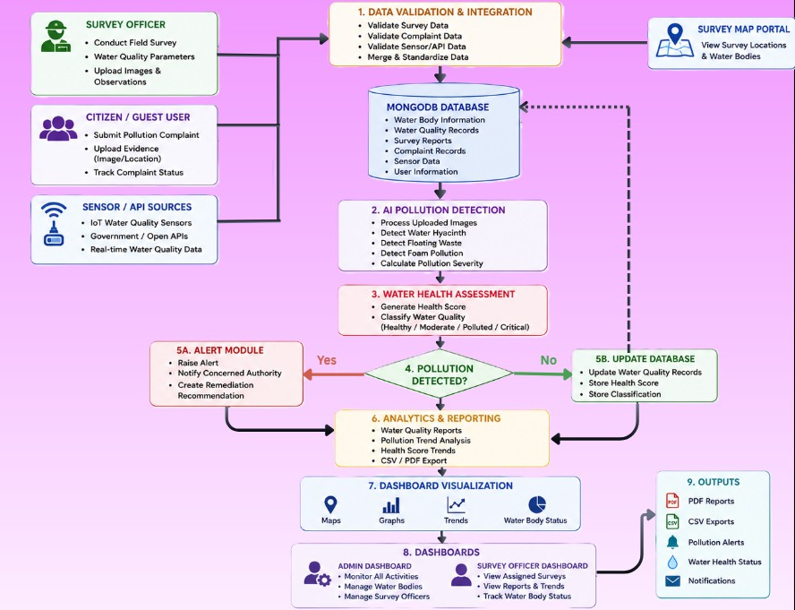

Reference to relevant patent and publication

Relevant Publications

- WATER QUALITY INDEX ASSESSMENT OF BHALSWA LAKE, NEW DELHI Deepika 1 and S. K. Singh 2 1. Research Scholar, Department of Environmental Engineering, Delhi Technological University, New Delhi, India1 2. Professor, Department of Environmental Engineering, Delhi Technological University, New Delhi, India2

- WATER QUALITY INDEX ASSESSMENT OF BHALSWA LAKE, NEW DELHI Deepika 1 and S. K. Singh 2 1. Research Scholar, Department of Environmental Engineering, Delhi Technological University, New Delhi, India1 2. Professor, Department of Environmental Engineering, Delhi Technological University, New Delhi, India2

- Water Quality Monitoring of Yamuna River by Using GIS Based Water Quality Index in Delhi, India Shikha Sharma1*, Pawan Kumar Jha2, Manju Rawat Ranjan1, Umesh Kumar Singh3 and Tanu Jindal1 1Amity Institute of Environmental Sciences, Amity University, Uttar Pradesh 201303, India 2Centre of Environmental Studies, University of Allahabad, Uttar Pradesh 211002, India 3Integrated Science Education and Research Centre (ISERC), Visva-Bharati University, Santiniketan- 731235, India

- Application of remote sensing and GIS in monitoring water quality parameters: A comprehensive review of key parameters Jayesh Rajbhar, Varunakshi Bhojane, Dhananjay Jadhav, Abhishek Wafare, Tejas Kadam Student, Professor, Student, Student, Student Department of Computer Engineering Pillai College of Engineering, New Panvel, India

- S. R. Kannan, L. M. Sundari, V. S. G. Akula, A. Mythili, D. Yobu, and C. Srinivasan, “LSTM-based Detection and Management of Emerging Waterborne Contaminants in IoT System,” pp. 1511–1516, Nov. 2025, doi: 10.1109/iceamst67459.2025.11335924.

- Dynamic monitoring and mapping of water quality indicators using multi-modal and multi-scale satellite imagery, UAVs, and open-source cloud computing platform Abhinav Galodha,M. V. Pep

- Analyzing the retrieval accuracy of optically active water components from satellite data under varying image resolutionsF. Sunar,Adalet Dervisoglu,Nur Yağmur,Ertuğrul Aslan,Mehmet Metin Özgüven

Have you conducted Primary Patent Search: NO
- Existing state-of-the-art and prior arts: (Brief background of the existing knowledge/product/process in the market)

Existing State-of-the-Art and Prior Arts
S. No. | Existing state of art | Drawbacks in existing state of art | Overcome (how your invention is overcoming the drawback)
1 | Manual Water Quality Monitoring (CPCB, DPCC, Laboratory Testing) | Sampling is periodic, labor-intensive, expensive, and does not provide real-time monitoring. Pollution events may remain undetected between sampling intervals. | JalRakshak integrates sensor data, historical records, and AI analytics to provide continuous monitoring and faster detection of pollution trends.
2 | IoT-Based Water Quality Monitoring Systems | Primarily focus on sensor readings and lack predictive analytics, restoration planning, and citizen participation. Sensor failures can also affect reliability. | JalRakshak combines water quality monitoring with AI-based prediction, GIS mapping, and community reporting to provide a holistic solution.
3 | GIS and Satellite-Based Water Body Mapping Systems | Useful for mapping and change detection but cannot directly assess water quality or capture local pollution incidents in real time. | JalRakshak integrates geospatial analysis with water quality indicators and citizen-generated reports for comprehensive assessment.
4 | Public Complaint and Grievance Portals | Reports are often fragmented, lack environmental context, and are not linked to water quality analytics or restoration priorities. | JalRakshak provides geotagged reporting linked with AI analysis, enabling authorities to prioritize actions based on environmental impact.
5 | Water Quality Index (WQI) Assessment Models | Most WQI systems only provide a static score and do not include predictive capabilities, restoration recommendations, or public participation. | JalRakshak generates a dynamic Water Health Score, predicts future pollution risks, identifies hotspots, and supports decision-making for restoration efforts
- Existing water body monitoring systems primarily rely on laboratory testing, Water Quality Index (WQI) assessment, IoT-based sensors, GIS mapping, and public grievance platforms. These solutions
- help monitor water quality, map water bodies, or collect pollution complaints, but generally operate independently and provide limited integration.
- Most existing systems lack a unified framework that combines water quality assessment, geospatial monitoring, and citizen participation. JalRakshak addresses this gap by integrating these components into a single platform for comprehensive water body monitoring and restoration support.

- List out the known ways about how others have tried to solve the same or similar problems? Indicate the disadvantages of these approaches. In addition, please identify any prior art documentation or other material that explains or provides examples of
such prior art efforts.

List the Technical features and Elements of the invention.

The invention "JalRakshak" is an AI-enabled water body monitoring and restoration platform comprising:
- Water Health Score calculation using pH, DO, BOD, Temperature, Total ColiForm.
- GIS-based mapping of water bodies and pollution hotspots.
- Historical water quality database integration.
- Community reporting system with image and location upload.
- Pollution hotspot identification and prioritization engine.
- Administrative dashboard for monitoring and decision support.
- Water body classification and health assessment module.
- Environmental analytics and reporting framework.
- Real-time visualization of water quality trends.

List out the features of your invention which are believed to be new and distinguish them over the closest technology.

The invention differs from existing systems through:
- Integration of water quality analysis, GIS mapping, and citizen reporting in a single platform.
- Dynamic Water Health Score for each water body.
- Community-generated environmental intelligence linked directly with water quality assessment.
- Pollution hotspot prioritization based on scientific and community data.
- Unified dashboard for authorities, researchers, and citizens.
- Restoration-oriented decision support rather than simple monitoring.

Has the invention been built or tested or implemented? If so, please provide the particulars of the first time it was successfully built or implemented (when, where, by whom, and evidence of this event including written or on-line pointers to documentary evidence):

Status: Prototype Developed.
The system has been implemented as a software prototype demonstrating:
- Water Health Score calculation.
- Water body visualization.
- Pollution reporting functionality.
- Dashboard analytics.

First Implementation:
- Date: 18/06/2026
- Location: ABES Institute of Technology, Ghaziabad, Uttar Pradesh
- Developed By: Anup Kumar, Anurag Kardam

Briefly state when and how you first conceived this idea?
The idea was conceived while studying the pollution status of the River Yamuna and urban water bodies in Delhi-NCR. Existing monitoring systems were found to be fragmented, lacking community

participation and integrated assessment mechanisms.
The concept evolved into a unified platform capable of combining environmental monitoring, water quality assessment, mapping, and public participation.
Date of Conception:
MAY, 2026

Have you sold, offered for sale, publicly used or published anything related to this invention? If yes, please briefly explain the dates and circumstances. List those individuals to whom you have revealed your invention. Were non-discloser documents signed prior to discloser in each case? Please state any deadlines of which you may be aware for filing an application on this invention.

To the best of our knowledge:
  - The invention has not been sold commercially.
  - No commercial offer for sale has been made.
  - No licensing agreement has been executed.

Disclosures may include:
  - Internal project discussions.
  - Faculty mentor reviews.

Persons informed:
  - Project team members: Anurag Kardam, Anup kumar.
  - Faculty mentors: Ms. Vineeta.
- NDA Status: No NDA executed unless specifically signed with external parties.

Patent Filing:
A patent application should be filed before any major public disclosure, publication, website launch, GitHub public release, conference paper publication, or commercial demonstration.

Include any reasons your invention would not have been obvious to someone of average skill in the art.
- The invention is not obvious because existing solutions generally address only one aspect of water management, such as water quality monitoring, GIS mapping, or public grievance handling.
- The inventive step lies in the integrated architecture that combines:
  - Water quality assessment,
  - GIS-based monitoring,
  - Community-generated environmental reporting,
  - Pollution hotspot prioritization,
  - Restoration-focused decision support.
- The combination produces a unified environmental management framework capable of identifying, assessing, prioritizing, and supporting restoration of water bodies, which is not achieved by existing standalone systems.

Additional comments by inventor (if you want to give more details out of scope of this IDF).
JalRakshak is designed as a scalable platform capable of deployment across rivers, lakes, ponds, wetlands, and urban water bodies. The framework can support Smart City initiatives, environmental governance programs, pollution control boards, and community-led conservation efforts. Future enhancements may

include IoT sensor integration, satellite-based monitoring, AI-driven prediction models, and mobile applications for citizen engagement.

