# Statistics 202A

## Anurag Pande – 604749647

Input data is taken as a randomized set of 100 values in the range of 0 to 1 as the X co-ordinate, and Y co-ordinate as ${(X}^{2}+randomvalue_{normalized}*sigma)$

Regularization can be observed as how close the predicted co-ordinates are to the predicted values. The value of lambda changes the regularization, fitting the predicted values differently to the actual dataset.

We can see that values of lambda > 1 do not produce quite accurate results, while values of lambda < 0.01 overfit the model too much.

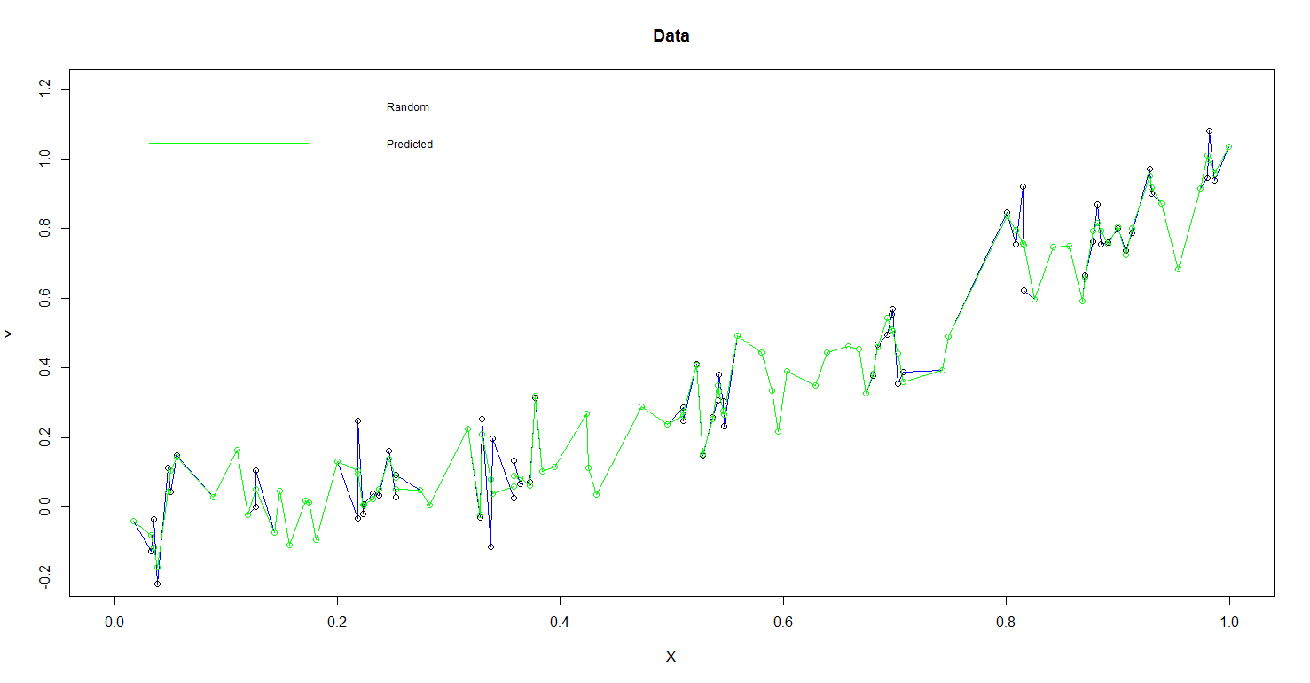

Sigma = 0.1, Lambda = 0.0

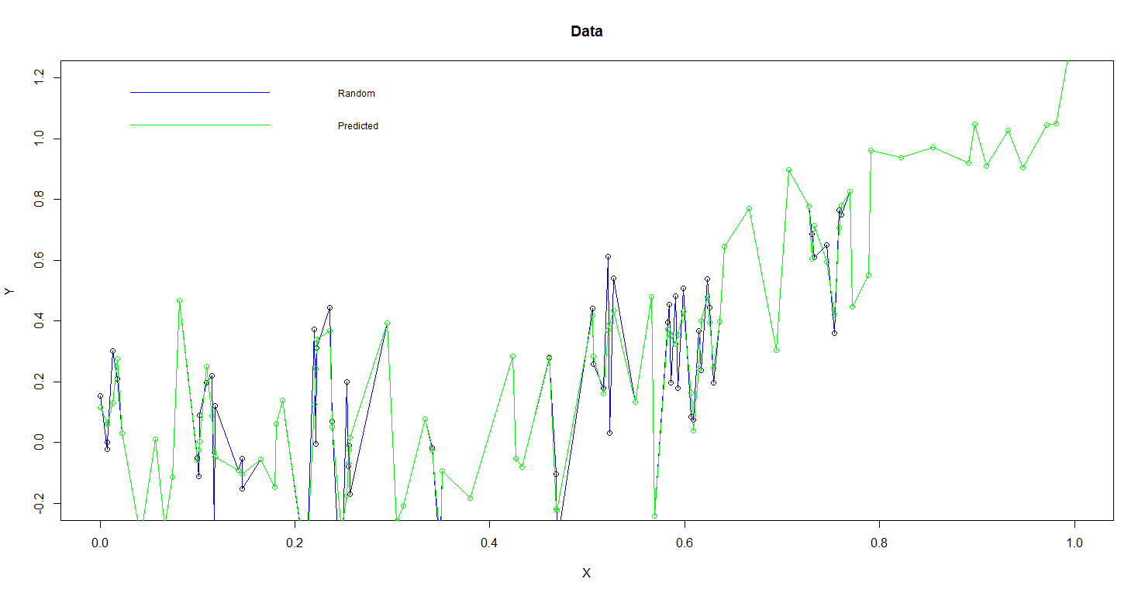

Sigma = 0.2, Lambda = 0.0

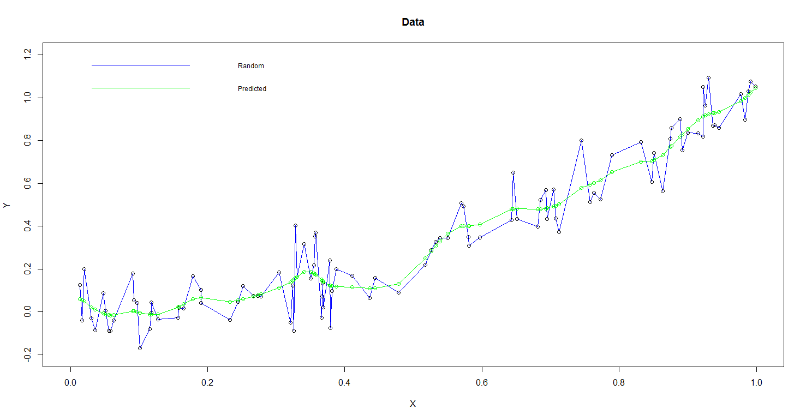

Sigma = 0.1, Lambda = 0.001

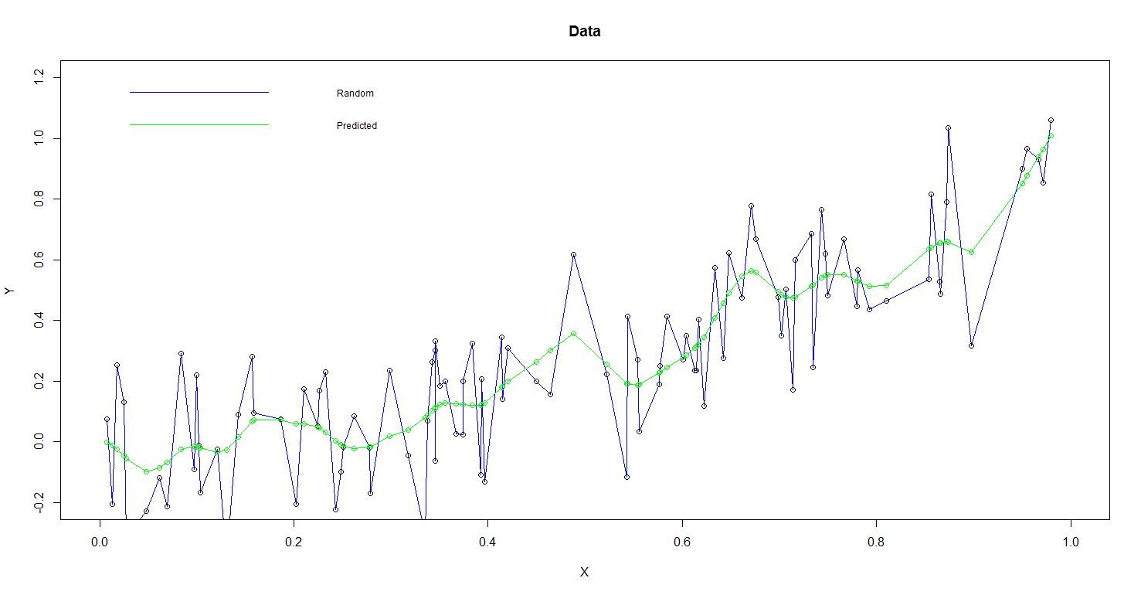

Sigma = 0.2, Lambda = 0.001

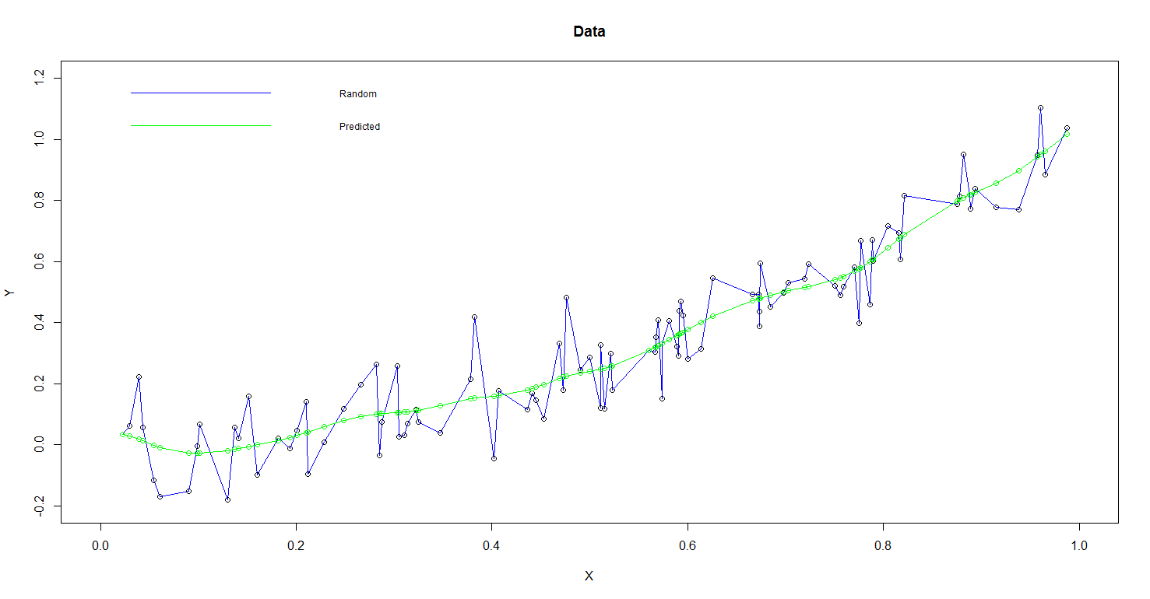

Sigma = 0.1, Lambda = 0.01

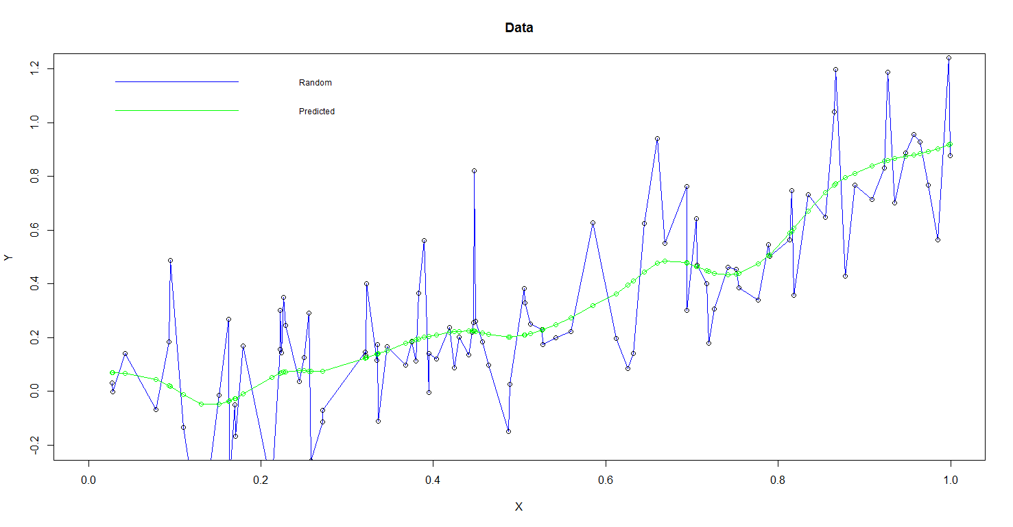

Sigma = 0.2, Lambda = 0.01

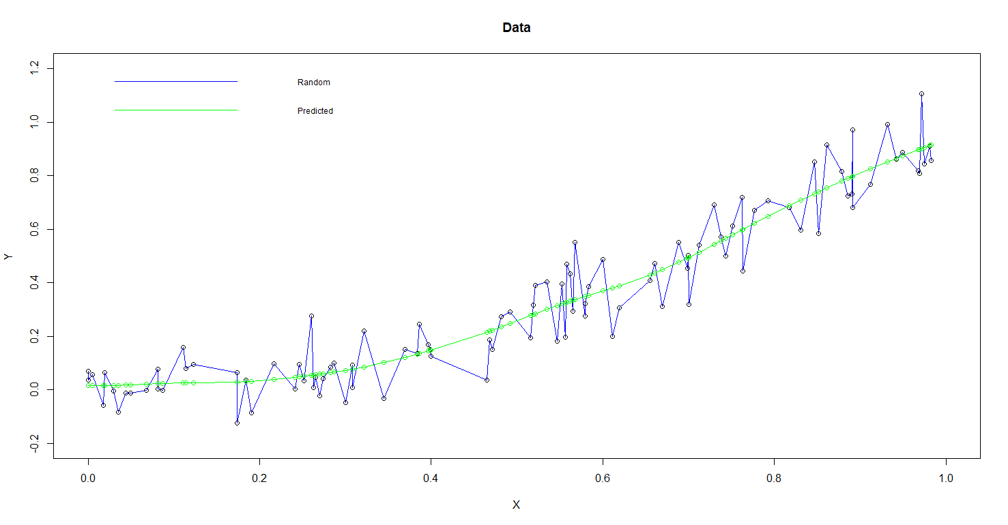

Sigma = 0.1, Lambda = 0.1

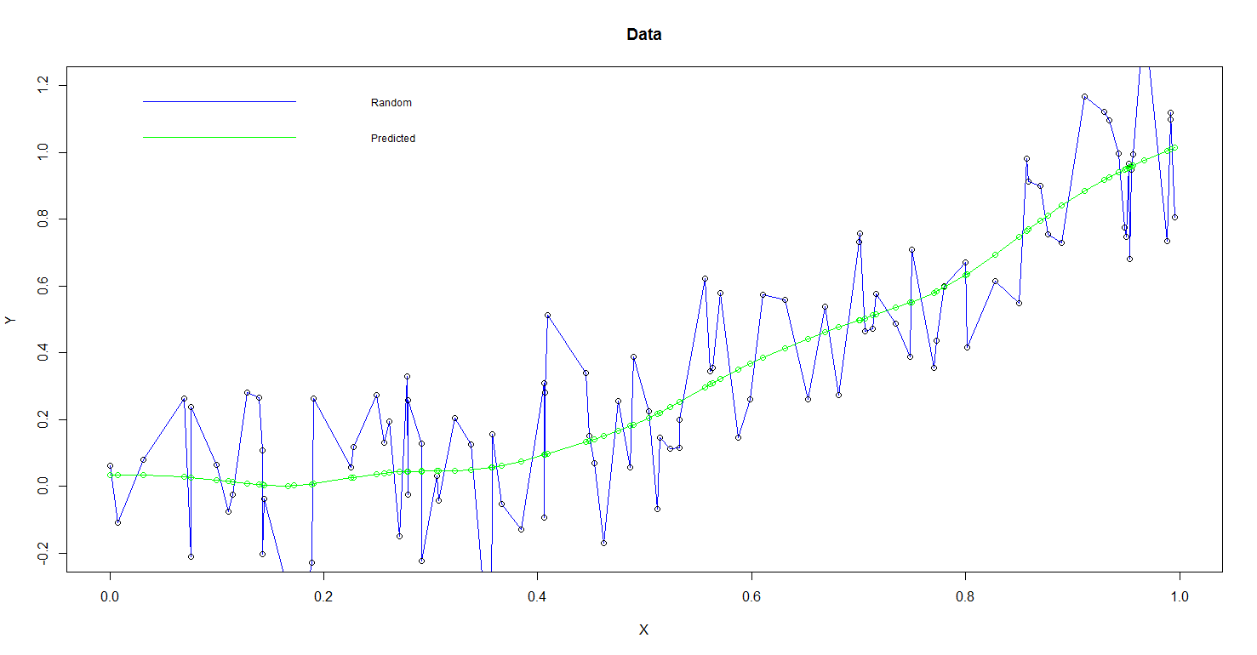

Sigma = 0.2, Lambda = 0.1

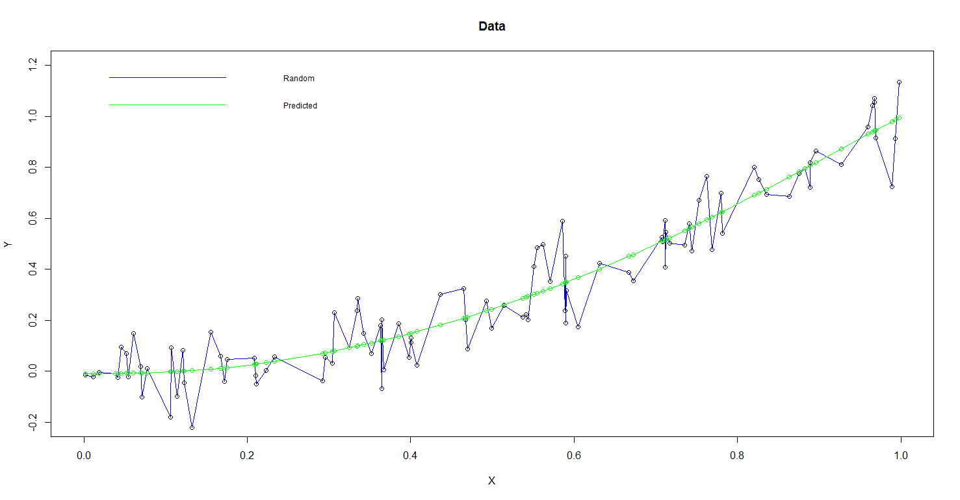

Sigma = 0.1, Lambda = 1

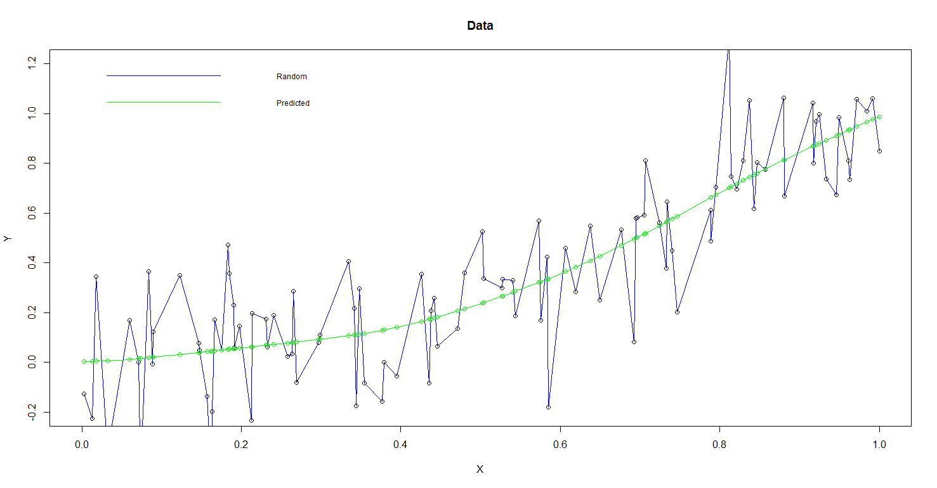

Sigma = 0.2, Lambda = 1

Sigma = 0.1, Lambda = 100

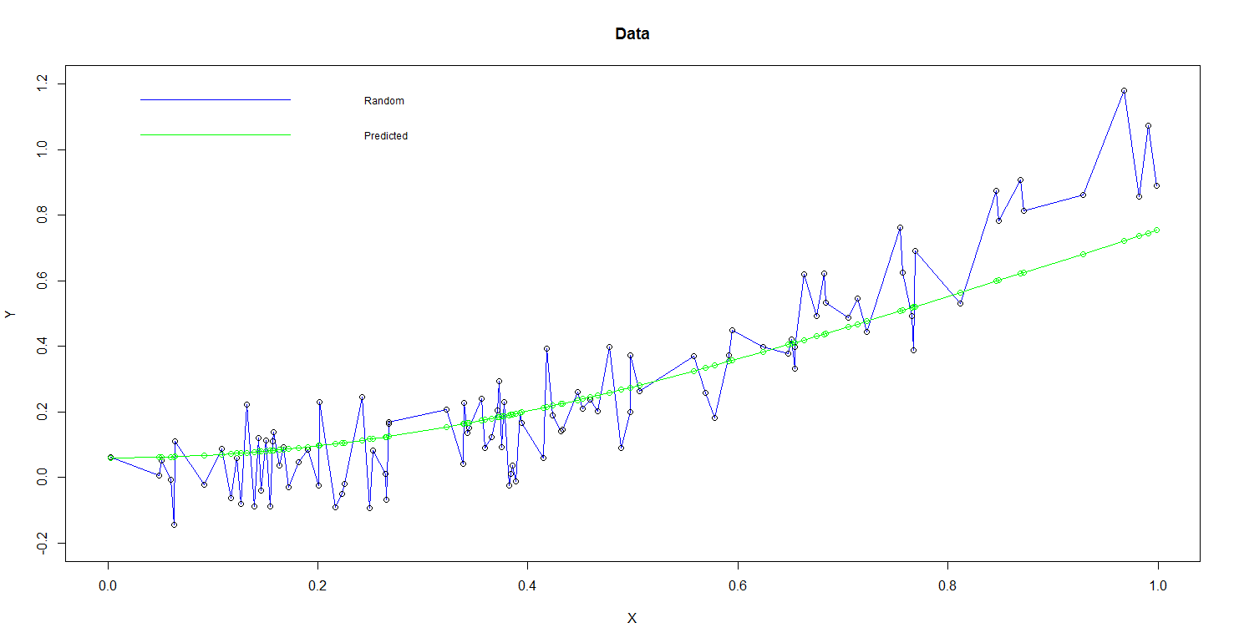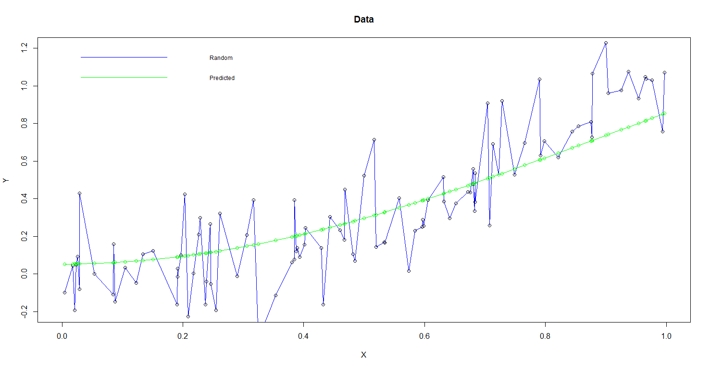

Sigma = 0.2, Lambda = 100

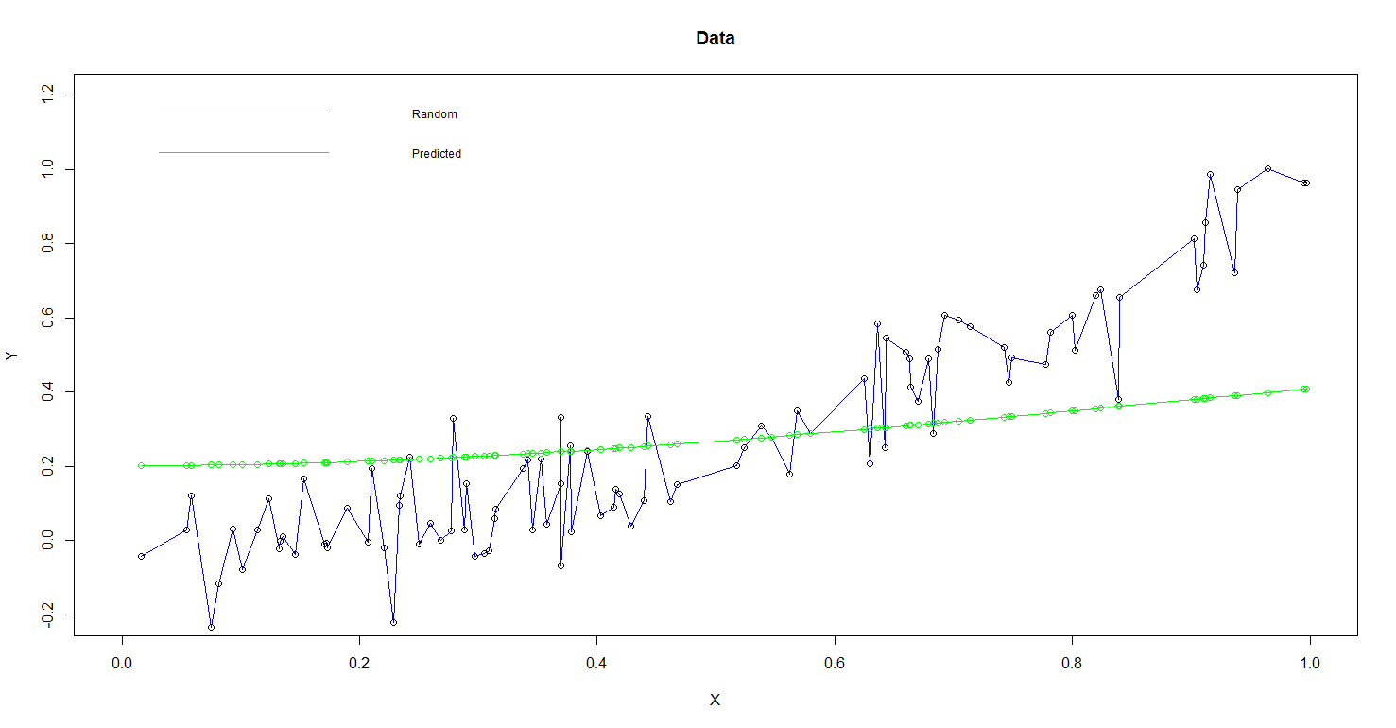

Sigma = 0.1, Lambda = 1000

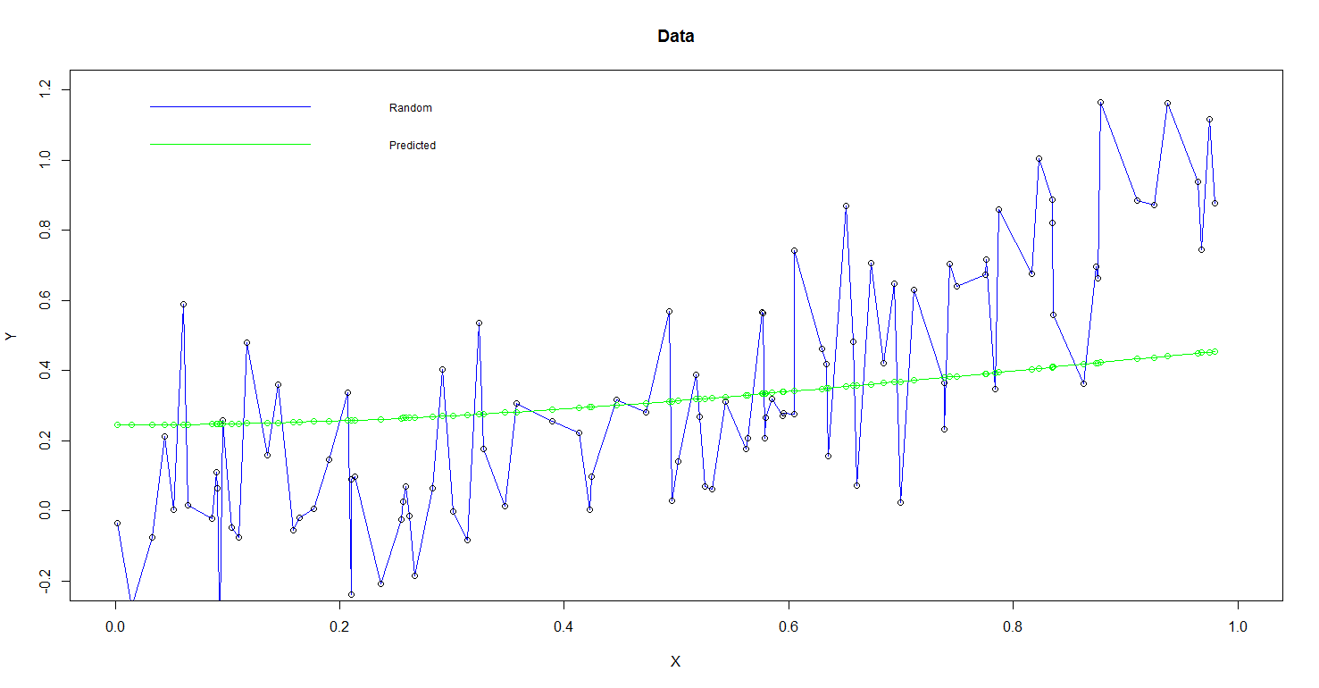

Sigma = 0.2, Lambda = 1000

**Divide data into 80% training data and 20% testing data as:**

X <- runif(n)

train_x <- X[1:80]  
test_x <- X[81:100]

train_x <- sort (train_x)  
test_x <- sort (test_x)

train_y <- train_x^2 + rnorm(80) * sigma  
test_y <- test_x^2 + rnorm(20) * sigma

**Then, the beta_spline can be got from the training data as:**

op_train <- mySpline(train_x,train_y,lambda,p)  
beta_spl <- op$beta_spline

**The beta spline is used on the test data as:**

op_test <- mySplineTest(test_x,test_y,lambda,p,beta_spl)

**Training error is calculated as:**

training_error = sum(abs(train_y - op_train$predicted_y))/length(train_y)

**Testing error is calculated as:**

testing_error = sum(abs(test_y - op_test$predicted_y))/length(test_y)

**The test data is calculated via a Spline Test function as follows:**

mySplineTest <- function(x, Y, lambda, p = 100, beta_spline){

n = length(x)

X <- matrix(x, nrow=n)

for ( k in (1:(p-1))/p)

X <- cbind(X,(x>k)*(x-k))

Yhat <- cbind(rep(1,n),X)%*% beta_spline

output <- list(beta_spline = beta_spline, predicted_y = Yhat)

return(output)

}

For lambda = 1

training_error = 0.08270616

testing_error = 0.103775

For lambda = 0.1

training_error = 0.07752532

testing_error = 0.06756782

For lambda = 0.01

training_error = 0.07071239

testing_error = 0.0753857

For lambda = 0.001

training_error = 0.07105358

testing_error = 0.07870062

For lambda = 100

training_error = 0.1061344

testing_error = 0.1051672

For lambda = 1000

training_error = 0.2157368

testing_error = 0.2620837

Here, for lambda, which is on the y-axis:

1 -> 0.001  
2 -> 0.01  
3 -> 0.1  
4 -> 1  
5 -> 100  
6 -> 1000

