**Project: Dataset Birth**

Project_1:

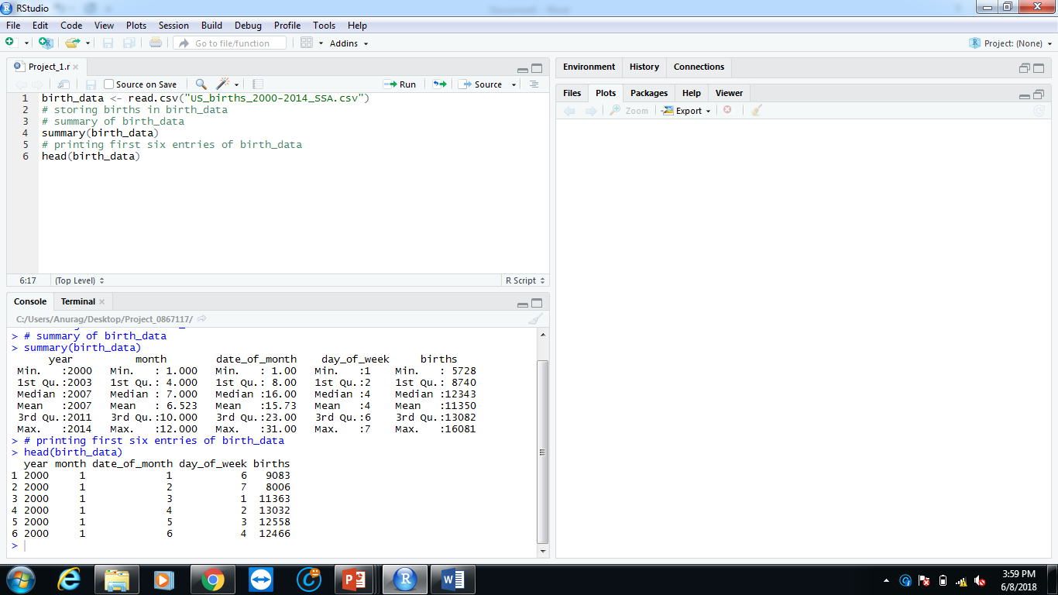Storing dataset in birth_data, printing summary of birth_data and first six entries.

Project_2:

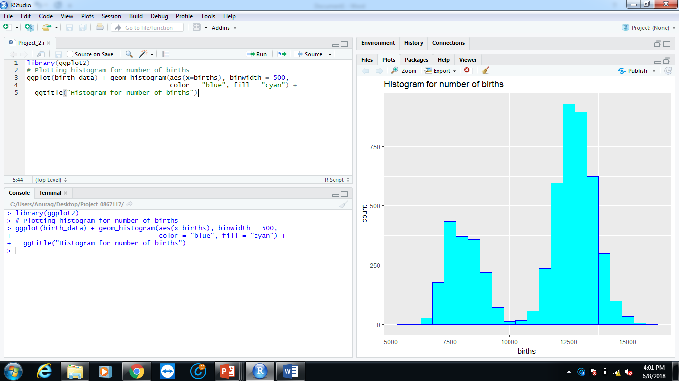Plotting histogram for number of births.

Project_3:

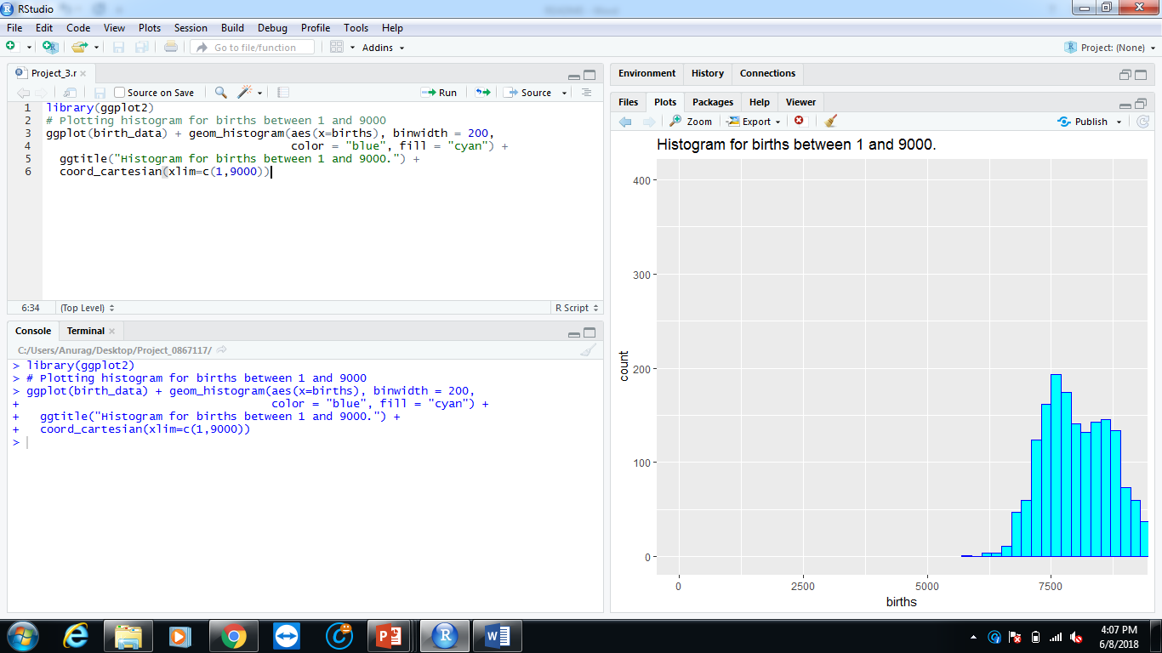Plotting histogram for births between 1 and 9000.

Project_4:

Printing number of births less than 7500; greater than 12500.

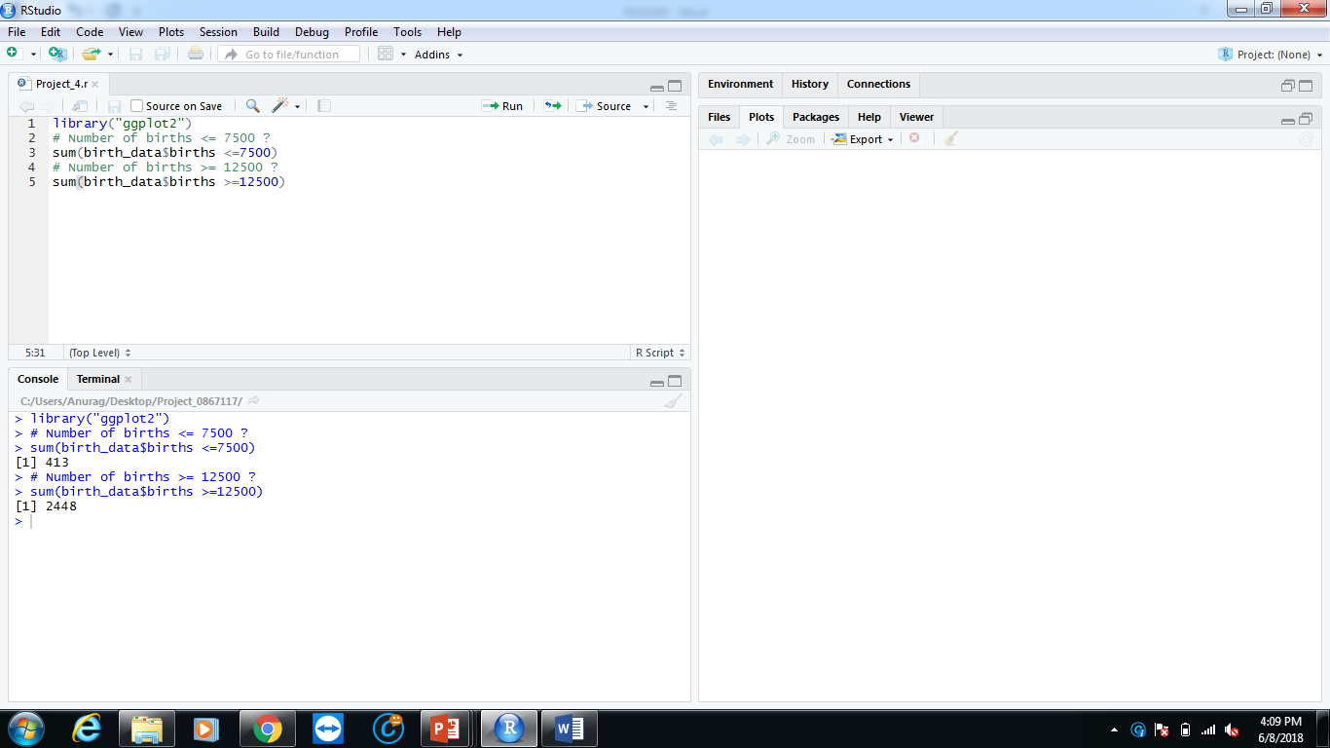

Project_5:

Reshaping birth_data with only year and births.

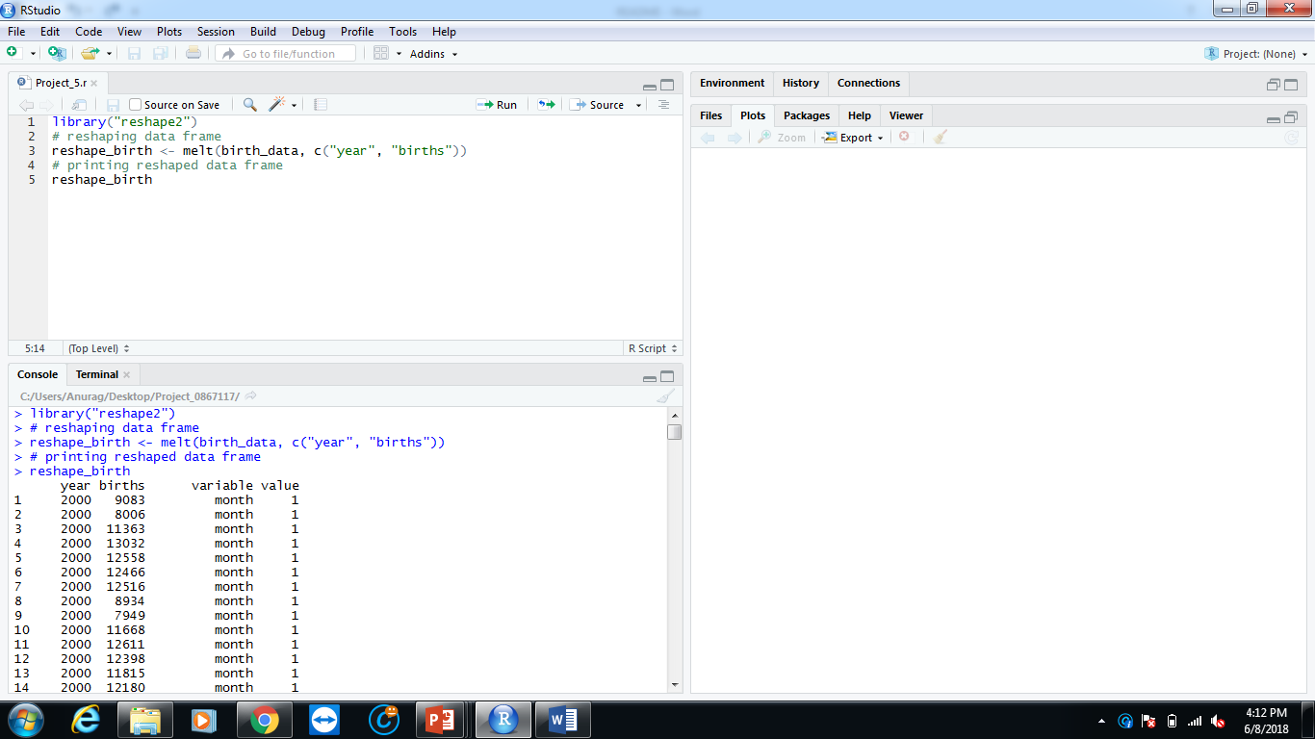

Project_6:

Plotting scatter graph of birth vs year with smooth curve.

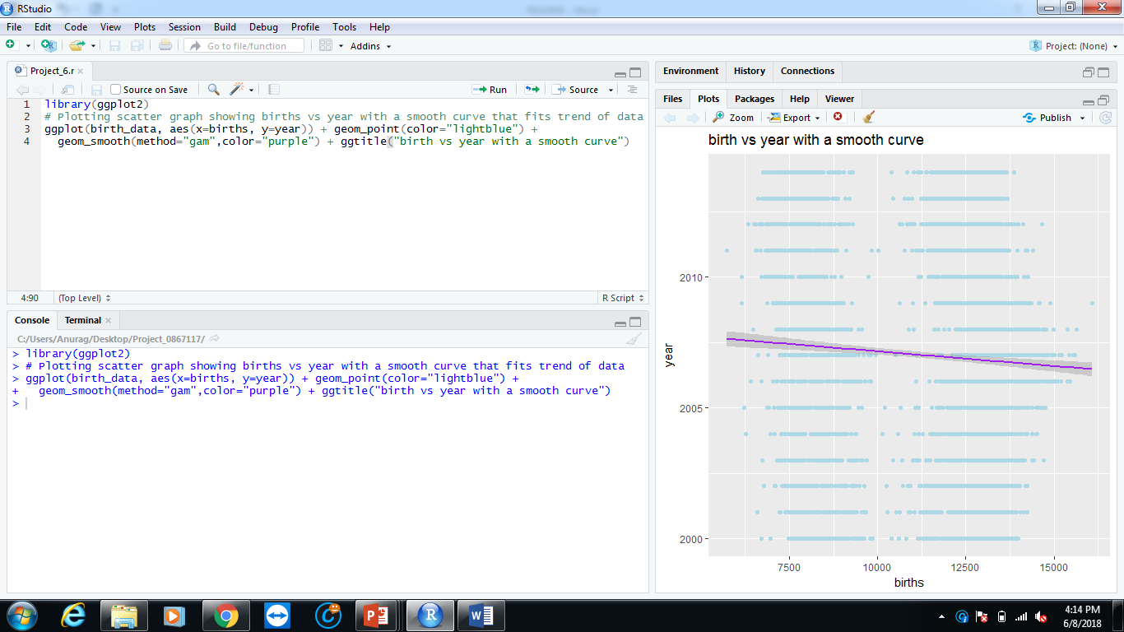

Project_7:

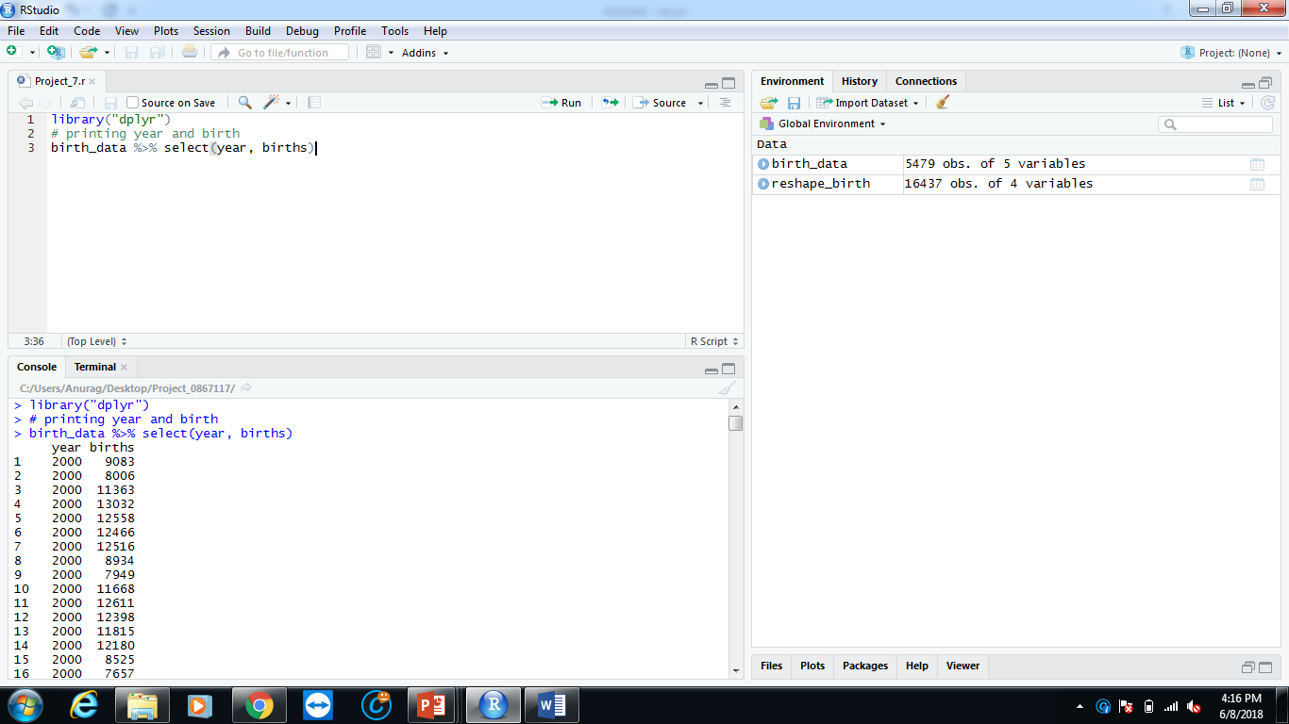Printing births and year from the dataset.

Project_8:

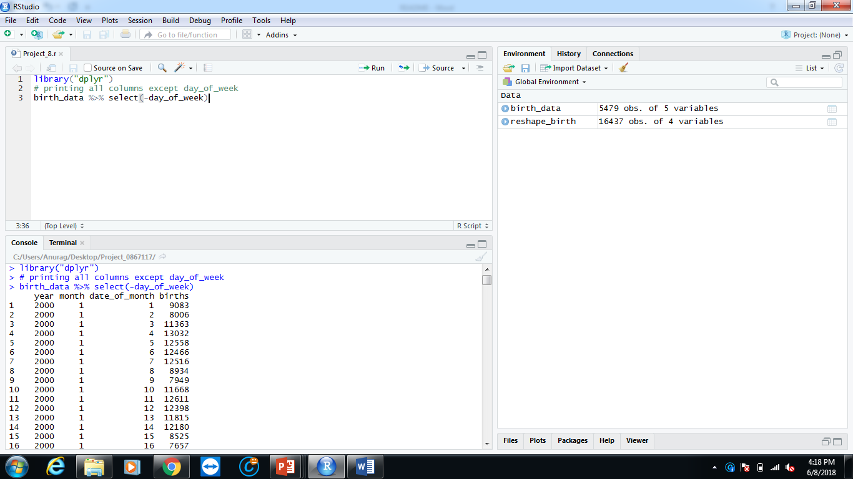Printing all columns except day_of_week from dataset.

Project_9:

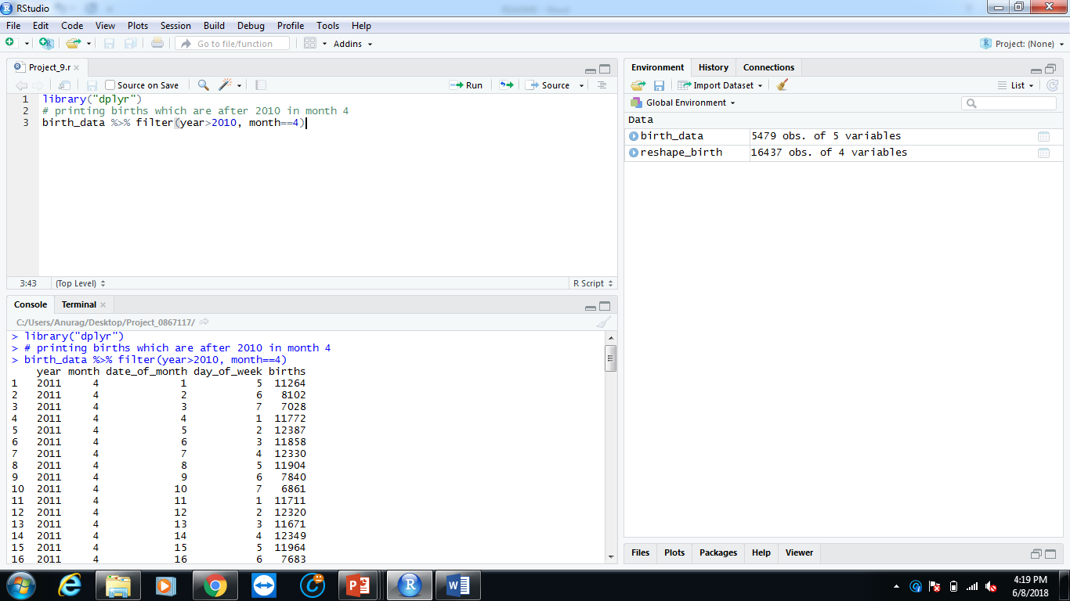Printing births after year 2010 and of a selected month 4.

Project_10:

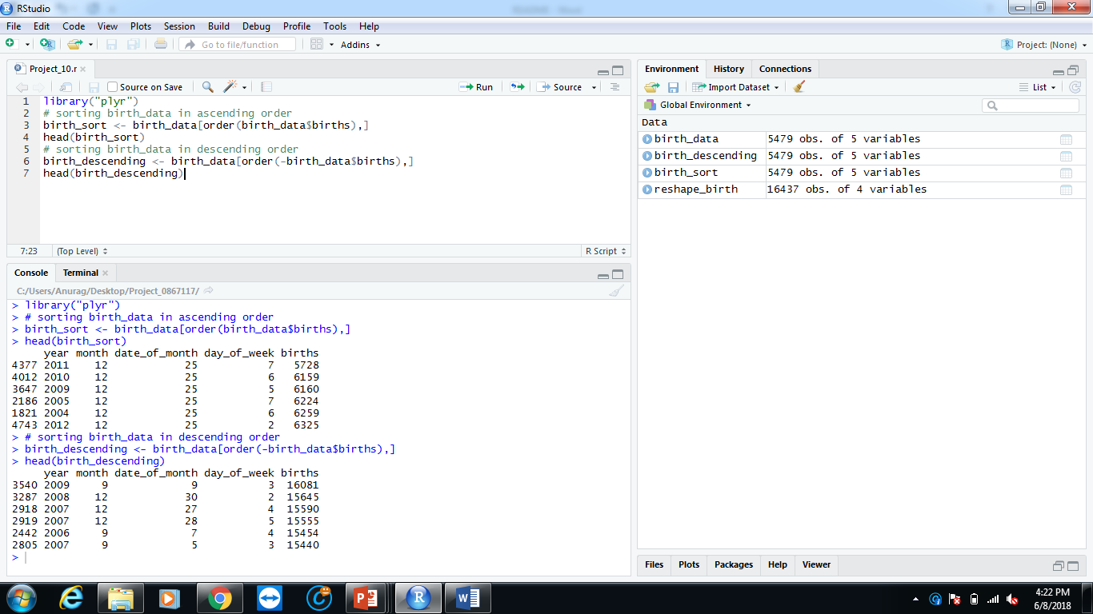Sorting birth_data into ascending and descending order according to births.

Project_11:

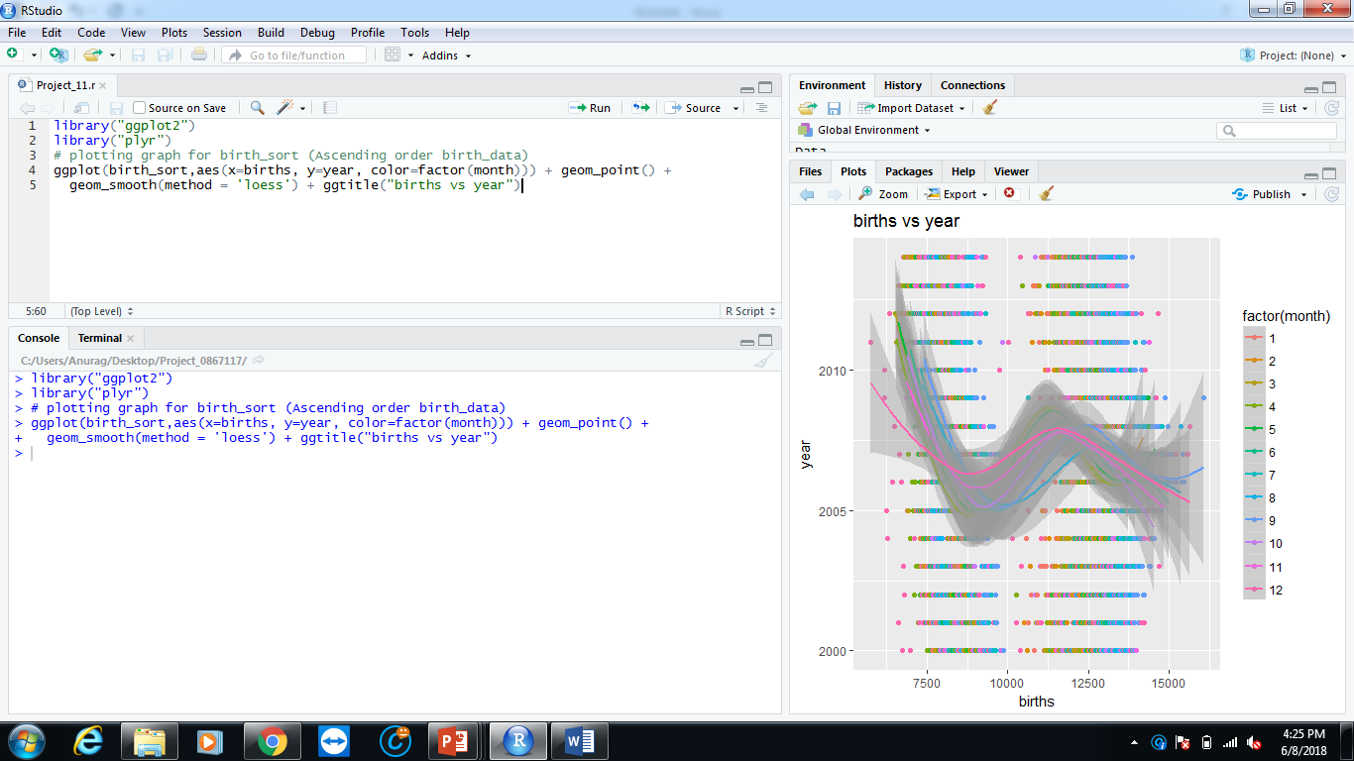Plotting graph for birth_sort (ascending order) and using factor = month and birth vs year.

Project_12:

Printing max number of births and then printing it with respect to month, year, day and day of week.

Project_13:

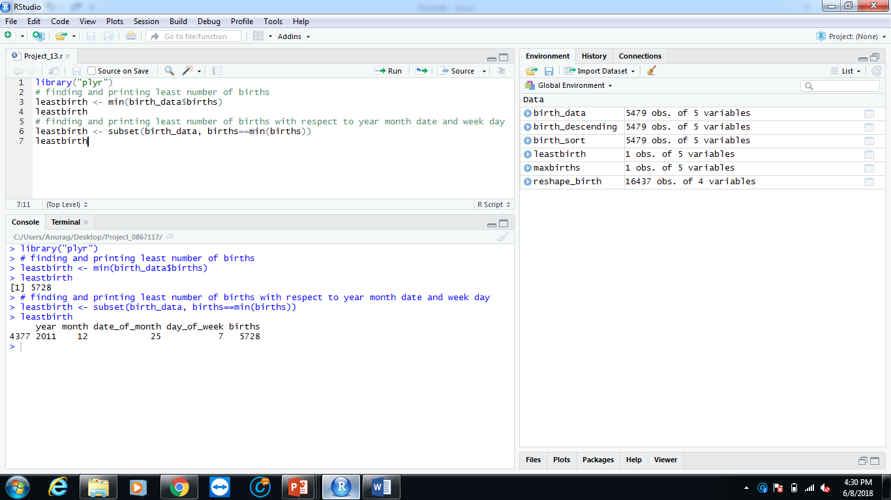Printing least number of births and then printing it with respect to month, year, day and day of week.

Project_14:

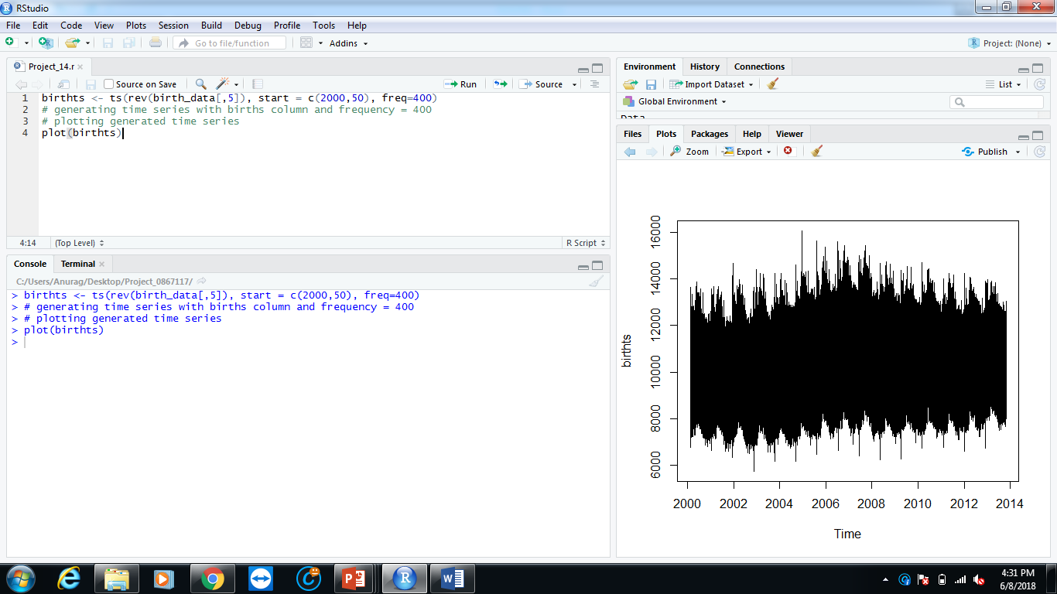Generating time series with births column and frequency = 400 and plotting the generated time series.

Project_15:

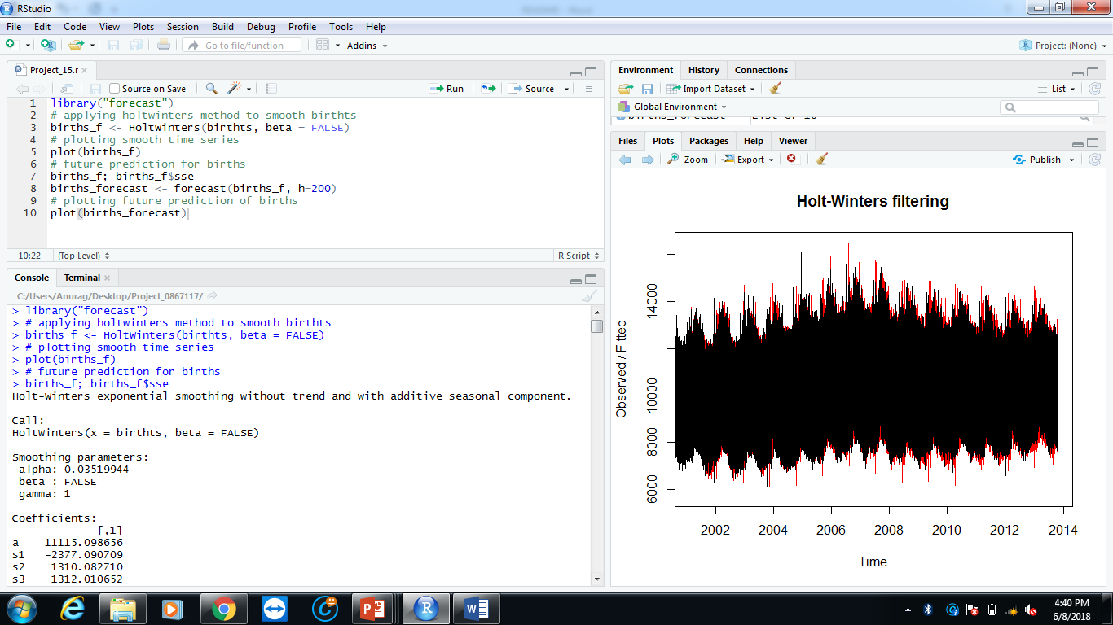Using HoltWinters filter make time series smooth and plotting the smooth time series. Future prediction for births and plotting the future predictions of births.

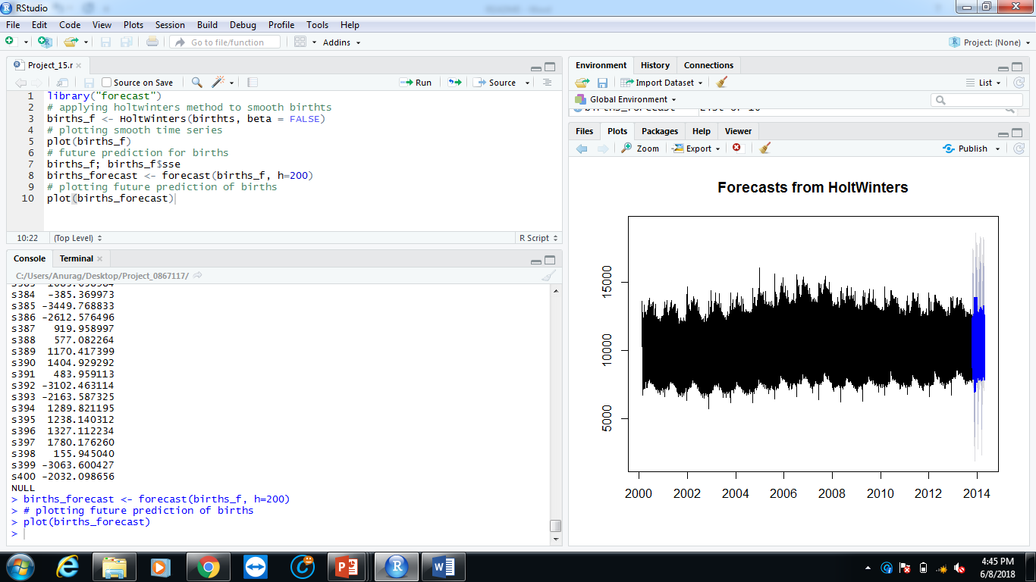Plot for future prediction of births.

Project_16:

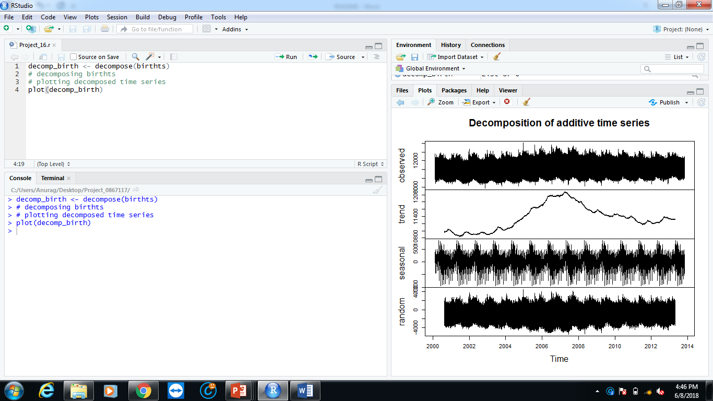Decomposing birthts time series and plotting the decomposed time series.

Project_17:

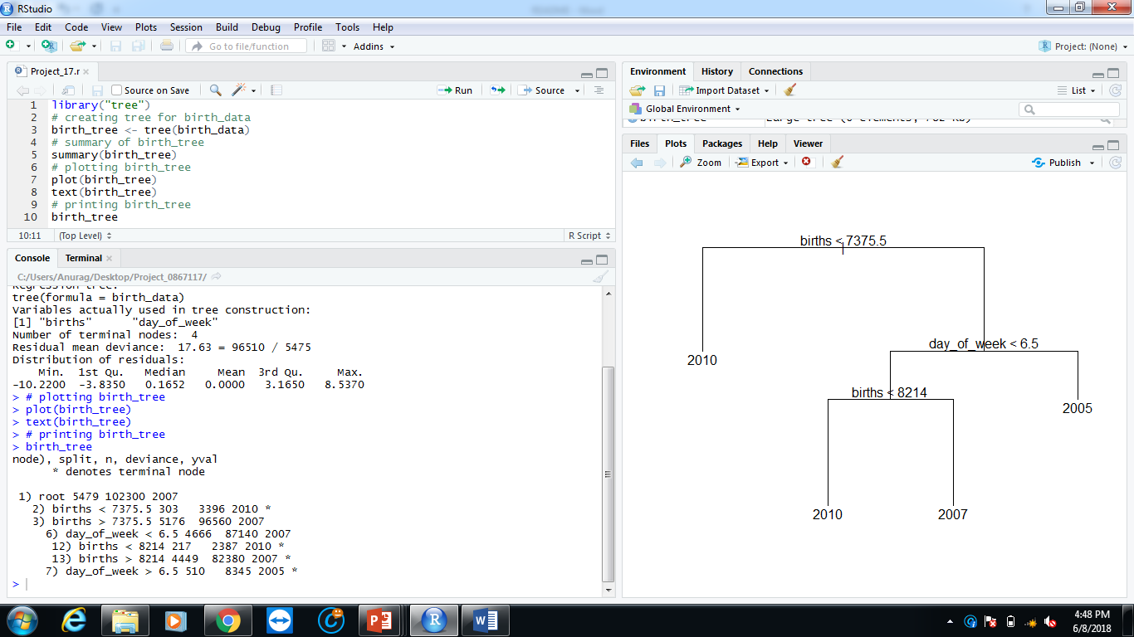Generating tree for birth_data and plotting the tree. Providing summary of the tree and printing the tree.