**Task-2**

**Exercise 1:**

Code:

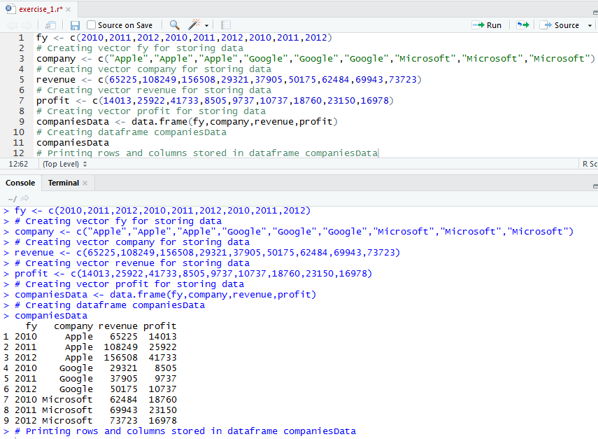Code for creating data frame for companiesData with given information of IT companies.

**Exercise 2:**

Code:

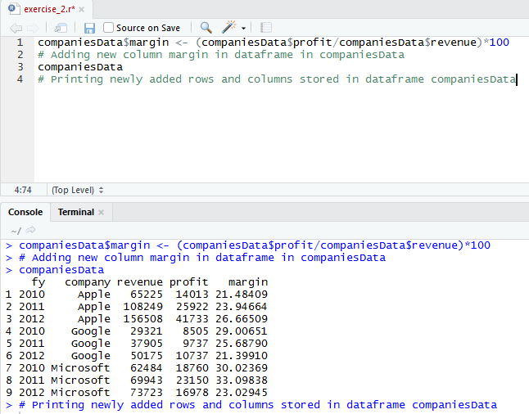Code for adding a new column margin whose values are obtained by dividing profit by revenue and then multiplying by 100.

**Exercise 3:**

Code:

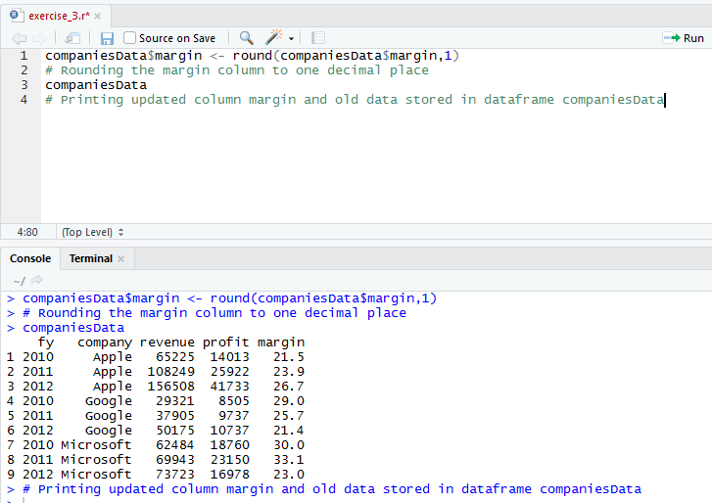Code for rounding of margin to one decimal place.

**Exercise 4:**

Code:

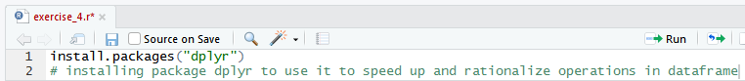Code for installing package dplyr (prerequisite package for data wrangling).

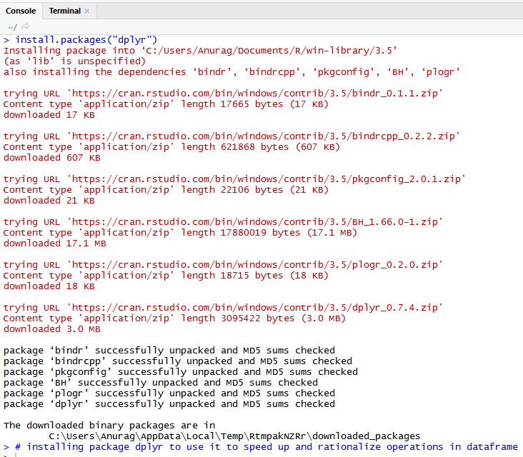

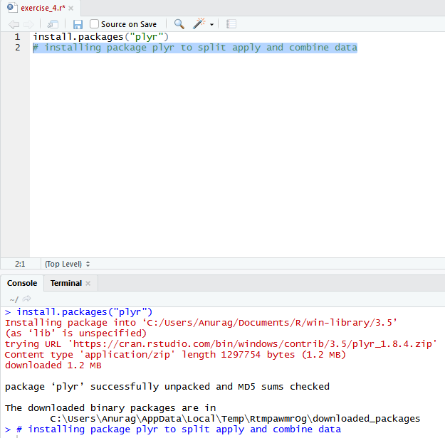Code for installing package plyr (prerequisite package for data wrangling).

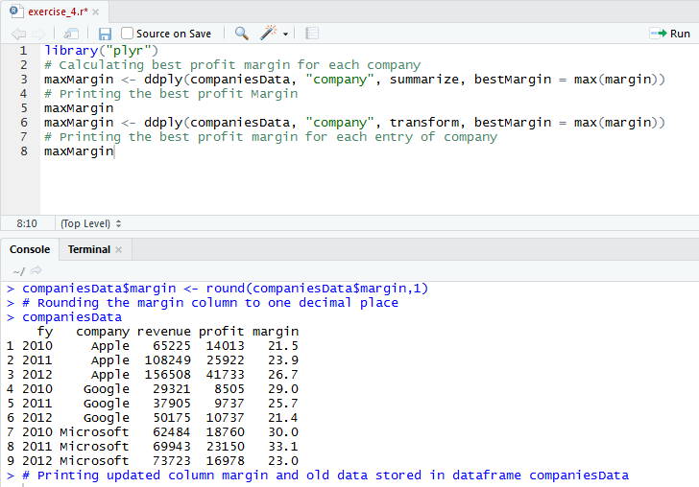Code for calculating best profit margin of each company.

**Exercise 5:**

Code:

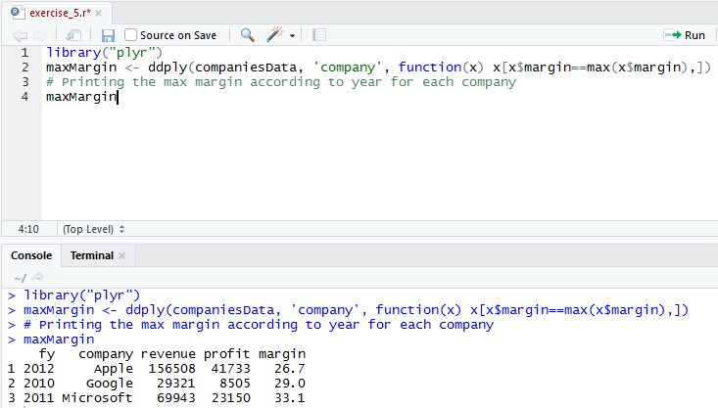Code for printing the year in which company has the maximum profit.

**Exercise 6:**

Code:

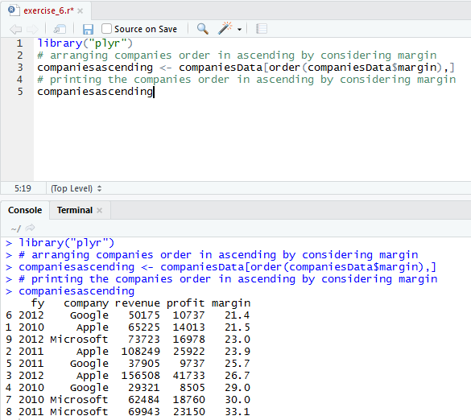Code for sorting companies according to their margin of profit in ascending order.

**Exercise 7:**

Code:

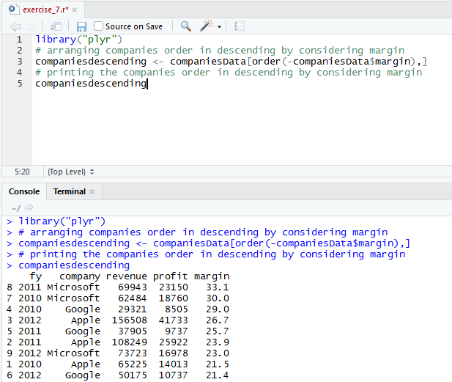Code for sorting companies according to their margin of profit in descending order.

**Exercise 8:**

Code:

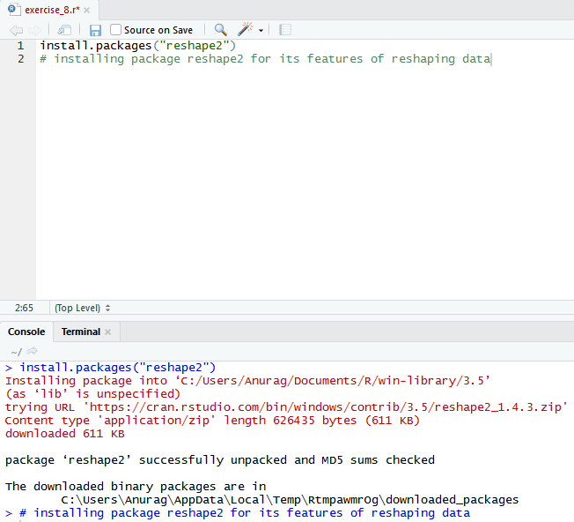Code for installing package reshape2 (prerequisite package for reshaping of data).

Code for reshaping data frame so that information appears as required.

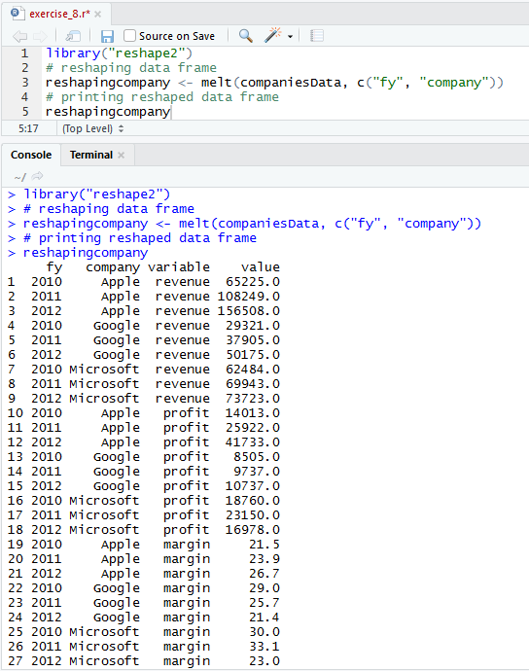

**Exercise 9:**

Code:

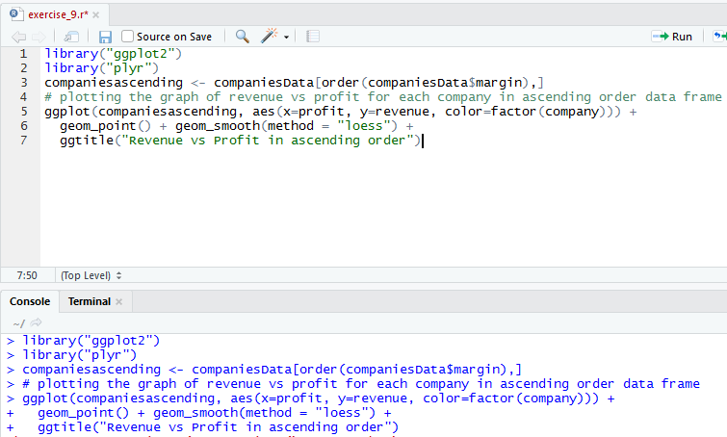Code for plotting graph revenue vs profit for each company in ascending order data frame using factor company.

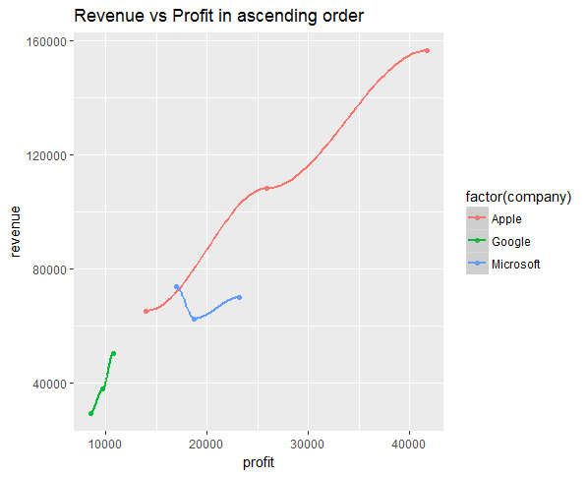Graph of revenue vs profit for each company in ascending order data frame using factor company.

**Exercise 10:**

Code:

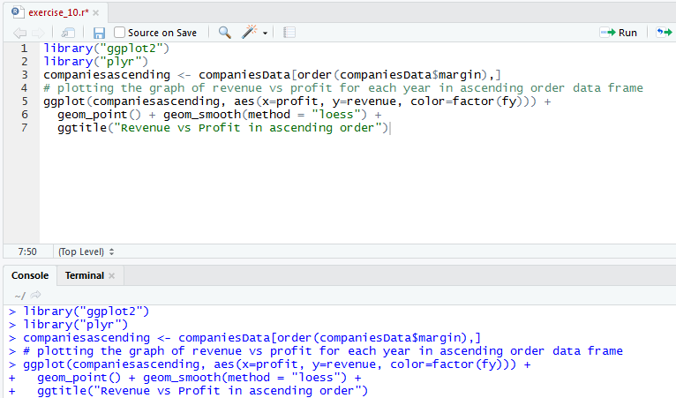Code for plotting graph revenue vs profit for each company in ascending order data frame using factor fy.

Graph of revenue vs profit for each company in ascending order data frame using factor company.

