**Task-3**

**Exercise 1:**

Code:

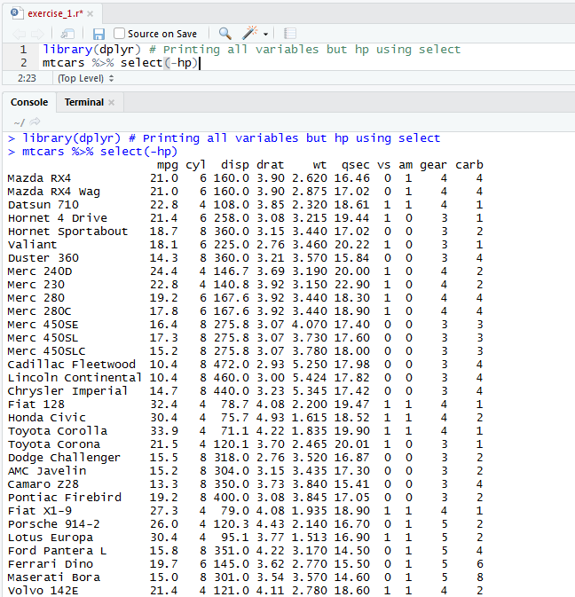Code for printing all variables but hp using select.

**Exercise 2:**

Code:

Code for printing mpg, hp, vs, am, gear.

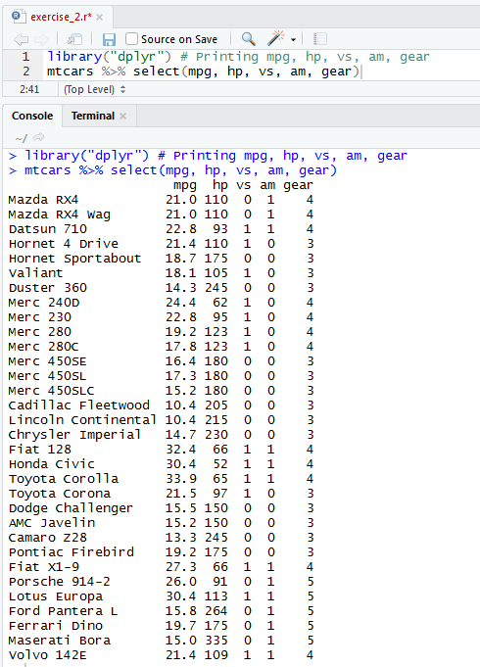

**Exercise 3:**

Code:

Code for creating object cars_m_h having mpg and hp from mtcars as miles_per_gallon and horse_power respectively and printing the object cars_m_h.

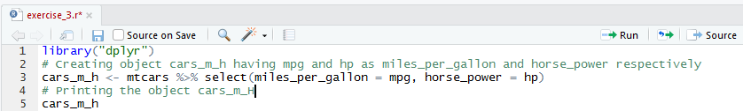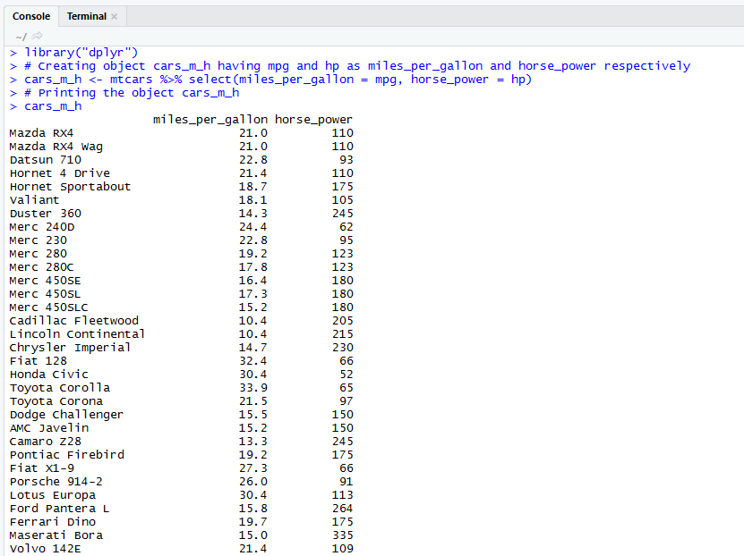

**Exercise 4:**

Code:

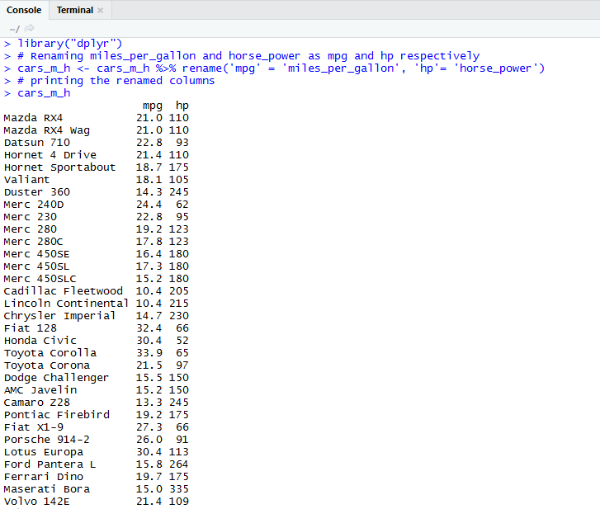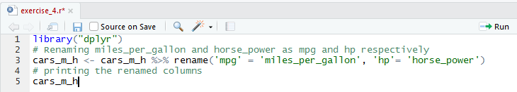Code for renaming miles_per_gallon and horse_power as mpg and hp respectively in cars_m_h object and printing the modified object.

**Exercise 5:**

Code:

Code for creating cars_m_h_s object having 10 to 35 rows of cars_m_h and printing cars_m_h_s object.

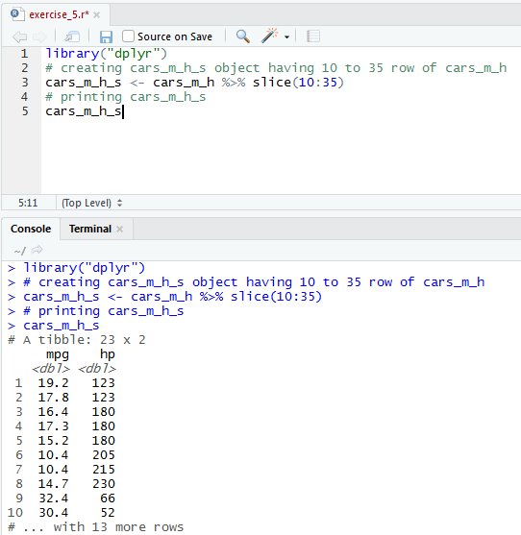

**Exercise 6:**

Code:

Code for printing cars_m_h_s object without any duplicates.

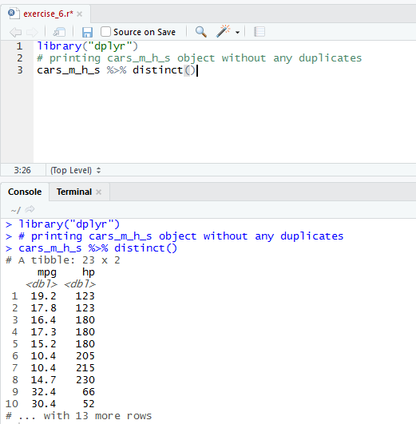

**Exercise 7:**

Code:

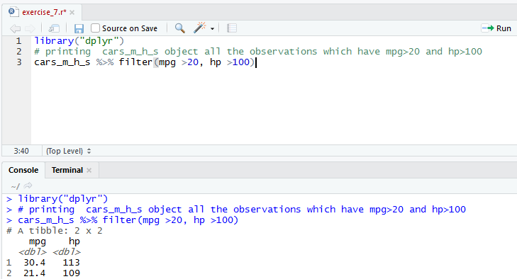Code for printing cars_m_h_s object all the observations which have mpg>20 and hp>100.

**Exercise 8:**

Code:

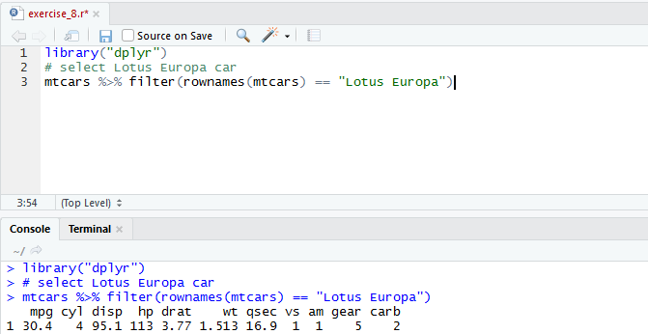Code for selecting and printing Lotus Europa car.

**Exercise 8:**

Code:

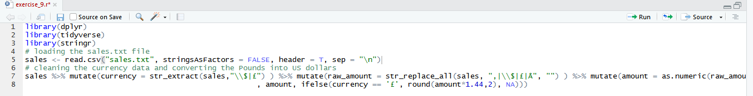Code for transforming currency data in a tidy way and converting Pounds into US dollars.

