**Task-4**

**Exercise 1:**

Code:

Code for storing AMZN.csv file in amazon and printing first 6 entries of the file.

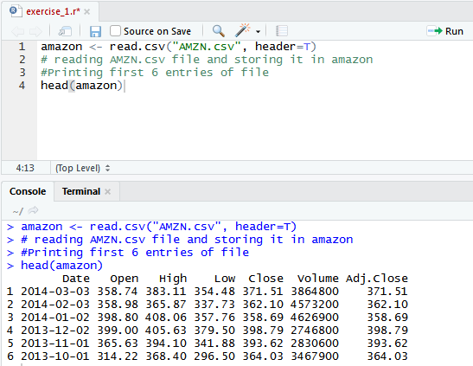

**Exercise 2:**

Code:

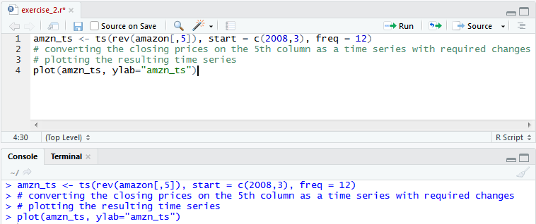Code for converting the closing prices at 5th column as a time series with required changes and plotting the resulted time series.

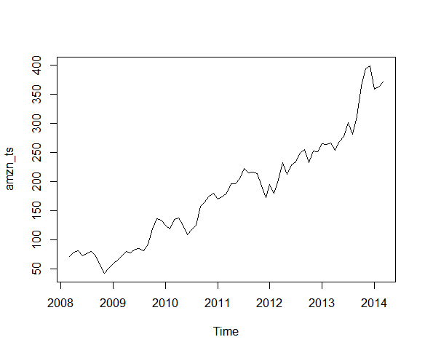Plot for resulting time series:

**Exercise 3:**

Code:

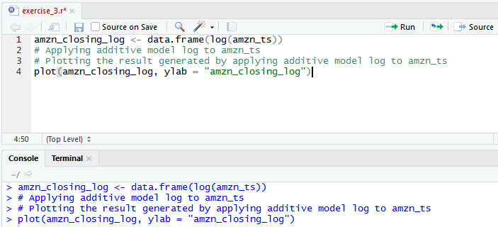Code for applying additive model log to amzn_ts and plotting the result.

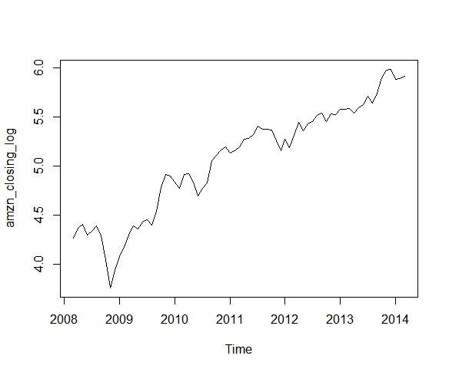Plot for result generated by applying additive model log on amzn_ts:

We observe that after applying log additive model the fluctuation at the lower values around 2009 shows greater effect as they are transformed to log.

**Exercise 4:**

Code:

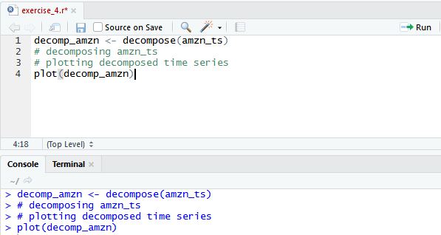Code for decomposing amzn_ts and plotting the time series.

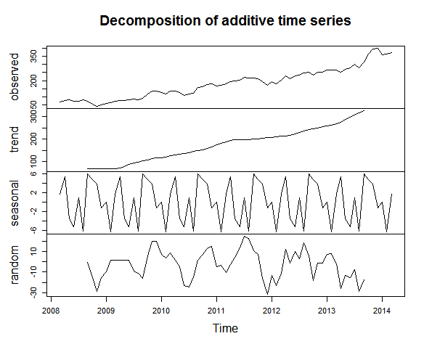Plot for the decomposed time series:

The trend shows expected rising trend in stock prices, except for the stock prices from 2008 to 2009 shows same financial growth.

**Exercise 5:**

Code:

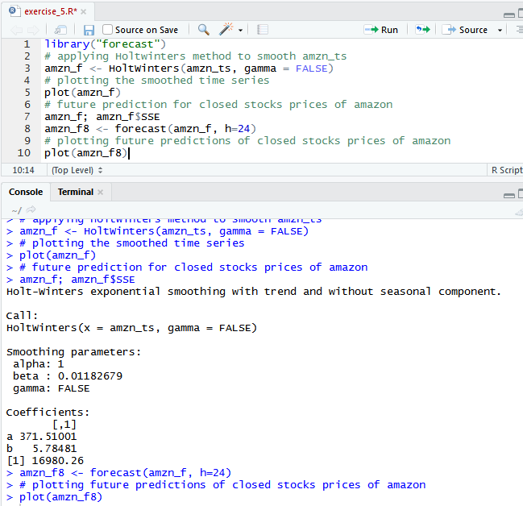Code to smooth amzn_ts using HoltWinters() method, plotting the smoothed time series, forecast future prediction of closed stock prices of amazon and plotting the future prediction.

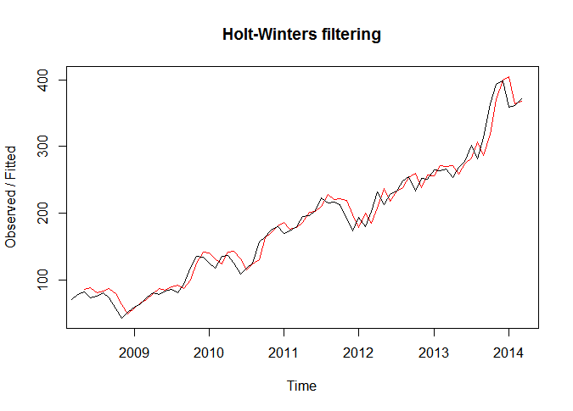Plot for the smoothed time series:

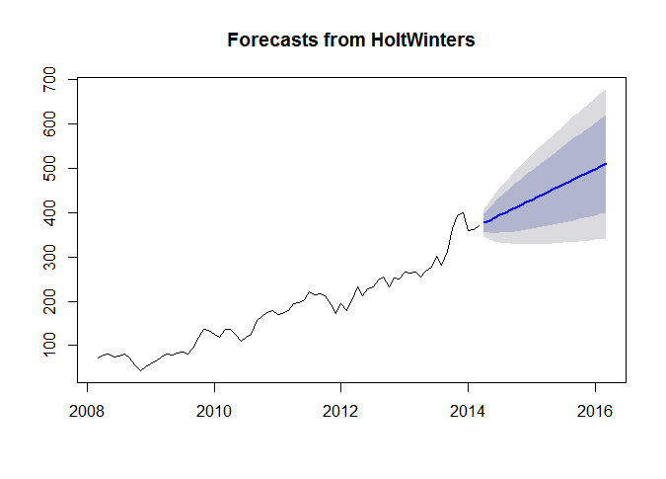Plot for future prediction: