**Task-5**

**Analytics5_1:**

Code:

Code for storing spam_ham.csv as email

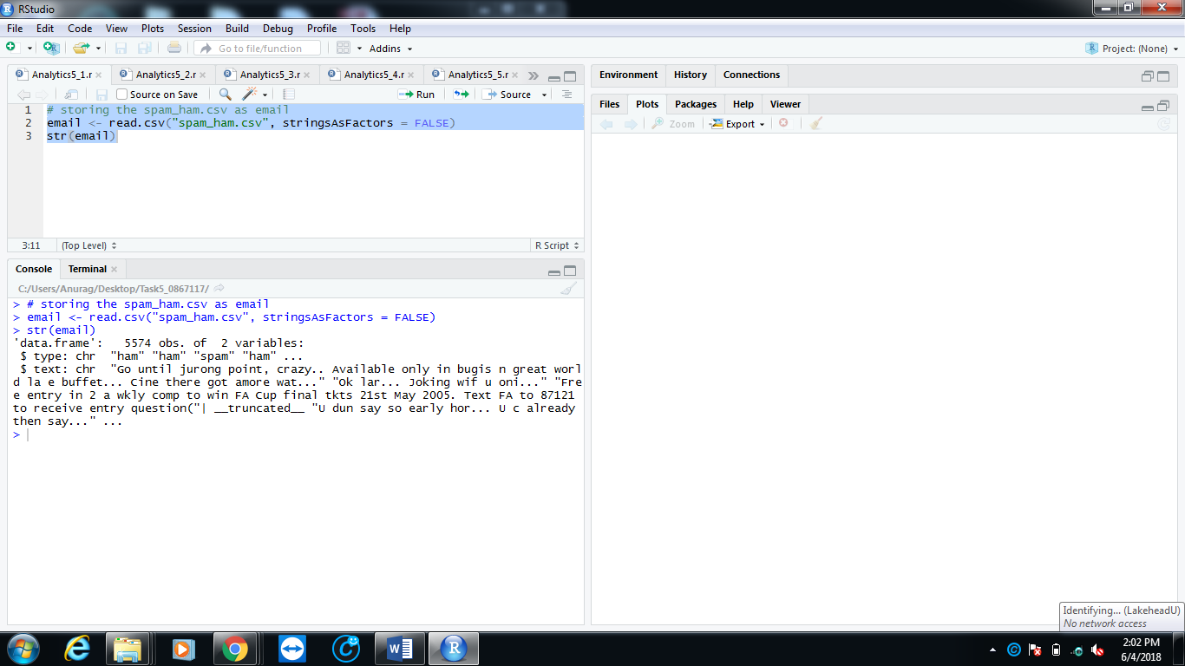

**Analytics5_2:**

Code:

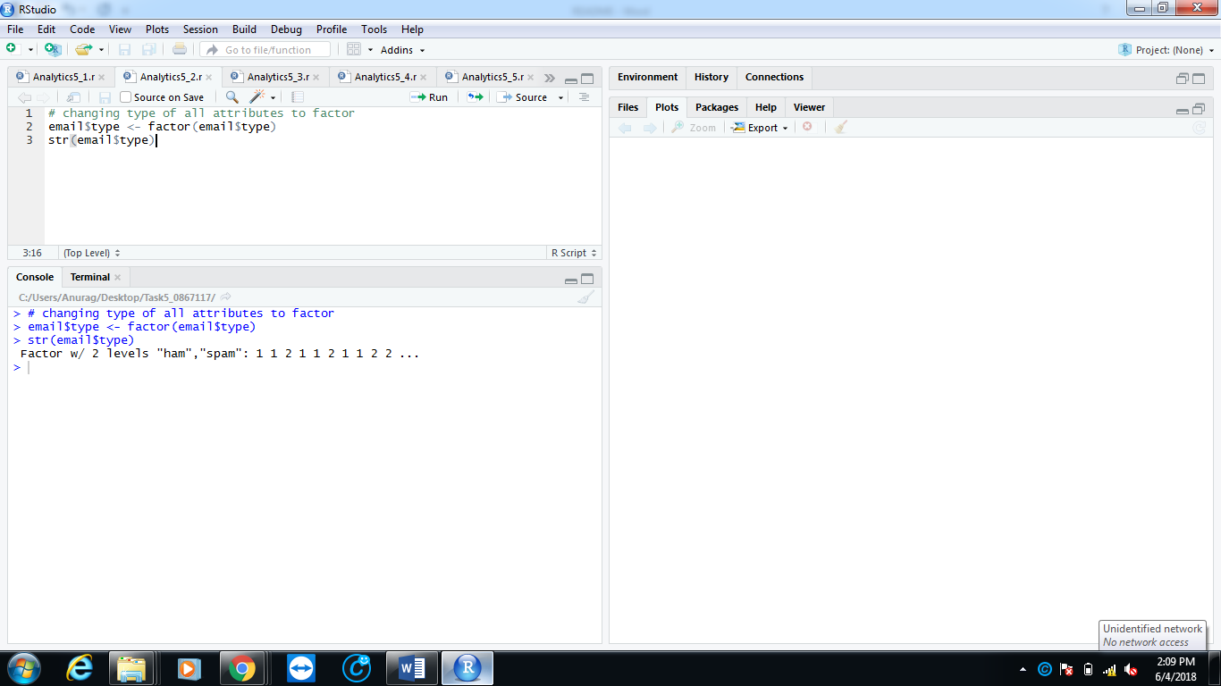Code for changing type of all attributes to factor.

**Analytics5_3:**

Code:

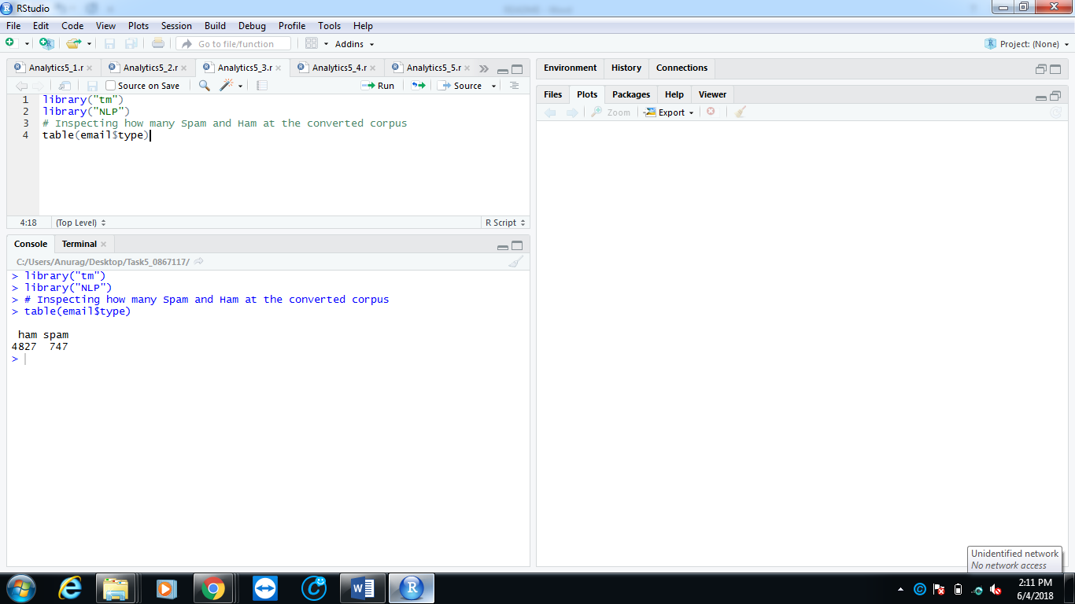Code for inspecting how many spam and ham.

**Analytics5_4:**

Code:

Code for building a email_corpus using method from tm library.

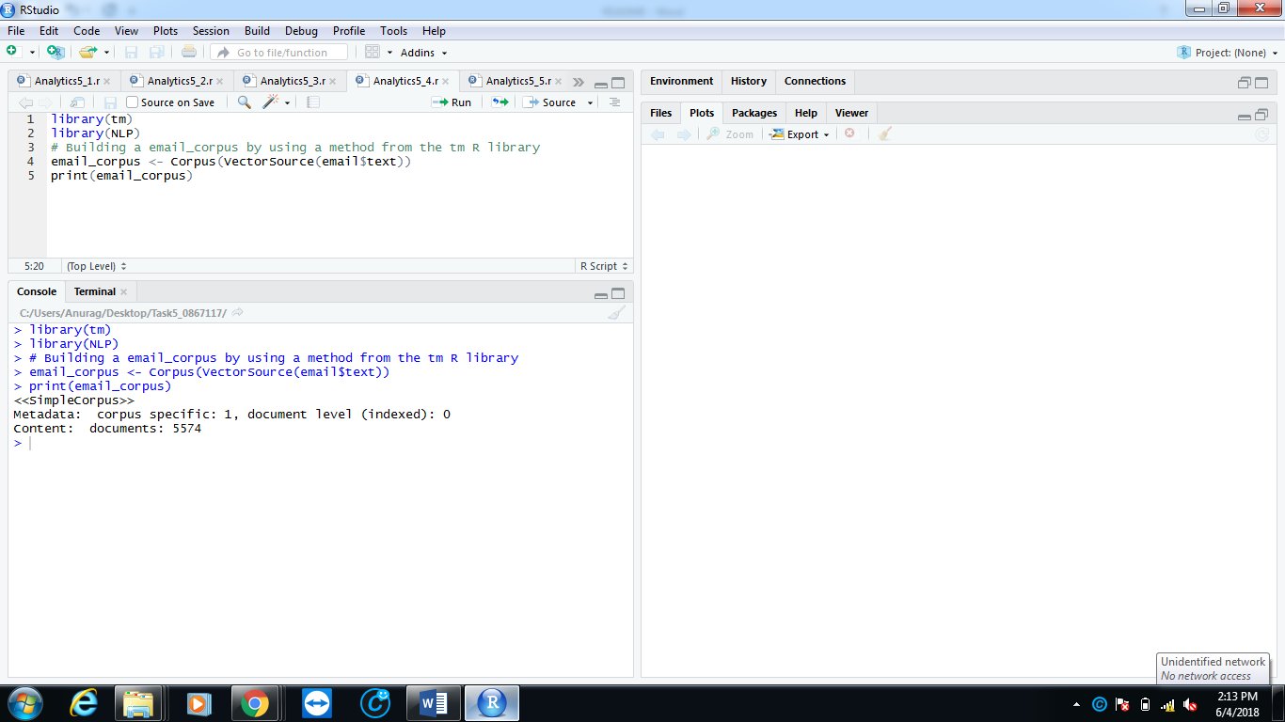

**Analytics5_5:**

Code:

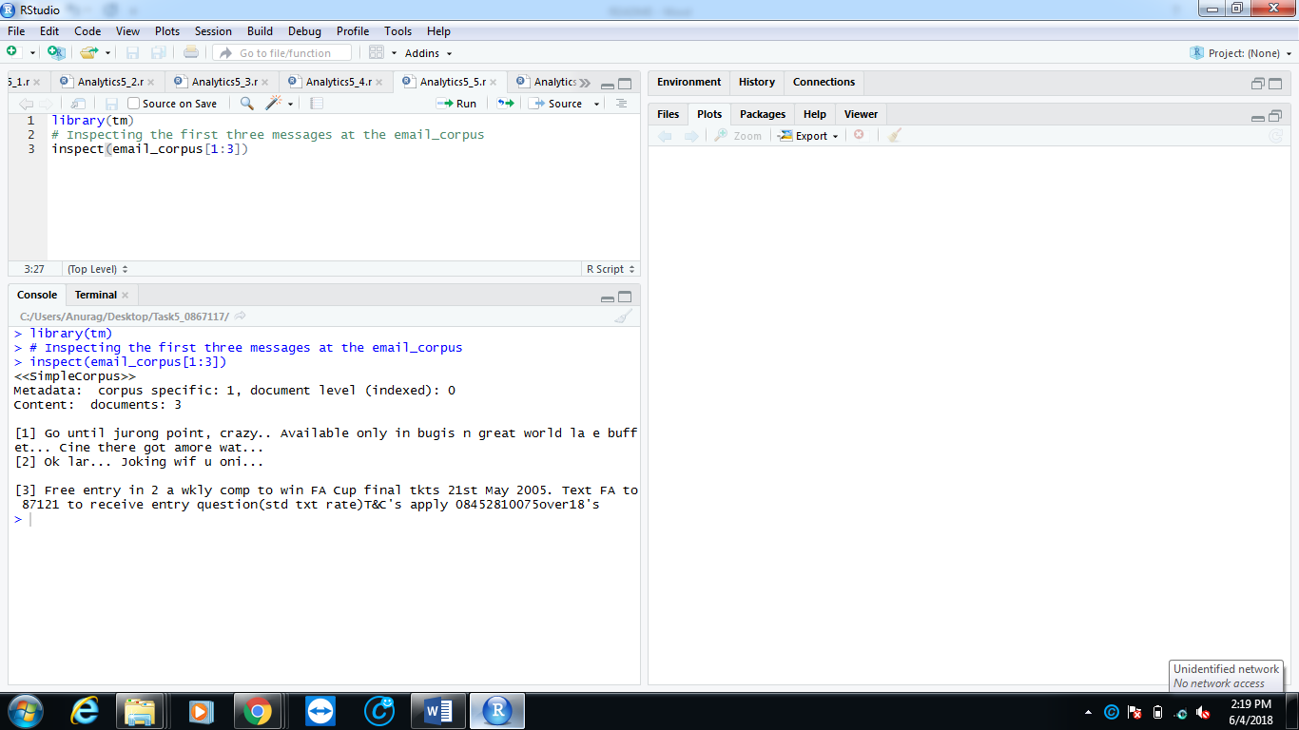Code for inspecting first three messages at the email_corpus.

**Analytics5_6:**

Code:

Code for cleaning corpus by changing alphabets to lower case, remove numbers, punctuations and strip whitespaces.

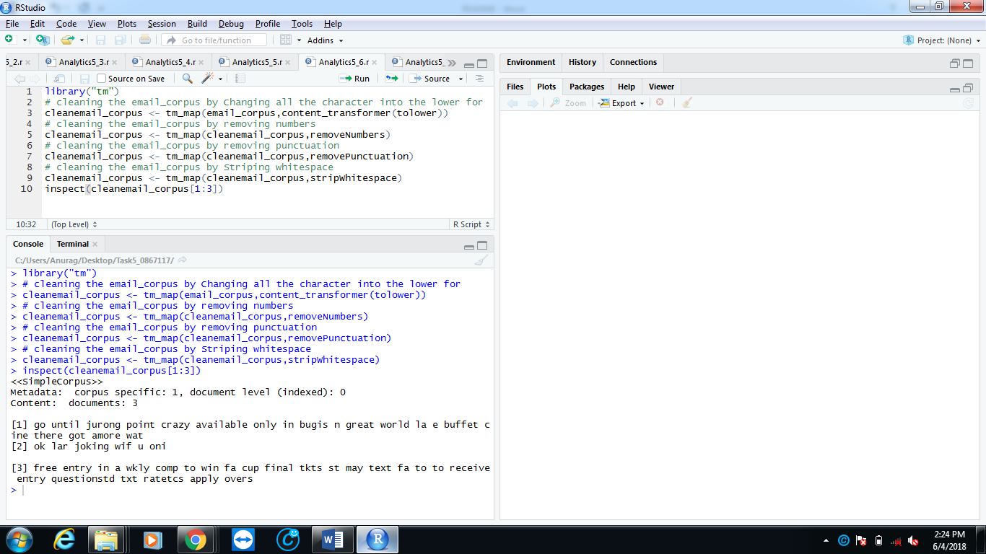

**Analytics5_7:**

Code:

Code for creating email_dtm for cleanemail_corpus.

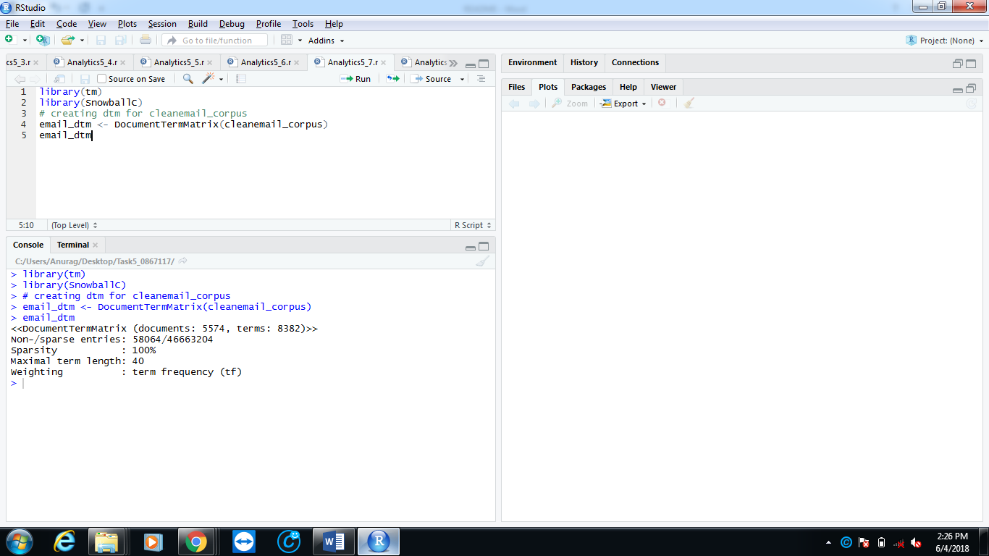

**Analytics5_8:**

Code:

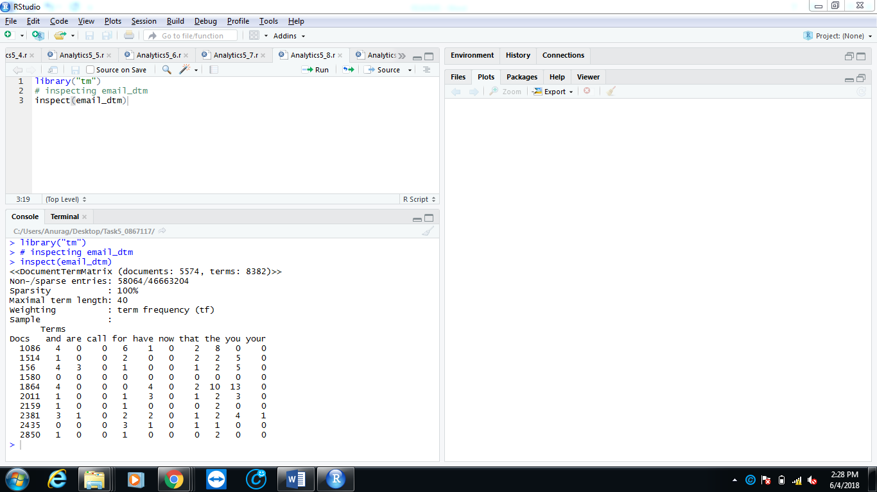Code for inspecting email_dtm.

**Analytics5_9:**

Code:

Code for splitting email_dtm into trainemail_dtm and testemail_dtm (80% training and 20% testing).

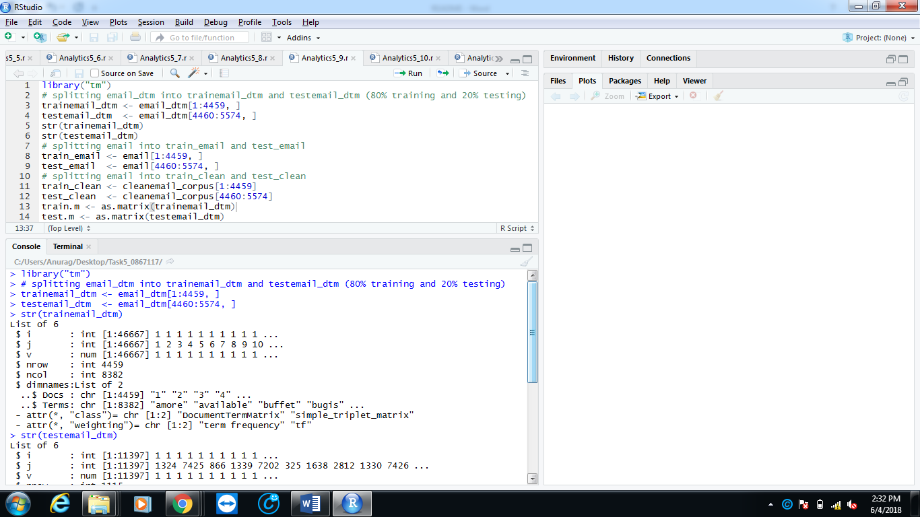

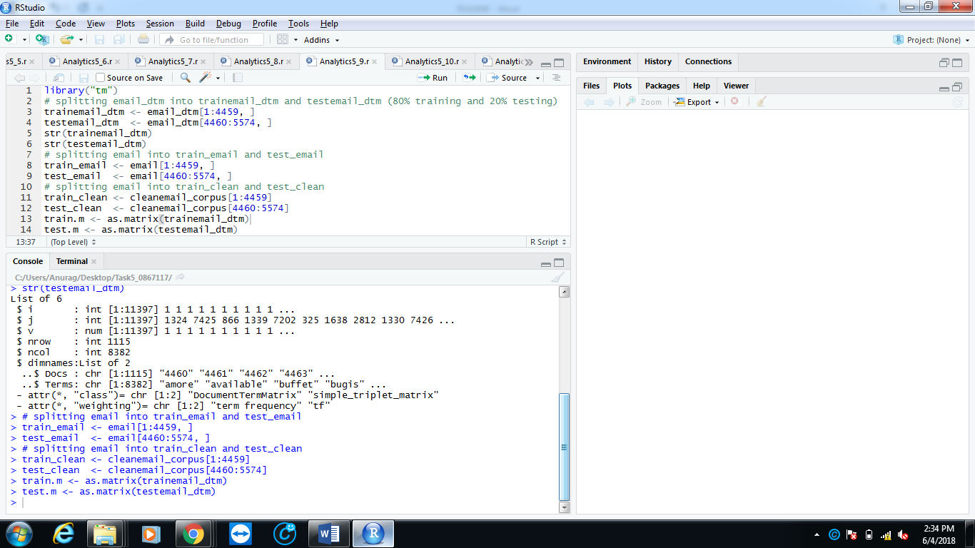

**Analytics5_10:**

Code:

Code for visualizing traindtm and testdtm using library wordcloud.

For testdtm wordcloud:

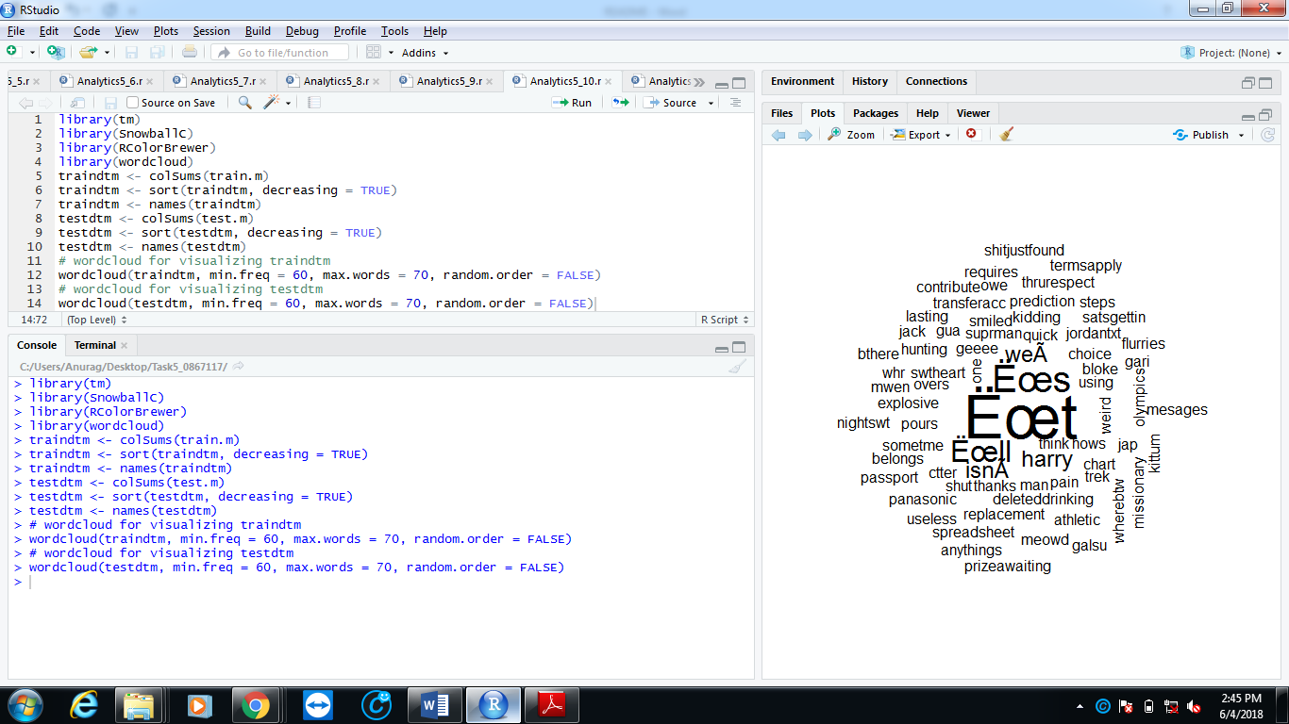

For testdtm wordcloud:-

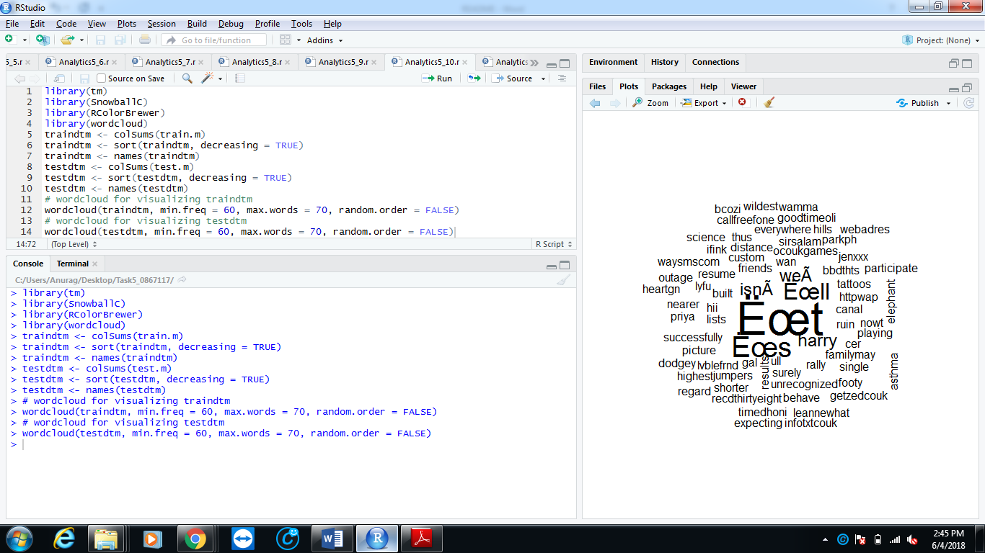

**Analytics5_11:**

Code:

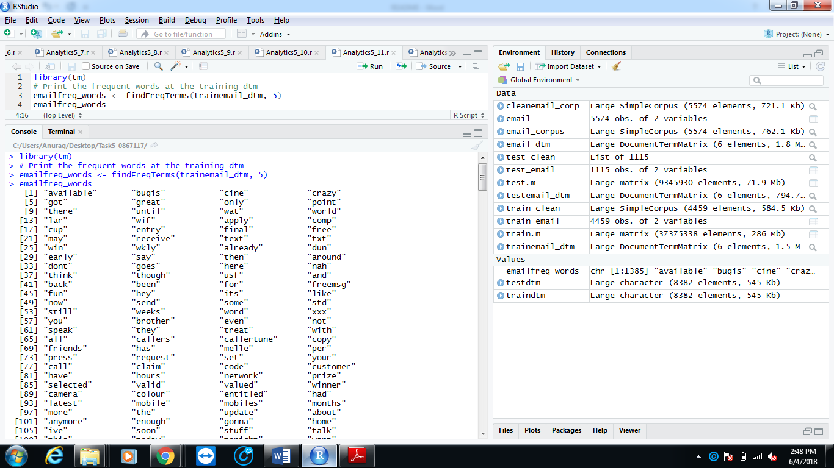Code for printing frequent words at training dtm.

**Analytics5_12:**

Code:

Code for training a naive bayes classifier and predict its outcome by testedtm.

