**Task-6**

**Exercise 1:**

Code:

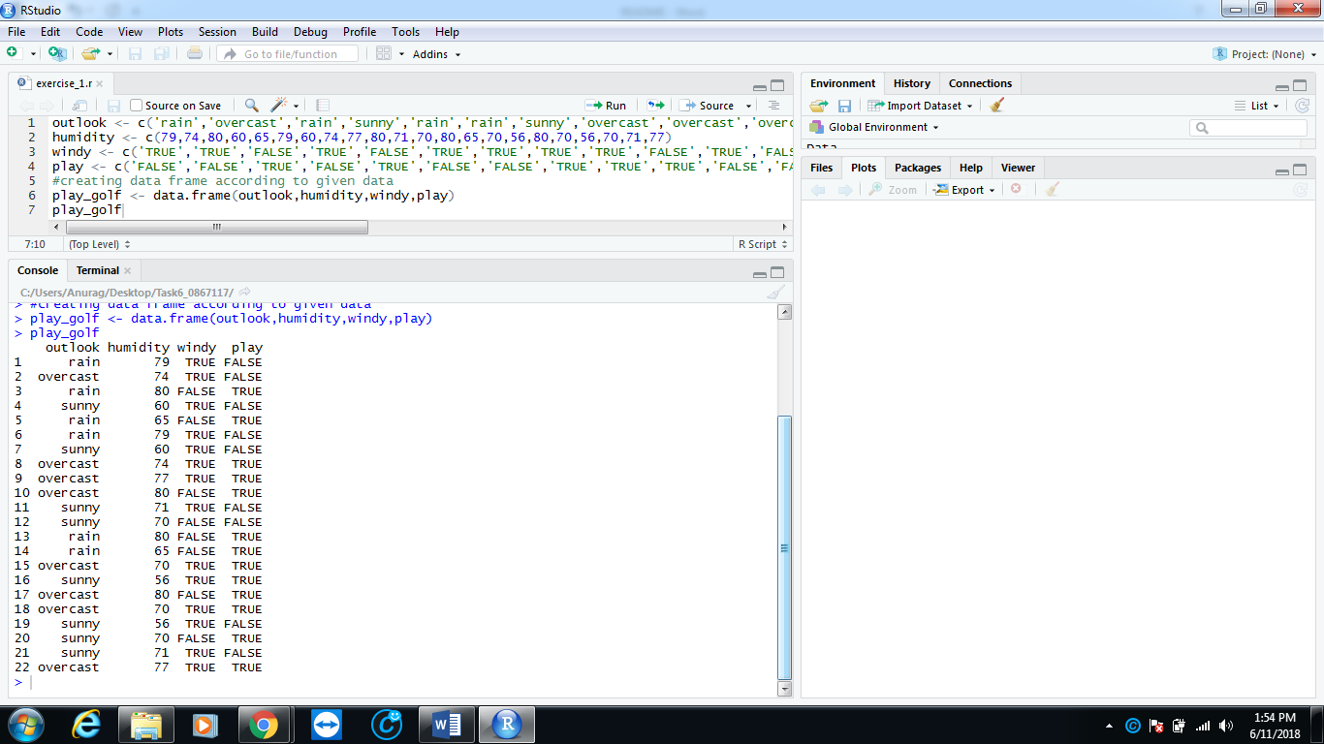Code for creating data frame according to given data.

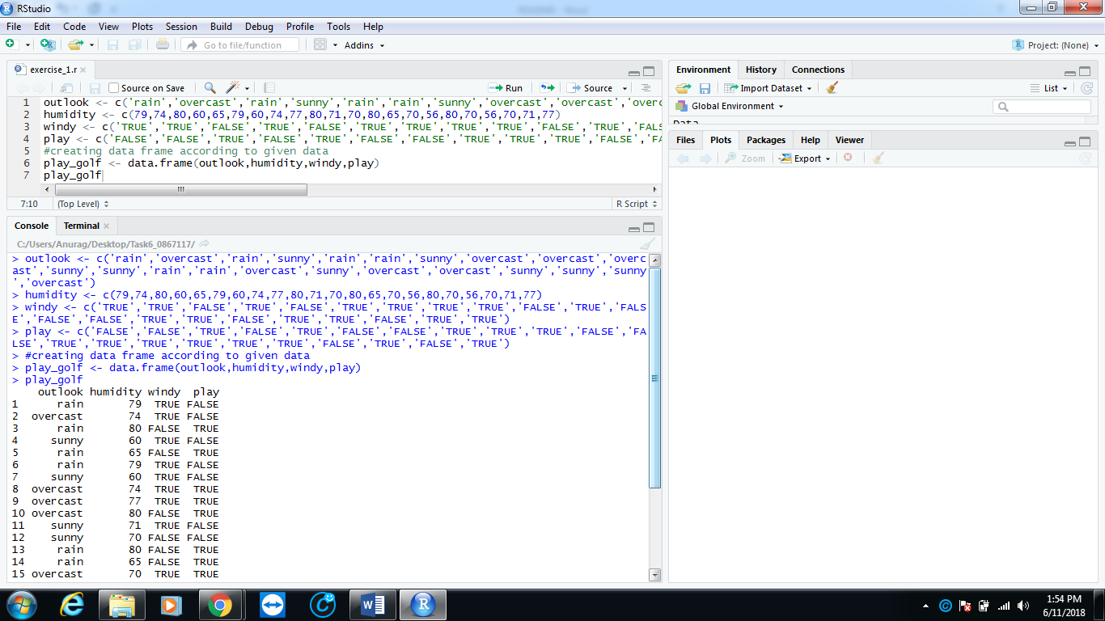

**Exercise 2:**

Code:

Code for generating tree.

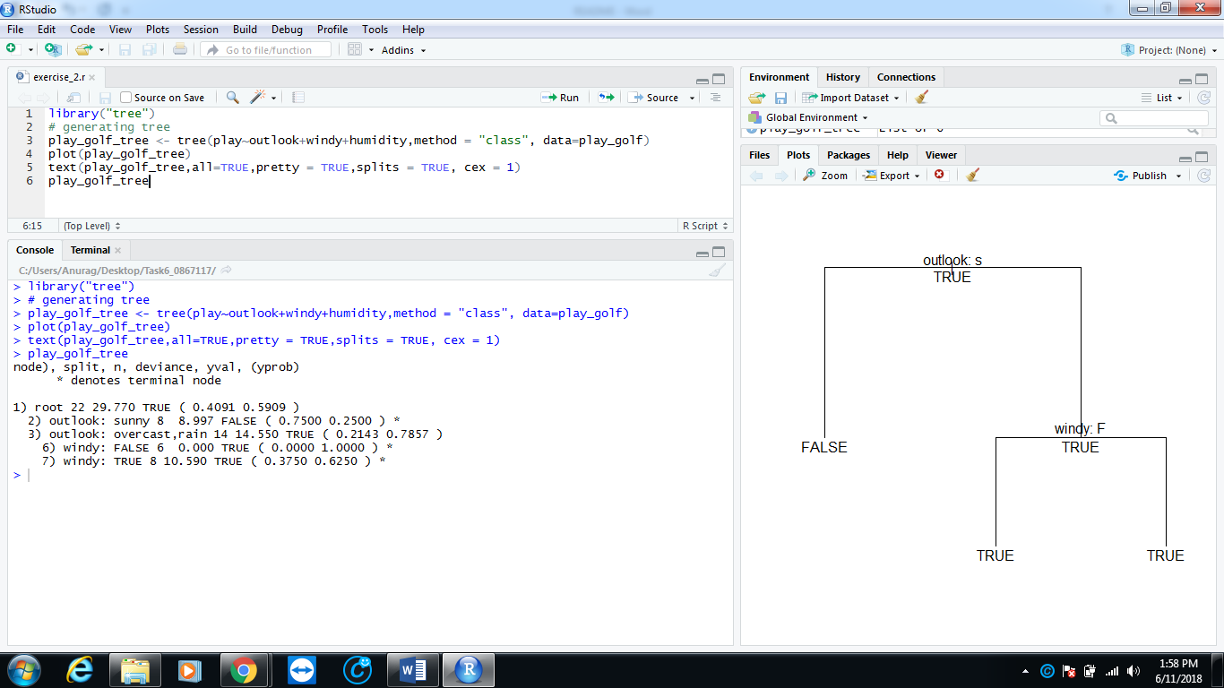

**Exercise 3:**

Code:

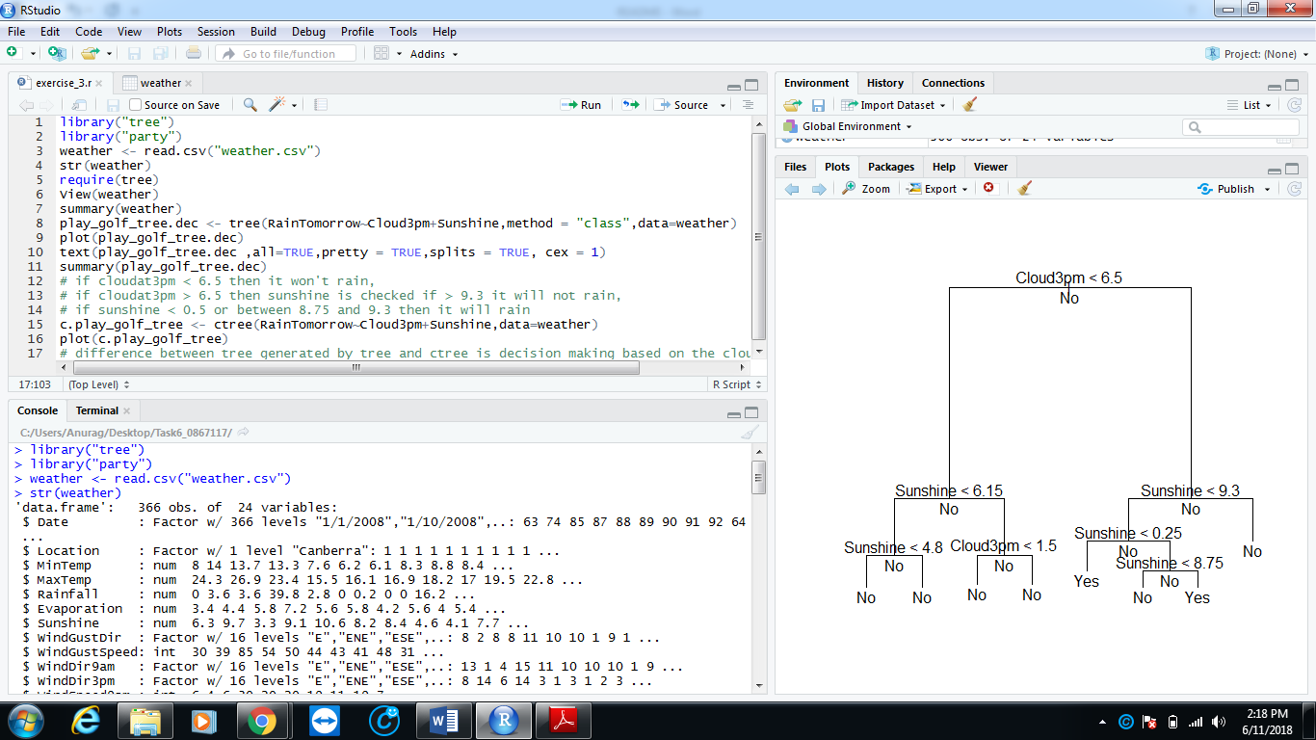Code for generating decision tree using weather data and generating another decision tree using ctree of package party for predicting rain tomorrow based on the today’s degree of sunshine and the degree of the cloud availability at 3pm. Explanation is given in comments with the main difference between decision tree generated by tree and ctree.

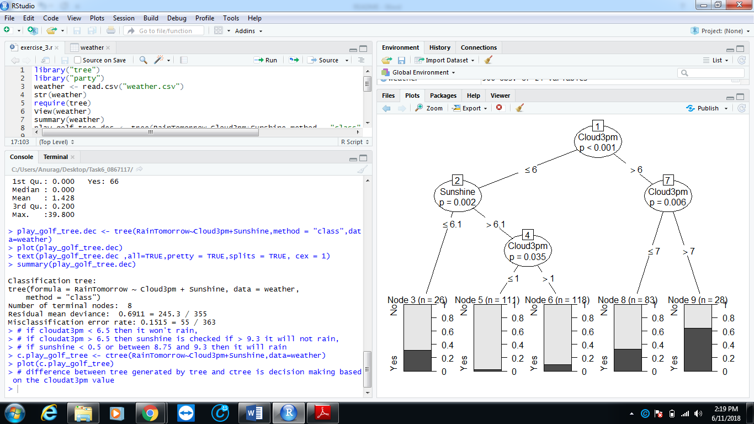

**Exercise 4:**

Code:

Code for building a decision tree using weather data for predicting if it will rain tomorrow (or not) based on the following attributes:

• Sunshine

• Pressure9am

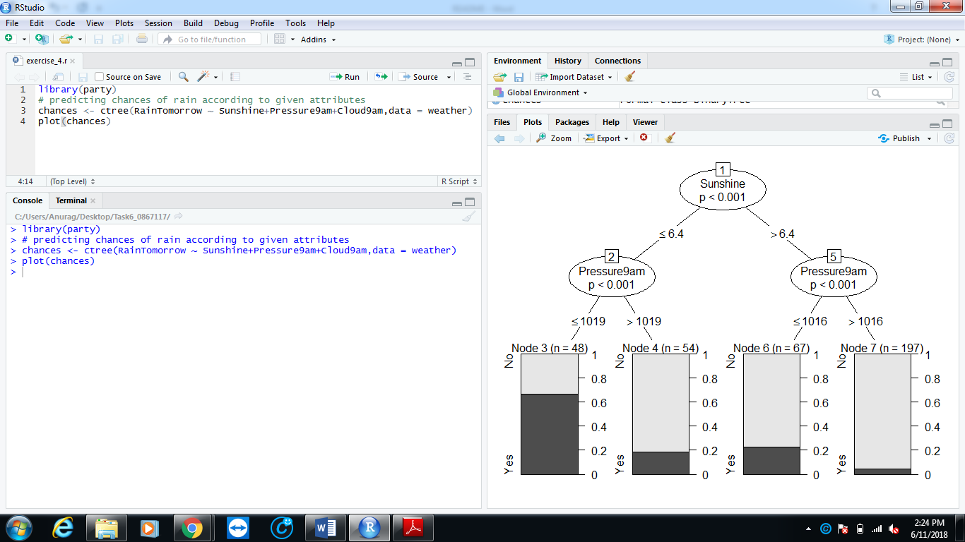• Cloud9am

**Exercise 5:**

Code:

Code for predicting whether it will rain tomorrow or not, using predict function on the tree generated in exercise 4 and plot the outcome of predict method.

