WHAT IS CONVULATION IN IMAGE PROCESSING?

It is a mathematical filter..
In image processing, convolution is the process of transforming an image by applying a kernel over each pixel and its local neighbors across the entire image. The kernel is a matrix of values whose size and values determine the transformation effect of the convolution process.

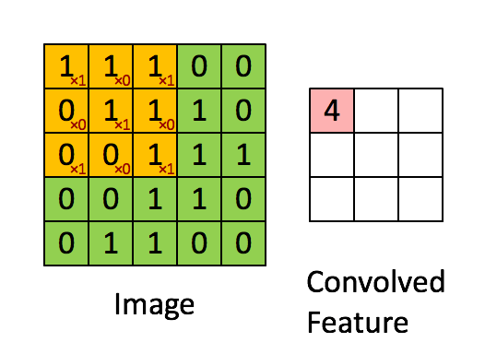
Convolution is just used to reduce the size of the signal/image and just extract out the best information possible in the least amount of space.
Convulation is used in image blurring,image sharpening and edge detection etc.

STRIDES
The window size that moves on the input image matrix is same as the kernel size.
The number of pixel by which the box is moved is called stride.In above picture the stride is 1 pixel,it can be any number of pixel depending upon the situation.
In the above convulation if the stride is 2 then we will get a 1*2 matrix.

The formula for doing convulation

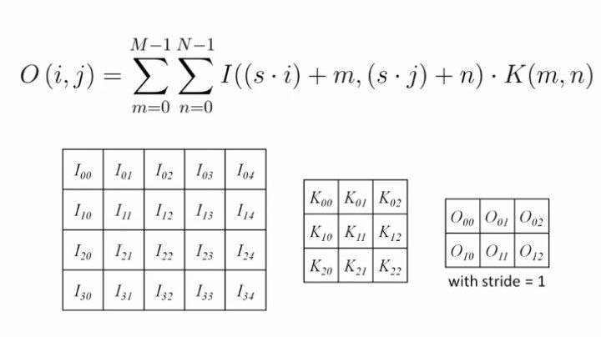
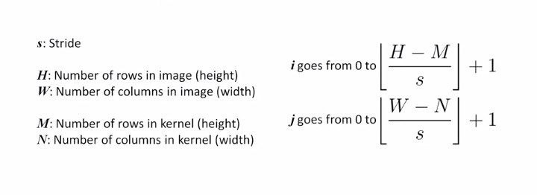
Clamping-

Sometimes the kernel is such that we get values in the resultant matrix that are greater than 255 or less than 0, in such cases we make the values as 255 or 0 if it is greater than 255 or less than 0 i.e negative.
In machine learning we have to deal with floating point values in such cases the value in the final matrix must be between 0 and 1. If not make it 0 or 1.
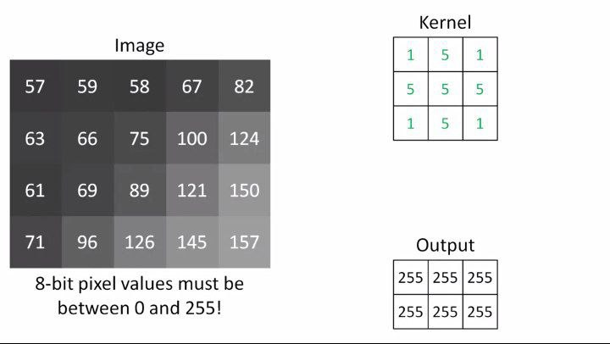
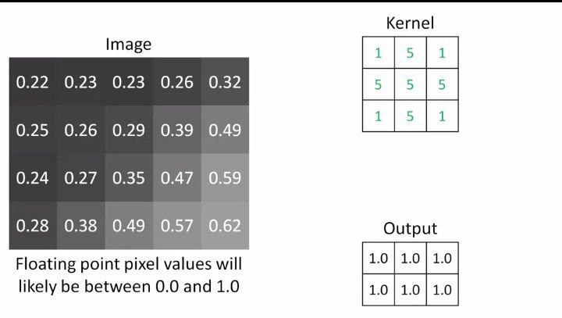

Image padding
when we want the input image to be of same dimension as the input image we can use padding as above we have seen that due to convulation the output image dimension reduces.
We can use padding there,so that we dont loose information. This is called same padding.
Some libraries dont add all the necessary padding to achieve the same dimension as the input image
but in keras it do so.
Then what is valid padding-
valid padding means no padding at all,the word valid means that we are taking the actual pixel values and not the false one that we add in the same padding approach.
All the above examples are done by valid padding.

Same padding-
Here the input image is 4*5 matrix and the output is 2*3 matrix , here we want the output to be 4*5 matrix so we will use same padding.
The formula is Padding=((S-1)*W-S+F)/2
WHERE S=stride
W=rows in original input image
F=rows in filter/kernel
In the above example if you calculate the padding turns out to be one, it means you have to add two column at the left and right and two rows at the top and bottom.
You have to alsso put value to those empty pixels
you can give all zeroes or give them the value of the nearest neighbour.
THUS THE PADDING IS DONE HERE.
WHEN FILTERING IT WILL GIVE A (4*5) OUTPUT IMAGE SAME AS THE ORIGINAL.
The padding visualization-
All zeroes approach
0 | 0 | 0 | 0 | 0 | 0 | 0
0 | 57 | 59 | 58 | 67 | 82 | 0
0 | 63 | 66 | 75 | 100 | 124 | 0
0 | 61 | 69 | 89 | 121 | 150 | 0
0 | 71 | 96 | 126 | 145 | 157 | 0
0 | 0 | 0 | 0 | 0 | 0 | 0

closest neighbour approach
57 | 57 | 59 | 58 | 67 | 82 | 82
57 | 57 | 59 | 58 | 67 | 82 | 82
63 | 63 | 66 | 75 | 100 | 124 | 124
61 | 61 | 69 | 89 | 121 | 150 | 150
71 | 71 | 96 | 126 | 145 | 157 | 157
71 | 71 | 96 | 126 | 145 | 157 | 157

IN some application we dont want to maintain the information in the border area, in that case we use valid padding or no padding,infact it is more computationally efficient to work without padding,it daves convulation steps,it also gives a smaller output matrix.
But sometimes we need border pixels as we want to keep the original size and dont want to loose the information at the border region for example in image blurring.

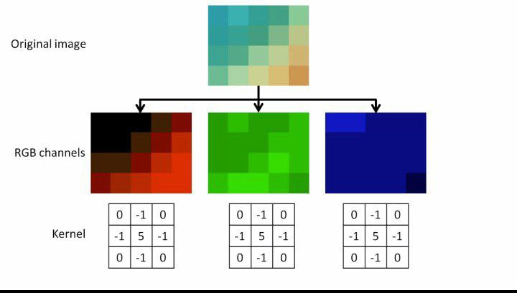
Most of the times we use colour images and every colour image is a combination of red,blue and green.In this case we first break the image in separate red,green and blue channels and apply separate kernels to each of them,the three kernels can be same or different,we can obtain very interesting results on varying the three kernels with respect to each other.

The three kwrnels are run on each of the RGB channels and we get resultant three outputs,the three outputs are then merged to get a single RGB final output image.
Edge detection is extremely useful in case of computer vision as it helps to differentiate between the boundaries of the image we want to detect and the background.

In edge detection we use padding as we dont want to loose the border information.

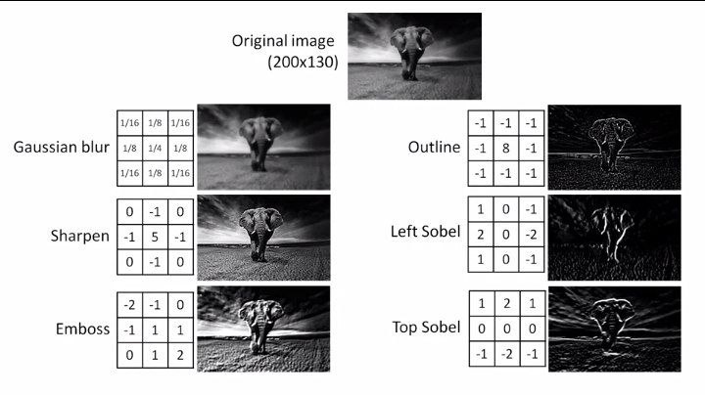

WHAT IS POOLING?

Pooling is a method of downsizing the output of the convulation layers as we want the dominant features.
A pooling layer is added after the convulational layers.
It not only downsizes but also helps in making a uniform feature map .

Average pooling-

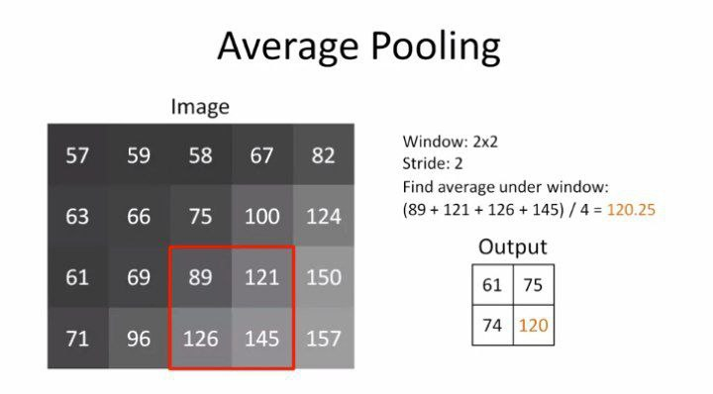
here also if you dont want to loose information do padding also the value in the final must be between 0 and 255 as you are representing an image.

Max pooling-

It is useful when we want the strongest features from the image.

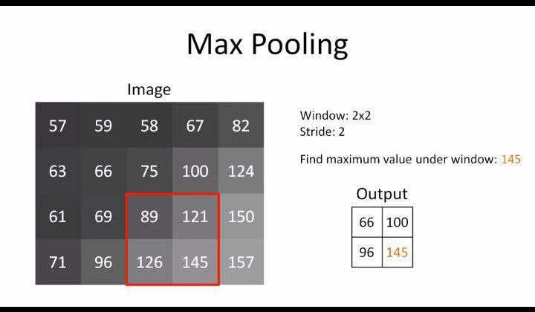
Min pooling-
Do the same thing as max pooling but choose the minimum.

Global pooling-

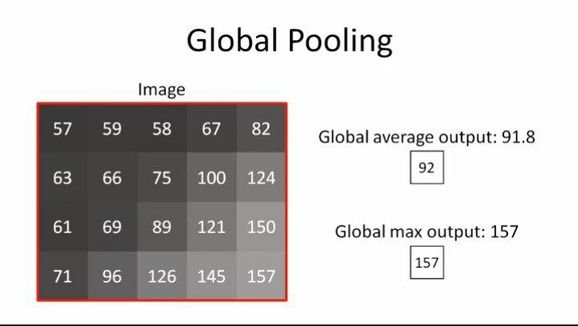
global pooling agressively downsizes the output of the convulational layer and hence it peaks the strongest feature.
Here we convert the pixels to 8 bit integers as it will become a image.
Overall pooling downsizes the output of the convulational layer in such a way that it highlights the feature generated by the convulational layers.

LOCAL TRANSLATION INVARIANCE-
max pooling gives us translation invariance.
Invariance means that even if the image of the subject differs then the model is able to classify it,the variation can be on contrast or in position.
Translation invariance means that the subject has moved left or right in the image.
Max pooling as it takes the highest value from the moving window helps us to predict the edge even if the subject is moved left or right. Edge generally have higher values in the matrix.

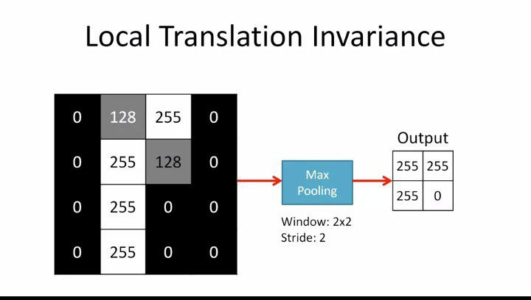
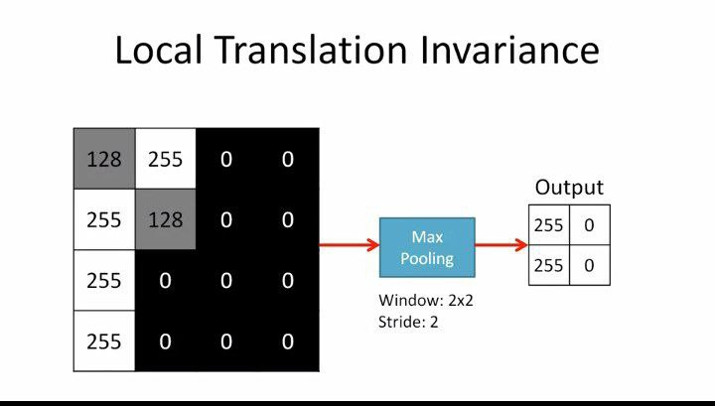
Types of invariance-
