Fraud Detection

Document Control Information

### Document Information

|  |  |
| --- | --- |
| Document Identification | Software Guide |
| Document Name | Fraud Detection Software Setup and Usage |
| Project Name | Firm Initiative |
| Client | - |
| Document Author | Anurag Yadav |
| Document Version | 1.0 |
| Document Status | Draft |
| Date Released | TBA |
| File Name | FI_Fraud_Detection.docx |

### Document Edit History

| Version | Date | Additions/Modifications | Prepared/Revised by |
| --- | --- | --- | --- |
| 1.0 | 02/02/2019 | Draft | Anurag Yadav |
|  |  |  |  |

### Document Review/Approval History

| Date | Name | Organization/Title | Comments |
| --- | --- | --- | --- |
|  |  |  |  |

# Table of Contents

Document Information 2

Document Edit History 2

Document Review/Approval History 2

Table of Contents 3

1. Introduction 4

1.1. About 4

2. Oracle DB Installation And Setup Process 5

2.1. Oracle DB Setup 5

4.2 Connecting to Oracle Database 19

4.3 Table Creation and Data Insertion 21

3. Elasticsearch Setup 25

3.1. Introduction 25

3.2. Basic Setup 25

4. Logstash Setup and Usage 26

4.1. Introduction 26

4.2. Logstash Setup 26

4.3. Run Logstash 26

5. Python Service Setup and Usage 27

5.1. Install Anaconda: 27

5.2. Flask Setup 31

5.3. Run Python Code 32

6. Appendix 33

6.1. Key Terms 33

# Introduction

## About

This is document to setup and run Fraud Detection Application.

Fraud Detection Application consists of two parts. Data Load part and Web Service Side. The Data load happens from Oracle DB to Elasticsearch using Logstash. This Elasticsearch data is then used by Python. Python uses an algorithm to find if the user’s latest data is in par with his older trend of data. The algorithm runs, and results are sent back to User Interface in JSON format. The UI renders is properly format.

# Oracle DB Installation & Setup Process

## Oracle DB Setup

To install Oracle database on your computer, you need to download the installer from the [download page](http://www.oracle.com/technetwork/database/enterprise-edition/downloads/index.html) of Oracle website.

After having the installation files which are in ZIP format, you need to extract them into a specific folder on your computer.

The following picture shows the structure of the folder of the Oracle installation files after extraction.

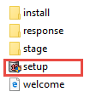

Now you need to double-click the setup.exe file to start the installation process. There will be 9 steps which mostly automatically execute.

**Step 1**. The installer asks you to provide your email address to get the latest security issues and updates. You can ignore it by clicking the Next button

[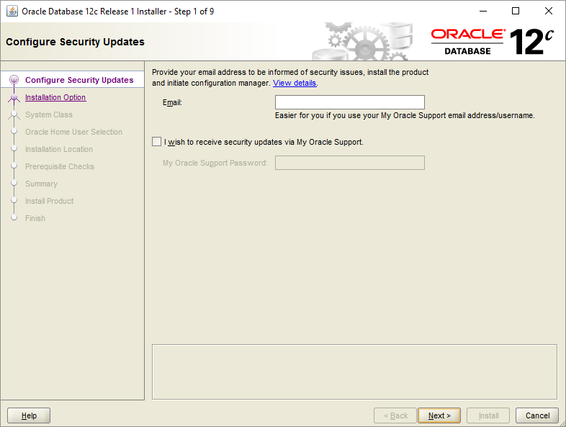](http://www.oracletutorial.com/wp-content/uploads/2015/12/Install-Oracle-Step-1.png)

Because I didn’t provide the email address, the Oracle database installer confirm it, you just need to click the No button to continue.

[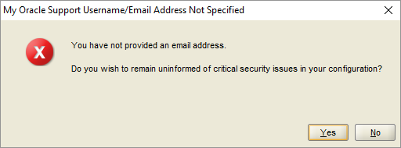](http://www.oracletutorial.com/wp-content/uploads/2015/12/Install-Oracle-Step-1-1.png)

**Step 2**. In step 2, Oracle installer ask you to whether you want to create and configure a database, install database software only or just upgrade an existing database. Because you install the Oracle database at the first time, choose the option 1 and click the Next button.

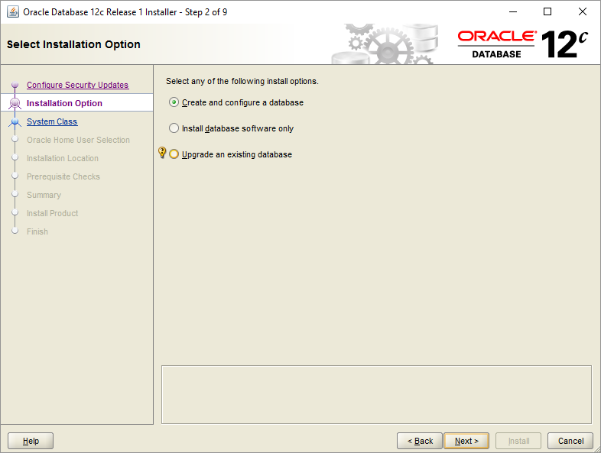

**Step 3.**The installer allows you to choose the system class. Because you install Oracle on your computer, not a server, therefore, you choose the first option: desktop class and click the Next button.

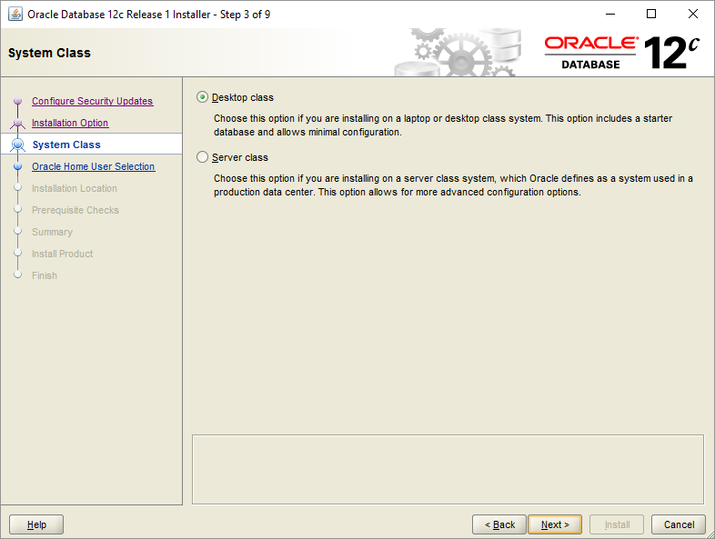

**Step 4.**This step allows you to specify the Windows user account to install and configure Oracle Home for enhanced security. Choose the third option: “Use Windows Built-in Account”.

[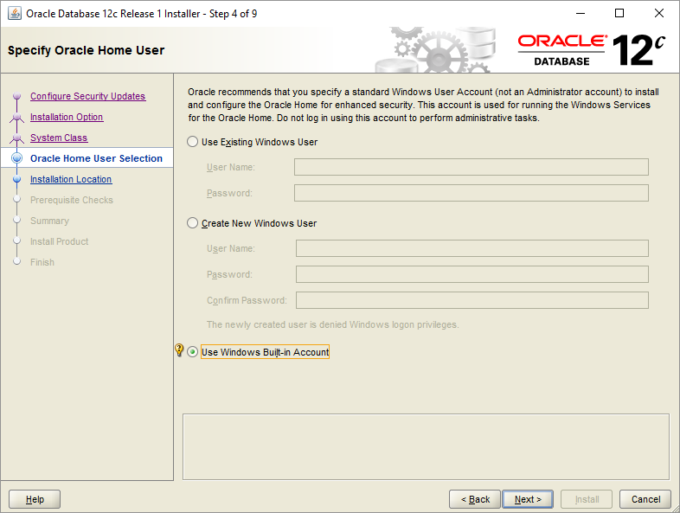](http://www.oracletutorial.com/wp-content/uploads/2015/12/Install-Oracle-Step-4.png)

**Step 5.**in this step you can (1) choose the folder on which Oracle database will be installed, (2) Global database name and password, (3) pluggable database name.

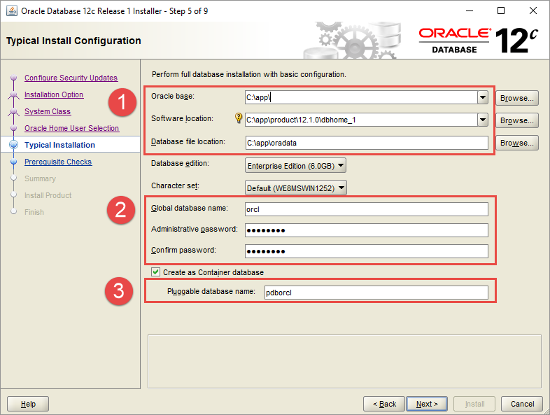

**Step 6.**The installer performs the prerequisite check.

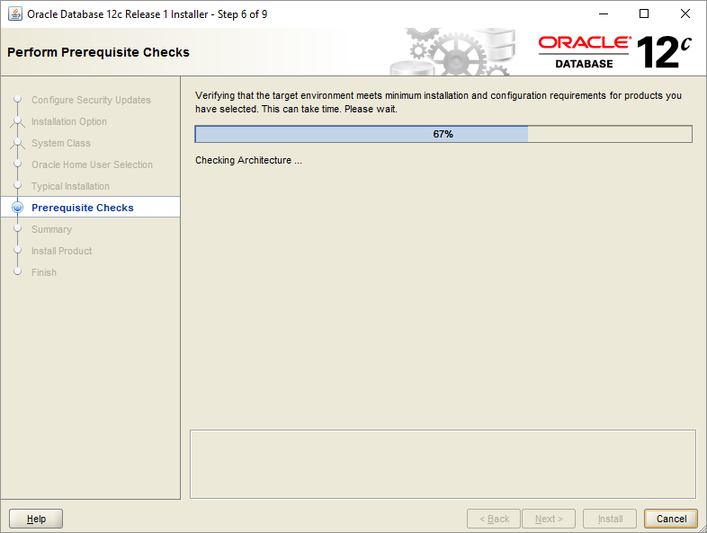

**Step 7**.  The installer shows you the summary of the information such as global settings, database information, etc. You need to review the information and click the install button if everything is fine.

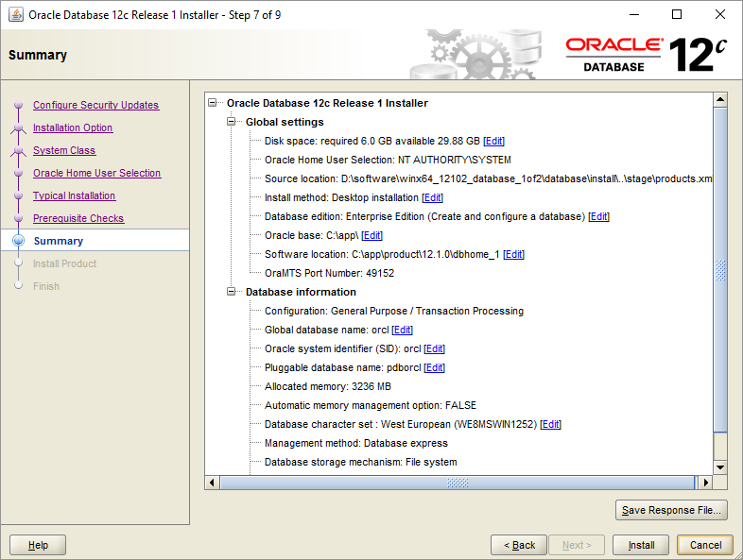

**Step 8.**The installer starts installing Oracle database. It will take a few minutes to complete, depending on your computer.

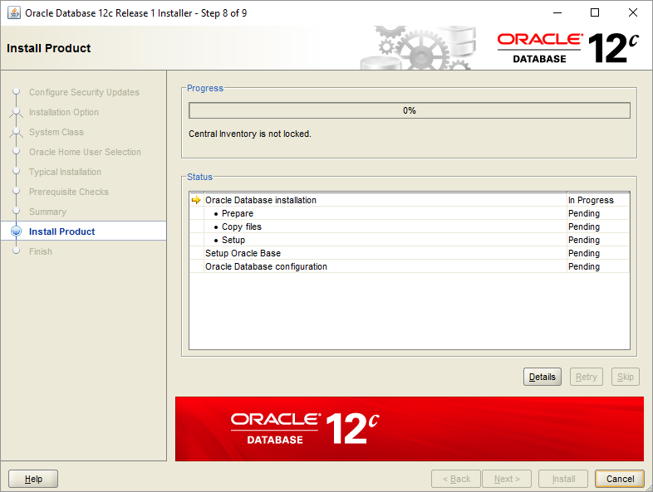

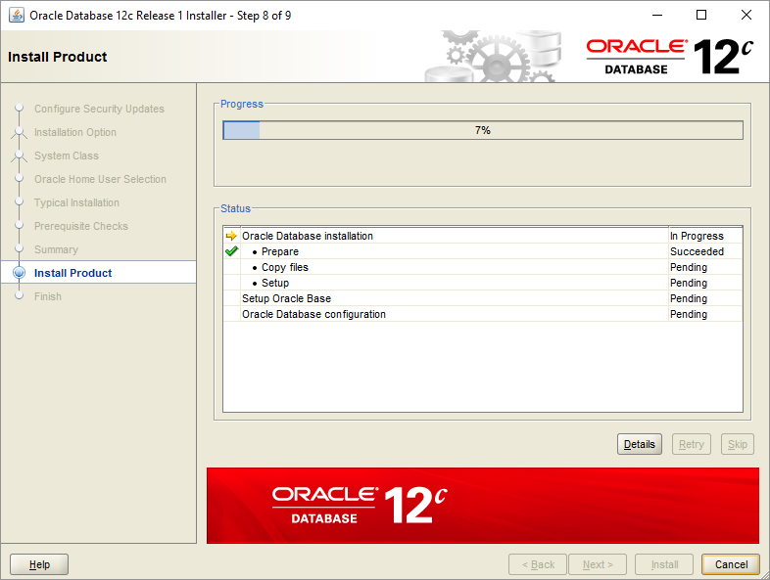

[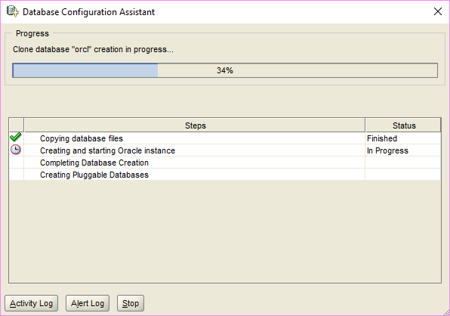](http://www.oracletutorial.com/wp-content/uploads/2015/12/Install-Oracle-Step-8-2.png)

You will see the Database Configuration Assistant window. Click the Password management… button to enter the password for Oracle database accounts.

[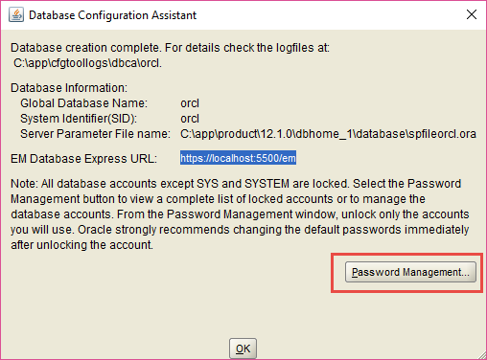](http://www.oracletutorial.com/wp-content/uploads/2015/12/Install-Oracle-Step-8-4.png)

Enter the password for SYS and SYSTEM accounts and then click OK button.

[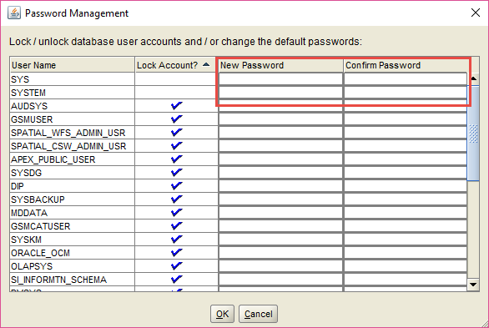](http://www.oracletutorial.com/wp-content/uploads/2015/12/Install-Oracle-Step-8-5.png)

**Step 9.**Once installation completes successfully, the installer will inform you as shown in the following screenshot. Click the Close button to close the window.

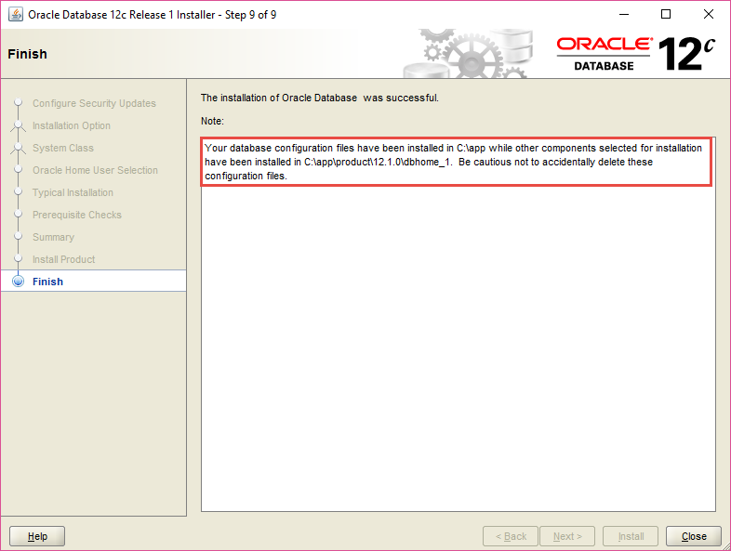

## 4.2 Connecting to Oracle Database

First, launch the SQL developer application provided by the Oracle Database.

Second, right-click the connections node and choose **New Connection …** menu item to create a new connection.

[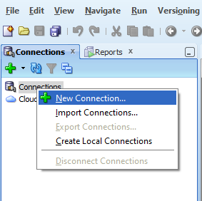](http://www.oracletutorial.com/wp-content/uploads/2015/12/SQL-Developer.png)

Third, enter the information that you provided during the installation process as shown in the following screenshot. Click the Connect button to connect to the Oracle Database.

[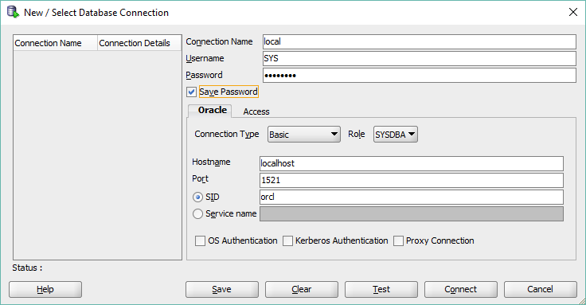](http://www.oracletutorial.com/wp-content/uploads/2015/12/SQL-Developer-New-Connection.png)

SQL developer will display all objects as shown below.

[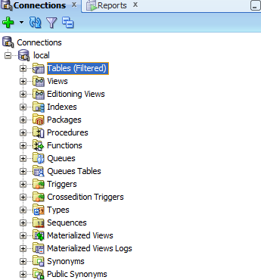](http://www.oracletutorial.com/wp-content/uploads/2015/12/SQL-Developer-Connected.png)

Congratulation! you have installed Oracle Database 12c successfully. Let’s start exploring Oracle.

## Table Creation and Data Insertion

Run DDL command to create table.

CREATE TABLE AI_DATA_FEED (

INDV_ID number(10) DEFAULT NULL,

CASE_NUM number(10) DEFAULT NULL,

REF_ININDV_ID varchar2(10) DEFAULT NULL,

DOB_DT varchar2(23) DEFAULT NULL,

LAST_NAME varchar2(8) DEFAULT NULL,

FIRST_NAME varchar2(8) DEFAULT NULL,

GENDER_CD varchar2(1) DEFAULT NULL,

INACTIVE_IND varchar2(1) DEFAULT NULL,

ACTIVE_IN_CASE_SW varchar2(1) DEFAULT NULL,

EFF_BEGIN_DT varchar2(23) DEFAULT NULL,

HIST_NAV_IND varchar2(1) DEFAULT NULL,

SSN_SW varchar2(1) DEFAULT NULL,

RESIDENCY_STATE_CD varchar2(2) DEFAULT NULL,

US_CITIZEN_SW varchar2(1) DEFAULT NULL,

RELATIONSHIP_TYPE_CD varchar2(4) DEFAULT NULL,

PREPARES_AND_PURCHASES_SW varchar2(1) DEFAULT NULL,

RELATIONSHIP_VRF_CD varchar2(2) DEFAULT NULL,

VERF_RECEIVED_DT varchar2(23) DEFAULT NULL,

PAYMENT_FREQUENCY_CD varchar2(2) DEFAULT NULL,

EMPLOYER_NAME varchar2(23) DEFAULT NULL,

EXPENSES_SW varchar2(1) DEFAULT NULL,

INCOME_IS_ACCESSIBLE_SW varchar2(1) DEFAULT NULL,

JOB_TITLE varchar2(20) DEFAULT NULL,

PROJECTION_PERIOD_DAYS_CD varchar2(2) DEFAULT NULL,

EMPLOYMENT_START_DT varchar2(23) DEFAULT NULL,

PROJECTION_PERIOD_END_DT varchar2(23) DEFAULT NULL,

PROJECTION_PERIOD_START_DT varchar2(23) DEFAULT NULL,

PROVIDER_ID varchar2(6) DEFAULT NULL,

LOST_EMPLOYMENT_SW varchar2(1) DEFAULT NULL,

PROCESS_ID varchar2(2) DEFAULT NULL,

IS_COMPLETE_SW_2 varchar2(1) DEFAULT NULL,

INSURANCE_INCOME_AMT varchar2(6) DEFAULT NULL,

HOURS_WK varchar2(4) DEFAULT NULL,

PLAN_TO_GAIN_IND_SW varchar2(1) DEFAULT NULL,

EMP_SEQ_NUM_1 varchar2(7) DEFAULT NULL,

PAY_EXP_SEQ_NUM varchar2(7) DEFAULT NULL,

PAYMENT_EXPENSE_DT varchar2(23) DEFAULT NULL,

PAYMENT_EXPENSE_AMT varchar2(4) DEFAULT NULL,

PAYMENT_EXPENSE_FREQUENCY_CD varchar2(2) DEFAULT NULL,

PAYMENT_EXPENSE_VRF_CD varchar2(2) DEFAULT NULL,

GROSS_PAY_PERIOD_AMT varchar2(4) DEFAULT NULL,

HOURS_PER_WK varchar2(2) DEFAULT NULL,

INCLUDE_PAYMENT_EXPENSE_SW varchar2(1) DEFAULT NULL,

PAYMENT_INDICATOR_CD varchar2(1) DEFAULT NULL,

REGULAR_HOURS varchar2(2) DEFAULT NULL,

TYPE_CD_1 varchar2(1) DEFAULT NULL,

VERF_RECEIVED_DT_2 varchar2(23) DEFAULT NULL,

CHANGE_ACTION_DT varchar2(23) DEFAULT NULL,

UNEARNED_SEQ_NUM varchar2(7) DEFAULT NULL,

UNEARNED_INCOME_TYPE_CD varchar2(4) DEFAULT NULL,

VERF_RECEIVED_DT_3 varchar2(23) DEFAULT NULL,

PAYMENT_FREQUENCY_CD_1 varchar2(2) DEFAULT NULL,

RESOURCE_SEQ_NUM varchar2(1) DEFAULT NULL,

CONTRIBUTION_ININDV_ID varchar2(1) DEFAULT NULL,

UNEARNED_SOURCE_CD varchar2(2) DEFAULT NULL,

UNEARNED_INCOME_VRF_CD varchar2(2) DEFAULT NULL,

OTHER_INCOME_AMT varchar2(4) DEFAULT NULL,

PROG_CD varchar2(2) DEFAULT NULL,

AID_REQUEST_SW varchar2(1) DEFAULT NULL,

POLICY_YEAR number(10) DEFAULT NULL,

AVERAGE_MONTHLY_HOURS varchar2(5) DEFAULT NULL,

BUDGETED_AMT varchar2(6) DEFAULT NULL,

BUDGET_TYPE_CD varchar2(2) DEFAULT NULL,

MA_BUDGET_AMT varchar2(6) DEFAULT NULL,

MA_PROJECTED_AMT varchar2(5) DEFAULT NULL,

PAYMENTS_EXPECTED varchar2(1) DEFAULT NULL,

PAYMENTS_RECEIVED varchar2(1) DEFAULT NULL,

PROJECTED_HOURS varchar2(4) DEFAULT NULL,

PROJECTION_AMT varchar2(5) DEFAULT NULL

) ;

Insert Data:

INSERT INTO AI_DATA_FEED (INDV_ID, CASE_NUM, REF_ININDV_ID, DOB_DT, LAST_NAME, FIRST_NAME, GENDER_CD, INACTIVE_IND, ACTIVE_IN_CASE_SW, EFF_BEGIN_DT, HIST_NAV_IND, SSN_SW, RESIDENCY_STATE_CD, US_CITIZEN_SW, RELATIONSHIP_TYPE_CD, PREPARES_AND_PURCHASES_SW, RELATIONSHIP_VRF_CD, VERF_RECEIVED_DT, PAYMENT_FREQUENCY_CD, EMPLOYER_NAME, EXPENSES_SW, INCOME_IS_ACCESSIBLE_SW, JOB_TITLE, PROJECTION_PERIOD_DAYS_CD, EMPLOYMENT_START_DT, PROJECTION_PERIOD_END_DT, PROJECTION_PERIOD_START_DT, PROVIDER_ID, LOST_EMPLOYMENT_SW, PROCESS_ID, IS_COMPLETE_SW_2, INSURANCE_INCOME_AMT, HOURS_WK, PLAN_TO_GAIN_IND_SW, EMP_SEQ_NUM_1, PAY_EXP_SEQ_NUM, PAYMENT_EXPENSE_DT, PAYMENT_EXPENSE_AMT, PAYMENT_EXPENSE_FREQUENCY_CD, PAYMENT_EXPENSE_VRF_CD, GROSS_PAY_PERIOD_AMT, HOURS_PER_WK, INCLUDE_PAYMENT_EXPENSE_SW, PAYMENT_INDICATOR_CD, REGULAR_HOURS, TYPE_CD_1, VERF_RECEIVED_DT_2, CHANGE_ACTION_DT, UNEARNED_SEQ_NUM, UNEARNED_INCOME_TYPE_CD, VERF_RECEIVED_DT_3, PAYMENT_FREQUENCY_CD_1, RESOURCE_SEQ_NUM, CONTRIBUTION_ININDV_ID, UNEARNED_SOURCE_CD, UNEARNED_INCOME_VRF_CD, OTHER_INCOME_AMT, PROG_CD, AID_REQUEST_SW, POLICY_YEAR, AVERAGE_MONTHLY_HOURS, BUDGETED_AMT, BUDGET_TYPE_CD, MA_BUDGET_AMT, MA_PROJECTED_AMT, PAYMENTS_EXPECTED, PAYMENTS_RECEIVED, PROJECTED_HOURS, PROJECTION_AMT)

SELECT 138160, 501102254, '138175', '19-MAY-2013 12.00.00 AM', 'RRMTLSJY', 'JGRVOPZM', 'M', 'N', 'Y', '01-SEP-2016 12.00.00 AM', 'F', 'Y', 'RI', 'Y', 'CH', 'Y', 'BC', '18-MAY-2018 12.00.00 AM', '', '', '', '', '', '', '', '', '', '', '', '', '', '', '', '', '', '', '', '', '', '', '', '', '', '', '', '', '', '', '', '', '', '', '', '', '', '', '', 'MA', 'N', 2013, '', '', '', '', '', '', '', '', '' FROM dual UNION ALL

SELECT 138160, 501102254, '138175', '19-MAY-2013 12.00.00 AM', 'RRMTLSJY', 'JGRVOPZM', 'M', 'N', 'Y', '01-SEP-2016 12.00.00 AM', 'F', 'Y', 'RI', 'Y', 'CH', 'Y', 'OT', '26-JUN-2018 10.30.22 AM', '', '', '', '', '', '', '', '', '', '', '', '', '', '', '', '', '', '', '', '', '', '', '', '', '', '', '', '', '', '', '', '', '', '', '', '', '', '', '', 'MA', 'N', 2013, '', '', '', '', '', '', '', '', '' FROM dual UNION ALL

SELECT 138160, 501102254, '446699', '19-MAY-2013 12.00.00 AM', 'RRMTLSJY', 'JGRVOPZM', 'M', 'N', 'Y', '01-SEP-2016 12.00.00 AM', 'F', 'Y', 'RI', 'Y', 'SB', 'Y', 'BC', '12-JAN-2018 11.46.25 AM', '', '', '', '', '', '', '', '', '', '', '', '', '', '', '', '', '', '', '', '', '', '', '', '', '', '', '', '', '', '', '', '', '', '', '', '', '', '', '', 'MA', 'N', 2013, '', '', '', '', '', '', '', '', '' FROM dual UNION ALL

SELECT 138160, 501102254, '446699', '19-MAY-2013 12.00.00 AM', 'RRMTLSJY', 'JGRVOPZM', 'M', 'N', 'Y', '01-SEP-2016 12.00.00 AM', 'F', 'Y', 'RI', 'Y', 'SB', 'Y', 'OT', '26-JUN-2018 10.30.22 AM', '', '', '', '', '', '', '', '', '', '', '', '', '', '', '', '', '', '', '', '', '', '', '', '', '', '', '', '', '', '', '', '', '', '', '', '', '', '', '', 'MA', 'N', 2013, '', '', '', '', '', '', '', '', '' FROM dual;

COMMIT:

This will insert data in Oracle DB.

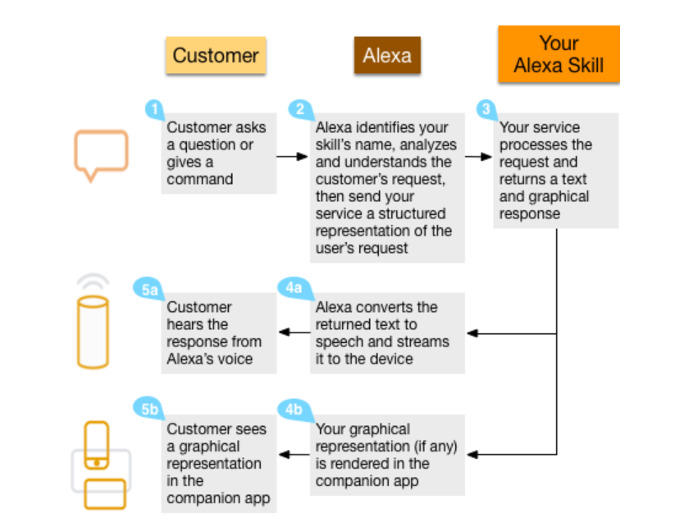

# Elasticsearch Setup

## Introduction

We need to push data from DB to Elasticsearch. Elasticsearch is will host the data for UI API to consume data. Elasticsearch can store millions of records and render then in split seconds. It can also be used to find patterns in data (analytics)

## Basic Setup

* + 1. Download the .zip archive for Elasticsearch v6.2.4 from: https://artifacts.elastic.co/downloads/elasticsearch/elasticsearch-6.2.4.zip
    2. Unzip it with your favourite unzip tool. This will create a folder called elasticsearch-6.2.4, which we will refer to as %ES_HOME%. In a terminal window, cd to the %ES_HOME% directory, for instance:
    3. cd c:\elasticsearch-6.2.4. Go inside the es directory and go inside config folder and change the below properties in elasticsearch.yml file:  
          
       network.host: {ip of the server}  
       http.port: 9200 (or any other port if this is occupied)
    4. Come back to ES_HOME and run the below command:  
       .\bin\elasticsearch.bat
    5. This will start ES server.   
       Test it by running a get command against ip-name:9200. It will tell the details about ES cluster.

Reference: [**https://www.elastic.co/guide/en/elasticsearch/reference/6.2/zip-windows.html**](https://www.elastic.co/guide/en/elasticsearch/reference/6.2/zip-windows.html)

# Logstash Setup and Usage

## Introduction

Logstash is middleware technology used to do sync up activities.

## Logstash Setup

1. If necessary, download and install the latest version of the Java from [**www.java.com**](https://www.java.com/).
2. Download the Logstash 5.6.14 Windows zip file from the [**downloads page**](https://www.elastic.co/downloads/logstash).
3. Extract the contents of the zip file to a directory on your computer, for example, C:\Program Files.
4. Now Logstash is ready to run. Once it gets config file.

## Run Logstash

* + 1. Place conf file at any feasible location. (Good to place inside logstash-x-x-x folder) 
    2. To start logstash with this config file.
    3. Go inside logstash-x-x-x and run .\bin\logstash -f db_es_fraud_detection.conf
    4. This will sync up data between DB and ES.

.

# Python Service Setup and Usage

We will use python Flask API to provide service to Angular JS code. To run python we will use Anaconda. We need to install Flask API too.

## Install Anaconda:

Ref Doc: [**https://docs.anaconda.com/anaconda/install/windows/**](https://docs.anaconda.com/anaconda/install/windows/)

1. [**Download the Anaconda installer**](https://www.anaconda.com/download/#windows).
2. Double click the installer to launch.
3. Click Next.
4. Read the licensing terms and click “I Agree”.
5. Select an install for “Just Me” unless you’re installing for all users (which requires Windows Administrator privileges) and click Next.
6. Select a destination folder to install Anaconda and click the Next button.
7. NOTE: Install Anaconda to a directory path that does not contain spaces or unicode characters.

NOTE: Do not install as Administrator unless admin privileges are required.

[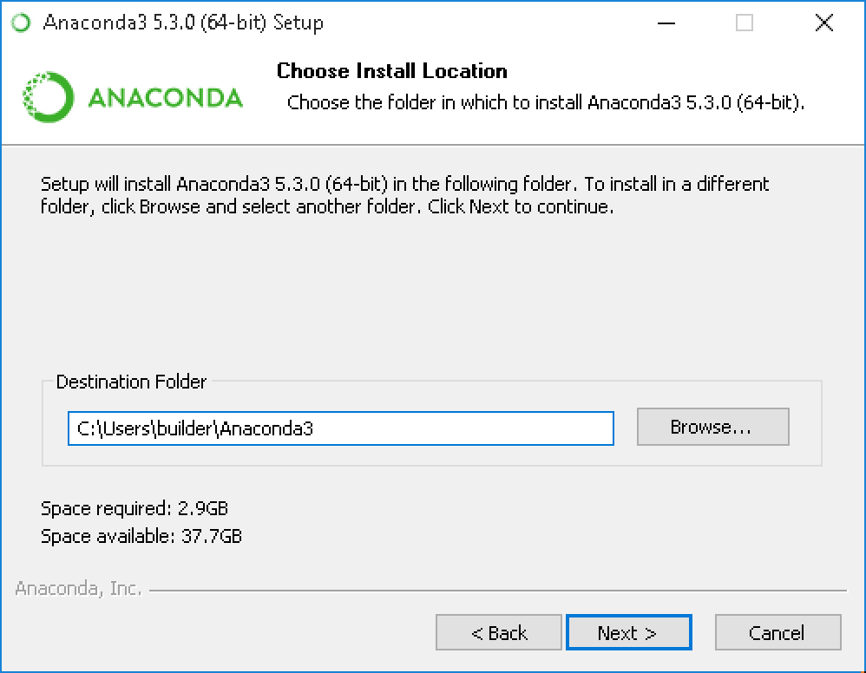](https://docs.anaconda.com/_images/install-win-destination.png)

1. Choose whether to add Anaconda to your PATH environment variable. We recommend not adding Anaconda to the PATH environment variable, since this can interfere with other software. Instead, use Anaconda software by opening Anaconda Navigator or the Anaconda Prompt from the Start Menu.

[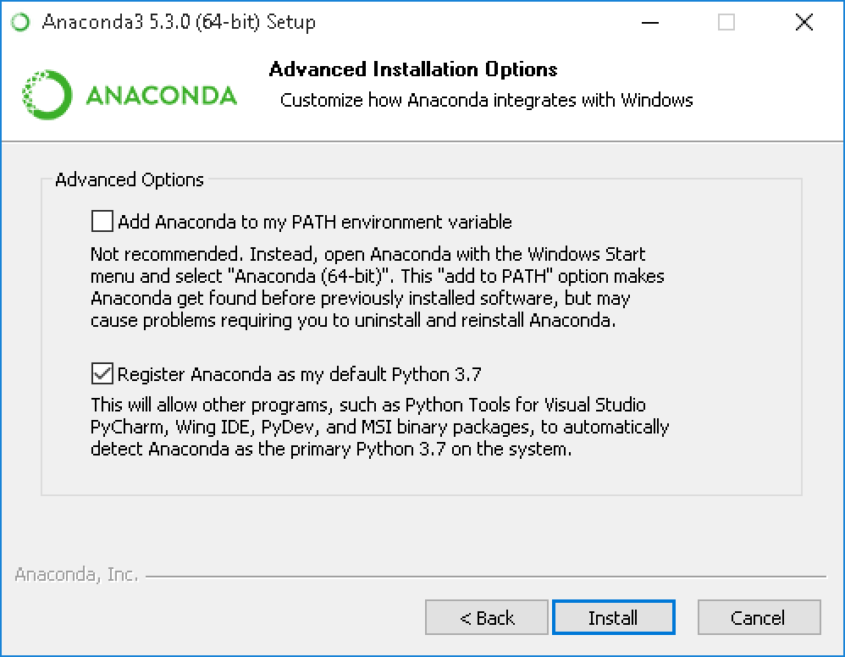](https://docs.anaconda.com/_images/install-win-path.png)

1. Choose whether to register Anaconda as your default Python. Unless you plan on installing and running multiple versions of Anaconda, or multiple versions of Python, accept the default and leave this box checked.
2. Click the Install button. If you want to watch the packages Anaconda is installing, click Show Details.
3. Click the Next button.
4. Optional: To [install VS Code](https://docs.anaconda.com/anaconda/user-guide/tasks/integration/vscode/), click the Install Microsoft VS Code button. After the install completes click the Next button.

[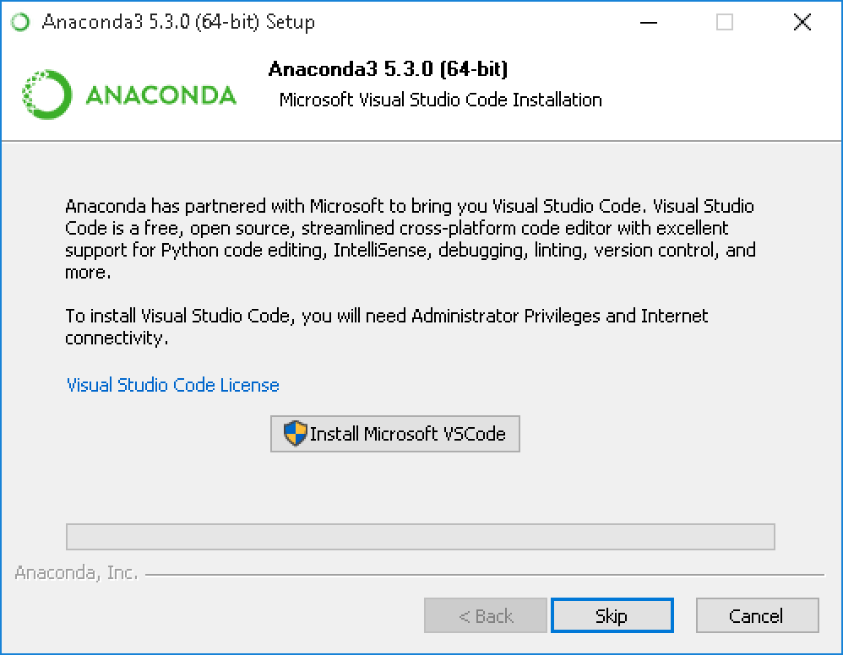](https://docs.anaconda.com/_images/vscode-install.png)

Or to install Anaconda without VS Code, click the Skip button.

NOTE: Installing VS Code with the Anaconda installer requires an internet connection. Offline users may be able to find an offline VS Code installer from Microsoft.

1. After a successful installation you will see the “Thanks for installing Anaconda” dialog box:

[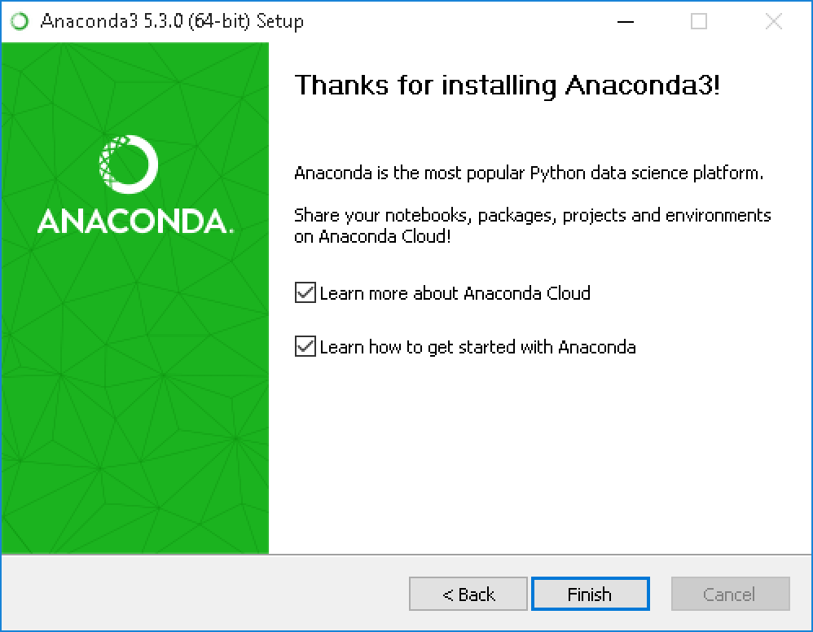](https://docs.anaconda.com/_images/anaconda-install-win.png)

1. If you wish to read more about Anaconda Cloud and how to get started with Anaconda, check the boxes “Learn more about Anaconda Cloud” and “Learn how to get started with Anaconda”. Click the Finish button.
2. After your install is complete, verify it by opening Anaconda Navigator, a program that is included with Anaconda: from your Windows Start menu, select the shortcut Anaconda Navigator. If Navigator opens, you have successfully installed Anaconda. If not, check that you completed each step above, then see our Help page.

[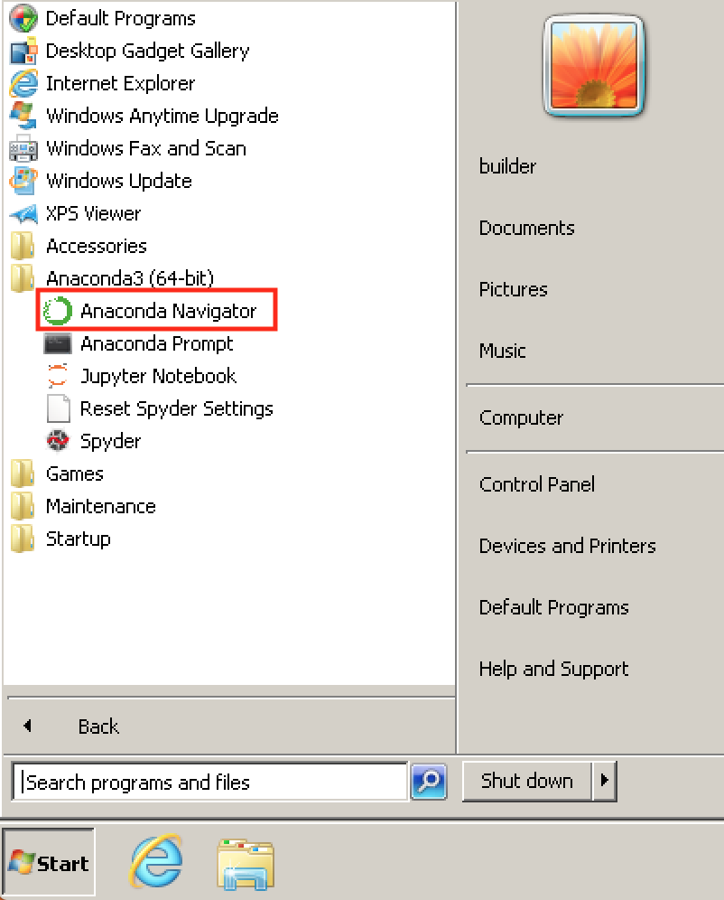](https://docs.anaconda.com/_images/navigator-anaconda-prompt.png)

## Flask Setup

* + 1. To Install Flask Package.
    2. Run: conda install -c anaconda flask
    3. This will download and install all packages required for Flask API

## Run Python Code

* + 1. Open Conda Prompt and navigate to the place where the below file is placed.
    2. To set up that we need to run. Run the below command:  
       set FLASK_APP=web_endpoint.py
    3. To start the above API.  
       python -m flask run
    4. This will start the API on localhost:5000
    5. To test if the API is running execute GET API (http:///localhost:5000/)and see if its responses with Http Status Code of 200.
    6. If so the API is ready to be used.

# Appendix

## Key Terms

| # | Term | Description |
| --- | --- | --- |
|  |  |  |
|  |  |  |
|  |  |  |
|  |  |  |
|  |  |  |
|  |  |  |
|  |  |  |