A

Project Report

On

**Multi Client And Server Chat**

Project Profile

**INTRODUCTion**

Chat server is a standalone application. To start chat you must be connected with the server after that your message can broadcast to the client though which we want to chat. Chat system is a complete client/server chat solution, independent chat system (it does not depend on any product of communication and chat). Chat system application is a GUI interface. This application makes it easy to find people on a network and communicate with them easily without being online and makes net messages easier to read.

Some features of the application are as follows:

• This application is used for sending messages from one client to another client. In this, server takes a message from the sender client and sends to another client. If any client wants to join the chatting then he runs the client application on client side, enters the login name and hits the login button and starts the chatting with other client.

• In this we are maintaining the list of user names (client name) also. After creating the connection with server, client sends the user name to server and server store it in the array list and sends this array list to all clients. Same like this when any client has logged out then server remove this name from the array list and send this updated array list to every client.

ABSTRACT

.

ABSTRACT Chatting, is a method of using technology to bring people and ideas “together” despite of the geographical barriers. The Chat Server is Communication Software intended for sending and receiving messages between the members logged in. The Chat server can be configured to listen at a particular port specified by the system administrator. The Chat clients have to Login with his/her name .After Login he/she can start chatting with multiple Clients at a time.

**Tools and Platform used**

Following is the list of the development of the proposed system:

**Technologies:**

**Java**

**Software Requirement**

**Notepad**

**Hardware Requirement**

Operating system is WINDOWS 7

32 bit processor is required

Intel Pentium class processor 800 MHz or higher

Minimum 256 MB RAM

Hard disk space require 40 GB

System Designing

**Snapshots**

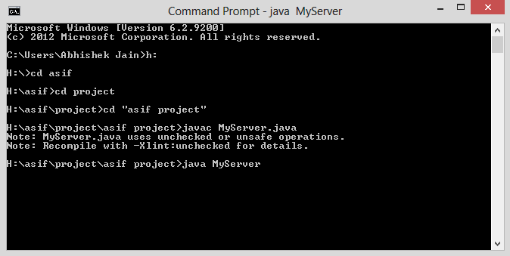

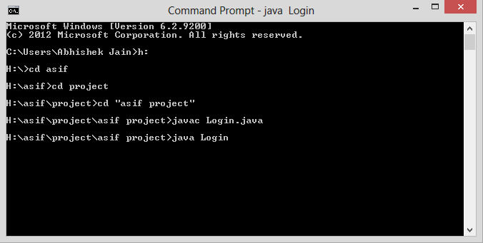

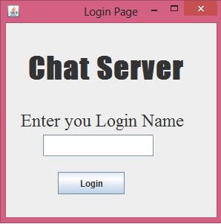

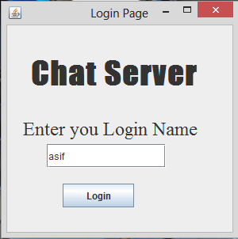

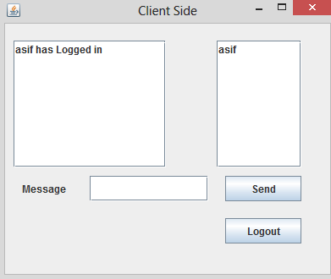

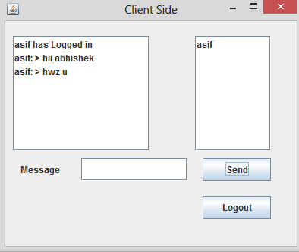

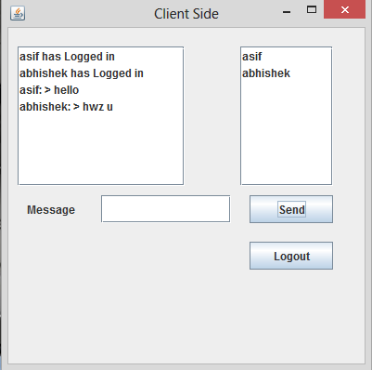

Conclusion & Future

Scope

**Conclusions**

The primary goal of this project is to give an idea about Client Server Chat. This project has given us an in depth information about java networking and its applications in day today life. If internet lives up to its potential, it will revolutionize the way people interact with information technology.

Limitations of the application are as follows:

1.) Before running the client application makes sure the server application is running. If server is not in running condition then you cannot start the chatting.

2.) Single point of failure, server goes down, the network goes down.

Future work

1. Can be implemented in large network .

2. Hi-speed multimedia transfer and audio video conferencing support.

3. Control all the computer system (clients) and sub-servers in large network like INTERNET.

REFERENCE

[1] <http://en.wikipedia.org/wiki/file>

[2][https://www.google.co.in/search](https://www.google.co.in/search?hl=en&q=flow+chart+for+file+sharin+system)

[3]http://powerpointpresentationon.blogspot.in

[4]http://it.toolbox.com/blogs/enterprise-solutions/