**Firstly  cd to the root project folder and then execute the git init command.**

1. **git init**

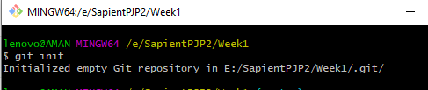

1. **git remote add origin** [**https://github.com/anurag97en/PJP2Week1.git**](https://github.com/anurag97en/PJP2Week1.git)

**git remote -v**



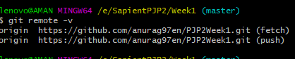

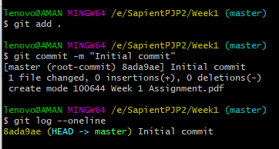

1. **git branch feature**

**git branch dev**

**git branch QA**

**git branch Prod**

**git branch delivery**

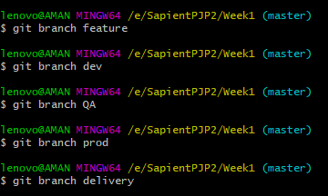 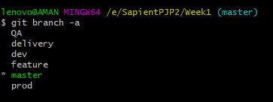

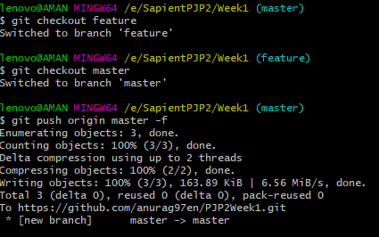

1. **git checkout feature**

**git push origin feature**

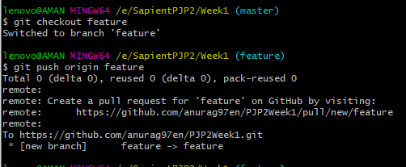

**git checkout dev**

**git push origin dev**

**git checkout QA**

**git push origin QA**

**git checkout Prod**

**git push origin Prod**

**git checkout delivery**

**git push origin delivery**

**type nul> newFile.txt**

**type nul> newFile1.txt**

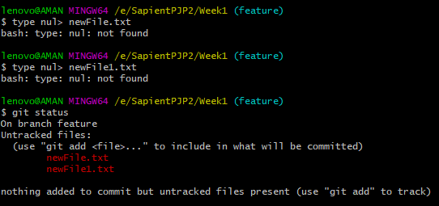

**vim newFile.txt**

**// write text in file and press :wq to return**

**mkdir FeatureFolder**

**cd FeatureFolder**

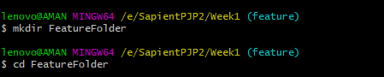

**git rm –r featureFolder // remove folder**

1. **git checkout feature**

**git add.**

**git commit –m “Second commit ”**

**git push --set-upstream origin feature**

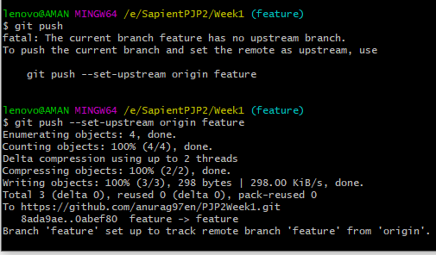

1. **git checkout dev**

**git pull origin feature**

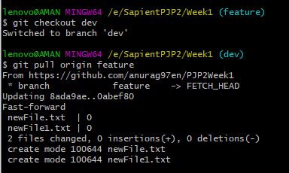

1. **git checkout delivery**

**git branch -a**

**git checkout QA**

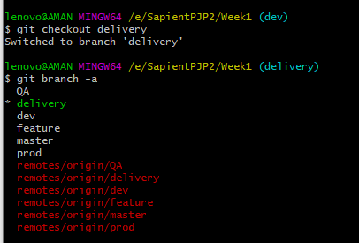

1. **git pull contacts the remote repository identified by origin and looks for updates. It fetches any updates and then merges the changes into the target branch**

**while**

**git checkout -b <branch> origin/<branch> creates a new branch based on origin/<branch> , and does not contact the remote repository.**

1. **git checkout delivery**

**git stash**

**git checkout feature**

**git merge master**

**git stash**

**git checkout QA**

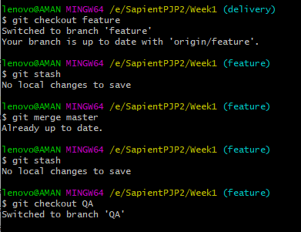

1. **git rebase master**



**C) 1. git log**

**git reset --soft**

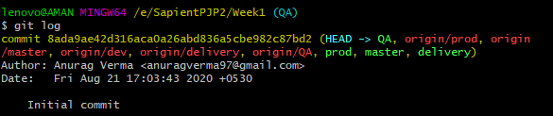



**2) git add.**

**git stash**

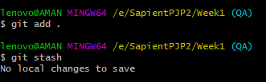

**3) git merge master**

**git rebase master**

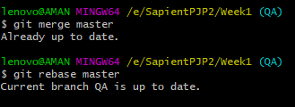

**GUI**

