1. Login to PSQL

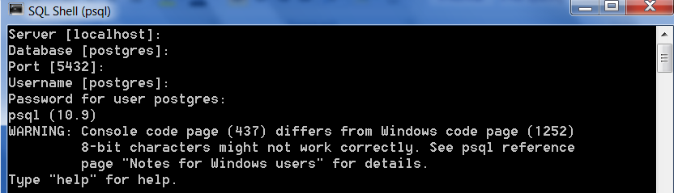

1. Create a Database PJPPractice



1. Display all the database

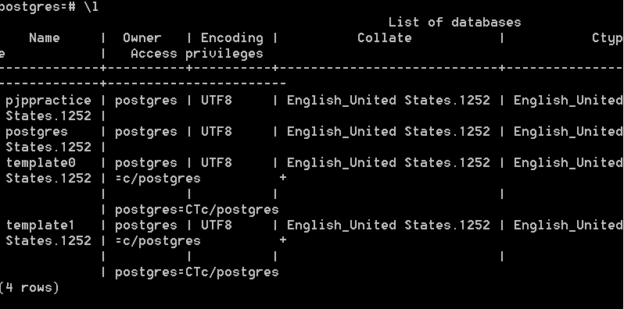

1. Change the database to PJPPractice

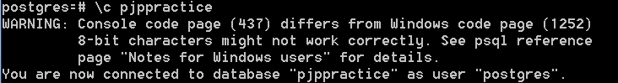

1. Create a table test



2. Add a column lname to the table test



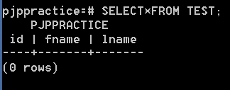

1. Rename the column name lname to last_name



1. Add the constraint primary key to the column id



1. Drop the column last_name

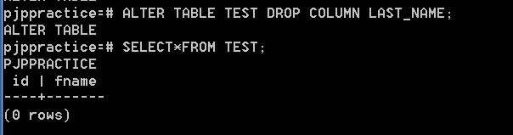

1. Rename the table name to test1

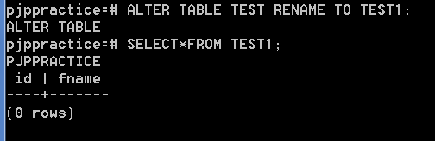.

QUESTION:

1.Write a query which displays the module code and the duration for modules whose duration is less than 6.

efs_db=# SELECT MODULECODE,DURATION FROM MODULES WHERE DURATION<6

modulecode | duration

------------+----------

JAV-1 | 3

JAV-3 | 3

JAV-6 | 4

JAV-7 | 3

WEB-1 | 4

(5 rows)

2.Write a query which will display the BATCHCODE, TRAINERID, COURSECODE, STARTDATE, CAPACITY

and BATCHSTRENGTH of the batches handled by the trainer KRISHNAN.

efs_db=# Select batchcode,trainerid,coursecode,startdate,capacity,batchstrength

from batches where trainerid in(select trainerid from trainers where trainername

='KRISHNAN');

batchcode | trainerid | coursecode | startdate | capacity | batchstrength

-----------+-----------+------------+------------+----------+---------------

3003 | 703 | 303 | 2012-01-02 | 10 | 10

3005 | 703 | 300 | 2011-01-02 | 5 | 5

3009 | 703 | 202 | 2012-07-09 | 10 | 5

(3 rows)

3.Write a query which displays all the module names of the course code 100.

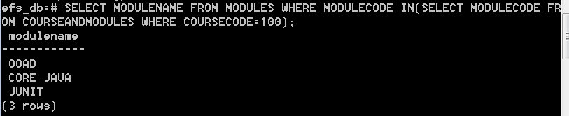

4.Write a query which displays the module names and course code for the course code 100.

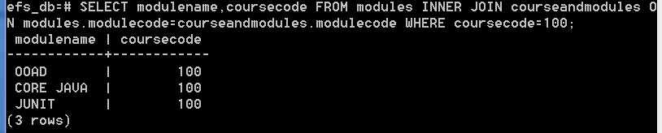

5."Write a query which will display the number of modules present in the course code 100.

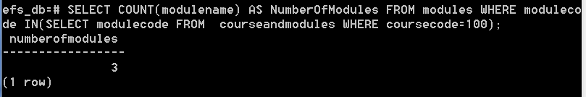

6."Write a query which will display all the course code and the number of modules present

in that particular course.

Hint: display module name count with alias""NumberofModules"""

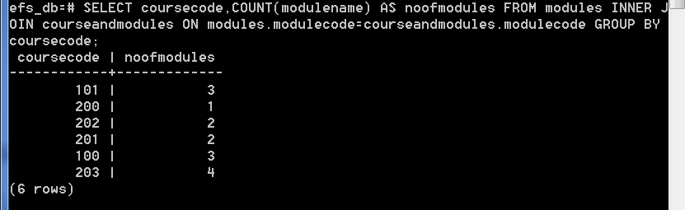

7.Write a query which will display the course title and fees which has the maximum fees.

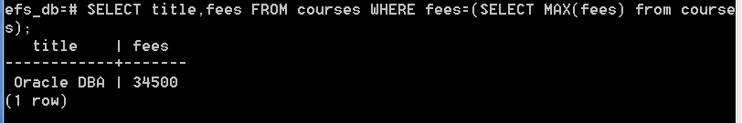

8.Write a query which will display the student id, student name, batch code, place and

phone number of the students who belongs to Batch '3001'.

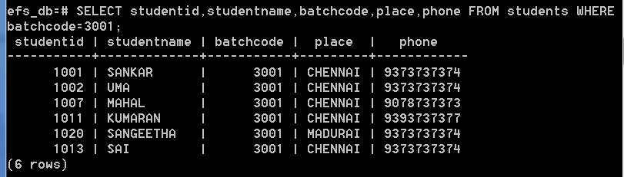

9.Write a Query which will display the student ID, Student name, Batch code, place and phone number who are from CHENNAI.

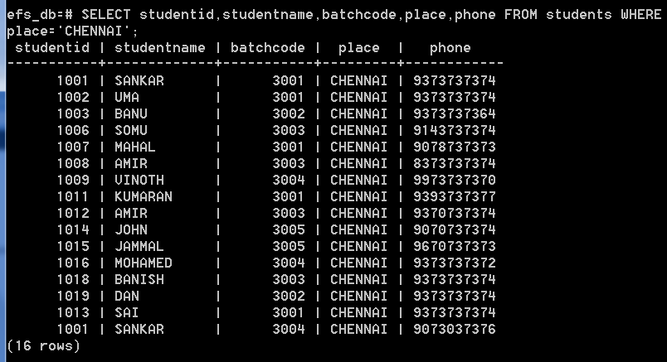

10.Write a query which displays the total number of modules which has less than 6 days duration.

Hint: display total number of modules with'LESSTHANSIXDAYS' as alias.

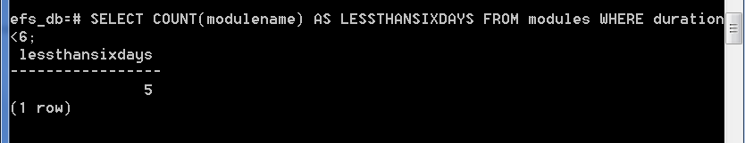

11.Write a query to display the batch code, course title, start date of the batches for the month of May and year 2012.

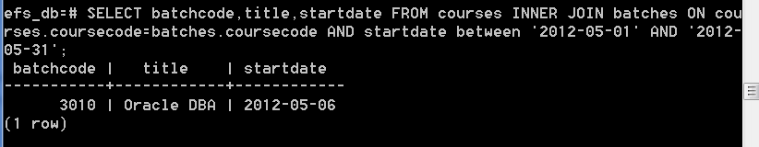

12.Write a query to display courses code, course title, course fees of the courses for which

no batches/training has been planned in the month of January and year 2012.

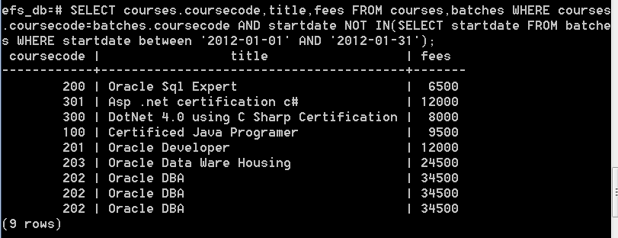

13.Write a query which displays the names of all the modules of the course titled 'Oracle DBA'

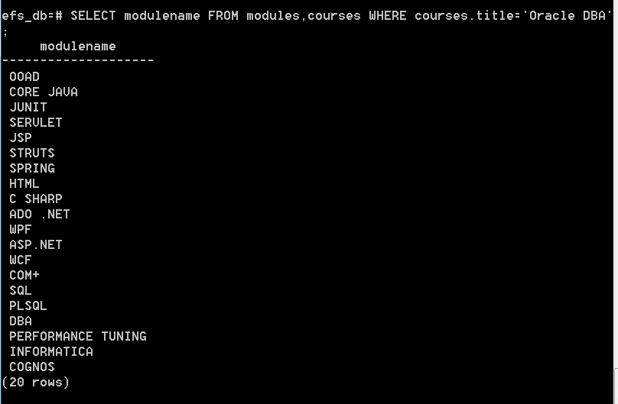

14.Write a Query which displays the student ID, Student name, Batch code, place and phone number

of the student's who took training from CHENNAI in the year 2012.

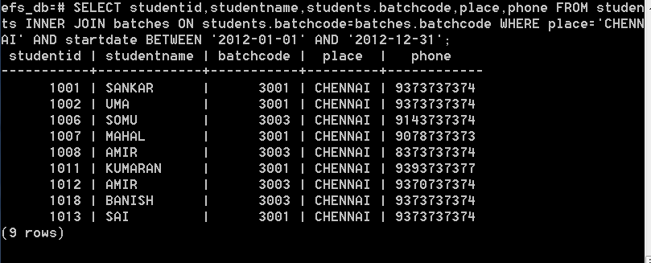

15.Write a query which will display the student id, student names who are enrolled for the course code 200?

