Python Project: Car Resale Price Analysis & Visualization System
- Prepared By: Anurag Srivastva
- Course: Executive PG Certification in Data Science and Artificial Intelligence
- Tool Used: Google Colab
- Organisation: Intellipaat (Associated with iHub Divyasampark,IIT Roorke)

Table of Contents
Section | Topic | Page
 | Problem Statement | 2
 | Introduction | 2-3
 | Objectives | 3-5
 | Dataset Description | 6
 | Data Analysis | 7-8
 | Data Cleaning and Preprocessing | 9-10
 | Exploratory Data Analysis (EDA) | 11-30
 | - Categorical Analysis | 11-14
 | - Numerical Analysis | 15-30
 | OOPs Implementation | 31-33
 | Conclusion | 34
 | Final Note | 35
 | GoogleColab Link | 35

Problem Statement
You are a data analyst working for a car dealership. Your goal is to understand the sales pattern, customer behavior, and make visual insights using Python basics, Object-Oriented Programming (OOPs), NumPy, Pandas, Matplotlib, and Seaborn.
Your job includes:
- Data cleaning and preprocessing
- Basic analysis
- OOP implementation
- Visualization
- Extracting insights

Datasets
Introduction
The resale market for automobiles is highly dynamic, and both dealerships as well as individual sellers benefit from a clear understanding of the factors that influence second-hand car prices. This project, “Car Resale Price Analysis and Visualization System”, has been designed to study used car sales data and identify meaningful trends that can support fair pricing strategies and targeted marketing.
The dataset includes several important details about each vehicle, such as:
- Car model and name
- Manufacturing year
- Current market price
- Resale or selling price
- Distance travelled (in KMs)
- Type of fuel used
- Seller category (dealer or individual)
- Transmission type (manual or automatic)
- Ownership history
With the help of Python and its analytical libraries—NumPy, Pandas, Matplotlib, and Seaborn—this project focuses on:
- Cleaning and preparing the dataset for analysis
- Identifying the key factors that affect resale prices
- Visualizing data patterns through bar charts, boxplots, histograms, scatter plots, and heatmaps
- Building an object-oriented structure by defining a Car class to capture attributes and behaviours

Objectives
This project aims to analyze a car resale dataset to gain insights into the used car market. We will use Python's data science libraries to perform data cleaning, exploratory data analysis (EDA), and data visualization. The project will also incorporate an object-oriented programming (OOP) approach to model car data and its related functionalities.
1. Data Cleaning and Preprocessing
The first step involves preparing the raw data for analysis. This includes:
- Importing the Dataset: We'll use the Pandas library to load the dataset into a Dataframe, which is a tabular data structure that is easy to manipulate.
- Handling Missing and Duplicate Values: We'll inspect the dataset for any missing (null) values and handle them, for example, by imputation or removal, as appropriate. We will also identify and remove any duplicate entries to ensure data integrity.
- Feature Engineering: A key part of preprocessing will be creating new, more informative features. For instance, we'll derive the age of the car from its 'Year' of manufacture to better understand how age affects resale value.
2. Exploratory Data Analysis (EDA)
EDA helps us understand the underlying characteristics of the data. We will:
- Statistical Summary: Get a quick overview of numerical features like Selling Price, Present Price, and Kms Driven using descriptive statistics (mean, median, standard deviation, etc.).
- Categorical Data Analysis: Group and summarize the data by categorical features such as Fuel Type, Seller Type, and Transmission to see how these factors influence other variables like price.
- Correlation Analysis: Compute the relationships between key numerical variables, such as the correlation between Present Price and Selling Price, to identify strong associations.
3. Object-Oriented Programming (OOP) Implementation
We will model the car data using OOP principles to create a reusable and structured code base.
- Defining the Car Class: We'll define a Car class with attributes like car_name, year, fuel_type, selling_price, and present_price.
- Encapsulating Behaviors: The class will include methods to perform various operations:
  - Displaying Information: A method to neatly display all the attributes of a specific car.
  - Profitability Check: A method to determine if a car is being resold at a significantly lower price than its current market value, which could indicate a potentially good deal.
  - Filtering: Methods to filter the car data based on specific attributes, such as fuel type or seller type.
  - Value Comparison: A method to compare two cars and recommend the better option based on price and other factors.
4. Data Visualization
Visualizations will be used to present the insights gleaned from the data in an easy-to-understand format. We will create various plots to:
- Visualize Key Distributions: Use bar plots to compare average selling prices across different fuel types and pie charts to show the distribution of cars by fuel type or transmission. A histogram will illustrate the overall distribution of selling prices.
- Analyze Relationships: A scatter plot will show the relationship between Present Price and Selling Price, with a regression line overlaid to predict resale price.
- Explore Data Patterns: Use boxplots to show the distribution of Kms Driven for different ownership types.
- Show Feature Correlations: A heatmap will provide a clear, color-coded view of the correlation matrix for all numerical features.
5. Insight Extraction
The final phase involves interpreting the analyses and visualizations to draw meaningful conclusions. We will aim to answer key business questions such as:
- Market Demand: Identify the most sought-after fuel type among consumers.
- Pricing Trends: Determine whether automatic or manual transmission cars command higher resale values.
- Depreciation: Analyze how a car's resale value decreases with age.
- Market Segmentation: Compare deals from dealers versus individual sellers to see which group typically offers better prices.
- Business Strategy: Summarize these findings into a concise report with actionable recommendations for a car dealership to optimize their pricing and inventory strategies.

Dataset Description
Hey there! This is a simple dataset all about used cars that are up for sale. Think of each row as a little snapshot of a single car, with all its details—from its condition to its price. It's got a mix of numbers and words that help us figure out what's going on in the used car market!
Dataset Overview
So, what's in this dataset? Well, it's got a total of 9 columns and n rows of data. Pretty straightforward!
Column Details
Column Name | Data Type | Description
Car_Name | Categorical | The car's make and model, like a 'Swift' or 'Innova'.
Year | Numerical | The year the car was made.
Selling_Price | Numerical | The price it's being sold for, in lakhs.
Present_Price | Numerical | The original, current price of the car (ex-showroom), also in lakhs.
Kms_Driven | Numerical | How many kilometers the car has been driven.
Fuel_Type | Categorical | What kind of fuel it runs on, like Petrol, Diesel, or CNG.
Seller_Type | Categorical | Tells you if the seller is a person or a dealership.
Transmission | Categorical | The type of gear system—either Manual or Automatic.
Owner | Numerical | How many people have owned the car before. 0 means it's brand new (first-hand)!

Data Loading

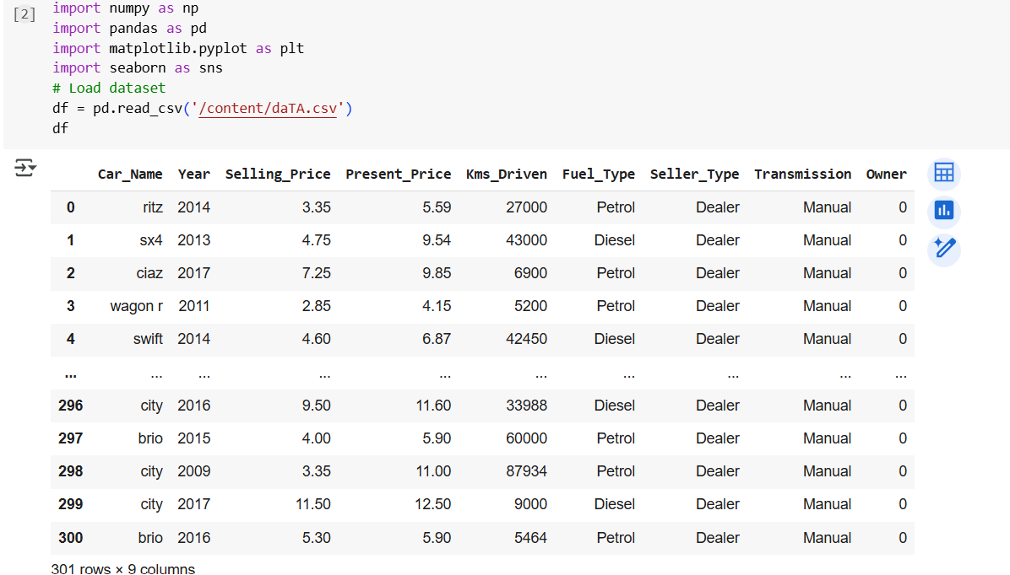

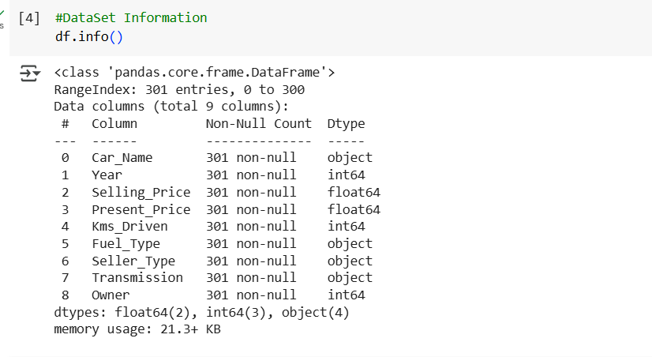

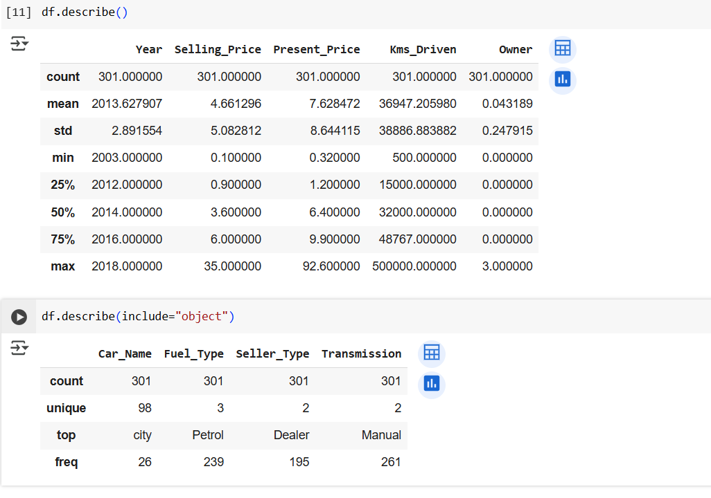

Data Cleaning and Preprocessing
- Checked for and handled any missing values in the dataset.
- Identified and removed any duplicate entries.
- Calculated a new Car_Age column by subtracting the car's Year of manufacture from 2025.
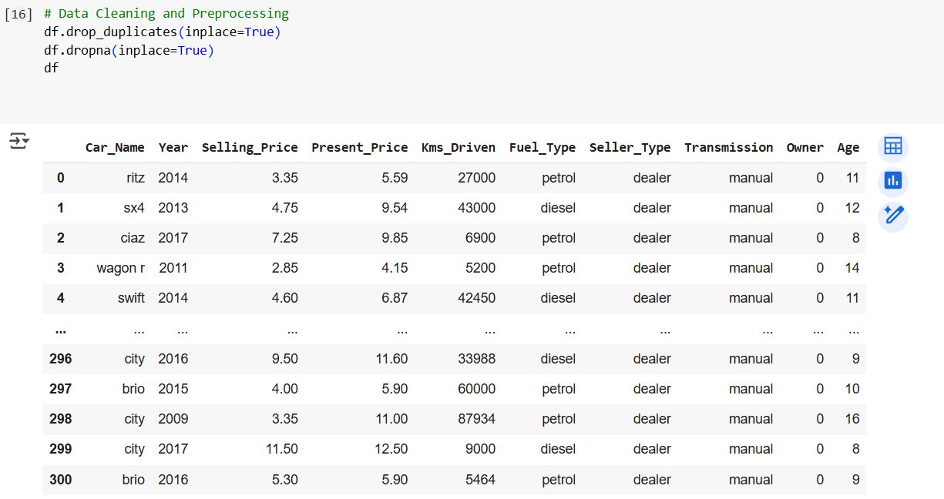
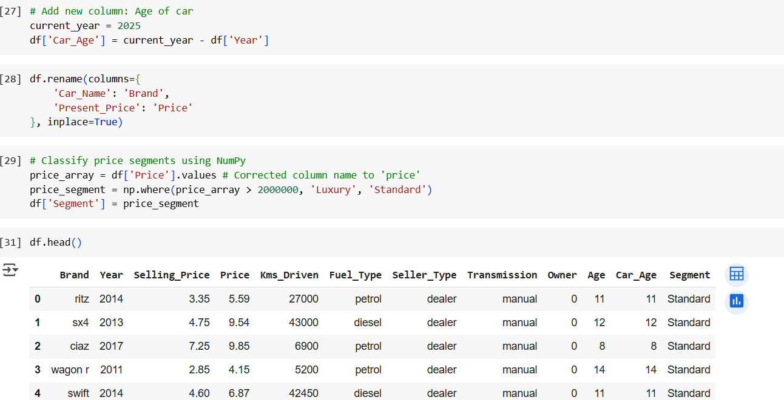

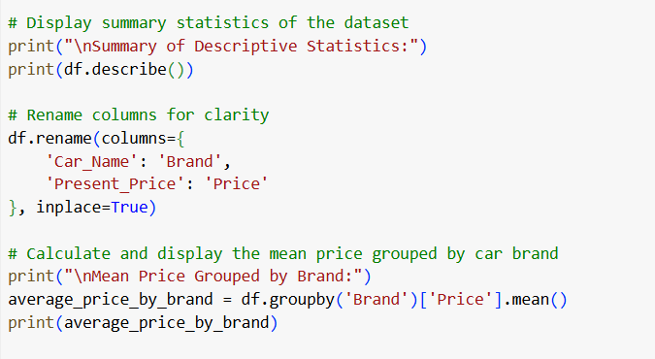
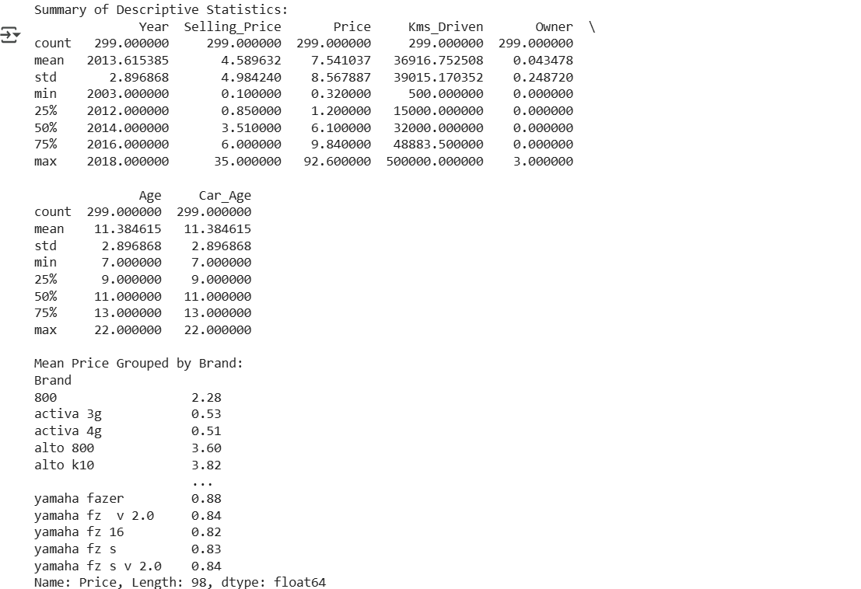

Exploratory Data Analysis/ Data Visualisation
Categorical Analysis
1.Pie Chart: Fuel Type Distribution and Transmission Type Distribution.
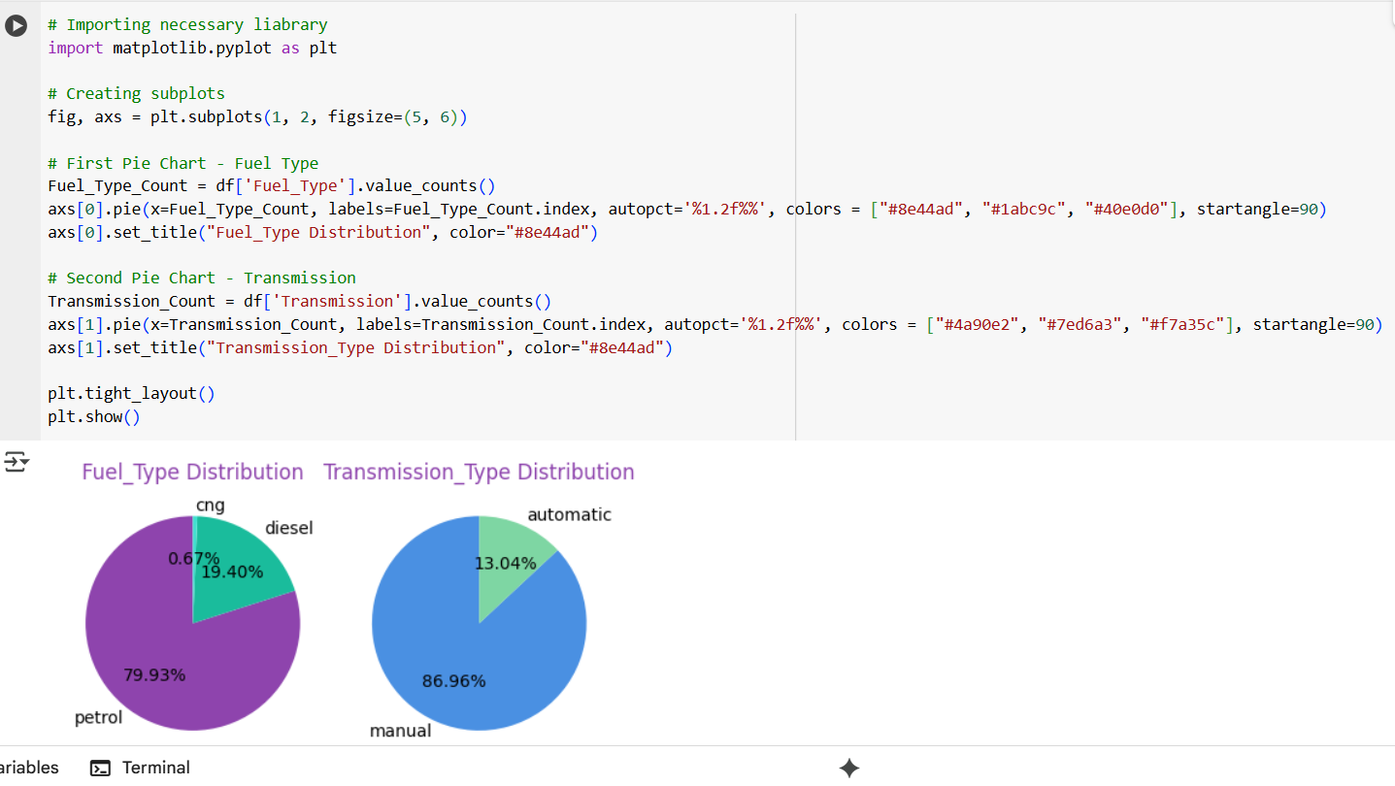
Interpretation:
1. Fuel Type Distribution
Most of the cars in the dataset run on Petrol, followed by Diesel. Very few cars use CNG.
-This tells us that Petrol cars are more popular in the resale market, likely because they are widely available and easier to maintain. Diesel cars are still present but less dominant, while CNG cars form only a very small segment.

2. Transmission Type Distribution
A large number of cars have Manual transmission, while only a smaller share are Automatic.
- This makes sense because Manual cars are generally cheaper and have been common for many years. Automatic cars are gaining popularity in cities, but in the resale market they are still fewer in number.
What This Means for Dealers
- Focus more on Petrol and Manual cars, since they make up the majority of sales.
- Keep some Automatic cars in stock too, as they appeal to city customers looking for convenience.
- Be aware of changing market trends, because the demand for Automatic and Electric cars is expected to rise in the future.

2. Count Plots:
i) Breakdown of Seller Type Categories
ii) Owner Count Distribution
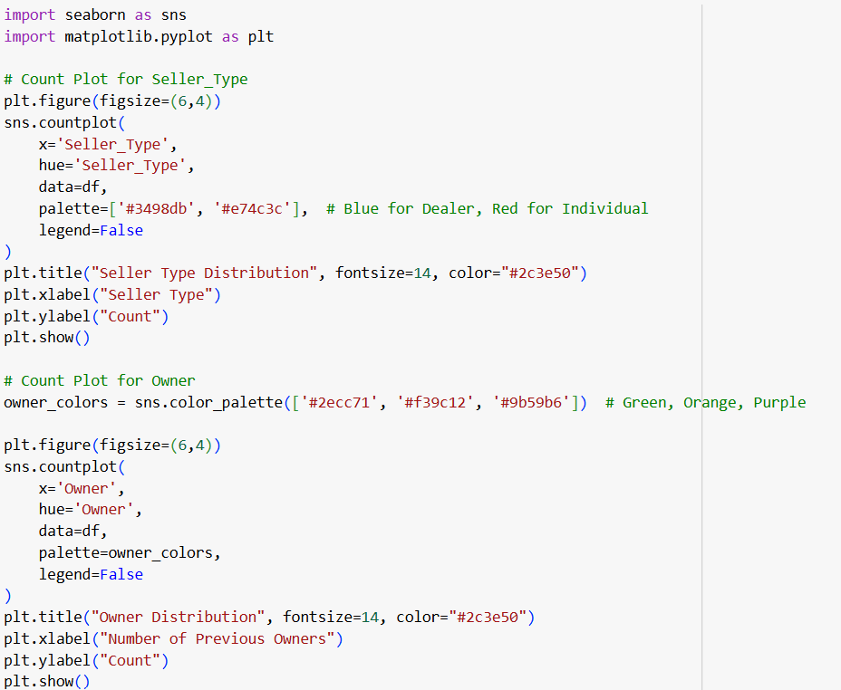
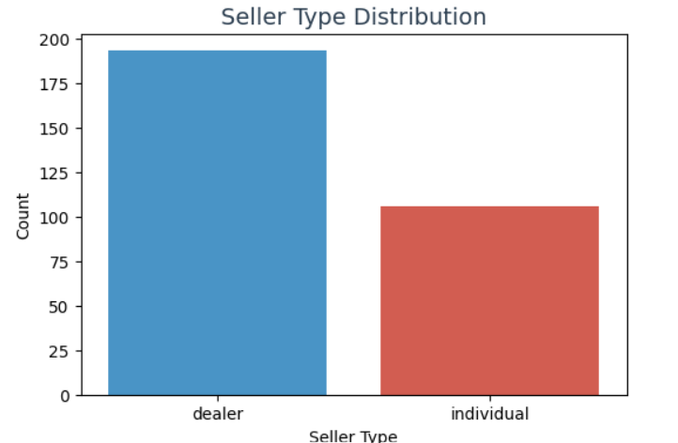
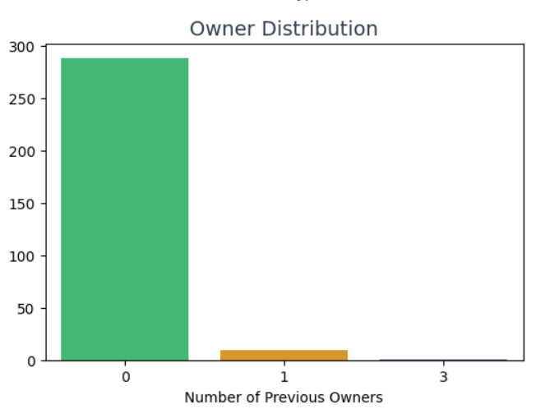

Interpretation:
1. Seller Type Distribution
The count plot shows two categories of sellers: Dealers and Individuals.
- Most of the cars in the dataset are listed by Individuals rather than by Dealers.
- This suggests that a majority of the resale market is made up of people selling their own personal cars directly, rather than going through showrooms or used-car dealerships.
Insight:
- Dealerships should recognize that individuals form a large supply base. Creating services like easy trade-in programs or direct purchase offers could help attract these sellers and increase dealership inventory.
2. Owner Distribution
The ownership distribution highlights how many previous owners a car has had.
- A significant majority of cars are first-owner vehicles (cars being resold by their original owner).
- There is also a smaller share of second-owner cars, while cars with three or more previous owners form a very tiny fraction of the dataset.
Insight:
- Buyers prefer first-owner cars because they are usually better maintained, have lower mileage, and hold higher resale value.
- Cars with multiple previous owners are harder to sell, as they are often seen as less reliable. Dealers should price them competitively if they want to move this segment.

Numerical Analysis
1.Histogram: Distribution of Resale Price
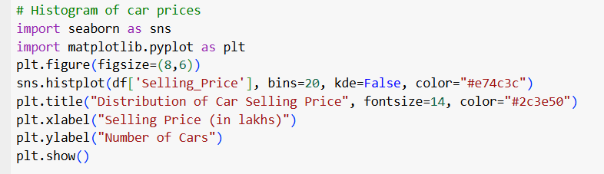
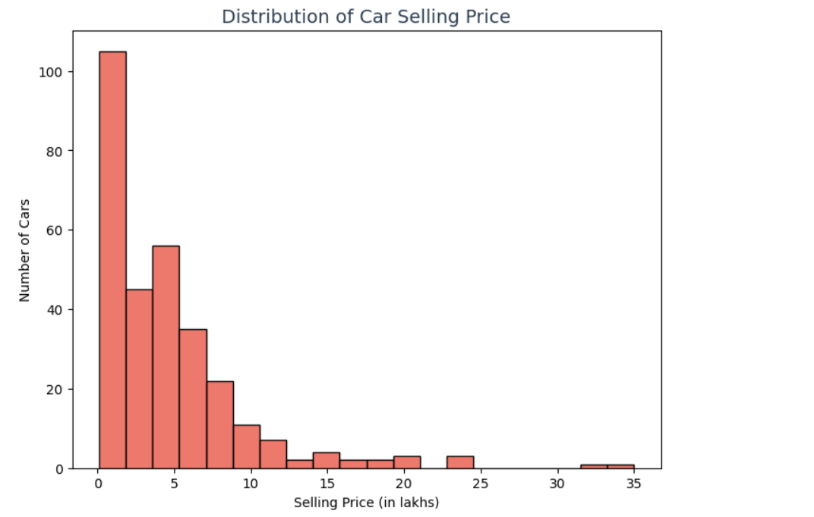

Interpretation of Histogram for Car Selling Price:
- Concentration of Cars at Lower Prices
  - The histogram shows that a large number of cars are clustered at lower selling prices (below 10 lakhs).
  - This suggests that budget and mid-segment cars dominate the resale market, which makes sense because they are more affordable and accessible to a wider group of buyers.
- Gradual Decline as Prices Increase
  - As the selling price rises beyond 10 lakhs, the number of cars decreases steadily.
  - This means fewer owners are reselling premium or high-end vehicles, and the demand for these cars is comparatively lower in the used-car segment.
- Rare High-End Cars
  - Cars priced above 15 lakhs appear only occasionally in the dataset.
  - These represent luxury or premium vehicles, which are a small niche within the resale market.
- Market Insights
  - The data indicates that the resale car market is price sensitive, with most activity happening in the affordable to mid-range category.
  - Dealers should focus on stocking and promoting these segments to attract the majority of customers.
  - While luxury cars can still be marketed, they may need targeted strategies (e.g., exclusive promotions, premium showrooms) since their buyer base is much smaller.

2. i.)Boxplot : Selling Price Distribution
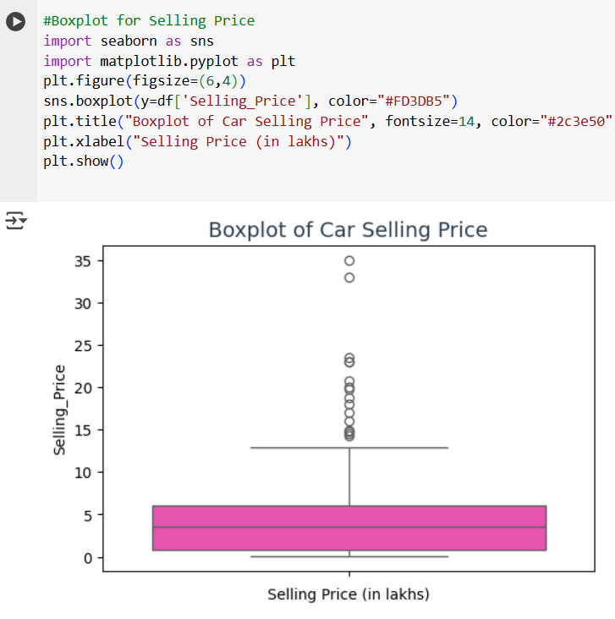
Interpretation of Boxplot for Selling Price:
- Median Selling Price
  - The line inside the box represents the median resale price of cars.
  - It shows the typical selling price around which most cars are traded.
- Spread of Prices (Interquartile Range)
  - The box covers the middle 50% of the data (IQR).
  - This means half of the cars fall within this range, giving us a good idea of the “normal” resale price range.
- Lower-Priced Cars
  - The left whisker extends towards the lower end, showing a high number of budget cars in the market.
  - These cars drive the majority of resale activity.
- Presence of Outliers
  - The individual points plotted beyond the right whisker represent outliers — cars that are priced much higher than the rest (luxury or premium vehicles).
  - These are rare cases compared to the main bulk of affordable and mid-range cars.
- Market Insight
  - The resale market is concentrated on affordable cars, with only a handful of high-value outliers.
  - Dealers should treat these outliers carefully, as they might take longer to sell and require targeted premium marketing.

ii.)Boxplot grouped by Fuel_Type or Transmission
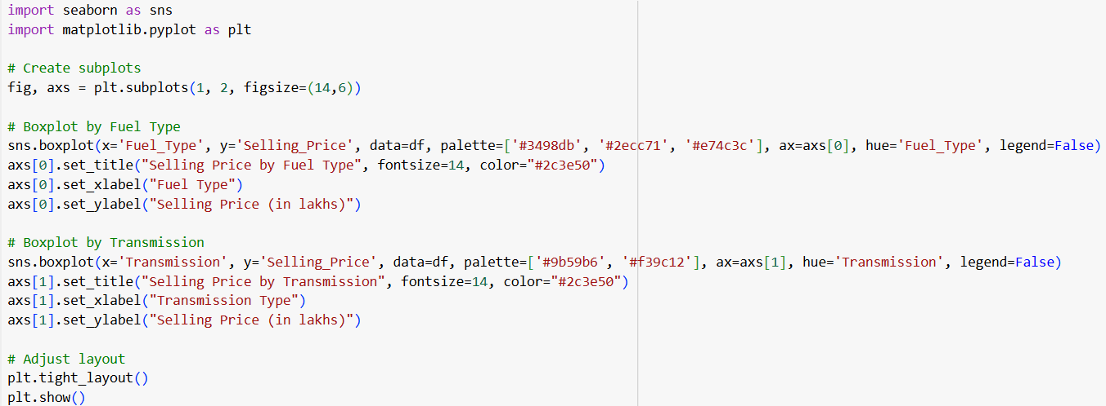

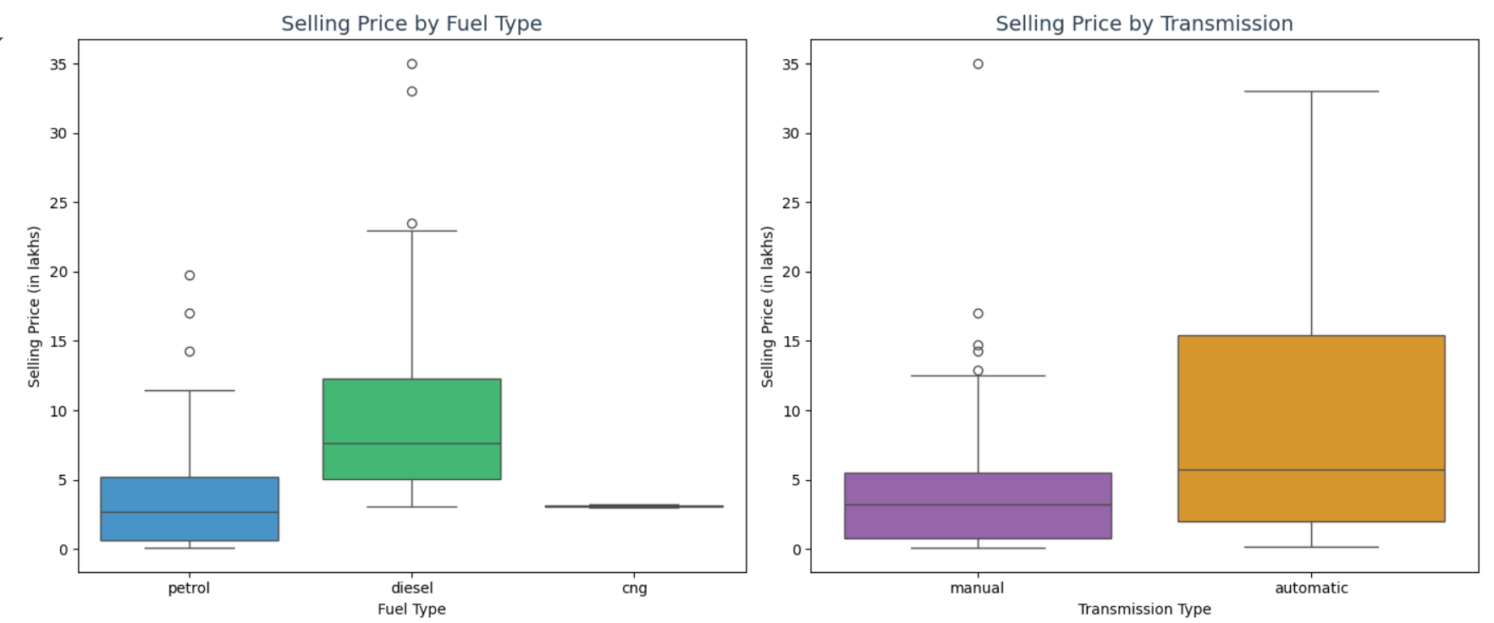

Interpretation:
Fuel Type vs. Selling Price
The box plot for 'Fuel_Type' will compare the distribution of selling prices for cars that run on Petrol, Diesel, and possibly CNG.
- Median and IQR: The median line inside each box will show the typical selling price for each fuel type. The box itself represents the interquartile range (IQR), showing where the middle 50% of cars fall in terms of price.
- Outliers: You will likely see outliers, represented by dots or diamonds, which are cars with significantly higher (or lower) selling prices than the rest of their group. These might be luxury models or very old, collectible cars.
- Key Insight: Generally, diesel cars tend to have a higher selling price distribution than petrol or CNG cars. This is often because diesel engines are more fuel-efficient and have a longer lifespan, making them more valuable in the used car market. The box plot would visually confirm this, showing a higher median and potentially a wider price range for diesel vehicles.

Transmission vs. Selling Price
The box plot for 'Transmission' will compare the selling prices of manual and automatic cars.
- Median and IQR: Similar to the fuel type plot, the median and IQR will show the typical price and spread for each transmission type.
- Outliers: Outliers in this plot might represent high-end luxury vehicles that are exclusively automatic or very rare vintage cars with manual transmissions.
- Key Insight: The plot is expected to show that automatic cars generally have a higher selling price than their manual counterparts. This is due to the convenience and technology associated with automatic transmissions, which are more common in newer and more expensive vehicle models. The box plot would likely show the entire distribution for automatic cars shifted to a higher price range compared to manual cars.

4.Bar Plot: Average Selling Price Vs Fuel Type
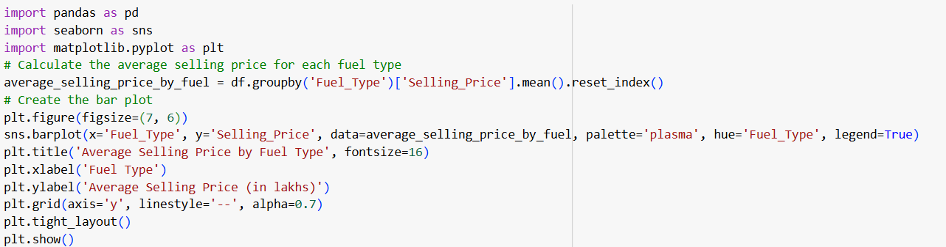
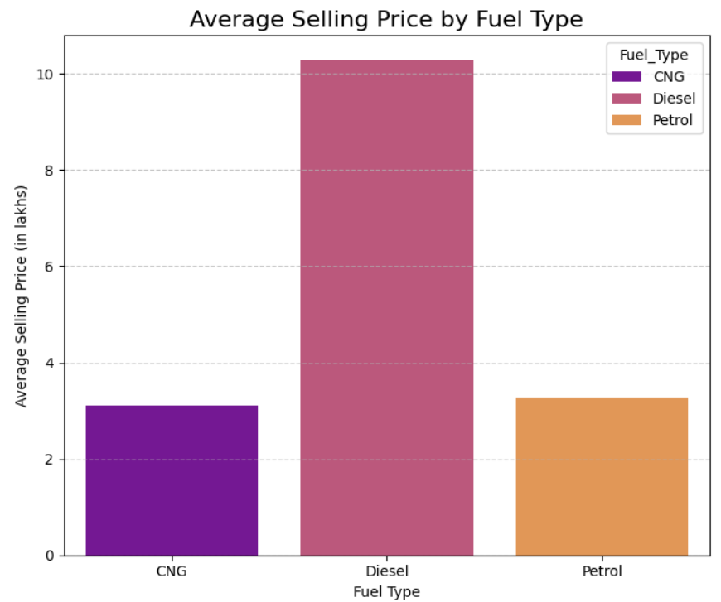

Interpretation:
Diesel vs. Selling Price
The plot shows that diesel cars have the highest average selling price, significantly surpassing both petrol and CNG vehicles. There are several key reasons for this:
- Fuel Efficiency: Diesel engines are generally more fuel-efficient than petrol engines, especially on long-distance journeys. This translates to lower running costs over the car's lifetime, making them a valuable asset in the used car market.
- Initial Cost and Value Retention: Diesel variants of a car model typically have a higher ex-showroom price than their petrol counterparts. This higher initial investment is often reflected in a stronger resale value.
- Durability: Diesel engines are renowned for their durability and a longer lifespan, often with higher mileage. This factor contributes to a car's perceived value and its ability to command a higher price.
Petrol vs. Selling Price
Petrol cars occupy the middle ground, with an average selling price lower than diesel but higher than CNG. This is largely because:
- Market Standard: Petrol cars form the largest segment of the Indian car market. Their pricing is a benchmark against which other fuel types are compared.
- Lower Initial Cost: Petrol variants are generally more affordable to purchase new, which affects their resale value.
- Maintenance: Maintenance for petrol engines is often considered to be less complex and more cost-effective than for diesel engines.
CNG vs. Selling Price
CNG cars have the lowest average selling price among the three fuel types. This trend is driven by:
- Conversion from Petrol: Many CNG vehicles are petrol cars that have been fitted with a CNG kit. These cars are usually a budget-friendly option for buyers seeking to reduce running costs.
- Initial Purpose: CNG cars are often purchased for their low fuel cost, making them a popular choice for city use and taxis, which may lead to higher mileage and subsequent depreciation.
- Performance: CNG engines typically produce less power and torque than their petrol or diesel equivalents, a trade-off for their lower running costs. This can affect their desirability and, consequently, their resale value.

ii.) BarPlot: Average Selling Price by Seller Type
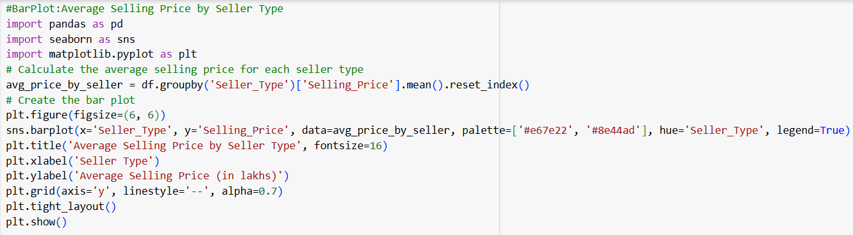
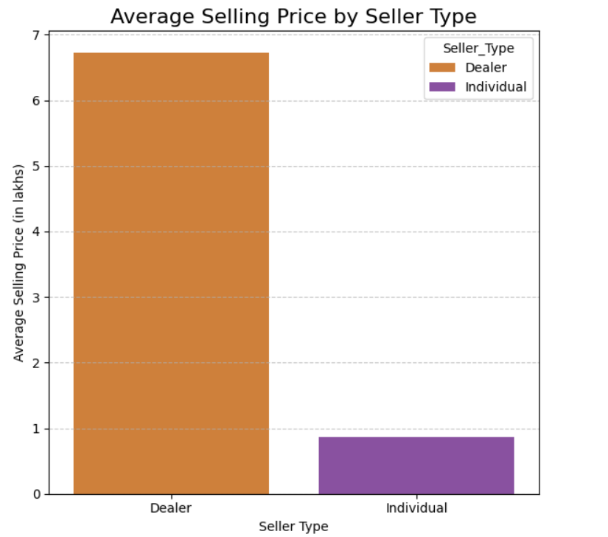

Interpretation:
Observation:
- Dealers consistently sell cars at a higher average price compared to Individuals.
- The price gap indicates that the seller type directly impacts resale value.
- Dealers:
  - Average selling price is the highest among the two categories.
  - This is likely due to added services like warranty, refurbishing, and financing options.
- Individuals:
  - Average selling price is noticeably lower.
  - Cars sold directly by owners are usually cheaper because they skip middlemen profit margins.
Business Insight:
- For Buyers:
  - If budget is a priority, buying from Individuals is cost-effective.
  - However, they should be cautious and thoroughly check the vehicle’s condition.
- For Sellers:
  - Dealers can command higher prices due to added trust, reputation, and service.
  - Individuals may sell faster but at lower prices, appealing to buyers looking for affordable deals.
Conclusion:
The bar plot highlights a simple but strong insight — Dealer = higher price, Individual = lower price.
This difference reflects how trust, added value, and business margins shape the used car market.

5.Line Plot: Average Selling Price Per Year
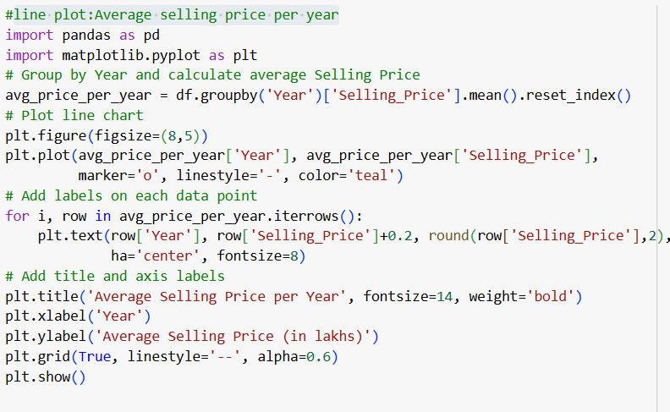
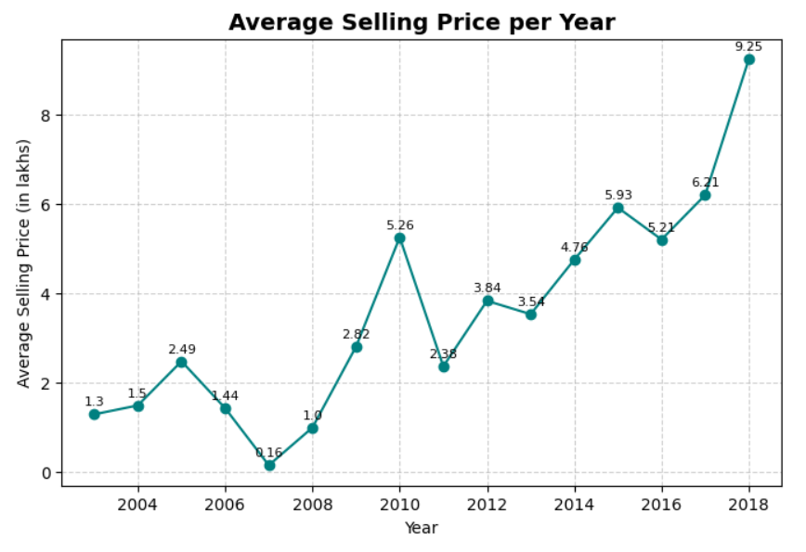

Interpretation:
Key Insights
Trend Observation:
- There’s a clear upward trend in average selling prices as the years progress.
- Newer cars (2015–2018) command significantly higher resale prices.
- Older models (2003–2009) are valued much lower on average.
Notable Points:
- 2007: Extremely low average price — likely due to very few old vehicles in the dataset, undervalued by buyers.
- 2010: Sharp spike in average price, possibly because more premium models entered the market that year.
- 2018: Highest average selling price — expected since these are the newest used cars in the dataset.
Insight:
- Car depreciation is clearly visible: as a car gets older, its resale value declines.
- Cars from recent years retain higher resale value, making them better for sellers.
- Buyers looking for affordable options should consider models older than 2012, while sellers benefit most from newer models.
Conclusion:
The line plot shows a direct link between car age and resale value — newer cars = higher price, older cars = lower price.

6.Scatter plot: Present Price Vs Selling Price
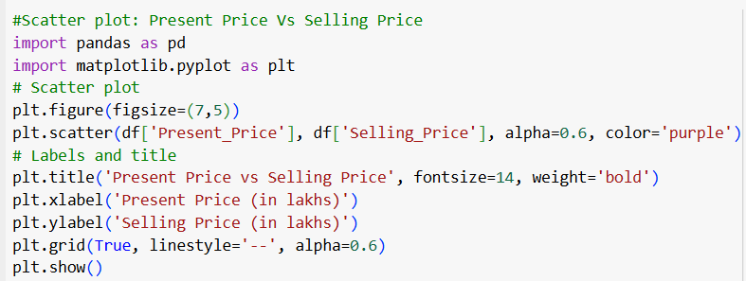
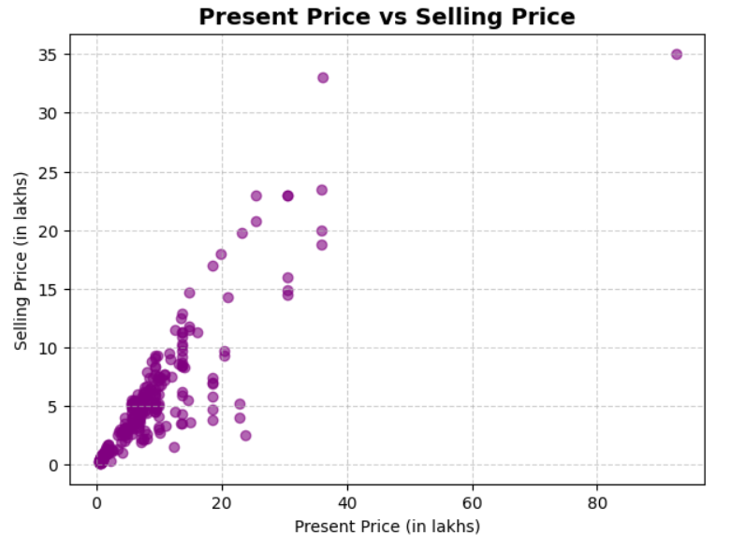
Interpretation
- The scatter plot will show how the current market price (Present Price) of a car relates to its Selling Price.
- General Trend: As the present price increases, the selling price also increases (positive correlation).
- Spread:
  - For low present prices (<5 lakhs) → selling prices are also low.
  - For higher present prices (>10 lakhs) → selling prices rise sharply, though some points may fall below the trend (cars depreciate fast).
- Insight: Selling price is strongly influenced by the present price, but cars never resell at the same value as their present price → clear evidence of depreciation.

7.Heatmap: Correlation Heatmap’s of Car Features
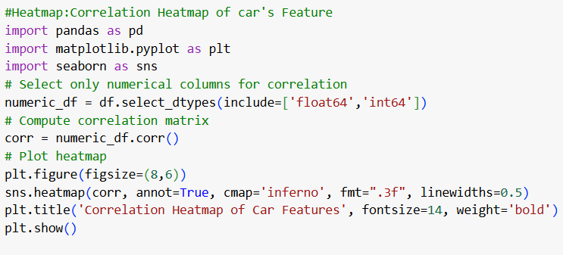
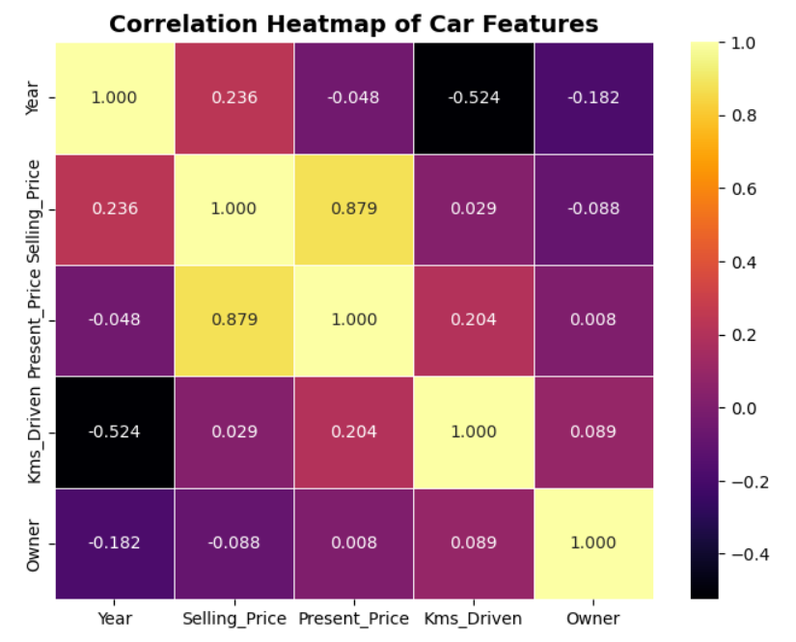
Interpretation:
Key Insights from the Heatmap
Key Insights from Heatmap Analysis
1. Selling Price & Present Price (Correlation: ~0.88)
- Shows a very strong positive relationship.
- The current market price is the best indicator of how much a car will sell for.
- Naturally, cars with higher market value tend to fetch higher resale prices.
2. Selling Price & Kms Driven (Correlation: ~0.03)
- Shows almost no relationship.
- In this dataset, kilometers driven doesn’t strongly influence selling price.
- Likely because factors like brand reputation, condition, and demand play a bigger role than mileage alone.
3. Year & Kms Driven (Correlation: ~-0.53)
- A moderate negative correlation.
- Older cars tend to have higher mileage, which is logical and expected.
- Confirms the intuition: the older the model, the more it has usually been driven.
4. Owner & Selling Price (Correlation: ~-0.09)
- A very weak negative relationship.
- Cars with more previous owners may sell for slightly less, but the impact is minor.
- Ownership history matters far less compared to car age and market value.
Business Takeaway
- The current market price (Present Price) and car age are the strongest drivers of resale value.
- Mileage and number of owners have only a small influence in this dataset.
- For pricing strategies or predictive models, focusing on Present Price + Age/Year will give the most reliable results.
.

OOPs Implementation:
To provide customer’s services by giving them better Car options.
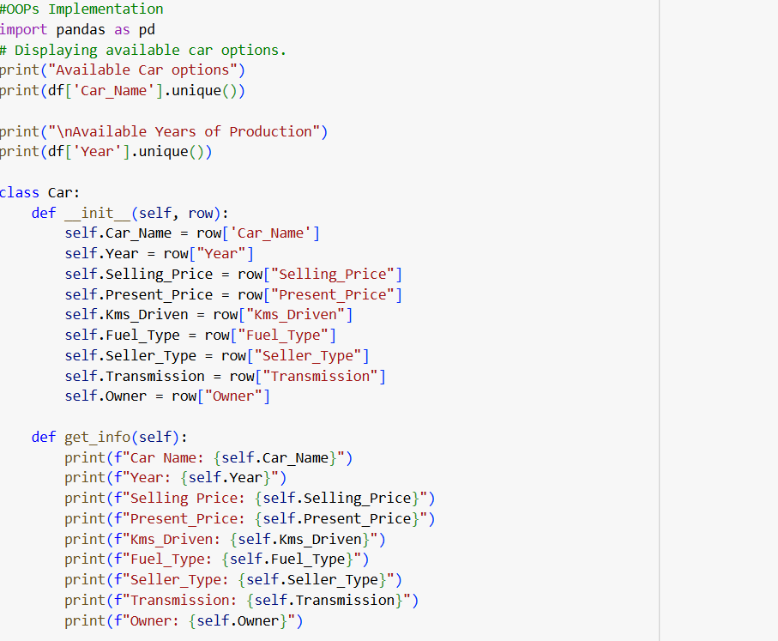
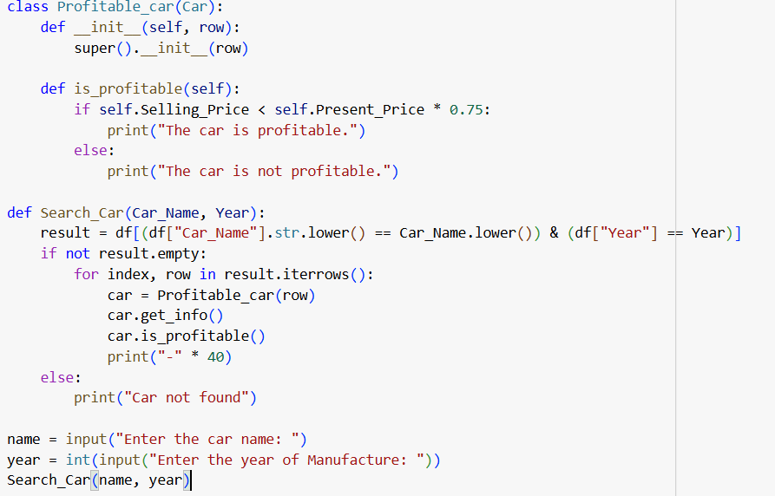
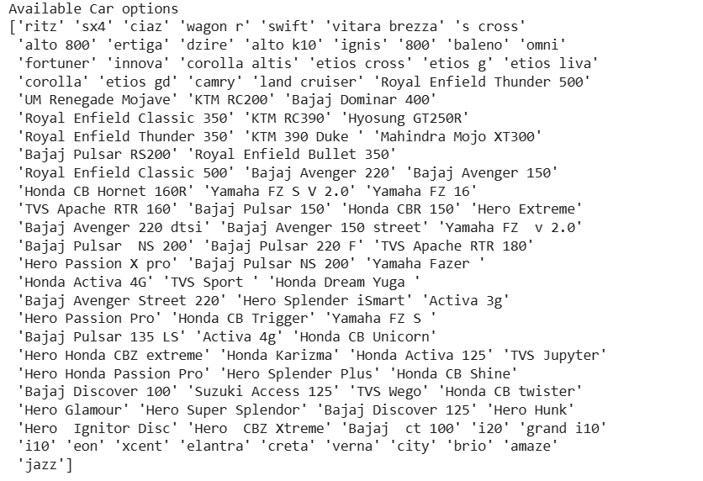
Output1:
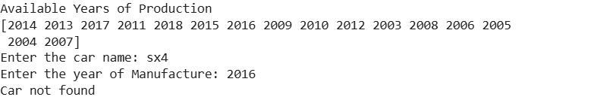
Output2:
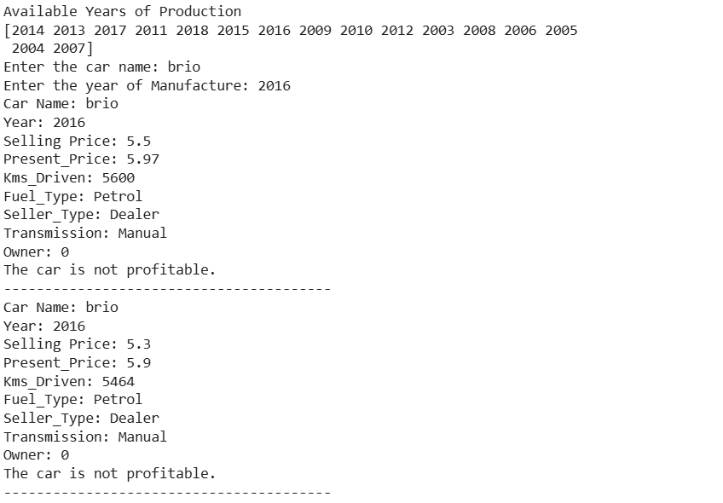

Overall Conclusion
This project set out to explore the factors that shape car resale prices using data cleaning, statistical analysis, and visualization techniques. The insights gained can help both dealerships and customers make smarter decisions in the used car market.
- Present Price as the strongest driver
Cars with a higher original market price tend to fetch higher resale values. The strong correlation (0.88) confirms that resale price largely follows the present price of the car.
- Impact of Age
Older cars consistently sell for less. The negative correlation between Age and resale price shows that depreciation significantly reduces a car’s value over time.
- Weaker influence of other variables
Factors like kilometers driven, number of previous owners, and year of manufacture show weaker or less consistent relationships with selling price, meaning they influence value but not as strongly on their own.
- Year vs. Age
Since Year and Age are perfectly inversely related, they provide the same information. For modeling, Age is often the better variable to retain as it directly reflects depreciation.
- Effect of multiple owners
Cars that have had multiple owners generally sell for less. This is likely due to buyer concerns about how well the car has been maintained.
- Market bias toward newer models
Cars older than 2010 are often undervalued, making them attractive to budget-conscious buyers. On the other hand, models from 2015–2018 tend to retain better value and offer higher profit margins for dealers.
- Trust in first-owner cars
First-owner vehicles are perceived as more reliable and better maintained, which boosts their resale price compared to cars that have exchanged hands multiple times.
- Sweet spot in pricing
The bulk of resale activity occurs in the ₹2–6 lakh price range. Cars in this segment are affordable to a large portion of buyers, making them the most competitive and in-demand category.

Final Note:
This analysis demonstrates that car resale value is influenced by multiple factors, including market price, age, ownership history, and vehicle specifications such as fuel and transmission type. Leveraging these insights enables dealerships to accurately assess vehicle worth, set competitive prices, and optimize profitability. At the same time, customers gain clarity on the key drivers of depreciation, empowering them to make more informed purchasing decisions. By applying data-driven approaches, both dealerships and customers benefit from improved transparency, fairness, and value in the car resale market.

GoogleColab Link-
https://colab.research.google.com/drive/1rBa1Cy6hxaSKaI5JULkOKrbEGiAcVWeR?usp=sharing

End of Document
Thank you for your attention to this project report.

Disclaimer: This analysis is based on the provided dataset and may not reflect the entirety of the car resale market. All visualizations and interpretations are for illustrative purposes.

