**Activity 6:**

**15th October 2019**

**Team: Anurag Bejju and Denise Chen**

**Hypothesis:** The quantity of symbols used doesn’t always give a clear scope of the value indicated by each symbol

**Example:**

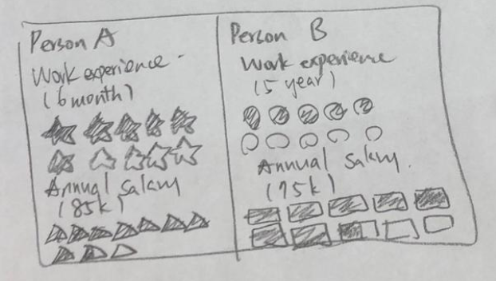

Things we can do to improve the usage of symbols to in order to provide a clear scope of the value

* We can represent quantities using symbol by light shade to dark shade colors
* We could use a single symbol and increase the size to represent quantity
* We could assign each symbol to a class range of quantity
* We could use density of symbols to identify more concentrated locations on a map
* We could use logos to categorize different quantities