**SQL QUERIES**

**CREATION OF TABLES**

1 - CREATE TABLE Employees (

EmployeeID INT,

Name VARCHAR(30),

Salary INT,

DepartmentID INT,

ManagerID INT,

DateOfBirth DATE );

2 - CREATE TABLE Customers ( CustomerID INT, CustName VARCHAR(100) );

3 - CREATE TABLE Orders (

OrderID INT,

CustomerID INT,

OrderDate DATE,

OrderValue INT );

**INSERTION OF VALUES INTO TABLES**

1 - INSERT INTO Employees VALUES

(1, 'Alice', 7500, 101, NULL, '1985-03-25'),

(2, 'Bob', 6800, 102, 1, '1990-07-15'),

(3, 'Charlie', 7200, 101, 1, '1982-11-10'),

(4, 'Diana ', 6900, 103, 2, '1987-09-30'),

(5, 'Edward', 7100, 102, 2, '1992-01-20');

2 - INSERT INTO Customers (CustomerID, CustName) VALUES

(201, 'John Doe'), (202, 'Jane Smith'), (203, 'Emily Johnson'),

(204, 'Michael Brown'),

(205, 'Sarah Davis');

3 - INSERT INTO Orders (OrderID, CustomerID, OrderDate, OrderValue) VALUES

(1001, 201, '2024-07-15', 250),

(1002, 201, '2024-07-16', 450),

(1003, 203, '2024-07-17', 300),

(1004, 204, '2024-07-18', 150),

(1005, 204, '2024-07-19', 600);

SELECT * FROM Employees

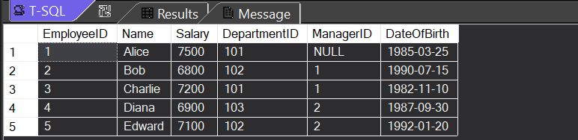

SELECT * FROM Customers

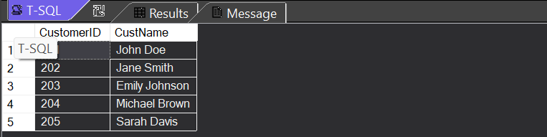

SELECT * FROM Orders

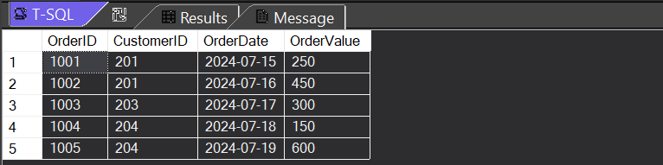

**QUERIES**

1 - Find Employees with No Manager

SELECT EmployeeID, Name

FROM Employees

WHERE ManagerID IS NULL;

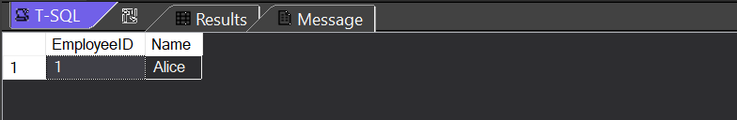

2 - Find Average Salary and Number of Employees in Each Department

SELECT

AVG(Salary) AS Avg_Salary, COUNT(EmployeeID) AS Emp_Count, DepartmentID

FROM Employees

GROUP BY DepartmentID;

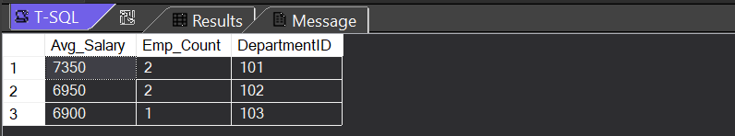

3 - Find the Oldest and Youngest Employees

- To find 'oldest' employee :

SELECT TOP 1

EmployeeID, Name, DateOfBirth, DATEDIFF(YEAR, DateOfBirth, GETDATE()) AS Age

FROM Employees

ORDER BY 4 DESC

-- LIMIT 1;

- To find 'youngest' employee :

SELECT TOP 1

EmployeeID, Name, DateOfBirth, DATEDIFF(YEAR, DateOfBirth, GETDATE()) AS Age

FROM Employees

ORDER BY 4;

--LIMIT 1;

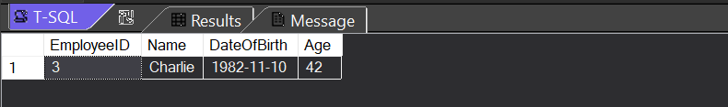

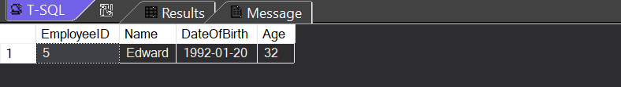

4 - Find Customers with Multiple Orders

SELECT

C.CustomerID,

C.CustName,

COUNT(O.OrderDate) AS OrderCount

FROM Customers AS C JOIN Orders AS O

ON C.CustomerID = O.CustomerID

GROUP BY C.CustomerID, C.CustName

HAVING COUNT(O.OrderDate) > 1;

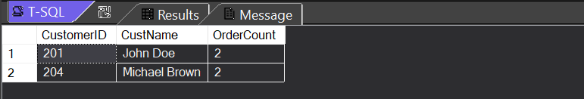

5 - Find Orders with the Largest Order Value

SELECT TOP 1

OrderID,

CustomerID,

OrderValue

FROM Orders

ORDER BY OrderValue DESC

--LIMIT 1;

