**ELECTRIC VEHICLE (EV) ADOPTION TRENDS ACROSS INDIA**

**Objective:**

To analyse the electric vehicle (EV) adoption trends across different states in India, identify key factors contributing to regional disparities, and propose strategies to enhance EV adoption.

**Problem Statement:**

Why do certain states in India exhibit significantly higher or lower rates of EV adoption, and what strategies can be implemented to address these regional disparities?

**Assumptions**

1. The dataset accurately represents the EV sales across Indian states.

2. EV sales data is indicative of overall EV adoption trends in each state.

3. Regional disparities in EV adoption are influenced by factors such as state policies, infrastructure, and consumer preferences.

**Research Questions**

1. Which states have the highest and lowest EV sales?

2. What is the distribution of EV sales across different vehicle types?

3. Which vehicle category (e.g., commercial or passenger) is the most popular?

4. How does the adoption of different vehicle types vary across states?

5. How have EV sales evolved over different years?

**Hypothesis**

1. States with higher urbanization and better infrastructure have higher EV sales.

2. Passenger vehicles have higher sales compared to commercial vehicles due to personal use.

3. Certain vehicle types (e.g., two-wheelers) dominate EV sales in states with higher population density.

4. EV sales have been increasing over the years due to favorable policies and increased consumer awareness.

**Analysis and Findings**

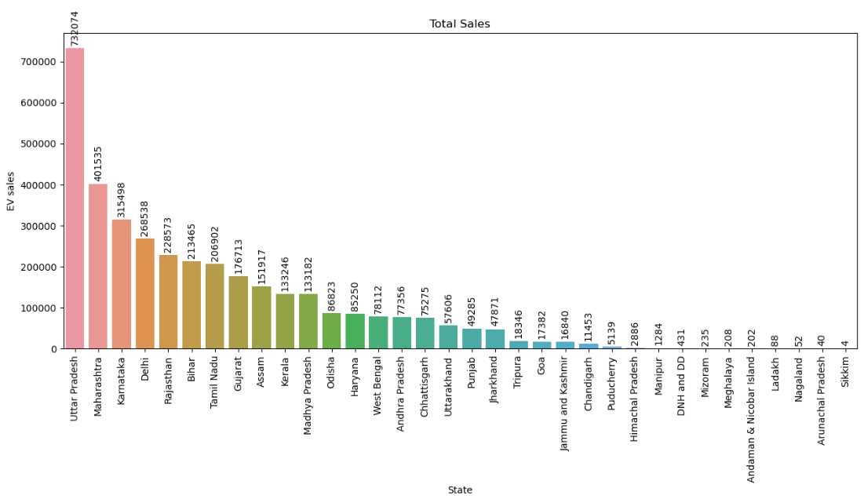

**Findings:**

* The states with the highest EV sales are Maharashtra, Karnataka, and Tamil Nadu.
* The states with the lowest EV sales are Mizoram, Nagaland, and Sikkim.

**Conclusion:**

* Higher EV sales in states like Maharashtra, Karnataka, and Tamil Nadu can be attributed to better infrastructure, government incentives, and higher urbanization levels. On the other hand, states with lower sales may lack adequate infrastructure and incentives for EV adoption.

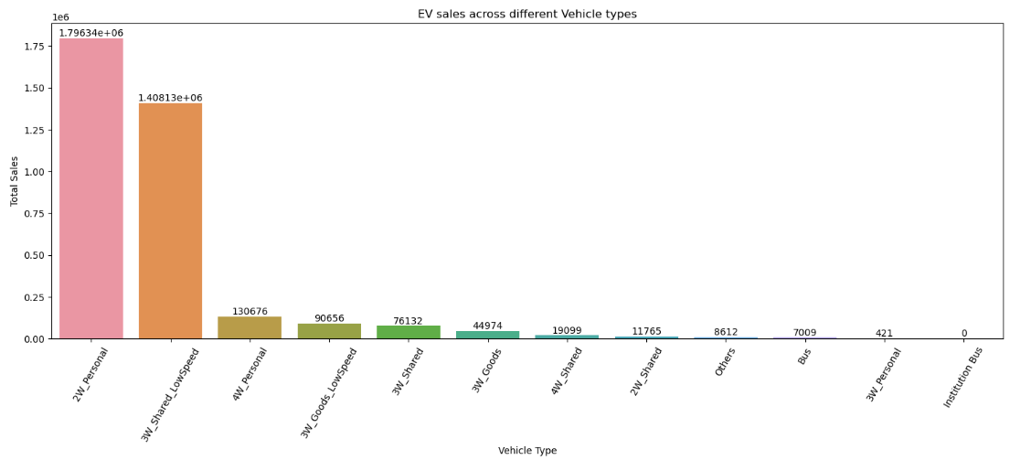

**Findings:**

* Two-wheelers dominate the EV sales, followed by three-wheelers and four-wheelers.

**Conclusion:**

* The high sales of two-wheelers indicate their popularity and practicality in Indian urban and rural settings. The affordability and ease of use of two-wheelers make them a preferred choice for many consumers.

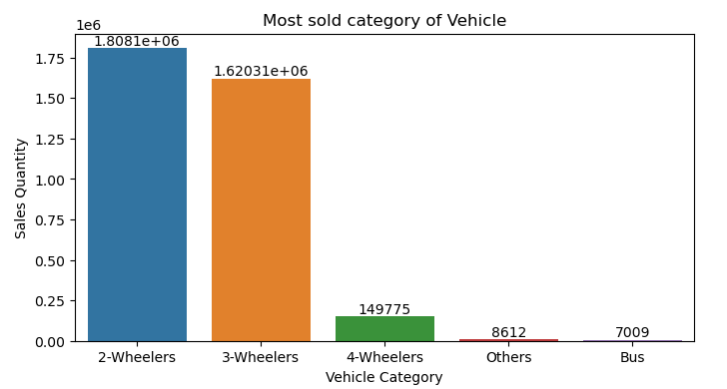

**Findings:**

* Passenger vehicles have significantly higher sales compared to commercial vehicles.

**Conclusion:**

* The dominance of passenger vehicles suggests that personal use of EVs is more widespread than commercial use. This could be due to increasing consumer awareness and preference for eco-friendly personal transportation.

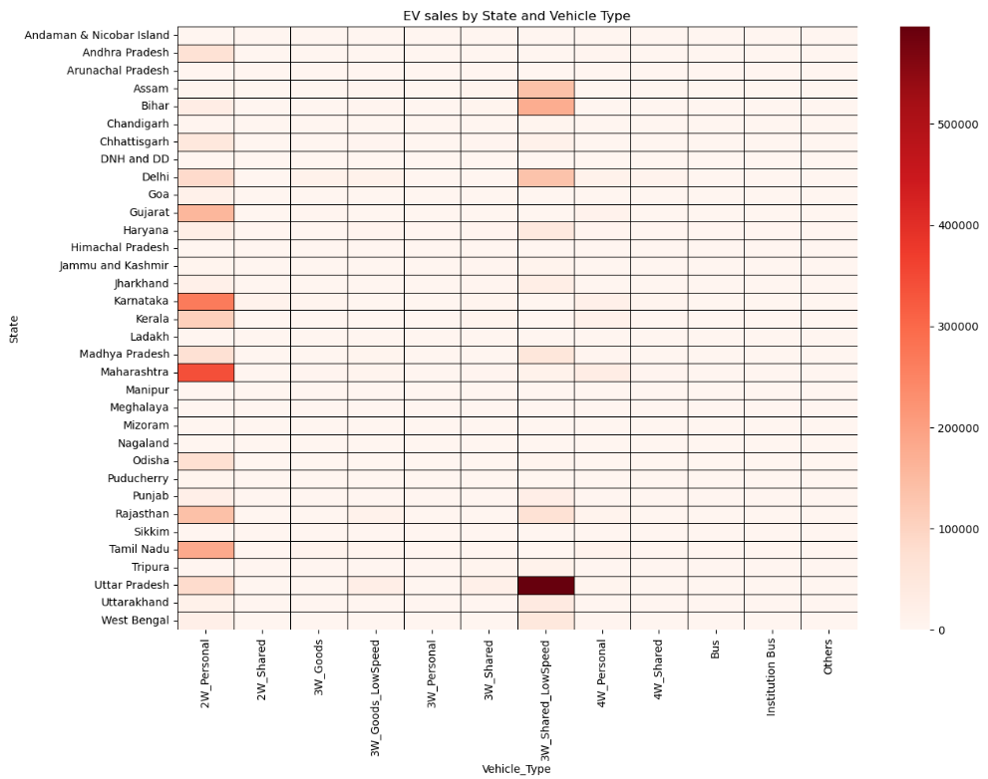

**Findings:**

* States like Maharashtra and Karnataka have high sales across all vehicle types, whereas states like Mizoram and Nagaland have low sales.

**Conclusion:**

* The variation in vehicle type adoption across states highlights the need for region-specific strategies to promote EV adoption. For instance, promoting two-wheelers in states with high population density and four-wheelers in states with better road infrastructure.

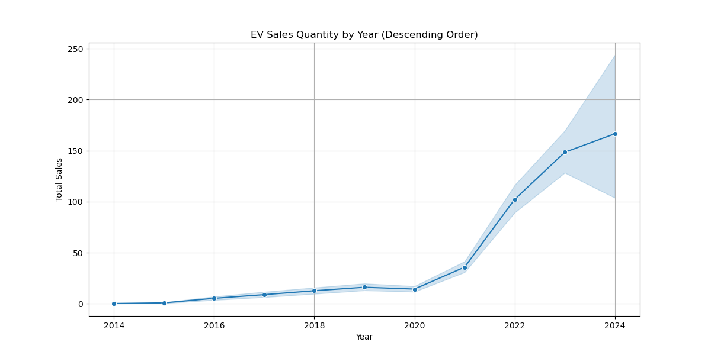

**Findings:**

* EV sales have shown a consistent upward trend over the years.

**Conclusion:**

* The increasing trend in EV sales can be attributed to growing environmental awareness, better technology, and supportive government policies. Continued efforts in these areas are likely to sustain this growth trajectory.

**Suggestions**

**Market Strategies**

- Focus on promoting popular vehicle categories (i.e. 2-Wheelers, 3-Wheelers ) in regions with higher adoption rates.

- Collaborate with local governments to address regional barriers to EV adoption.

- Analyse consumer preferences and tailor marketing strategies accordingly.