## Probability Practice :

### Part A :

Visitors to your website are asked to answer a single survey question before they get access to the content on the page. Among all of the users, there are two categories: Random Clicker (RC), and Truthful Clicker (TC). There are two possible answers to the survey: yes and no. Random clickers would click either one with equal probability. You are also giving the >information that the expected fraction of random clickers is 0.3.

After a trial period, you get the following survey results: 65% said Yes and 35% said No.

What fraction of people who are truthful clickers answered yes?

Probability of yes for a random clicker. P(Y/R) = 0.5

Fraction of random clicker P(R) = 0.3

Fraction of truthful clicker P(T) = 0.7

Fraction of yes P(Y) = 0.65

Fraction of no P(N) = 0.35

Fraction of yes explained as a sum of conditional probability P(Y) = P(Y/R)xP(R) + P(Y/T)xP(T)

0.65 = 0.5x0.3 + P(Y/T)x0.7

Fraction of truthful clickers that answered yes P(Y/T) = 0.714

### Part B :

Imagine a medical test for a disease with the following two attributes:

The sensitivity is about 0.993. That is, if someone has the disease, there is a probability of 0.993 that they will test positive. The specificity is about 0.9999. This means that if someone doesn't have the disease, there is probability of 0.9999 that they will test negative. In the general population, incidence of the disease is reasonably rare: about 0.0025% of all people have it (or 0.000025 as a decimal probability).

Suppose someone tests positive. What is the probability that they have the disease? In light of this calculation, do you envision any problems in implementing a universal testing policy for the disease?

P(D) = Probability of having the disease

P(T) = Probability of testing positive.

P(N) = Probability of testing negative

P(ND) = Probability of not having disease

P(T/D) = Probability of testing positive given that they have the disease

P(N/ND) = Probability of testing negative given that they do not have the disease

P(D) = 0.000025

P(T/D) = 0.993

P(N/ND) = 0.9999

We use Bayes theorem to calculate the probability, P(D/T) which is probability of having the disease given that the test is positive.

P(D/T) = P(T/D)xP(D)/ P(T)

P(T) = P(T/D)xP(D) + (1-P(N/ND))x(1-P(D))

P(D/T) = 0.993 x 0.000025/ ( 0.993 x 0.000025 + (1-0.9999) x (1 - 0.000025))

P(D/T) = 0.1988

If a universal testing policy is implemented, then the chance that they actually have the disease when they are tested positive is 0.198 which is a low value. The probability that the person does not have the disease is very high ( 1 - 0.000025 ). Because of this, if a user tests positive, then it is more likely that they do not have the disease than they do.

## Green buildings

library(ggplot2)  
library(lattice)  
library(mosaic)

## Loading required package: dplyr

##   
## Attaching package: 'dplyr'

## The following objects are masked from 'package:stats':  
##   
## filter, lag

## The following objects are masked from 'package:base':  
##   
## intersect, setdiff, setequal, union

## Loading required package: mosaicData

## Loading required package: Matrix

##   
## The 'mosaic' package masks several functions from core packages in order to add additional features.   
## The original behavior of these functions should not be affected by this.

##   
## Attaching package: 'mosaic'

## The following object is masked from 'package:Matrix':  
##   
## mean

## The following objects are masked from 'package:dplyr':  
##   
## count, do, tally

## The following objects are masked from 'package:stats':  
##   
## binom.test, cor, cov, D, fivenum, IQR, median, prop.test,  
## quantile, sd, t.test, var

## The following objects are masked from 'package:base':  
##   
## max, mean, min, prod, range, sample, sum

library(RCurl)

## Loading required package: bitops

set.seed(100)  
rm(list=ls()) #Clear Workspace  
temp = getURL("https://raw.githubusercontent.com/matt-staton/stat_380/master/greenbuildings.csv")  
greenbuildings = read.csv(text = temp, header=T)  
gbuild = greenbuildings  
  
attach(gbuild)  
gbuild$Rent_Diff = Rent - cluster_rent  
names(gbuild)

## [1] "CS_PropertyID" "cluster" "size"   
## [4] "empl_gr" "Rent" "leasing_rate"   
## [7] "stories" "age" "renovated"   
## [10] "class_a" "class_b" "LEED"   
## [13] "Energystar" "green_rating" "net"   
## [16] "amenities" "cd_total_07" "hd_total07"   
## [19] "total_dd_07" "Precipitation" "Gas_Costs"   
## [22] "Electricity_Costs" "cluster_rent" "Rent_Diff"

summary(gbuild)

## CS_PropertyID cluster size empl_gr   
## Min. : 1 Min. : 1.0 Min. : 1624 Min. :-24.950   
## 1st Qu.: 157452 1st Qu.: 272.0 1st Qu.: 50891 1st Qu.: 1.740   
## Median : 313253 Median : 476.0 Median : 128838 Median : 1.970   
## Mean : 453003 Mean : 588.6 Mean : 234638 Mean : 3.207   
## 3rd Qu.: 441188 3rd Qu.:1044.0 3rd Qu.: 294212 3rd Qu.: 2.380   
## Max. :6208103 Max. :1230.0 Max. :3781045 Max. : 67.780   
## NA's :74   
## Rent leasing_rate stories age   
## Min. : 2.98 Min. : 0.00 Min. : 1.00 Min. : 0.00   
## 1st Qu.: 19.50 1st Qu.: 77.85 1st Qu.: 4.00 1st Qu.: 23.00   
## Median : 25.16 Median : 89.53 Median : 10.00 Median : 34.00   
## Mean : 28.42 Mean : 82.61 Mean : 13.58 Mean : 47.24   
## 3rd Qu.: 34.18 3rd Qu.: 96.44 3rd Qu.: 19.00 3rd Qu.: 79.00   
## Max. :250.00 Max. :100.00 Max. :110.00 Max. :187.00   
##   
## renovated class_a class_b LEED   
## Min. :0.0000 Min. :0.0000 Min. :0.0000 Min. :0.000000   
## 1st Qu.:0.0000 1st Qu.:0.0000 1st Qu.:0.0000 1st Qu.:0.000000   
## Median :0.0000 Median :0.0000 Median :0.0000 Median :0.000000   
## Mean :0.3795 Mean :0.3999 Mean :0.4595 Mean :0.006841   
## 3rd Qu.:1.0000 3rd Qu.:1.0000 3rd Qu.:1.0000 3rd Qu.:0.000000   
## Max. :1.0000 Max. :1.0000 Max. :1.0000 Max. :1.000000   
##   
## Energystar green_rating net amenities   
## Min. :0.00000 Min. :0.00000 Min. :0.00000 Min. :0.0000   
## 1st Qu.:0.00000 1st Qu.:0.00000 1st Qu.:0.00000 1st Qu.:0.0000   
## Median :0.00000 Median :0.00000 Median :0.00000 Median :1.0000   
## Mean :0.08082 Mean :0.08677 Mean :0.03471 Mean :0.5266   
## 3rd Qu.:0.00000 3rd Qu.:0.00000 3rd Qu.:0.00000 3rd Qu.:1.0000   
## Max. :1.00000 Max. :1.00000 Max. :1.00000 Max. :1.0000   
##   
## cd_total_07 hd_total07 total_dd_07 Precipitation   
## Min. : 39 Min. : 0 Min. :2103 Min. :10.46   
## 1st Qu.: 684 1st Qu.:1419 1st Qu.:2869 1st Qu.:22.71   
## Median : 966 Median :2739 Median :4979 Median :23.16   
## Mean :1229 Mean :3432 Mean :4661 Mean :31.08   
## 3rd Qu.:1620 3rd Qu.:4796 3rd Qu.:6413 3rd Qu.:43.89   
## Max. :5240 Max. :7200 Max. :8244 Max. :58.02   
##   
## Gas_Costs Electricity_Costs cluster_rent Rent_Diff   
## Min. :0.009487 Min. :0.01780 Min. : 9.00 Min. :-45.9150   
## 1st Qu.:0.010296 1st Qu.:0.02330 1st Qu.:20.00 1st Qu.: -2.9650   
## Median :0.010296 Median :0.03274 Median :25.14 Median : 0.0000   
## Mean :0.011336 Mean :0.03096 Mean :27.50 Mean : 0.9213   
## 3rd Qu.:0.011816 3rd Qu.:0.03781 3rd Qu.:34.00 3rd Qu.: 3.2800   
## Max. :0.028914 Max. :0.06280 Max. :71.44 Max. :191.2800   
##

lm.fit = lm(Rent ~., data = gbuild)  
summary(lm.fit)

##   
## Call:  
## lm(formula = Rent ~ ., data = gbuild)  
##   
## Residuals:  
## Min 1Q Median 3Q Max   
## -5.284e-12 -3.500e-15 2.000e-16 3.200e-15 5.451e-12   
##   
## Coefficients: (1 not defined because of singularities)  
## Estimate Std. Error t value Pr(>|t|)   
## (Intercept) 7.172e-14 1.136e-14 6.311e+00 2.92e-10 ***  
## CS_PropertyID 1.293e-20 1.750e-21 7.387e+00 1.65e-13 ***  
## cluster 1.643e-17 3.157e-18 5.204e+00 2.00e-07 ***  
## size -1.023e-19 7.341e-21 -1.393e+01 < 2e-16 ***  
## empl_gr 2.160e-15 1.891e-16 1.142e+01 < 2e-16 ***  
## leasing_rate 5.162e-16 5.927e-17 8.711e+00 < 2e-16 ***  
## stories -1.470e-16 1.798e-16 -8.180e-01 0.4136   
## age 4.262e-16 5.245e-17 8.126e+00 5.14e-16 ***  
## renovated -2.132e-14 2.874e-15 -7.418e+00 1.31e-13 ***  
## class_a 3.958e-14 4.878e-15 8.116e+00 5.57e-16 ***  
## class_b 6.067e-15 3.812e-15 1.592e+00 0.1115   
## LEED 1.309e-14 3.981e-14 3.290e-01 0.7422   
## Energystar 5.628e-14 4.243e-14 1.326e+00 0.1847   
## green_rating -7.069e-14 4.266e-14 -1.657e+00 0.0975 .   
## net -2.460e-15 6.597e-15 -3.730e-01 0.7093   
## amenities -4.580e-15 2.801e-15 -1.636e+00 0.1020   
## cd_total_07 -1.284e-17 1.628e-18 -7.890e+00 3.42e-15 ***  
## hd_total07 3.904e-19 9.994e-19 3.910e-01 0.6961   
## total_dd_07 NA NA NA NA   
## Precipitation 2.724e-15 1.792e-16 1.520e+01 < 2e-16 ***  
## Gas_Costs -9.165e-12 8.727e-13 -1.050e+01 < 2e-16 ***  
## Electricity_Costs 5.655e-12 2.781e-13 2.033e+01 < 2e-16 ***  
## cluster_rent 1.000e+00 1.580e-16 6.331e+15 < 2e-16 ***  
## Rent_Diff 1.000e+00 1.259e-16 7.946e+15 < 2e-16 ***  
## ---  
## Signif. codes: 0 '***' 0.001 '**' 0.01 '*' 0.05 '.' 0.1 ' ' 1  
##   
## Residual standard error: 1.046e-13 on 7797 degrees of freedom  
## (74 observations deleted due to missingness)  
## Multiple R-squared: 1, Adjusted R-squared: 1   
## F-statistic: 7.408e+30 on 22 and 7797 DF, p-value: < 2.2e-16

confint(lm.fit)

## 2.5 % 97.5 %  
## (Intercept) 4.944170e-14 9.399177e-14  
## CS_PropertyID 9.497826e-21 1.635919e-20  
## cluster 1.023998e-17 2.261785e-17  
## size -1.166696e-19 -8.789077e-20  
## empl_gr 1.789213e-15 2.530539e-15  
## leasing_rate 4.000657e-16 6.324173e-16  
## stories -4.993372e-16 2.053959e-16  
## age 3.233495e-16 5.289668e-16  
## renovated -2.695144e-14 -1.568444e-14  
## class_a 3.002321e-14 4.914599e-14  
## class_b -1.405133e-15 1.353961e-14  
## LEED -6.494246e-14 9.113091e-14  
## Energystar -2.689349e-14 1.394475e-13  
## green_rating -1.543178e-13 1.293406e-14  
## net -1.539271e-14 1.047289e-14  
## amenities -1.007010e-14 9.093739e-16  
## cd_total_07 -1.603215e-17 -9.651347e-18  
## hd_total07 -1.568757e-18 2.349594e-18  
## total_dd_07 NA NA  
## Precipitation 2.372503e-15 3.075061e-15  
## Gas_Costs -1.087532e-11 -7.453807e-12  
## Electricity_Costs 5.109408e-12 6.199704e-12  
## cluster_rent 1.000000e+00 1.000000e+00  
## Rent_Diff 1.000000e+00 1.000000e+00

We can see here controlling for all avaialbe variables that the most significant predictors of price are PropertyID, cluster(ie:location), size, employment growth, cluster Rent, stories, leasing rate, hd-total-07 (total heating days in 2007), precipitation, Gas costs, age, class A, class B, net, amenities and electricity costs.

These predictors seem intuitive with the exception of green_rating having almost no predictive power. The green rating has a 95% CI of -6.827645e+00 8.221535e+00, which includes 0, leaving us to accept the null hypothesis that green rating is not statistically significant. Furthermore, I was very surprised to see renovation having very little predictive power, with a 95% confidence interval of -6.493550e-01 3.644221e-01.

names(lm.fit)

## [1] "coefficients" "residuals" "effects" "rank"   
## [5] "fitted.values" "assign" "qr" "df.residual"   
## [9] "na.action" "xlevels" "call" "terms"   
## [13] "model"

hist(gbuild$leasing_rate,plot=TRUE)

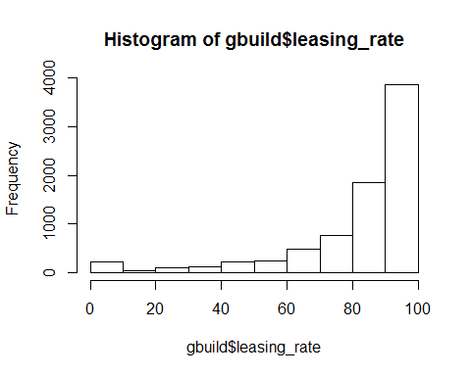

In order to do an apples to apples comparison of the previous analysis I will re-run the model with leasing rates >= 10%. Let's also plot rent as function of leasing rate to understand the effect removing the bottom 10 percentil will have.

gbuild_sub = subset(gbuild, gbuild$leasing_rate >= 10) #Remove lease rates <10%  
  
hist(gbuild_sub$leasing_rate,plot=TRUE)

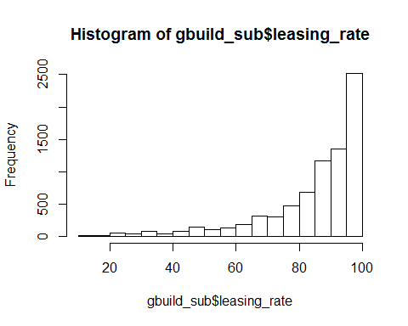

#Rent positively correlated with leasing rate  
plot(Rent~leasing_rate,data = gbuild_sub, col="blue",pch=16)

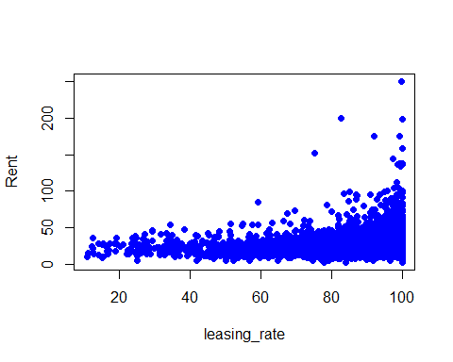

#Rent positively correlated with electricity costs  
plot(Rent~Electricity_Costs,data = gbuild_sub, col="blue",pch=16)  
  
abline(lm(Rent~leasing_rate,data = gbuild_sub),col="red")

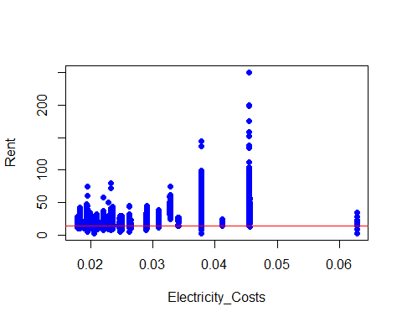

gbuild_sub$util_index = gbuild_sub$hd_total07*gbuild_sub$Gas_Costs +  
 gbuild_sub$cd_total_07 * gbuild_sub$Electricity_Costs  
lm.fit2 = lm(Rent ~.+util_index*class_a+cd_total_07*class_a+green_rating*class_a+empl_gr*class_a+empl_gr*green_rating, data = gbuild_sub)  
summary(lm.fit2)

##   
## Call:  
## lm(formula = Rent ~ . + util_index * class_a + cd_total_07 *   
## class_a + green_rating * class_a + empl_gr * class_a + empl_gr *   
## green_rating, data = gbuild_sub)  
##   
## Residuals:  
## Min 1Q Median 3Q Max   
## -1.221e-12 -1.100e-14 1.000e-15 1.040e-14 2.559e-11   
##   
## Coefficients: (1 not defined because of singularities)  
## Estimate Std. Error t value Pr(>|t|)   
## (Intercept) 1.696e-13 7.403e-14 2.291e+00 0.02202 *   
## CS_PropertyID 2.623e-20 5.412e-21 4.847e+00 1.28e-06 ***  
## cluster -2.619e-17 9.068e-18 -2.889e+00 0.00388 **   
## size -3.519e-20 2.088e-20 -1.685e+00 0.09197 .   
## empl_gr -3.503e-16 7.524e-16 -4.660e-01 0.64158   
## leasing_rate 3.802e-16 2.150e-16 1.768e+00 0.07704 .   
## stories 2.598e-16 5.126e-16 5.070e-01 0.61235   
## age 8.216e-17 1.540e-16 5.330e-01 0.59378   
## renovated 1.577e-16 8.302e-15 1.900e-02 0.98484   
## class_a -1.894e-14 2.036e-14 -9.310e-01 0.35213   
## class_b -6.154e-15 1.116e-14 -5.510e-01 0.58147   
## LEED 2.406e-14 1.129e-13 2.130e-01 0.83118   
## Energystar 5.744e-14 1.203e-13 4.770e-01 0.63309   
## green_rating -3.586e-14 1.223e-13 -2.930e-01 0.76940   
## net -2.120e-14 1.886e-14 -1.124e+00 0.26101   
## amenities 7.752e-15 8.077e-15 9.600e-01 0.33719   
## cd_total_07 2.097e-17 1.892e-17 1.108e+00 0.26774   
## hd_total07 7.324e-18 7.790e-18 9.400e-01 0.34718   
## total_dd_07 NA NA NA NA   
## Precipitation -5.308e-16 5.195e-16 -1.022e+00 0.30693   
## Gas_Costs 5.085e-12 4.338e-12 1.172e+00 0.24116   
## Electricity_Costs -5.203e-13 1.156e-12 -4.500e-01 0.65278   
## cluster_rent 1.000e+00 4.620e-16 2.164e+15 < 2e-16 ***  
## Rent_Diff 1.000e+00 3.592e-16 2.784e+15 < 2e-16 ***  
## util_index -5.825e-16 5.953e-16 -9.790e-01 0.32781   
## class_a:util_index -6.081e-16 2.966e-16 -2.050e+00 0.04039 *   
## class_a:cd_total_07 5.131e-17 1.184e-17 4.332e+00 1.50e-05 ***  
## class_a:green_rating 3.311e-14 2.966e-14 1.116e+00 0.26427   
## empl_gr:class_a -2.316e-15 1.017e-15 -2.278e+00 0.02275 *   
## empl_gr:green_rating -5.280e-16 1.330e-15 -3.970e-01 0.69150   
## ---  
## Signif. codes: 0 '***' 0.001 '**' 0.01 '*' 0.05 '.' 0.1 ' ' 1  
##   
## Residual standard error: 2.963e-13 on 7577 degrees of freedom  
## (73 observations deleted due to missingness)  
## Multiple R-squared: 1, Adjusted R-squared: 1   
## F-statistic: 7.118e+29 on 28 and 7577 DF, p-value: < 2.2e-16

confint(lm.fit2)

## 2.5 % 97.5 %  
## (Intercept) 2.444902e-14 3.146911e-13  
## CS_PropertyID 1.562321e-20 3.683954e-20  
## cluster -4.396784e-17 -8.417897e-18  
## size -7.613067e-20 5.742406e-21  
## empl_gr -1.825168e-15 1.124666e-15  
## leasing_rate -4.125658e-17 8.016243e-16  
## stories -7.450957e-16 1.264617e-15  
## age -2.197758e-16 3.840877e-16  
## renovated -1.611641e-14 1.643183e-14  
## class_a -5.884580e-14 2.096202e-14  
## class_b -2.803693e-14 1.572905e-14  
## LEED -1.971601e-13 2.452805e-13  
## Energystar -1.784055e-13 2.932774e-13  
## green_rating -2.756190e-13 2.039027e-13  
## net -5.818207e-14 1.577347e-14  
## amenities -8.080561e-15 2.358441e-14  
## cd_total_07 -1.612036e-17 5.806592e-17  
## hd_total07 -7.947044e-18 2.259476e-17  
## total_dd_07 NA NA  
## Precipitation -1.549050e-15 4.875257e-16  
## Gas_Costs -3.418602e-12 1.358805e-11  
## Electricity_Costs -2.787123e-12 1.746545e-12  
## cluster_rent 1.000000e+00 1.000000e+00  
## Rent_Diff 1.000000e+00 1.000000e+00  
## util_index -1.749422e-15 5.843577e-16  
## class_a:util_index -1.189638e-15 -2.664067e-17  
## class_a:cd_total_07 2.808932e-17 7.452550e-17  
## class_a:green_rating -2.502430e-14 9.124126e-14  
## empl_gr:class_a -4.308981e-15 -3.231612e-16  
## empl_gr:green_rating -3.135996e-15 2.080056e-15

We can see leasing rate has a positive effect on rent prices, we won't do anything with that for now, but we may need to control for that in the future.

Again we see none of the green IV's have any reliable predictave power as it relates to price. The most meaningful predictors remain to be Size,Employment growth, Class A, Class B, Net, HD-total07, Gas-Costs, Electricity-Costs, and Cluster_Rent (IE: Neighboorhood average rent)

The analysis doesn't account for lurking variables by just looking at median rent. It assumes the higher prices of green buildings are due to them being green, when we can clearly see from the regression model, they are not. This is because the regression model shows the marginal effect of each variable, and allows one to control for other factors. Furthermore, in order to reliably predict the price of the building, the developer should input the values of the most important predictors above to estimate. Using the median however was a good idea, because it is more robust to outliers.

Lets remove all statistically insignificant variables using step-wise regression;acknowledging that the coefficients may change slightly

lm.fit3 = step(lm.fit2 , scope=formula(lm.fit2), direction="back", k=log(length(gbuild_sub)))

## Start: AIC=-438764.6  
## Rent ~ CS_PropertyID + cluster + size + empl_gr + leasing_rate +   
## stories + age + renovated + class_a + class_b + LEED + Energystar +   
## green_rating + net + amenities + cd_total_07 + hd_total07 +   
## total_dd_07 + Precipitation + Gas_Costs + Electricity_Costs +   
## cluster_rent + Rent_Diff + util_index + util_index * class_a +   
## cd_total_07 * class_a + green_rating * class_a + empl_gr *   
## class_a + empl_gr * green_rating

## Warning: attempting model selection on an essentially perfect fit is  
## nonsense

##   
## Step: AIC=-438764.6  
## Rent ~ CS_PropertyID + cluster + size + empl_gr + leasing_rate +   
## stories + age + renovated + class_a + class_b + LEED + Energystar +   
## green_rating + net + amenities + cd_total_07 + hd_total07 +   
## Precipitation + Gas_Costs + Electricity_Costs + cluster_rent +   
## Rent_Diff + util_index + class_a:util_index + class_a:cd_total_07 +   
## class_a:green_rating + empl_gr:class_a + empl_gr:green_rating

## Warning: attempting model selection on an essentially perfect fit is  
## nonsense

## Df Sum of Sq RSS AIC  
## - empl_gr:green_rating 1 0 0 -438767  
## - class_a:green_rating 1 0 0 -438766  
## <none> 0 -438765  
## - class_a:util_index 1 0 0 -438763  
## - empl_gr:class_a 1 0 0 -438762  
## - LEED 1 0 0 -438760  
## - CS_PropertyID 1 0 0 -438753  
## - class_a:cd_total_07 1 0 0 -438749  
## - Electricity_Costs 1 0 0 -438737  
## - leasing_rate 1 0 0 -438736  
## - renovated 1 0 0 -438723  
## - Energystar 1 0 0 -438715  
## - hd_total07 1 0 0 -438714  
## - stories 1 0 0 -438711  
## - Precipitation 1 0 0 -438655  
## - class_b 1 0 0 -438629  
## - net 1 0 0 -438586  
## - amenities 1 0 0 -438520  
## - Gas_Costs 1 0 0 -438519  
## - age 1 0 0 -438514  
## - size 1 0 0 -438466  
## - cluster 1 0 0 -438168  
## - cluster_rent 1 411137 411137 30438  
## - Rent_Diff 1 680136 680136 34267  
##   
## Step: AIC=-438767.6  
## Rent ~ CS_PropertyID + cluster + size + empl_gr + leasing_rate +   
## stories + age + renovated + class_a + class_b + LEED + Energystar +   
## green_rating + net + amenities + cd_total_07 + hd_total07 +   
## Precipitation + Gas_Costs + Electricity_Costs + cluster_rent +   
## Rent_Diff + util_index + class_a:util_index + class_a:cd_total_07 +   
## class_a:green_rating + empl_gr:class_a

## Warning: attempting model selection on an essentially perfect fit is  
## nonsense

## Df Sum of Sq RSS AIC  
## - class_a:green_rating 1 0 0 -438769  
## <none> 0 -438768  
## - class_a:util_index 1 0 0 -438766  
## - empl_gr:class_a 1 0 0 -438764  
## - LEED 1 0 0 -438763  
## - CS_PropertyID 1 0 0 -438755  
## - class_a:cd_total_07 1 0 0 -438752  
## - Electricity_Costs 1 0 0 -438740  
## - leasing_rate 1 0 0 -438739  
## - renovated 1 0 0 -438725  
## - Energystar 1 0 0 -438718  
## - hd_total07 1 0 0 -438717  
## - stories 1 0 0 -438714  
## - Precipitation 1 0 0 -438658  
## - class_b 1 0 0 -438632  
## - net 1 0 0 -438584  
## - amenities 1 0 0 -438523  
## - Gas_Costs 1 0 0 -438521  
## - age 1 0 0 -438516  
## - size 1 0 0 -438466  
## - cluster 1 0 0 -438171  
## - cluster_rent 1 411193 411193 30436  
## - Rent_Diff 1 680136 680136 34263  
##   
## Step: AIC=-438769.7  
## Rent ~ CS_PropertyID + cluster + size + empl_gr + leasing_rate +   
## stories + age + renovated + class_a + class_b + LEED + Energystar +   
## green_rating + net + amenities + cd_total_07 + hd_total07 +   
## Precipitation + Gas_Costs + Electricity_Costs + cluster_rent +   
## Rent_Diff + util_index + class_a:util_index + class_a:cd_total_07 +   
## empl_gr:class_a

## Warning: attempting model selection on an essentially perfect fit is  
## nonsense

## Df Sum of Sq RSS AIC  
## <none> 0 -438770  
## - green_rating 1 0 0 -438768  
## - class_a:util_index 1 0 0 -438768  
## - empl_gr:class_a 1 0 0 -438766  
## - LEED 1 0 0 -438765  
## - CS_PropertyID 1 0 0 -438757  
## - class_a:cd_total_07 1 0 0 -438753  
## - Electricity_Costs 1 0 0 -438742  
## - leasing_rate 1 0 0 -438741  
## - renovated 1 0 0 -438727  
## - Energystar 1 0 0 -438720  
## - hd_total07 1 0 0 -438719  
## - stories 1 0 0 -438715  
## - Precipitation 1 0 0 -438660  
## - class_b 1 0 0 -438634  
## - net 1 0 0 -438591  
## - amenities 1 0 0 -438525  
## - Gas_Costs 1 0 0 -438523  
## - age 1 0 0 -438518  
## - size 1 0 0 -438469  
## - cluster 1 0 0 -438173  
## - cluster_rent 1 411770 411770 30443  
## - Rent_Diff 1 680334 680334 34262

summary(lm.fit3)

##   
## Call:  
## lm(formula = Rent ~ CS_PropertyID + cluster + size + empl_gr +   
## leasing_rate + stories + age + renovated + class_a + class_b +   
## LEED + Energystar + green_rating + net + amenities + cd_total_07 +   
## hd_total07 + Precipitation + Gas_Costs + Electricity_Costs +   
## cluster_rent + Rent_Diff + util_index + class_a:util_index +   
## class_a:cd_total_07 + empl_gr:class_a, data = gbuild_sub)  
##   
## Residuals:  
## Min 1Q Median 3Q Max   
## -1.219e-12 -1.120e-14 1.300e-15 1.020e-14 2.559e-11   
##   
## Coefficients:  
## Estimate Std. Error t value Pr(>|t|)   
## (Intercept) 1.659e-13 7.400e-14 2.242e+00 0.02496 *   
## CS_PropertyID 2.574e-20 5.408e-21 4.759e+00 1.98e-06 ***  
## cluster -2.849e-17 9.067e-18 -3.142e+00 0.00168 **   
## size -3.581e-20 2.088e-20 -1.715e+00 0.08636 .   
## empl_gr -3.208e-16 7.515e-16 -4.270e-01 0.66951   
## leasing_rate 4.159e-16 2.150e-16 1.935e+00 0.05304 .   
## stories 2.495e-16 5.125e-16 4.870e-01 0.62645   
## age 8.009e-17 1.537e-16 5.210e-01 0.60240   
## renovated 4.873e-16 8.301e-15 5.900e-02 0.95319   
## class_a -1.575e-14 2.017e-14 -7.810e-01 0.43503   
## class_b -6.861e-15 1.115e-14 -6.150e-01 0.53841   
## LEED 2.681e-14 1.128e-13 2.380e-01 0.81219   
## Energystar 6.321e-14 1.202e-13 5.260e-01 0.59899   
## green_rating -1.755e-14 1.209e-13 -1.450e-01 0.88457   
## net -2.121e-14 1.886e-14 -1.125e+00 0.26073   
## amenities 7.999e-15 8.073e-15 9.910e-01 0.32183   
## cd_total_07 2.087e-17 1.892e-17 1.103e+00 0.27014   
## hd_total07 7.712e-18 7.788e-18 9.900e-01 0.32212   
## Precipitation -5.167e-16 5.193e-16 -9.950e-01 0.31977   
## Gas_Costs 4.967e-12 4.336e-12 1.145e+00 0.25209   
## Electricity_Costs -3.902e-13 1.156e-12 -3.370e-01 0.73576   
## cluster_rent 1.000e+00 4.617e-16 2.166e+15 < 2e-16 ***  
## Rent_Diff 1.000e+00 3.592e-16 2.784e+15 < 2e-16 ***  
## util_index -5.886e-16 5.952e-16 -9.890e-01 0.32279   
## class_a:util_index -6.352e-16 2.957e-16 -2.148e+00 0.03176 *   
## class_a:cd_total_07 5.244e-17 1.180e-17 4.443e+00 8.99e-06 ***  
## empl_gr:class_a -2.467e-15 9.796e-16 -2.519e+00 0.01180 *   
## ---  
## Signif. codes: 0 '***' 0.001 '**' 0.01 '*' 0.05 '.' 0.1 ' ' 1  
##   
## Residual standard error: 2.962e-13 on 7579 degrees of freedom  
## (73 observations deleted due to missingness)  
## Multiple R-squared: 1, Adjusted R-squared: 1   
## F-statistic: 7.666e+29 on 26 and 7579 DF, p-value: < 2.2e-16

confint(lm.fit3)

## 2.5 % 97.5 %  
## (Intercept) 2.088064e-14 3.110011e-13  
## CS_PropertyID 1.513610e-20 3.633968e-20  
## cluster -4.626273e-17 -1.071480e-17  
## size -7.674500e-20 5.118619e-21  
## empl_gr -1.793931e-15 1.152382e-15  
## leasing_rate -5.447144e-18 8.373433e-16  
## stories -7.551991e-16 1.254132e-15  
## age -2.212730e-16 3.814592e-16  
## renovated -1.578538e-14 1.676003e-14  
## class_a -5.529029e-14 2.379531e-14  
## class_b -2.872016e-14 1.499860e-14  
## LEED -1.943457e-13 2.479583e-13  
## Energystar -1.724164e-13 2.988363e-13  
## green_rating -2.545419e-13 2.194381e-13  
## net -5.818189e-14 1.575771e-14  
## amenities -7.827249e-15 2.382491e-14  
## cd_total_07 -1.622360e-17 5.795607e-17  
## hd_total07 -7.555322e-18 2.297868e-17  
## Precipitation -1.534598e-15 5.012440e-16  
## Gas_Costs -3.533754e-12 1.346727e-11  
## Electricity_Costs -2.656771e-12 1.876338e-12  
## cluster_rent 1.000000e+00 1.000000e+00  
## Rent_Diff 1.000000e+00 1.000000e+00  
## util_index -1.755330e-15 5.782299e-16  
## class_a:util_index -1.214864e-15 -5.546056e-17  
## class_a:cd_total_07 2.930674e-17 7.558264e-17  
## empl_gr:class_a -4.387713e-15 -5.469624e-16

Surprisingly LEED remained in the model, however we fail to reject the null hypothesis that it is significant at the 95% level.

First we will begin by breaking the important continuous variables into manageable buckets. This will also serve us well to see the distribution of buildings across different ranges of values and setup our cross tab tables coming up. We will also limit the data to cities with positive employment growth, since Austin has one of the best economies in the country.

gbuild_sub$sizeCategory = cut(gbuild_sub$size, breaks = c(rep(0:20)*200000))  
gbuild_sub$storiesCategory = cut(gbuild_sub$stories, breaks = c(rep(0:12)*10))  
gbuild_sub$empl_grCategory = cut(gbuild_sub$empl_gr, breaks = c(rep(0:6)))  
gbuild_sub$ageCategory = cut(gbuild_sub$age, breaks = c(rep(0:10)*20))  
gbuild_sub$Electricity_CostsCategory = cut(gbuild_sub$Electricity_Costs,  
 breaks = c(seq(0.00,0.07, by=0.01)))  
gbuild_sub$Gas_CostsCategory = cut(gbuild_sub$Gas_Costs,  
 breaks = c(seq(0.00,0.03, by=0.005)))  
gbuild_sub$total_dd_07Category = cut(gbuild_sub$total_dd_07,  
 breaks = c(seq(0.00,9000, by=2000)))  
gbuild_sub$cd_total_07Category = cut(gbuild_sub$cd_total_07,  
 breaks = c(seq(0.00,6000, by=600)))  
attach(gbuild_sub)

## The following objects are masked from gbuild:  
##   
## age, amenities, cd_total_07, class_a, class_b, cluster,  
## cluster_rent, CS_PropertyID, Electricity_Costs, empl_gr,  
## Energystar, Gas_Costs, green_rating, hd_total07, leasing_rate,  
## LEED, net, Precipitation, renovated, Rent, size, stories,  
## total_dd_07

hist(gbuild_sub$size, breaks=75) #Good dispersion in target range

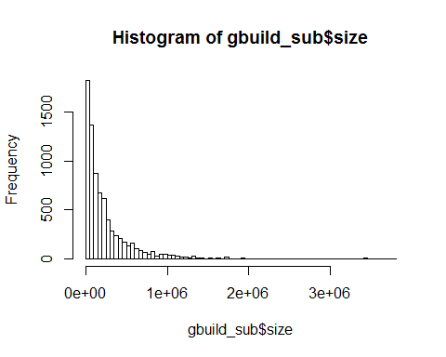

hist(gbuild_sub$stories) #Good dispersion in target range

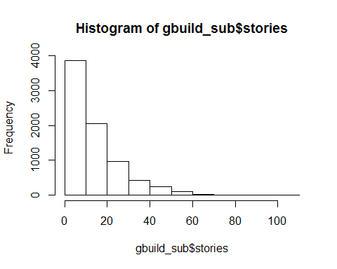 There appears to be a good distribution of buildings over the top predictors, so I'm not concerned about extrapolating outside of the observed ranges.

Next I inspect the theory that lower utility costs are the driver of higher rent prices in green buildings. In order to do this I create a feature called util_index, which is the sum of the products of gas costs and heating days and electric costs and cooling days. This feauture will allow us to measure the expense of HVAC in a single variable.

We begin by examing rents for green and non-green buildings as two different series across the full range of util_index:

gbuild_sub$util_index = gbuild_sub$hd_total07*gbuild_sub$Gas_Costs +  
 gbuild_sub$cd_total_07 * gbuild_sub$Electricity_Costs  
#Bucket util_index  
gbuild_sub$util_indexCategory = cut(gbuild_sub$util_index,  
 breaks = c(seq(0.00,200, by=25)))  
#Util index negatively correlated with rent; Higher utilities = lower rent  
plot(Rent~util_index,data = gbuild_sub, col="blue",pch=16)

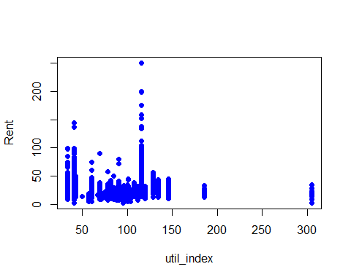

#Normalize util_index in case we need it  
gbuild_sub$util_index_norm = gbuild_sub$util_index/mean(gbuild_sub$util_index)  
  
summary(gbuild_sub)

## CS_PropertyID cluster size empl_gr   
## Min. : 1 Min. : 1.0 Min. : 2378 Min. :-24.950   
## 1st Qu.: 157426 1st Qu.: 272.0 1st Qu.: 52000 1st Qu.: 1.740   
## Median : 313238 Median : 479.0 Median : 132417 Median : 1.970   
## Mean : 435335 Mean : 590.1 Mean : 239465 Mean : 3.188   
## 3rd Qu.: 440780 3rd Qu.:1044.0 3rd Qu.: 302375 3rd Qu.: 2.380   
## Max. :6208103 Max. :1230.0 Max. :3781045 Max. : 67.780   
## NA's :73   
## Rent leasing_rate stories age   
## Min. : 2.98 Min. : 10.68 Min. : 1.00 Min. : 0.00   
## 1st Qu.: 19.50 1st Qu.: 79.51 1st Qu.: 4.00 1st Qu.: 23.00   
## Median : 25.29 Median : 90.24 Median : 10.00 Median : 34.00   
## Mean : 28.59 Mean : 84.88 Mean : 13.83 Mean : 47.04   
## 3rd Qu.: 34.20 3rd Qu.: 96.66 3rd Qu.: 20.00 3rd Qu.: 79.00   
## Max. :250.00 Max. :100.00 Max. :110.00 Max. :187.00   
##   
## renovated class_a class_b LEED   
## Min. :0.0000 Min. :0.0000 Min. :0.0000 Min. :0.000000   
## 1st Qu.:0.0000 1st Qu.:0.0000 1st Qu.:0.0000 1st Qu.:0.000000   
## Median :0.0000 Median :0.0000 Median :0.0000 Median :0.000000   
## Mean :0.3814 Mean :0.4083 Mean :0.4587 Mean :0.007032   
## 3rd Qu.:1.0000 3rd Qu.:1.0000 3rd Qu.:1.0000 3rd Qu.:0.000000   
## Max. :1.0000 Max. :1.0000 Max. :1.0000 Max. :1.000000   
##   
## Energystar green_rating net amenities   
## Min. :0.00000 Min. :0.00000 Min. :0.00000 Min. :0.000   
## 1st Qu.:0.00000 1st Qu.:0.00000 1st Qu.:0.00000 1st Qu.:0.000   
## Median :0.00000 Median :0.00000 Median :0.00000 Median :1.000   
## Mean :0.08295 Mean :0.08907 Mean :0.03555 Mean :0.538   
## 3rd Qu.:0.00000 3rd Qu.:0.00000 3rd Qu.:0.00000 3rd Qu.:1.000   
## Max. :1.00000 Max. :1.00000 Max. :1.00000 Max. :1.000   
##   
## cd_total_07 hd_total07 total_dd_07 Precipitation   
## Min. : 39 Min. : 0 Min. :2103 Min. :10.46   
## 1st Qu.: 684 1st Qu.:1419 1st Qu.:2869 1st Qu.:22.71   
## Median : 966 Median :2739 Median :4979 Median :23.16   
## Mean :1217 Mean :3440 Mean :4657 Mean :31.10   
## 3rd Qu.:1620 3rd Qu.:4796 3rd Qu.:6413 3rd Qu.:43.89   
## Max. :5240 Max. :7200 Max. :8244 Max. :58.02   
##   
## Gas_Costs Electricity_Costs cluster_rent Rent_Diff   
## Min. :0.009487 Min. :0.01780 Min. : 9.00 Min. :-45.9150   
## 1st Qu.:0.010296 1st Qu.:0.02330 1st Qu.:20.25 1st Qu.: -2.9100   
## Median :0.010296 Median :0.03274 Median :25.20 Median : 0.0000   
## Mean :0.011329 Mean :0.03095 Mean :27.60 Mean : 0.9903   
## 3rd Qu.:0.011816 3rd Qu.:0.03781 3rd Qu.:34.15 3rd Qu.: 3.3300   
## Max. :0.028914 Max. :0.06280 Max. :71.44 Max. :191.2800   
##   
## util_index sizeCategory storiesCategory empl_grCategory  
## Min. : 33.12 (0,2e+05] :4746 (0,10] :3867 (0,1]: 916   
## 1st Qu.: 40.47 (2e+05,4e+05] :1530 (10,20]:2049 (1,2]:2970   
## Median : 78.53 (4e+05,6e+05] : 672 (20,30]: 963 (2,3]:2307   
## Mean : 75.78 (6e+05,8e+05] : 297 (30,40]: 420 (3,4]: 624   
## 3rd Qu.: 96.17 (8e+05,1e+06] : 192 (40,50]: 245 (4,5]: 434   
## Max. :304.83 (1e+06,1.2e+06]: 117 (50,60]: 106 (5,6]: 98   
## (Other) : 125 (Other): 29 NA's : 330   
## ageCategory Electricity_CostsCategory Gas_CostsCategory  
## (20,40] :3183 (0,0.01] : 0 (0,0.005] : 0   
## (0,20] :1287 (0.01,0.02]: 826 (0.005,0.01]: 554   
## (80,100]:1250 (0.02,0.03]:2917 (0.01,0.015]:6993   
## (40,60] : 886 (0.03,0.04]:3535 (0.015,0.02]: 45   
## (60,80] : 553 (0.04,0.05]: 314 (0.02,0.025]: 0   
## (Other) : 503 (0.05,0.06]: 0 (0.025,0.03]: 87   
## NA's : 17 (0.06,0.07]: 87   
## total_dd_07Category cd_total_07Category util_indexCategory  
## (0,2e+03] : 0 (600,1.2e+03] :3523 (25,50] :2872   
## (2e+03,4e+03]:3044 (0,600] :1667 (75,100] :2428   
## (4e+03,6e+03]:2087 (1.8e+03,2.4e+03]: 823 (100,125]:1406   
## (6e+03,8e+03]:2308 (1.2e+03,1.8e+03]: 695 (50,75] : 626   
## NA's : 240 (2.4e+03,3e+03] : 424 (125,150]: 217   
## (4.8e+03,5.4e+03]: 259 (Other) : 43   
## (Other) : 288 NA's : 87   
## util_index_norm   
## Min. :0.4370   
## 1st Qu.:0.5341   
## Median :1.0364   
## Mean :1.0000   
## 3rd Qu.:1.2692   
## Max. :4.0228   
##

g_green = subset(gbuild_sub, green_rating==1)  
g_green = g_green[complete.cases(g_green),]  
g_ngreen = subset(gbuild_sub, green_rating==0)  
g_ngreen = g_ngreen[complete.cases(g_green),]  
  
plot(Rent~util_index,data = g_ngreen, col="blue",pch=16)  
points(Rent~util_index,data = g_green, col="red",pch=4)

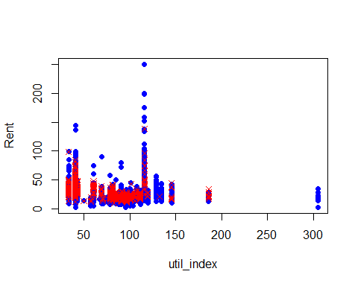 Well there isn't much to take from this graph. Let's try to do the same thing across total-dd_07-days:

plot(Rent~total_dd_07,data = g_ngreen, col="blue",pch=16)  
points(Rent~total_dd_07,data = g_green, col="red",pch=4)

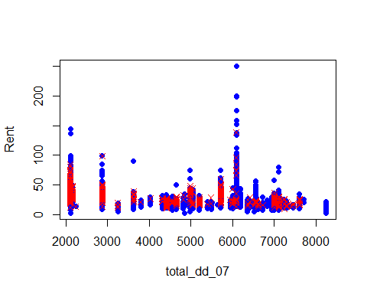

plot(Rent~cd_total_07,data = g_ngreen, col="blue",pch=16)  
points(Rent~cd_total_07,data = g_green, col="red",pch=4)

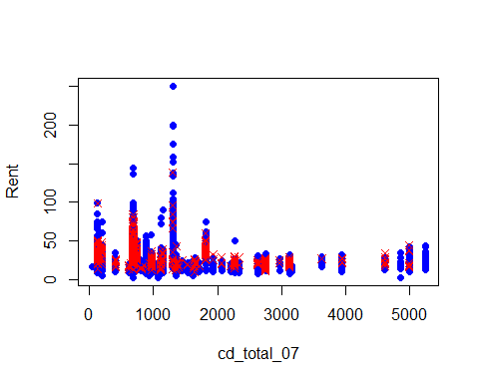 It appears green buildings are highly concentrated in milder climates. Lets look at a cross tab of green building frequencies by util_index and classs.

freq =xtabs(~green_rating+class_a+util_indexCategory, data = gbuild_sub)  
freq

## , , util_indexCategory = (0,25]  
##   
## class_a  
## green_rating 0 1  
## 0 0 0  
## 1 0 0  
##   
## , , util_indexCategory = (25,50]  
##   
## class_a  
## green_rating 0 1  
## 0 1624 951  
## 1 70 227  
##   
## , , util_indexCategory = (50,75]  
##   
## class_a  
## green_rating 0 1  
## 0 400 191  
## 1 7 28  
##   
## , , util_indexCategory = (75,100]  
##   
## class_a  
## green_rating 0 1  
## 0 1518 704  
## 1 42 164  
##   
## , , util_indexCategory = (100,125]  
##   
## class_a  
## green_rating 0 1  
## 0 714 588  
## 1 12 92  
##   
## , , util_indexCategory = (125,150]  
##   
## class_a  
## green_rating 0 1  
## 0 94 94  
## 1 1 28  
##   
## , , util_indexCategory = (150,175]  
##   
## class_a  
## green_rating 0 1  
## 0 0 0  
## 1 0 0  
##   
## , , util_indexCategory = (175,200]  
##   
## class_a  
## green_rating 0 1  
## 0 28 6  
## 1 4 5

The table above seems to indicate green buildings are highly concentrated in class a buildings. That would be a good reason why they appear to rent for more money. The table shows 3 splits of the util_index: 0-75,75-150,150-225

For those respective bins, 255 of the 332 green buildings or 76.8%, are found in class a buildings. 284/339 or 83.8% of green buildings are class a in the second bin. And 5/9 of the green buildings in the last bin are class A. It seems we've found something here. What if the higher rent prices for green buildings were a reflection of the class of the building instead of the green rating?

Lets dig deeper, and look at a few boxplots of rent by green rating for only class A buildings & non-class A buildings

gbuild_sub_A = subset(gbuild_sub, class_a == 1)  
gbuild_sub_NotA = subset(gbuild_sub, class_a == 0)  
boxplot(Rent ~ green_rating+util_indexCategory, data = gbuild_sub_A,  
 xlab= "Green Rating followed by Util_Index",  
 ylab="Rent",notch=TRUE,ylim=c(5,80),cex.axis=.7)

## Warning in bxp(structure(list(stats = structure(c(NA, NA, NA, NA, NA, NA, :  
## some notches went outside hinges ('box'): maybe set notch=FALSE

title("Class A Rent Prices by (Green Rating and Util Index)")

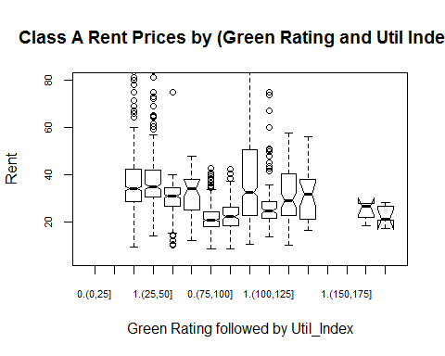

boxplot(Rent ~ green_rating+cd_total_07Category, data = gbuild_sub_A,  
 xlab= "Green Rating followed by Util_Index",  
 ylab="Rent",notch=TRUE,ylim=c(5,80),cex.axis=.8)

## Warning in bxp(structure(list(stats = structure(c(9.6, 28.2, 34.84, 41.5, :  
## some notches went outside hinges ('box'): maybe set notch=FALSE

title("Class A Rent Prices by (Green Rating and Util Index)")

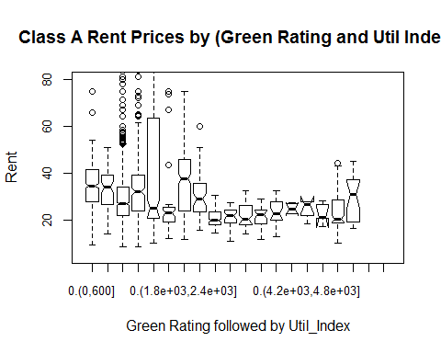

#boxplot(Rent ~ green_rating+total_dd_07Category, data = gbuild_sub_A, xlab= "Green Rating followed by total degree days", ylab="Rent",notch=TRUE,ylim=c(5,80),cex.axis=.8)  
boxplot(Rent ~ green_rating+util_indexCategory,   
 data = gbuild_sub_NotA, xlab= "Green Rating followed by Util_Index",ylab="Rent",  
 notch=FALSE,ylim=c(5,80),cex.axis=.8)  
 title("Non-Class A Rent Prices by (Green Rating and Util Index)")

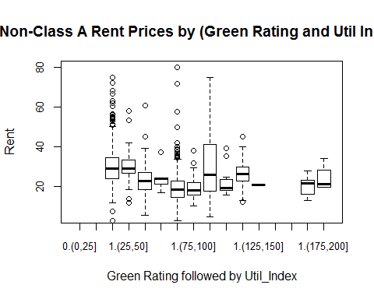

g_control1 = subset(gbuild_sub_A, net==1 & leasing_rate <= 80 & empl_gr > 0)  
freq =xtabs(~green_rating+empl_grCategory+util_indexCategory, data = g_control1)  
freq

## , , util_indexCategory = (0,25]  
##   
## empl_grCategory  
## green_rating (0,1] (1,2] (2,3] (3,4] (4,5] (5,6]  
## 0 0 0 0 0 0 0  
## 1 0 0 0 0 0 0  
##   
## , , util_indexCategory = (25,50]  
##   
## empl_grCategory  
## green_rating (0,1] (1,2] (2,3] (3,4] (4,5] (5,6]  
## 0 0 3 3 0 0 0  
## 1 0 2 0 0 0 0  
##   
## , , util_indexCategory = (50,75]  
##   
## empl_grCategory  
## green_rating (0,1] (1,2] (2,3] (3,4] (4,5] (5,6]  
## 0 0 0 0 0 0 0  
## 1 0 0 0 0 0 0  
##   
## , , util_indexCategory = (75,100]  
##   
## empl_grCategory  
## green_rating (0,1] (1,2] (2,3] (3,4] (4,5] (5,6]  
## 0 0 6 0 0 0 2  
## 1 0 0 1 1 0 0  
##   
## , , util_indexCategory = (100,125]  
##   
## empl_grCategory  
## green_rating (0,1] (1,2] (2,3] (3,4] (4,5] (5,6]  
## 0 1 0 0 6 0 0  
## 1 0 0 0 2 0 0  
##   
## , , util_indexCategory = (125,150]  
##   
## empl_grCategory  
## green_rating (0,1] (1,2] (2,3] (3,4] (4,5] (5,6]  
## 0 0 0 7 0 0 0  
## 1 0 0 1 0 0 0  
##   
## , , util_indexCategory = (150,175]  
##   
## empl_grCategory  
## green_rating (0,1] (1,2] (2,3] (3,4] (4,5] (5,6]  
## 0 0 0 0 0 0 0  
## 1 0 0 0 0 0 0  
##   
## , , util_indexCategory = (175,200]  
##   
## empl_grCategory  
## green_rating (0,1] (1,2] (2,3] (3,4] (4,5] (5,6]  
## 0 0 0 0 0 0 0  
## 1 0 0 0 0 0 0

rent_sum =xtabs(Rent~green_rating+empl_grCategory+util_indexCategory, data = g_control1)  
avg_rent = rent_sum/freq  
avg_rent

## , , util_indexCategory = (0,25]  
##   
## empl_grCategory  
## green_rating (0,1] (1,2] (2,3] (3,4] (4,5] (5,6]  
## 0   
## 1   
##   
## , , util_indexCategory = (25,50]  
##   
## empl_grCategory  
## green_rating (0,1] (1,2] (2,3] (3,4] (4,5] (5,6]  
## 0 28.33333 33.51333   
## 1 30.31500   
##   
## , , util_indexCategory = (50,75]  
##   
## empl_grCategory  
## green_rating (0,1] (1,2] (2,3] (3,4] (4,5] (5,6]  
## 0   
## 1   
##   
## , , util_indexCategory = (75,100]  
##   
## empl_grCategory  
## green_rating (0,1] (1,2] (2,3] (3,4] (4,5] (5,6]  
## 0 23.50000 25.00000  
## 1 14.34000 19.25000   
##   
## , , util_indexCategory = (100,125]  
##   
## empl_grCategory  
## green_rating (0,1] (1,2] (2,3] (3,4] (4,5] (5,6]  
## 0 23.65000 18.77167   
## 1 20.92000   
##   
## , , util_indexCategory = (125,150]  
##   
## empl_grCategory  
## green_rating (0,1] (1,2] (2,3] (3,4] (4,5] (5,6]  
## 0 17.84429   
## 1 18.61000   
##   
## , , util_indexCategory = (150,175]  
##   
## empl_grCategory  
## green_rating (0,1] (1,2] (2,3] (3,4] (4,5] (5,6]  
## 0   
## 1   
##   
## , , util_indexCategory = (175,200]  
##   
## empl_grCategory  
## green_rating (0,1] (1,2] (2,3] (3,4] (4,5] (5,6]  
## 0   
## 1

At this point we can see green buildings are highly correlated and that some green buildings in certain utility_index bins do rent for a premium. The last table is particularly interesting. Here we can see that green buildings generally only sell for a premium in modest to high growth cities.

Net pricing wasn't indicated as a strong predictor but let's do the same excercise controlling for non-net leases and some other features correlated with price.

#Control for important lurking variables  
g_control1 = subset(gbuild_sub_A, net==1 & leasing_rate <= 80 & empl_gr > 0)  
g_control2 = subset(gbuild_sub_A, net==1 & leasing_rate <= 80 & empl_gr <= 0)  
  
plot(gbuild$empl_gr)

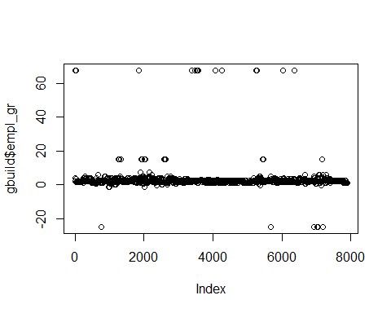

boxplot(Rent ~ green_rating+util_indexCategory, data = g_control1,  
 xlab= "Green Rating followed by Util_Index",  
 ylab="Rent",notch=TRUE,ylim=c(5,80),cex.axis=.8)

## Warning in bxp(structure(list(stats = structure(c(NA, NA, NA, NA, NA, NA, :  
## some notches went outside hinges ('box'): maybe set notch=FALSE

title("Class A Rent Prices by (Green Rating and Util Index)")

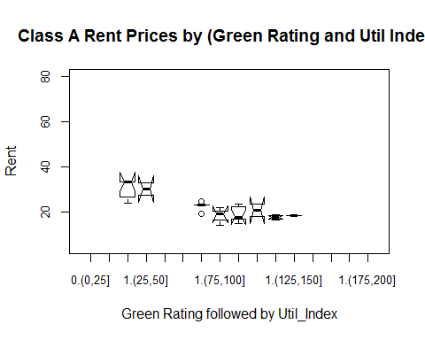

boxplot(Rent ~ green_rating+cd_total_07Category, data = g_control1,  
 xlab= "Green Rating followed by Util_Index",  
 ylab="Rent",ylim=c(5,40),cex.axis=.8)  
 title("Class A Rent Prices by (Green Rating and Util Index)")

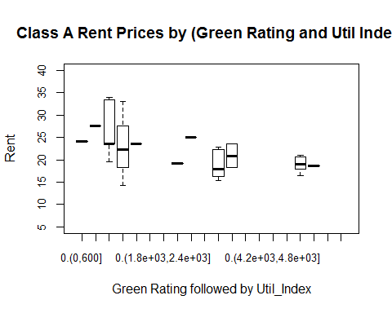

boxplot(Rent ~ green_rating+empl_grCategory, data = g_control1,  
 xlab= "Green Rating followed by Util_Index",  
 ylab="Rent",ylim=c(5,40),cex.axis=.8)  
 title("Class A Rent Prices by (Green Rating and Util Index)")

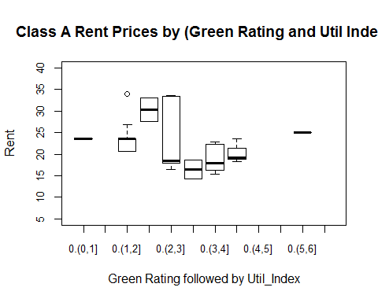

plot(Rent_Diff~util_index,data = g_ngreen, col="blue",pch=16)  
points(Rent_Diff~util_index,data = g_green, col="red",pch=4)

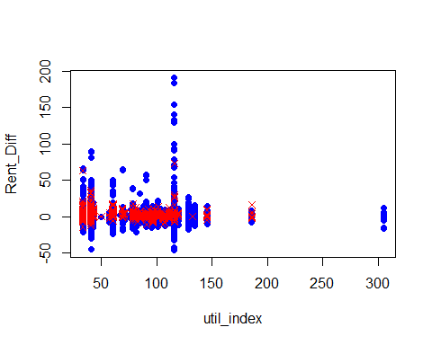

freq =xtabs(~green_rating+class_a+util_indexCategory, data = gbuild_sub)  
rent_sum =xtabs(Rent~green_rating+class_a+util_indexCategory, data = gbuild_sub)  
avg_rent = rent_sum/freq  
avg_rent

## , , util_indexCategory = (0,25]  
##   
## class_a  
## green_rating 0 1  
## 0   
## 1   
##   
## , , util_indexCategory = (25,50]  
##   
## class_a  
## green_rating 0 1  
## 0 30.76389 36.94904  
## 1 31.60100 37.39678  
##   
## , , util_indexCategory = (50,75]  
##   
## class_a  
## green_rating 0 1  
## 0 23.24820 31.24958  
## 1 24.31571 31.23036  
##   
## , , util_indexCategory = (75,100]  
##   
## class_a  
## green_rating 0 1  
## 0 19.39635 21.75456  
## 1 19.52500 22.79463  
##   
## , , util_indexCategory = (100,125]  
##   
## class_a  
## green_rating 0 1  
## 0 31.18513 40.77844  
## 1 22.53083 30.21543  
##   
## , , util_indexCategory = (125,150]  
##   
## class_a  
## green_rating 0 1  
## 0 26.40766 31.10670  
## 1 20.90000 31.30321  
##   
## , , util_indexCategory = (150,175]  
##   
## class_a  
## green_rating 0 1  
## 0   
## 1   
##   
## , , util_indexCategory = (175,200]  
##   
## class_a  
## green_rating 0 1  
## 0 20.44107 25.05500  
## 1 24.12000 23.05200

gbuild_notnet = subset(gbuild_sub,net==0)  
gbuild_net = subset(gbuild_sub,net==1)

g_cntrl_notnet = subset(gbuild_notnet, class_a == 1 | class_b == 1 & age <= 30 &  
 (empl_gr >= 1 & empl_gr <= 3) &  
 (stories >= 5 & stories <= 25) &  
 (size <= 300000 & size >= 200000))

freq =xtabs(~green_rating+empl_grCategory+class_a, data = gbuild_sub)  
freq

## , , class_a = 0  
##   
## empl_grCategory  
## green_rating (0,1] (1,2] (2,3] (3,4] (4,5] (5,6]  
## 0 491 1925 1166 331 261 52  
## 1 20 39 46 9 13 1  
##   
## , , class_a = 1  
##   
## empl_grCategory  
## green_rating (0,1] (1,2] (2,3] (3,4] (4,5] (5,6]  
## 0 359 876 877 214 119 35  
## 1 46 130 218 70 41 10

rent_sum =xtabs(Rent~green_rating+empl_grCategory+class_a, data = gbuild_sub)  
avg_rent = rent_sum/freq  
avg_rent

## , , class_a = 0  
##   
## empl_grCategory  
## green_rating (0,1] (1,2] (2,3] (3,4] (4,5] (5,6]  
## 0 31.16255 27.85325 25.59782 19.44486 17.98046 18.21058  
## 1 26.38250 29.19846 29.17696 19.60889 18.52154 10.51000  
##   
## , , class_a = 1  
##   
## empl_grCategory  
## green_rating (0,1] (1,2] (2,3] (3,4] (4,5] (5,6]  
## 0 35.87744 36.09933 32.41568 23.99907 20.45521 21.53857  
## 1 32.96804 31.20923 35.11009 24.44957 21.04268 22.44500

freq =xtabs(~green_rating+total_dd_07Category, data = gbuild_sub)  
rent_sum =xtabs(Rent~green_rating+total_dd_07Category, data = gbuild_sub)  
avg_rent = rent_sum/freq  
avg_rent

## total_dd_07Category  
## green_rating (0,2e+03] (2e+03,4e+03] (4e+03,6e+03] (6e+03,8e+03]  
## 0 32.41796 27.41713 26.10320  
## 1 35.60505 25.70507 25.92176

freq =xtabs(~green_rating+net+util_indexCategory, data = gbuild_sub)  
rent_sum =xtabs(Rent~green_rating+net+util_indexCategory, data = gbuild_sub)  
avg_rent = rent_sum/freq  
avg_rent

## , , util_indexCategory = (0,25]  
##   
## net  
## green_rating 0 1  
## 0   
## 1   
##   
## , , util_indexCategory = (25,50]  
##   
## net  
## green_rating 0 1  
## 0 33.18523 26.26608  
## 1 36.10089 31.93600  
##   
## , , util_indexCategory = (50,75]  
##   
## net  
## green_rating 0 1  
## 0 26.02386 17.39692  
## 1 30.32531 24.75000  
##   
## , , util_indexCategory = (75,100]  
##   
## net  
## green_rating 0 1  
## 0 20.16530 19.48324  
## 1 22.21375 20.95214  
##   
## , , util_indexCategory = (100,125]  
##   
## net  
## green_rating 0 1  
## 0 35.73954 31.22422  
## 1 29.80478 26.26857  
##   
## , , util_indexCategory = (125,150]  
##   
## net  
## green_rating 0 1  
## 0 29.23134 19.32667  
## 1 31.82778 19.02000  
##   
## , , util_indexCategory = (150,175]  
##   
## net  
## green_rating 0 1  
## 0   
## 1   
##   
## , , util_indexCategory = (175,200]  
##   
## net  
## green_rating 0 1  
## 0 21.14091 25.03000  
## 1 23.52667

freq

## , , util_indexCategory = (0,25]  
##   
## net  
## green_rating 0 1  
## 0 0 0  
## 1 0 0  
##   
## , , util_indexCategory = (25,50]  
##   
## net  
## green_rating 0 1  
## 0 2524 51  
## 1 292 5  
##   
## , , util_indexCategory = (50,75]  
##   
## net  
## green_rating 0 1  
## 0 578 13  
## 1 32 3  
##   
## , , util_indexCategory = (75,100]  
##   
## net  
## green_rating 0 1  
## 0 2151 71  
## 1 192 14  
##   
## , , util_indexCategory = (100,125]  
##   
## net  
## green_rating 0 1  
## 0 1238 64  
## 1 90 14  
##   
## , , util_indexCategory = (125,150]  
##   
## net  
## green_rating 0 1  
## 0 179 9  
## 1 27 2  
##   
## , , util_indexCategory = (150,175]  
##   
## net  
## green_rating 0 1  
## 0 0 0  
## 1 0 0  
##   
## , , util_indexCategory = (175,200]  
##   
## net  
## green_rating 0 1  
## 0 33 1  
## 1 9 0

plot(cluster_rent~util_index, data = subset(gbuild_sub,green_rating==1),col="blue") points(cluster_rent~util_index, data = subset(gbuild_sub,green_rating==0),col="red")

plot(Rent_norm~util_index, data = subset(gbuild_sub,green_rating==1),col="blue",pch=16) points(Rent_norm~util_index, data = subset(gbuild_sub,green_rating==0),col="red", pch=4)

```

Now lets examine rent by utility costs, after we control for some features. Let's assume the building will be class A, with median employment growth (2), roughly 250,000 sqft, and less than 10 years old.

boxplot(Rent ~ green_rating, data = gbuild_notnet, names= c("No","Yes"),title="Non-Net Leases", xlab= "Green Rating", ylab="Rent per sqft",notch=TRUE, ylim=c(5,80))

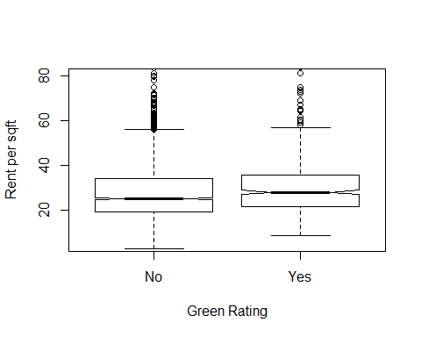

boxplot(Rent ~ green_rating, data = gbuild_net, names= c("No","Yes"),title="Net Leases", xlab= "Green Rating", ylab="Rent per sqft",notch=TRUE, ylim=c(5,80))

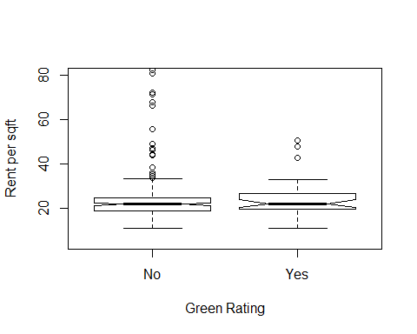

boxplot(Rent ~ Electricity_CostsCategory, data = gbuild_notnet, xlab= "Electric Costs per sqft", ylab="Rent per sqft",notch=TRUE,ylim=c(5,80))

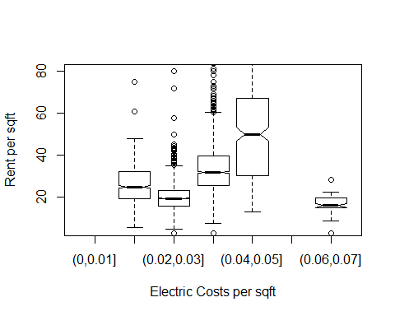

boxplot(Rent ~ Gas_CostsCategory, data = gbuild_notnet, xlab= "Gas Costs per sqft", ylab="Rent per sqft",notch=TRUE,ylim=c(5,80))

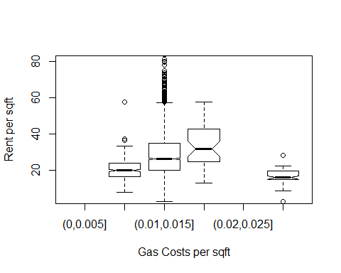

xtabs(~green_rating+net,data = gbuild_sub)

## net  
## green_rating 0 1  
## 0 6761 234  
## 1 645 39

Conclusion -

In conclusion, we have shown how risky and unreliable the former analysts recommendations were. By not using regression to control for the other features the recommendations was wreckless. We have attempted to isolate the effect of the green buildings outside of regression. While we weren't able to isolate the effect of green buildings completely, we believe its quite evident its highly correlated with other features that drive up rent, such as class a buildings and high employment growth cities. At a minimum we have shown that green buildings effect is not consistent throughout the data set, and that its unwise to generalize.

## Bootstrapping :

The value at risk and returns of each portfolio gives us a measure of how "safe" or "risky" an asset is.

suppressMessages(library(mosaic))  
suppressMessages(library(fImport))  
suppressMessages(library(foreach))  
  
mystocks = c("SPY","TLT","LQD","EEM","VNQ")  
myprices = yahooSeries(mystocks, from='2010-01-01', to='2016-07-30')  
  
  
# A helper function for calculating percent returns from a Yahoo Series  
YahooPricesToReturns = function(series) {  
 mycols = grep('Adj.Close', colnames(series))  
 closingprice = series[,mycols]  
 N = nrow(closingprice)  
 percentreturn = as.data.frame(closingprice[2:N,]) / as.data.frame(closingprice[1:(N-1),]) - 1   
 mynames = strsplit(colnames(percentreturn), '.', fixed=TRUE)  
 mynames = lapply(mynames, function(x) return(paste0(x[1], ".PctReturn")))  
 colnames(percentreturn) = mynames  
 as.matrix(na.omit(percentreturn))  
}  
  
myreturns = YahooPricesToReturns(myprices)

marshals appropriate evidence to characterize the risk/return properties of the five major asset classes listed above.

We will use bootstrap sampling to calculate the returns for each asset. The code below does bootstrapping for SPY alone. Similarly we implement the code for all assets.

sim_SPY = foreach(i=1:5000, .combine='rbind') %do% {  
 totalwealth = 100000  
 n_days = 20  
 weights_even = c(1.0, 0.0, 0.0, 0.0, 0.0)  
 holdings = weights_even * totalwealth  
 wealthtracker = rep(0, n_days)  
 for(today in 1:n_days) {  
 return.today = resample(myreturns, 1, orig.ids=FALSE)  
 holdings = holdings + holdings*return.today  
 totalwealth = sum(holdings)  
 wealthtracker[today] = totalwealth  
 holdings = weights_even * totalwealth  
 }  
 wealthtracker  
}

The average returns for SPY over 20 days is

mean(sim_SPY[,n_days])

## [1] 101076.9

5% value at risk for SPY is :

quantile(sim_SPY[,n_days], 0.05) - 100000

## 5%   
## -6183.525

outlines your choice of the "safe" and "aggressive" portfolios.

We derived a table like the one below to identify the assets as safe and aggresive based on their loss at risk and average returns.

uses bootstrap resampling to estimate the 4-week (20 trading day) value at risk of each of your three portfolios at the 5% level

Even split portfolio :

sim_even = foreach(i=1:500, .combine='rbind') %do% {  
 totalwealth = 100000  
 n_days = 20  
 weights_even = c(0.2, 0.2, 0.2, 0.2, 0.2)  
 holdings = weights_even * totalwealth  
 wealthtracker = rep(0, n_days)  
 for(today in 1:n_days) {  
 return.today = resample(myreturns, 1, orig.ids=FALSE)  
 holdings = holdings + holdings*return.today  
 totalwealth = sum(holdings)  
 wealthtracker[today] = totalwealth  
 holdings = weights_even * totalwealth  
 }  
 wealthtracker  
}

Average return for even split portfolio is

return_even <- mean(sim_even[,n_days])

5% value at risk for even split portfolio

risk_even <- quantile(sim_even[,n_days], 0.05) - 100000

Safe portfolio - The safe portfolio will use the safest assets - SPY, TLT and LQD ( at least 3 classes required )The safe assets are those that have low risk. We are choosing to invest about 80% of our wealth into SPY because SPY has the highest returns among the three and has medium to low risk :

sim_safe = foreach(i=1:500, .combine='rbind') %do% {  
 totalwealth = 100000  
 n_days = 20  
 weights_even = c(0.8, 0.1, 0.1, 0.0, 0.0)  
 holdings = weights_even * totalwealth  
 wealthtracker = rep(0, n_days)  
 for(today in 1:n_days) {  
 return.today = resample(myreturns, 1, orig.ids=FALSE)  
 holdings = holdings + holdings*return.today  
 totalwealth = sum(holdings)  
 wealthtracker[today] = totalwealth  
 holdings = weights_even * totalwealth  
 }  
 wealthtracker  
}

Average return for safe split portfolio is :

return_safe <- mean(sim_safe[,n_days])

5% value at risk for safe split portfolio :

risk_safe <- quantile(sim_safe[,n_days], 0.05) - 100000

Aggresive portfolio : In our 'Aggressive portfolio', we have chosen the assets that give the highest returns irrespective of the risk involved. EEM, VNQ are the two assets that gave us the highest returns. So, our aggressive portfolio includes EEM and VNQ. We are choosing to invest in EEM and VNQ in the ratio 3:7 because VNQ offers higher returns than EEM and we want to maximize our returns.

sim_high = foreach(i=1:500, .combine='rbind') %do% {  
 totalwealth = 100000  
 n_days = 20  
 weights_even = c(0.0, 0.0, 0.0, 0.3, 0.7)  
 holdings = weights_even * totalwealth  
 wealthtracker = rep(0, n_days)  
 for(today in 1:n_days) {  
 return.today = resample(myreturns, 1, orig.ids=FALSE)  
 holdings = holdings + holdings*return.today  
 totalwealth = sum(holdings)  
 wealthtracker[today] = totalwealth  
 holdings = weights_even * totalwealth  
 }  
 wealthtracker  
}

Average return for aggressive portfolio is

return_aggressive <- mean(sim_high[,n_days])

5% value at risk for aggresive portfolio :

risk_aggressive <- quantile(sim_high[,n_days], 0.05) - 100000

compares the results for each portfolio in a way that would allow the reader to make an intelligent decision among the three options.

Conclusion

Average returns over a 20 day period for the three portfolios :

Even :

return_even

## [1] 100769.3

Safe :

return_safe

## [1] 101402

Aggressive :

return_aggressive

## [1] 101438.9

Loss at risk for the three portfolios :

Even :

risk_even

## 5%   
## -4040.989

Safe :

risk_safe

## 5%   
## -3946.606

Aggressive :

risk_aggressive

## 5%   
## -7142.911

So, from the above estimations of risk and returns, if an investor is willing to be aggressive, then he stands to gain a lot in the returns and his loss at risk is also the highest among the three portfolios.

The safe portfolio does not yield higher returns than even portfolio and the loss at risk is also higher for safe portfolio as compared to the loss at risk value for even portfolio.

So, it is more beneficial to invest in an even portfolio.

Problem 3 :

## Market segmentation

Inital Set-up and Loading the Data:

# Change to required path  
  
  
library(flexclust)

## Loading required package: grid

## Loading required package: modeltools

## Loading required package: stats4

##   
## Attaching package: 'modeltools'

## The following object is masked from 'package:RCurl':  
##   
## clone

library(ggplot2)  
library(reshape2)  
library(corrplot)  
library(corrgram)  
  
  
mkt_seg = read.csv("C:/MSBA/James Scott Statistics/STA380-master/STA380-master/data/social_marketing.csv",header=T)  
str(mkt_seg)

## 'data.frame': 7882 obs. of 37 variables:  
## $ X : Factor w/ 7882 levels "123pxkyqj","12grikctu",..: 3720 2540 4096 596 3197 3609 4749 6518 7418 4917 ...  
## $ chatter : int 2 3 6 1 5 6 1 5 6 5 ...  
## $ current_events : int 0 3 3 5 2 4 2 3 2 2 ...  
## $ travel : int 2 2 4 2 0 2 7 3 0 4 ...  
## $ photo_sharing : int 2 1 3 2 6 7 1 6 1 4 ...  
## $ uncategorized : int 2 1 1 0 1 0 0 1 0 0 ...  
## $ tv_film : int 1 1 5 1 0 1 1 1 0 5 ...  
## $ sports_fandom : int 1 4 0 0 0 1 1 1 0 9 ...  
## $ politics : int 0 1 2 1 2 0 11 0 0 1 ...  
## $ food : int 4 2 1 0 0 2 1 0 2 5 ...  
## $ family : int 1 2 1 1 1 1 0 0 2 4 ...  
## $ home_and_garden : int 2 1 1 0 0 1 0 0 1 0 ...  
## $ music : int 0 0 1 0 0 1 0 2 1 1 ...  
## $ news : int 0 0 1 0 0 0 1 0 0 0 ...  
## $ online_gaming : int 0 0 0 0 3 0 0 1 2 1 ...  
## $ shopping : int 1 0 2 0 2 5 1 3 0 0 ...  
## $ health_nutrition: int 17 0 0 0 0 0 1 1 22 7 ...  
## $ college_uni : int 0 0 0 1 4 0 1 0 1 4 ...  
## $ sports_playing : int 2 1 0 0 0 0 1 0 0 1 ...  
## $ cooking : int 5 0 2 0 1 0 1 10 5 4 ...  
## $ eco : int 1 0 1 0 0 0 0 0 2 1 ...  
## $ computers : int 1 0 0 0 1 1 1 1 1 2 ...  
## $ business : int 0 1 0 1 0 1 3 0 1 0 ...  
## $ outdoors : int 2 0 0 0 1 0 1 0 3 0 ...  
## $ crafts : int 1 2 2 3 0 0 0 1 0 0 ...  
## $ automotive : int 0 0 0 0 0 1 0 1 0 4 ...  
## $ art : int 0 0 8 2 0 0 1 0 1 0 ...  
## $ religion : int 1 0 0 0 0 0 1 0 0 13 ...  
## $ beauty : int 0 0 1 1 0 0 0 5 5 1 ...  
## $ parenting : int 1 0 0 0 0 0 0 1 0 3 ...  
## $ dating : int 1 1 1 0 0 0 0 0 0 0 ...  
## $ school : int 0 4 0 0 0 0 0 0 1 3 ...  
## $ personal_fitness: int 11 0 0 0 0 0 0 0 12 2 ...  
## $ fashion : int 0 0 1 0 0 0 0 4 3 1 ...  
## $ small_business : int 0 0 0 0 1 0 0 0 1 0 ...  
## $ spam : int 0 0 0 0 0 0 0 0 0 0 ...  
## $ adult : int 0 0 0 0 0 0 0 0 0 0 ...

From looking at the various columns in the dataset, we decided to drop the columns spam and adult since they do not give us real insights into user preferences. In addition, we also combined the columns chatter and uncategorized into one since they represent the tweets that dont fit into any category.

mkt_seg_junk = mkt_seg[,-c(36,37)]  
mkt_seg_junk$chatter = mkt_seg_junk$uncategorized + mkt_seg_junk$chatter  
mkt_seg_junk = mkt_seg_junk[,-6] # Removing uncategorized  
  
# Without the id column  
mkt_seg_no_id = mkt_seg_junk[,-1]

To see if any of the variables are related, we plotted correlations. corrplot was used since it allows for easier and cleaner visualization of relationships.

# Looking at correlations between variables  
corr_matrix = cor(mkt_seg_no_id)  
corrplot(corr_matrix, type="lower", order="hclust")

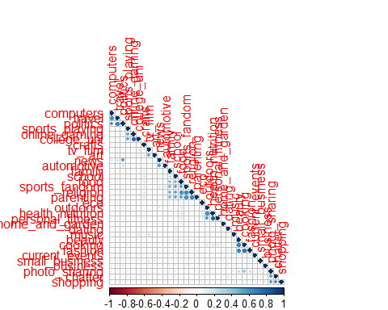

From the corrplot, it seems like there are likely to be about 4-8 clusters.

To find the optimal number of clusters, we implemented the Elbow method for k means clustering after scaling and centering the data.

library(factoextra)  
library(cluster)  
library(NbClust)  
  
# scaling before clustering  
mkt_seg_scale <- scale(mkt_seg_no_id, center=TRUE, scale=TRUE)   
  
set.seed(5)  
# Calculating wss till k=15  
k.max <- 15  
data <- mkt_seg_scale  
wss <- sapply(1:k.max,   
 function(k){kmeans(data, k, nstart=10 )$tot.withinss})  
plot(1:k.max, wss,  
 type="b", pch = 19, frame = FALSE,   
 xlab="Number of clusters K",  
 ylab="Total within-clusters sum of squares")  
abline(v = 8, lty =2)

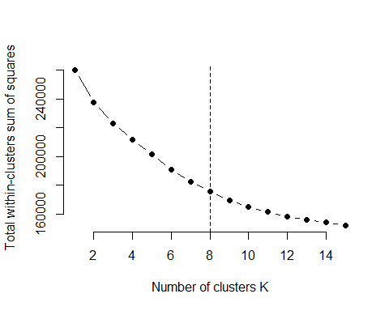

# Cross checking with factoextra package  
fviz_nbclust(data, kmeans, method = "wss")

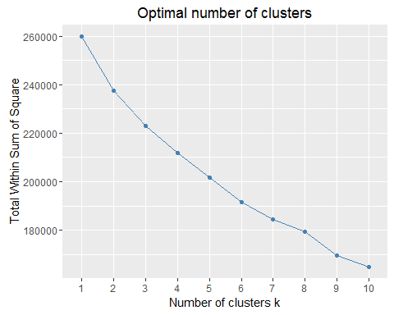

From the plots, the optimal number of clusters is 8. We chose 8 since it minimises wss to an acceptable value and will not have too many clusters that will it hard to interpret. We will use k means clustering with 8 clusters.

# K-means clustering  
set.seed(10)  
km_seg <- kmeans(mkt_seg_scale, 8, nstart = 30)  
  
# k-means group number of each observation  
clust_obs <- km_seg$cluster  
table(clust_obs)

## clust_obs  
## 1 2 3 4 5 6 7 8   
## 794 440 3480 371 364 698 504 1231

# Visualize k-means clusters  
fviz_cluster(km_seg, data = mkt_seg_scale, geom = "point",  
 stand = FALSE, frame.type = "norm")

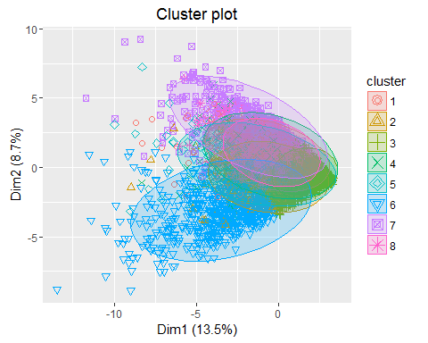

# Identifying where the centers of the clusters are  
clusters_cent = km_seg$centers  
imp_fact = t(clusters_cent)  
  
# Separating by cluster and only taking important features  
cluster_1 = imp_fact[which(abs(imp_fact[,1])>=0.4),1]  
cluster_2 = imp_fact[which(abs(imp_fact[,2])>=0.4),2]  
cluster_3 = imp_fact[which(abs(imp_fact[,3])>=0.4),3]  
names(cluster_3) = c("photo_sharing") # since only 1 variable  
cluster_4 = imp_fact[which(abs(imp_fact[,4])>=0.4),4]  
cluster_5 = imp_fact[which(abs(imp_fact[,5])>=0.4),5]  
cluster_6 = imp_fact[which(abs(imp_fact[,6])>=0.4),6]  
cluster_7 = imp_fact[which(abs(imp_fact[,7])>=0.4),7]  
cluster_8 = imp_fact[which(abs(imp_fact[,8])>=0.4),8]  
  
# Seeing how the clusters turned out  
cluster_1

## food health_nutrition cooking eco   
## 0.4577940 2.2002089 0.4025928 0.5419657   
## outdoors personal_fitness   
## 1.7114549 2.1673465

cluster_2

## sports_fandom politics news automotive   
## 0.6580063 1.2176757 2.6381607 2.5800077

cluster_3

## photo_sharing   
## -0.4056307

cluster_4

## online_gaming college_uni sports_playing   
## 3.497844 3.267583 2.149292

cluster_5

## travel politics news computers business   
## 3.2262928 3.0806307 1.1301224 2.8876695 0.5512909   
## small_business   
## 0.4158731

cluster_6

## sports_fandom food family crafts religion   
## 2.0833636 1.8417506 1.5028191 0.7294984 2.2793038   
## parenting school   
## 2.1526532 1.6869280

cluster_7

## photo_sharing music cooking beauty fashion   
## 1.2267360 0.5271313 2.8124735 2.5708935 2.6659507

cluster_8

## chatter photo_sharing tv_film music shopping   
## 1.2243274 0.8780005 0.5222805 0.4020824 1.1005971   
## business art small_business   
## 0.4458287 0.4056572 0.4204943

From the above results, we can drop cluster 3 since it has only 1 category and cluster 7 already has similar features.

Now, plotting important features of each cluster in a wordcloud.

par(mfrow=c(1,1))  
library(wordcloud)

## Loading required package: RColorBrewer

for (i in c(1,2,4,5,6,7,8)) { # skipping cluster 3  
wordcloud(colnames(mkt_seg_scale), km_seg$centers[i,], min.freq=0, max.words=100, scale=c(3,.5))  
}



From the clusters obtained, the market segments obtained are the following:

Cluster 1 - Health conscious users  
Cluster 2 - Users with more (stereotypical) masculine interests  
Cluster 3 - Youngsters (Cluster 3 was dropped and numbers of all others were changed accordingly)  
Cluster 4 - Businessmen/Business women  
Cluster 5 - Family oriented users  
Cluster 6 - Users with more (stereotypical) feminine interests  
Cluster 7 - Miscellaneous

These market segments are valuable to NutrientH20 because they now have a better understanding of their customer base by getting a fair idea of what age groups their customers are in, what phase of life they are going through and their hobbies/interests. They can tune their messaging strategy to have customized messages and promotions going out to people based on these interests.