**Protractor --version**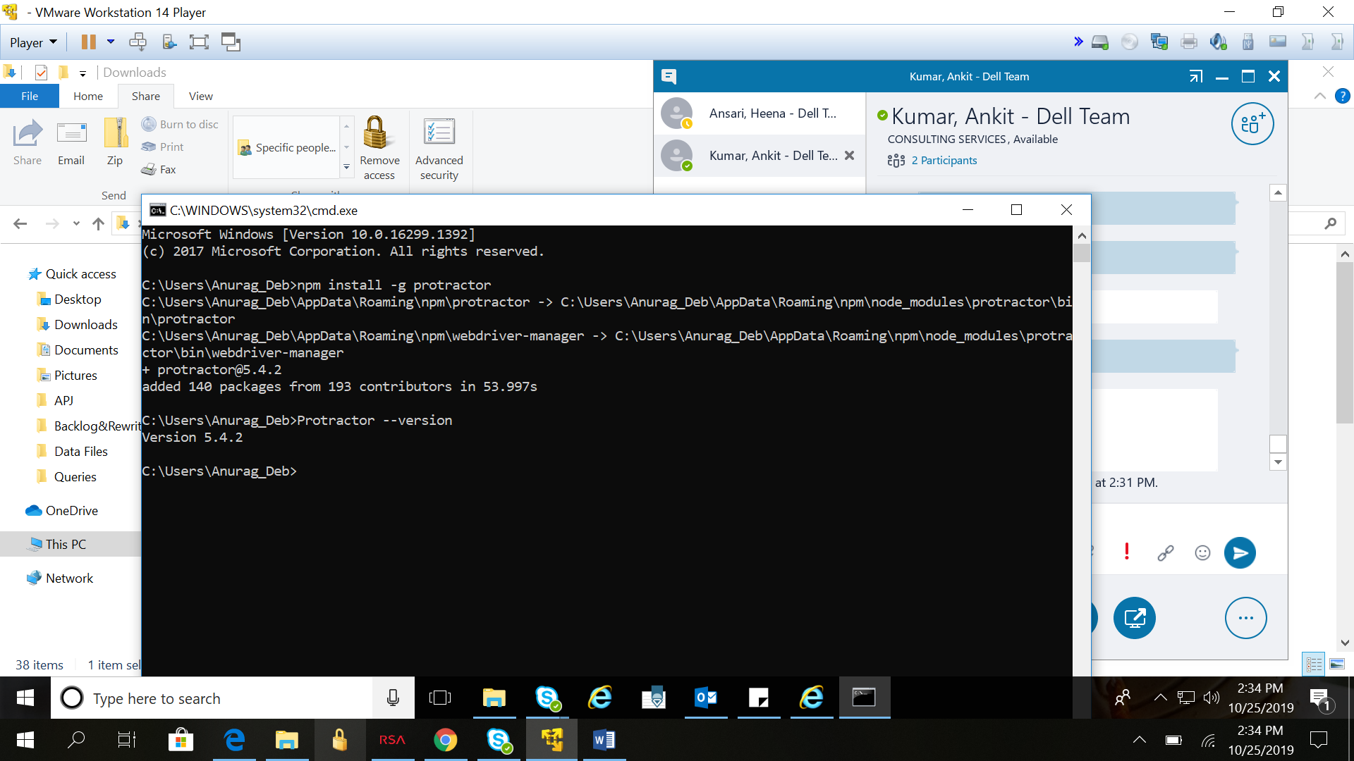webdriver-manager start

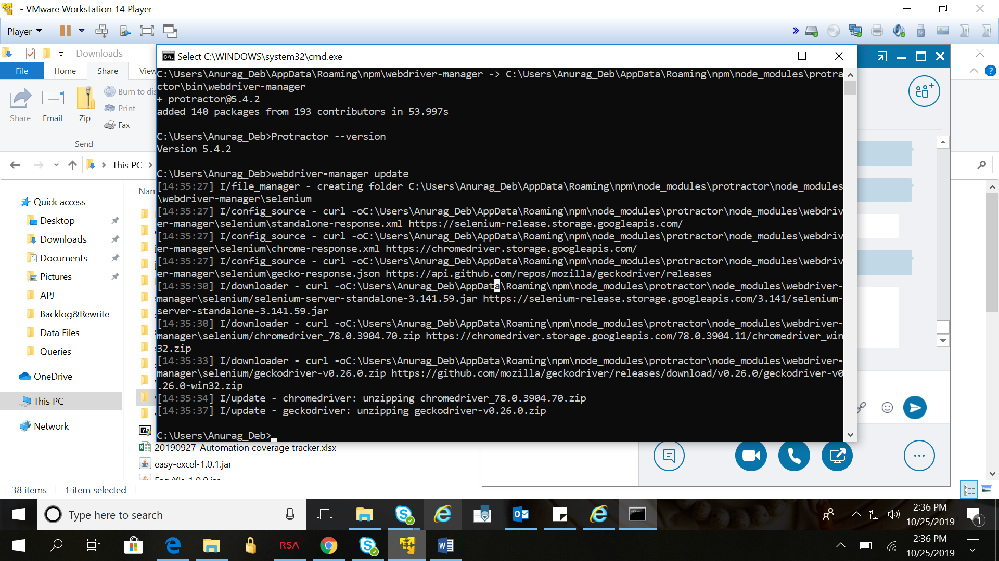

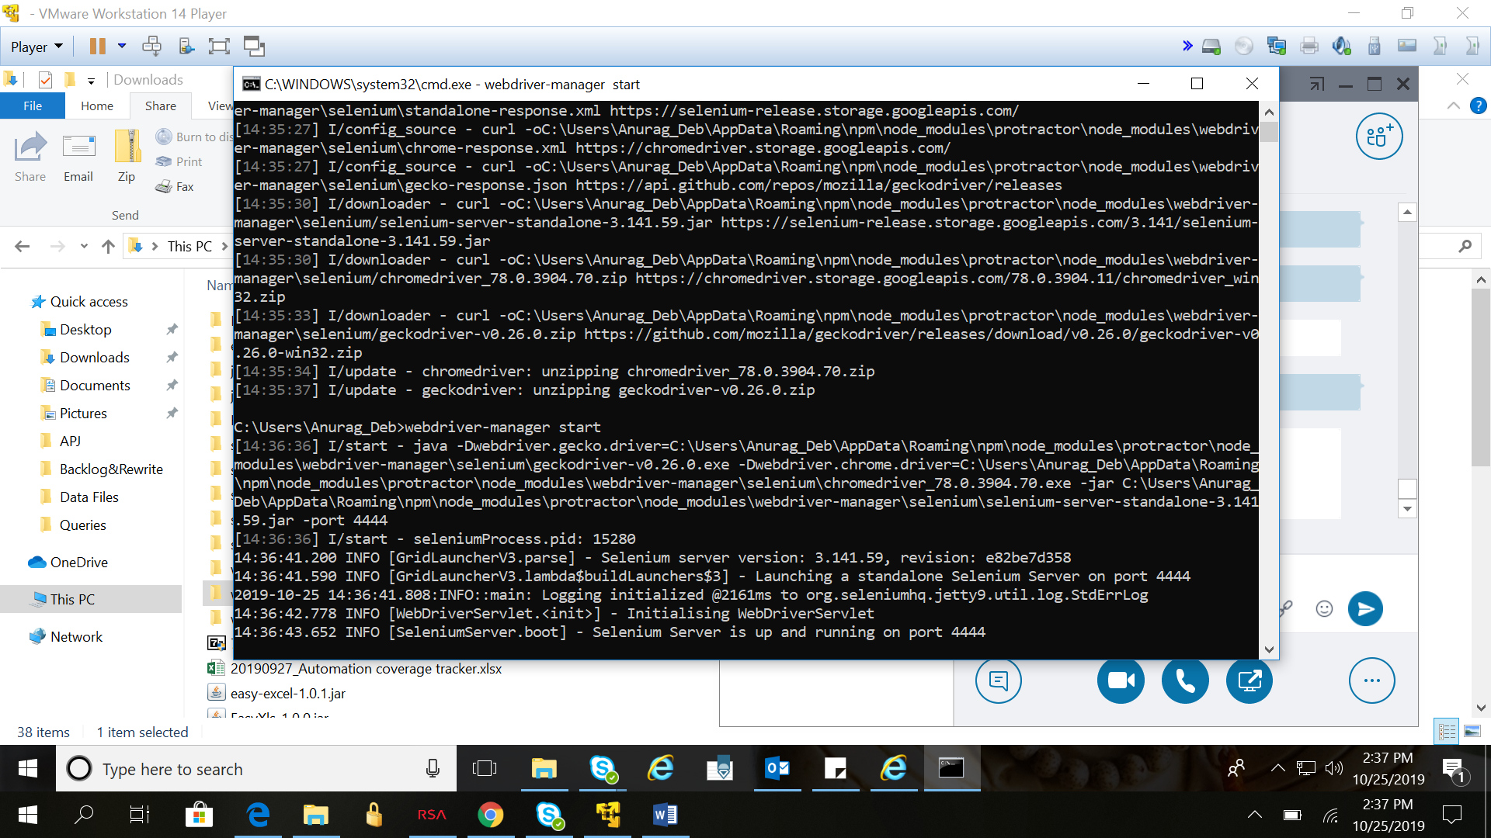

Now, if you go to the following URL (**http://localhost:4444/wd/hub/static/resource/hub.html**) in your browser, you will actually see the Web driver manager running in the background.

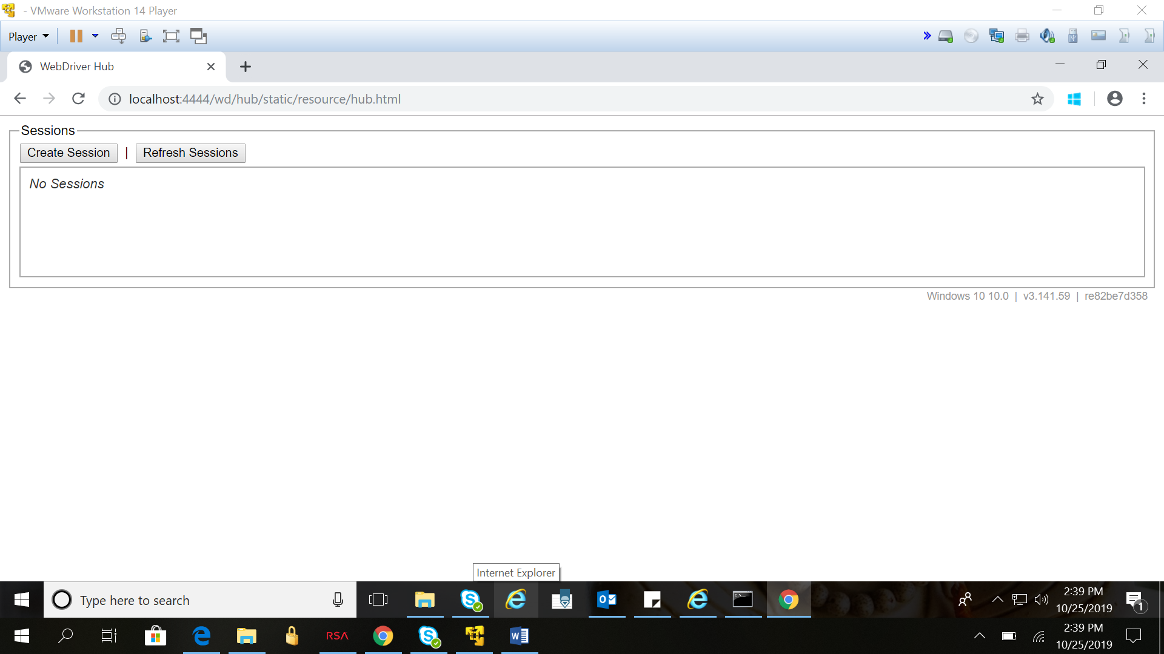

If it fails

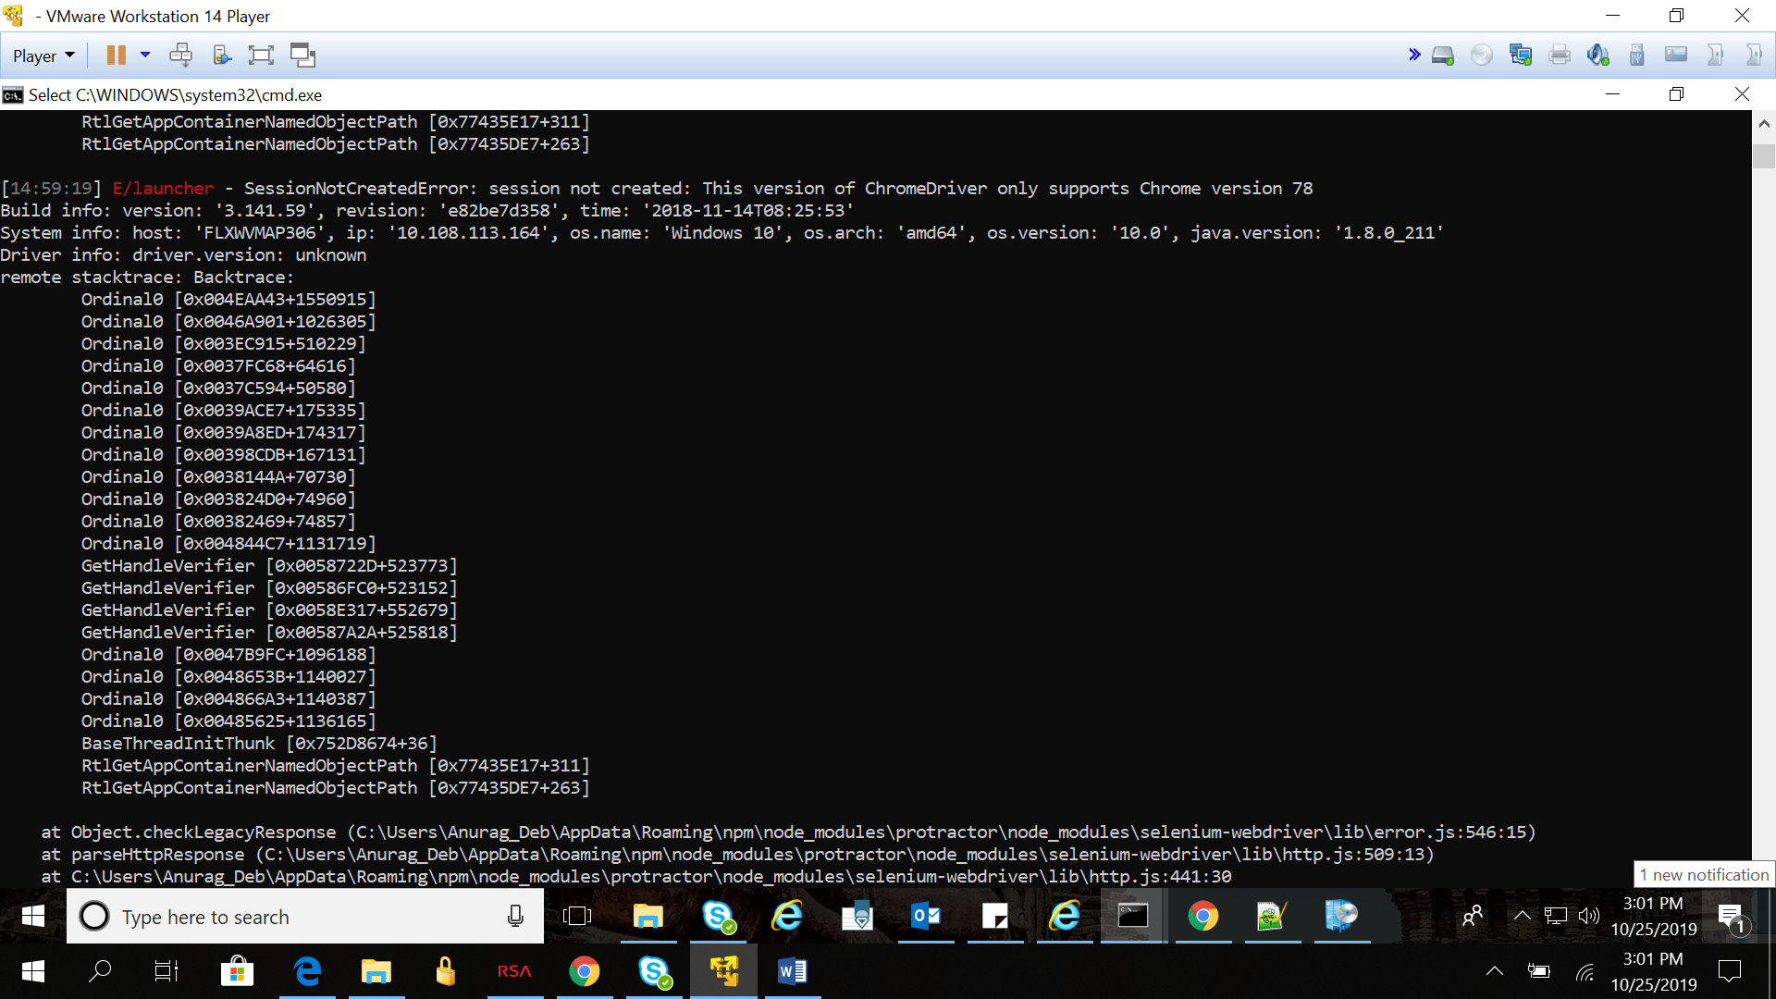 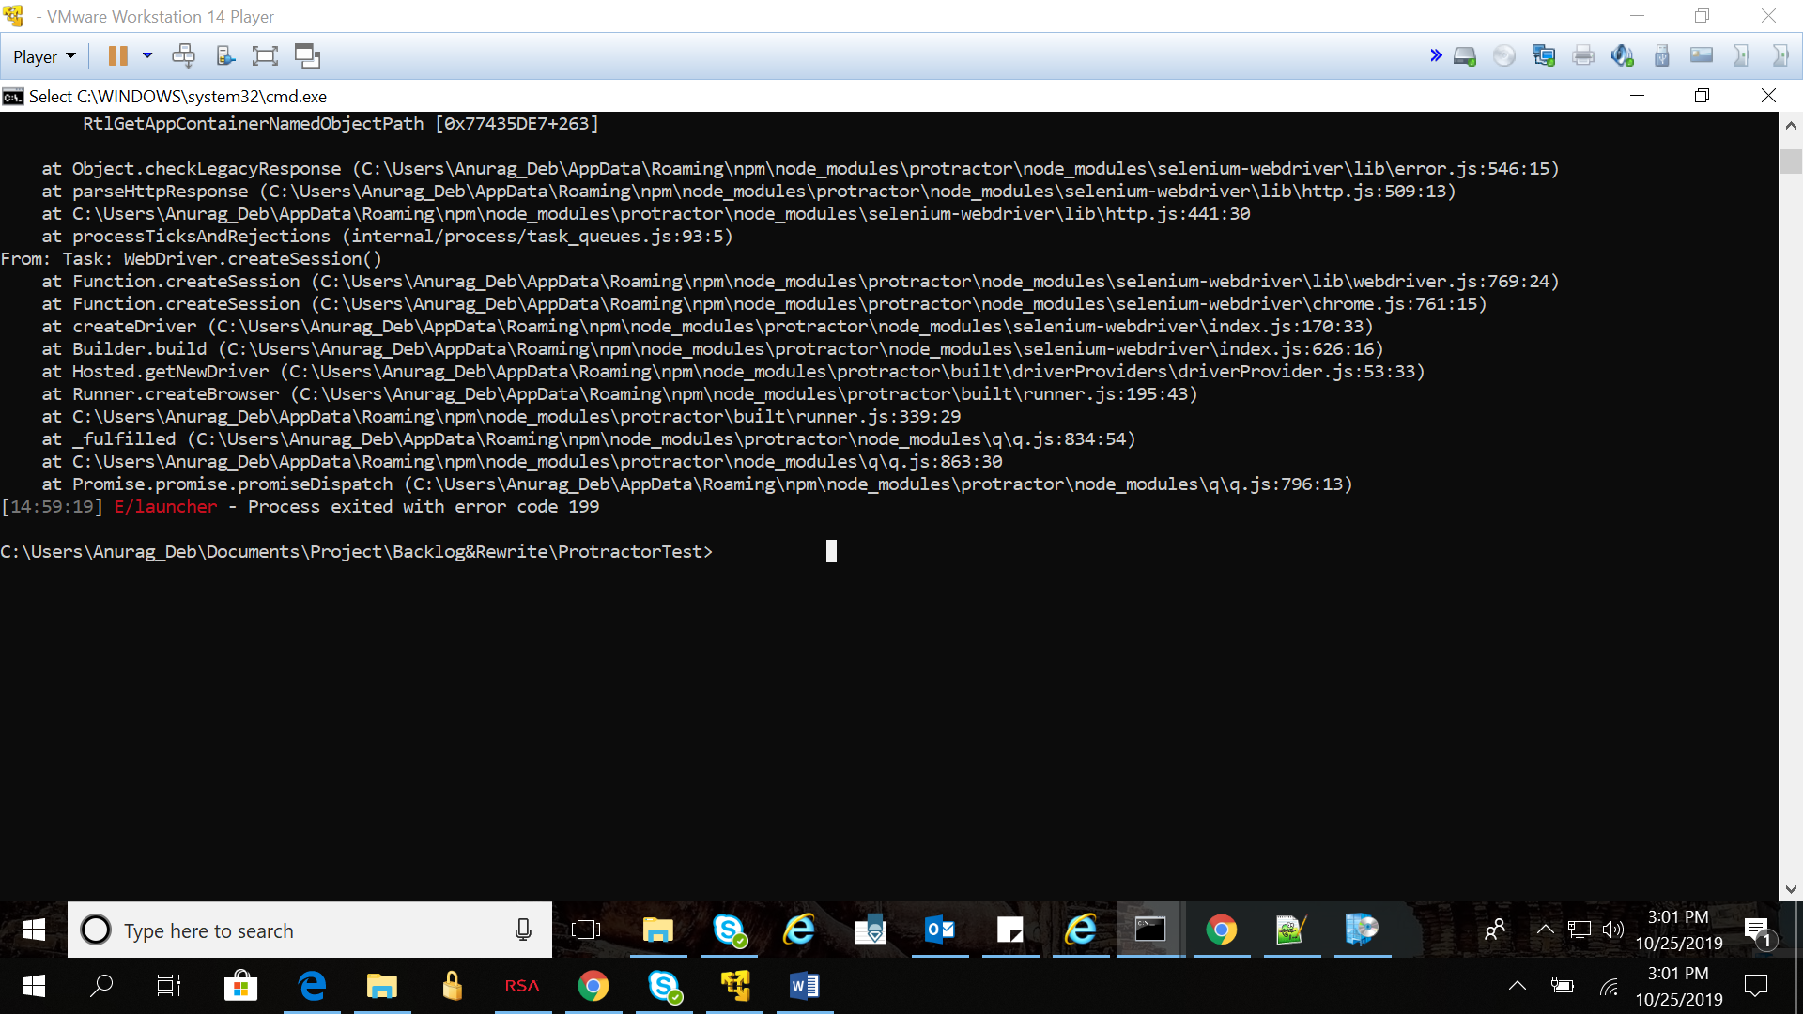

**Change Chrome driver**

C:\\Users\\Anurag_Deb\\AppData\\Roaming\\npm\\node_modules\\protractor\\node_modules\\webdriver-manager\\selenium\\