Configuration are Used and Issue are as follows

WAS Version – 6.1 (Trial Version 30 Days)
BIRT Version – 2.1.1

Issue – BIRT Reports (Text) are getting opened perfectly but BIRT Reports (Graphs/Charts) are not getting opened.

Description –

This is User Interface Screen Shot (1).

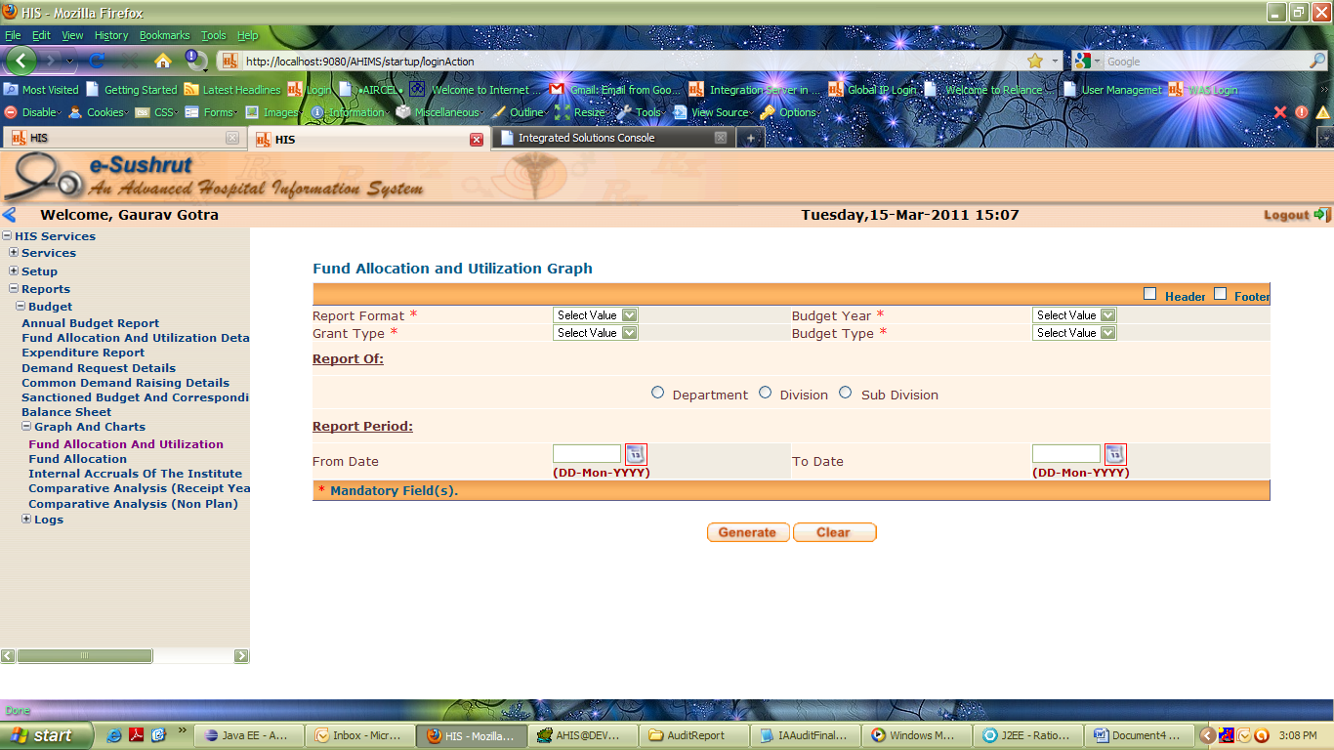

Screen Shot (1)

After Selecting Values from this page we click on Generate Button then following Error Occur – Screen Shot (2)

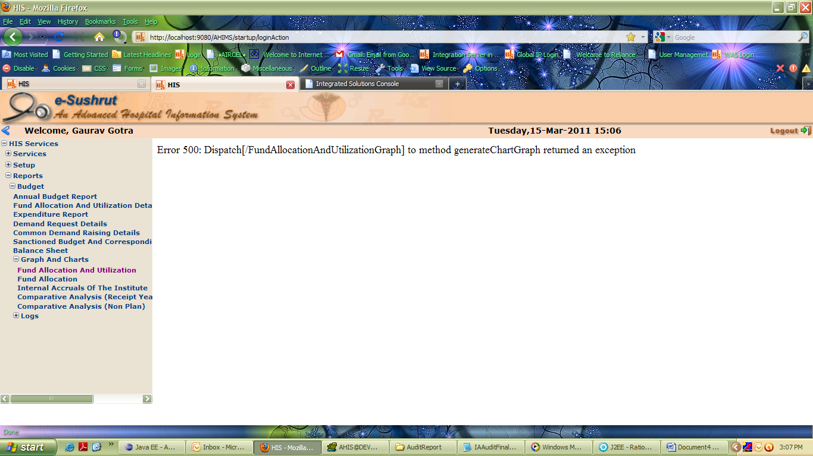

Screen Shot (2)

And this is Console Output

[3/15/11 15:07:01:937 IST] 00000025 SystemOut O inside generateChartGraph Function
[3/15/11 15:07:01:937 IST] 00000025 SystemOut O InSide Integration createGraphChartEssential
[3/15/11 15:07:01:937 IST] 00000025 SystemOut O Seat Id in populatDTO 10011
[3/15/11 15:07:01:953 IST] 00000025 ConnectionFac W J2CA0294W: Deprecated usage of direct JNDI lookup of resource AHIS. The following default values are used: [Resource-ref settings]

res-auth: 1 (APPLICATION)
res-isolation-level: 0 (TRANSACTION_NONE)
res-sharing-scope: true (SHAREABLE)
loginConfigurationName: null
loginConfigProperties: null
[Other attributes]

res-resolution-control: 999 (undefined)
res ref or CMP bean name: null
Database pool properties: null
primeID: 0
isCMP1_x: false (not CMP1.x)
isJMS: false (not JMS)

[3/15/11 15:07:01:984 IST] 00000025 ConnectionFac W J2CA0294W: Deprecated usage of direct JNDI lookup of resource AHIS. The following default values are used: [Resource-ref settings]

res-auth: 1 (APPLICATION)
res-isolation-level: 0 (TRANSACTION_NONE)
res-sharing-scope: true (SHAREABLE)
loginConfigurationName: null
loginConfigProperties: null
[Other attributes]

res-resolution-control: 999 (undefined)
res ref or CMP bean name: null
Database pool properties: null
primeID: 0
isCMP1_x: false (not CMP1.x)
isJMS: false (not JMS)

[3/15/11 15:07:02:000 IST] 00000025 SystemOut O Budget Year2010-2011
[3/15/11 15:07:02:000 IST] 00000025 SystemOut O Grant TypeG01
[3/15/11 15:07:02:000 IST] 00000025 SystemOut O Budget TypeB02
[3/15/11 15:07:02:000 IST] 00000025 SystemOut O Scheme Code-1
[3/15/11 15:07:02:000 IST] 00000025 SystemOut O Project Code-1
[3/15/11 15:07:02:000 IST] 00000025 SystemOut O Department128
[3/15/11 15:07:02:000 IST] 00000025 SystemOut O Division-1
[3/15/11 15:07:02:000 IST] 00000025 SystemOut O Sub Division-1
[3/15/11 15:07:02:000 IST] 00000025 SystemOut O Hospital Code108
[3/15/11 15:07:02:000 IST] 00000025 SystemOut O mode_Type1
[3/15/11 15:07:02:000 IST] 00000025 SystemOut O From_Date15-Mar-2011
[3/15/11 15:07:02:000 IST] 00000025 SystemOut O To_Date15-Mar-2011
[3/15/11 15:07:02:000 IST] 00000025 SystemOut O date_Message_Visibilitytrue
[3/15/11 15:07:02:140 IST] 00000025 WebApp E [Servlet Error]-[action]: com.ibm.ws.webcontainer.webapp.WebAppErrorReport: Dispatch[/FundAllocationAndUtilizationGraph] to method generateChartGraph returned an exception
at com.ibm.ws.webcontainer.webapp.WebAppDispatcherContext.sendError(WebAppDispatcherContext.java:536)
at com.ibm.ws.webcontainer.srt.SRTServletResponse.sendError(SRTServletResponse.java:930)
at org.apache.struts.actions.DispatchAction.dispatchMethod(DispatchAction.java:308)
at org.apache.struts.actions.DispatchAction.execute(DispatchAction.java:216)
at org.apache.struts.action.RequestProcessor.processActionPerform(RequestProcessor.java:484)
at org.apache.struts.action.RequestProcessor.process(RequestProcessor.java:274)
at org.apache.struts.action.ActionServlet.process(ActionServlet.java:1482)
at org.apache.struts.action.ActionServlet.doPost(ActionServlet.java:525)
at javax.servlet.http.HttpServlet.service(HttpServlet.java:763)
at javax.servlet.http.HttpServlet.service(HttpServlet.java:856)
at com.ibm.ws.webcontainer.servlet.ServletWrapper.service(ServletWrapper.java:966)
at com.ibm.ws.webcontainer.servlet.ServletWrapper.service(ServletWrapper.java:907)
at com.ibm.ws.webcontainer.filter.WebAppFilterChain.doFilter(WebAppFilterChain.java:118)
at com.ibm.ws.webcontainer.filter.WebAppFilterChain._doFilter(WebAppFilterChain.java:87)
at com.ibm.ws.webcontainer.filter.WebAppFilterManager.doFilter(WebAppFilterManager.java:701)
at com.ibm.ws.webcontainer.filter.WebAppFilterManager.doFilter(WebAppFilterManager.java:646)
at com.ibm.ws.webcontainer.servlet.ServletWrapper.handleRequest(ServletWrapper.java:475)
at com.ibm.ws.wswebcontainer.servlet.ServletWrapper.handleRequest(ServletWrapper.java:463)
at com.ibm.ws.webcontainer.servlet.CacheServletWrapper.handleRequest(CacheServletWrapper.java:92)
at com.ibm.ws.webcontainer.WebContainer.handleRequest(WebContainer.java:744)
at com.ibm.ws.wswebcontainer.WebContainer.handleRequest(WebContainer.java:1433)
at com.ibm.ws.webcontainer.channel.WCChannelLink.ready(WCChannelLink.java:93)
at com.ibm.ws.http.channel.inbound.impl.HttpInboundLink.handleDiscrimination(HttpInboundLink.java:465)
at com.ibm.ws.http.channel.inbound.impl.HttpInboundLink.handleNewInformation(HttpInboundLink.java:394)
at com.ibm.ws.http.channel.inbound.impl.HttpICLReadCallback.complete(HttpICLReadCallback.java:102)
at com.ibm.ws.tcp.channel.impl.AioReadCompletionListener.futureCompleted(AioReadCompletionListener.java:152)
at com.ibm.io.async.AbstractAsyncFuture.invokeCallback(AbstractAsyncFuture.java:213)
at com.ibm.io.async.AbstractAsyncFuture.fireCompletionActions(AbstractAsyncFuture.java:195)
at com.ibm.io.async.AsyncFuture.completed(AsyncFuture.java:136)
at com.ibm.io.async.ResultHandler.complete(ResultHandler.java:194)
at com.ibm.io.async.ResultHandler.runEventProcessingLoop(ResultHandler.java:741)
at com.ibm.io.async.ResultHandler$2.run(ResultHandler.java:863)
at com.ibm.ws.util.ThreadPool$Worker.run(ThreadPool.java:1510)

Note -
Both Text and Graph/Chart BIRT Reports are getting opened perfectly in Tomcat 5.5.

