**Databases and Data Warehouses**

**Assignment 1**

**Submitted By – Anurag Pandey**

**Roll No.** **23PGAI0059**

**Solution No.1**

**Attributes** : -

In an Entity-Relation model an attribute is a property or characteristic of an entity. Attributes are the properties that define a relation. An entity may contain any number of attributes. One of the attributes is considered as the primary key (this uniquely identifies the student, this must not be repetitive).

*Example*: Student has attributes like name, age, roll number, and many more. To uniquely identify the student, we use the primary key as a roll number as it is not repeated. Attributes can also be subdivided into another set of attributes.

**Domain**: -

In ER model a domain is a set of values for an attribute (i.e., the properties or characteristics of entities). The value set conforms to a common definition for the domain (e.g., type, format, syntax, and meaning).For all relation(r) the domain of all attributes of relation(r) must be atomic.

**Entity:** -

An entity is thing or objects in real world that is distinguishable other object.

**Entity set**: -

An entity has a set of properties and the values for some set of properties must uniquely identify an entity. Set of entities that has same type of properties or attributes.

**Relationship**: -

A relationship between values is mathematically represented as the Tuple of value that is the Tuple of all the values which corresponds to a row in a table. A relationship is an association among several entities.

**Relationship Set**: -

Set of relationships of the same type is known as relationship set.

**One to many Relationship**: -

when one row in table A may be linked with many rows in table B, but one row in table B is linked to only one row in table A

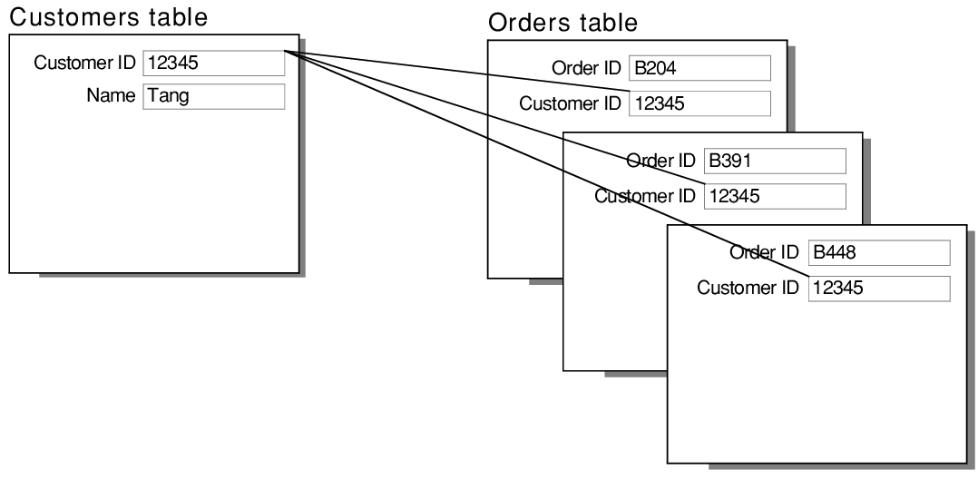

**Many to many Relationships**: -

A many-to-many relationship occurs when multiple records in a table are associated with multiple records in another table.

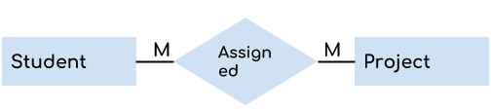

**Participation Constraints**:-

Participation constraints are two types as mentioned below −

1. **Total participation**

The participation of an entity set E in a relationship set R is said to be total if every entity in E Participates in at least one relationship in R.

E.g. Loan in figure is in a relationship with all the participants of customer; hence loan has Total participation with customer.

1. **Partial Participation**

If only some of the entities in E participate in relationship R, then the participation of E in R is said to be partial participation.

Eg. Customer in figure, are partially associated with loan, hence customer has partial relationship with loan.

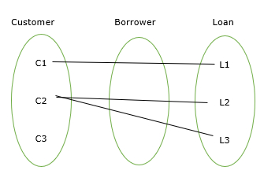

**Weak Entity Set**:-

A weak entity set is one whose existence is dependent on another entity set, called its identifying entity set.

**Solution No.2**

1. Basically it does not create any problem when only one person is managing the relations. But for easy understanding to someone else, the design is improved by changing one of the attribute names.
2. (i) X is the primary key for A but not B:-

We can use Referential integrity (foreign key)

e.g.:- foreign key in B(X) referencing primary key in A(X).

(ii) X is the primary key for both A and B

: Apply same primary key for both relation A(X) and B(X).

(iii) X is not the primary key for A nor for B:-

If X is a non key in both relation A & B, there is a high chance of Data redundancy, We can assign a foreign key for X in B refers to a non-primary unique key X in A

**Solution No.3**

(A) It Does not makes sense for a weak entity set to be in a one to one relationship with the strong entity set because, a weak entity set is one whose existence is dependent on another entity, called its identifying entity, The weak entity set must have total participation in the identifying relationship set, Thus In one to one relationship with weak entity set and strong entity set there may not be enough attributes in strong entity set to uniquely identify a weak entity set.

(B)Weak entity set can be converted into strong entity set by simply adding appropriate attributes, this approach results in the redundant storage of primary key. We have weak entity sets **to avoid the inconsistencies caused by duplicating the key of the strong entity.**

**Solution No.4**

**4(I) ER diagram for the given database is as below-**

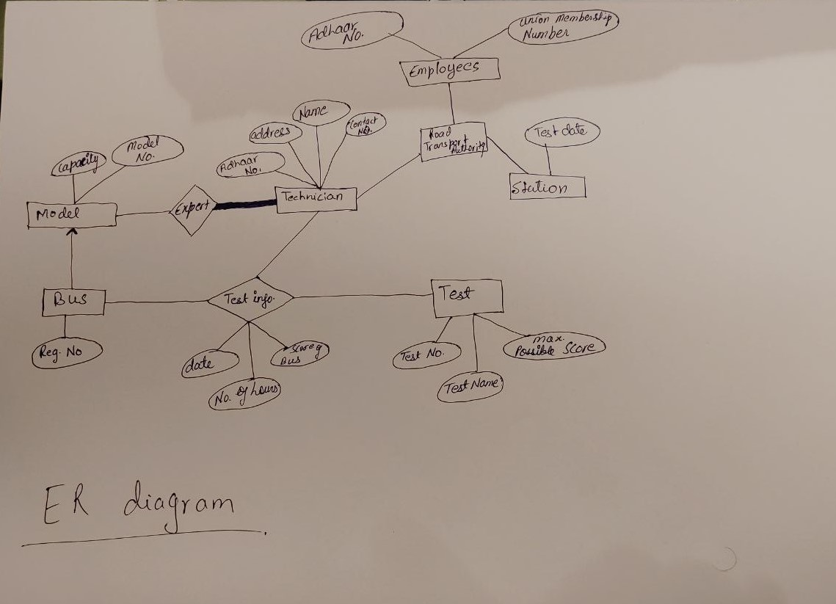

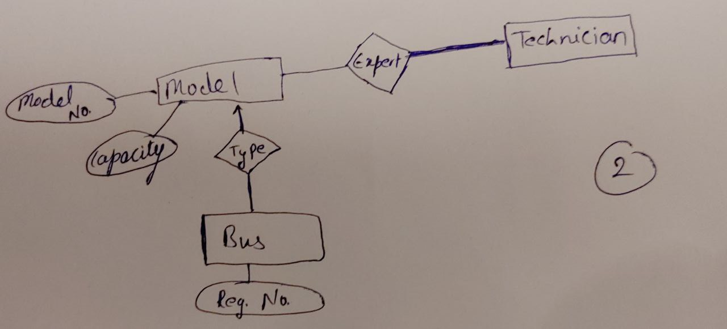**4(II) If a regulation is passed by RTA that only a technician who is an expert in a bus’s model is eligible to conduct the test on it then in the above diagram there will be one more relation equivalent to expert relationship for type of bus model and technician which can be inserted between bus and model.**

**Solution No.5**

**(A)**

Case I :-



**Representation one-to-one:**

Every Attribute of B is in relation with one attribute of A and vice versa.

Case II:-



**Representation one-to-many**:

Every Attribute of B is in relation with at least one attribute of A.

Case III:-



**Representation Many to many relationship**:

Representation

Every Attribute of B can be in relation with at more than one attribute of A and vice versa.

(B) If there is partial participation from any one of the sides or both we can apply Cardinality constraints or we can assign NULL value to the relationship attribute.