ModelicAI Studio: System Design
Nov 2, 2026 · @Anurag Dogra

Overview
ModelicAI Studio turns a plain-language request into a working, simulated Modelica model, and lets people inspect, change and re-run it in one browser workspace. It is built by Anurag Dogra (owner and maker) for students and researchers who model physical systems.
The product has two halves that share one OpenModelica engine:
- The workbench: model library, diagram with original Modelica Standard Library (MSL) icons, Modelica code editor, parameter panel, simulation setup, plots and live results on the diagram.
- Modi, the modelling assistant: a LangGraph agent that answers questions from the open model's facts, designs and edits models through a checked design loop, simulates, explains and fixes errors, and asks for approval before changing anything.
Design goals:
- Correct before shown: a proposed model must compile, be balanced, be built from library components and pass a test run before the user sees it.
- Human in control: structural changes and agent-chosen settings wait for Apply or Discard.
- Facts over guesses: numbers come from result files, units from OpenModelica's model description, and error causes from a structural diagnosis.
- Memory per model: every model keeps its chat, runs, revisions and notes across restarts.
- Focused scope: Modi only helps with modelling and simulation in ModelicAI.

Architecture at a glance
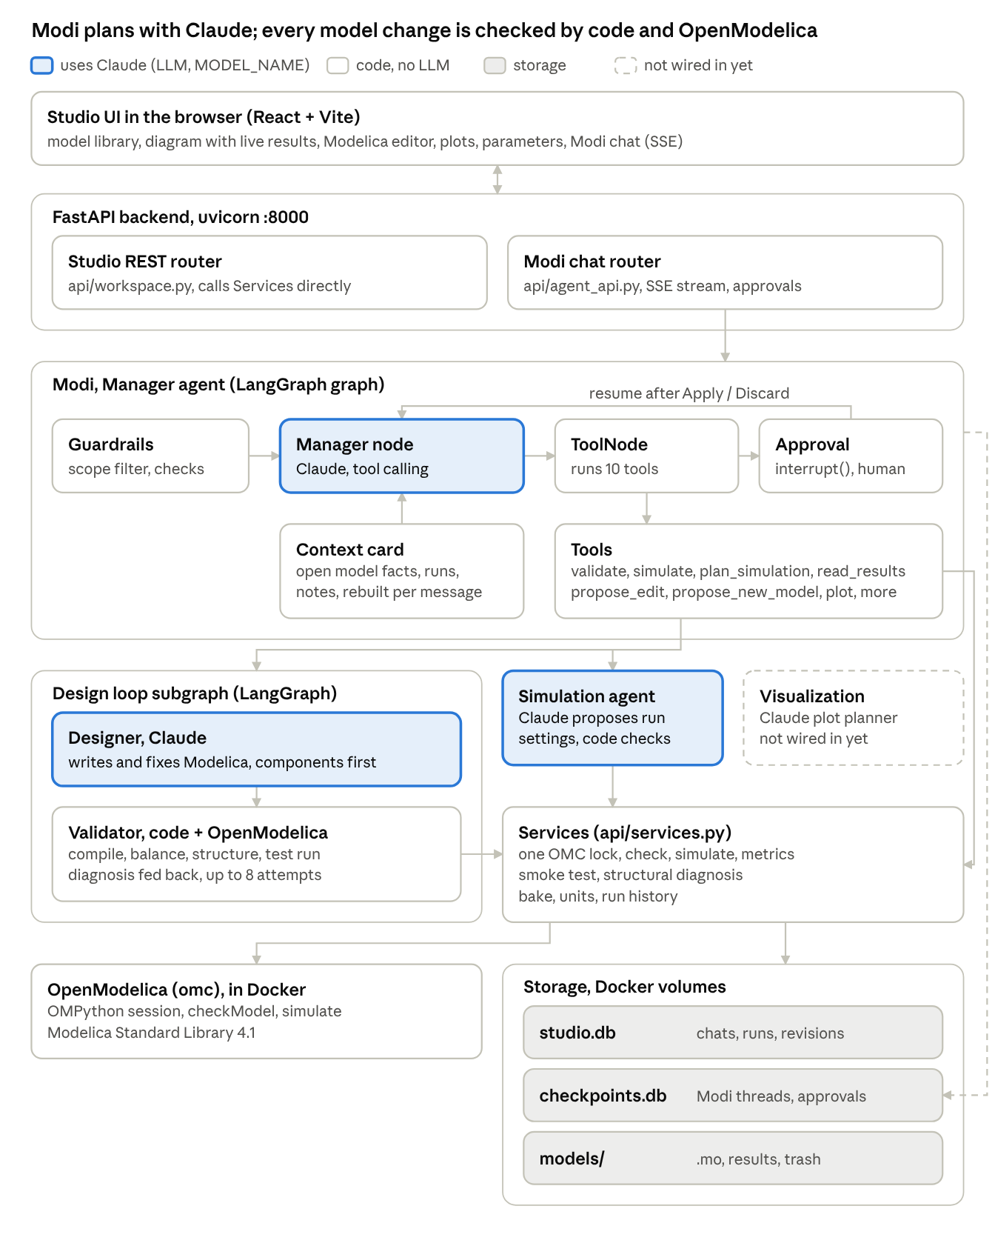
agentic system design · 4 LLM agents, code checks, OpenModelica, 3 stores
Only four parts call an LLM, all Claude through MODEL_NAME (default claude-haiku-5-5): Modi's manager node, the designer, the simulation agent, and the visualization planner, which is not wired in yet. Everything else is code: the guardrails, the context card, the validator gates, the services and the OpenModelica calls. Modi's state is checkpointed to checkpoints.db (dashed line); the Studio REST router calls the services directly for GUI actions, with no LLM involved.

Frontend
The frontend is a Vite + React app in frontend/. App.jsx is the static layout shell; studio.js is an imperative engine started once from a React effect, which keeps the diagram, editor and plot fast without re-rendering React on every frame.
Area | What it does | Built with
Model library | List, open, + New (fresh draft chat), delete (✕) | REST
Diagram | OMC scene: MSL icons, placements, wires; pan, zoom, drag, select; dark canvas inverts icons | SVG
Live results | Value badges, flowing wires, DynamicSelect animation (e.g. tank level), time player, plot marker | SVG + Modelica expression evaluator
Modelica editor | Syntax highlighting, error-line marking from OMC messages, Check (⌘S) | CodeMirror 5
Results panel | Variable tree, plots with real units and two axes, pinned runs, CSV export | Plotly.js
Parameters | Run-time overrides, expressions (2*k) with live values, Write into model | REST + parser
Simulation setup | Start, stop, intervals, solver; numeric-only validation | —
Modi chat | Streaming steps, approval cards, Fix with Modi cards, per-model history | Server-Sent Events
Themes | 11 themes + Auto (day/night), canvas toggle | CSS variables
During development npm run dev serves the UI on port 5173 and proxies /api to the backend; npm run build writes static/, which FastAPI serves at /studio.

Backend API
The backend is one FastAPI app (main.py, run by uvicorn on port 8000). At startup it builds the toolbox (SimulationOrchestrator: one OMC session, designer, simulation agent, graph parser), then mounts two routers and the static frontend. / redirects to /studio/; interactive API docs are at /docs.
Method + path | Purpose | Module
GET /api/studio/models | Model library with result status | workspace
GET / PUT / DELETE /api/studio/models/{name} | Read source + diagram fallback; save and check; delete (erase memory, move files to trash) | workspace
GET /models/{name}/diagram | Full scene from OMC: components, icons, wires, background, model icon | workspace
GET /models/{name}/parameters | Parameters and simulation options | workspace
POST /models/{name}/run | Simulate (no LLM), record the run, diagnosis on failure | workspace
GET /models/{name}/variables, /results, /units, /runs | Result variables, series, units, run history | workspace
POST /models/{name}/bake | Write parameter values or expressions into the source | workspace
GET /models/{name}/messages | Chat history of a model or draft | workspace
GET /icon/{class} | MSL icon proxy and cache (fallback view) | workspace
POST /api/studio/agent | Message to Modi, streamed back as SSE | agent_api
POST /api/studio/agent/resume | Apply, Discard or refine a proposal | agent_api
GET /api/studio/agent/pending | Open approval for a thread, if any | agent_api
All /models/... paths sit under /api/studio. Modi's stream emits typed events: step and tool (progress), tool_result, approval (a proposal card), applied, ui (plot, set parameters, refresh results), failed (opens a Fix with Modi card), message, error and done.

Modi, the Manager agent
Modi is a LangGraph StateGraph (agents/manager.py) with three nodes: manager (Claude with ten bound tools), tools (LangGraph ToolNode, errors returned as results instead of crashes) and approval (interrupt()). After tools run, the graph routes to approval when a tool returned a proposal, otherwise back to the manager; a reply without tool calls ends the turn.
On every message the manager receives: the system prompt and scope rules, the context card of the open model (components, parameters, last two runs with metrics, revisions, notes, origin, source) and the UI state (selected component, plotted variables, pending overrides), plus the last 30 messages of the thread.
Tool | What it does | Needs approval
read_model | Full source and card of the open or another model | No
read_results | Initial, final, min, max, time of max, 2% settling time per variable | No
validate | OMC check, plus structural diagnosis on failure | No
simulate | Run with given or last settings; diagnosis on failure | No
plan_simulation | Simulation agent chooses settings; checked, then proposed | Yes
propose_edit | Design loop on the current source; diff proposal | Yes
propose_new_model | Design loop from a description | Yes
set_parameters | Fills the parameter panel (run-time overrides) | No
plot | Selects variables in the plot | No
remember_note | Stores a lasting fact or goal for the model | No
Memory. A SqliteSaver checkpointer stores each thread in data/checkpoints.db, so a run paused for approval survives reloads and restarts. The UI chat history is kept separately in studio.db.

Design loop
The design loop (agents/design_graph.py) is the original designer → validator → retry StateGraph, run as a subgraph by propose_edit and propose_new_model. It works on a scratch copy in models/.proposals/<id>/, so the real model changes only after Apply.
Each attempt passes four gates in order; the first failure ends the attempt and its error goes back to the designer:
- Compiles: OMC checkModel with full diagnostics from the error buffer.
- Balanced: equation count equals variable count.
- Library components: at least two MSL component instances, unless the user asked for equations or edits an existing equation model.
- Test run: a short simulation up to the model's own stop time (200 points) catches initialization and runtime failures.
Failures on equation count, initialization or the test run carry the structural diagnosis (unconnected inputs, open fluid ports). If an attempt fails with the same error as the one before, the designer is told its last change did not help and must change approach. The loop allows DESIGN_MAX_RETRIES attempts (default 8, at most 10); after that Modi reports the failure instead of proposing a broken model.

Supporting agents and services
LLMs are used only where judgement is needed; everything that can be checked is checked by code.
Part | File | Uses an LLM | Role
Toolbox | agents/orchestrator.py | No | Creates the OMC session, designer, simulation agent and graph parser once
Designer | agents/designer.py | Yes | Writes and fixes Modelica, component-first, with an MSL cheat sheet and layout rules
Simulation agent | agents/simulation.py | Yes | Proposes stop time, intervals, solver, overrides from the model's physics
Visualization planner | agents/visualization.py | Yes | Plans plot layouts (kept; not wired in yet)
Context card | agents/context.py | No | Builds the open model's facts for Modi on every message
Guardrails | agents/guardrails.py | No | Scope filter and output check
Services | api/services.py | No | OMC operations under one lock: check, simulate, metrics, smoke test, diagnosis, apply code
Bake | api/bake.py | No | Paren-aware rewrite of parameter values and expressions in source
Simulation agent checks. Its JSON answer must have finite numbers, stop greater than start, 10 to 100,000 intervals, a known solver, and overrides only for existing parameters with numeric values. An invalid answer is sent back once with the reasons; a second failure falls back to the model's own experiment annotation. The result then passes the same validate_settings gate as every run.
Structural diagnosis. Services.diagnose() reads components and connections through OMC and lists unconnected connectors, ranked: causal inputs first (the usual cause of "too few equations"), then open fluid ports, then other physical connectors. It feeds the design loop, Modi's validate/simulate/propose_edit tools and the Simulate error card.

OpenModelica integration and diagram engine
One OMPython OMCSessionLocal runs inside the container as the non-root user modelica (OMC refuses to start as root). Every call that touches it holds omc_lock, so the web API, Modi and the design loop never interleave commands.
utils/omc_client.py loads the Modelica Standard Library at startup and runs compile_model: loadFile + checkModel, reading OMC's error buffer for real diagnostics. A model reported as successful but with different equation and variable counts is treated as failed.
utils/omc_graphics.py builds the diagram from OMC's graphical API, the same calls OMEdit uses:
- getComponents and getComponentAnnotations give instances and their Placement; getNthConnection and getNthConnectionAnnotation give wires and routes.
- getIconAnnotation (with inherited classes) gives each icon's primitives, rendered to SVG in Modelica coordinates; connector icons are placed at their icon transformation, which also yields port positions and types.
- DynamicSelect(static, dynamic) keeps both parts: the static one is drawn, the dynamic expression becomes a data-dyn-* attribute that the browser evaluates during playback (fills, text, colours, visibility, points).
- Text placeholders (%name, %R) are filled in the browser from component modifiers, resolved through model parameters (c=k shows c=10).
- Wires without routes get orthogonal routes that leave each pin in its facing direction.
Results and units. Results come from OMC's v4 .mat file (read_series, read_variable_names); units come from <Name>_init.xml. Base units are used, because result files store base units (K, not degC).

Data and persistence
All state lives in two folders, both mounted as Docker volumes and both git-ignored. Nothing is kept in process memory that matters after a restart.
Store | Location | Contents | Keyed by
Model files | models/<Name>/ | .mo source, OMC build output, _res.mat, _init.xml, graph_schema.json | model name
Proposals | models/.proposals/<id>/ | Scratch copies compiled and test-run by the design loop | proposal id
Trash | models/.trash/<Name>-<time>/ | Files of deleted models (no memory attached) | name + time
messages | data/studio.db | Chat history shown in the UI, proposals, decisions | model or _new_<id> draft
runs | data/studio.db | Settings, overrides, status, key metrics, wall time, source (GUI or agent) | model
revisions | data/studio.db | Every saved version of the code with a one-line summary | model
notes | data/studio.db | Facts and goals the user told Modi to remember | model
proposals | data/studio.db | Proposed edits, new models and run settings, with status | proposal id
model_meta | data/studio.db | Origin prompt and purpose of each model | model
Checkpoints | data/checkpoints.db | Modi's LangGraph state, including runs paused for approval | thread id
Thread ids. An open model's thread is its name; each "+ New" opens a fresh _new_<random> draft. A model created from a draft gets its own thread, seeded with the original prompt.
Deletion. Deleting a model erases its rows in every table above and its checkpoint thread, removes its proposal folders, and moves its files to the trash. A new model with the same name starts with no memory.

Key flows
New model from a sentence
- The user clicks "+ New" and writes a request; the UI posts it to /api/studio/agent with a fresh draft thread.
- The input filter passes it; Modi calls propose_new_model.
- The design loop writes, checks, balance-checks, structure-checks and test-runs the model in a scratch folder, streaming each step.
- The run pauses on an approval card. On Apply the model is saved, a revision recorded, and the UI opens the new model with its own chat.
Edit with approval
- The user asks for a change ("add a second spring"). Modi calls propose_edit with the current source.
- The design loop produces a checked version; the card shows the diff.
- Apply saves it; Discard changes nothing; a chat reply refines the proposal and loops back.
Simulate
- The GUI Simulate button checks the inputs, saves unsaved code via Check, then posts settings and overrides to /run. No LLM is involved.
- The backend simulates, computes metrics, records the run and returns the variables.
- The UI loads units, refreshes plots and starts the live diagram view on the final values.
Fix an error
- A failed Check or Simulate (GUI or Modi) shows a red card with the cleaned OMC message and the structural diagnosis.
- "Fix with Modi" sends the error; Modi re-validates, attaches the diagnosis as facts, and calls propose_edit.
- The design loop retries up to 8 times, escalating repeated errors, and proposes a fix only once it compiles, balances and runs. Modi then re-validates and re-simulates.

Guardrails and safety
Modi only helps people use ModelicAI; nothing changes a model without a person approving it.
Layer | Where | What it stops
Input filter | guardrails.check_input, before the LLM | Competitors and their vendors, other companies and AI products, outside topics, general code, translation, jailbreak phrases; refused with no tokens spent
Scope rules | Modi's system prompt | Comparisons, naming other products, revealing instructions; says it is Modi, built by Anurag Dogra
Output check | guard_reply after the LLM | Replies naming competitors or companies, non-Modelica code blocks
No code tools | Tool list | Modi cannot run code or write files except through proposals
Approvals | interrupt() | Structural edits, new models and agent-chosen settings wait for Apply
Input validation | UI and server | Non-numeric setup values, stop ≤ start, bad interval counts, unknown solvers, unsafe parameter expressions
Write limits | api/bake.py, services | Only numbers, booleans or clean expressions written into source; overrides sanitised before reaching OMC
Allowed by design: Modelica, the MSL, OpenModelica (the product's own engine), SI units such as "tesla", and the physics needed to model a system. The pasted OMC error inside a "Fix this … error" message is treated as data, not as a request.

Deployment and configuration
The product ships as one Docker image (Ubuntu 22.04, OpenModelica from the official apt repository, MSL 4.1 installed for the modelica user, Python 3.10). The frontend is built beforehand and copied in as static/.
cd frontend && npm install && npm run build && cd ..
docker build -t modelicai .
docker run --rm -p 8000:8000 -e ANTHROPIC_API_KEY=... \
-v "$PWD/data":/app/data -v "$PWD/models":/app/models modelicai
Variable | Default | Purpose
ANTHROPIC_API_KEY | none (required) | Claude access for Modi, designer, simulation agent
MODEL_NAME | claude-haiku-5-5 | Claude model for all agents (no temperature passed)
DESIGN_MAX_RETRIES | 8 (max 10) | Attempts per design request
STUDIO_DB | data/studio.db | Chats, runs, revisions, notes, proposals
STUDIO_CHECKPOINT_DB | data/checkpoints.db | Modi's LangGraph checkpoints
Development. Run the backend in the container on port 8000 and npm run dev in frontend/ on port 5173; Vite proxies /api to the backend. models/ and data/ are git-ignored; secrets live in .env* files, also ignored.

Limitations and roadmap
Known limitations
- One OMC session behind one lock: simulations and agent runs queue, one at a time.
- Single user, no accounts; anyone who reaches port 8000 sees every model.
- The diagram is view-only: components cannot be dragged in from a library or wired by hand yet.
- Most automated testing so far used stand-ins for OpenModelica and Claude; there is no test suite against the real engine.
- The Dockerfile does not build the frontend; static/ must be built first.
- The visualization planner exists but is not wired in.
Roadmap
- Commit the current work on a branch; add the frontend build and a .dockerignore to the Dockerfile.
- A test suite run inside the container against real OpenModelica: open, check, simulate, diagram, bake, design loop with a broken model, guardrail prompts.
- Mascot (Spring-Owl or elephant) as logo, Modi's avatar and state animations; a first-run welcome.
- Drag-and-drop editing: MSL library browser with original icons, place components, draw wires, code updated automatically.
- Parameter sweeps and run comparisons set up by Modi from one sentence; an explain mode for students; FMU and report export.
- Accounts, per-user workspaces, sharing by link, and several OMC sessions in parallel.

