Disease Management System
Project Proposal

Problem Statement
Healthcare management involves complex coordination between multiple stakeholders—patients, doctors, hospitals, pharmacies, insurance providers, and administrators. Current fragmented systems lead to inefficient appointment scheduling, delayed diagnoses, medication errors, and complicated insurance claim processes. This project addresses the need for a unified platform that streamlines healthcare workflows, improves patient care coordination, and simplifies administrative tasks.

Project Objectives and Goals
Primary Objective: Develop a comprehensive Java Swing-based Disease Management System that integrates all healthcare stakeholders into a single ecosystem.
Key Features:
- Patient registration, appointment booking, and medical history tracking
- Doctor scheduling, diagnosis management, and prescription handling
- Hospital and clinic administration with encounter management
- Pharmacy inventory and medication dispensing
- Insurance policy management with buy/claim workflows
- Email notifications for appointments, prescriptions, and insurance status
- Role-based dashboards with secure authentication

User Roles and Use Cases
1. Patient
- UC1: Register, login, and book appointments with doctors
- UC2: View medical history, diagnoses, and prescriptions
- UC3: Purchase insurance, submit claims, and manage wallet balance
2. Doctor
- UC1: View scheduled appointments and patient queue
- UC2: Record diagnoses, vital signs, and prescribe medications
- UC3: Refer patients to specialists or labs
3. Hospital Admin
- UC1: Manage doctor assignments and hospital resources
- UC2: Oversee patient encounters and hospital operations
4. Pharmacy Admin
- UC1: View and fulfill prescription orders
- UC2: Manage medication inventory
5. Insurance Admin
- UC1: Review and approve/reject insurance requests
- UC2: Process insurance claims from patients
6. System Admin
- UC1: Create and manage all enterprises (hospitals, pharmacies, insurance companies)
- UC2: Configure system-wide settings and user accounts

System Architecture, Design Approach & Work Requests
Architecture: Multi-tier Java Swing application with MVC pattern
Main Components:
- Presentation Layer: Java Swing GUI panels for each role
- Business Layer: Core business logic, validations, and workflows
- Data Layer: In-memory object model with directory-based data management
Approach: Ecosystem-based design where the system contains multiple networks (Healthcare Network), each containing enterprises (Hospitals, Pharmacies, Insurance Companies) with their respective organizations and roles.
Cross-Organization Requests (≥1 required)
Examples:
- Patient (Hospital Org) → NGO Admin (NGO Org) for sponsorship
- Patient (Hospital Org) → Insurance Admin (Insurance Org) for claim
- Doctor (Hospital Org) → Lab Admin (Lab Org) for test updates
These requests move between different organizations inside or across enterprises.
Cross-Enterprise Requests (≥1 required)
Examples:
- Hospital Enterprise → Insurance Enterprise for claim decisions
- Lab Enterprise → Hospital Enterprise for diagnosis support

Object Model (UML Class Diagram)
Ecosystem Hierarchy
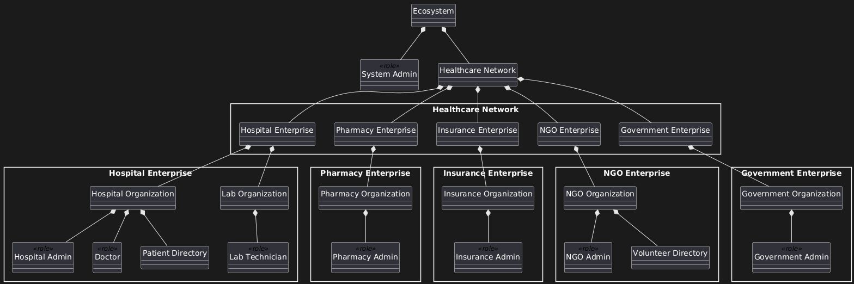

Key Classes and Relationships
- Patient: name, email, accountBal, insuranceRequest, vitalSigns[], encounters[], prescriptions[]
- Doctor: name, specialty, hospital, appointmentList[], patientQueue[]
- Encounter: patient, doctor, diagnosis, prescription, timestamp
- InsuranceAdmin: name, premium, coverage, patientList[]
- Prescription: medication, dosage, pharmacy, status

Data Input and Output
Inputs:
- User registration and login credentials
- Appointment booking details
- Diagnosis and prescription information
- Insurance purchase/claim requests
- Wallet balance additions
Outputs:
- Dashboard views for each role
- Appointment confirmation emails
- Insurance approval/rejection notifications
- Prescription fulfillment alerts
- Patient medical history reports
- System-generated email notifications via Gmail SMTP

Implementation Plan and Timeline
Week | Milestone
1 | Project setup, class hierarchy, and basic GUI framework
2 | Patient and Doctor modules with appointment system
3 | Hospital admin, encounters, and diagnosis workflow
4 | Pharmacy module and prescription management
5 | Insurance module with buy/claim functionality
6 | Email integration and notification system
7 | Testing, bug fixes, and UI polish
8 | Final presentation preparation

Assumptions and Limitations
Assumptions:
- Users have valid email addresses for notifications
- Single ecosystem instance running locally
- Gmail SMTP configured for email services
- All monetary values in USD
Limitations:
- No persistent database (in-memory storage only)
- No real payment gateway integration
- Single-user session (no concurrent multi-user support)
- No mobile/web interface (desktop only)
- Simulated insurance approval workflow

Team Members
Anurag Patwardhan 002026703
Agnel Salve 002545083
Aatish Khune 002516638

