Sales & Revenue Analysis Dashboard

Objective
The objective of this project is to analyze sales performance, revenue generation, and profitability using interactive dashboard visualizations.
Tools Used
- Power BI
- Microsoft Excel / CSV Dataset
Dataset Description
The Sample Superstore dataset contains sales transactions including product information, customer details, regional data, sales, profit, and order information.
Dashboard Components
- Total Sales KPI
- Total Profit KPI
- Total Orders KPI
- Sales by Category
- Profit by Region
- Sales Trend Analysis
- Top 10 Products by Sales
- Region and Category Filters
Key Results
- Total Sales: 2.30 Million
- Total Profit: 286.40 Thousand
- Total Orders: 5.009 Thousand
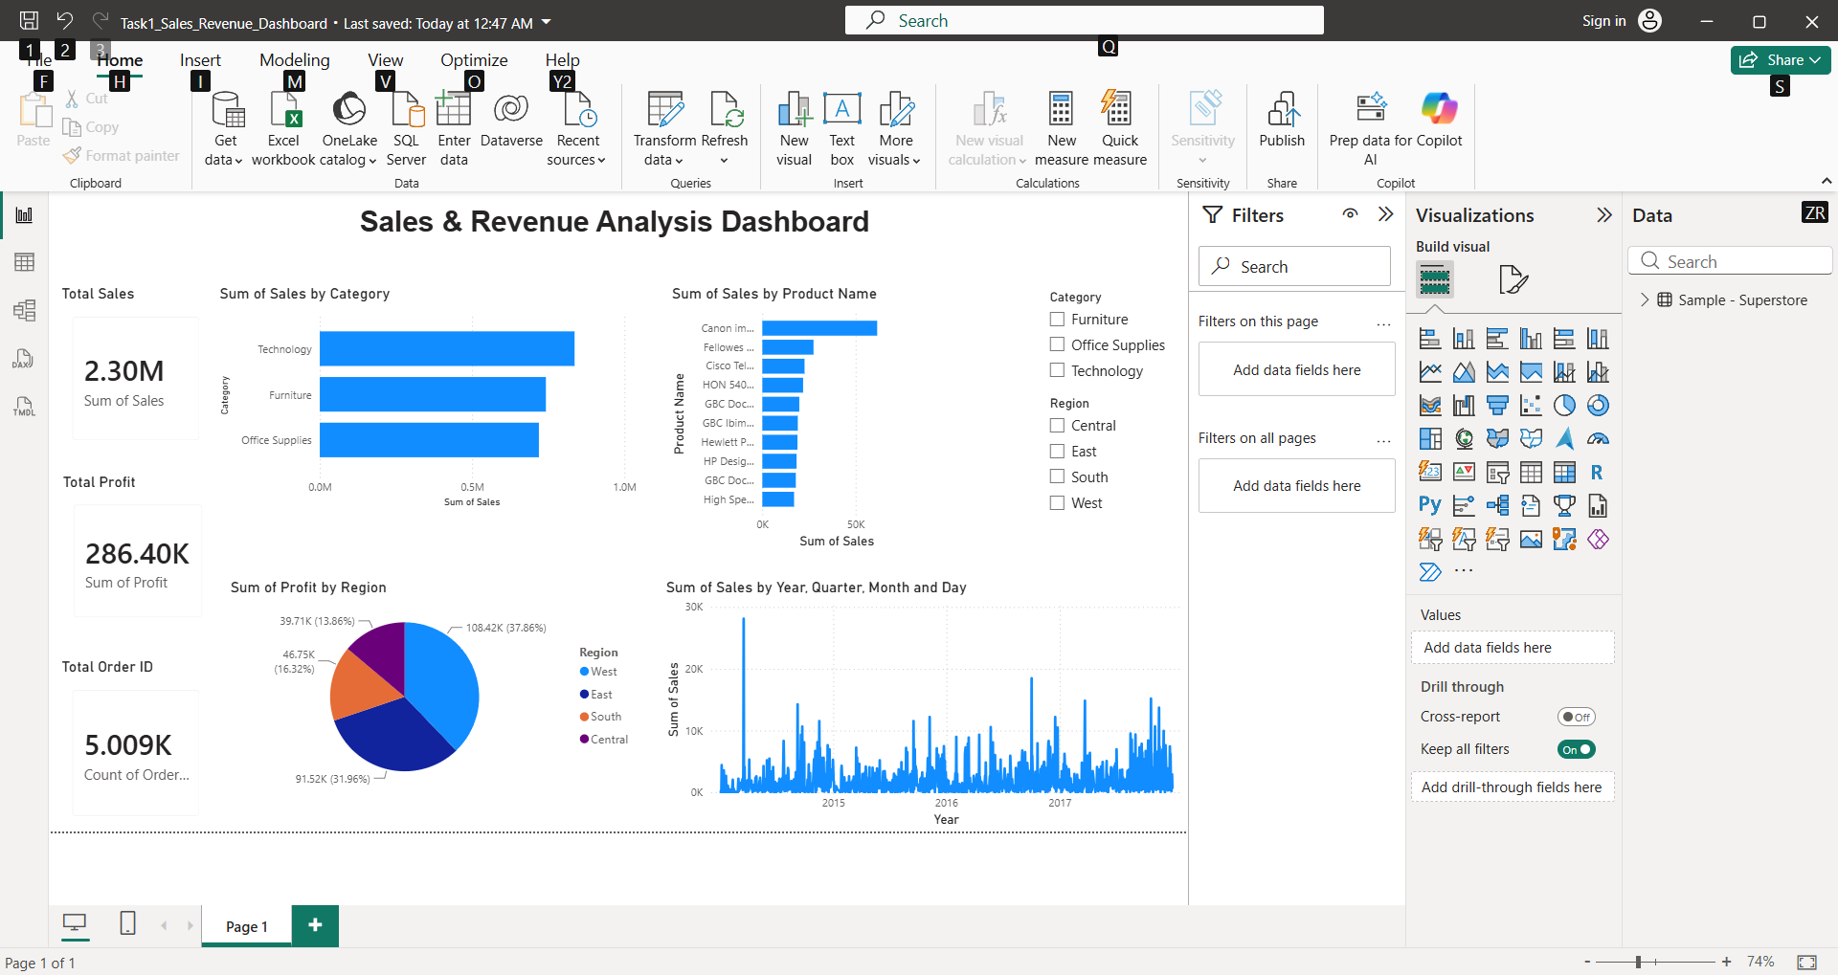
Figure 1: Sales & Revenue Analysis Dashboard
Key Insights
- Technology category generated the highest sales.
- West region contributed the highest profit.
- Sales increased steadily over the years.
- A small group of products contributed significantly to total sales.
Conclusion
The dashboard successfully visualized business performance and provided insights into sales trends, profitability, and product performance. Interactive filters improved analytical capabilities and decision-making.

