Customer Segmentation Using K-Means Clustering

Objective
The objective of this project is to segment customers into distinct groups based on annual income and spending behavior.
Tools Used
- Python
- Pandas
- Scikit-Learn
- Matplotlib
Dataset Description
The Mall Customers dataset contains customer demographic and spending information for 200 customers.
Methodology
- Data loading and exploration
- Missing value verification
- Feature selection
- K-Means clustering
- Cluster visualization
Results
Cluster Distribution:
- Cluster 0: 81 Customers
- Cluster 1: 39 Customers
- Cluster 2: 22 Customers
- Cluster 3: 35 Customers
- Cluster 4: 23 Customers
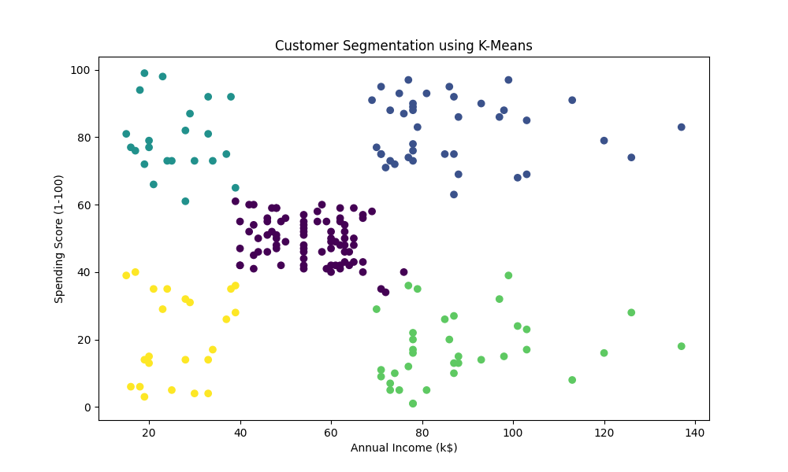
Figure 1: Customer Segmentation using K-Means Clustering
Key Insights
- Premium customers were identified through high spending behavior.
- Some customers have high income but lower spending patterns.
- Medium-income customers formed the largest segment.
- Customer segmentation can improve targeted marketing campaigns.
Conclusion
K-Means clustering successfully identified meaningful customer groups and demonstrated how machine learning can support customer relationship management and business strategy.

