Predictive Analytics Using Historical Sales Data

Objective
The objective of this project is to forecast future sales using historical sales records and machine learning techniques.
Tools Used
- Python
- Pandas
- Scikit-Learn
- Matplotlib
Dataset Description
The Sample Superstore dataset was used to analyze historical sales performance and predict future sales trends.
Methodology
- Data preprocessing
- Date conversion
- Monthly sales aggregation
- Linear Regression model training
- Future sales prediction
- Trend visualization
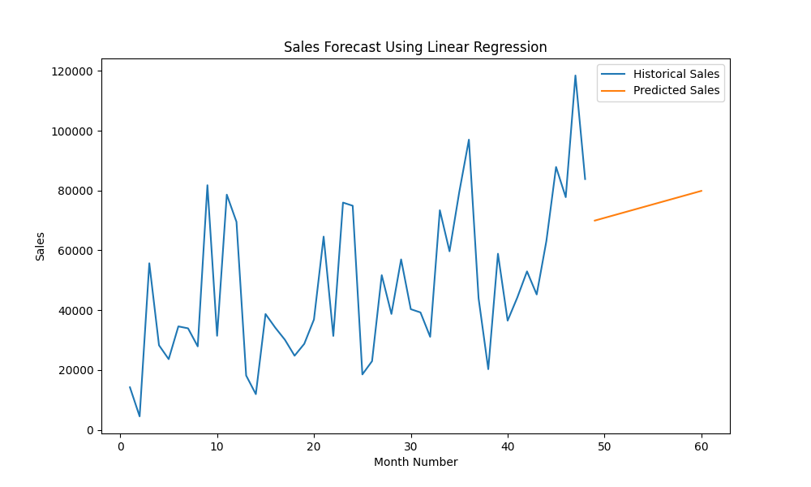
Figure 1: Historical Sales and Future Sales Forecast
Forecast Results
Predicted Future Sales:
- Month 1: 69,957.54
- Month 2: 70,859.54
- Month 3: 71,761.55
- Month 4: 72,663.56
- Month 5: 73,565.57
- Month 6: 74,467.57
- Month 7: 75,369.58
- Month 8: 76,271.59
- Month 9: 77,173.60
- Month 10: 78,075.60
- Month 11: 78,977.61
- Month 12: 79,879.62
Key Insights
- Historical sales exhibited an upward trend.
- Future sales are expected to increase steadily.
- The predictive model provides valuable planning information for business decision-making.
Conclusion
Linear Regression successfully forecasted future sales trends and demonstrated the application of predictive analytics in business environments.

