Name:-Anurag Haldey

Class:-TY CC-1

Roll No:-2215055

Enrolment No:-MITU21BTIT0010

# Lab Experiment : 1

Statement:- Design a Company Registration Form with CSS styles that includes all of the

form tag's features. Show the relevant Form output in a compatible browser.

HTML CODE:-

<!DOCTYPE html>

<html>

    <head>

        <title>

                REGISTRATION FORM

        </title>

        <!-- Link the external CSS file -->

        <link rel="stylesheet" href="LabExp1.css">

    </head>

    <body>

        <div class="title"> REGISTRATION FORM FOR COMPANY </div>

        <form>

            <table>

                <tr>

                    <td> YOUR NAME :- </td>

                    <td> <input type="name"> </td>

                </tr>

                <tr>

                    <td> YOUR FATHER'S NAME :- </td>

                    <td> <input type="name"> </td>

                </tr>

                <tr>

                    <td> YOUR MOTHER'S NAME :- </td>

                    <td> <input type="name"> </td>

                </tr>

                <tr>

                    <td> YOUR PASSWORD :- </td>

                    <td> <input type="password"> </td>

                </tr>

                <tr>

                    <td> YOUR GENDER :- </td>

                    <td>

                        <input type="radio" name="GENDER"> Male

                        <input type="radio" name="GENDER"> Female

                    </td>

                </tr>

                <tr>

                    <td> YOUR EMAIL :- </td>

                    <td> <input type="email"> </td>

                </tr>

                <tr>

                    <td> YOUR ADHAR NUMBER:- </td>

                    <td> <input type="number"> </td>

                </tr>

                <tr>

                    <td> YOUR CONTACT NUMBER:- </td>

                    <td> <input type="number"> </td>

                </tr>

                <tr>

                    <td>

                        <input type="submit" value="submit">

                    </td>

                </tr>

            </table>

        </form>

    </body>

</html>

CSS CODE:-

* {

    margin: 0;

    padding: 0;

    box-sizing: border-box;

}

body {

    font-family: Arial, sans-serif;

    background-color: #f0f0f0;

    padding: 20px;

}

.title {

    text-align: center;

    font-size: 24px;

    font-weight: bold;

    margin-bottom: 20px;

}

form {

    max-width: 400px;

    margin: 0 auto;

    background-color: #ffffff;

    padding: 20px;

    border-radius: 5px;

    box-shadow: 0 0 5px rgba(0, 0, 0, 0.2);

}

table {

    width: 100%;

    border-collapse: collapse;

}

table td {

    padding: 8px;

}

input[type="name"],

input[type="password"],

input[type="email"],

input[type="number"] {

    width: 100%;

    padding: 8px;

    border: 1px solid #ccc;

    border-radius: 4px;

}

input[type="radio"] {

    margin-right: 5px;

}

input[type="submit"] {

    width: 100%;

    padding: 10px;

    background-color: #4CAF50;

    color: #fff;

    border: none;

    border-radius: 4px;

    cursor: pointer;

}

input[type="submit"]:hover {

    background-color: #45a049;

}

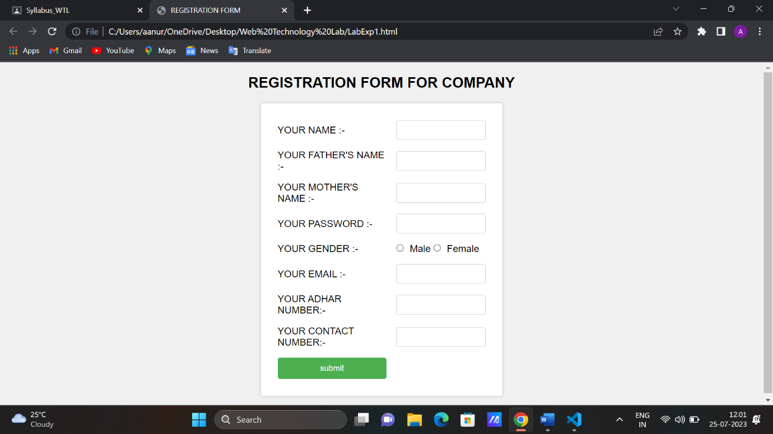

# Explaination of HTML Part

The main part of this HTML code is a registration form for a company.

1. **<title>**: Sets the title of the web page, which appears in the browser's title bar or tab. In this case, the title is "REGISTRATION FORM."
2. **<link rel="stylesheet" href="LabExp1.css">**: Links an external CSS file named "LabExp1.css" to the HTML document.
3. **<div class="title"> REGISTRATION FORM FOR COMPANY </div>**: Creates a div element with the class "title" and displays the text "REGISTRATION FORM FOR COMPANY" inside it.
4. **<form>**: Defines a form that contains various input fields to collect user information.
5. **<table>**: Creates a table for organizing the form elements in a tabular layout.
6. Input fields: The table contains several rows (**<tr>**) with two cells (**<td>**) each. The first cell holds the label for each input field, and the second cell contains the corresponding input elements.
7. Input types: The input elements have different types such as "text," "password," "radio," "email," and "number
8. **<input type="submit" value="submit">**: This is a submit button that users can click to submit the form data.

# Explaination of CSS Part

The main part of this CSS code applies styling to the registration :-

1. **\***: Resets default styles for all elements by removing margins and paddings and ensuring the box-sizing is set to "border-box."
2. **body**: Sets the font-family to Arial, sans-serif, and defines a light gray background color (#f0f0f0) for the entire page. Adds padding around the body content.
3. **.title**: It aligns the text to the center, sets the font size to 24px, bolds the text, and adds a bottom margin of 20px.
4. **form**: Styles the form container. Sets the maximum width to 400px and centers it on the page with auto margins.
5. **table**: Styles the table element, making it take up 100% width and collapsing the borders between cells.
6. **table td**: Adds padding to the table cells for better spacing.
7. **input[type="name"], input[type="password"], input[type="email"], input[type="number"]**: Styles input fields for name, password, email, and number types. Sets them to 100% width, adds padding, a light gray border, and rounded corners.
8. **input[type="radio"]**: Styles radio buttons by adding a small margin between them for spacing.
9. **input[type="submit"]**: Styles the submit button. Sets it to 100% width, adds padding, a green background color (#4CAF50), white text color, removes the border, and gives it rounded corners.