Name:-Anurag Haldey

Class:-TY CC-1

Roll No:-2215055

Enrolment No:-MITU21BTIT0010

a] Create an HTML script for Coffee: shop online web content utilizing HTML

tags and CSS capabilities. Use a coffee cup and relevant images to enhance the

presentation. Provide a coffee type selection option, as well as a rate for the

coffee type pick. Tables should be used whenever possible.

HTML Code:-

<!DOCTYPE html>

<html lang="en">

<head>

    <meta charset="UTF-8">

    <meta name="viewport" content="width=device-width, initial-scale=1.0">

    <title>Anurag's Coffee Shop</title>

    <link rel="stylesheet" href="LabExp2A.css">

</head>

<body>

    <header>

        <h1>Anurag's Coffee Shop</h1>

    </header>

    <main>

        <div class="coffee-menu">

            <h2>Menu</h2>

            <table>

                <tr>

                    <td class="coffee-image">

                        <img src="HotCoffee1.jpg" alt="Coffee Cup">

                    </td>

                    <td class="coffee-details">

                        <h3>Regular Coffee</h3>

                        <p>A classic cup of coffee.</p>

                    </td>

                    <td class="coffee-price">₹250.00</td>

                    <td class="coffee-add-to-cart">

                        <button onclick="addToCart('Regular Coffee', 250)">Add to Cart</button>

                    </td>

                </tr>

                <!-- Add more coffee types here -->

                <!-- Example for Espresso -->

                <tr>

                    <td class="coffee-image">

                        <img src="Espresso.jpg" alt="Espresso">

                    </td>

                    <td class="coffee-details">

                        <h3>Espresso</h3>

                        <p>A concentrated shot of coffee.</p>

                    </td>

                    <td class="coffee-price">₹260.00</td>

                    <td class="coffee-add-to-cart">

                        <button onclick="addToCart('Espresso', 260)">Add to Cart</button>

                    </td>

                </tr>

                <!-- Add more coffee types here -->

                <tr>

                    <td class="coffee-image">

                        <img src="ColdCoffee.jpg" alt="Cold Coffee">

                    </td>

                    <td class="coffee-details">

                        <h3>Cold Coffee</h3>

                        <p>Cold coffee with Chocolate.</p>

                    </td>

                    <td class="coffee-price">₹270.00</td>

                    <td class="coffee-add-to-cart">

                        <button onclick="addToCart('Cold Coffee', 270)">Add to Cart</button>

                    </td>

                </tr>

                </tr>

                <td class="coffee-image">

                    <img src="Americano.jpg" alt="Americano Coffee">

                </td>

                <td class="coffee-details">

                    <h3>Americano</h3>

                    <p>Dilluted espresso with hot water.</p>

                </td>

                <td class="coffee-price">₹290.00</td>

                <td class="coffee-add-to-cart">

                    <button onclick="addToCart('Cold Coffee', 270)">Add to Cart</button>

                </td>

                </tr>

                <td class="coffee-image">

                    <img src="Cappuccino.jpg" alt="Cappuccino">

                </td>

                <td class="coffee-details">

                    <h3>Cappucino</h3>

                    <p>Triple espresso shot with hot milk.</p>

                </td>

                <td class="coffee-price">₹300.00</td>

                <td class="coffee-add-to-cart">

                    <button onclick="addToCart('Cold Coffee', 270)">Add to Cart</button>

                </td>

                </tr>

                <td class="coffee-image">

                    <img src="Machhiato.jpg" alt="Macchiato">

                </td>

                <td class="coffee-details">

                    <h3>Macchiato</h3>

                    <p>Stained with espresso and foam.</p>

                </td>

                <td class="coffee-price">₹350.00</td>

                <td class="coffee-add-to-cart">

                    <button onclick="addToCart('Cold Coffee', 270)">Add to Cart</button>

                </td>

                </tr>

                <!-- Add more coffee types here -->

                <!-- Add more coffee types here -->

                <!-- Continue adding the remaining coffee types -->

            </table>

        </div>

    </main>

    <footer>

        <p>&copy; 2023 Anurag's Coffee Shop. All rights reserved.</p>

    </footer>

    <script>

        let cartItems = [];

        function addToCart(coffeeType, price) {

            cartItems.push({ coffeeType, price });

            alert(coffeeType + " added to cart!");

        }

    </script>

</body>

</html>

CSS Code:-

/* Updated CSS Styles with Increased Hovering */

body {

    font-family: Arial, sans-serif;

    margin: 0;

    padding: 0;

    background-color: #f7e4d8;

    background-image: url('coffee_background.jpg');

    background-repeat: no-repeat;

    background-size: cover;

  }

  header {

    background-color: #333;

    color: #fff;

    padding: 1rem;

    text-align: center;

    border-bottom: 5px solid #b56a47;

  }

  main {

    padding: 2rem;

  }

  h1 {

    margin: 0;

    font-size: 3rem;

  }

  .coffee-menu {

    margin-top: 2rem;

    border: 3px solid #b56a47;

    border-radius: 10px;

    padding: 1rem;

    background-color: #fff;

    box-shadow: 0 0 10px rgba(0, 0, 0, 0.2);

  }

  table {

    width: 100%;

    border-collapse: collapse;

  }

  th, td {

    padding: 1rem;

    border-bottom: 1px solid #ddd;

  }

  th {

    background-color: #f2f2f2;

  }

  .coffee-image img {

    width: 100px;

    height: 100px;

    border-radius: 50%;

    object-fit: cover;

    border: 2px solid #b56a47;

    box-shadow: 0 0 5px rgba(0, 0, 0, 0.2);

    transition: transform 0.3s ease-in-out, box-shadow 0.3s ease-in-out;

  }

  .coffee-image img:hover {

    transform: scale(1.1) rotate(3deg);

    box-shadow: 0 0 10px rgba(0, 0, 0, 0.3);

  }

  .coffee-details h3 {

    font-size: 1.5rem;

    margin-bottom: 0.5rem;

    color: #b56a47;

  }

  .coffee-price {

    font-weight: bold;

    color: #b56a47;

  }

  footer {

    background-color: #333;

    color: #fff;

    text-align: center;

    padding: 1rem;

    border-top: 5px solid #b56a47;

  }

Explaination HTML:-

The code represents the website of "Anurag's Coffee Shop."

It displays a coffee menu with various coffee types, images, descriptions, and prices.

Customers can add coffee items to their cart by clicking the "Add to Cart" button.

The website uses an external CSS file for styling.

JavaScript is used to handle adding items to the cart and displaying an alert when an item is added.

The footer contains a copyright notice for the year 2023.

Explaination CSS:-

* The body has a background color and image, and the font is set to Arial, sans-serif.
* The header has a dark background color, white text, and a bottom border with a specific color.
* The main section has padding for spacing.
* The coffee menu has a light background, border, and rounded corners, with a shadow effect.
* The table's cells have padding and a bottom border for separation.
* The coffee images have a circular shape with a border, and a hover effect scales and rotates them with a shadow.
* The coffee names have a larger font size and a specific color.
* The coffee prices are in bold and have a specific color.
* The footer has a dark background color, white text, and a top border with a specific color.

Output:-

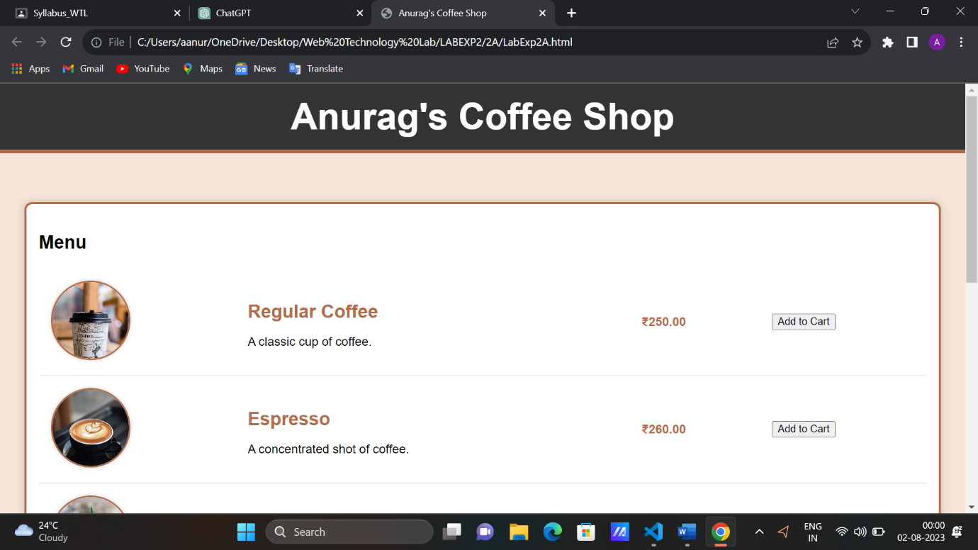

b] Create an HTML Script for a Car Service Center utilizing HTML tags and

CSS features: Enhance content with numerous car workshop photographs and

car accessories, as well as details on various car servicing packages.

HTML Code:-

<!DOCTYPE html>

<html lang="en">

<head>

    <meta charset="UTF-8">

    <meta name="viewport" content="width=device-width, initial-scale=1.0">

    <title>Car Service Center</title>

    <link rel="stylesheet" href="LabExp2B.css">

</head>

<body>

    <header>

        <h1>ANURAG CAR CARE (ACC)</h1>

        <nav>

            <ul>

                <li><a href="#services">Services</a></li>

                <li><a href="#workshop">Workshop</a></li>

                <li><a href="#accessories">Accessories</a></li>

                <li><a href="#contact">Contact</a></li>

            </ul>

        </nav>

    </header>

    <section id="services">

        <h2>Car Servicing Packages</h2>

        <div class="service-card">

            <img src="CarServicing1.jpg" alt="Car Servicing Package 1">

            <h3>Package 1</h3>

            <p>Our Package 1 includes regular maintenance services for your car. It covers engine oil change, air filter

                replacement, tire rotation, and basic diagnostics. Keep your car in top shape with this essential

                package.</p>

        </div>

        <div class="service-card">

            <img src="CarServicing2.jpg" alt="Car Servicing Package 2">

            <h3>Package 2</h3>

            <p>Choose Package 2 for a comprehensive car care experience. This package includes all the services from

                Package 1, along with brake inspection, battery health check, and coolant replacement. Give your car the

                care it deserves with Package 2.</p>

        </div>

        <!-- Add more service cards as needed -->

    </section>

    <section id="workshop">

        <h2>Our Workshop</h2>

        <div class="workshop-photos">

            <img src="CarWorkShop1.jpg" alt="Workshop Photo 1">

            <img src="CarWorkShop2.jpg" alt="Workshop Photo 2">

            <img src="CarWorkShop3.jpg" alt="Workshop Photo 3">

            <!-- Add more workshop photos as needed -->

        </div>

    </section>

    <section id="accessories">

        <h2>Car Accessories</h2>

        <div class="accessory-item">

            <img src="CarAccesory1.jpg" alt="Car Accessory 1">

            <h3>Accessory 1</h3>

            <p>Enhance your driving experience with Accessory 1. This premium car accessory includes a state-of-the-art

                entertainment system with touchscreen controls, advanced connectivity options, and immersive sound

                quality.</p>

        </div>

        <div class="accessory-item">

            <img src="CarAccesory2.jpg" alt="Car Accessory 2">

            <h3>Accessory 2</h3>

            <p>Accessory 2 offers added safety and convenience features for your car. It includes a GPS navigation

                system, rearview camera, and parking sensors. Upgrade your car with Accessory 2 for a smarter driving

                experience.</p>

        </div>

        <!-- Add more accessory items as needed -->

    </section>

    <section id="contact">

        <h2>Contact Us</h2>

        <p>If you have any questions or want to book a service, please fill out the form below:</p>

        <form>

            <!-- Your form elements go here -->

        </form>

    </section>

    <footer>

        <p>&copy; 2023 ANURAG CAR CARE(ACC). All rights reserved.</p>

    </footer>

</body>

</html>

CSS Code:-

/* Global styles */

body {

    font-family: Arial, sans-serif;

    margin: 0;

    padding: 0;

    background-color: #f9f9f9;

  }

  header {

    background-color: #333;

    color: #fff;

    text-align: center;

    padding: 1rem 0;

  }

  nav ul {

    list-style: none;

  }

  nav li {

    display: inline-block;

    margin-right: 20px;

  }

  nav a {

    color: #fff;

    text-decoration: none;

    transition: color 0.3s;

  }

  nav a:hover {

    color: #ff8c00;

  }

  section {

    padding: 2rem;

  }

  h2 {

    text-align: center;

    margin-bottom: 20px;

    color: #ff8c00;

    font-size: 28px;

  }

  /* Styling for Service Cards */

  .service-card {

    text-align: center;

    margin: 20px;

    padding: 20px;

    border: 1px solid #ccc;

    border-radius: 5px;

    background-color: #fff;

    box-shadow: 0 4px 8px rgba(0, 0, 0, 0.1);

    transition: transform 0.3s;

  }

  .service-card img {

    max-width: 20%;

    margin-bottom: 10px;

    border-radius: 5px;

  }

  .service-card h3 {

    color: #333;

  }

  .service-card p {

    color: #666;

  }

  .service-card:hover {

    transform: translateY(-5px);

  }

  /* Styling for Workshop Photos */

  .workshop-photos {

    display: flex;

    justify-content: space-between;

    flex-wrap: wrap;

  }

  .workshop-photos img {

    width: 30%;

    margin: 10px;

    border: 1px solid #ccc;

    border-radius: 5px;

    box-shadow: 0 4px 8px rgba(0, 0, 0, 0.1);

    transition: transform 0.3s;

  }

  .workshop-photos img:hover {

    transform: scale(1.1);

  }

  /* Styling for Car Accessories */

  .accessory-item {

    text-align: center;

    margin: 20px;

    padding: 20px;

    border: 1px solid #ccc;

    border-radius: 5px;

    background-color: #fff;

    box-shadow: 0 4px 8px rgba(0, 0, 0, 0.1);

    transition: transform 0.3s;

  }

  .accessory-item img {

    max-width: 20%;

    margin-bottom: 10px;

    border-radius: 5px;

  }

  .accessory-item h3 {

    color: #333;

  }

  .accessory-item p {

    color: #666;

  }

  .accessory-item:hover {

    transform: translateY(-5px);

  }

  /* Styling for Contact Form */

  form {

    max-width: 400px;

    margin: 0 auto;

  }

  /* Styling for Footer */

  footer {

    background-color: #333;

    color: #fff;

    text-align: center;

    padding: 1rem 0;

  }

HTML Explaination:-

The code is an HTML webpage for a Car Service Center called "ANURAG CAR CARE (ACC)." It includes sections for displaying car servicing packages, workshop photos, car accessories, and a contact form. The page is styled using a CSS file named "LabExp2B.css."

CSS Code Explaination:-

The code contains global styles for a Car Service Center website:

1. Sets the global font, margin, padding, and background color for the entire page.
2. Styles the header with a dark background, white text, and centered content.
3. Formats the navigation menu with horizontal links and a hover effect that changes link color.
4. Defines styles for each section, adding padding and centering the heading with an orange color.
5. Creates a card layout for car servicing packages, workshop photos, and car accessories, with a subtle box-shadow and hover effect.
6. Aligns workshop photos in a flexible layout with a scaling effect on hover.
7. Styles the contact form, centering it with a maximum width.
8. Formats the footer with a dark background, white text, and centered content.

Output:-

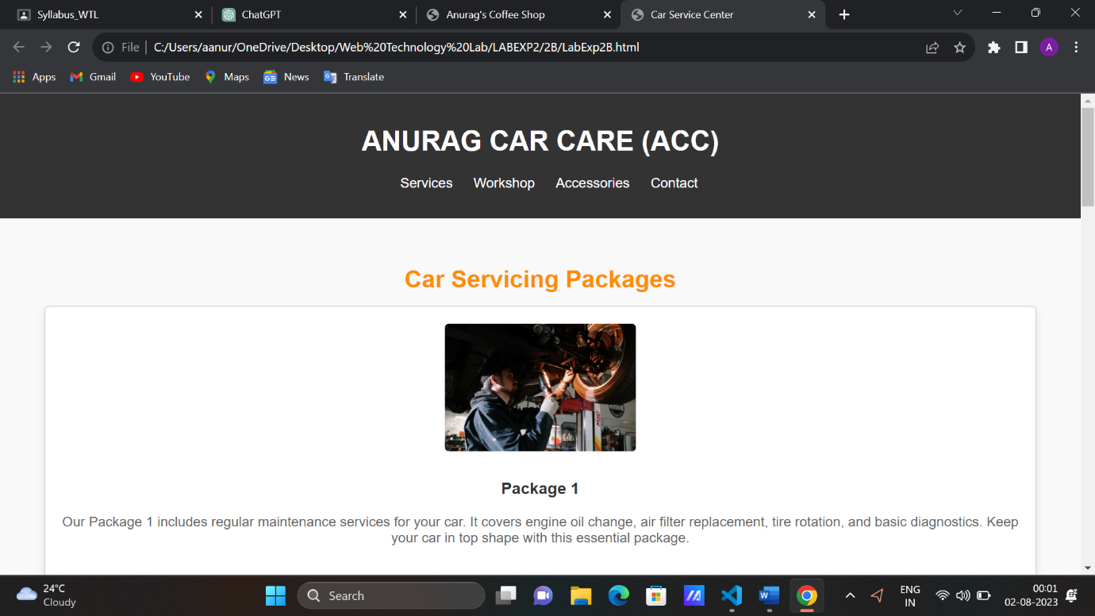

c] Create an HTML Script for a Flower Shop utilising HTML tags and CSS

features: CSS Selectors with Optional Beautification demonstrate output with a

variety of floral photos and the available flower stock in the floweriest shop.

Provide animation using CSS.

HTML Code:-

<!DOCTYPE html>

<html lang="en">

<head>

  <meta charset="UTF-8">

  <meta name="viewport" content="width=device-width, initial-scale=1.0">

  <title>Anurag Floweriest Shop</title>

  <link rel="stylesheet" href="LabExp2C.css">

</head>

<body>

  <header>

    <h1>Welcome to Anurag Floweriest Shop</h1>

  </header>

  <nav>

    <ul>

      <li><a href="#home">Home</a></li>

      <li><a href="#products">Products</a></li>

      <li><a href="#about">About</a></li>

      <li><a href="#contact">Contact</a></li>

    </ul>

  </nav>

  <main>

    <section id="home">

      <h2>Beautiful Flowers</h2>

      <div class="flower-gallery">

        <!-- Add floral photos here -->

        <img src="Flower1.jpg" alt="Flower 1">

        <img src="Flower2.jpg" alt="Flower 2">

        <img src="Flower3.jpg" alt="Flower 3">

        <!-- Add more images as needed -->

      </div>

    </section>

    <section id="products">

      <h2>Available Flower Stock</h2>

      <div class="flower-stock">

        <!-- Add available flower stock details here -->

        <div class="flower-item">

          <img src="Rose.jpg" alt="Rose">

          <h3>Rose</h3>

          <p>Price: ₹10</p>

        </div>

        <div class="flower-item">

          <img src="Tulip.jpg" alt="Tulip">

          <h3>Tulip</h3>

          <p>Price: ₹8</p>

        </div>

        <div class="flower-item">

            <img src="Lilly.jpg" alt="lily">

            <h3>Lilly</h3>

            <p>Price: ₹10</p>

          </div>

          <div class="flower-item">

            <img src="Marygold.jpg" alt="Marygold">

            <h3>Marygold</h3>

            <p>Price: ₹10</p>

          </div>

        <!-- Add more flower items as needed -->

      </div>

    </section>

    <section id="about">

      <h2>About Floweriest Shop</h2>

      <p>Khare Town,Beside DP Paan shop ,Dharampeth Nagpur, Maharashtra 442402</p>

    </section>

    <section id="contact">

      <h2>Contact Us</h2>

      <p>Email: aanurag2003haldey@gmail.com</p>

      <p>Phone: 9022507638</p>

    </section>

  </main>

  <footer>

    <p>&copy; 2023 Anurag Floweriest Shop. All rights reserved.</p>

  </footer>

</body>

</html>

CSS Code:-

body {

    font-family: 'Helvetica', Arial, sans-serif;

    margin: 0;

    padding: 0;

    background-color: #f9f9f9;

    color: #333;

  }

  header {

    background-color: #f9d5e5;

    padding: 20px;

    text-align: center;

  }

  h1 {

    margin: 0;

    font-size: 36px;

    font-weight: bold;

  }

  nav {

    background-color: #f9f9f9;

    padding: 10px;

    box-shadow: 0 2px 5px rgba(0, 0, 0, 0.1);

  }

  nav ul {

    list-style: none;

    margin: 0;

    padding: 0;

    display: flex;

    justify-content: center;

  }

  nav li {

    margin: 0 10px;

  }

  nav a {

    text-decoration: none;

    color: #555;

    font-size: 18px;

    padding: 5px 10px;

    border-radius: 5px;

    transition: background-color 0.3s ease;

  }

  nav a:hover {

    background-color: #f9d5e5;

  }

  main {

    padding: 20px;

  }

  h2 {

    color: #555;

    margin-bottom: 20px;

  }

  .flower-gallery {

    display: flex;

    justify-content: center;

    flex-wrap: wrap;

    gap: 10px;

  }

  .flower-gallery img {

    width: 200px;

    height: 200px;

    object-fit: cover;

    border-radius: 10px;

    box-shadow: 0 2px 5px rgba(0, 0, 0, 0.1);

  }

  .flower-stock {

    display: grid;

    grid-template-columns: repeat(auto-fit, minmax(200px, 1fr));

    gap: 20px;

  }

  .flower-item {

    text-align: center;

    border: 1px solid #ddd;

    padding: 10px;

    border-radius: 10px;

    transition: transform 0.3s ease;

  }

  .flower-item img {

    width: 120px;

    height: 120px;

    object-fit: cover;

    border-radius: 50%;

  }

  .flower-item h3 {

    margin: 10px 0;

    font-size: 24px;

  }

  .flower-item p {

    font-size: 16px;

    margin: 0;

  }

  .flower-item:hover {

    transform: scale(1.05);

  }

  footer {

    text-align: center;

    padding: 10px;

    background-color: #f9d5e5;

    margin-top: 20px;

  }

  footer p {

    margin: 0;

    font-size: 14px;

  }

  /* Add animation for the header */

  @keyframes headerAnimation {

    0% {

      transform: translateY(-20px);

      opacity: 0;

    }

    100% {

      transform: translateY(0);

      opacity: 1;

    }

  }

  header h1 {

    animation: headerAnimation 1s ease;

  }

HTML Code Explaination:-

The HTML code is for a webpage of "Anurag Floweriest Shop," with sections for Home, Products, About, and Contact. It displays beautiful flower images, available flower stock with prices, and shop contact information.

CSS Code Explaination:-

The main part of the CSS code provides styling for an "Anurag Floweriest Shop" webpage:

1. Sets the font, background color, and text color for the entire page.
2. Styles the header with a light pink background, centered text, and padding.
3. Defines styles for the navigation menu with links and hover effect.
4. Styles the main content area with padding.
5. Creates a responsive flower gallery with images and a grid for available flower stock.
6. Formats flower items with text, image, and border radius.
7. Adds a hover effect to flower items to scale up when hovered.
8. Styles the footer with a light pink background, centered text, and padding.
9. Includes a keyframe animation to animate the header's appearance.

Output:-

